---

Module 1: Relational model, schema design & PostgreSQL data types
The mental model first
A relational database is built on one core idea: **data lives in tables, and tables relate to each other through values** — not pointers, not nested objects. Every row in a table represents one fact. Every column represents one attribute of that fact.
This sounds obvious, but it has a deep implication: if you design your schema correctly, you can answer *any* question about your data using SQL — even questions you didn't anticipate when you built the schema.---
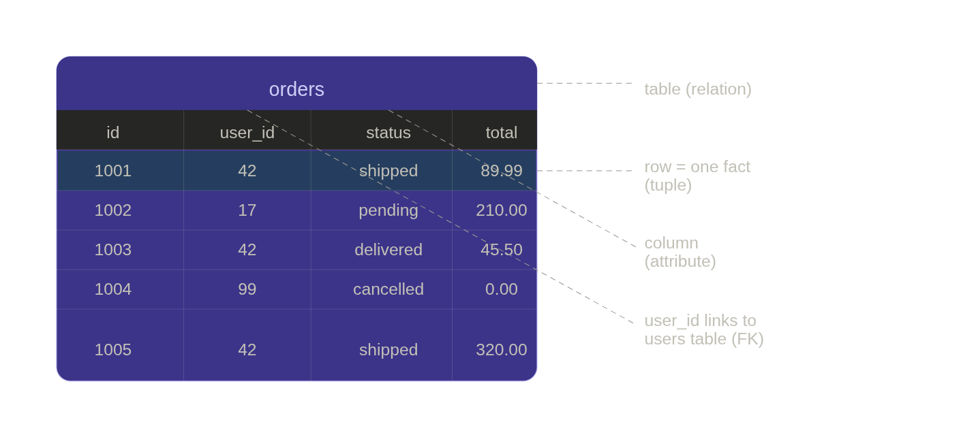
### PostgreSQL data types — what actually matters in backend work
Picking the right type is not pedantic. Wrong types cause bugs, slow queries, and painful migrations. Here's what a mid-level dev needs to know cold:

**Numeric types**

```sql
-- Use BIGINT for IDs in any system that might grow
-- INT runs out at ~2.1 billion rows — sounds like a lot until you log events
user_id BIGINT
order_id BIGINT

-- SERIAL / BIGSERIAL = auto-increment (old way)
id BIGSERIAL PRIMARY KEY

-- IDENTITY = SQL standard way (preferred in modern PostgreSQL)
id BIGINT GENERATED ALWAYS AS IDENTITY PRIMARY KEY

-- NUMERIC(precision, scale) for money — NEVER use FLOAT for currency
price NUMERIC(12, 2) -- up to 9999999999.99, exact
-- FLOAT/DOUBLE lose precision: 0.1 + 0.2 = 0.30000000000000004
```

**Text types**

```sql
-- VARCHAR(n) vs TEXT — in PostgreSQL there is almost NO performance difference
-- TEXT is preferred for flexibility; VARCHAR(n) when you want a DB-enforced limit
email TEXT -- unconstrained
status VARCHAR(20) -- you want the DB to reject 'this_is_way_too_long_status'
country_code CHAR(2) -- fixed-width, e.g. 'IN', 'US'
```

**Time types — a common source of production bugs**

```sql
-- TIMESTAMP vs TIMESTAMPTZ
-- Always use TIMESTAMPTZ in backend systems. It stores UTC + timezone awareness.
-- TIMESTAMP stores local time with no timezone — causes bugs across regions.
created_at TIMESTAMPTZ NOT NULL DEFAULT NOW()
updated_at TIMESTAMPTZ NOT NULL DEFAULT NOW()

-- DATE for calendar dates only (no time component)
birth_date DATE

-- INTERVAL for durations
expires_in INTERVAL -- e.g. '30 days'
```

**Boolean**

```sql
is_active BOOLEAN NOT NULL DEFAULT TRUE
```

**PostgreSQL-specific power types (unique advantages)**

```sql
-- UUID — great for distributed IDs, no coordination needed
id UUID DEFAULT gen_random_uuid() -- pg 13+

-- JSONB — stored as binary, indexable, queryable
-- Use for semi-structured data: feature flags, metadata, third-party payloads
metadata JSONB

-- ARRAY — store multiple values in one column
tags TEXT[]
scores INTEGER[]

-- ENUM — enforced at DB level, fast storage
CREATE TYPE order_status AS ENUM ('pending', 'shipped', 'delivered', 'cancelled');
status order_status NOT NULL DEFAULT 'pending'
```

---

### Constraints — the DB enforcing your business rules

Constraints are your last line of defence. Your application can have bugs, your API can be bypassed, your queue consumer can crash mid-write. The database constraint cannot be bypassed.

```sql
CREATE TABLE users (
id BIGINT GENERATED ALWAYS AS IDENTITY PRIMARY KEY,
email TEXT NOT NULL UNIQUE,
username TEXT NOT NULL,
age INT CHECK (age >= 13), -- business rule enforced at DB level
created_at TIMESTAMPTZ NOT NULL DEFAULT NOW()
);

CREATE TABLE orders (
id BIGINT GENERATED ALWAYS AS IDENTITY PRIMARY KEY,
user_id BIGINT NOT NULL REFERENCES users(id) ON DELETE CASCADE,
status VARCHAR(20) NOT NULL DEFAULT 'pending',
total NUMERIC(12,2) NOT NULL CHECK (total >= 0),
created_at TIMESTAMPTZ NOT NULL DEFAULT NOW()
);
```

**`ON DELETE` behaviour — this comes up constantly in interviews:**

```sql
-- CASCADE: delete user → all their orders deleted too
-- Good for: audit logs, sessions, carts
REFERENCES users(id) ON DELETE CASCADE

-- SET NULL: delete user → order.user_id becomes NULL
-- Good for: soft deletes, keeping historical records
REFERENCES users(id) ON DELETE SET NULL

-- RESTRICT / NO ACTION (default): delete user → error if orders exist
-- Good for: financial records, anything that must not orphan
REFERENCES users(id) ON DELETE RESTRICT
```

---

### NULL semantics — the silent bug source

NULL means "unknown", not "empty" or "zero". This causes real backend bugs:

```sql
-- This returns NO rows even when discount IS NULL
SELECT * FROM orders WHERE discount != 0;

-- Correct — you must check NULL explicitly
SELECT * FROM orders WHERE discount != 0 OR discount IS NULL;

-- COALESCE returns the first non-NULL value — use it in APIs
SELECT COALESCE(discount, 0) AS discount FROM orders;

-- NULL in aggregates: COUNT(*) counts all rows, COUNT(col) skips NULLs
SELECT COUNT(*), -- total rows
COUNT(discount) -- rows where discount is not null
FROM orders;
```
---
### LLD exercise: designing a real backend schema

Let's design the `users`, `products`, and `orders` tables for an e-commerce backend — the kind of schema you'd be asked to draw in an LLD round.The full SQL DDL for this schema:
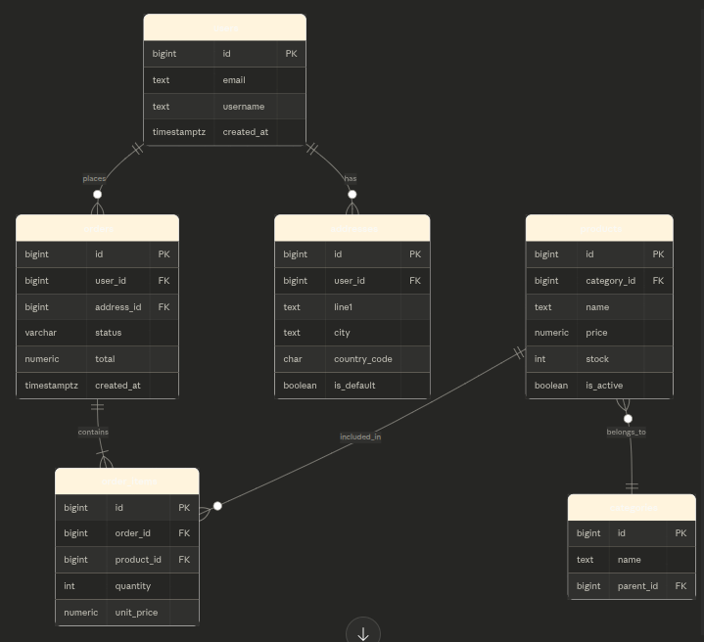

```sql
CREATE TABLE categories (
id BIGINT GENERATED ALWAYS AS IDENTITY PRIMARY KEY,
name TEXT NOT NULL UNIQUE,
parent_id BIGINT REFERENCES categories(id) ON DELETE SET NULL -- self-ref for sub-categories
);

CREATE TABLE users (
id BIGINT GENERATED ALWAYS AS IDENTITY PRIMARY KEY,
email TEXT NOT NULL UNIQUE,
username TEXT NOT NULL,
created_at TIMESTAMPTZ NOT NULL DEFAULT NOW()
);

CREATE TABLE addresses (
id BIGINT GENERATED ALWAYS AS IDENTITY PRIMARY KEY,
user_id BIGINT NOT NULL REFERENCES users(id) ON DELETE CASCADE,
line1 TEXT NOT NULL,
city TEXT NOT NULL,
country_code CHAR(2) NOT NULL,
is_default BOOLEAN NOT NULL DEFAULT FALSE
);

CREATE TABLE products (
id BIGINT GENERATED ALWAYS AS IDENTITY PRIMARY KEY,
category_id BIGINT REFERENCES categories(id) ON DELETE SET NULL,
name TEXT NOT NULL,
price NUMERIC(12,2) NOT NULL CHECK (price > 0),
stock INT NOT NULL DEFAULT 0 CHECK (stock >= 0),
is_active BOOLEAN NOT NULL DEFAULT TRUE,
created_at TIMESTAMPTZ NOT NULL DEFAULT NOW()
);

CREATE TABLE orders (
id BIGINT GENERATED ALWAYS AS IDENTITY PRIMARY KEY,
user_id BIGINT NOT NULL REFERENCES users(id) ON DELETE RESTRICT,
address_id BIGINT REFERENCES addresses(id) ON DELETE SET NULL,
status VARCHAR(20) NOT NULL DEFAULT 'pending',
total NUMERIC(12,2) NOT NULL CHECK (total >= 0),
created_at TIMESTAMPTZ NOT NULL DEFAULT NOW()
);

CREATE TABLE order_items (
id BIGINT GENERATED ALWAYS AS IDENTITY PRIMARY KEY,
order_id BIGINT NOT NULL REFERENCES orders(id) ON DELETE CASCADE,
product_id BIGINT NOT NULL REFERENCES products(id) ON DELETE RESTRICT,
quantity INT NOT NULL CHECK (quantity > 0),
unit_price NUMERIC(12,2) NOT NULL CHECK (unit_price >= 0)
-- unit_price is stored separately — product price can change later
);
```

**Key design decisions to explain in an interview:**

`unit_price` is stored in `order_items` even though `products` already has `price`. Why? Because the product's price can change tomorrow, but the historical order must reflect what the customer actually paid. This is called a **temporal data problem** and it's a very common interview discussion point.

`ON DELETE RESTRICT` on `orders.user_id` — you don't want deleting a user to silently delete their order history. Financial records must be retained. Instead, in production you'd soft-delete users by adding a `deleted_at TIMESTAMPTZ` column.

`parent_id` on `categories` is a self-referential foreign key — it creates a tree structure (Electronics → Phones → Smartphones). This pattern comes up in org charts, comment threads, and folder structures.

---

### Backend use case: what this looks like in a real service

In a Node.js / Python backend, this schema maps directly to your ORM models or repository layer. The constraints you define here save you from writing validation code in 5 different places:

```sql
-- Your API tries to create a product with price = -10
-- The DB rejects it: ERROR: new row violates check constraint "products_price_check"
-- This is defence in depth — even if your service layer has a bug, data stays clean

-- Your job queue tries to delete a user who has unpaid orders
-- ON DELETE RESTRICT fires: ERROR: update or delete on table "users" violates foreign key constraint
-- This prevents orphaned financial records without any application code
```

---

### Interview questions for Module 1

These are real questions asked at mid-level backend interviews:

**Q: Why use `BIGINT` instead of `INT` for IDs?**
`INT` overflows at ~2.1 billion. For a high-traffic system generating events or logs, that's reachable in months. `BIGINT` supports up to ~9.2 quintillion. The storage difference (4 vs 8 bytes) is negligible. Always use `BIGINT` for IDs.

**Q: Why store `unit_price` in `order_items` when you already have `price` in `products`?**
Product prices change. If you join to `products.price` at query time, you'd get today's price for a 3-year-old order. `unit_price` is a snapshot of what the customer paid. This is the core of immutable event/fact recording.

**Q: What's the difference between `TIMESTAMP` and `TIMESTAMPTZ`?**
`TIMESTAMP` stores a naive datetime with no timezone info — it assumes your DB server's local timezone. `TIMESTAMPTZ` stores UTC and is timezone-aware. In any multi-region or cloud backend, always use `TIMESTAMPTZ`. Bugs from naive timestamps in production are notoriously hard to debug.

**Q: When would you use `JSONB` vs a proper relational column?**
Use JSONB for truly semi-structured, schema-variable data: user preferences, third-party webhook payloads, feature flag configs, metadata you don't query often. Use relational columns when you need to filter, sort, join, or enforce constraints on the data. JSONB is not a replacement for schema design — it's an escape hatch for genuine variability.

**Q: What does `ON DELETE CASCADE` vs `ON DELETE RESTRICT` mean and when do you choose each?**
`CASCADE` propagates the delete — deleting a parent deletes children. Use when children have no meaning without the parent (sessions, cart items). `RESTRICT` blocks the delete if children exist. Use for financial/audit data that must be retained. Choosing wrong causes either data loss or confusing errors in production.

---

Module 2: Core SQL querying

The anatomy of a SELECT statement
Most people learn SQL clauses in the order they write them. But the database executes them in a completely different order — and understanding this is what separates people who guess at queries from people who reason through them.
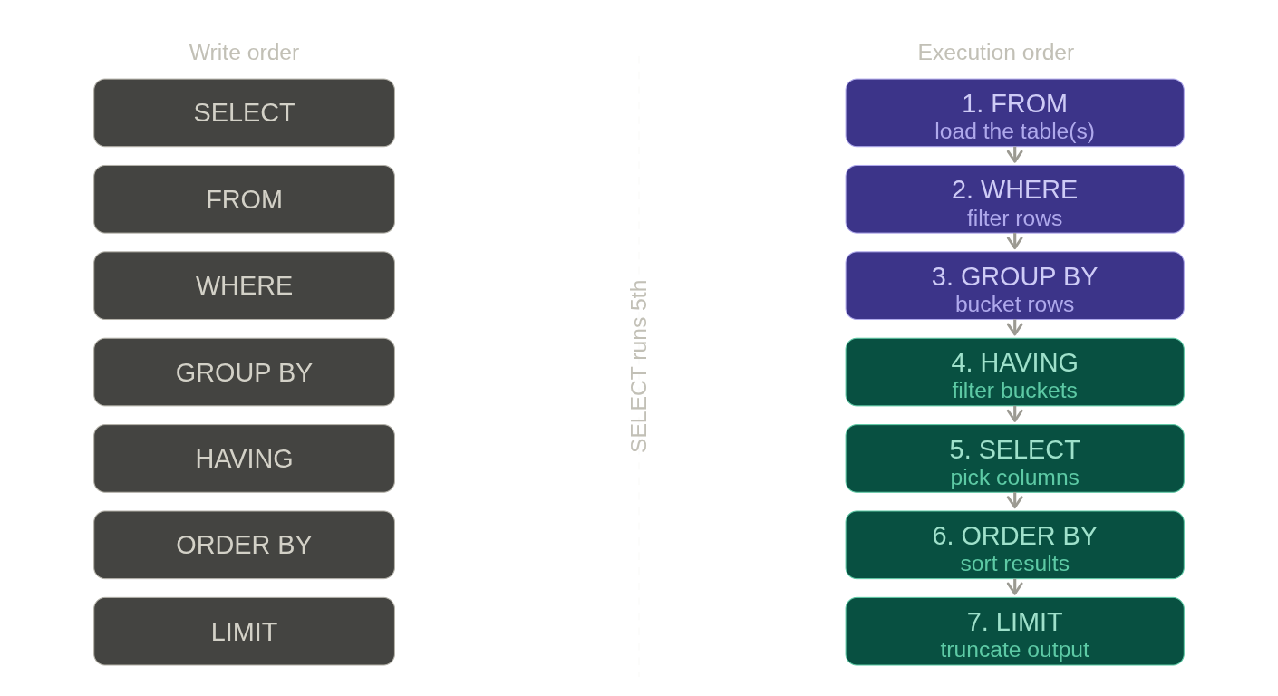

The most important thing here: SELECT runs 5th. This is why you cannot use a column alias defined in SELECT inside a WHERE clause — WHERE runs before SELECT has even computed the alias. This confuses almost every developer at some point.
-- WRONG — alias not yet defined when WHERE runs
SELECT total * 0.9 AS discounted
FROM orders
WHERE discounted > 100; -- ERROR: column "discounted" does not exist

-- CORRECT — repeat the expression, or use a subquery / CTE
SELECT total * 0.9 AS discounted
FROM orders
WHERE total * 0.9 > 100;

SELECT and filtering
-- Basic fetch — what your GET /orders API might run
SELECT id, user_id, status, total, created_at
FROM orders;

-- Filter by exact value
SELECT * FROM orders
WHERE status = 'shipped';

-- Multiple conditions
SELECT * FROM orders
WHERE status = 'shipped'
AND total > 100;

-- IN — cleaner than multiple OR conditions
SELECT * FROM orders
WHERE status IN ('shipped', 'delivered');

-- NOT IN — be careful with NULLs here (covered below)
SELECT * FROM orders
WHERE status NOT IN ('cancelled');

-- BETWEEN — inclusive on both ends
SELECT * FROM orders
WHERE created_at BETWEEN '2024-01-01' AND '2024-12-31';

-- Pattern matching — LIKE is case-sensitive in PG, ILIKE is case-insensitive
SELECT * FROM users
WHERE email LIKE '%@gmail.com';

SELECT * FROM users
WHERE username ILIKE 'john%'; -- PostgreSQL-specific, very handy
The NULL trap with NOT IN — a real interview gotcha:
-- Suppose status has one NULL row
-- This returns ZERO rows even though you expect results
SELECT * FROM orders WHERE status NOT IN ('cancelled', NULL);

-- Why? NOT IN with NULL uses ≠ internally.
-- NULL ≠ anything is NULL (unknown), so every row fails the check.

-- Safe version — always filter NULLs explicitly
SELECT * FROM orders
WHERE status NOT IN ('cancelled')
AND status IS NOT NULL;

Sorting and pagination
-- ORDER BY — default is ASC
SELECT id, total, created_at
FROM orders
ORDER BY created_at DESC;

-- Multi-column sort — useful for deterministic ordering
SELECT id, status, total
FROM orders
ORDER BY status ASC, total DESC;

-- NULLS LAST / NULLS FIRST — PostgreSQL specific, important for nullable columns
SELECT id, discount
FROM orders
ORDER BY discount DESC NULLS LAST; -- NULLs go to bottom
Pagination — two approaches and their tradeoffs:
-- OFFSET pagination — simple, but slow on large datasets
-- Page 3 of 20 results per page:
SELECT id, total, created_at
FROM orders
WHERE user_id = 42
ORDER BY created_at DESC
LIMIT 20 OFFSET 40; -- OFFSET 40 = skip first 40 rows

-- Problem: at OFFSET 10000, the DB still scans and discards 10000 rows.
-- Also: if a new order is inserted between page 1 and page 2, you see duplicates.

-- CURSOR / KEYSET pagination — fast, stable, production preferred
-- "Give me items after this cursor"
SELECT id, total, created_at
FROM orders
WHERE user_id = 42
AND created_at < '2024-06-15 10:30:00' -- last seen timestamp
ORDER BY created_at DESC
LIMIT 20;
-- No offset scan. Index seek directly to the cursor point.
-- This is what Twitter, Instagram, and most APIs actually use.
This is a very common interview question at mid-level: "How would you implement pagination for an endpoint returning millions of orders?" The expected answer is keyset/cursor pagination, and you need to explain why OFFSET breaks down.

DISTINCT and deduplication
-- DISTINCT — remove duplicate rows in result
SELECT DISTINCT status FROM orders;
-- Returns: pending, shipped, delivered, cancelled

-- DISTINCT ON (col) — PostgreSQL specific, very powerful
-- Get the most recent order per user
SELECT DISTINCT ON (user_id)
user_id, id AS order_id, total, created_at
FROM orders
ORDER BY user_id, created_at DESC;
-- Keeps the first row per user_id group after ordering by created_at DESC
-- i.e., the most recent order per user
DISTINCT ON is a PostgreSQL feature that shows up in interviews specifically. It's often the cleanest solution to "get the latest record per group" without a subquery.

Column expressions and aliases
-- Computed columns — common in reporting APIs
SELECT
id,
total,
total * 0.18 AS gst_amount,
total * 1.18 AS total_with_gst,
UPPER(status) AS status_display,
DATE(created_at) AS order_date -- strip time, keep date
FROM orders;

-- CASE WHEN — conditional logic in SQL (replaces if/else)
SELECT
id,
total,
CASE
WHEN total >= 500 THEN 'high'
WHEN total >= 100 THEN 'medium'
ELSE 'low'
END AS order_tier
FROM orders;

-- CASE with status labels — for display APIs
SELECT
id,
CASE status
WHEN 'pending' THEN 'Order Placed'
WHEN 'shipped' THEN 'On the Way'
WHEN 'delivered' THEN 'Delivered'
WHEN 'cancelled' THEN 'Cancelled'
ELSE 'Unknown'
END AS status_label
FROM orders;

Working with dates — very common in assessments
-- Orders from the last 7 days
SELECT * FROM orders
WHERE created_at >= NOW() - INTERVAL '7 days';

-- Orders from today
SELECT * FROM orders
WHERE DATE(created_at) = CURRENT_DATE;

-- Extract parts of a timestamp
SELECT
id,
EXTRACT(YEAR FROM created_at) AS order_year,
EXTRACT(MONTH FROM created_at) AS order_month,
EXTRACT(DOW FROM created_at) AS day_of_week -- 0=Sunday, 6=Saturday
FROM orders;

-- Truncate to month (for monthly grouping)
SELECT
DATE_TRUNC('month', created_at) AS month,
COUNT(*) AS order_count
FROM orders
GROUP BY DATE_TRUNC('month', created_at)
ORDER BY month;

Backend API patterns — what these queries look like in practice
Here's how a typical GET /users/:id/orders endpoint maps to SQL:
-- GET /users/42/orders?status=shipped&page=1&limit=10&sort=created_at&order=desc

SELECT
o.id,
o.status,
o.total,
o.created_at
FROM orders o
WHERE o.user_id = 42 -- from URL param
AND o.status = 'shipped' -- from query param (optional filter)
ORDER BY o.created_at DESC -- from sort param
LIMIT 10 -- from limit param
OFFSET 0; -- from page param: (page-1) * limit
This is a parameterized query in every backend framework. Never interpolate user input directly into SQL — that's a SQL injection vulnerability. Always use $1, ?, or named params depending on your driver.

SQL coding assessment patterns for this module
These are the exact question types you'll face:
Pattern 1 — Filter + sort + limit: "Find the top 5 most expensive active products in the Electronics category."
SELECT p.id, p.name, p.price
FROM products p
JOIN categories c ON p.category_id = c.id
WHERE c.name = 'Electronics'
AND p.is_active = TRUE
ORDER BY p.price DESC
LIMIT 5;
Pattern 2 — Conditional classification: "Label each order as 'high', 'medium', or 'low' value."
SELECT
id,
total,
CASE
WHEN total >= 500 THEN 'high'
WHEN total >= 100 THEN 'medium'
ELSE 'low'
END AS value_tier
FROM orders
ORDER BY total DESC;
Pattern 3 — Date range filtering: "Find all orders placed in the last 30 days that are still pending."
SELECT id, user_id, total, created_at
FROM orders
WHERE status = 'pending'
AND created_at >= NOW() - INTERVAL '30 days'
ORDER BY created_at ASC;
Pattern 4 — Deduplication: "Get the list of distinct countries our users are from."
SELECT DISTINCT country_code
FROM addresses
ORDER BY country_code;

Interview questions for Module 2
Q: What's the difference between WHERE and HAVING? WHERE filters individual rows before grouping. HAVING filters groups after GROUP BY. You can't use aggregate functions like COUNT() in WHERE — that's what HAVING is for.
Q: Why is OFFSET pagination bad for large datasets? The database still scans and discards all rows before the offset. OFFSET 50000 with LIMIT 20 scans 50,020 rows and throws away 50,000. Cursor/keyset pagination uses an indexed WHERE clause to seek directly to the right position — O(log n) instead of O(n).
Q: What does DISTINCT ON do and is it standard SQL? It's PostgreSQL-specific. It returns one row per distinct value of the specified column(s), keeping the first row per group based on the ORDER BY. Standard SQL would require a subquery with ROW_NUMBER(). DISTINCT ON is cleaner but only works in PostgreSQL.
Q: Why should you never use SELECT * in production application code? It fetches all columns including large ones (JSONB blobs, TEXT fields), breaking when you add new columns (your deserialization may fail), and prevents the query planner from using index-only scans. Always select exactly the columns you need.
Q: What is a parameterized query and why does it matter? A parameterized query separates SQL code from user-supplied data. The DB driver sends the SQL structure and the data separately, so the DB never interprets user input as SQL. This prevents SQL injection completely. String interpolation in SQL is always wrong.

Is created_at the cursor?
Yes, created_at is acting as the cursor here. A cursor is just any stable, ordered value you use as a "bookmark" to say "give me everything after this point." It doesn't have to be a special type — it can be a timestamp, an integer ID, or a composite of both.
The value '2024-06-15 10:30:00' is simply the created_at of the last row you saw on the previous page, passed back in as a filter.

Do you need to define anything at the DB level?
No magic "cursor object" needs to be declared. But you do need one important thing:
An index on (user_id, created_at DESC)
CREATE INDEX idx_orders_user_created
ON orders (user_id, created_at DESC);
Without this, the DB falls back to a full scan anyway, and you lose the keyset advantage entirely. With it, the DB does a direct index seek to user_id = 42 AND created_at < [cursor] and reads exactly 20 rows — touching nothing else.

Won't the DB still sort rows before answering?
This is the key insight — not if the index is already sorted that way.
Here's what happens with vs. without the index:
Situation | What the DB does
No index | Full scan → sort all matching rows → apply LIMIT
Index on (user_id, created_at DESC) | Seek directly into the index at the cursor point → read 20 rows in order → done
When the index matches your ORDER BY, the DB reads rows pre-sorted from the index itself — no separate sort step occurs at all. This is why keyset pagination is O(1) regardless of how deep into the dataset you are, while OFFSET is O(n) because it must count and discard rows.

One practical caveat
created_at alone can be non-unique (two orders placed at the same millisecond). In production, you'd typically use a composite cursor:
WHERE user_id = 42
AND (created_at, id) < ('2024-06-15 10:30:00', 8821)
ORDER BY created_at DESC, id DESC
This guarantees stable pagination even with timestamp ties, and your index should reflect the same: (user_id, created_at DESC, id DESC).

Cursor pagination with a properly indexed column (e.g., ID or timestamp) provides highly efficient
time complexity, where
is total records and
is page size. Unlike offset pagination, it avoids scanning prior records, enabling fast, constant-time performance (
) to find the next page, ideal for large datasets and infinite scroll.
Time Complexity Analysis
- Locating the Cursor:
to search for the starting point using a B-tree index.
- Fetching the Page:
to read the next
rows (page size) sequentially from the index.
- Total Complexity:
, resulting in stable, fast performance regardless of how deep into the dataset the user is.
Key Takeaways
- Efficiency: The query WHERE id > last_seen_id ORDER BY id ASC LIMIT 10 leverages an index to jump directly to the target record.
- Performance: Performance remains stable (near constant) even with millions of records, unlike OFFSET which becomes exponentially slower as the offset increases.
- Use Cases: Highly suited for infinite scrolling (social media feeds) or real-time data, but not suitable for skipping directly to a specific page (e.g., jump to page 100).
- Limitations: Requires a unique, strictly sorted cursor column.
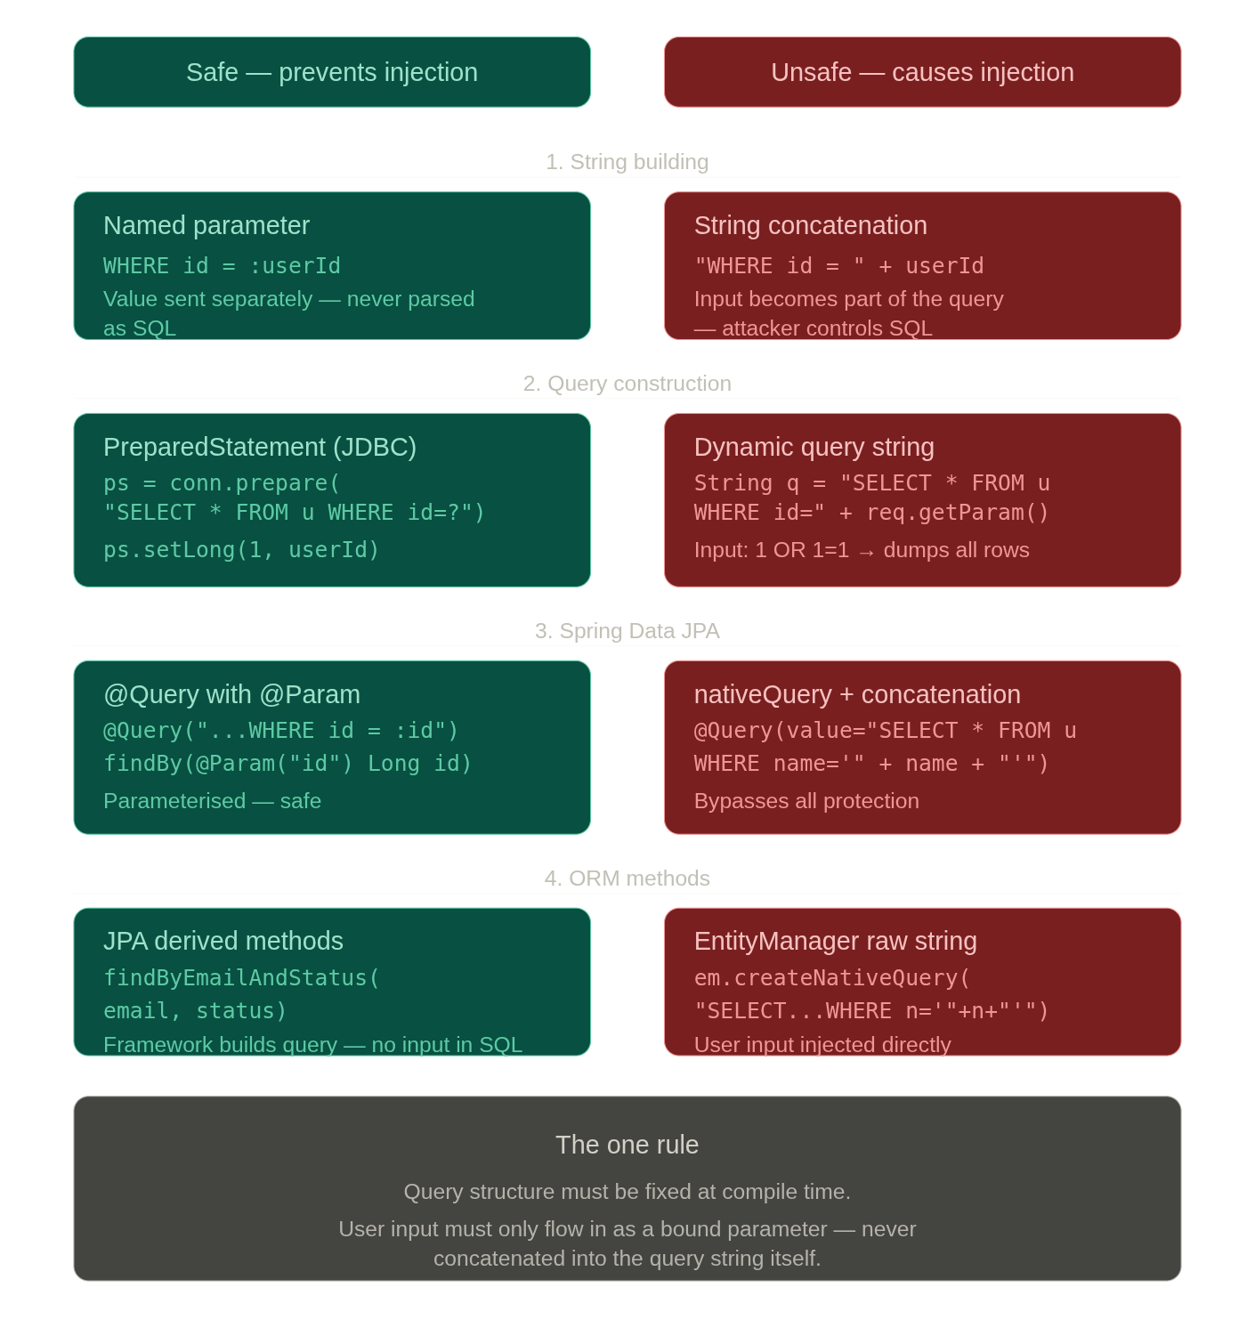
The attack string that breaks unsafe code:
Input: ' OR '1'='1
Injected into a concatenated query like "SELECT * FROM users WHERE name='" + name + "'", this becomes:
SELECT * FROM users WHERE name='' OR '1'='1'
-- Returns every row in the table
Or worse, with '; DROP TABLE users; -- — it terminates the query and executes a second one entirely.
Why String params are riskier than Long:
With a Long, Java throws a NumberFormatException before the input even reaches the DB. A String parameter has no such type gate — the only protection is whether you're using parameterised binding or not. So with strings, the binding method is the entire line of defence.
The one subtle trap — LIKE with wildcards:
Even with safe parameterised binding, this is risky:
// @Param binding is safe, but the user controls % wildcards
@Query("SELECT u FROM User u WHERE u.name LIKE :name")
List<User> search(@Param("name") String name);
// Input: "%" → matches every row — a full table scan
You need to sanitise the wildcard characters (%, _) in the value before binding, even though the binding itself is safe from injection.
The core principle across all cases: query structure is fixed, user data is just data — never syntax.

Module 3: JOINs — deep dive
JOINs are the most tested SQL topic in coding assessments and the most misunderstood in interviews. Most people know what an INNER JOIN does. What separates a mid-level dev is knowing why each join behaves the way it does, and being able to reason through multi-table joins without running the query first.

The mental model: JOINs as set operations on rows
Before any syntax, build this intuition: a JOIN takes two tables and produces a new virtual table by matching rows according to a condition. The type of JOIN decides what happens to rows that don't match.
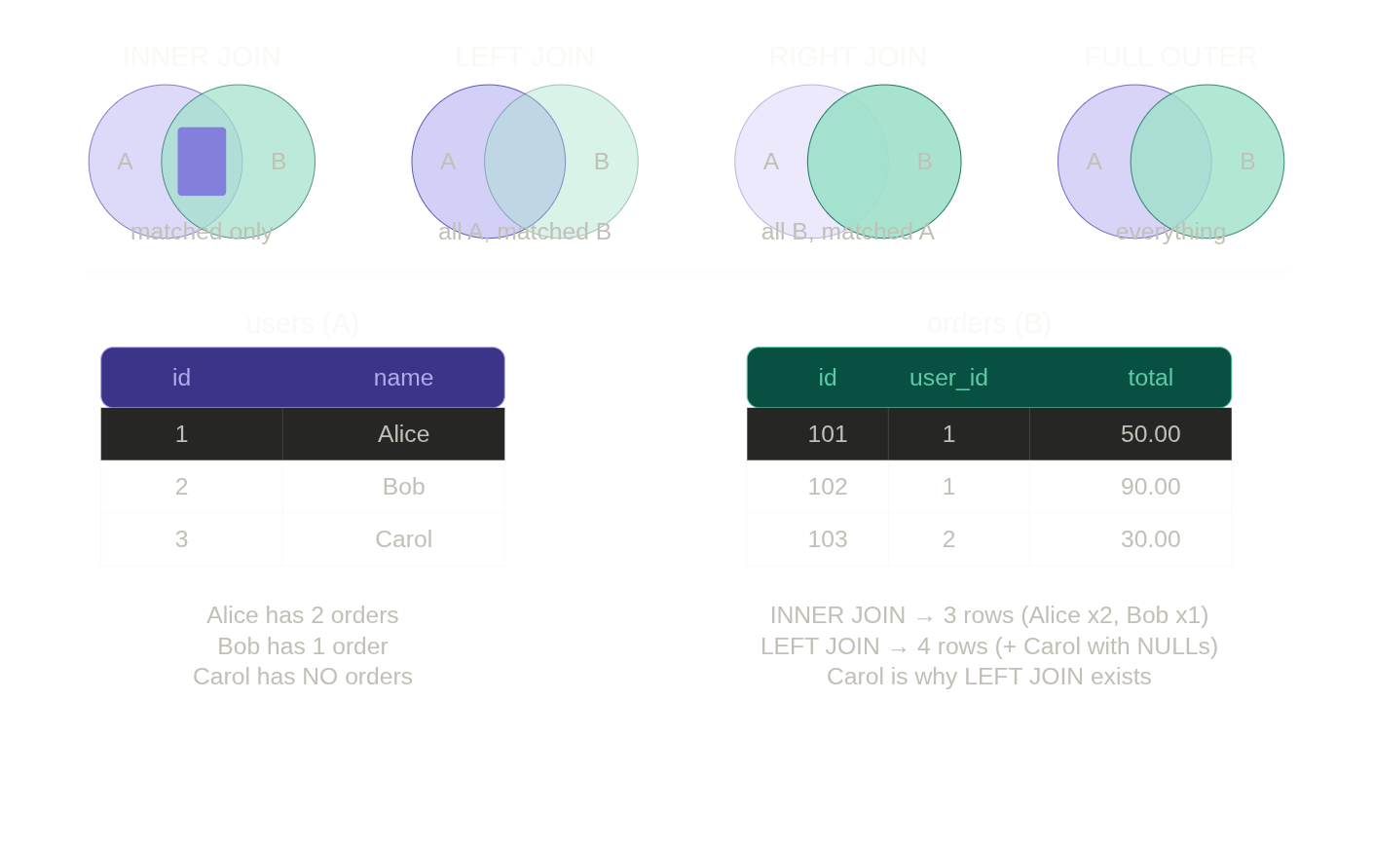The key insight: Carol is the reason LEFT JOIN exists. Whenever you need to include rows from a table even when there's no match in the other table, you need a LEFT JOIN.

INNER JOIN — only matched rows
-- Get all orders with their user's name
-- Carol won't appear because she has no orders
SELECT
u.id AS user_id,
u.username,
o.id AS order_id,
o.total,
o.status
FROM users u
INNER JOIN orders o ON o.user_id = u.id;

-- Result: only users who have at least one order
-- Alice appears twice (2 orders), Bob once, Carol not at all
-- Multi-table INNER JOIN — orders with user AND address details
SELECT
o.id AS order_id,
u.username,
u.email,
a.city,
a.country_code,
o.total,
o.status
FROM orders o
INNER JOIN users u ON o.user_id = u.id
INNER JOIN addresses a ON o.address_id = a.id;
-- Only orders that have BOTH a matching user AND a matching address

LEFT JOIN — all rows from the left, NULLs for no match
-- All users and their orders — including users with no orders
SELECT
u.id AS user_id,
u.username,
o.id AS order_id,
o.total
FROM users u
LEFT JOIN orders o ON o.user_id = u.id;
-- Carol appears with order_id = NULL, total = NULL
The most important LEFT JOIN pattern — finding rows with NO match:
-- Find users who have NEVER placed an order
-- This is one of the most common assessment questions
SELECT u.id, u.username, u.email
FROM users u
LEFT JOIN orders o ON o.user_id = u.id
WHERE o.id IS NULL;
-- After the LEFT JOIN, unmatched users have o.id = NULL
-- WHERE o.id IS NULL keeps only those unmatched users
This pattern — LEFT JOIN ... WHERE right_table.id IS NULL — is called an anti-join. It's faster than NOT IN on large tables and avoids the NULL trap. Memorise it.
-- Real backend use case: find products that have never been ordered
-- (candidates for removal from catalogue)
SELECT p.id, p.name, p.price
FROM products p
LEFT JOIN order_items oi ON oi.product_id = p.id
WHERE oi.id IS NULL;

RIGHT JOIN — all rows from the right
RIGHT JOIN is just a LEFT JOIN with tables swapped. In practice, most developers always rewrite RIGHT JOINs as LEFT JOINs because it reads more naturally (the "main" table comes first).
-- These two queries return identical results
SELECT u.username, o.id AS order_id
FROM orders o
RIGHT JOIN users u ON o.user_id = u.id;

-- Preferred — rewritten as LEFT JOIN
SELECT u.username, o.id AS order_id
FROM users u
LEFT JOIN orders o ON o.user_id = u.id;

FULL OUTER JOIN — everything from both sides
-- All users and all orders, matched where possible, NULLs elsewhere
-- Rare in application code, common in data reconciliation and reporting
SELECT
u.username,
o.id AS order_id,
o.total
FROM users u
FULL OUTER JOIN orders o ON o.user_id = u.id;

-- Use case: reconciling two datasets to find mismatches
-- e.g. find rows that exist in table A but not B, AND rows in B but not A
SELECT a.id AS a_id, b.id AS b_id
FROM table_a a
FULL OUTER JOIN table_b b ON a.ref_id = b.ref_id
WHERE a.id IS NULL OR b.id IS NULL;

CROSS JOIN — every combination
-- Produces M × N rows — every row in A paired with every row in B
-- Use case: generating combinations (sizes × colours for a product catalogue)
SELECT
s.name AS size,
c.name AS colour
FROM sizes s
CROSS JOIN colours c;
-- 3 sizes × 4 colours = 12 rows

-- Also written implicitly (old SQL style — avoid in new code)
SELECT * FROM sizes, colours;

SELF JOIN — a table joined to itself
This is where interviews get interesting. A self join is used when rows in a table relate to other rows in the same table.
-- categories table has parent_id that references categories.id
-- Find each category with its parent's name
SELECT
child.name AS category,
parent.name AS parent_category
FROM categories child
LEFT JOIN categories parent ON child.parent_id = parent.id;
-- LEFT JOIN so top-level categories (parent_id IS NULL) still appear

-- Real use case: employee/manager hierarchy
SELECT
emp.id AS employee_id,
emp.name AS employee,
mgr.name AS manager
FROM employees emp
LEFT JOIN employees mgr ON emp.manager_id = mgr.id;

JOIN conditions — ON vs USING vs implicit
-- ON — explicit, most flexible
JOIN orders o ON o.user_id = u.id

-- USING — shorthand when column names are identical in both tables
JOIN orders USING (user_id) -- both tables must have a column named user_id

-- Non-equality JOINs — valid and useful
-- e.g. find all orders placed during a promotional period
JOIN promotions p ON o.created_at BETWEEN p.start_date AND p.end_date

-- JOIN on multiple conditions
JOIN order_items oi ON oi.order_id = o.id AND oi.quantity > 1

The full e-commerce multi-table JOIN
This is the kind of query a backend API endpoint genuinely runs — order details page:
-- GET /orders/:id — full order detail
SELECT
o.id AS order_id,
o.status,
o.created_at,
u.username,
u.email,
a.line1,
a.city,
a.country_code,
p.name AS product_name,
oi.quantity,
oi.unit_price,
oi.quantity * oi.unit_price AS line_total
FROM orders o
INNER JOIN users u ON o.user_id = u.id
LEFT JOIN addresses a ON o.address_id = a.id -- LEFT: address may be deleted
INNER JOIN order_items oi ON oi.order_id = o.id
INNER JOIN products p ON oi.product_id = p.id
WHERE o.id = 1001;
Notice the LEFT JOIN on addresses — addresses can be soft-deleted or the user can remove them, but the order history must still be readable. This is a deliberate design choice, not an accident.

JOIN execution and performance intuition
This becomes critical in Module 7 (indexes), but plant this now:
-- The DB executes JOINs pair by pair:
-- Step 1: orders JOIN users → intermediate result set
-- Step 2: result JOIN addresses → another intermediate result
-- Step 3: result JOIN order_items → ...
-- Step 4: result JOIN products → final result

-- The order of JOINs in your SQL doesn't strictly control execution order —
-- the query planner may reorder them. But it matters for readability and
-- for hinting the planner in complex queries.

-- Index rule of thumb: the JOIN column on the "many" side must be indexed.
-- orders.user_id should have an index because you join on it constantly.
-- We'll build this in Module 7.

Common assessment patterns for JOINs
Pattern 1 — Aggregate with JOIN: "Find the total amount spent per user, including users who spent nothing."
SELECT
u.id,
u.username,
COALESCE(SUM(o.total), 0) AS total_spent
FROM users u
LEFT JOIN orders o ON o.user_id = u.id
GROUP BY u.id, u.username
ORDER BY total_spent DESC;
-- COALESCE converts NULL (users with no orders) to 0
Pattern 2 — Anti-join (find missing relationships): "Find all products that have never been ordered."
SELECT p.id, p.name
FROM products p
LEFT JOIN order_items oi ON oi.product_id = p.id
WHERE oi.id IS NULL;
Pattern 3 — Self join for hierarchy: "List every category alongside its parent category name."
SELECT
c.name AS category,
p.name AS parent
FROM categories c
LEFT JOIN categories p ON c.parent_id = p.id
ORDER BY p.name NULLS FIRST, c.name;
Pattern 4 — Multi-table with filter: "Get usernames and total order value for all users who placed a shipped order in the last 30 days."
SELECT
u.username,
SUM(o.total) AS total_value
FROM users u
INNER JOIN orders o ON o.user_id = u.id
WHERE o.status = 'shipped'
AND o.created_at >= NOW() - INTERVAL '30 days'
GROUP BY u.id, u.username
ORDER BY total_value DESC;

Interview questions for Module 3
Q: What's the difference between INNER JOIN and LEFT JOIN? INNER JOIN returns only rows where a match exists in both tables. LEFT JOIN returns all rows from the left table, with NULLs in the right-side columns where there's no match. Use LEFT JOIN when the relationship is optional — a user may or may not have orders.
Q: How do you find rows in table A that don't exist in table B? LEFT JOIN ... WHERE b.id IS NULL. This is an anti-join. You could also use NOT EXISTS (SELECT 1 FROM b WHERE b.fk = a.id) — which is often faster on large tables because it short-circuits on the first match. Avoid NOT IN when the subquery column can contain NULLs.
Q: Can you join a table to itself? When would you? Yes — self joins. Used for hierarchical data (categories, org charts, threaded comments) where rows reference other rows in the same table. You alias the table twice to distinguish which "copy" you're reading from.
Q: What's a CROSS JOIN? When is it actually useful? It produces a cartesian product — every row in A paired with every row in B. Useful for generating combinations: product variants (size × colour), test data generation, or scheduling scenarios (every employee × every shift slot). Dangerous if used accidentally on large tables — a 1000-row × 1000-row cross join gives 1 million rows.
Q: Why might you choose NOT EXISTS over NOT IN? NOT IN with a subquery that returns any NULL will return zero rows — a silent, devastating bug. NOT EXISTS doesn't have this problem; it checks for the existence of a match and handles NULLs correctly. It also short-circuits on the first match found, making it faster on large datasets.

Module 4: Aggregations & window functions
Aggregations are in every SQL assessment. Window functions are what separate a mid-level SQL writer from a junior one — interviewers specifically use them to filter candidates. Master this module and you'll solve problems others stare at blankly.

Part 1: Aggregations
Aggregations collapse multiple rows into a single computed value. The six functions you need cold:
COUNT(*) -- count all rows (including NULLs)
COUNT(col) -- count non-NULL values in col
SUM(col) -- total
AVG(col) -- mean (returns NUMERIC, can be NULL if no rows)
MIN(col) -- smallest value
MAX(col) -- largest value
-- Basic aggregates on the orders table
SELECT
COUNT(*) AS total_orders,
COUNT(DISTINCT user_id) AS unique_customers,
SUM(total) AS revenue,
AVG(total) AS avg_order_value,
MIN(total) AS smallest_order,
MAX(total) AS largest_order
FROM orders
WHERE status != 'cancelled';
The COUNT(*) vs COUNT(col) distinction is a classic interview trap:
SELECT
COUNT(*) AS all_rows, -- 5
COUNT(discount) AS has_discount, -- only rows where discount IS NOT NULL
COUNT(DISTINCT user_id) AS unique_users -- distinct non-NULL user_ids
FROM orders;

GROUP BY — bucketing rows
GROUP BY splits rows into groups, then aggregates run per group. Every column in SELECT must either be in GROUP BY or inside an aggregate function. This rule is enforced strictly — PostgreSQL will error if you break it.
-- Revenue and order count per user
SELECT
user_id,
COUNT(*) AS order_count,
SUM(total) AS total_spent,
AVG(total) AS avg_order_value
FROM orders
GROUP BY user_id
ORDER BY total_spent DESC;
-- Orders per status — classic reporting query
SELECT
status,
COUNT(*) AS count,
SUM(total) AS total_revenue
FROM orders
GROUP BY status
ORDER BY count DESC;
-- Monthly revenue — GROUP BY a computed expression
SELECT
DATE_TRUNC('month', created_at) AS month,
COUNT(*) AS order_count,
SUM(total) AS revenue
FROM orders
GROUP BY DATE_TRUNC('month', created_at)
ORDER BY month;

HAVING — filtering groups
WHERE filters rows before grouping. HAVING filters groups after aggregation. This distinction is one of the most tested concepts in SQL interviews.
-- Users who have placed more than 3 orders
SELECT
user_id,
COUNT(*) AS order_count
FROM orders
GROUP BY user_id
HAVING COUNT(*) > 3;
-- Cannot use WHERE here — COUNT(*) doesn't exist yet at WHERE stage

-- High-value users: spent more than 1000 total, with at least 2 orders
SELECT
user_id,
COUNT(*) AS order_count,
SUM(total) AS total_spent
FROM orders
WHERE status != 'cancelled' -- WHERE filters rows first
GROUP BY user_id
HAVING SUM(total) > 1000 -- HAVING filters groups after
AND COUNT(*) >= 2
ORDER BY total_spent DESC;
Here is how WHERE and HAVING interact — the execution flow makes it click:---
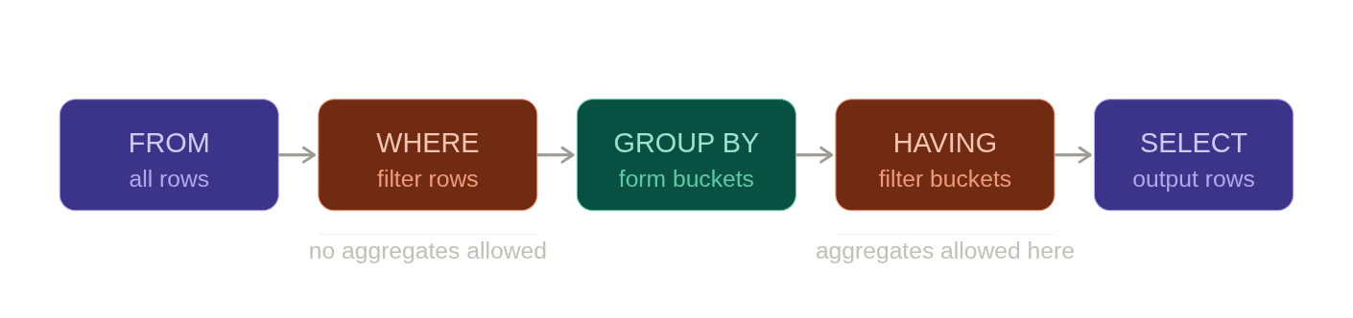

Part 2: Window functions — the real power
A window function computes a value for each row using other rows — without collapsing them into a single output row. This is the key difference from GROUP BY.
-- GROUP BY: collapses 5 orders into 1 row per user
SELECT user_id, SUM(total) FROM orders GROUP BY user_id;
-- Returns: 3 rows (one per user)

-- Window function: computes the sum but keeps all rows
SELECT user_id, total, SUM(total) OVER (PARTITION BY user_id)
FROM orders;
-- Returns: 5 rows (all original rows, each enriched with the user's total)
The OVER (...) clause is what makes it a window function. It defines the "window" — which rows to consider when computing the value for each row.---
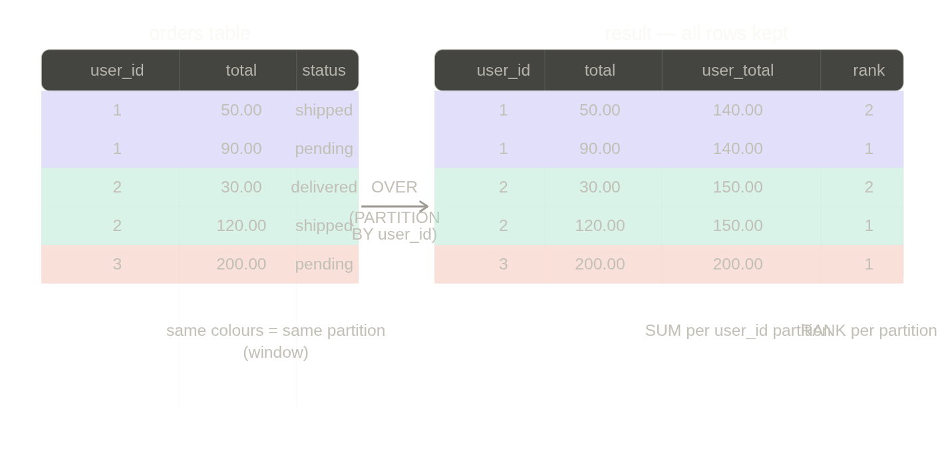The OVER() clause anatomy
function_name() OVER (
PARTITION BY col -- divide rows into groups (like GROUP BY, but rows are kept)
ORDER BY col -- order within each partition
ROWS/RANGE BETWEEN ... -- frame definition (advanced)
)
PARTITION BY and ORDER BY inside OVER() are independent of any GROUP BY or ORDER BY in the outer query. They only affect the window computation.

ROW_NUMBER, RANK, DENSE_RANK
These three are the most tested window functions in SQL assessments. Know the difference cold.
SELECT
user_id,
total,
ROW_NUMBER() OVER (PARTITION BY user_id ORDER BY total DESC) AS row_num,
RANK() OVER (PARTITION BY user_id ORDER BY total DESC) AS rank,
DENSE_RANK() OVER (PARTITION BY user_id ORDER BY total DESC) AS dense_rank
FROM orders;
Suppose user 1 has orders: 90, 90, 50. Here's what each returns:
total | ROW_NUMBER | RANK | DENSE_RANK
90 | 1 | 1 | 1
90 | 2 | 1 | 1
50 | 3 | 3 | 2
ROW_NUMBER — always unique, no ties, arbitrary tiebreaker. Use when you need exactly one row per group. RANK — ties get the same rank, then skips numbers (1,1,3). Use for leaderboards where gaps matter. DENSE_RANK — ties get the same rank, no gaps (1,1,2). Use when you want "top 3 distinct ranks."

The top-N per group pattern — most common assessment question
"Get the most recent order per user." This appears in nearly every SQL assessment at a mid-level:
-- Step 1: number rows within each user's partition, newest first
-- Step 2: keep only row_num = 1 (most recent per user)
SELECT user_id, order_id, total, created_at
FROM (
SELECT
user_id,
id AS order_id,
total,
created_at,
ROW_NUMBER() OVER (
PARTITION BY user_id
ORDER BY created_at DESC
) AS rn
FROM orders
) ranked
WHERE rn = 1;
This is a pattern you must be able to write from memory. In PostgreSQL you can also use DISTINCT ON for this specific case (Module 2), but the ROW_NUMBER approach works in all databases and handles ties explicitly.
-- Top 3 most expensive products per category
SELECT category_id, name, price
FROM (
SELECT
category_id,
name,
price,
RANK() OVER (PARTITION BY category_id ORDER BY price DESC) AS rnk
FROM products
WHERE is_active = TRUE
) ranked
WHERE rnk <= 3;
-- RANK instead of ROW_NUMBER because ties at same price should both appear

LAG and LEAD — accessing adjacent rows
LAG looks at the previous row. LEAD looks at the next row. Both are relative to the ORDER BY inside OVER().
-- Month-over-month revenue change
WITH monthly AS (
SELECT
DATE_TRUNC('month', created_at) AS month,
SUM(total) AS revenue
FROM orders
GROUP BY 1
)
SELECT
month,
revenue,
LAG(revenue) OVER (ORDER BY month) AS prev_month_revenue,
revenue - LAG(revenue) OVER (ORDER BY month) AS revenue_change,
ROUND(
100.0 * (revenue - LAG(revenue) OVER (ORDER BY month))
/ NULLIF(LAG(revenue) OVER (ORDER BY month), 0),
2
) AS pct_change
FROM monthly
ORDER BY month;
NULLIF(x, 0) prevents division-by-zero when a previous month had zero revenue. This is a production pattern you'll use constantly.
-- For each order, show the previous order's total by the same user
SELECT
user_id,
id AS order_id,
created_at,
total,
LAG(total) OVER (PARTITION BY user_id ORDER BY created_at) AS prev_order_total,
LEAD(total) OVER (PARTITION BY user_id ORDER BY created_at) AS next_order_total
FROM orders;

SUM / AVG / COUNT as window functions
These aggregate functions work inside OVER() too — they compute running or partitioned totals while keeping all rows.
-- Running total of revenue over time
SELECT
id,
created_at,
total,
SUM(total) OVER (ORDER BY created_at) AS running_total,
AVG(total) OVER (ORDER BY created_at
ROWS BETWEEN 6 PRECEDING AND CURRENT ROW) AS rolling_7_avg
FROM orders;
-- ROWS BETWEEN 6 PRECEDING AND CURRENT ROW = 7-row rolling window
-- Each order's total as a % of that user's total spend
SELECT
user_id,
id AS order_id,
total,
SUM(total) OVER (PARTITION BY user_id) AS user_total,
ROUND(
100.0 * total / SUM(total) OVER (PARTITION BY user_id),
1
) AS pct_of_user_spend
FROM orders;

NTILE — bucketing rows into N groups
-- Divide users into 4 spending quartiles
SELECT
user_id,
total_spent,
NTILE(4) OVER (ORDER BY total_spent DESC) AS quartile
FROM (
SELECT user_id, SUM(total) AS total_spent
FROM orders
GROUP BY user_id
) user_totals;
-- quartile 1 = top 25% spenders, quartile 4 = bottom 25%

Backend use cases for window functions
Window functions appear directly in backend reporting APIs and analytics services:
-- Dashboard: each product's sales rank within its category
-- Sent to a frontend leaderboard component
SELECT
p.name,
c.name AS category,
SUM(oi.quantity * oi.unit_price) AS category_revenue,
RANK() OVER (
PARTITION BY p.category_id
ORDER BY SUM(oi.quantity * oi.unit_price) DESC
) AS rank_in_category
FROM order_items oi
JOIN products p ON oi.product_id = p.id
JOIN categories c ON p.category_id = c.id
JOIN orders o ON oi.order_id = o.id
WHERE o.status != 'cancelled'
GROUP BY p.id, p.name, p.category_id, c.name;
-- Fraud detection: flag users whose current order is 3x their average
SELECT
user_id,
id AS order_id,
total,
AVG(total) OVER (PARTITION BY user_id) AS user_avg,
CASE
WHEN total > 3 * AVG(total) OVER (PARTITION BY user_id)
THEN TRUE ELSE FALSE
END AS is_suspicious
FROM orders;

System design angle — aggregations at scale
This is where interviews go from SQL to architecture:
At high volume, running SUM(total) over millions of orders on every dashboard request is expensive. The pattern is pre-aggregation:
you maintain a user_stats table that gets updated incrementally — either via a background job, a trigger, or an event-driven worker that listens to the orders topic. The dashboard reads from user_stats instead of aggregating raw orders every time. PostgreSQL materialized views (Module 11) are the database-native way to do this. This is also where CQRS (Module 15) comes in — your write model is orders, your read model is user_stats.

Assessment drill — common patterns
Pattern: Running total "Show each order with a running total of revenue, ordered by date."
SELECT
id,
created_at,
total,
SUM(total) OVER (ORDER BY created_at) AS running_total
FROM orders
WHERE status != 'cancelled';
Pattern: Rank within group "Find the top 2 products by revenue in each category."
SELECT category_id, product_id, revenue
FROM (
SELECT
p.category_id,
p.id AS product_id,
SUM(oi.quantity * oi.unit_price) AS revenue,
RANK() OVER (
PARTITION BY p.category_id
ORDER BY SUM(oi.quantity * oi.unit_price) DESC
) AS rnk
FROM order_items oi
JOIN products p ON oi.product_id = p.id
GROUP BY p.category_id, p.id
) t
WHERE rnk <= 2;
Pattern: Period-over-period change "Show month-over-month order count change."
WITH monthly AS (
SELECT DATE_TRUNC('month', created_at) AS month, COUNT(*) AS cnt
FROM orders GROUP BY 1
)
SELECT
month,
cnt,
cnt - LAG(cnt) OVER (ORDER BY month) AS change
FROM monthly;

Interview questions for Module 4
Q: What is the difference between GROUP BY and a window function? GROUP BY collapses rows — you lose the original rows and get one row per group. A window function computes across rows but keeps every row in the result. Use GROUP BY when you want summaries; use window functions when you want to enrich each row with aggregate context.
Q: What's the difference between RANK and DENSE_RANK? Both assign the same rank to tied rows. RANK skips subsequent numbers after a tie (1, 1, 3). DENSE_RANK never skips (1, 1, 2). Use DENSE_RANK when "top 3 ranks" should mean top 3 distinct values, not top 3 row positions.
Q: How would you get the most recent record per user? ROW_NUMBER() OVER (PARTITION BY user_id ORDER BY created_at DESC) in a subquery, then filter WHERE rn = 1. In PostgreSQL, DISTINCT ON (user_id) with ORDER BY user_id, created_at DESC is equivalent and cleaner.
Q: What does PARTITION BY do inside OVER()? It divides the result set into partitions — like a GROUP BY but without collapsing rows. The window function then runs independently within each partition. Without PARTITION BY, the entire result set is treated as one partition.
Q: Can you use a window function in a WHERE clause? No — window functions are evaluated after WHERE and GROUP BY, in the SELECT stage. To filter on a window function result, wrap it in a subquery or CTE, then filter in the outer query.

Module 5: Subqueries & CTEs
This module is about query composition — breaking a complex problem into steps. In a live coding interview, the difference between someone who stares at the screen and someone who methodically builds the solution is almost always whether they know how to decompose a query. CTEs are your primary tool for that.

Three ways to compose queries
There are three mechanisms for using one query's result inside another. Each has a different use case:---
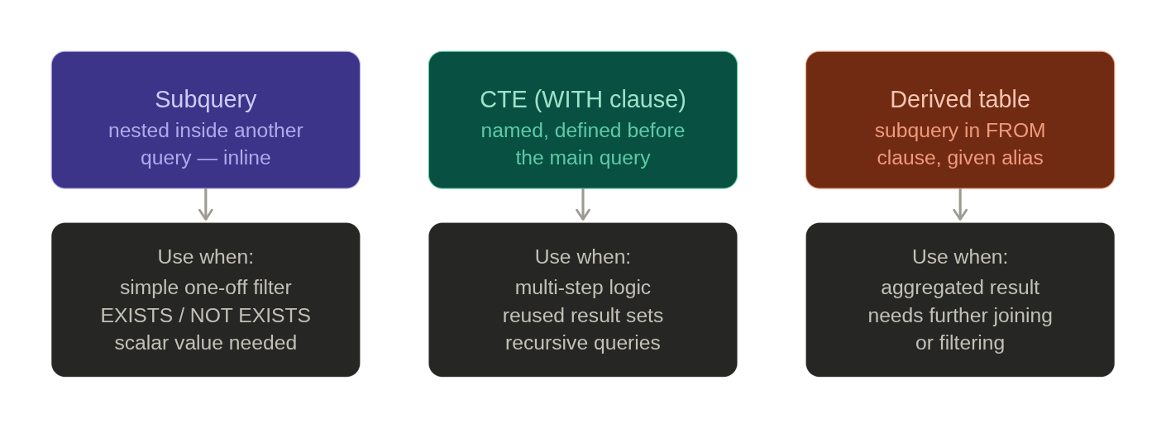

Part 1: Subqueries
A subquery is a SELECT statement nested inside another statement. It can appear in four positions — each with distinct behaviour.

In WHERE — scalar comparison
-- Find orders with total above the average order value
SELECT id, user_id, total
FROM orders
WHERE total > (
SELECT AVG(total) FROM orders
);
-- The inner query returns one value (scalar): e.g. 87.50
-- The outer query compares each row's total to that scalar

In WHERE — with IN
-- Find users who have placed at least one shipped order
SELECT id, username, email
FROM users
WHERE id IN (
SELECT DISTINCT user_id
FROM orders
WHERE status = 'shipped'
);

In WHERE — with EXISTS / NOT EXISTS
EXISTS is usually preferred over IN for large datasets. It stops scanning as soon as it finds the first match — short-circuit evaluation.
-- EXISTS version — same result, often faster
SELECT id, username, email
FROM users u
WHERE EXISTS (
SELECT 1 -- the value doesn't matter, just existence
FROM orders o
WHERE o.user_id = u.id
AND o.status = 'shipped'
);

-- NOT EXISTS — find users who have never ordered (anti-join, Module 3 pattern)
SELECT id, username
FROM users u
WHERE NOT EXISTS (
SELECT 1 FROM orders o
WHERE o.user_id = u.id
);
Notice SELECT 1 inside EXISTS — the actual value returned is irrelevant. The DB only checks whether any row exists. Writing SELECT * works too but SELECT 1 signals intent clearly.

Correlated subquery — references the outer query
A correlated subquery re-executes for every row in the outer query. It's the most powerful but also the most dangerous — can be very slow on large tables.
-- For each order, find how many other orders the same user placed before it
SELECT
id AS order_id,
user_id,
created_at,
(
SELECT COUNT(*)
FROM orders o2
WHERE o2.user_id = o1.user_id -- references outer query's row
AND o2.created_at < o1.created_at -- placed before current order
) AS prior_order_count
FROM orders o1;
-- Runs the subquery once per row in orders — O(n) subquery executions
-- Fine for small tables, use window functions for large ones
This pattern is important to recognise — and important to know when to replace with a window function:
-- Better version using window function (one pass, not N passes)
SELECT
id AS order_id,
user_id,
created_at,
ROW_NUMBER() OVER (
PARTITION BY user_id
ORDER BY created_at
) - 1 AS prior_order_count
FROM orders;

In SELECT — scalar subquery
-- Embed a computed value per row inline
SELECT
p.id,
p.name,
p.price,
(
SELECT COUNT(*)
FROM order_items oi
WHERE oi.product_id = p.id
) AS times_ordered
FROM products p;
-- Again: correlated, runs once per product row
-- Better replaced with a LEFT JOIN + COUNT for large tables

In FROM — derived table
A subquery in FROM acts like a temporary table. You must give it an alias.
-- Find users whose average order value is above 100
SELECT user_id, avg_order_value
FROM (
SELECT
user_id,
AVG(total) AS avg_order_value
FROM orders
WHERE status != 'cancelled'
GROUP BY user_id
) AS user_averages -- alias required
WHERE avg_order_value > 100
ORDER BY avg_order_value DESC;

Part 2: CTEs — the WITH clause
A CTE (Common Table Expression) is a named subquery defined before the main query using WITH. It's not a performance optimisation by itself — it's a readability and structure tool. In PostgreSQL, the planner can inline or materialise CTEs depending on the version and complexity.
-- Same query as above, rewritten as a CTE — much more readable
WITH user_averages AS (
SELECT
user_id,
AVG(total) AS avg_order_value
FROM orders
WHERE status != 'cancelled'
GROUP BY user_id
)
SELECT user_id, avg_order_value
FROM user_averages
WHERE avg_order_value > 100
ORDER BY avg_order_value DESC;

Chaining multiple CTEs — the interview power move
This is what interviewers mean when they say "walk me through how you'd solve this." You decompose a hard problem into named steps:
-- Question: "Find the top 3 users by revenue in the last 90 days,
-- and show what % of total revenue they represent."

WITH
-- Step 1: revenue per user, last 90 days
user_revenue AS (
SELECT
user_id,
SUM(total) AS revenue
FROM orders
WHERE created_at >= NOW() - INTERVAL '90 days'
AND status != 'cancelled'
GROUP BY user_id
),

-- Step 2: total revenue across all users (single scalar)
total_revenue AS (
SELECT SUM(revenue) AS total
FROM user_revenue
),

-- Step 3: rank users
ranked AS (
SELECT
ur.user_id,
ur.revenue,
RANK() OVER (ORDER BY ur.revenue DESC) AS rnk
FROM user_revenue ur
)

-- Final: join everything together, filter top 3
SELECT
r.user_id,
u.username,
r.revenue,
ROUND(100.0 * r.revenue / tr.total, 2) AS revenue_pct
FROM ranked r
JOIN users u ON r.user_id = u.id
CROSS JOIN total_revenue tr -- single-row table, safe to cross join
WHERE r.rnk <= 3
ORDER BY r.rnk;
In a live interview, narrate this out loud: "I'll first compute per-user revenue, then get the total in a second CTE so I can calculate percentages, then rank and filter." This demonstrates structured thinking, which is exactly what the interviewer is assessing.

CTE vs subquery — when to choose which
-- Use a subquery when the logic is simple and used only once
SELECT * FROM orders
WHERE total > (SELECT AVG(total) FROM orders);

-- Use a CTE when:
-- 1. The result is referenced more than once
-- 2. The logic has multiple steps
-- 3. You want readable, debuggable code in an interview

-- This is WRONG (subquery referenced twice — computed twice):
SELECT *
FROM (SELECT user_id, SUM(total) AS rev FROM orders GROUP BY user_id) t
WHERE t.rev > (SELECT AVG(rev) FROM
(SELECT user_id, SUM(total) AS rev FROM orders GROUP BY user_id) t2);

-- This is RIGHT (CTE computed once, referenced twice):
WITH user_rev AS (
SELECT user_id, SUM(total) AS rev
FROM orders GROUP BY user_id
)
SELECT * FROM user_rev
WHERE rev > (SELECT AVG(rev) FROM user_rev);

Part 3: Recursive CTEs
Recursive CTEs solve hierarchical / graph traversal problems — category trees, org charts, threaded comments, bill of materials. This is a distinct mid-level topic interviewers use to test whether you can go beyond basic SQL.
The structure is always the same: an anchor (the starting point) UNION ALL'd with the recursive step (one level deeper), with a termination condition.
-- Traverse the categories tree — find all descendants of 'Electronics'
WITH RECURSIVE category_tree AS (

-- Anchor: start at the root
SELECT id, name, parent_id, 0 AS depth
FROM categories
WHERE name = 'Electronics'

UNION ALL

-- Recursive step: join children to current frontier
SELECT
c.id,
c.name,
c.parent_id,
ct.depth + 1
FROM categories c
INNER JOIN category_tree ct ON c.parent_id = ct.id
-- Stops when no more children match

)
SELECT id, name, depth
FROM category_tree
ORDER BY depth, name;
How the recursion works:
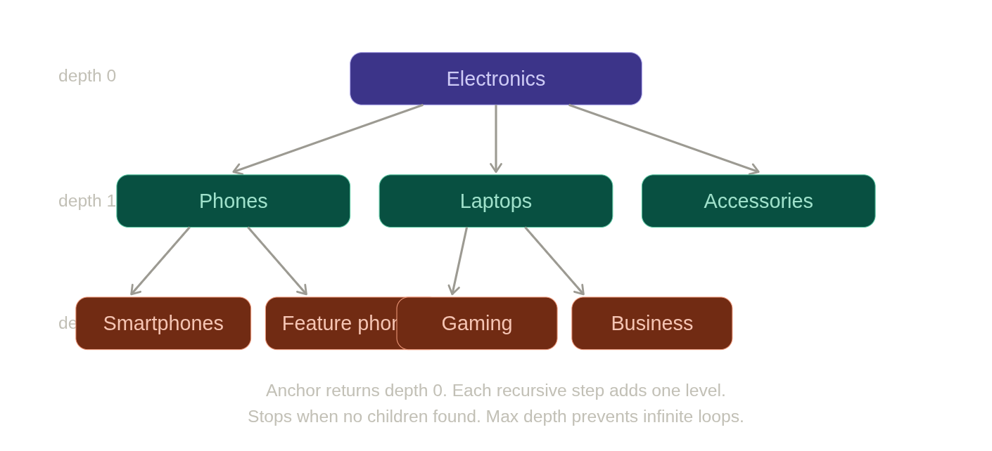
```sql -- Safe recursive CTE — always add a depth limit to prevent infinite loops -- (circular foreign keys or bad data can cause infinite recursion) WITH RECURSIVE category_tree AS ( SELECT id, name, parent_id, 0 AS depth, ARRAY[id] AS path -- track visited IDs FROM categories WHERE name = 'Electronics'
UNION ALL

SELECT c.id, c.name, c.parent_id,
ct.depth + 1,
ct.path || c.id
FROM categories c
INNER JOIN category_tree ct ON c.parent_id = ct.id
WHERE ct.depth < 10 -- max depth guard
AND NOT c.id = ANY(ct.path) -- cycle guard
) SELECT id, name, depth FROM category_tree ORDER BY depth, name;
#### Real backend use case — building a breadcrumb trail

```sql
-- Given a leaf category ID, walk UP to the root to build a breadcrumb
-- e.g. Smartphones → Phones → Electronics
WITH RECURSIVE breadcrumb AS (
SELECT id, name, parent_id, 0 AS level
FROM categories
WHERE id = 42 -- start from the leaf

UNION ALL

SELECT c.id, c.name, c.parent_id, b.level + 1
FROM categories c
INNER JOIN breadcrumb b ON c.id = b.parent_id -- walk upward
)
SELECT name, level
FROM breadcrumb
ORDER BY level DESC; -- root first
-- Result: Electronics (level 2), Phones (level 1), Smartphones (level 0)

The WITH clause in DML — CTEs for writes
CTEs aren't just for SELECT. In PostgreSQL you can use them with INSERT, UPDATE, and DELETE. This is a powerful pattern for multi-step writes in a single round-trip:
-- Deactivate a product and log it in an audit table, atomically
WITH deactivated AS (
UPDATE products
SET is_active = FALSE
WHERE id = 101
RETURNING id, name -- RETURNING gives you the updated row
)
INSERT INTO product_audit_log (product_id, action, acted_at)
SELECT id, 'deactivated', NOW()
FROM deactivated;
-- Move cancelled orders to an archive table and delete them from main table
WITH moved AS (
DELETE FROM orders
WHERE status = 'cancelled'
AND created_at < NOW() - INTERVAL '1 year'
RETURNING *
)
INSERT INTO orders_archive
SELECT * FROM moved;
This is a common backend pattern — archiving old data while keeping the operation atomic. No risk of deleting rows that weren't archived.

PostgreSQL CTE materialisation
In PostgreSQL 12+, the planner decides whether to inline or materialise a CTE:
-- Force materialisation (compute once, store result) — PG 12+
WITH user_rev AS MATERIALIZED (
SELECT user_id, SUM(total) AS rev FROM orders GROUP BY user_id
)
SELECT * FROM user_rev WHERE rev > 500;

-- Force inlining (let planner treat it like a subquery, may enable better plans)
WITH user_rev AS NOT MATERIALIZED (
SELECT user_id, SUM(total) AS rev FROM orders GROUP BY user_id
)
SELECT * FROM user_rev WHERE rev > 500;
For interviews, knowing this distinction exists (and that pre-PG-12, all CTEs were materialised and acted as "optimisation fences") shows strong PostgreSQL knowledge.

Assessment patterns for this module
Pattern: Multi-step problem decomposition "Find users who placed their first order in the last 30 days and have already placed a second order."
WITH first_orders AS (
SELECT
user_id,
MIN(created_at) AS first_order_date
FROM orders
GROUP BY user_id
),
new_users AS (
SELECT user_id
FROM first_orders
WHERE first_order_date >= NOW() - INTERVAL '30 days'
),
repeat_buyers AS (
SELECT user_id
FROM orders
WHERE user_id IN (SELECT user_id FROM new_users)
GROUP BY user_id
HAVING COUNT(*) >= 2
)
SELECT u.id, u.username, u.email
FROM users u
JOIN repeat_buyers rb ON rb.user_id = u.id;
Pattern: Percentile / comparison to average "Find products priced above the average price in their category."
WITH category_avg AS (
SELECT category_id, AVG(price) AS avg_price
FROM products
WHERE is_active = TRUE
GROUP BY category_id
)
SELECT p.id, p.name, p.price, ca.avg_price
FROM products p
JOIN category_avg ca ON p.category_id = ca.category_id
WHERE p.price > ca.avg_price
ORDER BY p.category_id, p.price DESC;
Pattern: Recursive hierarchy "Find all subcategories under 'Electronics' at any depth."
WITH RECURSIVE sub AS (
SELECT id, name, 0 AS depth FROM categories WHERE name = 'Electronics'
UNION ALL
SELECT c.id, c.name, s.depth + 1
FROM categories c JOIN sub s ON c.parent_id = s.id
)
SELECT * FROM sub WHERE depth > 0 ORDER BY depth, name;

System design angle
In microservices, CTEs with RETURNING (the write CTE pattern above) reduce round trips to the database — critical when you're paying per-query latency. Instead of: UPDATE → check result → INSERT, you do it in one atomic statement. This matters for operations where you need both the update and the side effect (audit log, archive, notification record) to succeed or fail together, without distributed transactions.

Interview questions for Module 5
Q: What is a CTE and how is it different from a subquery? Both define a temporary result set, but a CTE is named, defined once at the top with WITH, and can be referenced multiple times in the query. A subquery is anonymous and inline. CTEs make complex multi-step queries readable and debuggable — in a live interview setting, always reach for a CTE over a deeply nested subquery.
Q: What is a correlated subquery and what's the risk? A correlated subquery references a column from the outer query, causing it to re-execute for every row the outer query processes. On a table with 100k rows, that's 100k subquery executions. Always ask whether the logic can be rewritten as a JOIN or window function before using a correlated subquery in production.
Q: When would you use EXISTS over IN? EXISTS short-circuits — it stops as soon as it finds one matching row. IN computes the full list first. EXISTS handles NULLs correctly whereas NOT IN with a nullable column can silently return zero rows. Prefer EXISTS/NOT EXISTS for subqueries that check membership in large tables.
Q: What is a recursive CTE? Give a use case. A recursive CTE refers to itself using UNION ALL. The anchor clause defines the starting rows; the recursive step joins back to the CTE to add one more level. Used for hierarchical data: category trees, org charts, comment threads, folder structures. Always include a depth limit or cycle guard to prevent infinite loops on bad data.
Q: In PostgreSQL, what changed about CTEs in version 12? Before PG 12, all CTEs were automatically materialised — computed once and stored — which acted as an optimisation fence, preventing the planner from pushing predicates inside. From PG 12 onward, the planner can inline CTEs by default when safe to do so, giving better query plans. You can override this with MATERIALIZED or NOT MATERIALIZED keywords.

Module 6: Normalization & denormalization
This module is pure LLD interview territory. When an interviewer says "design the database for X" or "why did you structure it this way", everything in this module is what you're drawing on. Normalization is the theory behind why schemas are designed the way they are — and denormalization is the engineering judgement about when to break those rules.

Why normalization exists — the root problem
Without normalization, you get data anomalies. These are the exact bugs that normalization prevents:
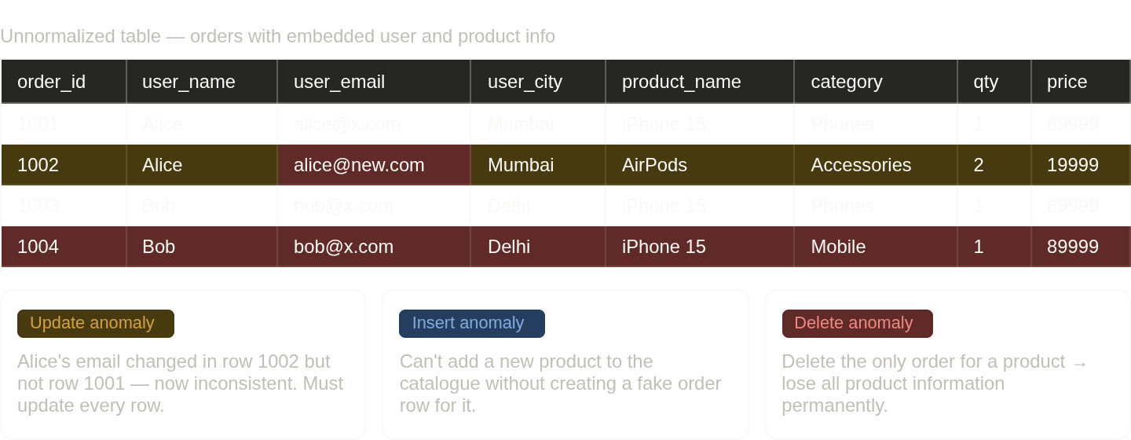
These three anomalies are what every normal form is designed to eliminate. Keep them in mind as you read each rule.

The normal forms — each one fixes a specific problem

First Normal Form (1NF) — atomicity
Rule: Every cell contains a single, indivisible value. No repeating groups. No arrays in columns.
-- VIOLATES 1NF — multiple values in one column
CREATE TABLE orders_bad (
id INT,
user_id INT,
product_ids TEXT -- '101,102,103' stored as a string
);

-- Also violates 1NF — repeating column groups
CREATE TABLE orders_bad2 (
id INT,
product_1 INT,
product_2 INT,
product_3 INT -- what if there's a 4th product?
);

-- CORRECT — each fact in its own row (this is order_items from Module 1)
CREATE TABLE order_items (
id BIGINT PRIMARY KEY,
order_id BIGINT NOT NULL,
product_id BIGINT NOT NULL,
quantity INT NOT NULL
);
PostgreSQL note: PostgreSQL has native ARRAY and JSONB types, which technically violate 1NF. This is intentional for specific use cases (tags, metadata). The rule still applies for anything you need to filter, join, or enforce constraints on.

Second Normal Form (2NF) — no partial dependencies
Rule: Must be in 1NF. Every non-key column must depend on the entire primary key, not just part of it. This only matters when the primary key is composite (multiple columns).
-- VIOLATES 2NF — composite PK is (order_id, product_id)
-- product_name depends only on product_id, not the full PK
CREATE TABLE order_items_bad (
order_id BIGINT,
product_id BIGINT,
product_name TEXT, -- depends only on product_id (partial dependency)
category_name TEXT, -- depends only on product_id (partial dependency)
quantity INT, -- depends on full PK (order_id, product_id) ✓
unit_price NUMERIC, -- depends on full PK ✓
PRIMARY KEY (order_id, product_id)
);

-- CORRECT — move product attributes to their own table
CREATE TABLE products (
id BIGINT PRIMARY KEY,
name TEXT,
category_name TEXT
);

CREATE TABLE order_items (
order_id BIGINT,
product_id BIGINT REFERENCES products(id),
quantity INT,
unit_price NUMERIC,
PRIMARY KEY (order_id, product_id)
);
The signature of a 2NF violation: you find yourself saying "this column is about the product, not about the order-product relationship."

Third Normal Form (3NF) — no transitive dependencies
Rule: Must be in 2NF. No non-key column should depend on another non-key column (transitive dependency). Every non-key column must depend directly on the primary key and nothing else.
-- VIOLATES 3NF
CREATE TABLE orders_bad (
id BIGINT PRIMARY KEY,
user_id BIGINT,
user_email TEXT, -- depends on user_id, not on order id (transitive)
user_city TEXT, -- depends on user_id (transitive)
zip_code VARCHAR(10),
city TEXT, -- depends on zip_code, not on order id (transitive)
total NUMERIC
);
-- Dependency chain: id → user_id → user_email (transitive: user_email depends on user_id, not id)
-- Dependency chain: id → zip_code → city (transitive)

-- CORRECT — each entity owns its own attributes
CREATE TABLE users (
id BIGINT PRIMARY KEY,
email TEXT,
city TEXT
);

CREATE TABLE orders (
id BIGINT PRIMARY KEY,
user_id BIGINT REFERENCES users(id),
zip_code VARCHAR(10),
total NUMERIC
);

CREATE TABLE zip_codes (
zip VARCHAR(10) PRIMARY KEY,
city TEXT,
state TEXT
);
The mnemonic commonly used: "every non-key attribute must depend on the key, the whole key, and nothing but the key." 1NF = the key. 2NF = the whole key. 3NF = nothing but the key.

Boyce-Codd Normal Form (BCNF) — stricter 3NF
Rule: For every functional dependency X → Y, X must be a superkey. BCNF is a stricter version of 3NF that handles edge cases with overlapping candidate keys.
In practice, if your schema is in 3NF, it's usually in BCNF. BCNF violations are rare and involve tables with multiple overlapping candidate keys — uncommon in typical backend systems. Know the definition, but don't over-index on it.

Visualising the decomposition
Here's how a single flat table decomposes step-by-step through the normal forms:---
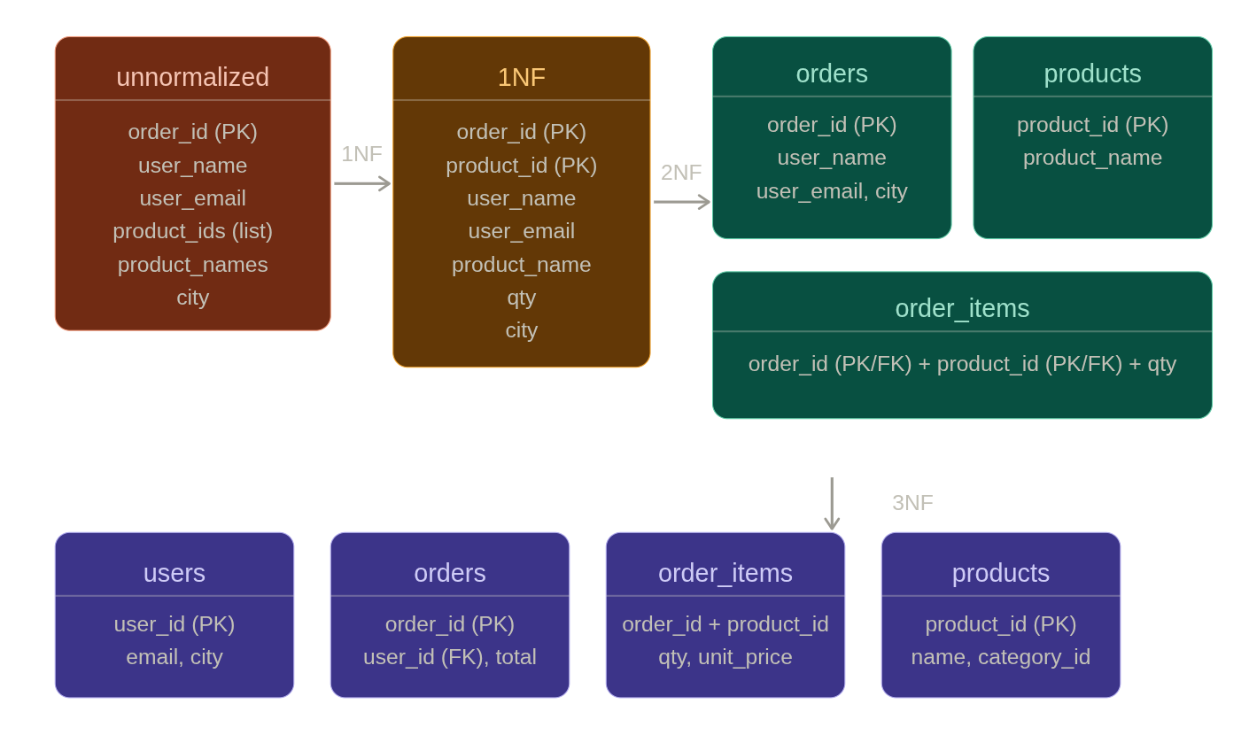

Denormalization — deliberately breaking the rules
Normalization gives you correctness. Denormalization trades some correctness for performance. In real backend systems, you almost always end up with some deliberate denormalization. The key word is deliberate — you must be able to justify every deviation.
When to denormalize:
-- Scenario: your orders list API does this join on every request
SELECT o.id, o.total, u.username, u.email
FROM orders o
JOIN users u ON o.user_id = u.id
WHERE o.status = 'shipped';

-- At 10M orders + heavy traffic, that join is expensive every time.
-- Denormalized: store username directly on orders
ALTER TABLE orders ADD COLUMN username TEXT;
-- Now the query is a simple table scan — no join

-- Tradeoff: if a user changes their username, you must update all their orders too.
-- Acceptable if username rarely changes. Not acceptable if it changes frequently.
The key questions to ask before denormalizing:
- How often does the duplicated data change? (If rarely — safe to denormalize)
- What's the consistency requirement? (Can we tolerate eventual consistency?)
- Is this a read-heavy or write-heavy path? (Denormalize for reads, normalize for writes)

Common denormalization patterns in backend systems
Pattern 1 — Storing derived values
-- Normalized: compute order total by summing order_items every time
SELECT SUM(quantity * unit_price) FROM order_items WHERE order_id = 1001;

-- Denormalized: store total on orders, update when items change
ALTER TABLE orders ADD COLUMN total NUMERIC(12,2);
-- Update via trigger or application logic when items are added/removed
-- Benefit: one-column read instead of aggregate join
-- Risk: total can drift out of sync if update logic has bugs
Pattern 2 — Storing counts
-- Normalized: count comments per post
SELECT COUNT(*) FROM comments WHERE post_id = 55;

-- Denormalized: increment/decrement a counter column
ALTER TABLE posts ADD COLUMN comment_count INT DEFAULT 0;
-- Extremely common in social platforms — reading a counter is O(1)
-- Risk: counter drift under concurrent writes (requires atomic increment)

-- PostgreSQL atomic increment — race-condition safe
UPDATE posts SET comment_count = comment_count + 1 WHERE id = 55;
-- This is safe because PostgreSQL's row-level locking makes this atomic
Pattern 3 — Redundant foreign key for query shortcutting
-- Normalized: to get the user of an order_item, you join order_items → orders → users
SELECT u.* FROM order_items oi
JOIN orders o ON oi.order_id = o.id
JOIN users u ON o.user_id = u.id
WHERE oi.id = 999;

-- Denormalized: store user_id directly on order_items
ALTER TABLE order_items ADD COLUMN user_id BIGINT REFERENCES users(id);
-- Now you can reach the user from an order_item with one join
-- Common in analytics tables and event logs
Pattern 4 — Materialized/summary tables
-- Instead of aggregating millions of rows for every dashboard request:
CREATE TABLE daily_revenue_summary (
date DATE PRIMARY KEY,
order_count INT,
revenue NUMERIC(14,2),
updated_at TIMESTAMPTZ
);
-- Populated by a nightly job or event-driven worker
-- Dashboard reads from this table: microseconds vs seconds

