Bhautik Makwana

Jr. Software Engineer

**xUnit Test with .NET**

* <https://www.codemotion.com/magazine/dev-hub/backend-dev/testing-your-c-code-with-xunit/>

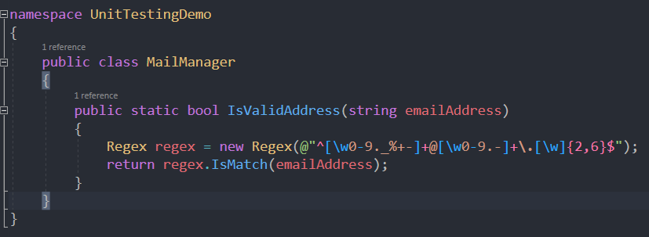

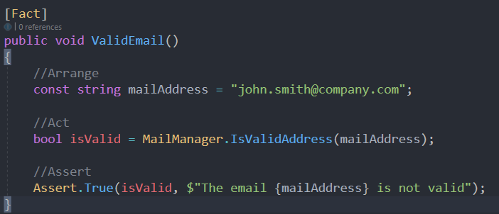

Luckily, xUnit helps you with ***theories***. A theory is a parametric unit test that allows you to represent a set of unit tests that share the same structure.

