Project Title: Social Web App.

Developed by: BhautikKachhadiya.

Developed in: Python (version - 3.8.3)/Django(version – 3.0.6)

Description:

This application is useful for people for creating the group on different subjects like Space, automobile, information technology Etc.

Using this app people can create different Group, make a posts on different groups, they can join the interested group, and read the posts of different Groups and gain the information.

1. Run The project.

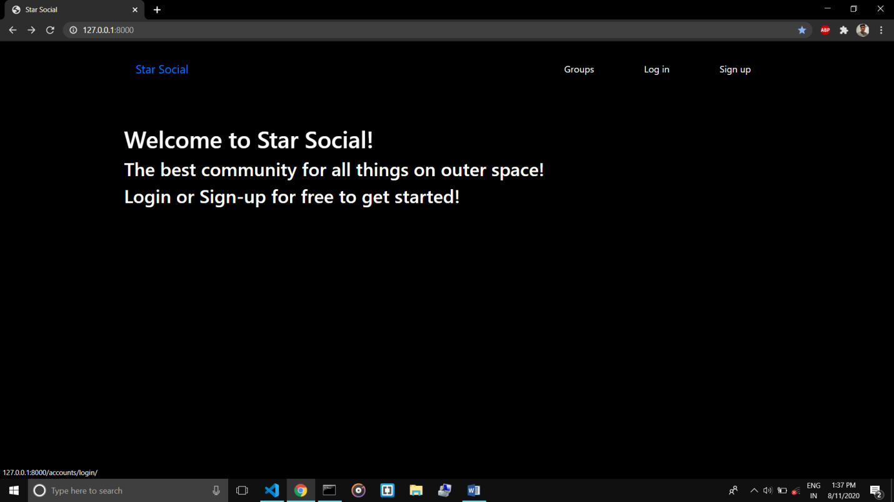

2>For Signup click on signup button.

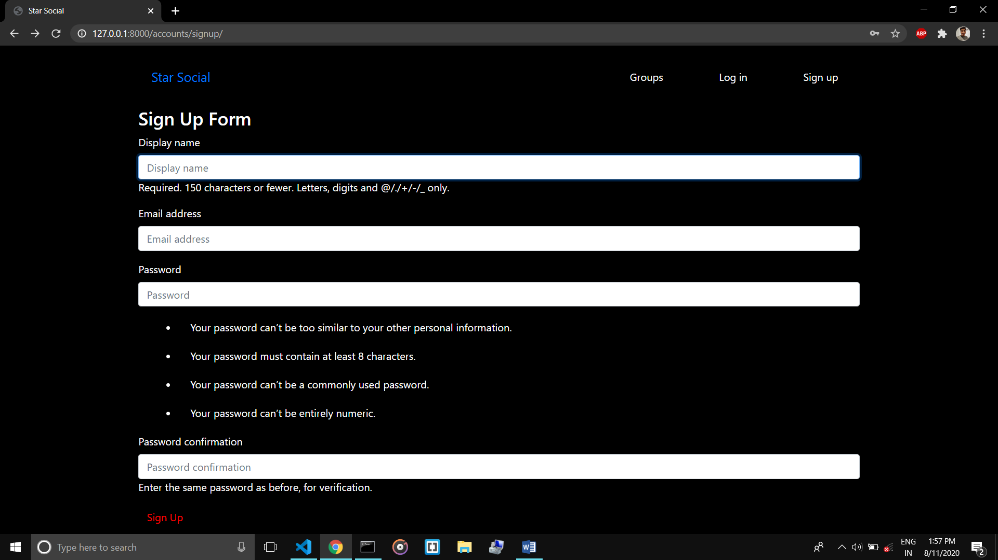

After entering required detail click on sign Up OR press Enter for submit the Data.

3>For Login, click on Login link on navigation bar.

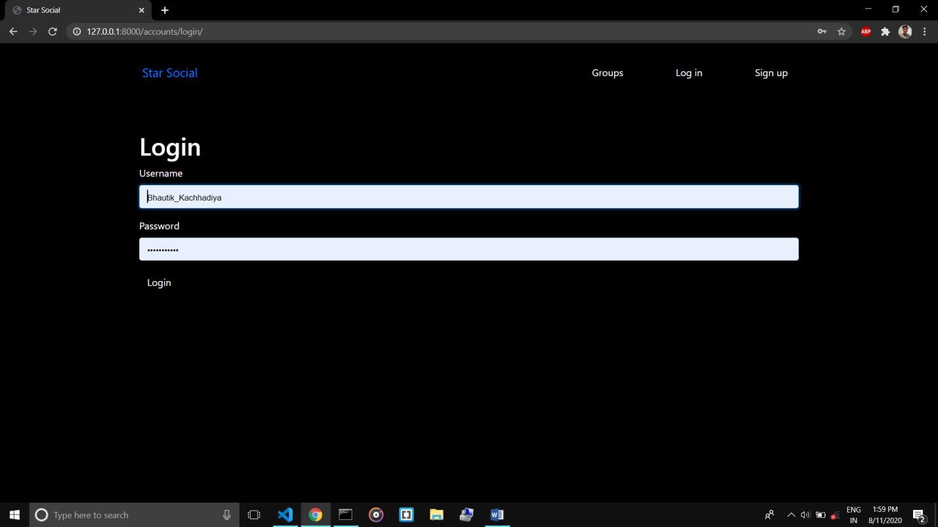

4> after login, the Homepage looks as Follows.

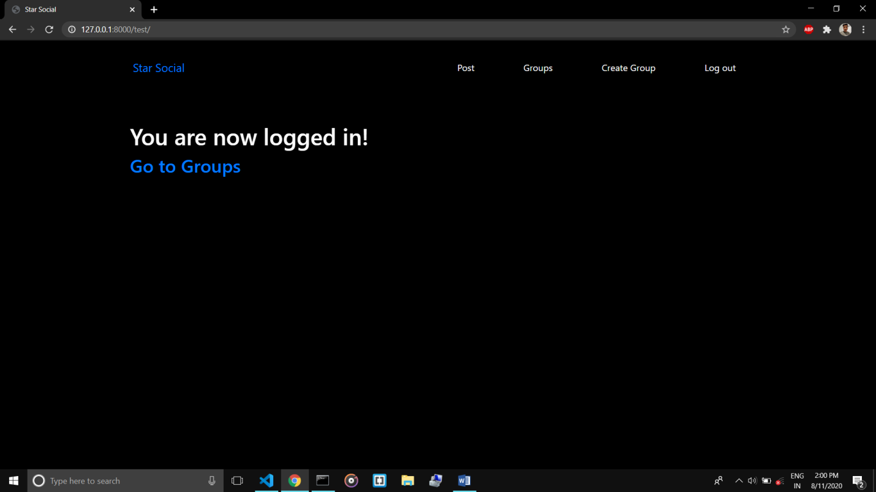

5> For Create a Pot, click on Post link,

Enter a message, select a group and Post it.

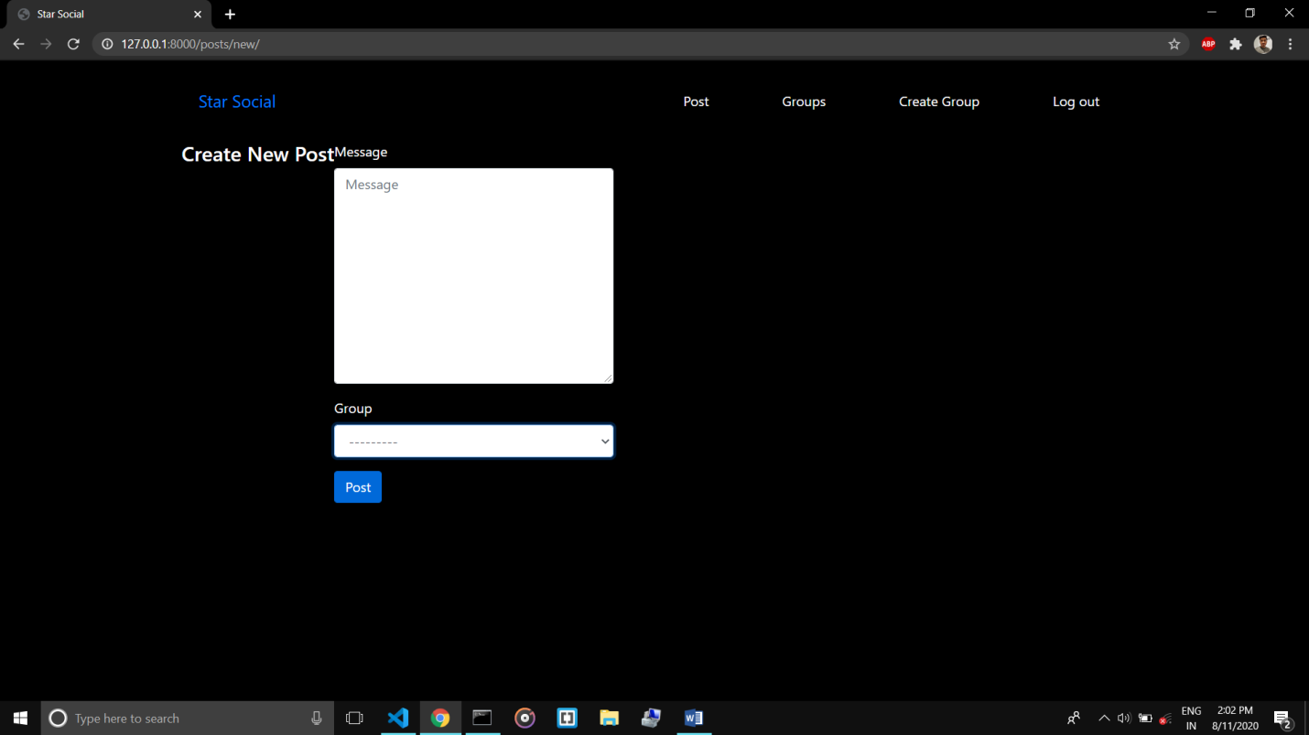

6>For see The list all Group, click on Groups Link on nav-bar.

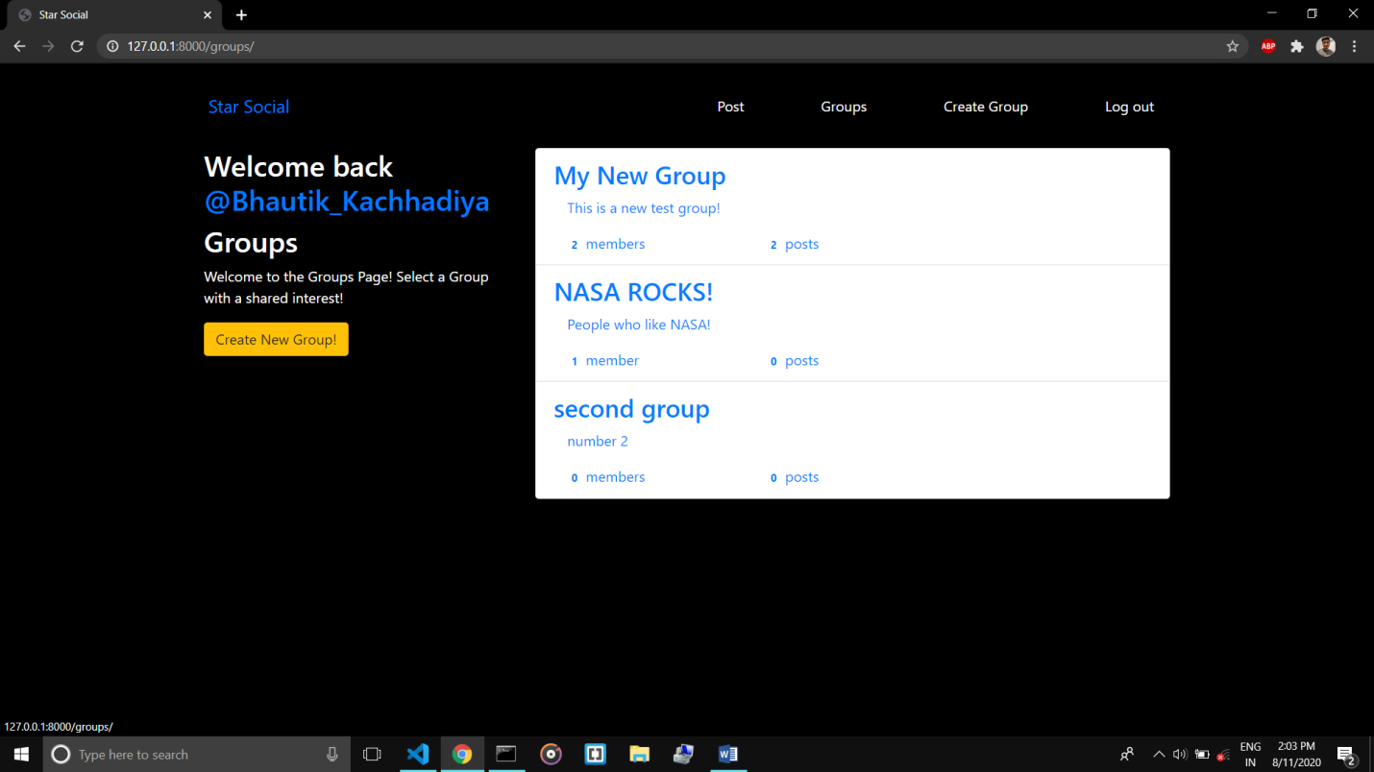

7>For see the all post of particular Group, click on that Group.

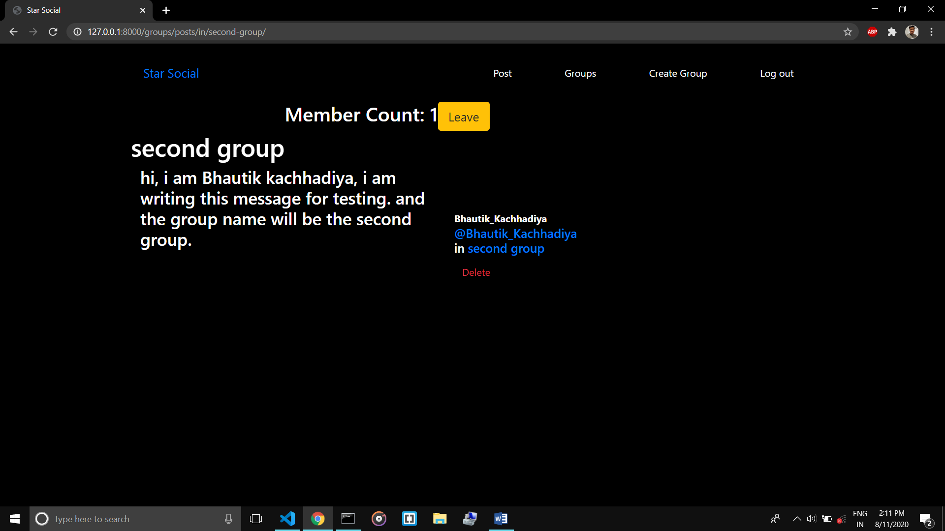

8> inside the group user can join, leave and delete their own post.

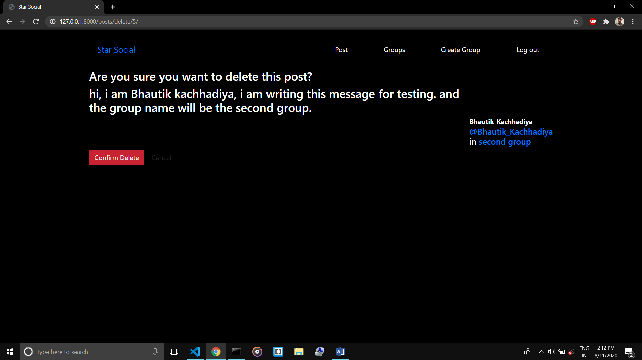

Thanks For Your Time,

Hope u like my Django Learning Project……….