Personal Finance Management System with Expense Prediction

Introduction and Problem Statement
In today's world, where money decisions really matter, our project is like a helpful friend for folks who want to handle their money better. We've built a simple and smart system that can predict how much money you might spend soon. Our goal is to give you the tools to make smart money choices, organize your money well, and reach your money goals.
We think everyone should feel confident about their money, so our project is like a clear guide in the sometimes-confusing world of personal finance. Using easy-to-understand info and a simple setup, we want to make managing your money easy. Our aim is to help you take control of your money journey and move towards a future where your money works well for you.

Tools, Technologies and Principles used
In our project, we harnessed the power of Python as our primary programming language, leveraging its versatility and extensive libraries for data science and machine learning. Here's a breakdown of the key tools, technologies, and principles we utilized:
- Python: Python served as the backbone of our project, providing a flexible and efficient environment for data manipulation, analysis, and machine learning.
- Pandas: Pandas, a powerful data manipulation library in Python, played a central role in handling and preparing our dataset. Its intuitive data structures facilitated seamless data preprocessing.
- Matplotlib: Matplotlib, a data visualization library, enabled us to create insightful charts and graphs. Visual representations were crucial in understanding patterns in our dataset and conveying information to users.
- Scikit learn (sklearn) Library: We employed scikit-learn, a machine learning library in Python, to implement essential functionalities such as splitting the dataset into training and testing sets using the train_test_split module.

Methodology
Our project methodology involved a systematic approach to developing a Personal Finance Management System with an integrated expense prediction model. The key steps encompassed in our methodology are as follows:
1. Problem Definition:

Objective:
Our primary objective is to create a versatile Personal Finance Management System capable of addressing various financial needs. The core goals include predicting monthly expenses, optimizing investment portfolios, and assessing credit risk. By achieving these objectives, our system aims to empower users with valuable insights, fostering better financial decision-making and contributing to their overall financial well-being.
Top of Form

2. Data Collection:
- Source: Collect relevant data for training our model. Our dataset included columns such as Date, Description, Paymode, Voucher_No, Debit, and Credit.

3. Data Preprocessing:
- Cleaning: Address any missing or inconsistent data, ensuring a clean dataset for analysis.
- Transformation: Convert data types, handle categorical variables, and extract relevant temporal features from the Date column.

4. Feature Engineering:
- Temporal Features: Extract month and other relevant temporal features to enhance the model's understanding of time patterns.
- Text Feature Conversion: Utilize natural language processing techniques to convert textual descriptions into numerical features, allowing the model to comprehend descriptive information.

5. Model Selection:
- Algorithm Choice: Select a Linear Regression algorithm as the initial model, given its simplicity and suitability for predicting numerical values.

6. Training the Model:
- Splitting Data: Implement the train-test-split technique to divide the dataset into training and testing sets.
- Model Training: Train the Linear Regression model using the training set to enable it to learn patterns and relationships in the data.
7. Model Evaluation:
- Metric Selection: Assess the model's performance using evaluation metrics such as Mean Absolute Error (MAE) and Root Mean Square Error (RMSE).
- Testing Data: Evaluate the model's predictions against the testing dataset to ensure its effectiveness in real-world scenarios.
8. Results Analysis:
- Insights: Interpret the results, gaining insights into the model's predictive capabilities and understanding any limitations or areas for improvement.
9. Iterative Refinement:
- Feedback Loop: Based on the results and user feedback, iterate and refine the model and system to enhance accuracy and usability.
10. User Interface Implementation:
- Development: Implement a user-friendly interface to facilitate easy data input and interaction with the system.
11. Documentation:
- Record Keeping: Document the entire process, including tools, technologies, and decisions made at each stage.
This methodology allowed us to methodically approach the development of our Personal Finance Management System, ensuring the creation of a reliable and user-centric solution for expense prediction and financial management.

Dataset

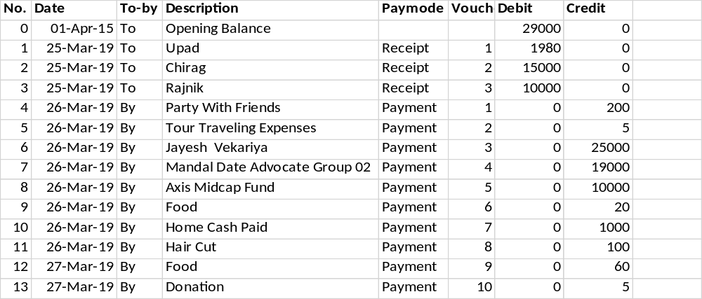

Implementation Details
Screenshot of code

Results
Show the results in form of table, graph, etc. and some of the discussion about the result.

Analysis
Result analysis in detail.

Conclusion
Final conclusion of your research/project. Also include what improvements can be done further

References
The references made to various books, articles or magazines etc. during project development.

Appendix

