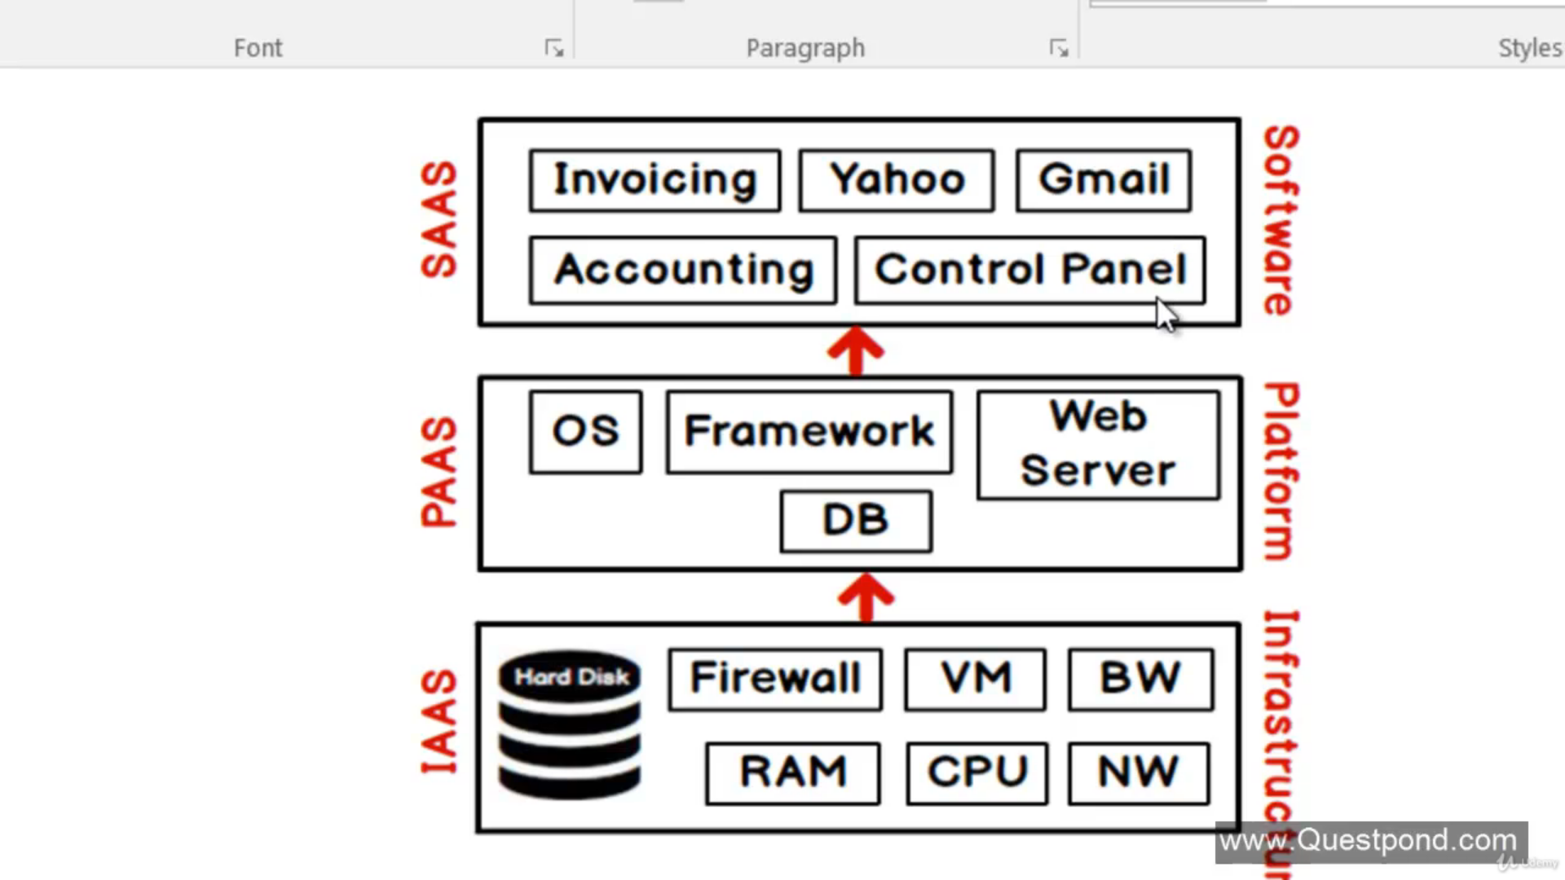

Note : Database is act as a platform.

Resource Group: All resources belongs to 1 project is sotred in resource group.

While creating resource group, there is option called resource group location: it means that in which location you want to store the **MetaData** of that resource group.

Hosting the Application :

To host webApps we use AppService Resource of Azure.

While creating resource you can choose App Service Plan according to your need.

Method for Deployment:

1. Using visual studio
2. FTP method
3. Kudu
4. Using CI/CD devops.

Virtual Machines:

If you stop your Virtual Machines it will not stop costing, Because your Virtual Machine also cost you for Storage, So Storage Cost will still charged.

While Crating VM you need to choose Region where your Company’s belong.

We can choose Availability option to separate our 2 VMs(if we have more then 1) into separate regions in any case of floods, EarthQuakes etc.

DevOps:

Development + Operations

This is a Philosophy/Mindset Term only, maintain relationship between developers and Operations teams for Agile. Inshort DevOps engineer do both things.

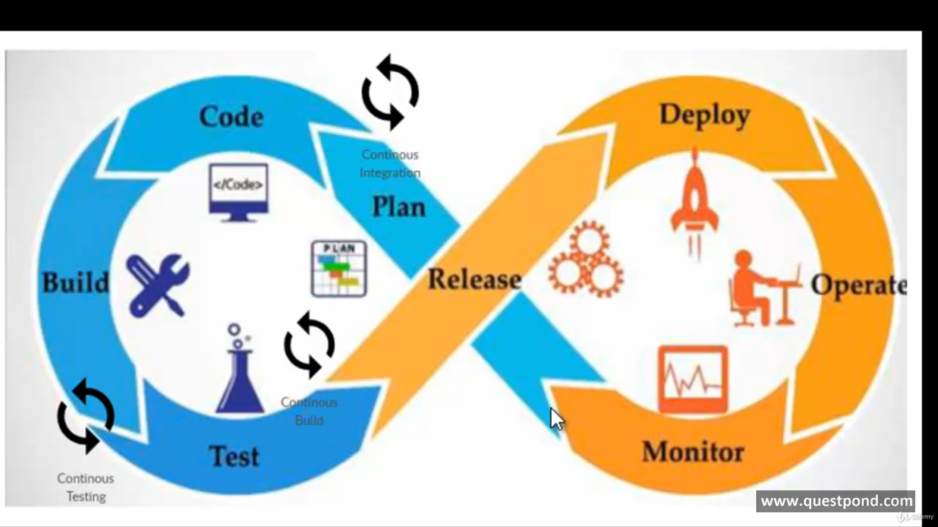

Developers: do Plan, code , build application, testing, Release to operation team

Operations: do deployment, operate, Manage, configure it as per environment, release to customer, helps the customer to know about the changes. {Inshort works on cloud like Azure.}

This Above cycle in picture can be done by creating Azure Devops resource/organization in Azure

**CLOUD CDN**