PROJECT DOCUMENTATION

Streamlining IT Procurement:
Automating Standard Laptop Orders with Flow Designer
ServiceNow Flow Designer / Service Catalog Automation
Team ID | SWTID-2026-1824
Team Size | 4
Team Leader | Bhavadharani S
Team Member | Archana M
Team Member | Akila S
Team Member | Priyanga D
Team E-Mail IDs
bhavabhava623@gmail.com
archanamanimegalai039@gmail.com
akila2007ok@gmail.com
p11368992@gmail.com

1. Introduction

1.1 Project Overview
IT departments routinely receive requests for standard employee equipment such as laptops. When procurement and fulfilment depend on manual coordination, the same data may be entered repeatedly, tasks can be missed, and request status can be difficult to track. This project demonstrates a ServiceNow-based approach for streamlining that process by connecting a Standard Laptop catalog item to a Flow Designer flow.
The automation is centred on a Service Catalog trigger and a Create Catalog Task action. The configured flow is named “Standard laptop task”. When the catalog request is submitted, the flow can create a fulfilment task associated with the requested item, providing a structured path from request submission to task creation and tracking.

1.2 Objective
- To create a standard laptop request item in the ServiceNow Service Catalog.
- To configure a Flow Designer flow named “Standard laptop task”.
- To use a Service Catalog trigger to start the automation when a request is placed.
- To use the Create Catalog Task action to generate the fulfilment work automatically.
- To test the end-to-end process by ordering the catalog item and verifying the submitted request.

1.3 Project Outcome
The screenshots supplied with the project show the flow being configured and activated, the Standard Laptop catalog item using the Standard laptop task flow under its Process Engine settings, and a successful catalog order submission. This provides a practical demonstration of the intended automation path.

1.4 Technologies and Components Used
Component | Purpose
ServiceNow Service Catalog | Provides the Standard Laptop request item.
Flow Designer / Workflow Studio | Builds and manages the procurement automation.
Service Catalog Trigger | Starts the flow from a catalog request.
Create Catalog Task | Creates a task for fulfilment processing.
Requested Item Record | Provides request context to the flow.

2. Problem Statement and Proposed Solution

2.1 Problem Statement
A standard laptop request may require several manual actions: receiving the request, checking the requested item, creating fulfilment work, assigning or routing the task, and updating the requester. Without an automated workflow, these steps may depend on individual users remembering to perform them in sequence.

2.2 Proposed Solution
The project uses ServiceNow Flow Designer to connect a Service Catalog request with a fulfilment action. The solution is intentionally simple and repeatable: a user submits the Standard Laptop catalog item, the Service Catalog trigger starts the flow, and the Create Catalog Task action produces the task needed for fulfilment.

2.3 Process Flow
1. User opens the Service Catalog
2. User selects the Standard Laptop catalog item
3. User submits the laptop request
4. Service Catalog trigger starts “Standard laptop task”
5. Flow reads the Requested Item Record
6. Create Catalog Task generates the fulfilment task
7. Request and task can be tracked in ServiceNow

2.4 Scope
- Service Catalog configuration for a Standard Laptop item.
- Flow Designer configuration for the “Standard laptop task” flow.
- Service Catalog trigger and Create Catalog Task action.
- Basic validation through a test request submission.

2.5 Out of Scope
- Vendor purchase-order integration.
- Payment or finance-system integration.
- Inventory reservation and asset lifecycle automation beyond the demonstrated catalog/task flow.
- Advanced approvals, SLAs, notifications, or integrations not shown in the supplied screenshots.

3. Implementation

3.1 Create the Flow
- Open Workflow Studio / Flow Designer from the ServiceNow instance.
- Create a new flow and name it “Standard laptop task”.
- Leave the flow inactive while configuration is being completed.
- Add a Service Catalog trigger so the flow can respond to catalog requests.

3.2 Configure the Trigger
The supplied flow screenshot shows the trigger as “Service Catalog”. The data panel exposes the Requested Item Record together with run-start information. This gives the flow access to the catalog request context needed for the next action.

3.3 Add the Create Catalog Task Action
- Add an action under the Actions section.
- Select “Create Catalog Task”.
- Use the requested item data exposed by the Service Catalog trigger as the context for fulfilment.
- Review the output fields shown by the action, including Catalog Task and Action Status.
- Save the flow and activate it after the configuration is complete.

3.4 Connect the Flow to the Standard Laptop Catalog Item
In the Standard Laptop catalog item, open the Process Engine settings. The supplied screenshot shows the Flow field set to “Standard laptop task”, which connects the catalog item to the automation created in Workflow Studio.

3.5 Activate and Test
After the flow is configured, activate it and submit the Standard Laptop item from the Service Catalog. A successful test should create the requested item record and trigger the fulfilment action. The final screenshot supplied for the project shows a successful request-submission confirmation.

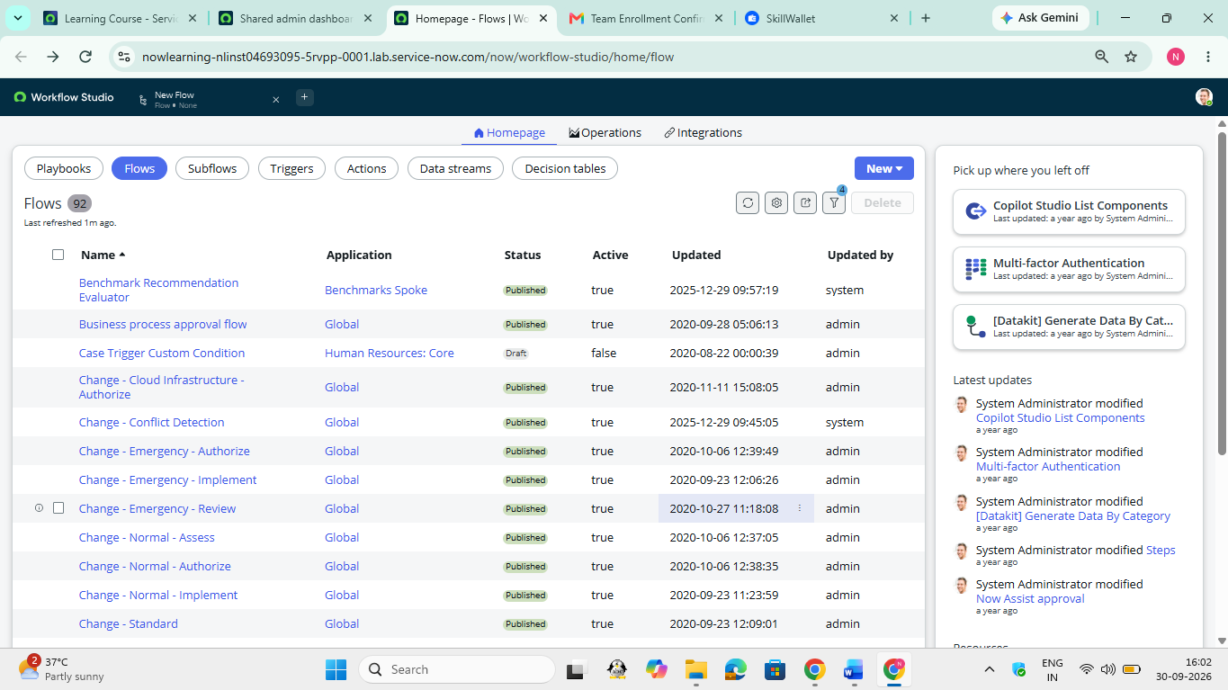
Figure 1. Workflow Studio – Flow list before configuration.
Observation: The Workflow Studio Flow list is visible and provides the starting point for creating or opening a flow.

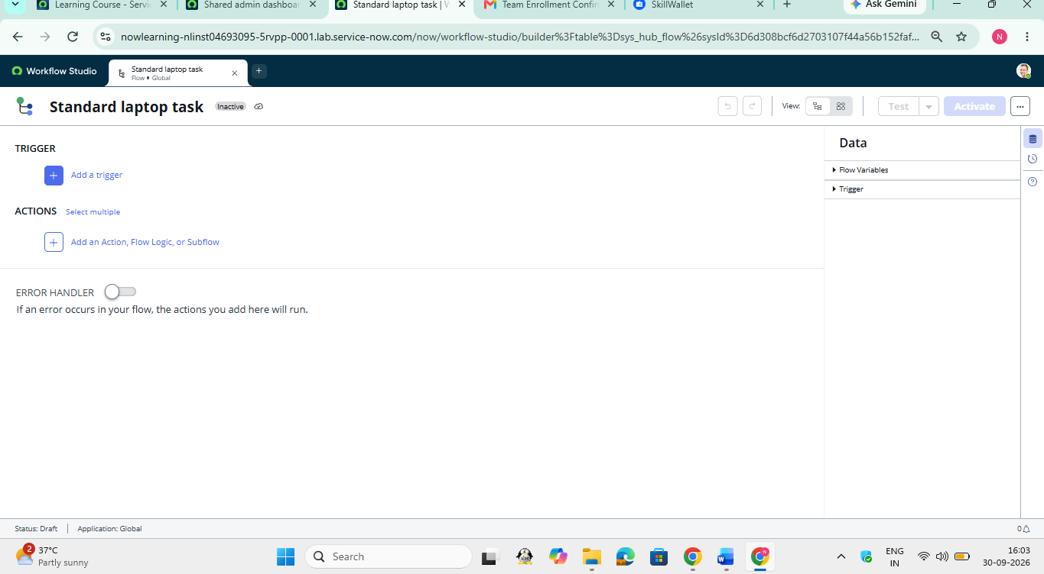
Figure 2. “Standard laptop task” flow – initial builder screen.
Observation: The flow builder shows the Trigger and Actions areas, with Add a trigger and Add an Action, Flow Logic, or Subflow available.

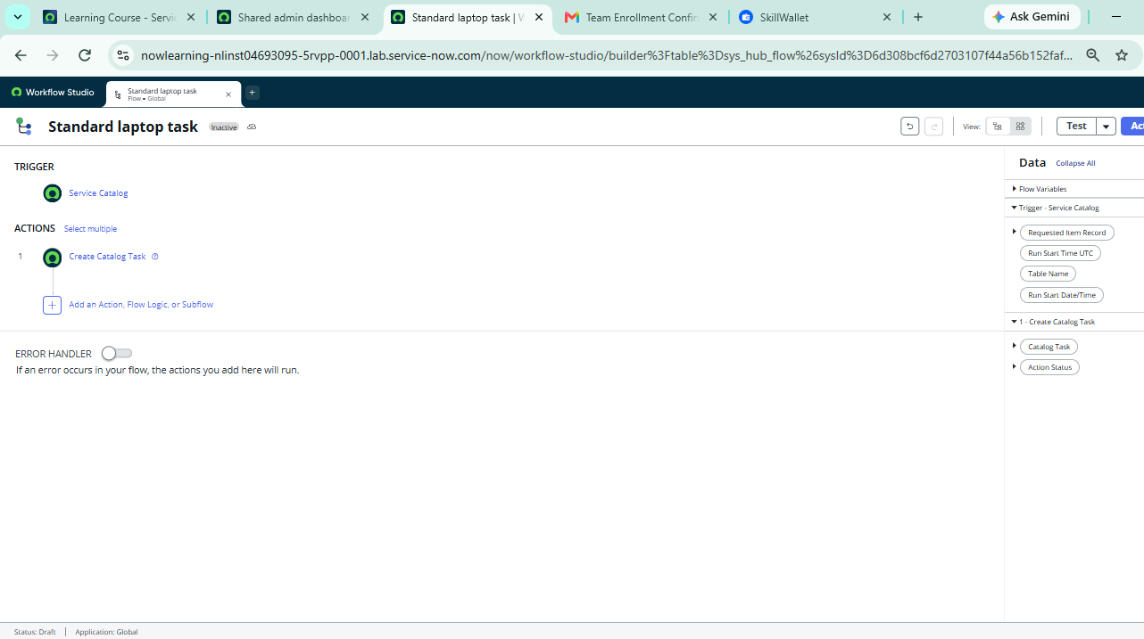
Figure 3. Configured flow with Service Catalog trigger and Create Catalog Task action.
Observation: The flow contains a Service Catalog trigger followed by the Create Catalog Task action. The Data panel exposes the Requested Item Record and related run information.

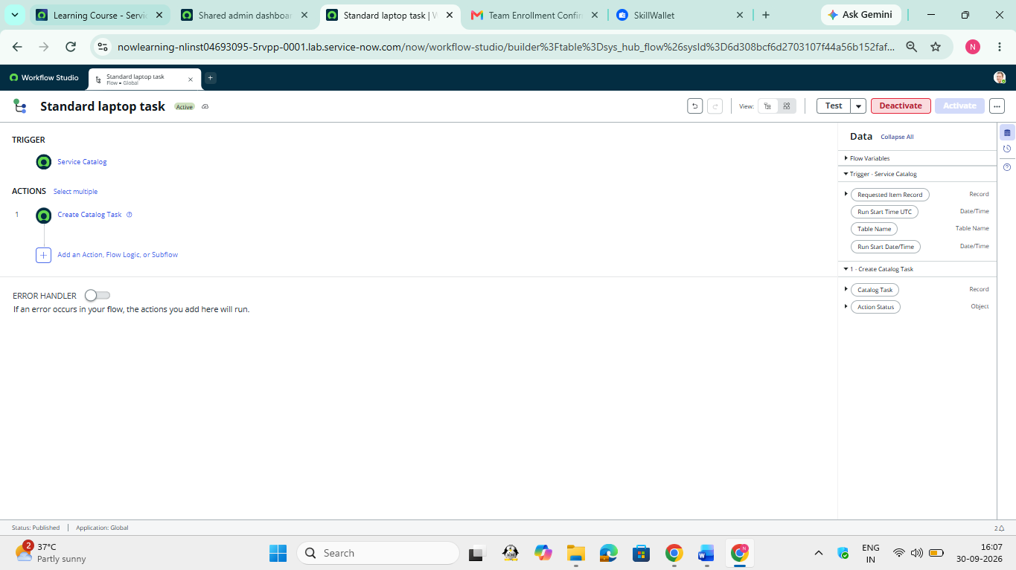
Figure 4. “Standard laptop task” flow activated.
Observation: The flow status is shown as active/published and the Deactivate control is available, indicating that the automation is enabled.

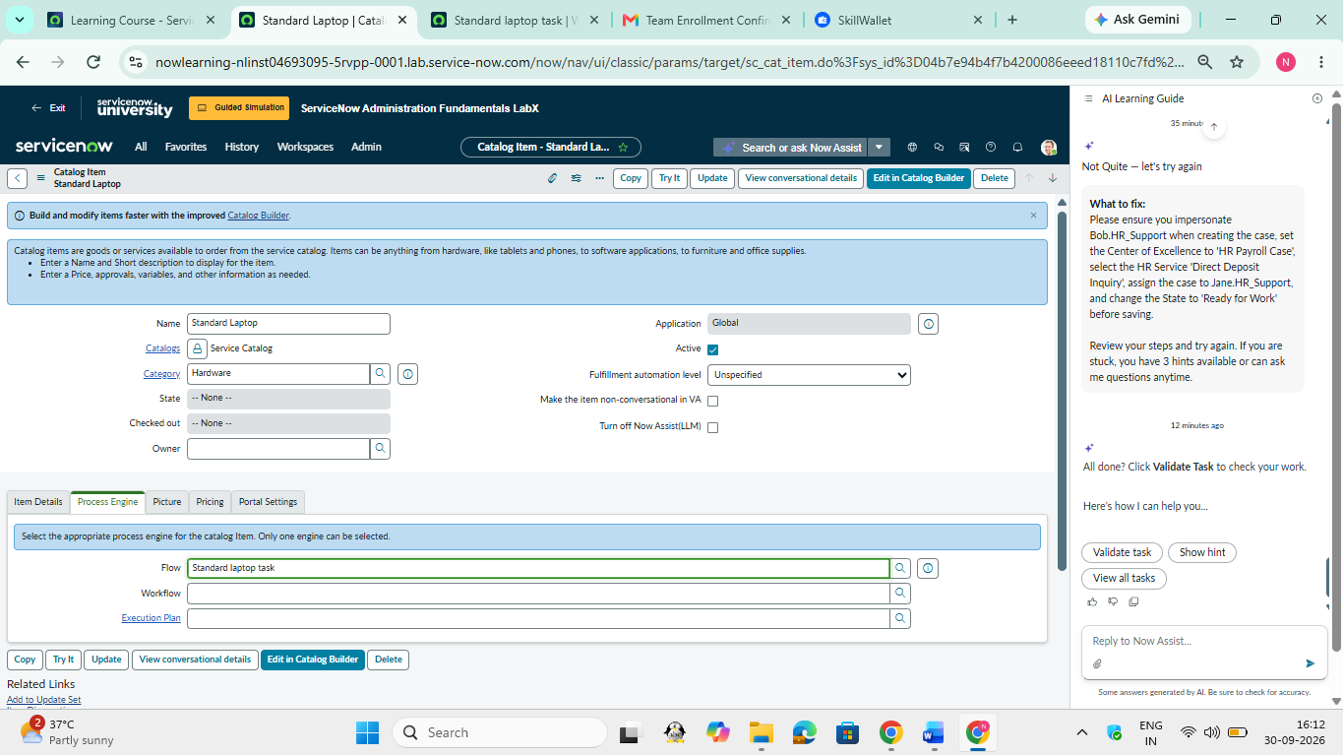
Figure 5. Standard Laptop catalog item connected to the flow.
Observation: The Standard Laptop item is active, under the Hardware category, and its Process Engine Flow field is set to “Standard laptop task”.

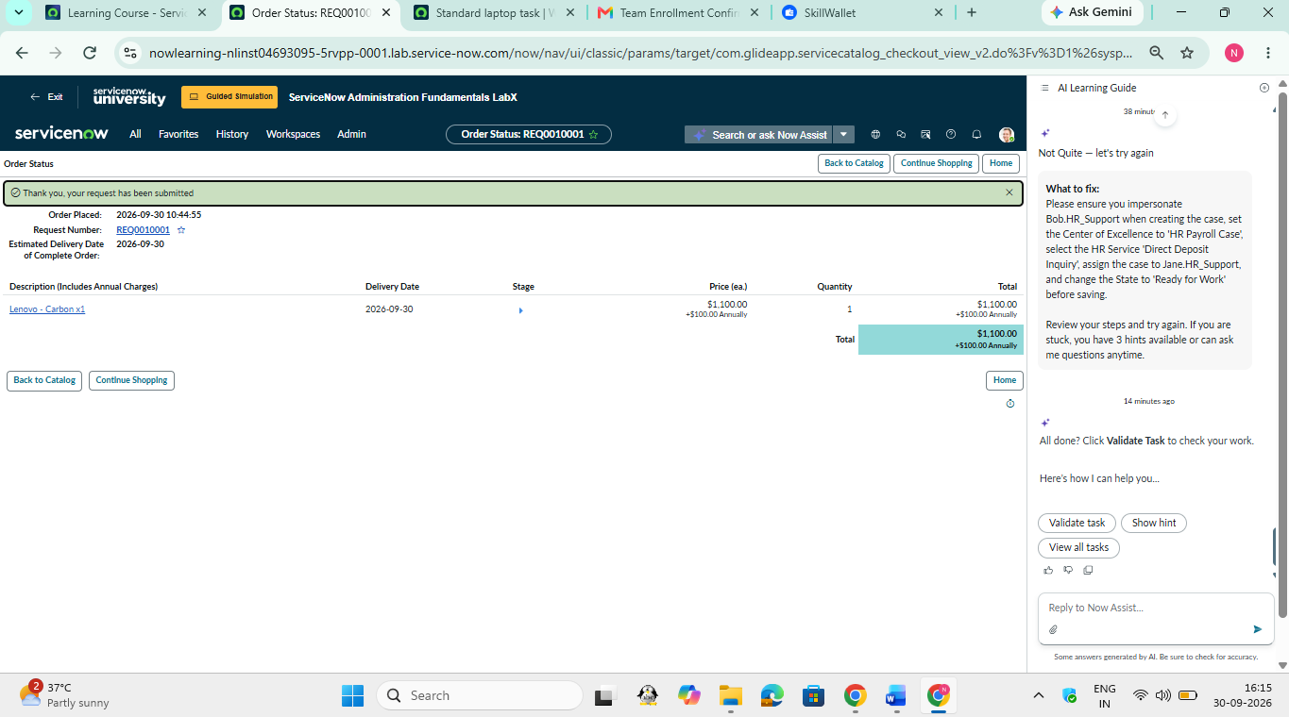
Figure 6. Successful Standard Laptop catalog order submission.
Observation: The order status page confirms that the request was submitted. The example shown includes a Lenovo - Carbon x1 item with quantity 1 and an estimated annual charge of $1,100.

4. Testing and Validation

4.1 Test Case 1 – Flow Configuration
Expected: the “Standard laptop task” flow contains a Service Catalog trigger and a Create Catalog Task action. Result shown in the supplied screenshots: the configured flow displays both elements.

4.2 Test Case 2 – Flow Activation
Expected: the flow becomes active so that new catalog requests can trigger it. Result shown: the flow is active/published and the Deactivate button is available.

4.3 Test Case 3 – Catalog Item Association
Expected: the Standard Laptop catalog item points to the intended flow. Result shown: the Process Engine Flow field contains “Standard laptop task”.

4.4 Test Case 4 – User Order
Expected: a user can submit the Standard Laptop catalog item and receive an order-status confirmation. Result shown: the request is submitted successfully, with an order-status page displaying a request number and the ordered Lenovo - Carbon x1 item.
Test | Expected | Observed in screenshots | Status
T1 | Trigger + action configured | Service Catalog + Create Catalog Task visible | Pass
T2 | Flow active | Active/published status visible | Pass
T3 | Catalog item linked | Flow field = Standard laptop task | Pass
T4 | Request submitted | Order status confirmation shown | Pass

5. Benefits, Limitations and Future Enhancements

5.1 Benefits
- Reduces repetitive manual steps in standard laptop fulfilment.
- Provides a consistent trigger-to-task process for catalog requests.
- Makes the procurement workflow easier to understand and track.
- Supports repeatable execution through ServiceNow Flow Designer.
- Creates a foundation for extending the process with approvals, notifications, assignment rules, and integrations.

5.2 Limitations of the Demonstrated Scope
- The screenshots demonstrate the flow, catalog-item linkage, and order submission; they do not by themselves prove vendor fulfilment or physical laptop delivery.
- The demonstrated flow contains one visible action, so more complex procurement rules would require additional actions or flow logic.
- The project documentation does not include external purchasing or inventory integrations.

5.3 Future Enhancements
- Add approval steps based on laptop cost, department, or employee role.
- Automatically assign tasks to the appropriate procurement or IT fulfilment group.
- Send requester notifications when the request changes state.
- Integrate inventory/asset records so stock availability can be checked before fulfilment.
- Integrate vendor or purchase-order systems for end-to-end procurement tracking.

6. Conclusion
The project demonstrates how ServiceNow Flow Designer can streamline a standard IT procurement process by linking a Service Catalog item with an automated fulfilment task. The implemented flow, “Standard laptop task”, uses a Service Catalog trigger and a Create Catalog Task action, while the Standard Laptop catalog item references that flow through its Process Engine settings. The supplied test screenshots show the flow being configured and activated and a Standard Laptop request being submitted successfully.

7. Key Learnings
- How Workflow Studio / Flow Designer is used to create and activate an automation flow.
- How a Service Catalog trigger can start an automation when a request is submitted.
- How Create Catalog Task supports fulfilment work creation.
- How a catalog item can be linked to a flow through Process Engine settings.
- How to validate the workflow with a real catalog order submission.

Appendix A – Demonstrated Configuration Summary
Configuration Item | Value shown in project
Catalog Item | Standard Laptop
Application | Global
Category | Hardware
Flow | Standard laptop task
Trigger | Service Catalog
Action | Create Catalog Task
Example order | Lenovo - Carbon x1; Quantity 1
Example annual charge | $1,100.00 shown on order status

