**ADMISSIONS:**

* B.TECH total intake - 1140
* Fee structure for B.Tech courses - <https://www.vrsiddhartha.ac.in/programmes-and-fee-structure/>

**CUTOFFS FOR EAMCET/EAPCET:**

CSE:

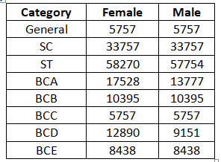

ECE:

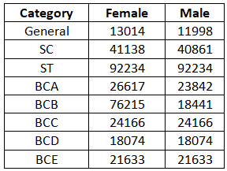

IT:

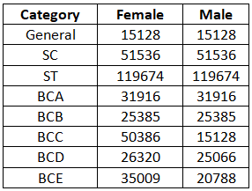

EEE:

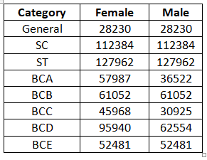

ME:

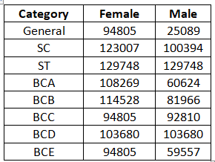

CIVIL:

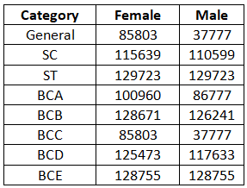

EIE:

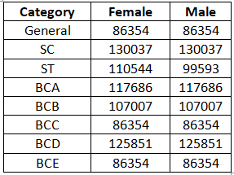

**FACULTY:**

Total-319

Faculty with Ph.D.s -134

pursuing Ph.D.s – 137

**ABOUT THE COLLEGE:**

- EAMCET code: VRSE

- Dr. A.V.Ratna Prasad, M.Tech(IIT.Kgp),Ph.D -- Principal

- First self-financed Engineering College in composite state of Andhra Pradesh established in the year 1977 and first private college to offer PG Programmes in engineering in Andhra Pradesh in the year 1998.

- Offering 8 UG (B.Tech) Courses with intake of 1140, 9 M.Tech (Specialisations) -108, MBA-60, MCA-60. Total Sudent Strength in the campus- 5421.

- Autonomous College by UGC since 2006 & extended for 10 years, upto 2027-28 without visit to the college, first in A.P.

- NIRF Ranking- The college is ranked among the top 200 engineering institutions in the country for the lass three consecutive years and got a rank of 156 in 2020. It was updated to 178 in 2021.

- NPTEL/SWAYM- The institute secured AAA ranking and all India 7th position for the participation by students and faculty.

- Collaboration with 7 foreign universities in USA and Australia.

- 60 MoUs with Industry Partners and Internship in 130 Companies

**HOSTEL:**

In hostel, accommodation is provided to 1070 students.

|  |  |  |
| --- | --- | --- |
|  | **Boys** | **Girls** |
| **Total no of Rooms** | 136 | 310 |
| **Total no of Beds per Room** | 3 | 2 or 3 |
| **Room rent** | 1000 | 500 - 750 |
| **Mess Bill per Day** | 90- 95 | 70-75 |
| **Food Details** | Tiffin , Lunch ,Snacks, Dinner and 1 day non veg every week | |
| **Availability of Wifi** | No | Yes |
| **Security Details** | **Yes** | **yes** |

**DEPARTMENT DETAILS:**

**Electronics communication and engineering**

Established in : 1977

current intake : 240

current hod : Dr. D Venkata Rao

placements link: <https://www.vrsiddhartha.ac.in/ece/placements-home/>

faculty : 55

adjunct faculty : 2

no.of phd's : 22

no.of Dr's : 22

**Mechanical engineering**

Established in : 1977

current intake : 180

current hod : Dr.N.Vijaya Sai

placements link : <https://www.vrsiddhartha.ac.in/me/campus-placements/>

faculty : 47

adjunct faculty : 0

no.of phd's : 25

no.of Dr's : 25

**Information and technology**

Established in : 2000

current intake : 120

current hod : Dr. M. Suneetha

placements link : <https://www.vrsiddhartha.ac.in/it/placements-summary/>

faculty : 30

adjunct faculty : 7

no.of phd's : 10

no.of Dr's : 10

**Electrical and electronics engineering**

Established in : 1977

current intake : 120

current hod : Dr. P. V. R. L. Narasimham

placements link : <https://www.vrsiddhartha.ac.in/eee/placements-page/>

faculty : 27

adjunct faculty : 2

no.of phd's : 23

no.of Dr's : 13

**Electronics and Instrumental Engineering**

Established in : 2003

current intake : 120

current hod : Dr. G. Narashima Swamy

placements link : <https://www.vrsiddhartha.ac.in/eie/placements/>

faculty : 24

adjunct faculty : 0

no.of phd's : 6

no.of Dr's : 4

**Civil Engineering**

Established in : 1977

current Intake : 180

current hod : Dr. Chava Srinivas

placements link : <https://www.vrsiddhartha.ac.in/ce/placements-home/>

facullty : 41

adjunct faculty : 6

no.of phd's : 15

no.of Dr's : 15

**Computer Science and Engineering**

Established in : 1985

current intake : 180

current hod : Dr. D. Rajeswara Rao

placements link: <https://www.vrsiddhartha.ac.in/cse/placements-home/>

faculty : 36

adjunct faculty : 2

no.of phd's : 14

no.of Dr's : 3

**RANK CHECKING DATA**

**Female Category**

**general (girls)**

1-20000 -cse,it,ece

20000-40000-eee

40000 and more- eie,me,civil

**sc**

1-35000-cse

35000-55000-it,ece

55000 and more- eee, eie, civil, me

**st**

1-60000 -cse

60000-100000-ece

100000 and more- it,eee,civil,me,eie

**bca**

1-30000- cse,ece

30000-60000-it,eee

60000 and more - eie,civil,me

**bcb**

1-20000 -cse

20000-70000-it,eee

70000 and more - me,civil,eie,ece

**bcc**

1-20000 -cse

20000-40000-ece

40000 and more- eie,me,it,eee,civil

**bcd**

1-20000 -cse,ece

20000-70000-it

70000 and more - me,civil,eie,eee

**bce**

1-25000 - cse, ece

25000-60000-eee,it

60000 and more -civil,eie,me

**Male Category**

**general(male)**

1-20000 -cse,it,ece

20000-40000-eee,me,civil

40000 and more- eie

**sc**

1-35000-cse

35000-55000-it,ece

55000 and more- eee, eie, civil, me

**st**

1-60000 -cse

60000-100000-ece,eie

100000 and more- it,eee,civil,me

**bca**

1-30000- cse,ece

30000-60000-it,eee

60000 and more - eie,civil,me

**bcb**

1-30000 -cse,it,ece

30000-100000-eee,me

100000 and more- civil,eie

**bcc**

1-20000 -cse,it

20000-40000-ece,civil,eee

40000 and more- eie,me

**bcd**

1-20000 -cse,ece

20000-70000-it,eee

70000 and more - me,civil,eie

**bce**

1-25000 - cse, ece, it

25000-60000-eee,me

60000 and more -civil,eie