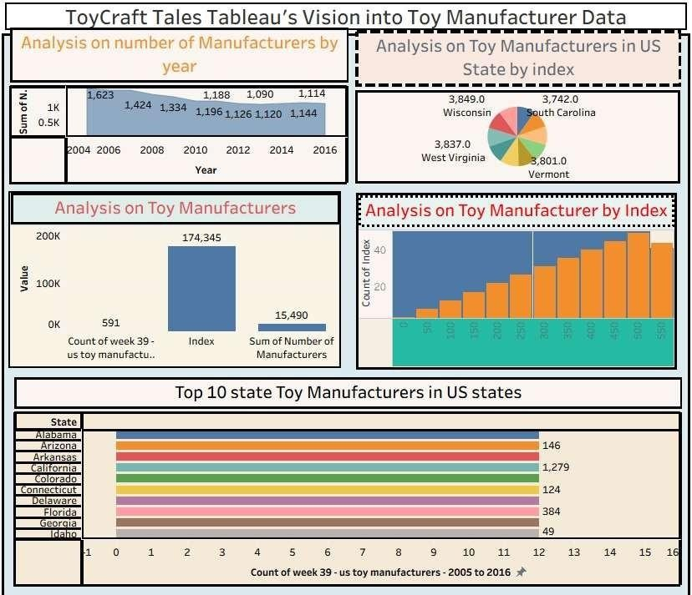

**Link:**

https://public.tableau.com/app/profile/kommini.sandeep.ratna.kum ar/viz/ToyCraftTales_17511728522240/ToyCraftTalesTableausVisionin toToyManufacturerData?publish=yes