Ideation Phase

Brainstorm & Idea Prioritization Template

|  |  |
| --- | --- |
| Date | 3 July 2025 |
| Team ID | LTVIP2025TMID50858 |
| Project Name | ToyCraft Tales: Tableau's Vision into Toy Manufacturer Data |
| Maximum Marks | 4 Marks |

**Step-1: Team Gathering, Collaboration and Select the Problem Statement**

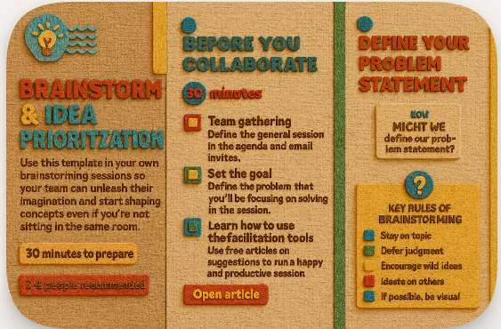

**Step-2: Brainstorm, Idea Listing and Grouping**

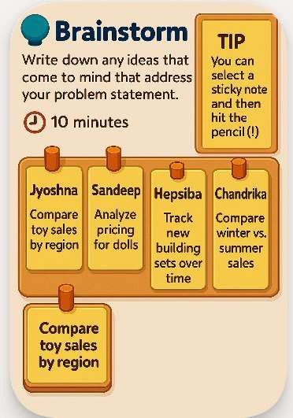

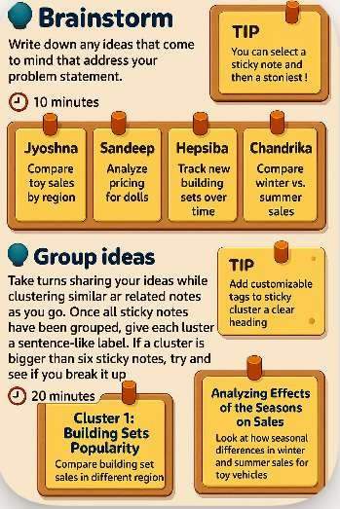

**Step-3: Idea Prioritization**

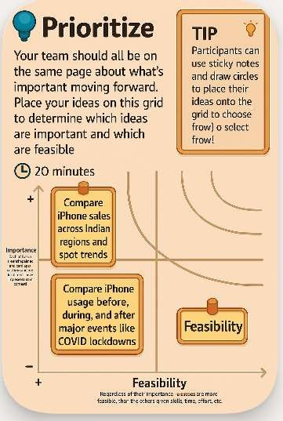

Submitted Template link:

https://app.mural.co/t/da9640/m/da9640/1750069641517/0f044a20c64822d02c0f812d3 4 60c24477a5a6fa?sender=u47cabad28f7fc43c7e754820

**Conclusion: Building Blocks of Insightful Exploration**

Like assembling a vibrant toy set, I pieced together a variety of colorful ideas to explore how Apple’s iPhone has shaped the Indian landscape—using Tableau as my creative toolkit. Through structured brainstorming, these ideas formed four delightful clusters:

🅧 **Clusters of Curiosity:**

* 📍 Mapping how iPhones are used across regions
* 💰 Understanding how finances affect iPhone ownership
* ⏳ Tracking how the market shifts over time
* 🎁 Studying offers and changing public moods

Each concept was ranked like prized pieces in a toy collection—based on how well they fit the project vision and what tools Tableau can bring to life.

As a solo creator, this process gave me a crisp blueprint for how the final dashboard playset should look. The top-ranked ideas will become the main attractions—guiding visuals, crafting stories, and unlocking insights.