1. Open anaconda navigator

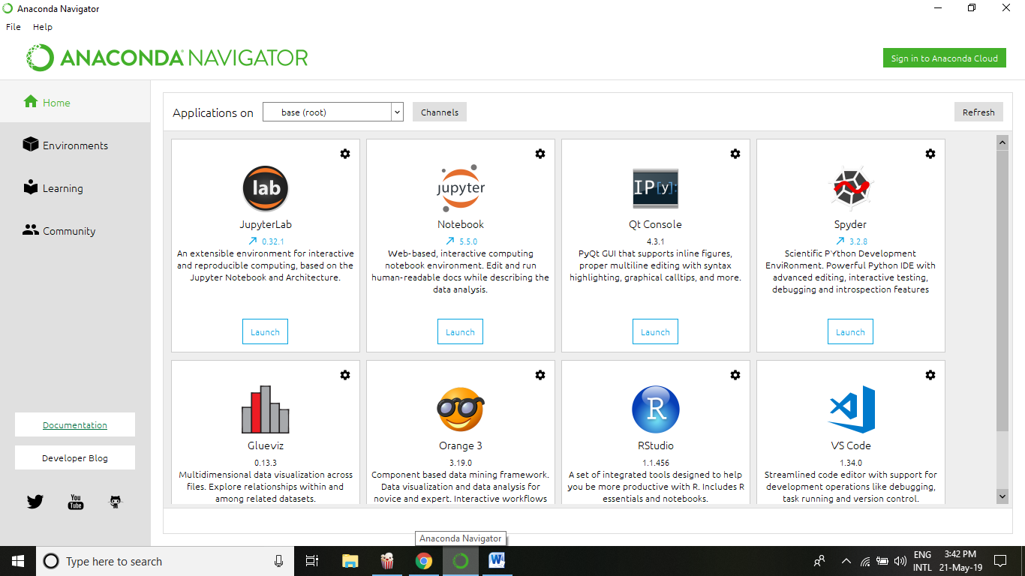

1. Select Environments tab from left side and choose the ‘create’ option

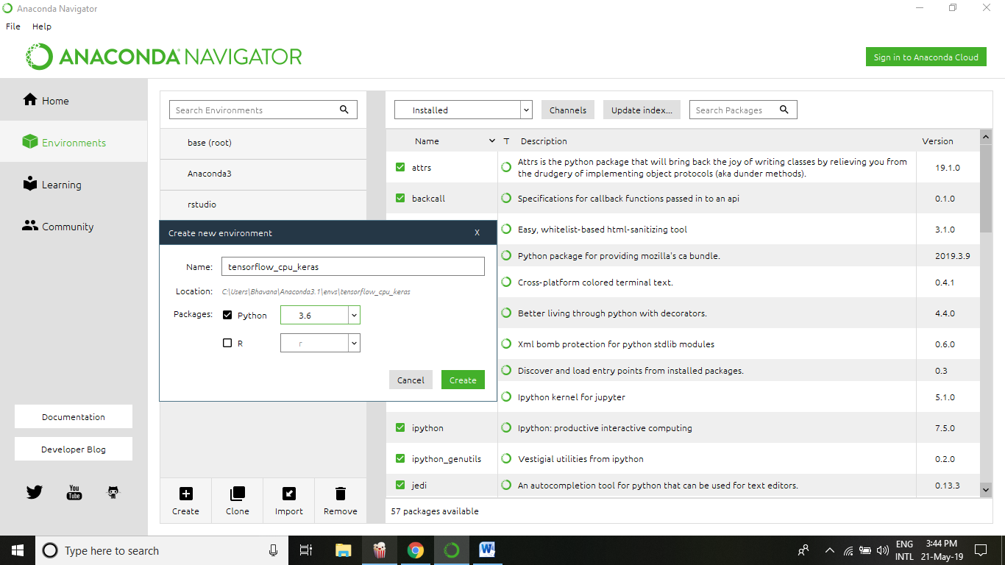

1. Click on the play button and choose ‘open terminal’ option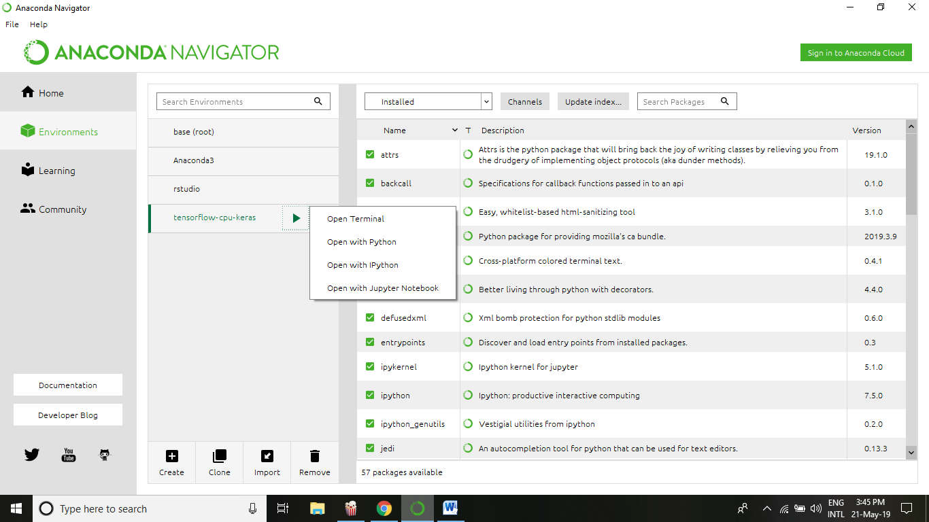
2. On the terminal, Run

pip install tensorflow and then

pip install keras

1. To check installation

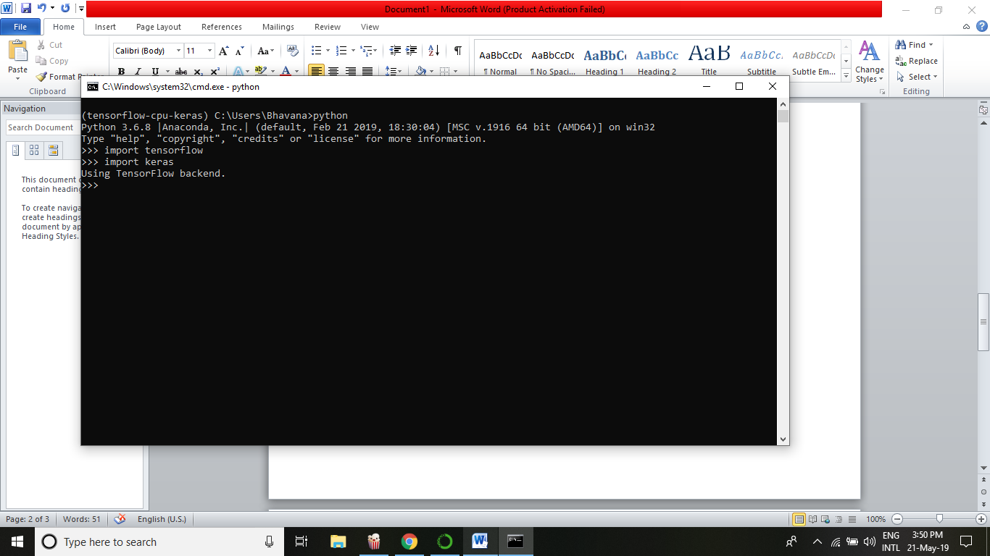

1. Launch python ide from the tensorflow_cpu_keras(new environment) channel

