SonarQube Report
Before:
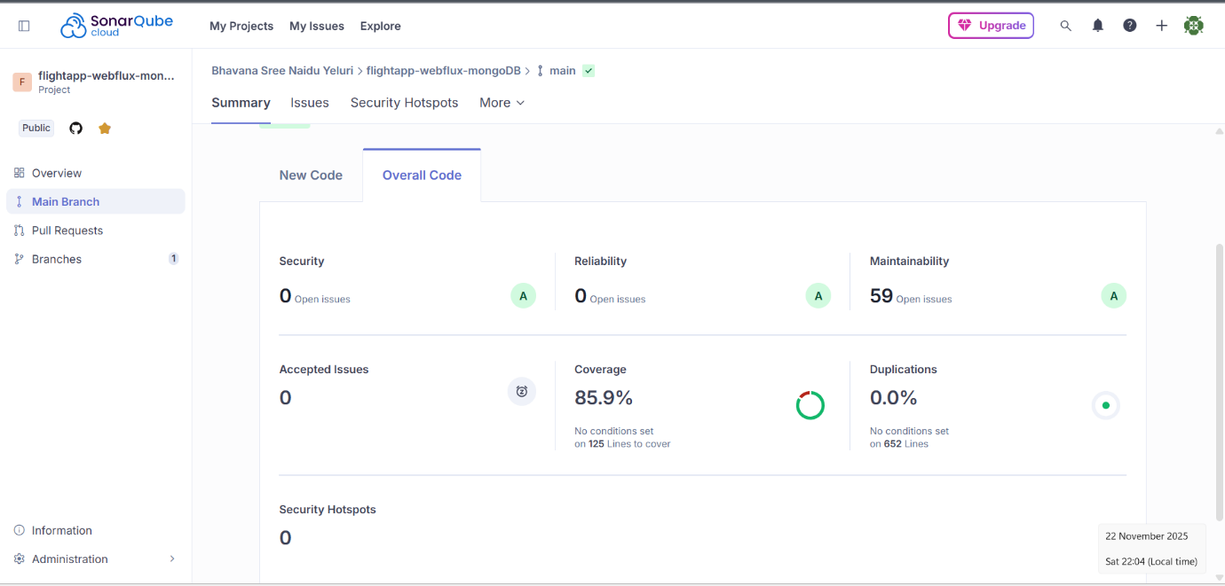
- 59 issues detected
- 85.9% coverage
After:
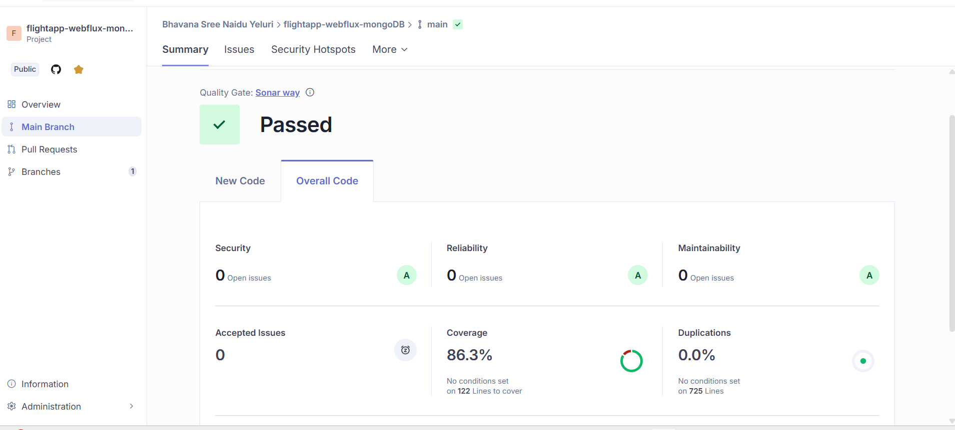
- 0 issues
- 86.3% test coverage

Jacoco Report:
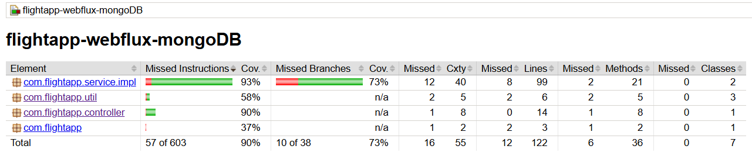
- 90% test coverage
Jmeter Screenshots:
Get history by email:
Summary Report:
20 requests:
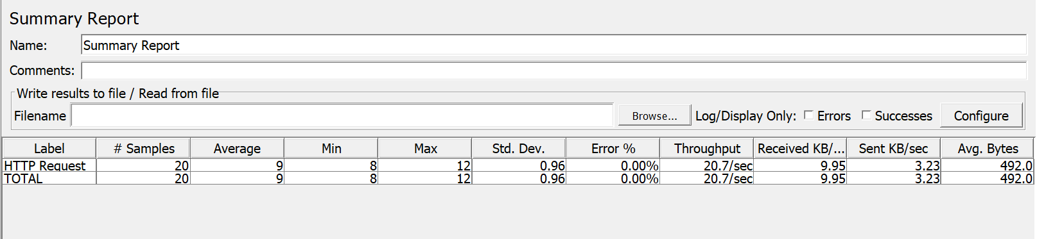
50 requests:
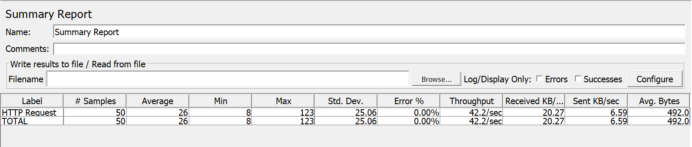
100 requests:
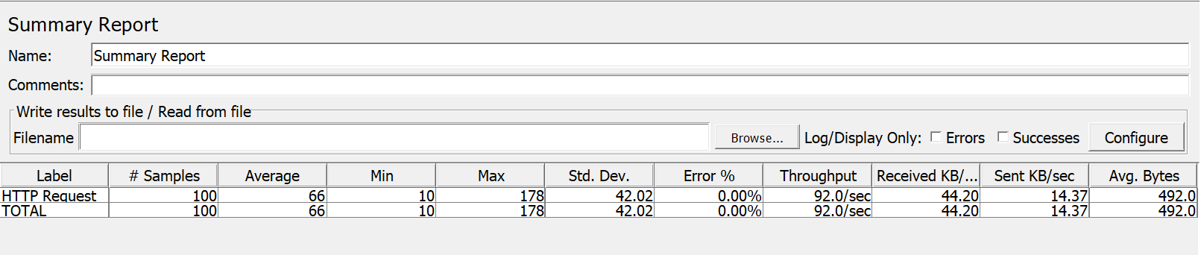

Results tree:
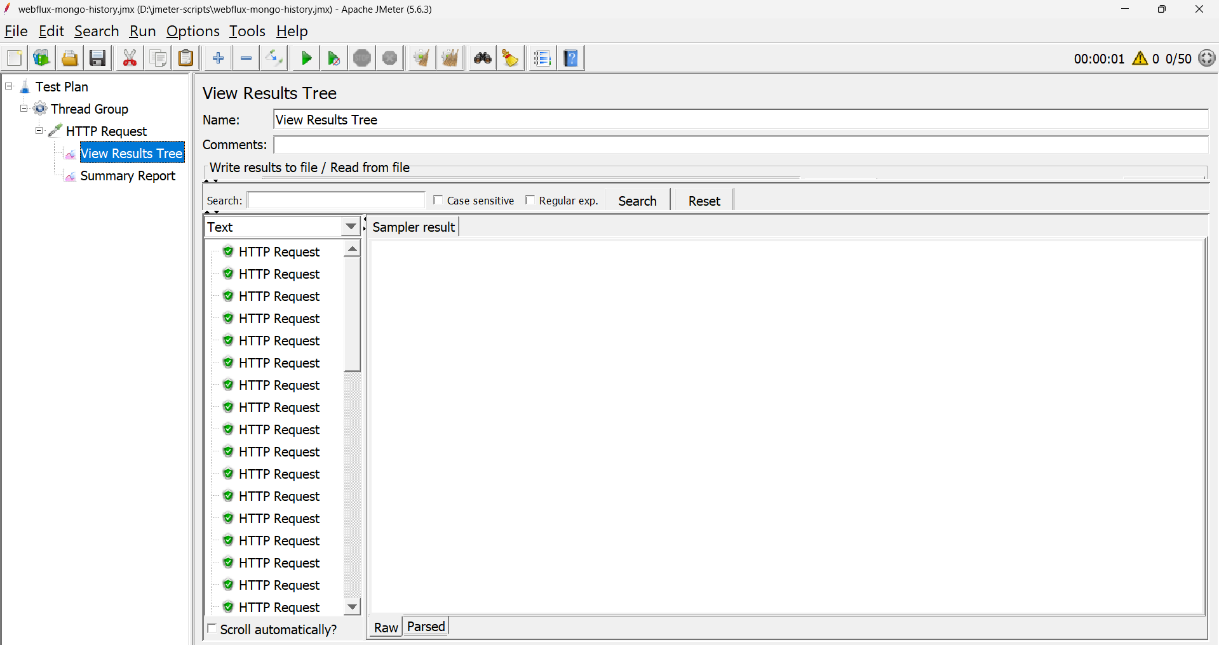
Get ticket by PNR:
Summary Report:
20 requests:
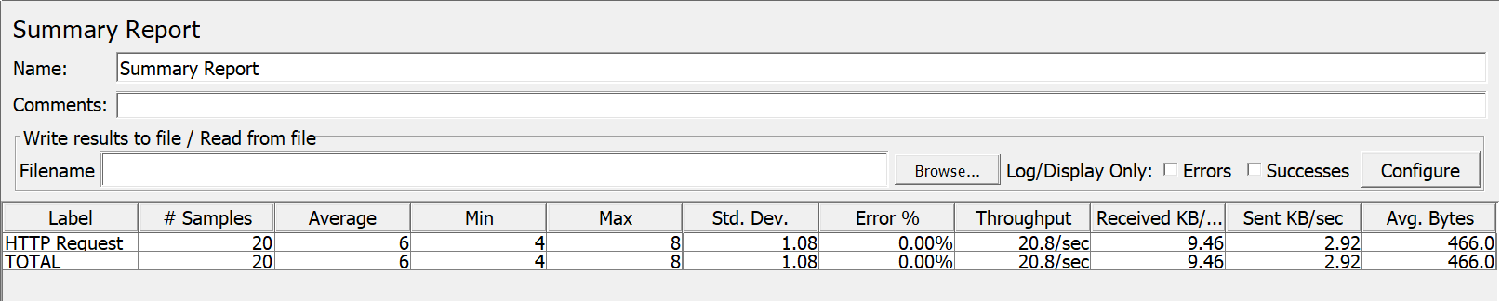
50 requests:
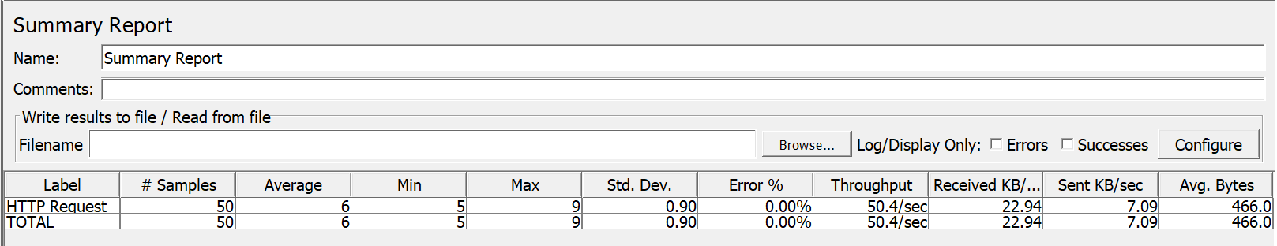
100 requests:
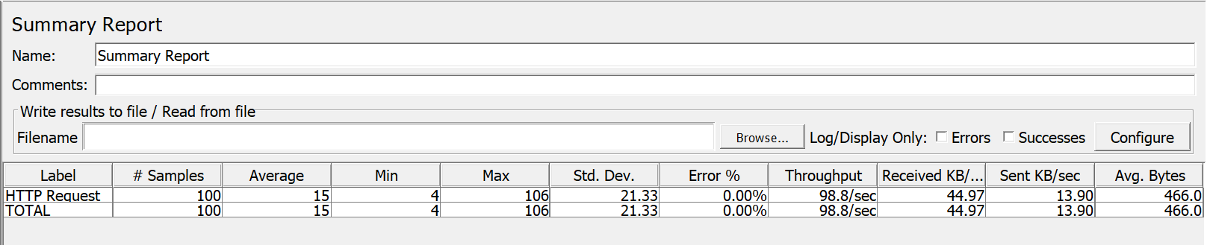
Results Tree:
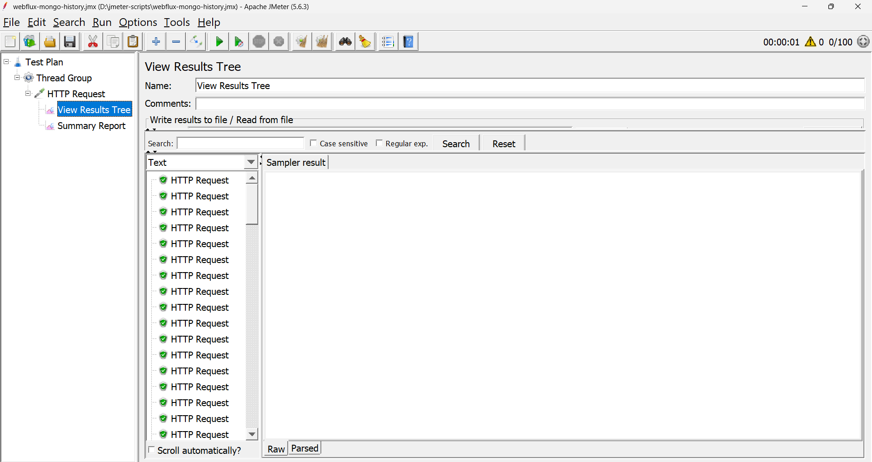
Book tickets:
Summary Report:
20 requests:
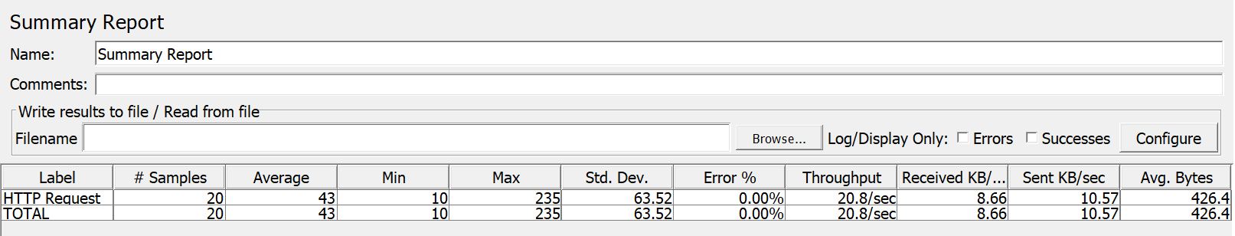
50 requests:
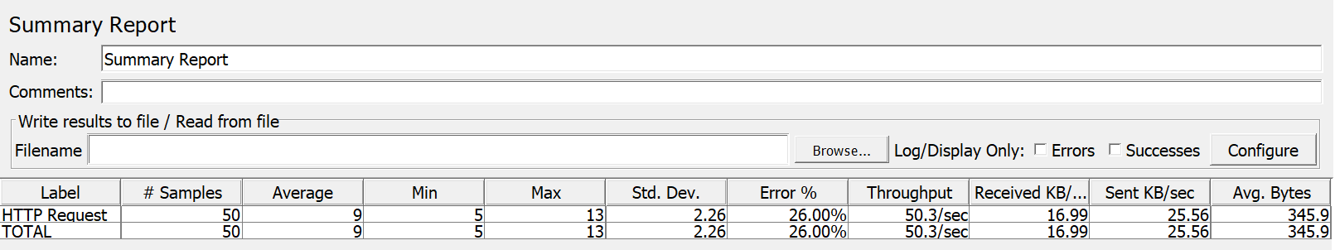
100 requests:
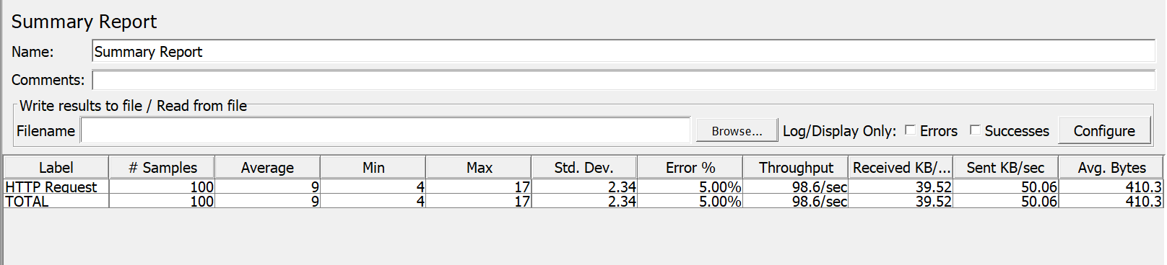
Results Tree:
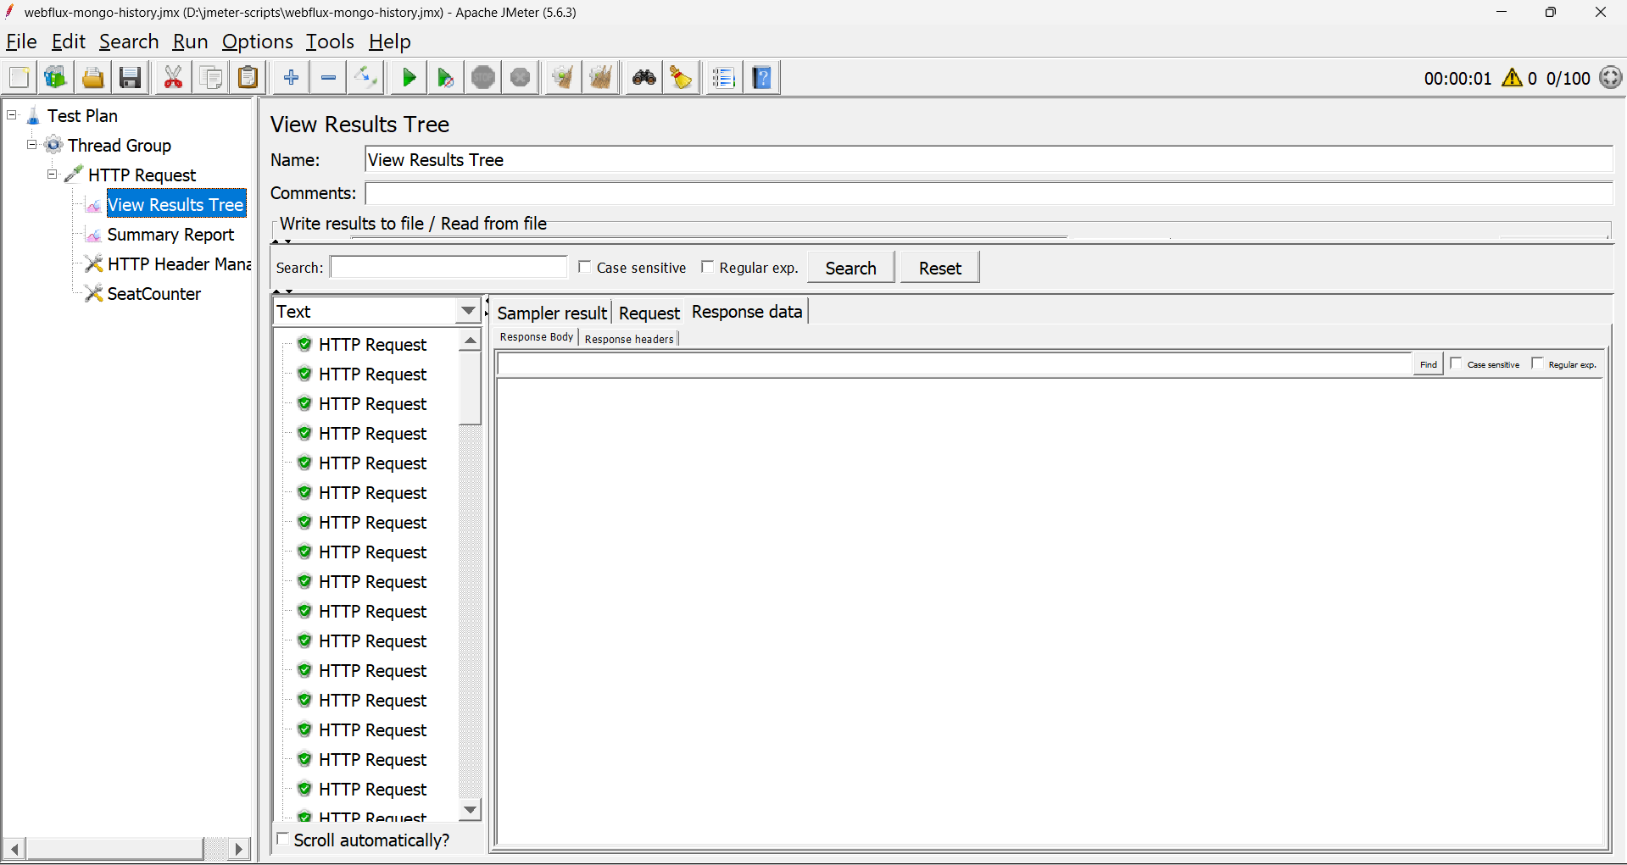
Seat Counter:
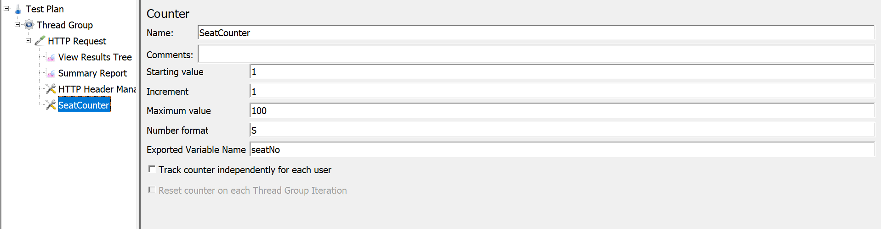
Header Manager:
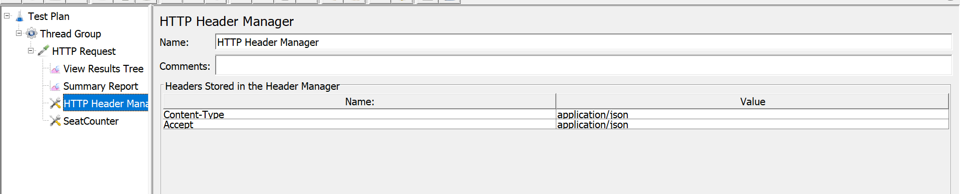

HTTP Request:
