ASSIGNMENT – 7
Report by Bhavana Sree Naidu Yeluri

Contents
- Project Overview
- System Architecture
- Eureka Dashboard
- Docker
- MongoDB Screenshots
- Postman Screenshots
- Email Notification
- Message Broker – RabbitMQ
- SonarQube
- Jacoco
- Jmeter
- Newman
- Swagger
- Config Server

Project Overview
- This project is a distributed microservices-based Flight Booking Platform built using Spring Boot, Spring Cloud, Docker, and MongoDB.
- The system handles flight search, user authentication, ticket booking, payments, and notifications in a scalable, fault-tolerant way.
System Architecture
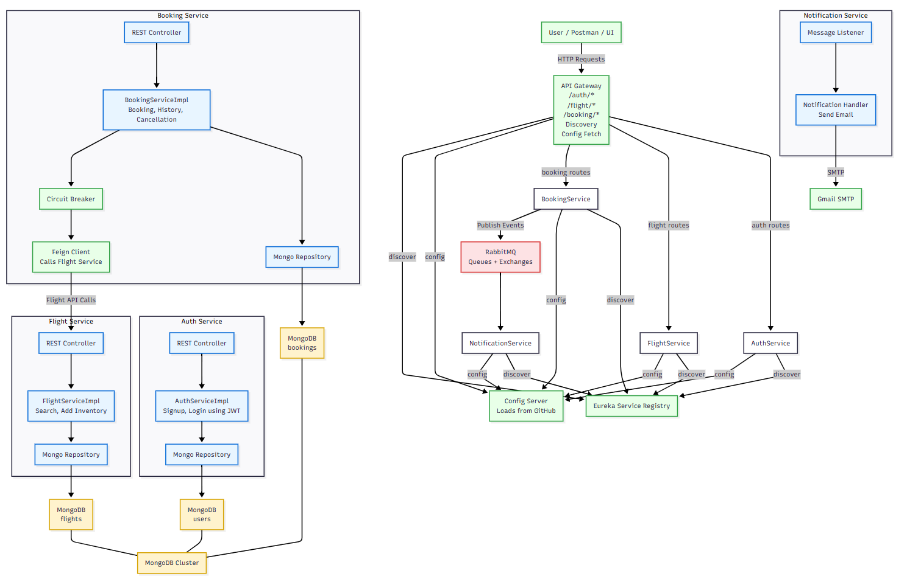

Eureka Dashboard
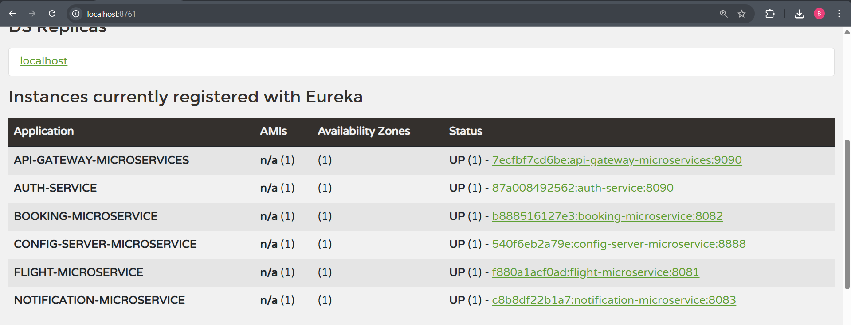
Docker
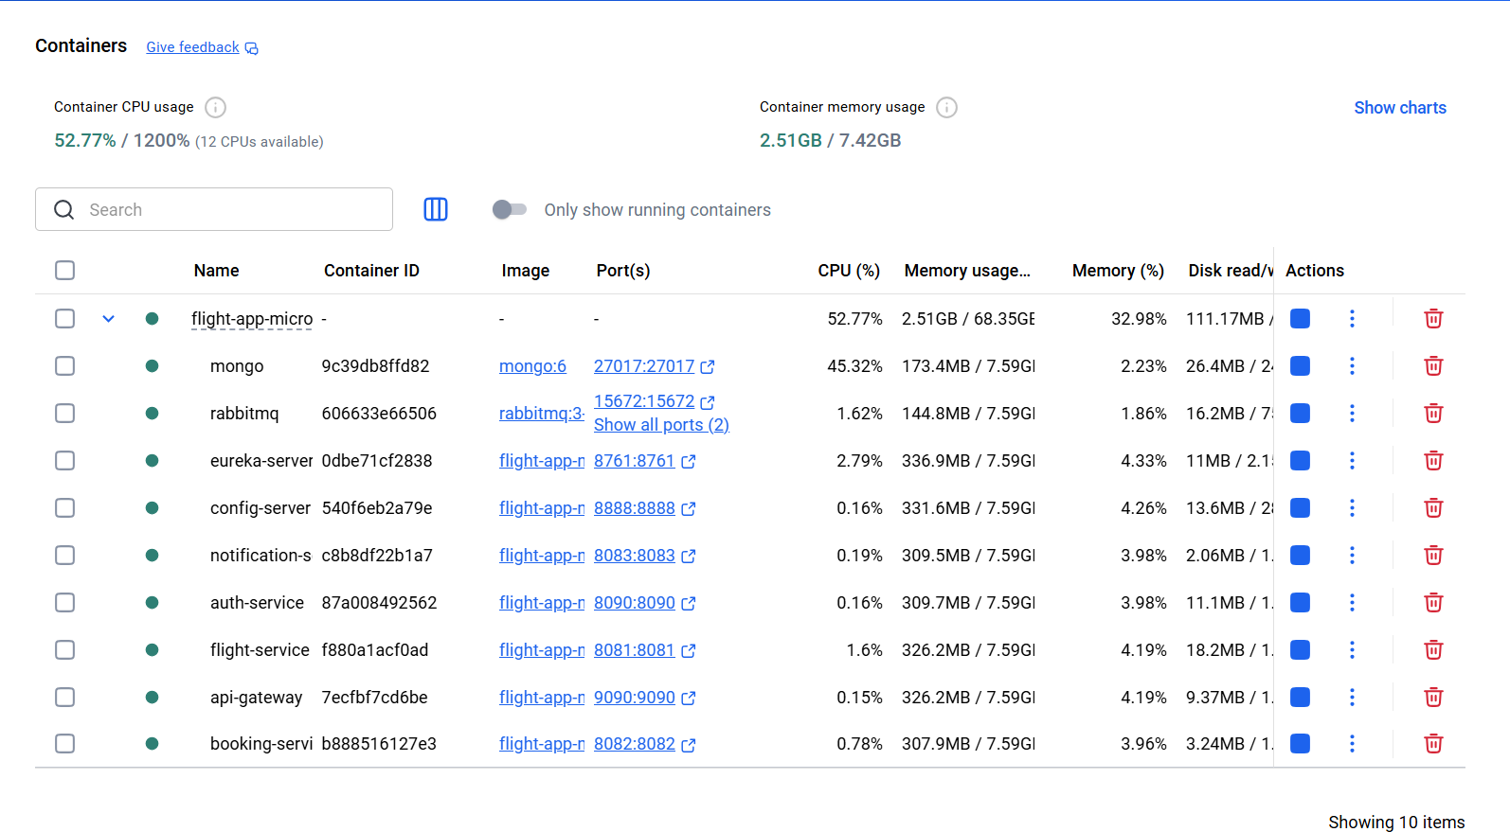
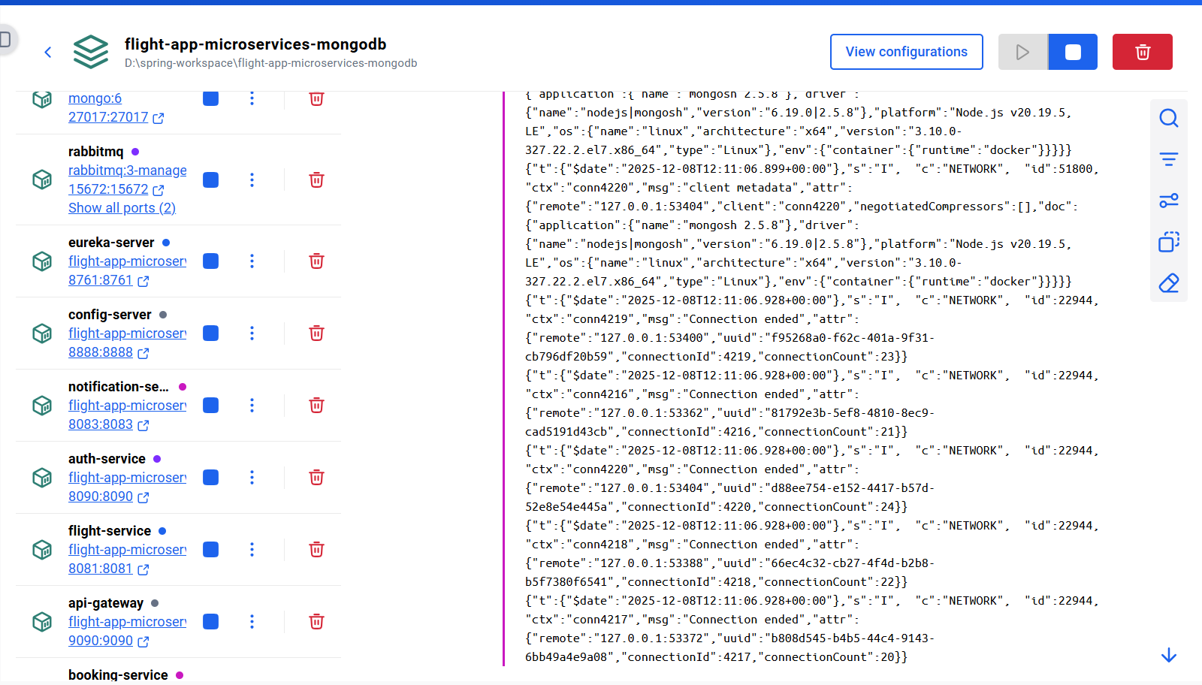

MongoDB Screenshots
- Roles in authdb
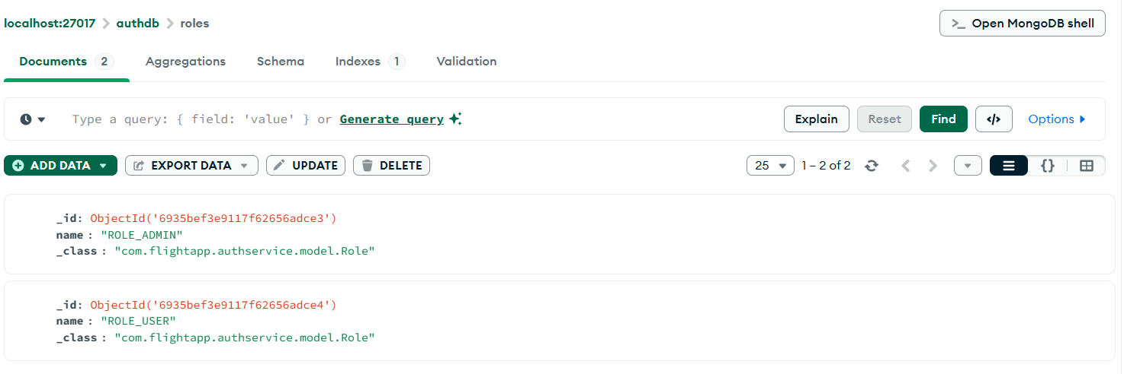
- Users in authdb
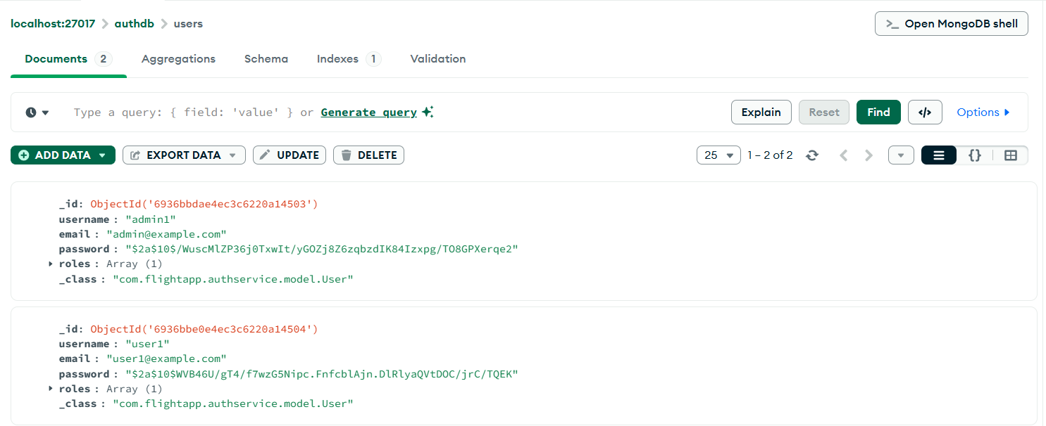
- Bookings in bookingdb
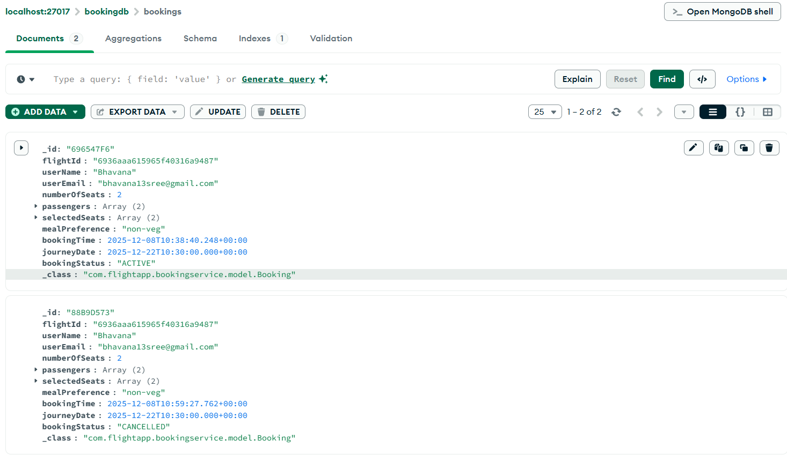
- Flights in flightdb
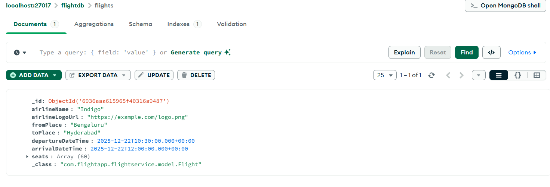
Postman Screenshots
- Admin signup
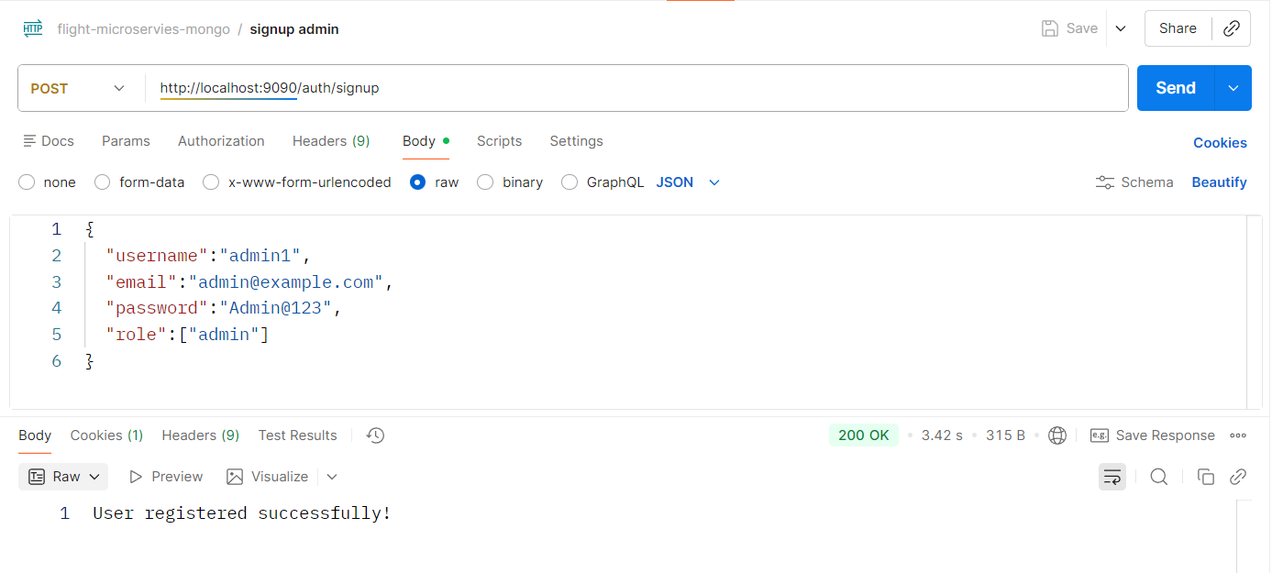
- Admin sign in
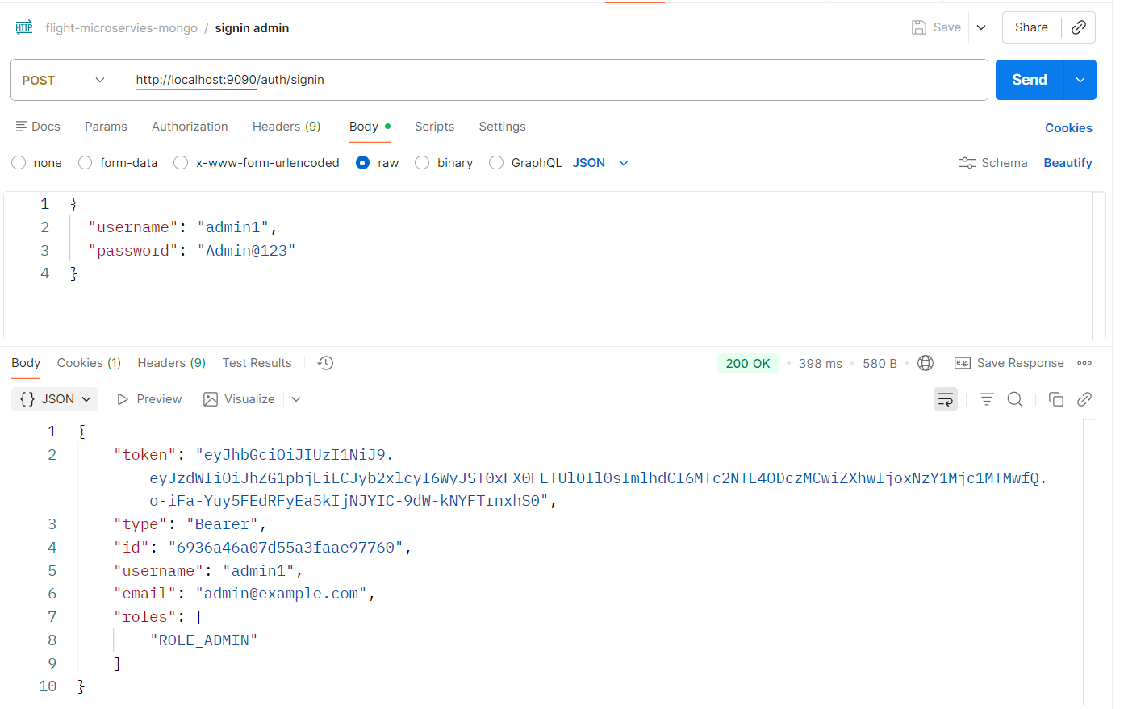
- Add Inventory – admin route
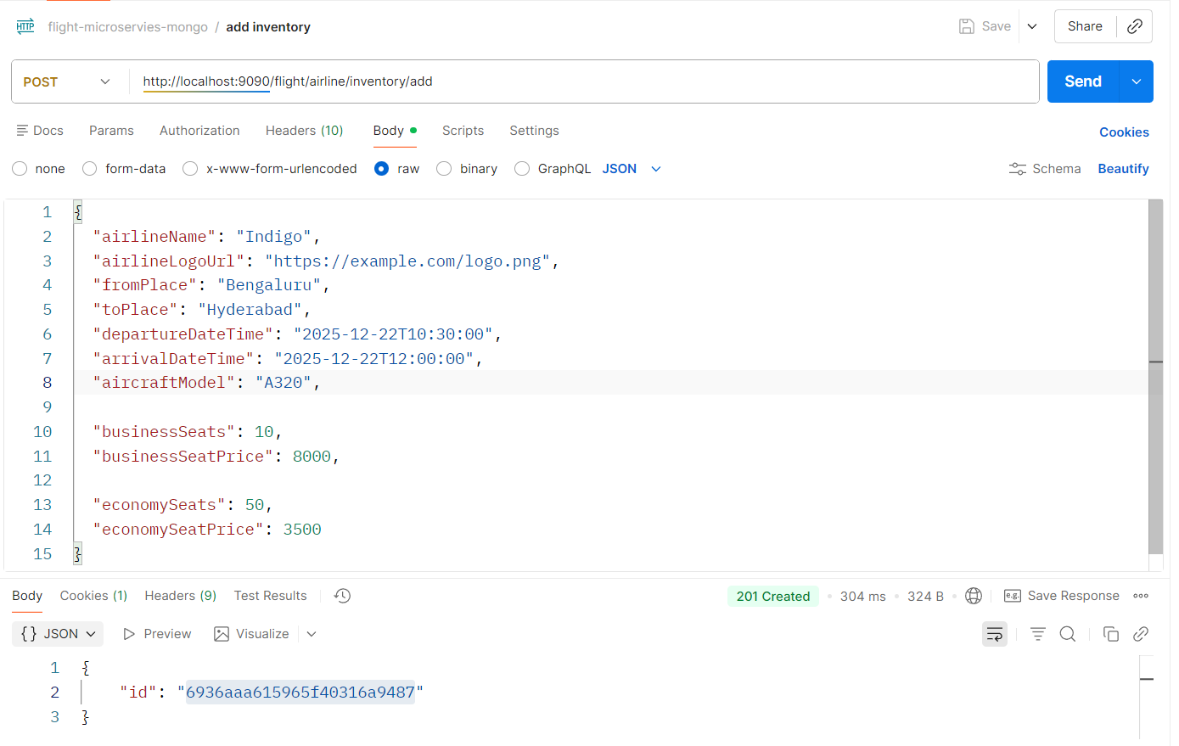
- User signup
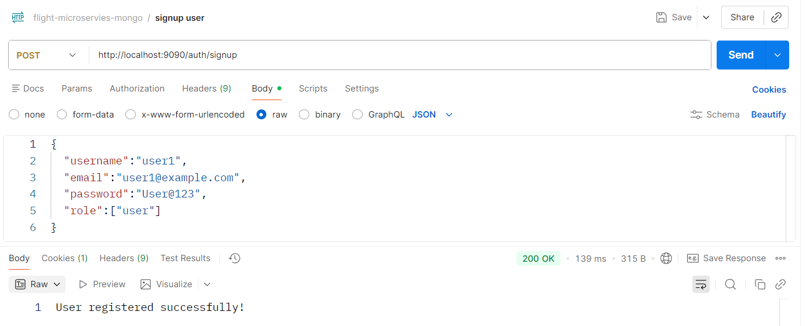

- User sign in
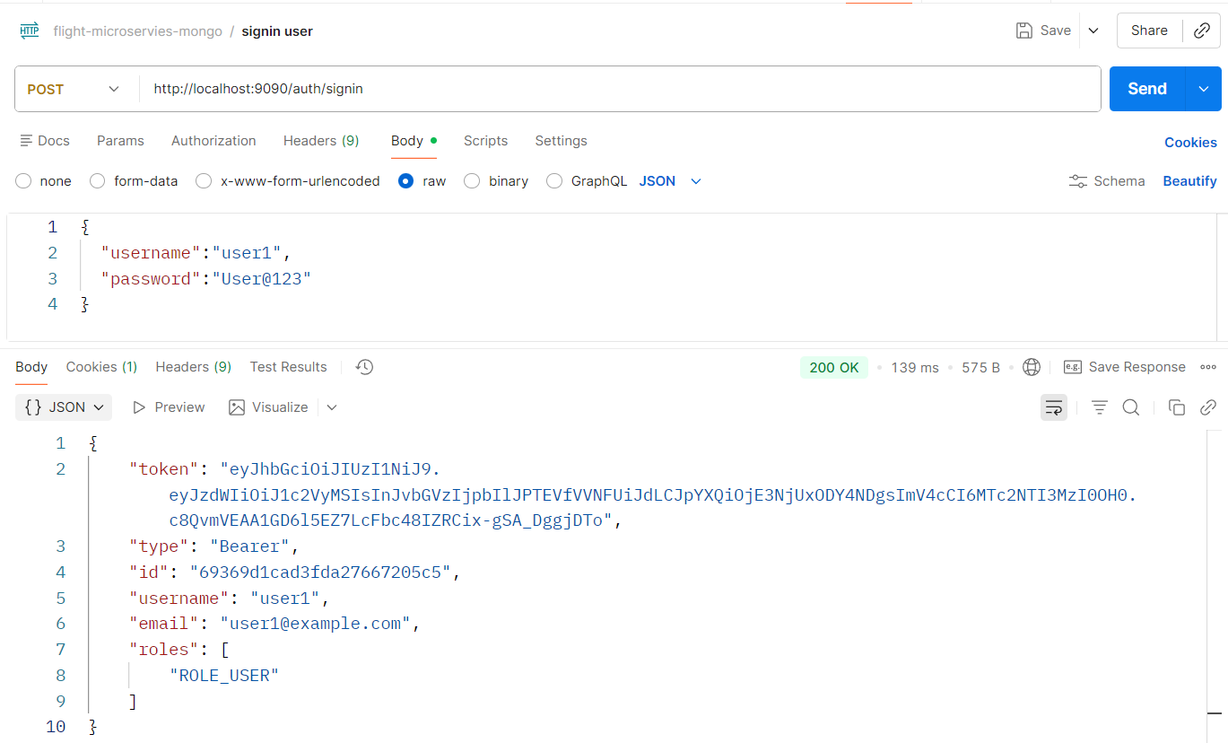
- Cancel ticket – user route
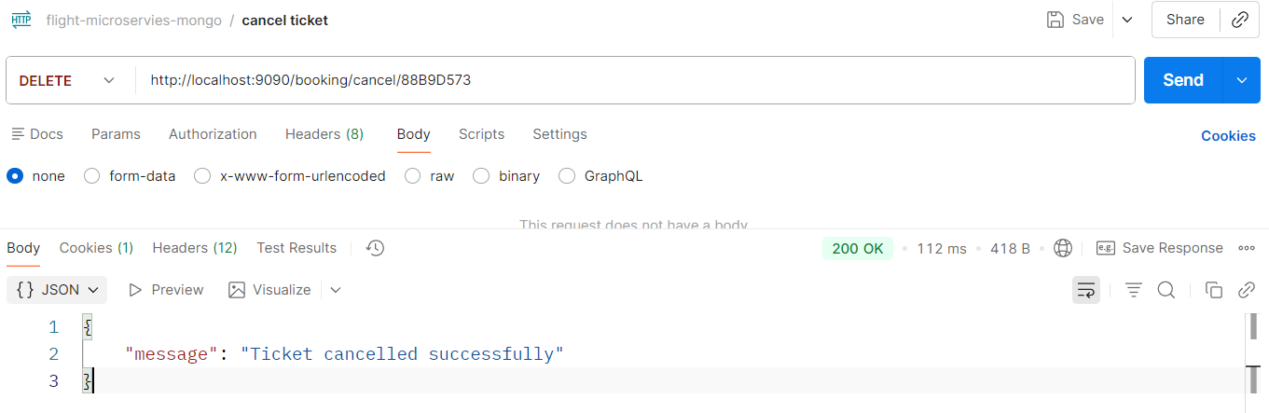
- Book flight – user route
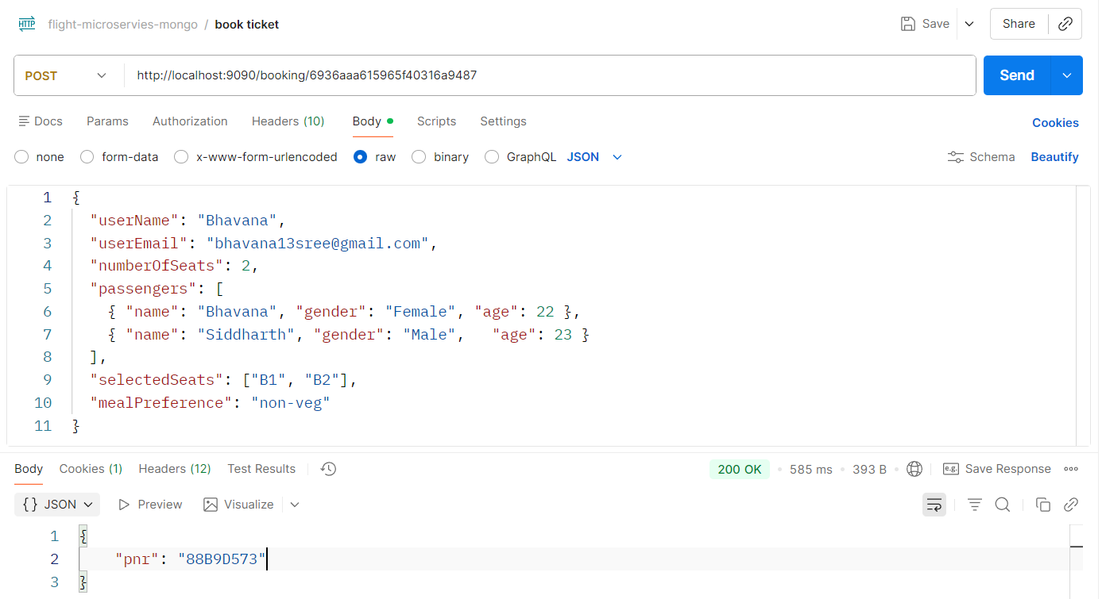
- Get history using email – user route
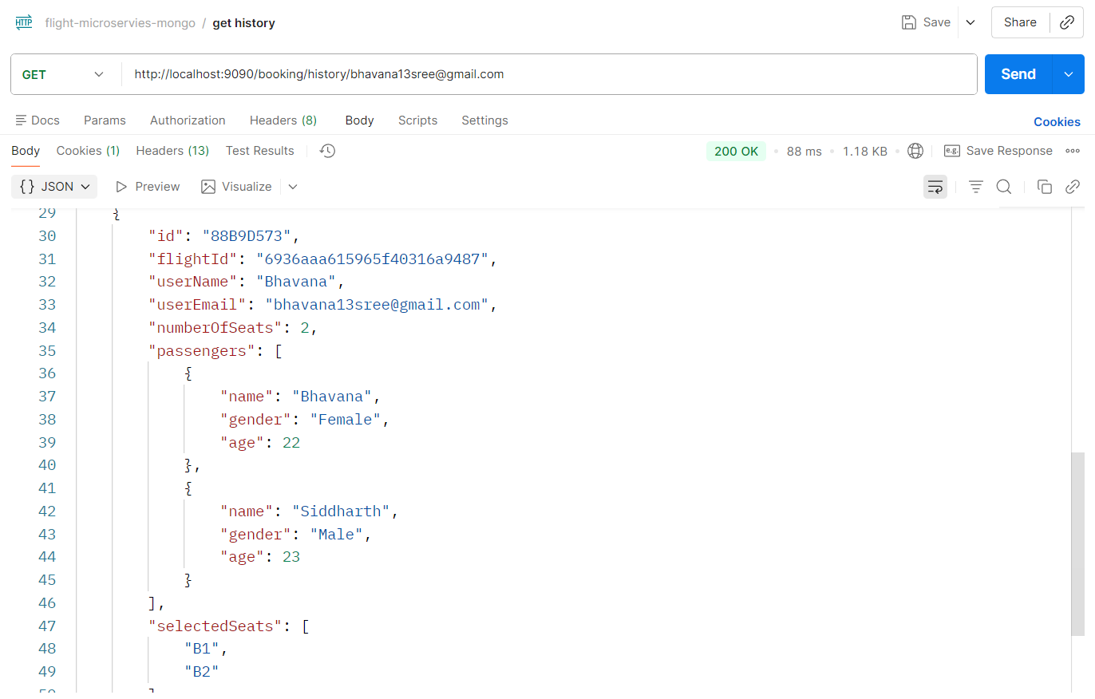
- Get ticket by PNR – user route
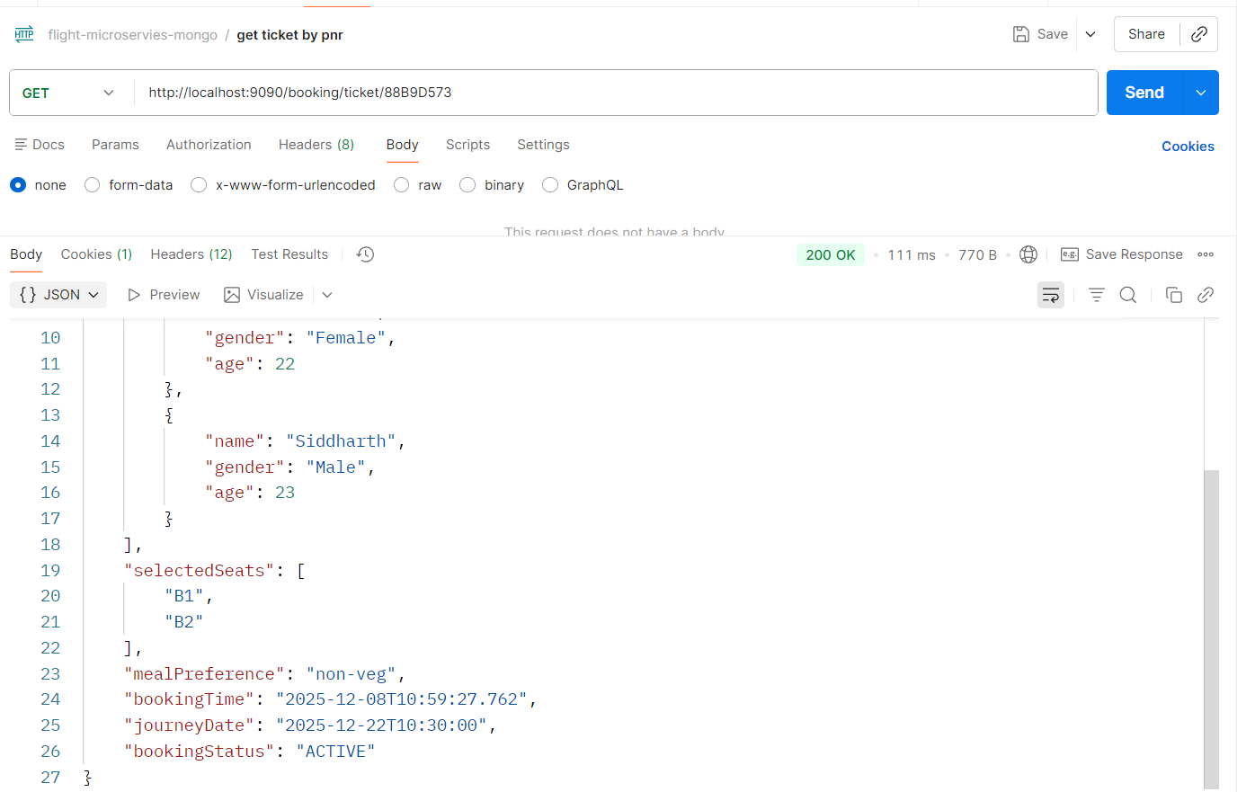

- Search Flight – user route
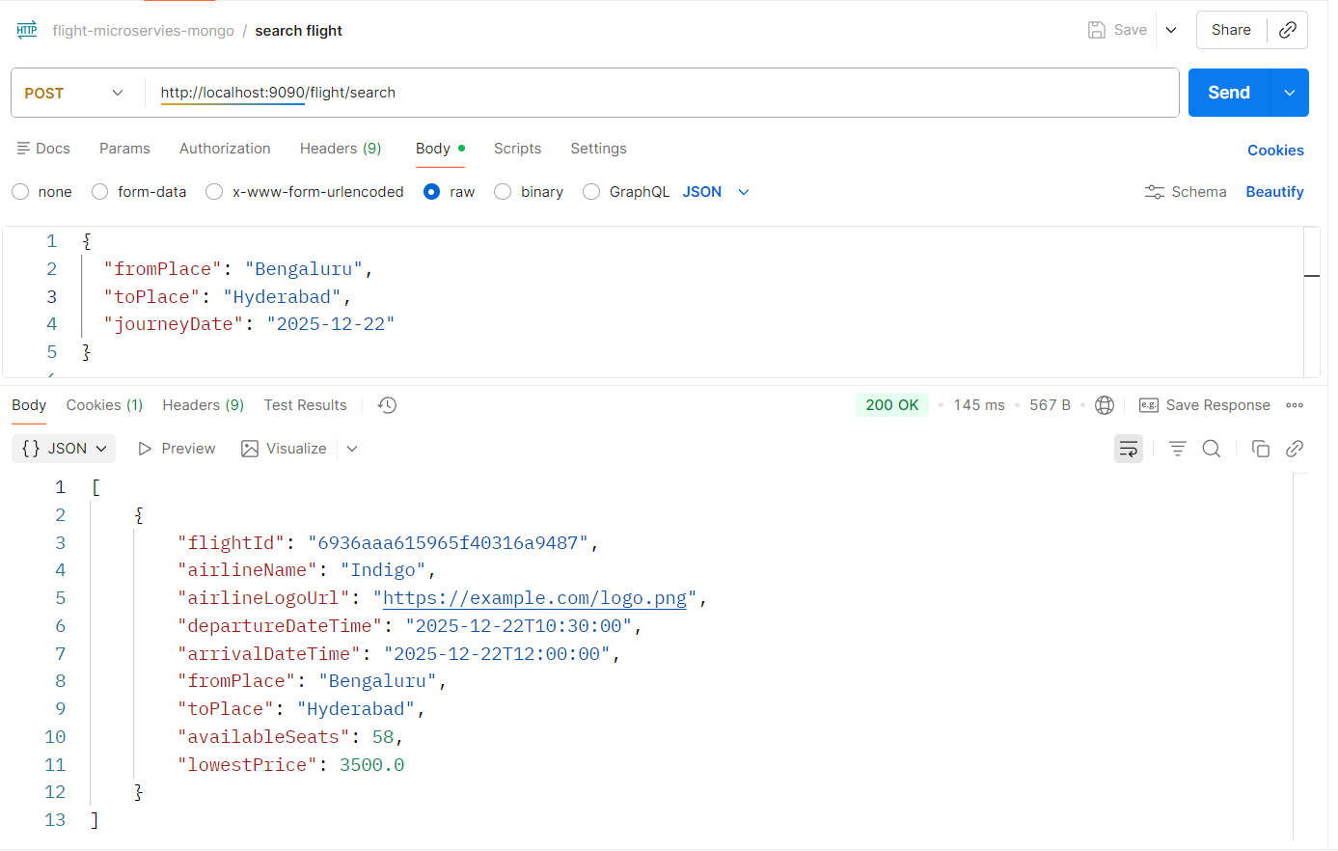
Email Notification
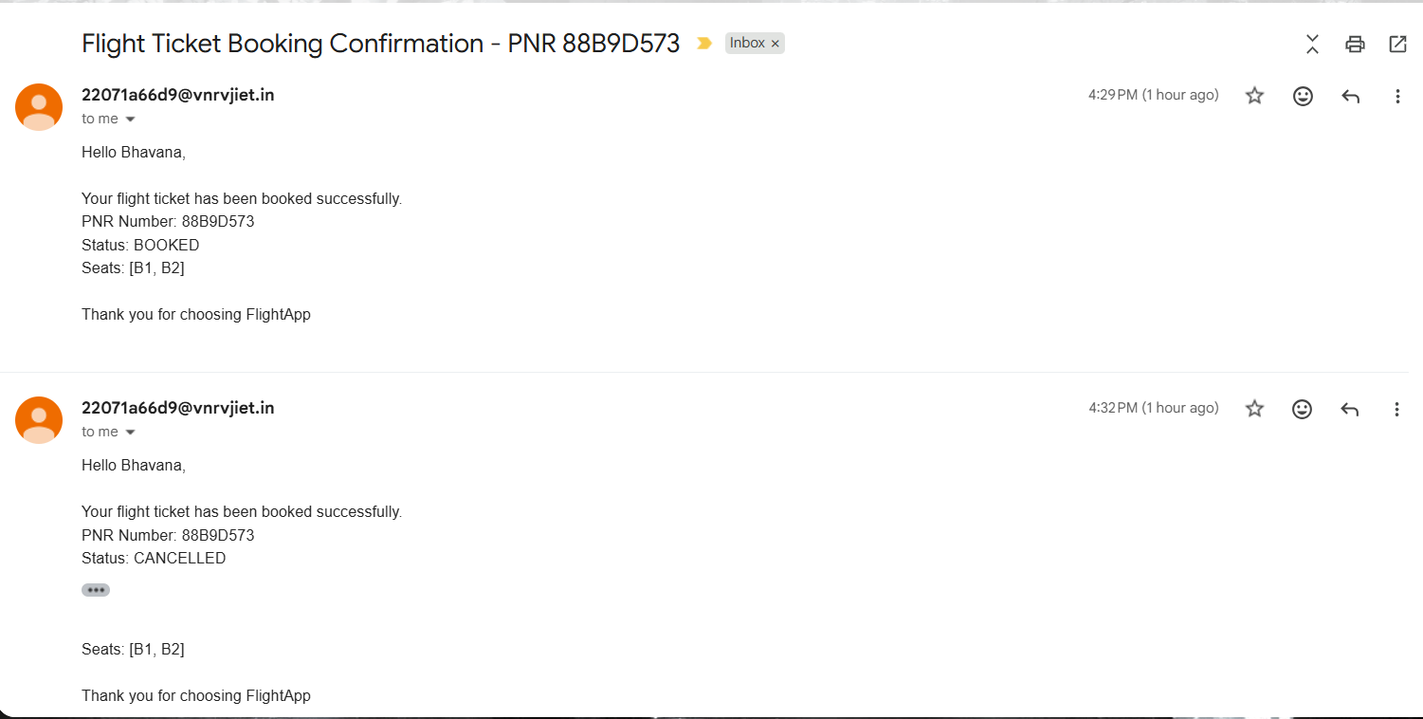

Message broker – RabbitMQ
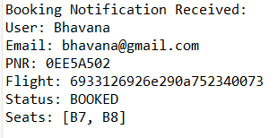
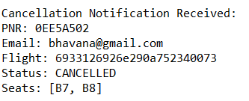
Sonarqube
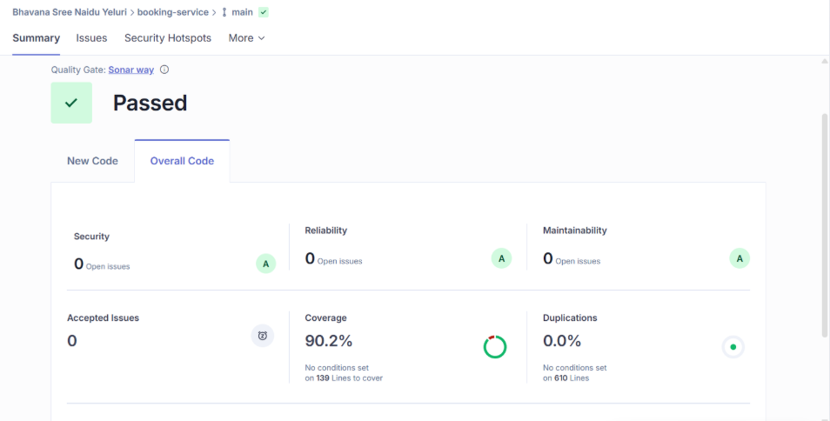
Jacoco
  - 95% coverage
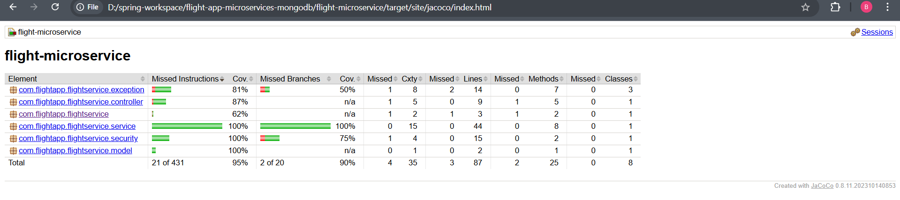

Jmeter
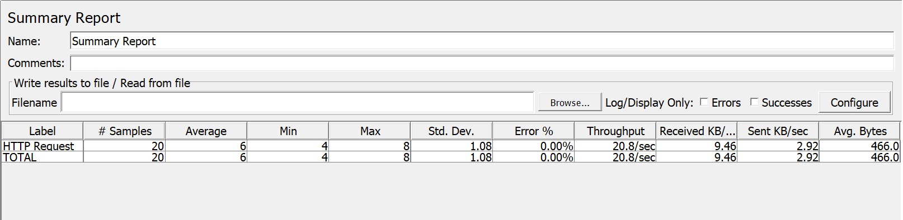
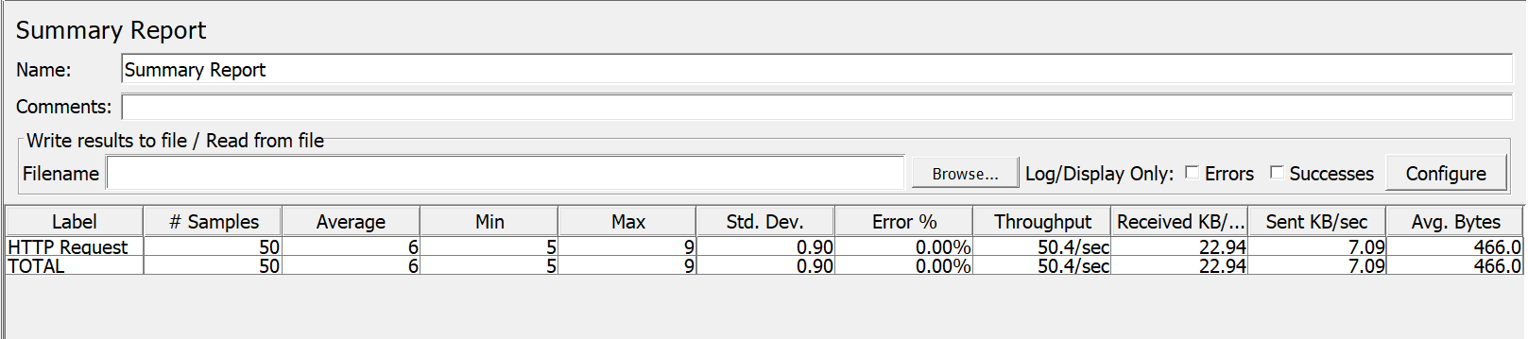
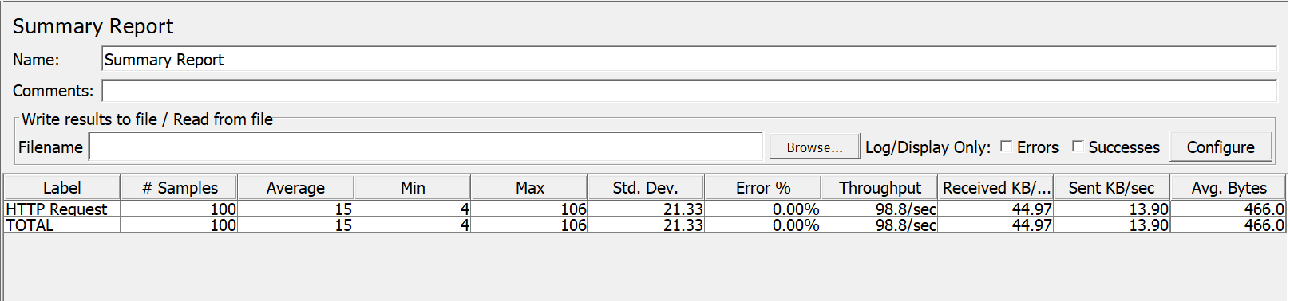
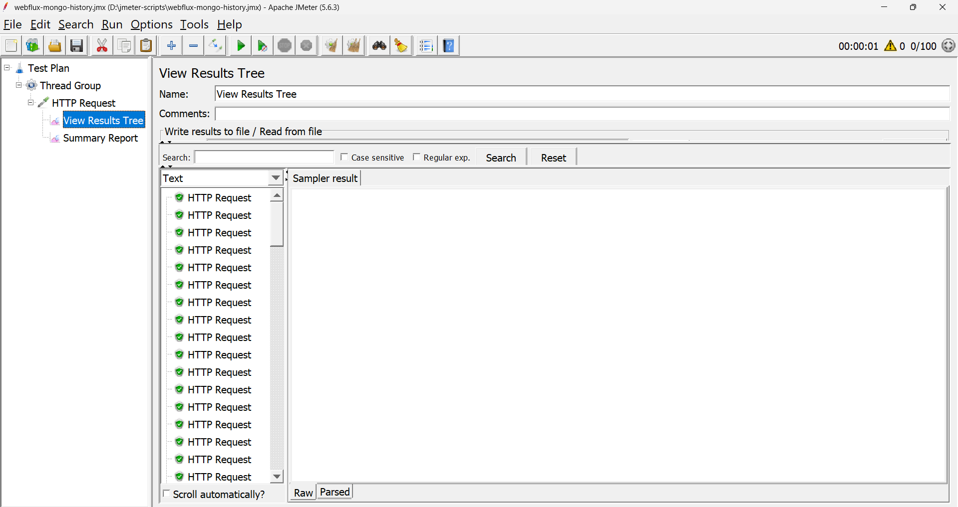

Newman
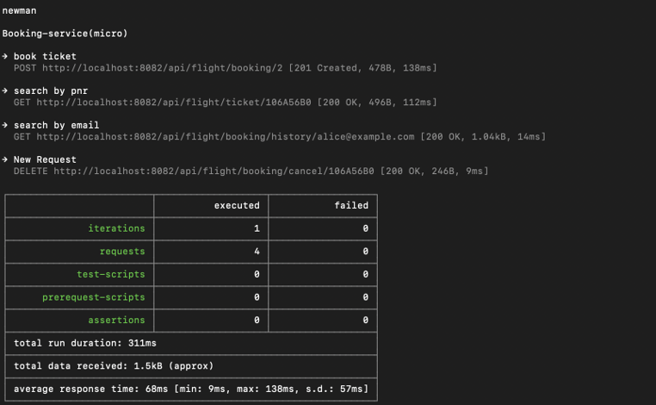
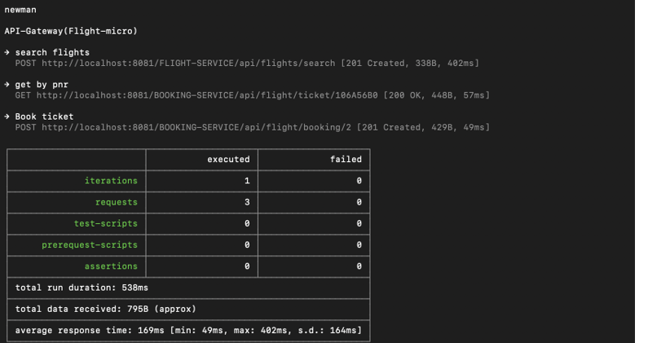

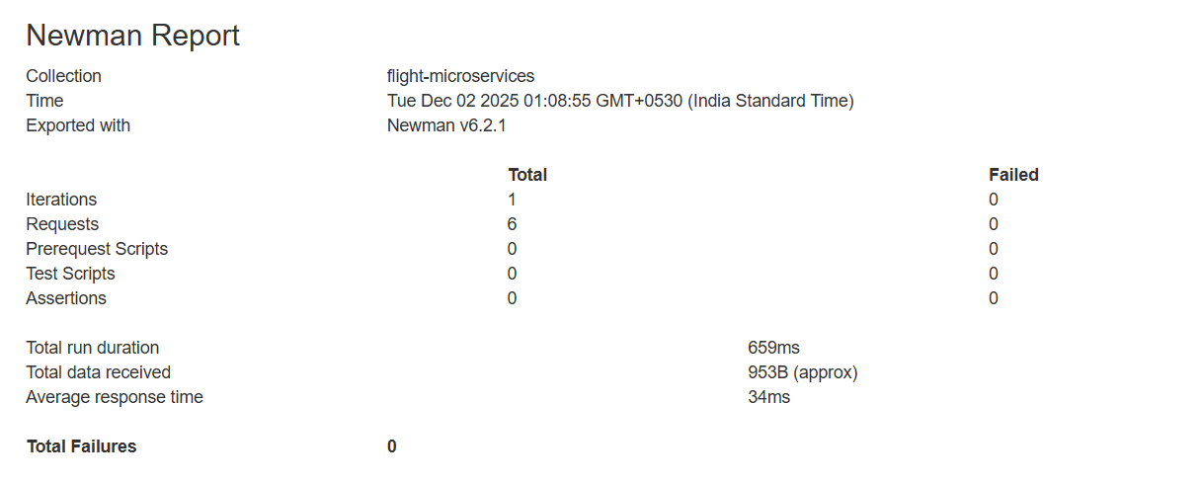
Swagger
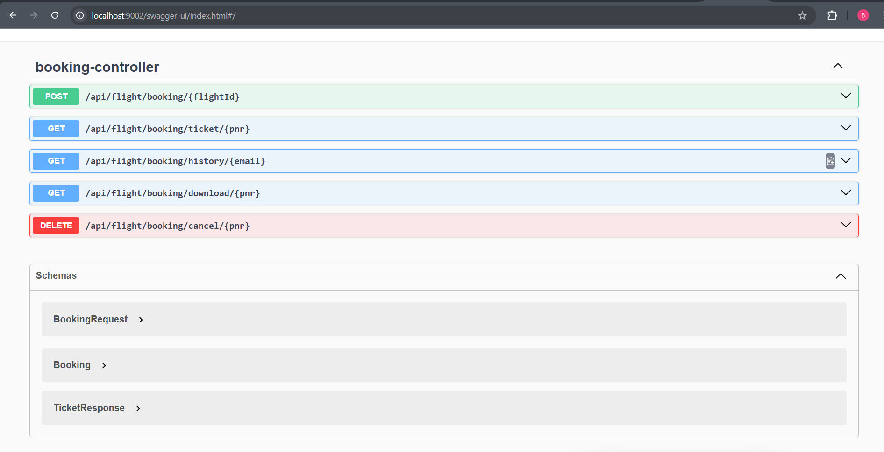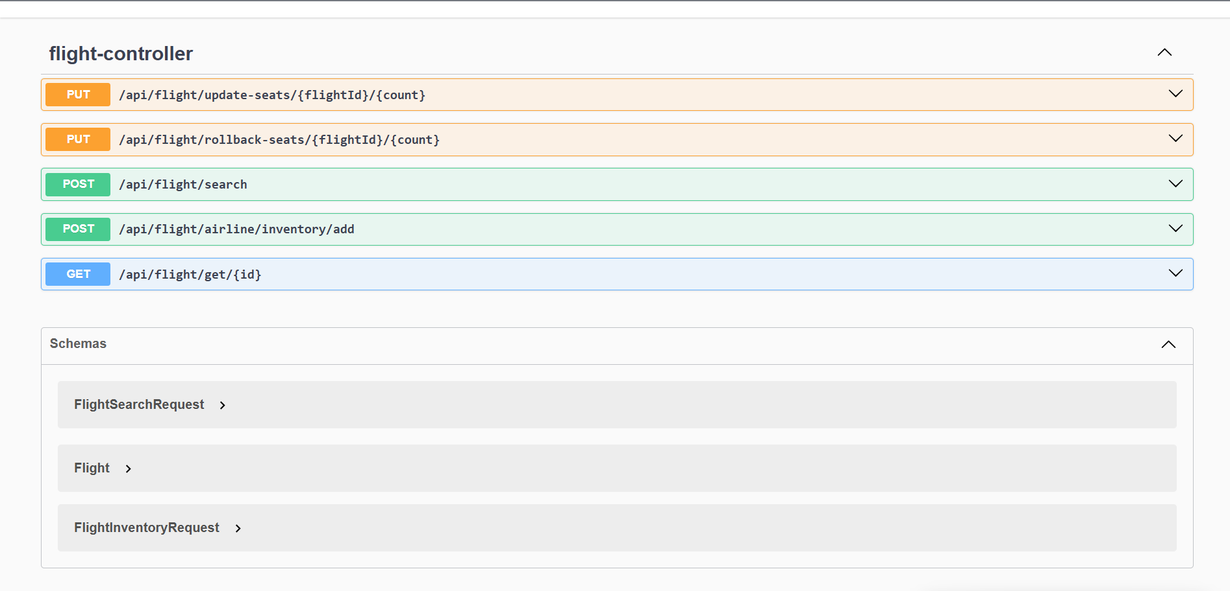

Config Server
