***ANUDIP FOUNDATION***

A Project Report on

**AIRLINE RESERVATION SYSTEM**

By

Batch : ANP-C7344

|  |  |
| --- | --- |
| **Student ID** | **Student Name** |
| AF0368265 | Pratiksha Shrishail Mhanta |
| AF0369864 | Bhavana Ballkrishna Bingi |

**Under the Guidence of**

Mrs. Rajshri Chandrabhan Thete

AIRLINE RESERVATION SYSTEM

Airline reservation systems (ARS) are systems that allow an airline to sell their inventory (seats). It contains information on schedules and fares and contains a database of reservations and of tickets issued. ARSs are part of passenger service system (PSS), which are applications supporting the direct contact with the passenger.

**Entities:**

* Ticket
* Booking
* User
* Enquiry
* Admin
* Payment
* Flight

**VARIOUS ENTITIES:**

* **Ticket :**
* **Attributes** :
* Ticket_id
* user_id (Foreign key)
* Flight_id
* Seat_number
* Ticket_status
* Ticket_price
* booking_date
* **Booking :**
* **Attributes :**
* booking_id
* booking_type
* booking_date
* user_id(Foreign key)
* **User :**
* **Attributes** :
* user_id
* user_name
* user_mobileno
* user_email_id
* user_address
* **Enquiry :**
* **Attributes:**
* enquiry_id
* enquiry_title
* enquiry_type
* enquiry_date
* user_id(Foreign key)
* **Admin :**
* **Attributes:**
* Admin_id
* Admin_username
* Admin_password
* Admin_email
* Admin_full_name
* **Payment :**
* **Attributes :**
* Payment_id
* booking_id
* Payment_date
* Payment_amount
* Payment_status
* **Flight :**
* **Attributes :**
* Flight_id
* Flight_number
* Departure_airport
* Destination_airport
* Departure_datetime
* Arrival_datetime
* Total_seats
* Available_seats
* Ticket_price

**ER Diagram of Airline Reser vation System**

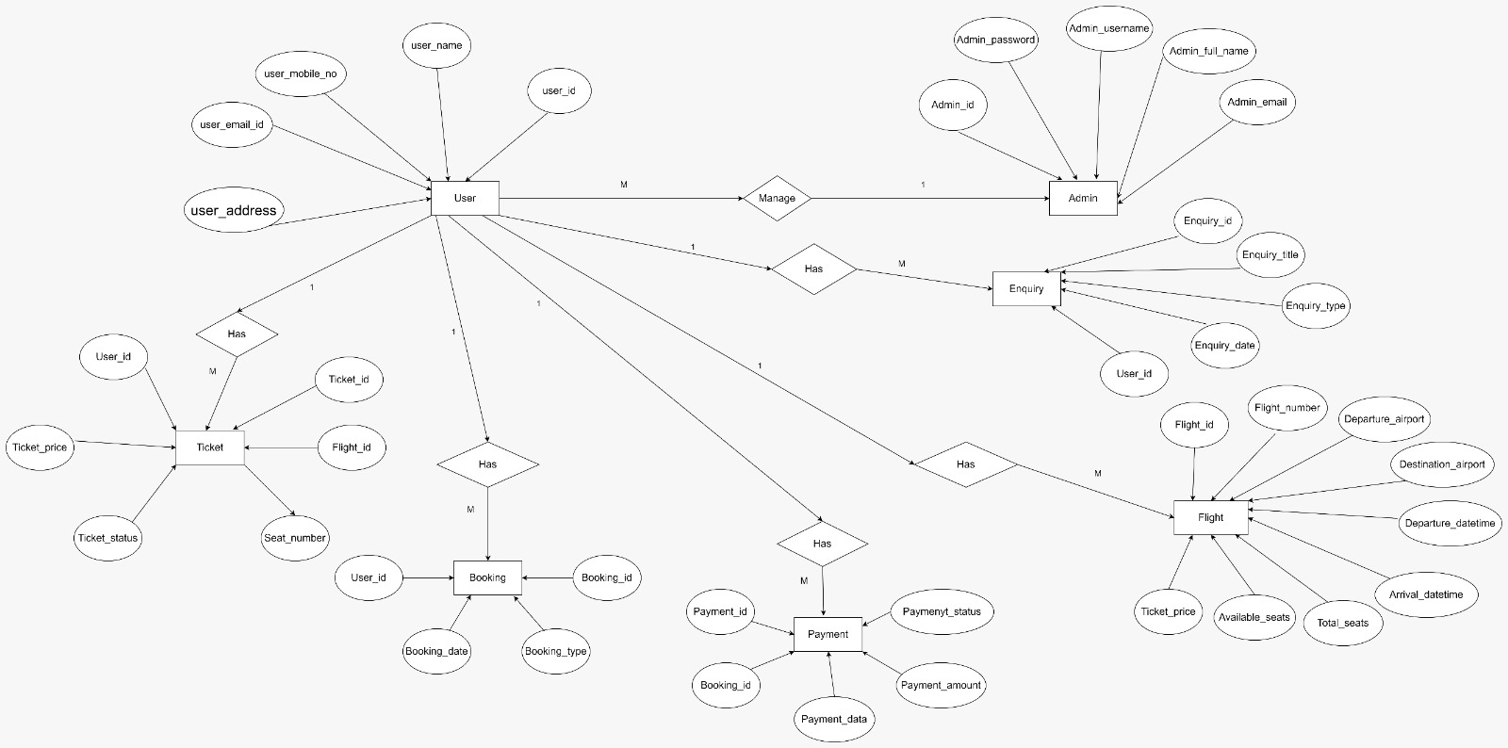

**CLASS DIAGRAM FOR AIRLINE RESERVATION SYSTEM:**

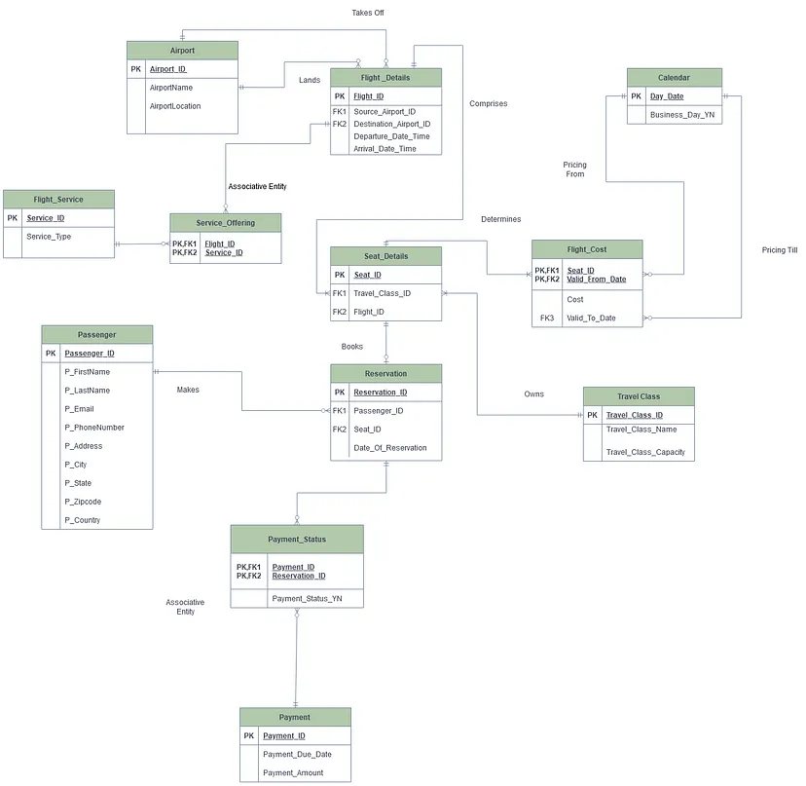

**CONCLUSION:**

Airline reservation systems are essential tools that have revolutionized the way air travel is planned and enforced. You need to know how the Airline reservation System was designed and built using diagrams. With the help of an ER diagram will help you make a system that works well. They offer a convenient and efficient way for customers to search, select, and reserve flights while providing administrators with the control they need to manage flight schedules, pricing, and user data.

