**Exercise 1: Implementing the Singleton Pattern**

1. **Implement the Singleton Pattern:**

public class Logger {

private static Logger instance;

private Logger() {

System.out.println("Logger initialized.");

}

// Public method to provide access to the single instance

public static Logger getInstance() {

if (instance == null) {

instance = new Logger(); // Lazy initialization

}

return instance;

}

public void log(String message) {

System.out.println("[LOG]: " + message);

}

}

1. **Test the Singleton Implementation**

public class Main {

public static void main(String[] args) {

// Get the singleton instance

Logger logger1 = Logger.getInstance();

logger1.log("Application started.");

// Get the instance again

Logger logger2 = Logger.getInstance();

logger2.log("Another operation performed.");

// Verify both references point to the same object

if (logger1 == logger2) {

System.out.println("Both logger instances are the same. Singleton confirmed.");

} else {

System.out.println("Different instances! Singleton failed.");

}

}

}

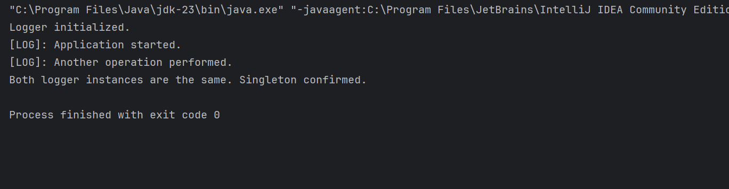

**Exercise 2: Implementing the Factory Method Pattern**

public class FactoryMethodPatternExample {  
  
 // Document interface  
 interface Document {  
 void open();  
 }  
  
 // Concrete implementations  
 static class WordDocument implements Document {  
 public void open() {  
 System.*out*.println("Opening Word document...");  
 }  
 }  
  
 static class PdfDocument implements Document {  
 public void open() {  
 System.*out*.println("Opening PDF document...");  
 }  
 }  
  
 static class ExcelDocument implements Document {  
 public void open() {  
 System.*out*.println("Opening Excel document...");  
 }  
 }  
  
 // Abstract Factory  
 abstract static class DocumentFactory {  
 public abstract Document createDocument();  
 }  
  
 // Concrete Factories  
 static class WordDocumentFactory extends DocumentFactory {  
 public Document createDocument() {  
 return new WordDocument();  
 }  
 }  
  
 static class PdfDocumentFactory extends DocumentFactory {  
 public Document createDocument() {  
 return new PdfDocument();  
 }  
 }  
  
 static class ExcelDocumentFactory extends DocumentFactory {  
 public Document createDocument() {  
 return new ExcelDocument();  
 }  
 }  
  
 // Main method to test the factory  
 public static void main(String[] args) {  
 DocumentFactory wordFactory = new WordDocumentFactory();  
 Document wordDoc = wordFactory.createDocument();  
 wordDoc.open();  
  
 DocumentFactory pdfFactory = new PdfDocumentFactory();  
 Document pdfDoc = pdfFactory.createDocument();  
 pdfDoc.open();  
  
 DocumentFactory excelFactory = new ExcelDocumentFactory();  
 Document excelDoc = excelFactory.createDocument();  
 excelDoc.open();  
 }  
}

