 

**Placement Empowerment Program**

***Cloud Computing and DevOps Centre***

Set Up a Cloud-Based Monitoring Service Enable basic cloud monitoring (e.g., Cloud Watch on AWS). View metrics like CPU usage and disk I/O for your cloud VM.

Name: Bhavana Vijayan Department: IT



**Introduction**

In cloud computing, effective monitoring is crucial for ensuring the performance, reliability, and availability of cloud resources. **AWS CloudWatch** provides a comprehensive monitoring solution for AWS resources, enabling users to track various metrics in real-time. This Proof of Concept (PoC) focuses on leveraging **CloudWatch** to monitor the performance of an EC2 instance by enabling basic monitoring for key metrics such as **CPU utilization** and **disk I/O**. This PoC demonstrates how to enable, view, and analyze these metrics, giving insights into the health and performance of cloud-based virtual machines.

**Overview:**

This PoC will walk through the process of setting up **AWS CloudWatch** to monitor an EC2 instance. The main steps include:

1. Enabling basic cloud monitoring for an EC2 instance.

2. Viewing key metrics such as **CPU utilization** and **disk read/write operations**, to assess the performance of the instance.

3. Exploring how CloudWatch provides real-time insights into the instance’s resource usage, allowing administrators to identify performance bottlenecks or issues before they affect the service.

By completing this PoC, users will understand how to integrate CloudWatch monitoring for EC2 instances, enabling effective performance monitoring of virtual machines in the cloud.

**Objective:**

The primary objective of this PoC is to enable **basic cloud monitoring** using **AWS CloudWatch** and view essential metrics for an EC2 instance. Specific goals include:

**Enabling CloudWatch monitoring** for an EC2 instance.

**Viewing CPU usage** and **disk I/O** metrics to analyze the instance's performance.

Understanding how CloudWatch helps in real-time monitoring by providing visibility into cloud resource health.

**Importance of this PoC:**

**1. Performance Monitoring**: By tracking **CPU usage**, **disk I/O**, and **network traffic**, CloudWatch provides crucial insights into the resource utilization of an EC2 instance, which helps in identifying and troubleshooting performance issues.

**2. Real-time Visibility**: Enabling CloudWatch monitoring ensures that administrators have access to real-time data about the instance's performance. This allows quick reactions to changes in resource consumption, preventing downtime or service degradation.

**3. Resource Management**: Understanding the resource consumption of the EC2 instance (such as CPU usage and disk I/O) helps in optimizing the instance’s capacity and managing resources efficiently, which can also lead to cost savings.

**4. Proactive Issue Detection**: CloudWatch allows the user to monitor and understand patterns in the system’s resource usage, helping detect performance anomalies or bottlenecks before they impact the system.

**Step-by-Step Overview**

Step 1:

1. Go to AWS Management Console.

2. Enter your username and password to log in.

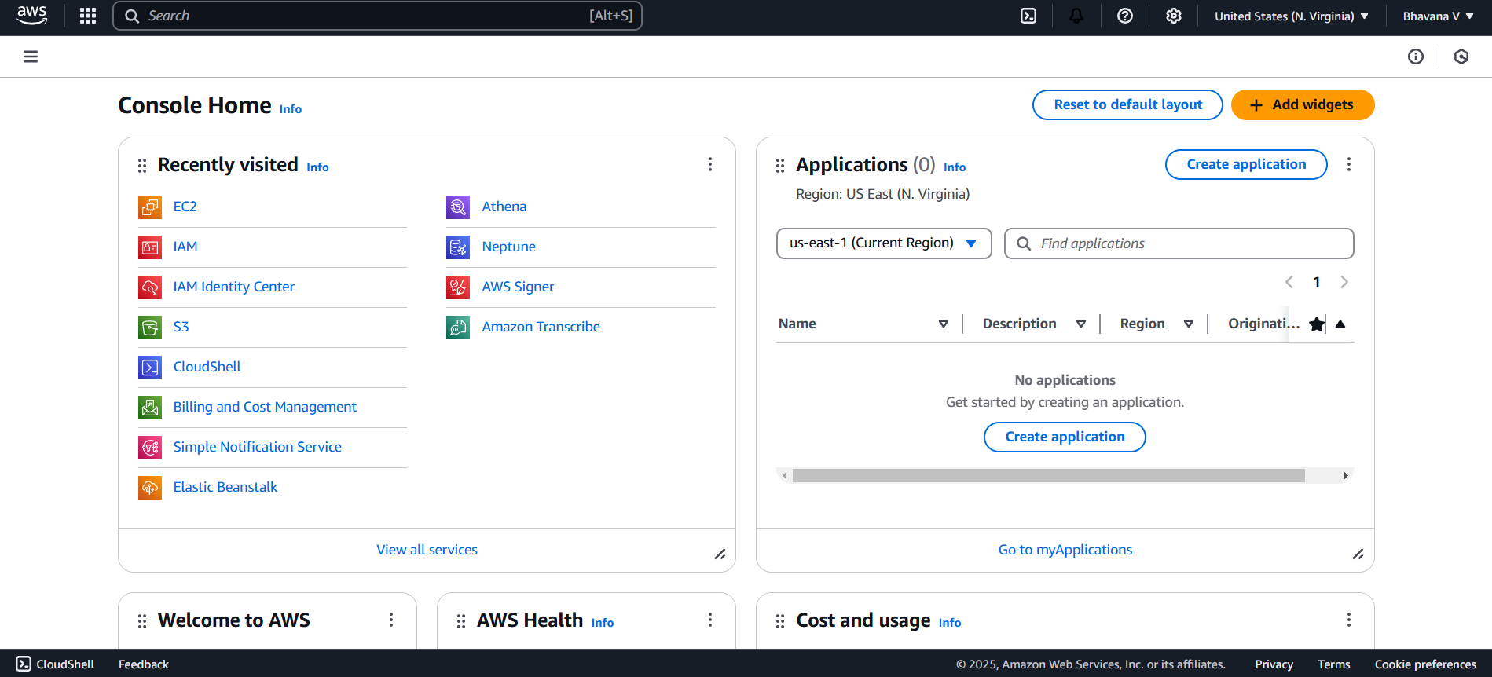

Step 2:

On the EC2 Dashboard, click on **Launch Instances** and enter a name for your instance (e.g., "My Monitoring Instance"). Leave other settings as default and Click **Launch Instance**

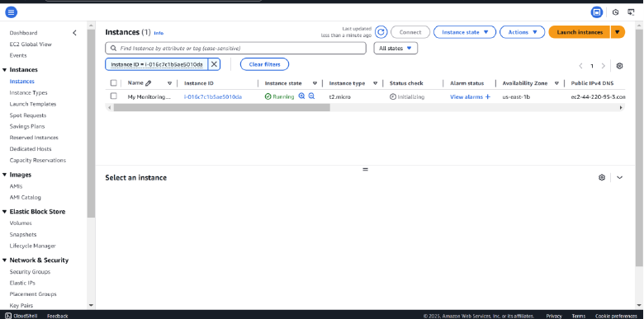

Step 3:

**Go to the EC2 Dashboard** in the AWS Console.

In the left menu, click **Volumes** under **Elastic Block Store (EBS)**.

Click **Create Volume**.

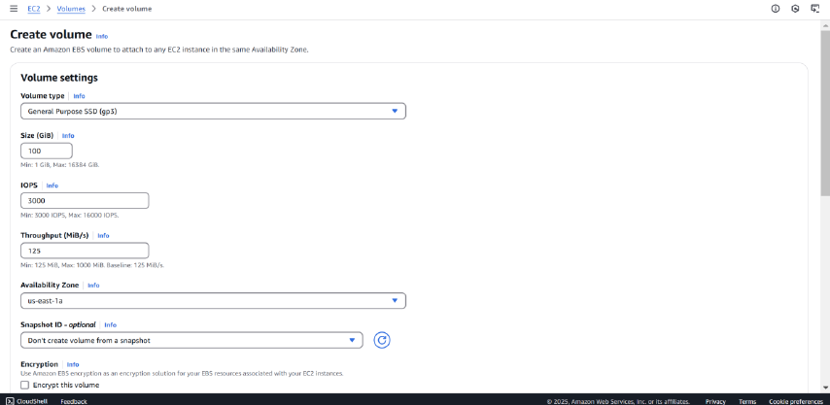

Step 4:

Once created, go to your **Volumes** list, select the newly created volume, and click **Actions** > **Attach Volume**

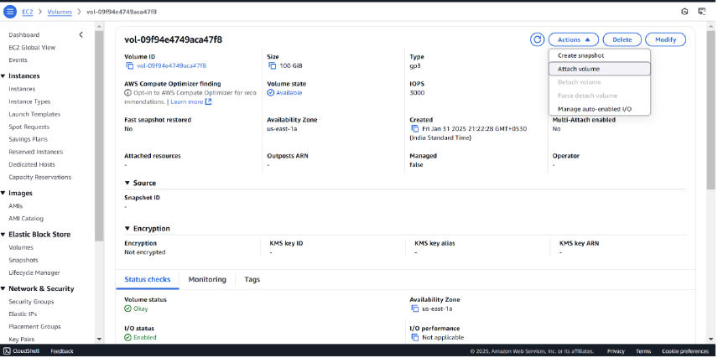

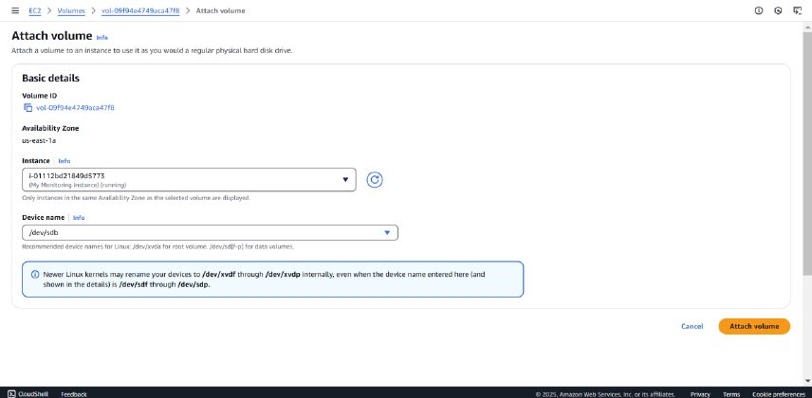

Step 5:

On the AWS Console homepage, look for the search bar at the top.

Type **CloudWatch** in the search bar and press **Enter**.

From the search results, click on **CloudWatch**.

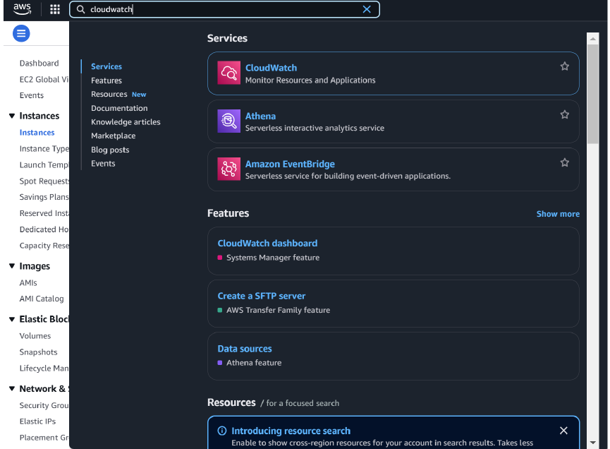

Step 6:

In the CloudWatch dashboard, look at the left-hand menu.

Click on **Metrics**.

Under **Browse**, click on **EC2**.

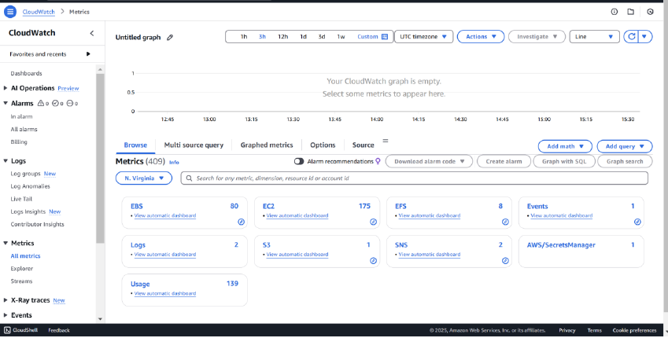

Then click on the **Per-Instance Metrics.**

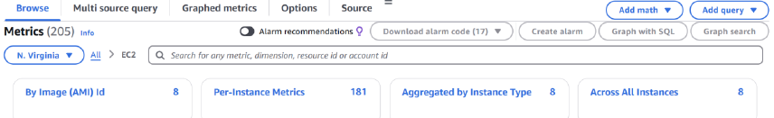

Step 7:

You should now see a list of metrics for all your EC2 instances, such as:

**CPUUtilization** (CPU usage)

**DiskReadOps** / **DiskWriteOps** (Disk I/O)

Identify the specific EC2 instance you want to monitor (it will be listed by its instance ID).

Click on the metrics associated with your instance

To view detail click Graphed metrics

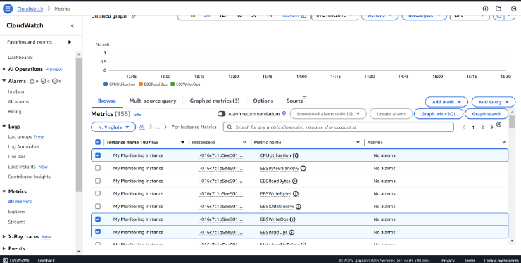

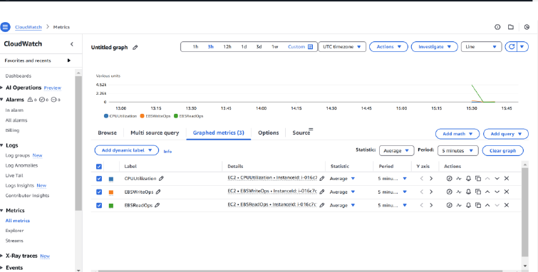

**Outcome**

This Proof of Concept (PoC) aimed to establish a **cloud-based monitoring service** using **AWS CloudWatch** to track key performance metrics for an EC2 instance, specifically focusing on **CPU utilization** and **Disk I/O** (DiskReadOps and DiskWriteOps).

Here's the outcome of the PoC:

1. **CloudWatch Setup**: Successfully configured AWS **CloudWatch** to monitor EC2 instance metrics like **CPU utilization** and **Disk I/O** (DiskReadOps, DiskWriteOps).

2. **Disk I/O Monitoring**: Added an **EBS volume** to the EC2 instance to track **DiskReadOps** and **DiskWriteOps** metrics, which were visualized in CloudWatch.

3. **Cost Efficiency**: The EBS volume was within the **AWS Free Tier** limits (30 GB), and all metrics stayed within **Free Tier** usage, incurring no additional cost.