 

**Placement Empowerment Program**

***Cloud Computing and DevOps Centre***

Set Up a Virtual Machine in the Cloud Create a free-tier AWS account. Launch a virtual machine and SSH into it.

Name: Bhavana Vijayan Department: IT



**Introduction**

The objective of this Proof of Concept (POC) is to explore the process of setting up a virtual machine in the cloud using the AWS Free Tier. A virtual machine (VM) is a crucial component in cloud computing, enabling users to deploy and manage scalable computing resources without requiring physical hardware. This POC serves as a foundational exercise for understanding cloud infrastructure and using AWS EC2 to create a simple and cost-effective computing environment.

**Overview**

This POC demonstrates the step-by-step process to:

1. Create a free AWS account.
2. Launch a virtual machine using AWS EC2.
3. Configure and secure the instance with a key pair and a security group.
4. Connect to the VM using SSH from a Windows system. The project covers basic tasks that are essential for beginners in cloud computing, offering hands-on experience with AWS infrastructure.

**Objectives**

**1. Learn AWS EC2 Basics**: Understand how to create, configure, and launch an EC2 instance.

**2. Practice Secure Connections**: Use SSH to securely connect to the instance.

**3. Gain Practical Experience**: Explore the AWS Management Console to manage and interact with cloud resources.

**4. Understand Free Tier Usage**: Work within the AWS Free Tier to avoid unnecessary costs.

**Importance**

1. **Foundation for Cloud Computing**: Understanding how to launch and manage virtual machines is a fundamental skill for cloud practitioners.

**Skill Development**: This POC builds hands-on skills in AWS, including instance management, security configurations, and connecting via SSH.

**Scalability and Flexibility**: Demonstrates how cloud infrastructure allows for rapid deployment of resources compared to traditional setups.

**Cost-Effective Learning**: Using AWS Free Tier enables users to explore cloud computing without financial investment.

**Career Relevance**: Knowledge of setting up virtual machines in AWS is highly valuable for careers in IT, cloud computing, and DevOps.

**Step-by-Step Overview**

Step 1:

1. Go to AWS Management Console.

2. Enter your username and password to log in.

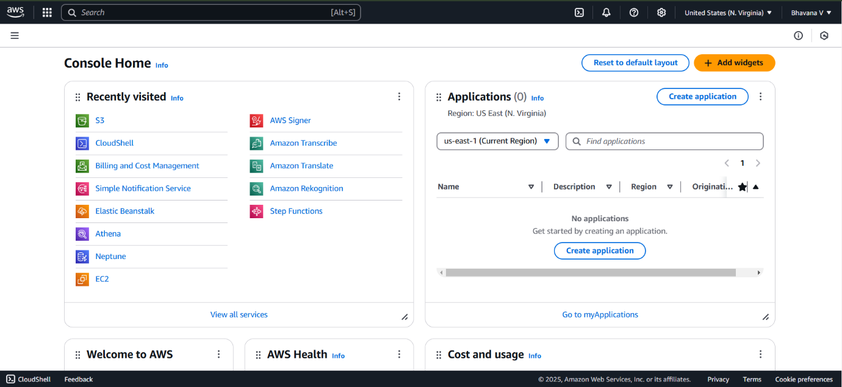

Step 2: Navigate to the AWS Management Console and search for EC2..

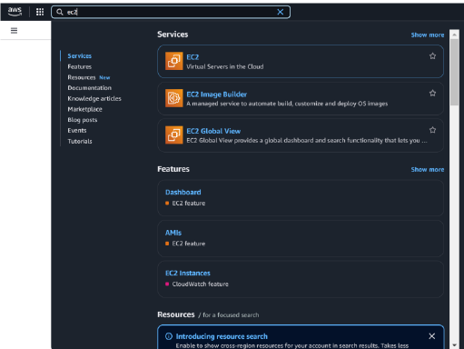

Step 3:

Click Launch Instances.

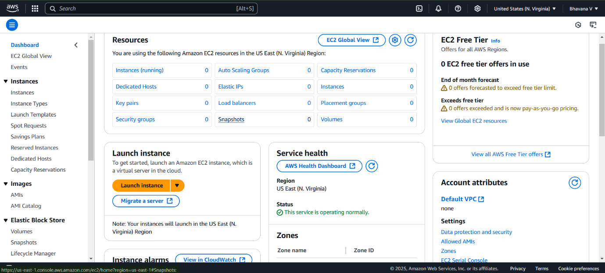

Step 4:

1. Choose **Amazon Linux 2023 Free Tier AMI** or **Ubuntu Free Tier AMI**.
2. Select the **t2.micro** instance type (free tier).

3. Configure security group:

Allow **SSH** (Port 22) from your IP.

4. Add a key pair:

If you don’t have one, create a new key pair and download it as a .pem file.

1. Click **Launch Instance**.

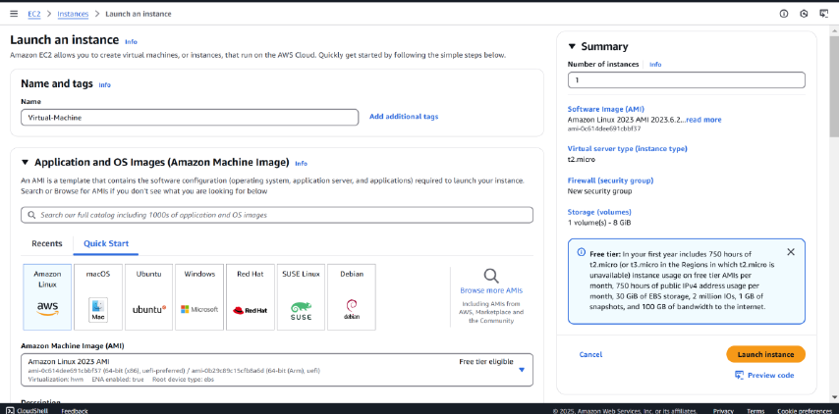

Step 5:

Check your running instance in the Instances section . Select your Instance and click the Connect Option.

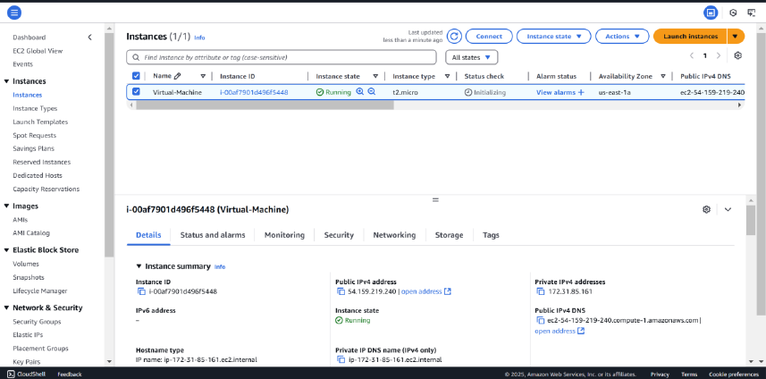

Step 6:

Go to the SSH client section, and copy the command provided under the 'Example' section.

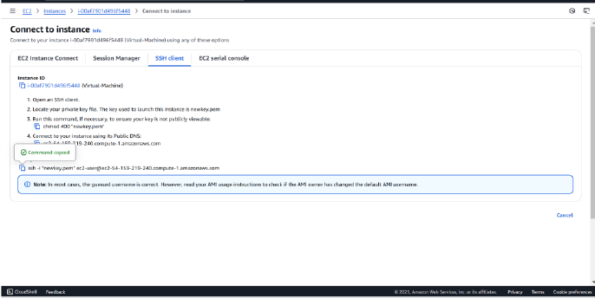

Step 7:

Open PowerShell, navigate to the Downloads folder. Run the SSH command from the EC2 Connect section, replace the key name with your downloaded key (e.g., new.pem), press Enter, and type yes when prompted.

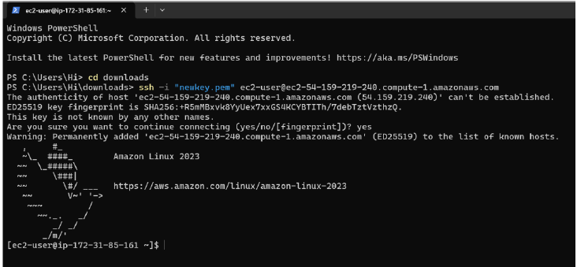

Successfully completed the setup of a virtual machine in AWS.

**Outcome**

By completing this PoC of setting up a virtual machine in AWS, you will:

1. Create and configure a free AWS account to use cloud resources within the Free Tier.
2. Launch an EC2 instance with Amazon Linux or Ubuntu as the operating system.
3. Generate and manage a secure key pair for SSH access to your EC2 instance.
4. Configure a security group to allow SSH connections to your instance from your IP address.
5. Successfully connect to the EC2 instance via SSH using the public IP address.

6. Gain hands-on experience with AWS EC2 and foundational cloud computing concepts.