VISVESVARAYA TECHNOLOGICAL UNIVERSITY
BELGAVI-590018,KARNATAKA.

A Report on
LOW COST FACIAL RECOGNITION SOFTWARE ENABLED SURVEILLANCE CAMERA WITH GPS

SUBMITTED BY
BHASKAR KESHAV HEGDE 4UB15EC015
BHAVANA P 4UB15EC016
BHAVYASHREE P 4UB15EC017
BIBI AYESHA 4UB15EC018
Under The Guidance Of
DR.SRIDHARAMURTHY SK
Associate professor
Dept of ECE
UNIVERSITY B.D.T COLLEGE OF ENGINEERING
DAVANGERE-577004


2018-2019

DEPARTMENT OF ELECTRONICS AND COMMUNICATION ENGINEERING
UNIVERSITY B.D.T. COLLEGE OF ENGINEERING,DAVANGERE-577004

ABSTRACT

The face is one of the easiest ways to distinguish the individual identity of each their. Face recognition is a personal identification system that uses personal characteristics of a person to identify the person's identity. Human face recognition procedure basically consists of two phases, namely face detection, where this process takes place very rapidly in humans, except under conditions where the object is located at a short distance away, the next is the introduction, which recognize a face as individuals. Stage is then replicated and developed as a model for facial image recognition (face recognition) is one of the much-studied biometrics technology and developed by experts. There are two kinds of methods that are currently popular in developed face recognition pattern namely, Eigenface method and Fisherface method. Facial image recognition Eigenface method is based on the reduction of face-dimensional space using Principal Component Analysis (PCA) for facial features. The main purpose of the use of PCA on face recognition using Eigen faces was formed (face space) by finding the eigenvector corresponding to the largest eigenvalue of the face image. The area of this project face detection system with face recognition is Image processing. The software requirements for this project is python software.

Keywords: face detection, Eigen face, PCA, Python

Extension: There are vast number of applications from this face detection project, this project can be extended that the various parts in the face can be detect which are in various directions and shapes.

Raspberry PI Quad Core 1.2GHz Broadcom BCM2837 ,64bit CPU, 1GB RAM ,BCM43438 wireless LAN and Bluetooth Low Energy(BLE) on board 40-pin extended GPIO(General purpose I/O) 4 USB 2 ports 4 pole stereo output and composite video port (analog video transmission) .Full size HDMI(High Definition Multimedia Interface), CSI(Camera Serial Interface) camera port for connecting a Raspberry Pi camera, DSI(Display Serial Interface) display port for connecting a Raspberry Pi touch screen display, Micro SD port for loading your operating system and storing data. Upgraded switched Micro USB power source up to 2.5A.
The Raspberry Pi is a credit-card sized computer capable of doing just about anything a desktop PC does. From web surfing and word processing, to playing Mine craft or acting as a media player , the Raspberry Pi's capabilities are extensive . With plenty of streaming BlueRay-quality video. If you are looking to incorporate the Pi into your next embedded design, the 0.1" spaced 40-pin GPIO header give access to 27 GPIO , UART , I2C , SPI as well as both 3.3 V and 5V power sources.
The Software Requirements are
1.SD Formatter is designed specifically for SD/SDH/SDXC memory cards. The utility differs from operating system format utilities that are meant to format a variety of storage media SD Formatter works with a number of Windows and Mac operating systems. It can be used with the following devices Secure Digital slot on computer-Important for SDXC card users.
USB Secure Digital memory card reader PC Card, Card BUS or Express Card SD adapter .

2.Etcher is a software which is used to burn the OS image to make it compatibility to install into storage disk, here we installed raspbian.

3.Raspbian is the main basic software for Raspberry Pi devices, officially supported by the Raspberry Pi foundation. In fact, it is an operating system, based on Debian and optimized for Raspberry Pi hardware. It comes with lots of pre-installed pieces of software appropriate for most of ARM users and developers. The main operating system, ready to use and optimized to the needs of the most developers and makers is Raspbian.
INDEX

CONTENTS

page

LIST OF FIGURES

ABSTRACT

1.INRODUCTION……………………………………………………………….1

1.1. FACE RECOGNIZATION…………………………………………………..1

1.1.1 GEOMWTRIC……………………………………………………...1

1.1.2 PHOTOMETRIC………………………………………………........1

1.2 FACE DETECTION……………………………………………………….2

1.2.1 PRE-PROCSSING…………………………………………………..2

1.2.2 CLASSIFICATION…………………………………………………3

1.2.3 LOCALIZATION…………………………………………………...3

2.DIGITAL IMAGE PROCESSING…………………………………...……...4

2.1. DIGITAL IMAGE PROCESSING……………………………………….4

2.2. FUNDAMENTAL STEPS IN IMAGE PROCESSING……..……………5

2.3. ELEMENTS OF DIGITAL IMAGE PROCESSING SYSTEM………….6 2.3.1. A SIMPLE IMAGE FORMATION MODEL………………..…….....6

3.FACE DETECTION………………………………………………………….7

3.1 FACE DETECTION IN IMAGE………………………………………….7

3.2 REAL TIME FACE DETECTION………………………………………..8

3.3 FACE DETECTION PROCESS…………………………………………..10

3.4 FACE DETETION ALGORITHM………………………………………..13

- FACE RECOGNITION………………………………………………………15

4.1 FACE RECOGNITION USING GEOMETRICAL FEATURES……………...15 4.1.1 FACE RECOGNITION USING TEMPLATE MATCHING……...…….........16
4.2 PROBLEM SCOPE AND SYSTEM SPECIFICATIONS………...…………17

4.3 BRIEF OUTLINE OF THE IMPLEMENTED SYSTEM……..………………17

4.4 FACE RECOGNITION DIFFICULTIE………………….……………………19

4.4.1 INTER CLASS SIMILARITY……………….…………………………20

4.4.2 INTRA CLASS SIMILARITY………….………………………………20

4.5 PRINCIPAL COMPONENT ANALYSIS………………………………………21

4.6 UNDER STANDING EIGEN FACES……..……………………………………21

4.7 IMPROVING FACE DETECTION USING RECONSTRUCTION…………....25

4.8 POSE INVARIENT FACE RECOGNITION……………………………………26

- CONCLUSION………………………………………………………………………..28

- REFERENCE.................................................................................................................30

CHAPTER-1

INTRODUCTION

Face recognition is the task of identifying an already detected object as a known or unknown face. Often the problem of face recognition is confused with the problem of face detection. Face Recognition on the other hand is to decide if the "face" is someone known, or unknown, using for this purpose a database of faces in order to validate this input face.

1.1 FACE RECOGNIZATION:

DIFFERENT APPROACHES OF FACE RECOGNITION:

There are two predominant approaches to the face recognition problem: Geometric (feature based) and photometric (view based). As researcher interest in face recognition continued, many different algorithms were developed, three of which have been well studied in face recognition literature.

Recognition algorithms can be divided into two main approaches:

1.1.1 Geometric: Is based on geometrical relationship between facial landmarks, or in other words the spatial configuration of facial features. That means that the main geometrical features of the face such as the eyes, nose and mouth are first located and then faces are classified on the basis of various geometrical distances and angles between features. (Figure 3)
.
1.1.2 Photometric stereo: Used to recover the shape of an object from a number of images taken under different lighting conditions. The shape of the recovered object is defined by a gradient map(using as adjustment layer), which is made up of an array of surface normals (Zhao and Chellappa, 2006) (Figure 2)

Popular recognition algorithms include:

- Principal Component Analysis using Eigenfaces, (PCA)

- Linear Discriminate Analysis,

3. Elastic Bunch Graph Matching using the Fisherface algorithm,

Department of ECE Page 1
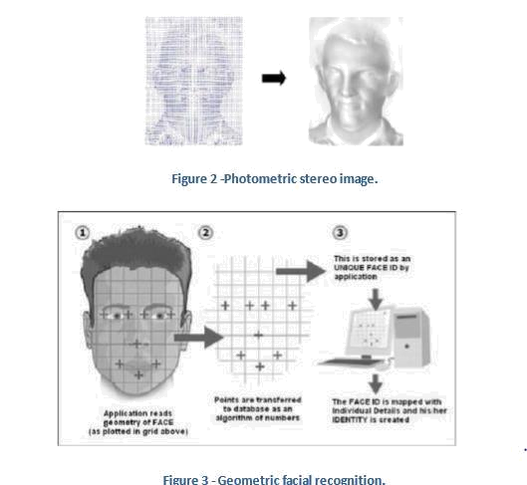

.

1.2 FACE DETECTION:

Face detection involves separating image windows into two classes; one containing faces, tarning the background (clutter). It is difficult because although commonalities exist between faces, they can vary considerably in terms of age, skin color and facial expression. The problem is further complicated by differing lighting conditions, image qualities and geometries, as well as the possibility of partial occlusion and disguise. An ideal face detector would therefore be able to detect the presence of any face under any set of lighting conditions, upon any background. The face detection task can be broken down into two steps. The first step is a classification task that takes some arbitrary image as input and outputs a binary value of yes or no, indicating whether there are any faces present in the image. The second step is the face localization task that aims to take an image as input and output the location of any face or faces within that image as some bounding box with (x, y, width, height).

The face detection system can be divided into the following steps:-

1.2.1 Pre-Processing: To reduce the variability in the faces, the images are processed before they are fed into the network. All positive examples that is the face images are obtained by cropping

Department of ECE Page 2

images with frontal faces to include only the front view. All the cropped images are then corrected for lighting through standard algorithms.

1.2.2 Classification: Neural networks are implemented to classify the images as faces or nonfaces by training on these examples. We use both our implementation of the neural network toolbox for this task. Different network configurations are experimented with to optimize the results.

1.2.3 Localization: The trained neural network is then used to search for faces in an image and if present localize them in a bounding box. Various Feature of Face on which the work has done on:-Position Scale Orientation Illumination
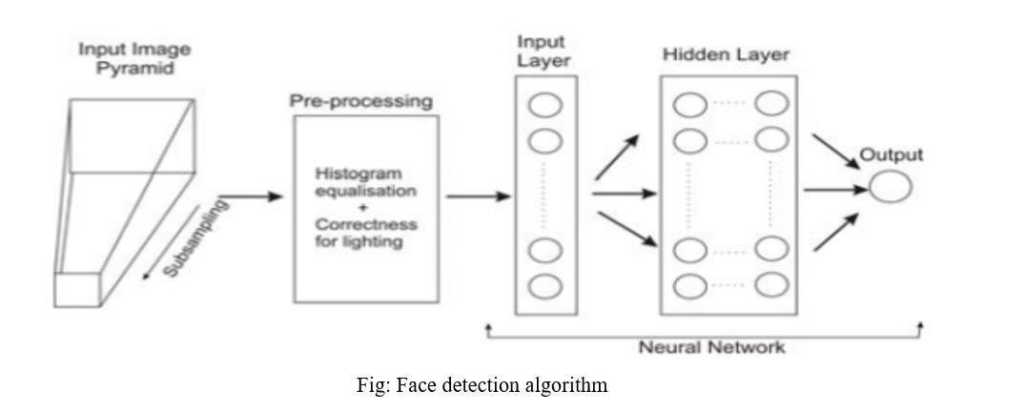

Department of ECE Page 3
CHAPTER-2

DIGITAL IMAGE PROCESSING

2.1 DIGITAL IMAGE PROCESSING

Interest in digital image processing methods stems from two principal application areas:

- Improvement of pictorial information for human interpretation

- Processing of scene data for autonomous machine perception

In this second application area, interest focuses on procedures for extracting image information in a form suitable for computer processing.

Examples includes automatic character recognition, industrial machine vision for product assembly and inspection, military recognizance, automatic processing of fingerprints etc.

Image:

Am image refers a 2D light intensity function f(x, y), where(x, y) denotes spatial coordinates and the value of f at any point (x, y) is proportional to the brightness or gray levels of the image at that point. A digital image is an image f(x, y) that has been discretized both in spatial coordinates and brightness. The elements of such a digital array are called image elements or pixels.

A simple image model:

To be suitable for computer processing, an image f(x, y) must be digitalized both spatially and in amplitude. Digitization of the spatial coordinates (x, y) is called image sampling. Amplitude digitization is called gray-level quantization.

The storage and processing requirements increase rapidly with the spatial resolution and the number of gray levels.

Example: A 256 gray-level image of size 256x256 occupies 64k bytes of memory.

Types of image processing

- Low level processing

- Medium level processing

- High level processing

Department of ECE Page 4

Low level processing means performing basic operations on images such as reading an image resize, image rotate, RGB to gray level conversion, histogram equalization etc…, The output image obtained after low level processing is raw image .Medium level processing means extracting regions of interest from output of low level processed image. Medium level processing deals with identification of boundaries i.e. edges .This process is called segmentation. High level processing deals with adding of artificial intelligence to medium level processed signal.

2.2 FUNDAMENTAL STEPS IN IMAGE PROCESSING

Fundamental steps in image processing are

- Image acquisition: to acquire a digital image

- Image pre-processing: to improve the image in ways that increases the chances for success of the other processes.

- Image segmentation: to partitions an input image into its constituent parts of object and convert the input data to a from suitable for computer processing.

- Image description: to extract the features that result in some quantitative information of interest of features that are basic for differentiating one class of objects from another.

- Image recognition: to assign a label to an object based on the information provided by its description.

Segmentation
Segmentation |  | Description
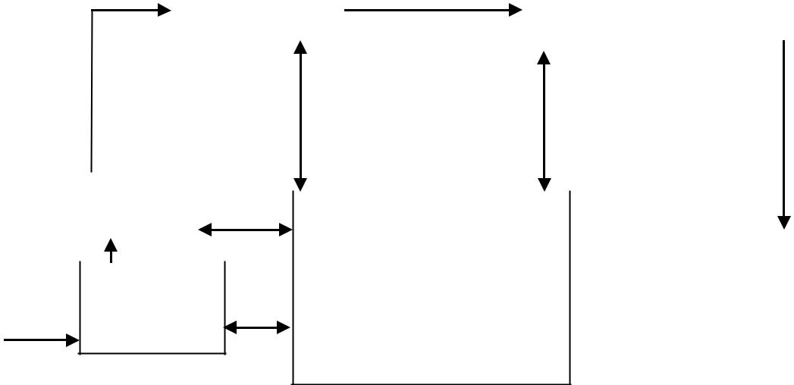

Pre-processing
 |  |  |  |  |  | Recognition
 | Image
 | acquisition |  |  | Knowledge base

problem

fig. Fundamental steps in digital image processing

Department of ECE Page 5
2.3 ELEMENTS OF DIGITAL IMAGE PROCESSING SYSTEMS

A digital image processing system contains the following blocks as shown in the figure
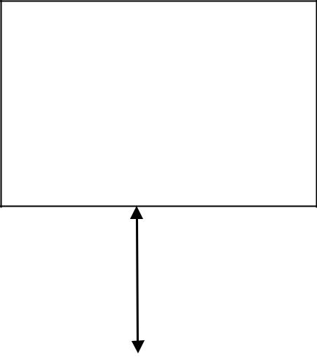

Storage

- Optical discs

- Tape

- Video tape

- Magnetic discs

Image |  |  |  |  |  |  | Display unit
acquisition |  |  | Processing Unit |  |  |  | • | TV monitors
equipments |  |  |  |  |  |  | • | TV monitors
 |  |  | • | Computer |  |  | • | Printers
• | Video |  | • | Work station |  |  | • | Projectors
• | Scanner

Communication channel

Fig. Elements of digital image processing systems

The basic operations performed in a digital image processing system include

- Acquisition

- Storage

- Processing

- Communication

- Display

Department of ECE Page 6
CHAPTER-3

FACE DETECTION

The problem of face recognition is all about face detection. This is a fact that seems quite bizarre to new researchers in this area. However, before face recognition is possible, one must be able to reliably find a face and its landmarks. This is essentially a segmentation problem and in practical systems, most of the effort goes into solving this task. In fact the actual recognition based on features extracted from these facial landmarks is only a minor last step.

There are two types of face detection problems:

- Face detection in images and

- Real-time face detection

3.1 FACE DETECTION IN IMAGE
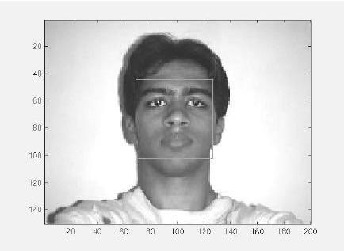

Figure A successful face detection in an image with a frontal view of a human face.

Most face detection systems attempt to extract a fraction of the whole face, thereby eliminating most of the background and other areas of an individual's head such as hair that are not necessary for the face recognition task. With static images, this is often done by running a across the image. The face detection system then judges if a face is present inside the window (Brunelli and Poggio, 1993). Unfortunately, with static images there is a very large search space of possible locations of a face in an image

Department of ECE Page 7

Most face detection systems uses an example based learning approach to decide whether or not a face is present in the window at that given instant (Sung and Poggio,1994 and Sung,1995). A neural network or some other classifier is trained using supervised learning with 'face' and 'non-face' examples, thereby enabling it to classify an image (window in face detection system) as a 'face' or 'non-face'. Unfortunately, while it is relatively easy to find face examples, how would one find a representative sample of images which represent non-faces (Rowley et al., 1996). Therefore, face detection systems using example based learning need thousands of 'face' and 'non-face' images for effective training. Rowley, Baluja, and Kanade (Rowley et al.,1996) used 1025 face images and 8000 non-face images (generated from 146,212,178 sub-images) for their training set.

There is another technique for determining whether there is a face inside the face detection system's window - using Template Matching. The difference between a fixed target pattern (face) and the window is computed and threshold. If the window contains a pattern which is close to the target pattern(face) then the window is judged as containing a face. An implementation of template matching called Correlation. Templates uses a whole bank of fixed sized templates to detect facial features in an image (Bichsel, 1991 & Brunelli and Poggio, 1993). By using several templates of different (fixed) sizes, faces of different scales (sizes) are detected. The other implementation of template matching is using a deformable template (Yuille, 1992). Instead of using several fixed size templates, we use a deformable template (which is non-rigid) and thereby change the size of the template hoping to detect a face in an image.

A face detection scheme that is related to template matching is image invariants. Here the fact that the local ordinal structure of brightness distribution of a face remains largely unchanged under different illumination conditions (Sinha, 1994) is used to construct a spatial template of the face which closely corresponds to facial features. In other words, the average grey-scale intensities in human faces are used as a basis for face detection. For example, almost always an individual's eye region is darker than his forehead or nose. Therefore an image will match the template if it satisfies the 'darker than' and 'brighter than' relationships (Sung and Poggio, 1994).

3.2 REAL-TIME FACE DETECTION

Real-time face detection involves detection of a face from a series of frames from a video-capturing device. While the hardware requirements for such a system are far more stringent, from a computer vision stand point, real-time face detection is actually a far simpler process than detecting a face in a static image. This is because unlike most of our surrounding

Department of ECE Page 8

environment, people are continually moving. We walk around, blink, fidget, wave our hands about, etc.


Figure . Frame 1 from camera Figure . Frame 2 from camera
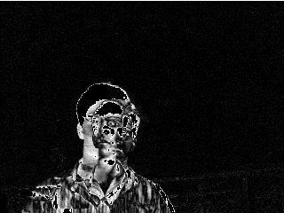

Figure. Spatio-Temporally filtered image

Since in real-time face detection, the system is presented with a series of frames in which to detect a face, by using spatio-temperal filtering (finding the difference between subsequent frames), the area of the frame that has changed can be identified and the individual detected (Wang and Adelson, 1994 and Adelson and Bergen 1986).Further more as seen in Figure exact face locations can be easily identified by using a few simple rules, such as,

1) The head is the small blob above a larger blob -the body

Department of ECE Page 9

2) Head motion must be reasonably slow and contiguous -heads won't jump around erratically (Turk and Pentland 1991a, 1991b).

Real-time face detection has therefore become a relatively simple problem and is possible even in unstructured and uncontrolled environments using these very simple image processing techniques and reasoning rules.

3.3 FACE DETECTION PROCESS
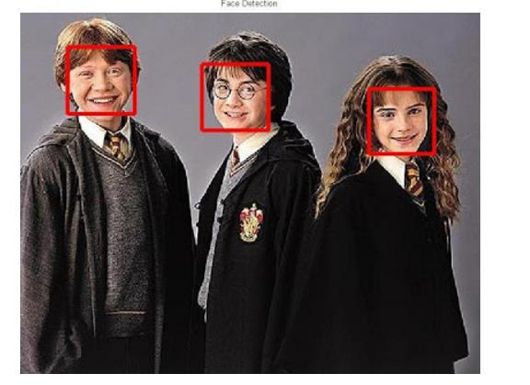

Fig. Face detection

It is process of identifying different parts of human faces like eyes, nose, mouth, etc… this process can be achieved by using PYTHON code. To do this it would be useful to study the grey-scale intensity distribution of an average human face. The following 'average human face' was constructed from a sample of 30 frontal view human faces, of which 12 were from females and 18 from males. A suitably scaled color map has been used to highlight grey-scale intensity differences.
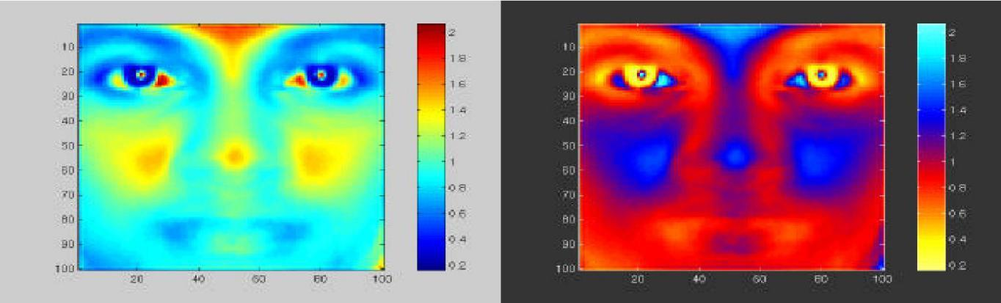

scaled colormap scaled colormap (negative)

Figure. Average human face in grey-scale

Department of ECE Page 10

The grey-scale differences, which are invariant across all the sample faces are strikingly apparent. The eye-eyebrow area seem to always contain dark intensity (low) gray-levels while nose forehead and cheeks contain bright intensity (high) grey-levels. After a great deal of experimentation, the researcher found that the following areas of the human face were suitable for a face detection system based on image invariants and a deformable template.
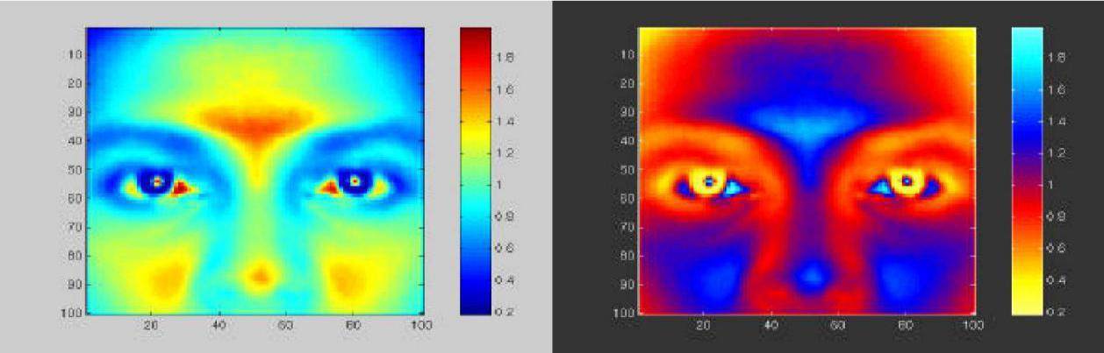

scaled colormap scaled colormap (negative)

Figure . Area chosen for face detection (indicated on average human face in gray scale)

The above facial area performs well as a basis for a face template, probably because of the clear divisions of the bright intensity invariant area by the dark intensity invariant regions. Once this pixel area is located by the face detection system, any particular area required can be segmented based on the proportions of the average human face. After studying the above images it was subjectively decided by the author to use the following as a basis for dark intensity sensitive and bright intensity sensitive templates. Once these are located in a subject's face, a pixel area 33.3% (of the width of the square window) below this.
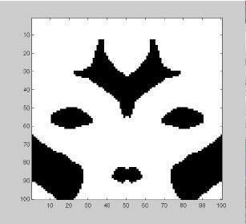

Figure. Basis for a bright intensity invariant sensitive template.

Note the slight differences which were made to the bright intensity invariant sensitive template which were needed because of the pre-processing done by

Department of ECE Page 11
the system to overcome irregular lighting . Now that a suitable dark and bright intensity invariant templates have been decided on, it is necessary to find a way of using these to make 2 A-units for a perceptron, i.e. a computational model is needed to assign neurons to the distributions displayed .
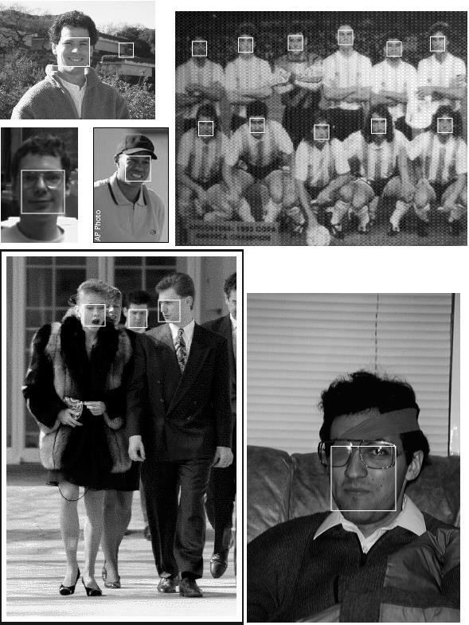

Fig. Scanned image detection

1.Scan window over image

2.Classify window as either

  - Face

  - Non - Face

Department of ECE Page 12
3.4 FACE DETECTION ALGORITHM
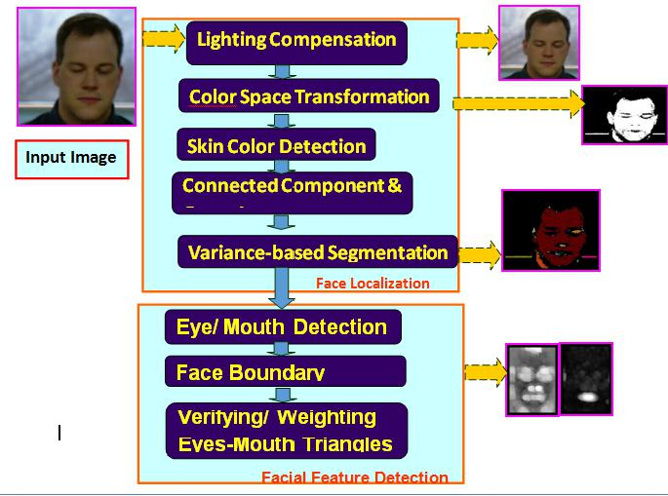

Fig. Face detection algorithm
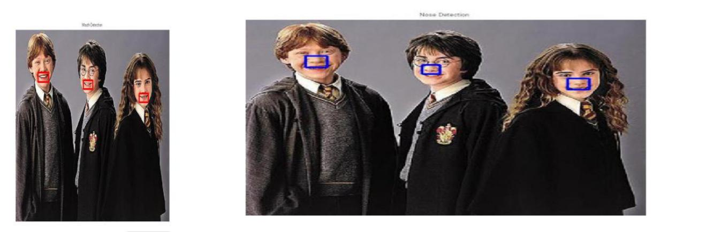

Fig .mouth detection Fig. Noise detection

Department of ECE Page 13
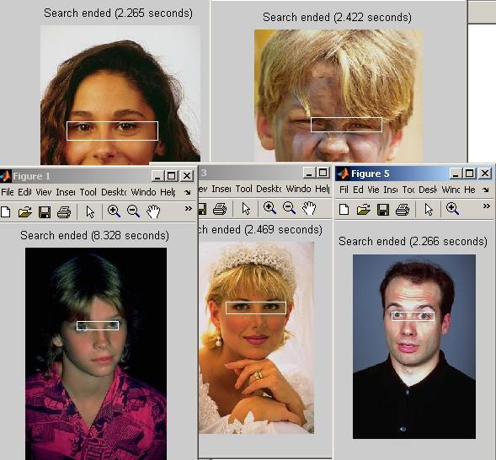

Fig. Eye detection

Department of ECE Page 14
CHAPTER-4

FACE RECOGNITION

Over the last few decades many techniques have been proposed for face recognition. Many of the techniques proposed during the early stages of computer vision cannot be considered successful, but almost all of the recent approaches to the face recognition problem have been creditable. According to the research by Brunelli and Poggio (1993) all approaches to human face recognition can be divided into two strategies:

  - Geometrical features and

- Template matching.

4.1 FACE RECOGNITION USING GEOMETRICAL FEATURES

This technique involves computation of a set of geometrical features such as nose width and length, mouth position and chin shape, etc. from the picture of the face we want to recognize. This set of features is then matched with the features of known individuals. A suitable metric such as Euclidean distance (finding the closest vector) can be used to find the closest match. Most pioneering work in face recognition was done using geometric features (Kanade, 1973), although Craw et al. (1987) did relatively recent work in this area.
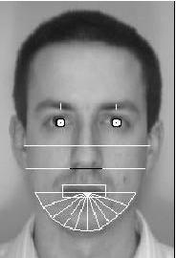

Figure. Geometrical features (white) which could be used for face recognition

The advantage of using geometrical features as a basis for face recognition is that recognition is possible even at very low resolutions and with noisy images (images with many disorderly pixel intensities). Although the face cannot be viewed in detail its overall geometrical configuration can be extracted for face recognition. The technique's main disadvantage is that automated extraction of the facial geometrical features is very hard. Automated geometrical

Department of ECE Page 15

feature extraction based recognition is also very sensitive to the scaling and rotation of a face in the image plane (Brunelli and Poggio, 1993). This is apparent when we examine Kanade's(1973) results where he reported a recognition rate of between 45-75 % with a database of only 20 people. However if these features are extracted manually as in Goldstein et al. (1971), and Kaya and Kobayashi (1972) satisfactory results may be obtained.

4.1.1 Face recognition using template matching

This is similar the template matching technique used in face detection, except here we are not trying to classify an image as a 'face' or 'non-face' but are trying to recognize a face.
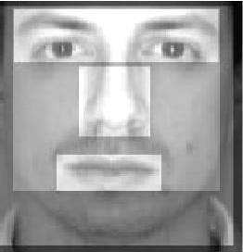

Figure . Face recognition using template matching

Whole face, eyes, nose and mouth regions which could be used in a template matching strategy. The basis of the template matching strategy is to extract whole facial regions (matrix of pixels) and compare these with the stored images of known individuals. Once again Euclidean distance can be used to find the closest match. The simple technique of comparing grey-scale intensity values for face recognition was used by Baron (1981). However there are far more sophisticated methods of template matching for face recognition. These involve extensive pre-processing and transformation of the extracted grey-level intensity values. For example, Turk and

Pentland (1991a) used Principal Component Analysis, sometimes known as the Eigen faces

approach, to pre-process the gray-levels and Wiskott et al. (1997) used Elastic Graphs encoded using Gabor filters to pre-process the extracted regions. An investigation of geometrical features versus template matching for face recognition by Brunelli and Poggio (1993) came to the conclusion that although a feature based strategy may offer higher recognition speed and smaller memory requirements, template based techniques offer superior recognition accuracy.

Department of ECE Page 16
4.2 PROBLEM SCOPE AND SYSTEM SPECIFICATION

The following problem scope for this project was arrived at after reviewing the literature on face detection and face recognition, and determining possible real-world situations where such systems would be of use. The following system(s) requirements were identified

- A system to detect frontal view faces in static images.

- A system to recognize a given frontal view face.

- Only expressionless, frontal view faces will be presented to the face detection & recognition.

- All implemented systems must display a high degree of lighting invariance.

- All systems must posses near real-time performance.

- Both fully automated and manual face detection must be supported.

- Frontal view face recognition will be realized using only a single known image.

- Automated face detection and recognition systems should be combined into a fully automated face detection and recognition system. The face recognition sub-system must display a slight degree of invariance to scaling and rotation errors in the segmented image extracted by the face detection sub-system.

- The frontal view face recognition system should be extended to a pose invariant face recognition system.

Unfortunately although we may specify constricting conditions to our problem domain, it may not be possible to strictly adhere to these conditions when implementing a system in the real-world.

4.3 BRIEF OUT LINE OF THE IMPLEMENTED SYSTEM

Fully automated face detection of frontal view faces is implemented using a deformable template algorithm relying on the image invariants of human faces. This was chosen because a similar neural-network based face detection model would have needed far too much training data to be implemented and would have used a great deal of computing time. The main difficulties in implementing a deformable template based technique were the creation of the bright and dark intensity sensitive templates and designing an efficient implementation of the detection algorithm.
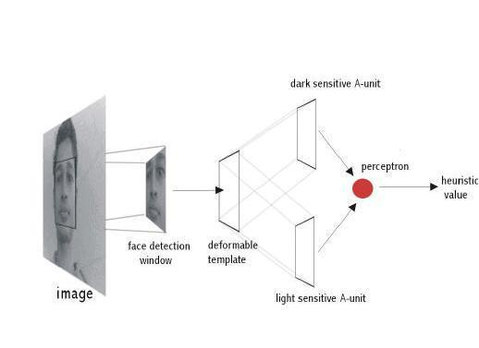

Figure. Implemented fully automated frontal view face detection model

Department of ECE Page 17

A manual face detection system was realized by measuring the facial proportions of the average face, calculated from 30 test subjects. To detect a face, a human operator would identify the locations of the subject's eyes in an image and using the proportions of the average face, the system would segment an area from the image.

A template matching based technique was implemented for face recognition. This was because of its increased recognition accuracy when compared to geometrical features based techniques and the fact that an automated geometrical features based technique would have required complex feature detection pre-processing.

Of the many possible template matching techniques, Principal Component Analysis was chosen because it has proved to be a highly robust in pattern recognition tasks and because it is relatively simple to implement. The author would also liked to have implemented a technique based on Elastic Graphs but could not find sufficient literature about the model to implement such a system during the limited time available for this project.
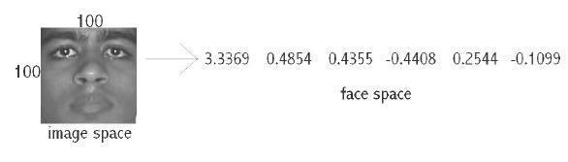

Figure . Principal Component Analysis transform from 'image space' to 'face space'.
Using Principal Component Analysis, the segmented frontal view face image is

transformed from what is sometimes called 'image space' to 'face space'. All faces in the face database are transformed into face space. Then face recognition is achieved by transforming any given test image into face space and comparing it with the training set vectors. The closest matching training set vector should belong to the same individual as the test image. Principal Component Analysis is of special interest because the transformation to face space is based on the variation of human faces (in the training set). The values of the 'face space' vector correspond to the amount certain 'variations' are present in the test image.

Department of ECE Page 18

Face recognition and detection system is a pattern recognition approach for personal identification purposes in addition to other biometric approaches such as fingerprint recognition, signature, retina and so forth. Face is the most common biometric used by humans applications ranges from static, mug-shot verification in a cluttered background.
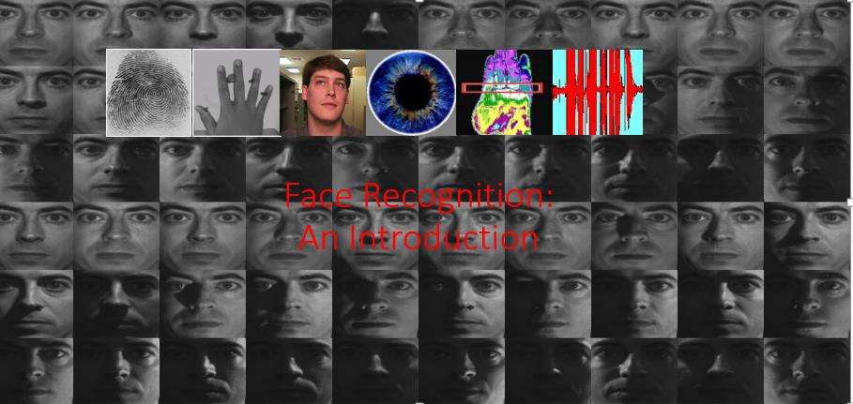

Fig . Face Recognition

4.4 FACE RECOGNITION DIFFICULTIES

- Identify similar faces (inter-class similarity)

- Accommodate intra-class variability
2.1 head pose

2.2 illumination conditions

2.3 expressions

2.4 facial accessories

2.5 aging effects

3. Cartoon faces

Department of ECE Page 19
4.4.1 Inter - class similarity:

Different persons may have very similar appearance
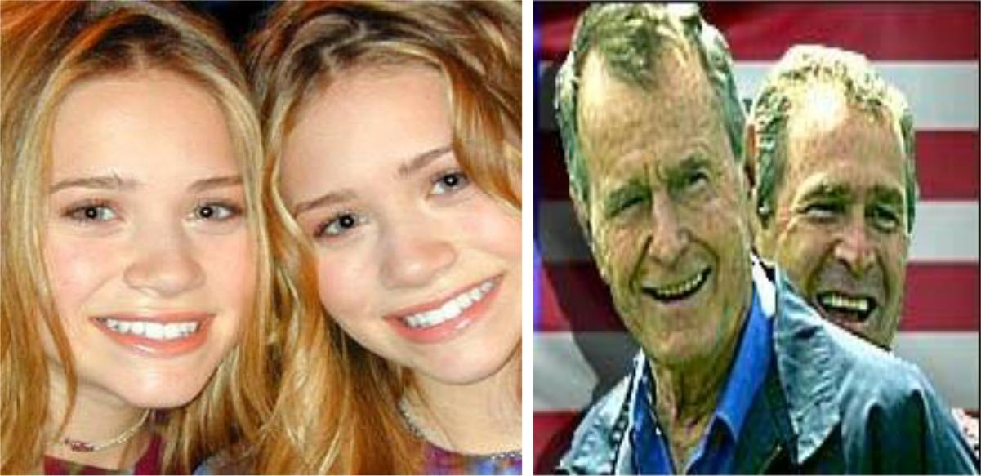

Fig . Face recognition twins

Face recognition and detection system is a pattern recognition approach for personal identification purposes in addition to other biometric approaches such as fingerprint recognition, signature, retina and so forth. The variability in the faces, the images are processed before they are fed into the network. All positive examples that is the face images are obtained by cropping images with frontal faces to include only the front view. All the cropped images are then corrected for lighting through standard algorithms.

4.4.2 Inter – class variability

Faces with intra-subject variations in pose, illumination, expression, accessories, color, occlusions, and brightness.

Department of ECE Page 20
4.5 PRINCIPAL COMPONENT ANALYSIS (PCA)

Principal Component Analysis (or Karhunen-Loeve expansion) is a suitable strategy for face recognition because it identifies variability between human faces, which may not be immediately obvious. Principal Component Analysis (hereafter PCA) does not attempt to categories faces using familiar geometrical differences, such as nose length or eyebrow width. Instead, a set of human faces is analyzed using PCA to determine which 'variables' account for the variance of faces. In face recognition, these variables are called Eigen faces because when plotted they display an eerie resemblance to human faces. Although PCA is used extensively in statistical analysis, the pattern recognition community started to use PCA for classification only relatively recently. As described by Johnson and Wichern (1992), principal component analysis is concerned with explaining the variance-covariance structure through a few linear combinations of the original variables. Perhaps PCA's greatest strengths are in its ability for data reduction and interpretation. For example a 100x100 pixel area containing a face can be very accurately represented by just 40 Eigen values. Each Eigen value describes the magnitude of each Eigen face in each image. Furthermore, all interpretation (i.e. recognition) operations can now be done using just the 40 Eigen values to represent a face instead of the manipulating the 10000 values contained in a 100x100 image. Not only is this computationally less demanding but the fact that the recognition information of several thousand.

4.6 UNDERSTANDING EIGENFACES

Any grey scale face image I(x,y) consisting of a NxN array of intensity values may also be consider as a vector of N². For example, a typical 100x100 image used in this thesis will have to be transformed into a 10000 dimension vector!
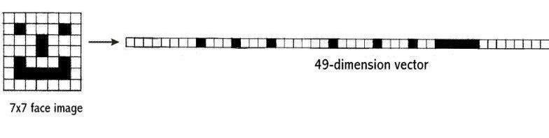

Figure. A 7x7 face image transformed into a 49 dimension vector.

This vector can also be regarded as a point in 10000 dimension space. Therefore, all the images of subjects' whose faces are to be recognized can be regarded as points in 10000 dimension

Department of ECE Page 21

space. Face recognition using these images is doomed to failure because all human face images are quite similar to one another so all associated vectors are very close to each other in the 10000-dimension space.
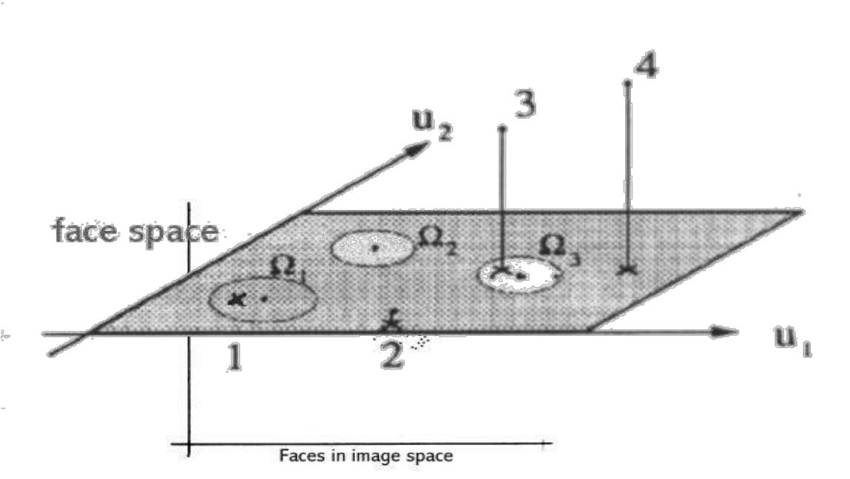
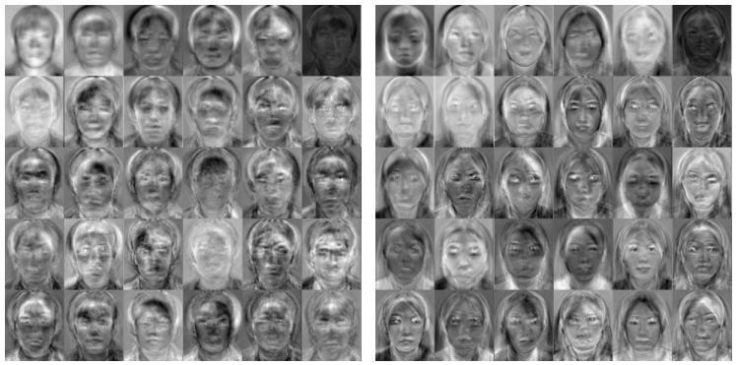

Fig. Eigenfaces

The transformation of a face from image space (I) to face space (f) involves just a simple matrix multiplication. If the average face image is A and U contains the (previously calculated) Eigen faces.

f = U * (I - A)

This is done to all the face images in the face database (database with known faces) and to the image (face of the subject) which must be recognized. The possible results when projecting a face into face space are given in the following figure.

.

Department of ECE Page 22
There are four possibilities:

- Projected image is a face and is transformed near a face in the face database.

2.Projected image is a face and is not transformed near a face in the face database.

3.Projected image is not a face and is transformed near a face in the face database.

- Projected image is not a face and is not transformed near a face in the face database. While it is possible to find the closest known face to the transformed image face

by calculating the Euclidean distance to the other vectors, how does one know whether the image that is being transformed actually contains a face? Since PCA is a many-to-one transform, several vectors in the image space (images) will map to a point in face space (the problem is that even non-face images may transform near a known face image faces space vector). Turk and Pentland (1991a), described a simple way of checking whether an image is actually of a face. This is by transforming an image into face space and then transforming it back (reconstructing) into image space. Using the previous notation,

I' = U^{T} *U * (I - A)

With these calculations it is possible to verify that an image is of a face and recognize that face. O'Toole et al. (1993) did some interesting work on the importance of Eigen faces with large and small Eigen values. They showed that the Eigen vectors with larger Eigen values convey information relative to the basic shape and structure of the faces. This kind of information is most useful in categorizing faces according to sex, race etc. Eigen vectors with smaller Eigen values tend to capture information that is specific to single or small subsets of learned faces and are useful for distinguishing a particular face from any other face. Turk and Pentland (1991a) showed that about 40 Eigen faces were sufficient for a very good description of human faces since the reconstructed image have only about 2% RMS pixel-by-pixel errors.

Department of ECE Page 23

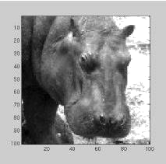

 | 0.8235
 | 0.0661
 | -0.8786
 | -0.4727
 | -0.0646
 | 0.6642
 | -0.4840
 | -0.4501
 | -0.2506
 | 0.1591
 | 0.3359
 | 0.0048
 | 0.0745
 | ………..
Hippo in image space | Hippo in face space
 | 0.7253
 | -0.0392
 | 0.2896
 | -0.1725
 | -0.2642
 | -0.0014
 | -0.0814
 | -0.0054
 | -0.0623
 | -0.0965
 | -0.0879
 | 0.0745
 | -0.0261
 | …………
Face in image space | Face in face space
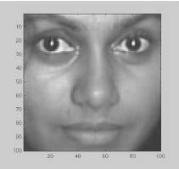

Reconstructed hippo in image space
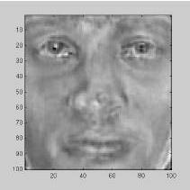
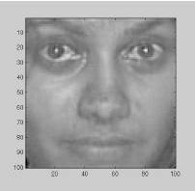

Reconstructed face in image space

Figure. Images and there reconstruction. The Euclidean distance between a face image and its reconstruction will be lower than that of a non-face image

Department of ECE Page 24

4.7 IMPROVING FACE DETECTION USING RECONSTRUCTIN

Reconstruction cannot be used as a means of face detection in images in near real-time since it would involve resizing the face detection window area and large matrix multiplication, both of which are computationally expensive. However, reconstruction can be used to verify whether potential face locations identified by the deformable template algorithm actually contain a face. If the reconstructed image differs greatly from the face detection window then the window probably does not contain a face. Instead of just identifying a single potential face location, the face detection algorithm can be modified to output many high 'faceness' locations which can be verified using reconstruction. This is especially useful because occasionally the best 'faceness' location found by the deformable template algorithm may not contain the ideal frontal view face pixel area.

 | Output from Face detection system
 | Heuristic | X | y | width
 | 978 | 74 | 31 | 60
 | 1872 | 74 | 33 | 60
 | 1994 | 75 | 32 | 58
 | 2125 | 76 | 32 | 56
 | 2418 | 76 | 34 | 56
 | 2389 | 79 | 32 | 50
 | 2388 | 80 | 33 | 48
 | 2622 | 81 | 33 | 46
 | 2732 | 82 | 32 | 44
Best heuristic location (94,65,20) | 2936 | 84 | 33 | 40
 | 2822 | 85 | 58 | 38
 | 2804 | 86 | 60 | 36
 | 2903 | 86 | 62 | 36
 | 3311 | 89 | 62 | 30
 | 3373 | 91 | 63 | 26
 | 3260 | 92 | 64 | 24
 | 3305 | 93 | 64 | 22
 | 3393 | 94 | 65 | 20
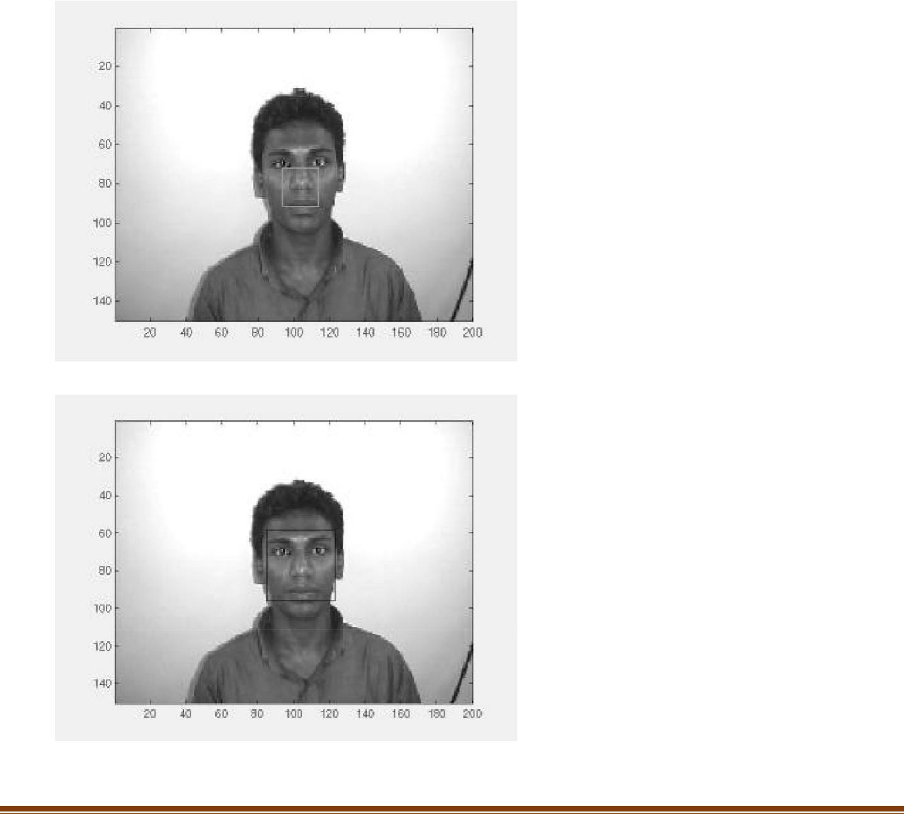

Department of ECE Page 25

potential face locations that have been identified by the face detection system (the best face locations it found on its search) are checked whether they contain a face. If the threshold level (maximum difference between reconstruction and original for the original to be a face) is set correctly this will be an efficient way to detect a face. The deformable template algorithm is fast and can reduce the search space of potential face locations to a handful of positions. These are then checked using reconstruction. The number of locations found by the face detection system can be changed by getting it to output, not just the best face locations it has found so far but any location, which has a 'faceness' value, which for example is, at least 0.9 times the best heuristic value that has been found so far. Then there will be many more potential face locations to be checked using reconstruction. This and similar speed versus accuracy trade-off decisions have to be made keeping in mind the platform on which the system is implemented.

Similarly, instead of using reconstruction to check the face detection system's output, the output's correlation with the average face can be checked. The segmented areas with a high correlation probably contains a face. Once again a threshold value will have to be established to classify faces from non-faces. Similar to reconstruction, resizing the segmented area and calculating its correlation with the average face is far too expensive to be used alone for face detection but is suitable for verifying the output of the face detection system.

4.8 POSE INVARIANT FACE RECOGNITION

Extending the frontal view face recognition system to a pose-invariant recognition system is quite simple if one of the proposed specifications of the face recognition system is relaxed. Successful pose-invariant recognition will be possible if many images of a known individual are in the face database. Nine images from each known individual can be taken as shown below. Then if an image of the same individual is submitted within a 30º angle from the frontal view he or she can be identified.
Nine images in face database from a single known individual
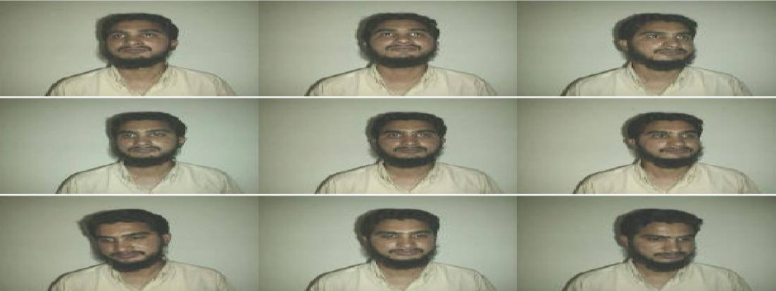

Department of ECE Page 26
Unknown image from same individual to be identified


Fig: Pose invariant face recognition.

Pose invariant face recognition highlights the generalization ability of PCA. For example, when an individual's frontal view and 30º left view known, even the individual's 15º left view can be recognized.

Department of ECE Page 27
5.CONCLUSION

The computational models, which were implemented in this project, were chosen after extensive research, and the successful testing results confirm that the choices made by the researcher were reliable. The system with manual face detection and automatic face recognition did not have a recognition accuracy over 90%, due to the limited number of Eigen faces that were used for the PCA transform. This system was tested under very robust conditions in this experimental study and it is envisaged that real-world performance will be far more accurate. The fully automated frontal view face detection system displayed virtually perfect accuracy and in the researcher's opinion further work need not be conducted in this area.

The fully automated face detection and recognition system was not robust enough to achieve a high recognition accuracy. The only reason for this was the face recognition subsystem did not display even a slight degree of invariance to scale, rotation or shift errors of the segmented face image. However, if some sort of further processing, such as an eye detection technique, was implemented to further normalize the segmented face image, performance will increase to levels comparable to the manual face detection and recognition system. Implementing an eye detection technique would be a minor extension to the implemented system and would not require a great deal of additional research. All other implemented systems displayed commendable results and reflect well on the deformable template and Principal Component Analysis strategies. The most suitable real-world applications for face detection and recognition systems are for mugshot matching and surveillance. There are better techniques such as iris or retina recognition and face recognition using the thermal spectrum for user access and user verification applications since these need a very high degree of accuracy. The real-time automated pose invariant face detection and recognition system proposed would be ideal for crowd surveillance applications. If such a system were widely implemented its potential for locating and tracking suspects for law enforcement agencies is immense.

The implemented fully automated face detection and recognition system (with an eye detection system) could be used for simple surveillance applications such as ATM user security, while the implemented manual face detection and automated recognition system is ideal of mugshot matching. Since controlled conditions are present when mugshots are gathered, the frontal view face recognition scheme should display a recognition accuracy far better than the results, which were obtained in this study, which was conducted under adverse conditions.

Department of ECE Page 28

Furthermore, many of the test subjects did not present an expressionless, frontal view to the system. They would probably be more compliant when a 6'5'' policeman is taking their mugshot. In mugshot matching applications, perfect recognition accuracy or an exact match is not a requirement. If a face recognition system can reduce the number of images that a human operator has to search through for a match from 10000 to even a 100, it would be of incredible practical use in law enforcement.

The automated vision systems implemented in this thesis did not even approach the performance, nor were they as robust as a human's innate face recognition system. However, they give an insight into what the future may hold in computer vision.

Department of ECE Page 29
6.REFERENCE

- Adelson, E. H., and Bergen, J. R. (1986) The Extraction of Spatio-Temporal Energy in

- Human and Machine Vision, Proceedings of Workshop on Motion: Representation and

- Analysis (pp. 151-155) Charleston, SC; May 7-9

- AAFPRS(1997). A newsletter from the American Academy of Facial Plastic and Reconstructive Surgery. Third Quarter 1997, Vol. 11, No. 3. Page 3.

- Baron, R. J. (1981). Mechanisms of human facial recognition. International Journal of Man Machine Studies, 15:137-178

- Beymer, D. and Poggio, T. (1995) Face Recognition From One Example View, A.I. Memo No. 1536, C.B.C.L. Paper No. 121. MIT

- Bichsel, M. (1991). Strategies of Robust Objects Recognition for Automatic Identification of Human Faces. PhD thesis, , Eidgenossischen Technischen Hochschule, Zurich.
- Brennan, S. E. (1982) The caricature generator. M.S. Thesis. MIT.

- Brunelli, R. and Poggio, T. (1993), Face Recognition: Features versus Templates. IEEE Transactions on Pattern Analysis and Machine Intelligence, 15(10):1042-1052

- Craw, I., Ellis, H., and Lishman, J.R. (1987). Automatic extraction of face features. Pattern Recognition Letters, 5:183-187, February.

- Deffenbacher K.A., Johanson J., and O'Toole A.J. (1998) Facial ageing, attractiveness, and distinctiveness. Perception. 27(10):1233-1243

- Dunteman, G.H. (1989) Principal Component Analysis. Sage Publications.

- Frank, H. and Althoen, S. (1994). Statistics: Concepts and applications. Cambridge University Press. p.110

- Gauthier, I., Behrmann, M. and Tarr, M. (1999). Can face recognition really be dissociated from object recognition? Journal of Cognitive Neuroscience, in press.

- Goldstein, A.J., Harmon, L.D., and Lesk, A.B. (1971). Identification of human faces. In Proc. IEEE, Vol. 59, page 748

- de Haan, M., Johnson, M.H. and Maurer D. (1998) Recognition of individual faces and average face prototypes by 1- and 3- month-old infants. Centre for Brain and Cognitive

- Development, Department of Psychology, Birkbeck College.

- Hadamard, J. (1923) Lectures on the Cauchy Problem in Linear Partial Differential Equations , Yale University Press

Department of ECE Page 30

- Haralick, R.M. and Shapiro, L.G.. (1992) Computer and Robot Vision, Volume I. Addison-Wesley

- Haxby, J.V., Ungerleider, L.G., Horwitz, B., Maisog, J.M., Rapoport, S.I., and Grady, C.L. (1996). Face encoding and recognition in the human brain. Proc. Nat. Acad. Sci. 93: 922 - 927.

- Heisele, B. and Poggio, T. (1999) Face Detection. Artificial Intelligence Laboratory. MIT.

- Jang., J., Sun, C., and Mizutani, E. (1997) Neuro-Fuzzy and Soft Computing. Prentice Hall.

- Johnson, R.A., and Wichern, D.W. (1992) Applied Multivariate Statistical Analysis. Prentice Hall. p356-395

Department of ECE Page 31

