# M-Query

1. Table.Distinct – This is use for Removing duplicate value

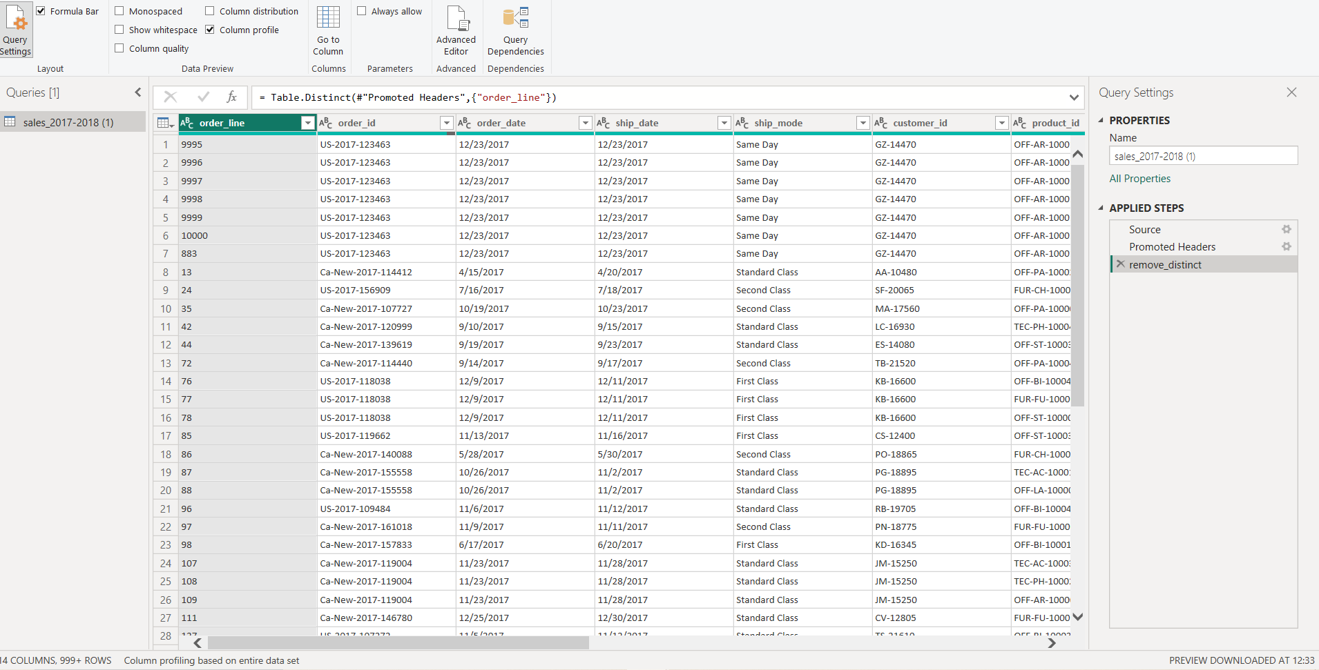

1. Table.sort :

