**BHAVANA CK**

1BM20CS403

CSE -4A

**PROGRAM 4: STUDENT FACULTY DATABASE**

**Consider the following database for student enrollment for course :**

**STUDENT(snum : integer, sname : string, major: string, lvl : string, age: integer)**

**CLASS(cname: string, meets at: time, room: string, fid: integer)**

**ENROLLED(snum: integer, cname: string)**

**FACULTY(fid: integer, fname: string, deptid: integer)**

**The meaning of these relations is straightforward; for example, Enrolled has one record per student-class pair such that the student is enrolled in the class. Level(lvl) is a two character code with 4 different values (example: Junior: JR etc)**

**Write the following queries in SQL. No duplicates should be printed in any of the answers.**

1. Find the names of all Juniors (level = JR) who are enrolled in a class taught by
2. Find the names of all classes that either meet in room R128 or have five or more Students enrolled.
3. Find the names of all students who are enrolled in two classes that meet at the same time.
4. Find the names of faculty members who teach in every room in which some class is taught.
5. Find the names of faculty members for whom the combined enrollment of the courses that they teach is less than five.
6. Find the names of students who are not enrolled in any class.
7. For each age value that appears in Students, find the level value that appears most often. For example, if there are more FR level students aged 18 than SR, JR, or SO students aged 18, you should print the pair (18, FR).

create database studentfaculty;

use studentfaculty;

create table student(

snum int not null,

sname varchar(20) not null,

major varchar(2) not null,

lvl varchar(2) not null,

age int not null,

primary key (snum)

);

create table faculty(

fid int not null,

fname varchar(20) not null,

deptid int not null,

primary key(fid)

);

create table class(

cname varchar(20) not null,

meetsat datetime not null,

room varchar(4) not null,

fid int not null,

primary key (cname),

foreign key(fid)references faculty(fid)

);

create table enrolled(

snum int not null,

cname varchar(20) not null,

primary key(snum,cname),

foreign key(snum)references student(snum),

foreign key(cname) references class(cname )

);

insert into student values (1,"Jhon","CS","Sr",19) ,

(2,"Smith","CS","Jr",20),

(3,"Jacob","CV","Sr",20),

(4,"Tom","CS","Jr",20),

(5,"Rahul","CS","Jr",20),

(6,"Ria","CS","Sr",21);

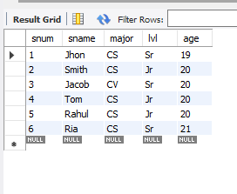

insert into faculty values(11,"Harish",1000),

(12,"MV",1000),

(13,"Mira",1001),

(14,"Shiva",1002),

(15,"Nupur",1000);

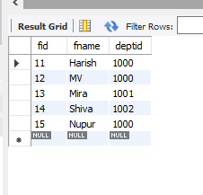

insert into class values("class 1","2015-11-12 10:15:16","R1",14),

("class 10","2015-11-12 10:15:16","R128",14),

("class 2","2015-11-12 10:15:20","R2",12),

("class 3","2015-11-12 10:15:25","R3",11),

("class 4","2015-11-12 20:15:20","R4",14),

("class 5","2015-11-12 20:15:20","R3",15),

("class 6","2015-11-12 13:20:20","R2",14),

("class 7","2015-11-12 10:10:10","R3",14);

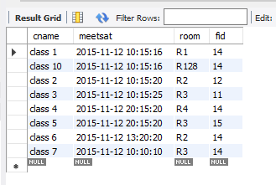

insert into enrolled values(1,"class 1"),

(2,"class 1"),

(3,"class 3"),

(4,"class 3"),

(5,"class 4");

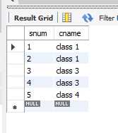

------ Find the names of all Juniors (level = JR) who are enrolled in a class taught by

select s.sname from student s,enrolled e,class c

where s.snum=e.snum and c.cname = e.cname and c.fid =(select fid from faculty

where fname ="Harish")and s.lvl="Jr";

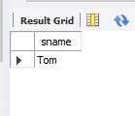

------ Find the names of all classes that either meet in room R128 or have five or more Students enrolled.

select c.cname from class c

where c.room = "R128"

or c.cname in(select e.cname from enrolled e group by e.cname having count(*)>=5);

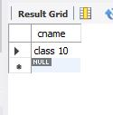

------ Find the names of all students who are enrolled in two classes that meet at the same time.

select distinct s.sname from student s

where s.snum in(select e1.snum from enrolled e1,enrolled e2,class c1,class c2

where e1.snum=e2.snum and e1.cname<>e2.cname and e1.cname = c1.cname

and e2.cname=c2.cname and c1.meetsat=c2.meetsat);

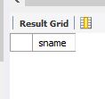

------ Find the names of faculty members who teach in every room in which some class is taught.

select f.fname,c.fid from faculty f,class c

where f.fid = c.fid

group by c.fid

having count(c.fid)=(select count(distinct room) from class);

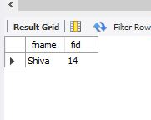

------ Find the names of faculty members for whom the combined enrollment of the courses that they teach is less than five.

select distinct fname from faculty f

where 5>(select count(e.snum)from enrolled e,class c

where c.cname = e.cname and c.fid = f.fid);

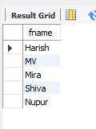

------ Find the names of students who are not enrolled in any class.

select s.sname from student s

where snum not in(select snum from enrolled);

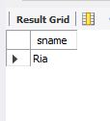

------ For each age value that appears in Students, find the level value that appears most often. For example, if there are more FR level students aged 18 than SR, JR, or SO students aged 18, you should print the pair (18, FR).

select s.age,s.lvl from student s

group by s.age having s.lvl in(select s1.lvl from student s1

where s1.age = s.age group by s1.age having count(*)>=all(select s2.lvl from student s2

where s2.age = s1.age group by s2.age));

