BHAVANA CK

1BM20CS403

CSE-4A

**Program 6 : Order Database**

**Consider the following schema for Order Database:**

**SALESMAN (*Salesman_id, Name, City, Commission*)**

**CUSTOMER (*Customer_id, Cust_Name, City, Grade, Salesman_id*)**

**ORDERS (*Ord_No, Purchase_Amt, Ord_Date, Customer_id, Salesman_id*)**

**Write SQL queries to**

**1. Count the customers with grades above Bangalore’s average.**

**2. Find the name and numbers of all salesmen who had more than one customer.**

**3. List all salesmen and indicate those who have and don’t have customers in their cities (Use UNION operation.)**

**4. Create a view that finds the salesman who has the customer with the highest order of a day.**

**5. Demonstrate the DELETE operation by removing salesman with id 1000. All his orders must also be deleted.**

create database Orderdb;

use Orderdb;

create table Salesman(

salesman_id int not null,

salesman_name varchar(20) not null,

city varchar(20) not null,

commission int not null,

primary key(salesman_id)

);

create table Customer(

customer_id int not null,

customer_name varchar(20) not null,

city varchar(20) not null,

grade int not null,

salesman_id int,

primary key(customer_id),

foreign key(salesman_id)references Salesman(salesman_id) on delete set null

);

create table Orders(

order_id int not null,

purchase_amt int not null,

order_date date not null,

customer_id int not null,

salesman_id int,

primary key(order_id),

foreign key(customer_id)references Customer(customer_id),

foreign key(salesman_id)references Salesman(salesman_id) on delete set null

);

insert into Salesman

values(1000,'John','Bangalore',25),

(2000,'Ravi','Bangalore',20),

(3000,'Kumar','Mysore',15),

(4000,'Smith','Delhi',30),

(5000,'Harsha','Hyderabad',15);

insert into Customer

values(10,'Preethi','Bangalore',100,1000),

(11,'Vivek','Mangalore' ,300,1000),

(12,'Bhaskar','Chennai',400,2000),

(13,'Chethan','Bangalore',200,2000),

(14,'Mamatha','Bangalore',400,3000);

insert into Orders

values(50,5000,'2017-05-04',10,1000),

(51,450,'2017-01-20',10,2000),

(52,1000,'2017-02-24',13,2000),

(53,3500,'2017-04-13',14,3000),

(54,550,'2017-03-09',12,2000);

----- **Count the customers with grades above Bangalore’s average.**

select count(customer_name)from Customer where grade> (Select avg(grade) from Customer where city ='Bangalore');

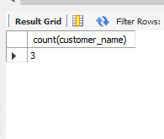

**------- Find the name and numbers of all salesmen who had more than one customer.**

select distinct c.salesman_id,s.salesman_name from Customer c,Salesman s

where c.salesman_id=s.salesman_id

and 1<(select count(customer_id) from Customer where salesman_id=c.salesman_id);

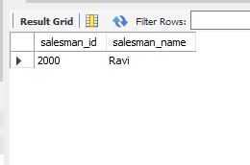

------ **List all salesmen and indicate those who have and don’t have customers in their cities (Use UNION operation.)**

select s.salesman_name,c.customer_name from Salesman s,Customer c

where s.salesman_id=c.salesman_id and c.city=s.city

union

select s.salesman_name,'No Match' from Salesman s,Customer c

where s.salesman_id = c.salesman_id and c.city!=s.city;

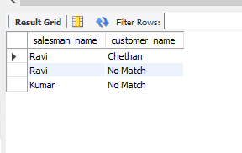

-------**Create a view that finds the salesman who has the customer with the highest order of a day.**

create view salesman_view as

select o.order_date ,salesman_id,sum(o.purchase_amt)from Orders o group by order_date

having sum(purchase_amt)=(select max(sum(purchase_amt))from Customer

where order_date =o.order_date and salesman_id =o.salesman_id);

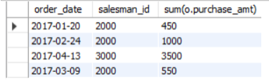

------**Demonstrate the DELETE operation by removing salesman with id 1000. All his orders must also be deleted.**

delete from Salesmn where salesman_id=1000;

select*from Salesman;

select * from Orders;

