RAJIV ACADEMY FOR TECHNOLOGY & MANAGEMENT


MINI PROJECT
On
Scanning of Ideas for Opportunities
Topic:
Portable Solar Charger with Battery Bank
Submitted for the partial fulfillment towards the award
of the degree in
MASTER OF BUSINESS ADMINISTRATION
Of
Dr. A.P.J. Abdul Kalam Technical University,
Uttar Pradesh, Lucknow

Submitted By Under the Supervision of
Bhavana Dubey Ms.Varsha Sharma
Roll Number: MB25005 Department of Management

DECLARATION
I, Bhavana Dubey, pursuing Master of Business Administration (MBA), hereby declare that the Mini Project Report titled:“Portable Solar Charger with Battery Bank”
is my original work carried out under the guidance of Ms.Varsha Sharma Faculty, Department of Management Studies.
I further declare that:
- The work presented in this report is authentic and has not been submitted, in part or full, to any other University or Institution for the award of any degree, diploma, or certificate.
- All sources of information and references used in the preparation of this report have been duly acknowledged.
I take full responsibility for the authenticity of the content of this project report.
Date: ______________________
Signature of the Student
Bhavana Dubey

CERTIFICATE

This is to certify that the Mini Project titled “Portable Solar Charger with Battery Bank” submitted by Bhavana Dubey, student of MBA (2025–27), Rajeev Academy for Technology & Management, has been completed under my supervision in partial fulfillment of the requirements for the course BMB 152 – Mini Project–1.
The project represents the student’s original work and has not been submitted anywhere else for any academic purpose.
Faculty Guide Signature:
Date: _____________________

ACKNOWLEDGEMENT

I express my profound gratitude to my project guide and all the faculty members of the Department of Management Studies for their unwavering guidance, motivation, and support throughout the execution of this project. Their insightful suggestions helped me explore the subject thoroughly and structure my work in a meaningful way.
I am deeply thankful to the teachers, institutional staff, and students who participated in my surveys and interviews as part of the opportunity scanning process. Their honest responses provided practical insights into the existing challenges in attendance management and student performance evaluation.
I appreciate the institution for offering an academic environment that nurtures creativity, innovation, and critical thinking. I also extend heartfelt thanks to my friends and classmates who assisted me in secondary research, data gathering, and proof-reading.
Lastly, I am indebted to my family for constantly motivating me and encouraging me to put in my best efforts.

Introduction
The increasing dependence on smartphones, personal gadgets, and small electronic devices has created a constant need for portable power solutions. The world is moving toward sustainable energy sources, and solar energy has emerged as one of the most accessible and eco-friendly alternatives. While traditional power banks rely on electricity for charging, they become ineffective during outdoor travel, emergencies, and in rural areas with limited power availability.
To bridge this gap, the idea of a Portable Solar Charger with Battery Bank was selected while scanning opportunities for innovation. This product captures solar energy through photovoltaic panels and stores it in a rechargeable battery pack, enabling device charging anytime, anywhere. It combines sustainability, affordability, and convenience—making it highly relevant in today’s world.

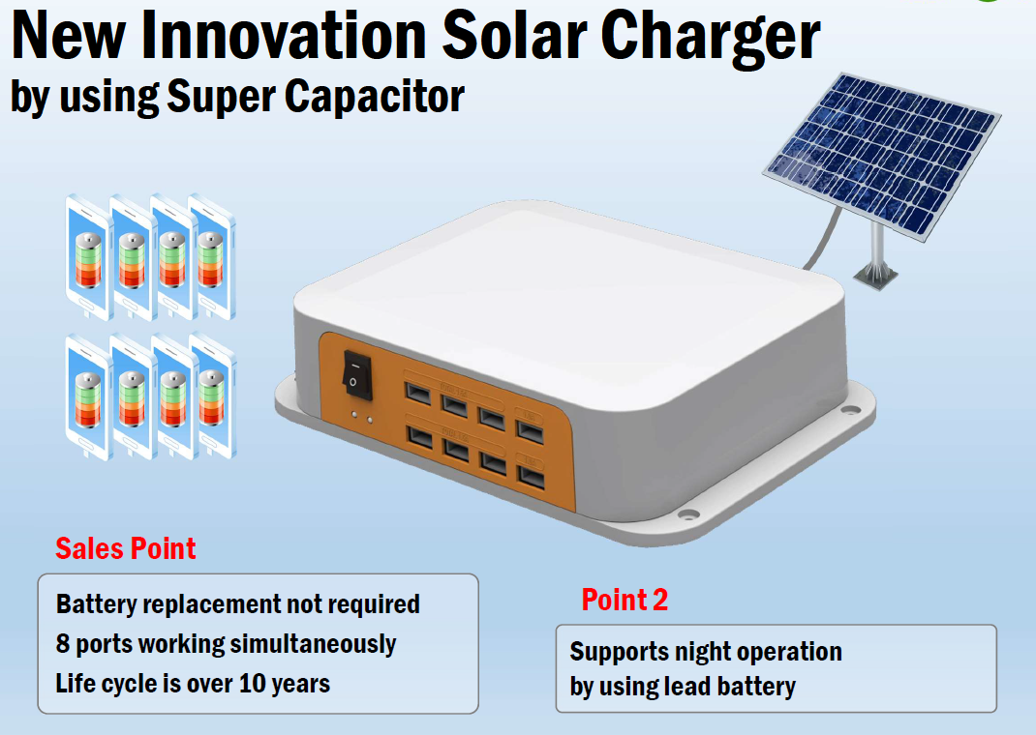

Importance and Relevance of the Idea

Growing Dependence on Portable Electronics
People rely extensively on devices like smartphones, Bluetooth speakers, TWS earbuds, fitness bands, and digital cameras. These devices require uninterrupted battery support. The portable solar charger provides a reliable power source during travel, trekking, fieldwork, and power outages.

Environmental Sustainability
Solar energy is clean, renewable, and abundant. By shifting from conventional electricity-based chargers to solar-powered alternatives, users reduce their carbon footprint. This innovation promotes environmental consciousness and supports global sustainability initiatives.

Practical for Rural and Remote Regions
In many areas, electricity supply is inconsistent. Portable solar chargers can greatly benefit rural households, small shops, farmers, and travelers in remote regions.

Emergency Use
During natural disasters, power failures, and outdoor emergencies, a solar-powered battery bank can be a lifesaver.

Feasibility Analysis

Technical Feasibility
- Solar panels (5W–20W) are widely available.
- Lithium-ion batteries are cost-effective and offer good power capacity.
- Charging controllers and voltage regulators can be easily integrated.
- The design does not require complex manufacturing.

Economic Feasibility
- Estimated production cost: ₹800–₹2,500 depending on battery size.
- Affordable pricing ensures high demand.
- Can be manufactured locally with minimal resources.

Operational Feasibility
- Lightweight and easy to use.
- Requires little to no maintenance.
- Works in all environments where sunlight is available.

Market Feasibility
- Suitable for students, travelers, trekkers, remote workers, photographers, and rural users.
- Increasing demand for portable chargers boosts market acceptance.

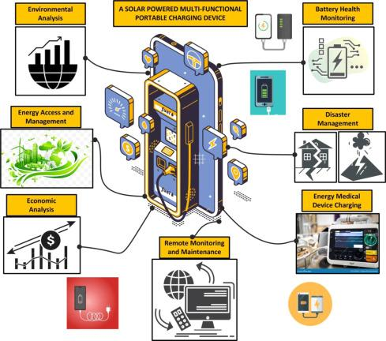

Detailed Description of the Idea
A portable solar charger with a built-in battery bank consists of: -
Solar panels for capturing sunlight.
Battery bank for storing energy.
Charge controller for regulating energy flow.
USB charging ports for output.
LED indicators for power status.
Lightweight casing, often foldable.
The device works by converting sunlight into electrical energy, storing it, and providing charging capability even at night.
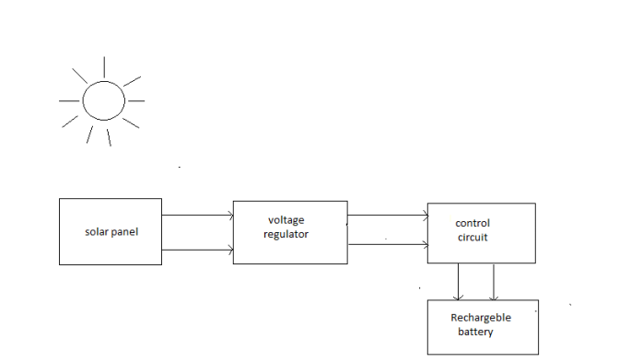

Working Principle:-
• The solar panel converts sunlight into electrical energy.
• The charge controller regulates voltage and current to protect the battery.
• The battery bank stores energy for later use.
• USB output ports supply power to electronic devices.
• The system works in a continuous circular cycle as long as sunlight is available.

Target Market

Primary Market
- Frequent travelers
- Trekking and camping enthusiasts
- Students and professionals
- Rural households
- Farmers working outdoors

Secondary Market
- Disaster management authorities
- NGOs working in remote villages
- Defense and paramilitary units
- Mountaineers and explorers

Market Trends & Need
- Growing adoption of smartphones and personal gadgets.
- Increased travel culture.
- Rising awareness about renewable energy.

SWOT Analysis

Strengths
- Renewable and eco-friendly energy source
- Works without electricity
- Highly portable and user-friendly
- Low maintenance

Weaknesses
- Charging depends on sunlight
- Slower compared to traditional electricity chargers
- Weather-dependent performance

Opportunities
- Growing demand for eco-friendly products
- Can expand into the rural electrification market
- Opportunity for government partnerships and subsidies
- Can be enhanced with wireless charging, waterproofing, and fast-charge technology

Threats
- Competition from high-capacity traditional power banks
- Cheap low-quality imports affecting market trust
- Seasonal variations in solar intensity

Product Design Description

- Foldable solar panel sheet connected with hinges.
- Shock-proof ABS casing for the battery bank.
- Weather-resistant coating on solar panels.
- 2–3 USB ports for charging multiple devices.
- LED indicators for battery and charging status.

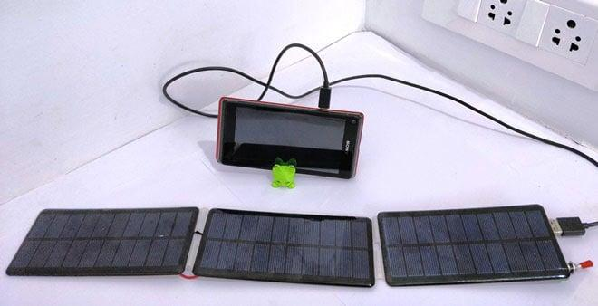

Future Enhancements

- Wireless charging support
- Flexible solar panels
- Solar tracking technology
- Waterproof and rugged design
- Larger capacity (30,000mAh+)
- Built-in flashlight or SOS signal

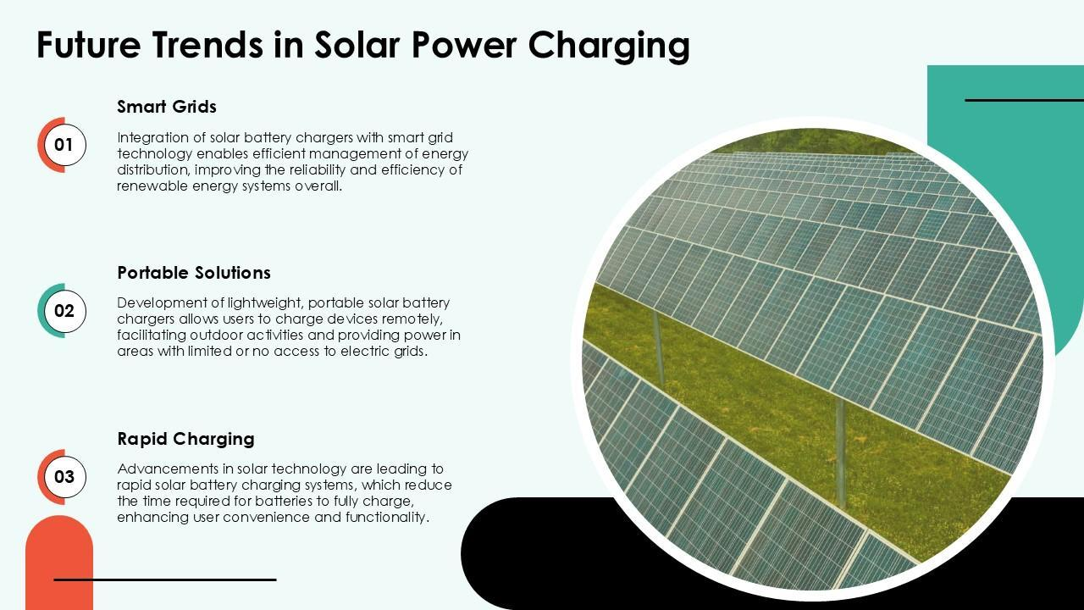

Costing and Financial Feasibility
A detailed costing analysis helps determine whether manufacturing the Portable Solar Charger with Battery Bank is financially viable.

Estimated Cost Breakdown (Per Unit)
Component | Estimated Cost (INR)
Solar Panel (10W) | ₹250–₹350
Lithium-Ion Battery (10,000–15,000 mAh) | ₹300–₹500
Charge Controller / Regulator | ₹80–₹120
USB Ports & Wiring | ₹30–₹50
Protective ABS Casing | ₹80–₹100
LED Indicators | ₹10–₹20
Assembly & Labour | ₹50–₹100
Packaging | ₹20–₹30
Total Estimated Cost | ₹820–₹1,270

Selling Price Suggestion
- Retail Selling Price: ₹1,500 – ₹2,000
- Profit Margin: 25% – 40% depending on scale.

Break-Even Analysis (Simplified)
- Fixed setup cost (tools, workspace): ₹20,000 – ₹30,000
- Profit per unit: ₹300 – ₹600
- Break-even point: ~60–80 units
This shows the product is financially viable even with small-scale production.

Environmental Impact Assessment
The environmental impact assessment of the Portable Solar Charger with Battery Bank studies how the product influences the environment across its entire life cycle—from material extraction, manufacturing, usage, and disposal. Solar-powered devices play an important role in reducing carbon footprints and promoting sustainability.

Positive Environmental Impacts

1. Zero Emission During Use
The portable solar charger produces no greenhouse gases during its operation. It relies completely on sunlight, making it a clean energy product.

2. Reduction in Electricity Consumption
Traditional power banks require grid electricity, most of which in India is generated from coal. Using solar chargers reduces dependency on non-renewable energy sources.

3. Promotion of Renewable Energy Awareness
By adopting small-scale solar devices, users become more aware of renewable energy and tend to adopt other eco-friendly practices in daily life.

4. Encourages Off-Grid Sustainable Living
For rural areas, solar chargers reduce pressure on local electricity systems, especially in communities where power supply is scarce.

Environmental Benefits at Large Scale
If solar chargers become widely adopted: - Significant reduction in fossil fuel usage - Lower carbon dioxide emissions - Reduced burden on national electricity grids - Encouragement of circular economy for electronic components

Environmental Limitations
- Weather dependency reduces efficiency during monsoons or cloudy days.
- Recharging may slow down in winter due to lower sunlight intensity.
- Overuse and poor disposal can contribute to e-waste.

Long-Term Environmental Forecast
If portable solar chargers gain mainstream acceptance: - India could save millions of units of electricity annually. - Carbon emissions could decline as consumers shift to solar charging. - Reduction in reliance on diesel generators during emergencies. - More green jobs related to solar manufacturing and recycling.

Comparative Environmental Impact
Factor | Traditional Power Banks | Solar Chargers
Energy Source | Grid electricity | Sunlight (free & clean)
CO₂ Emission | High | Zero during use
Long-Term Effect | Higher carbon footprint | Sustainable and renewable
Waste Generation | Moderate | Low (with recycling programs)

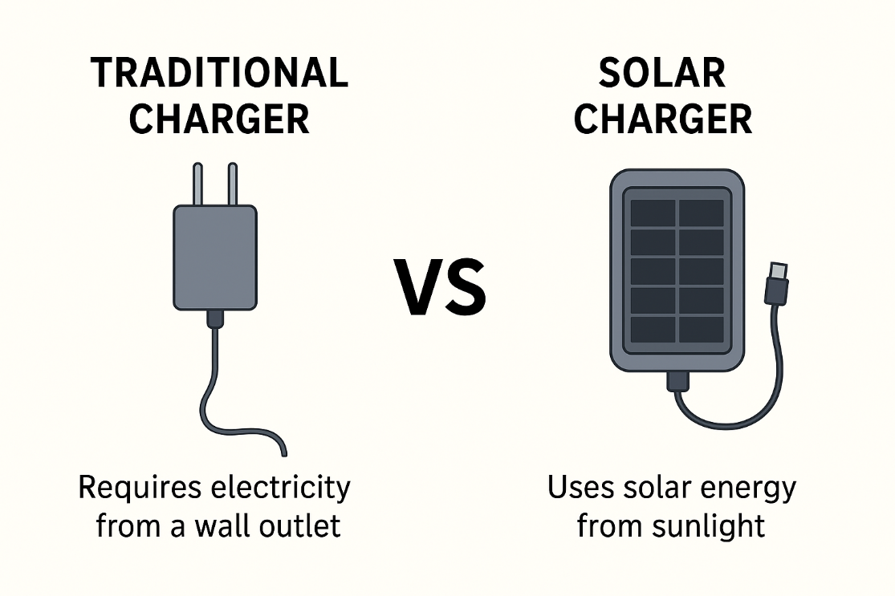

Conclusion
The Portable Solar Charger with Battery Bank is a simple yet impactful innovative idea that addresses a real and growing problem of reliable mobile charging. In today’s digital world, where smartphones and electronic devices are essential for communication, education, business, and safety, uninterrupted power access has become a necessity rather than a luxury. However, frequent power cuts, remote locations, outdoor activities, and emergency situations highlight the limitations of traditional charging systems.
This project successfully demonstrates how solar energy, a renewable and eco-friendly resource, can be effectively used to develop a portable and practical charging solution. The proposed system not only reduces dependency on grid electricity but also promotes sustainable energy usage. The idea is technically feasible, economically viable, and environmentally responsible, making it suitable for both urban and rural users.
Through feasibility analysis, costing evaluation, use-case scenarios, case study, and environmental impact assessment, it is evident that the Portable Solar Charger has strong market potential. The targeted market such as travelers, students, farmers, disaster-affected areas, and rural households further proves its relevance. The SWOT analysis also shows that while there are some limitations like weather dependency, the strengths and opportunities significantly outweigh the weaknesses.

In conclusion, this innovative idea has the potential to contribute positively to energy conservation, environmental protection, and social development. With further improvements in solar panel efficiency, battery technology, and design optimization, the product can become even more effective and widely adopted. Thus, the Portable Solar Charger with Battery Bank stands as a meaningful step towards a greener, smarter, and more sustainable future.

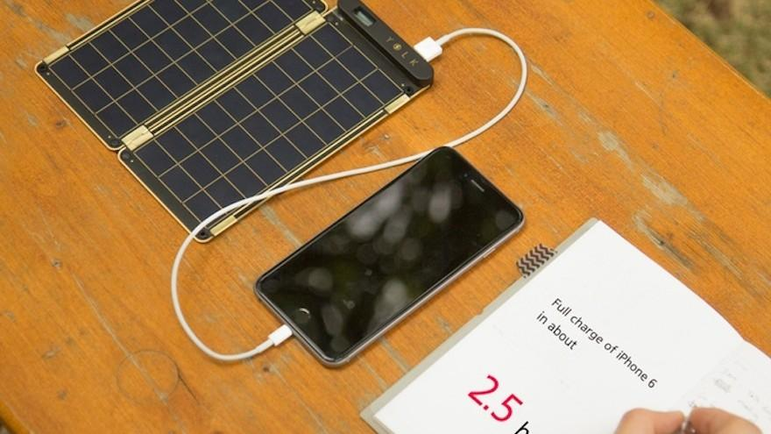

Survey Questionnaire (Google Form)
The primary data for this project was collected through an online survey using Google Forms. The questionnaire was circulated among respondents using the following link:

Survey Link:
https://docs.google.com/forms/d/e/1FAIpQLSdP8VgLFTmKdWrSHzXbVwH4sraP-9bBzM8y4S2yNfSXd1W5aQ/viewform?usp=header

