Brains In Jars

***Team***

***Department: Information Technology***

Name : B. Naga Mallika

Roll no.19131A1216

Gmail: 19131a1216@gvpce.ac.in



Name : G. Bhavana

Roll no.19131A1236

Gmail: 19131a1236@gvpce.ac.in

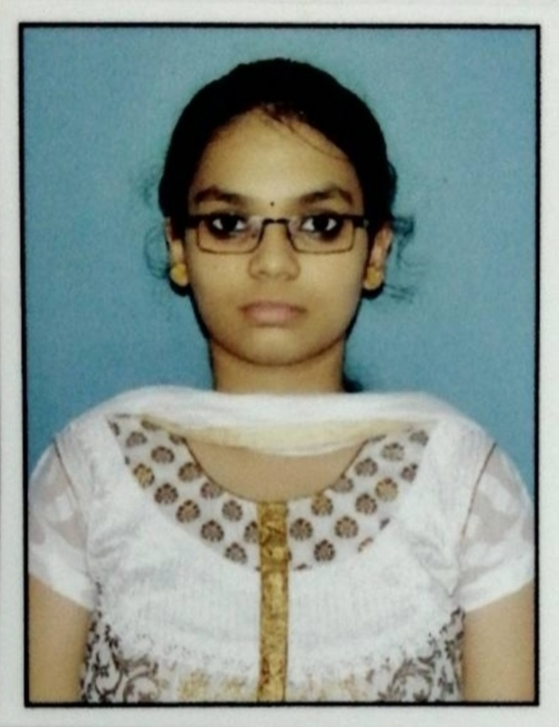

Name : K. Sai Supraja

Roll no.19131A1246

Gmail: 19131a1246@gvpce.ac.in

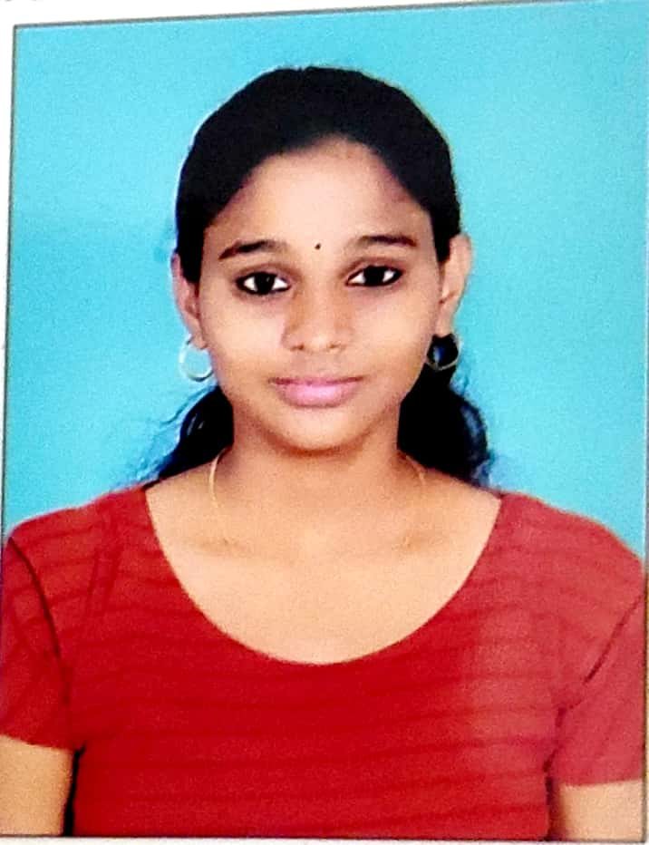

Name : P. Bhanu

Roll no.20135A1208

Gmail: 20135a1208@gvpce.ac.in



***Project Guide***

Name:DR.K.K.Sandya Rani

Gmail: sandhyaranikk@gvpce.ac.in

***Abstract***

*Data visualization involves presenting data in graphical or pictorial form which makes the information easy to understand. It helps to explain facts and determine courses of action. It will benefit any field of study that requires innovative ways of presenting large, complex information. The advent of computer graphics has shaped modern visualization. This**paper presents a brief introduction of sorting the arrays with providing speed to perform the sort .*

***Domains where our solution can be implemented***

* *Data structures.*

***Our solution helping the selected domains***

Data Structures and Algorithms is a fundamental course in Computer Science. However, many students find it difficult because it requires abstract thinking. It would be very helpful if there was a visualization tool of data structures such as arrays for students to manipulate. The tool would allow students to see how an element is sorted in an array. Moreover, this tool would provide a simple language, by which students can write their own algorithms so that the execution of the algorithm is animated.

***Our engineering sol*ution**

This project is intended to create an exploration environment, in which students can learn through experimentation. This tool can be used as an effective supplement to the traditional classroom education and textbook for Data Structures and Algorithms courses. In this paper, a software application that features the visualization of commonly used data structures like array and demonstrates how the elements in the array are sorted.

.

***Team’s vision***

To implement a successful visualization for array sorting algorithms.



Name

:DR.K.K.Sandya Rani Gmail: sandhyaranikk@gvpce.ac.in