AI-INTEGRATED DECENTRALIZED E-VOTING SYSTEM USING ETHEREUM BLOCKCHAIN
A Project Report Submitted in Partial fulfilment of the Requirement for the
Award of the Degree of

BACHELOR OF TECHNOLOGY
IN
COMPUTER SCIENCE AND ENGINEERING
Submitted by
NARIGAMMAGARI NANDINI
(229Y1A0594)

AKETY GURU SRAVANI | CHOWDAM CHOWDESWAR
(229Y1A0501) | (229Y1A0523)
GANGAVARAM BHAVANA
(229Y1A0541)

Under the Guidance of
S. KALYANI BAI M.Tech,
Assistant Professor
Department of Computer Science and Engineering


K.S.R.M. COLLEGE OF ENGINEERING
(UGC - AUTONOMOUS)
Approved by AICTE, New Delhi & Affiliated to JNTUA, Ananthapuramu
(Accredited by NAAC with A+ Grade & B.Tech.(Civil, EEE, Mech, ECE and CSE) Programs by NBA)
(An ISO 9001:2015,14001:2015,50001:2018 Certified Institution)
KADAPA – 516 005 (A.P.)
2025- 2026

K.S.R.M. COLLEGE OF ENGINEERING
(UGC - AUTONOMOUS)
Approved by AICTE, New Delhi & Affiliated to JNTUA, Ananthapuramu
(Accredited by NAAC with A+ Grade & B.Tech.(Civil, EEE, Mech, ECE and CSE) Programs by NBA)
(An ISO 9001:2015,14001:2015,50001:2018 Certified Institution)
KADAPA – 516 005 (A.P.)

DEPARTMENT OF COMPUTER SCIENCE AND ENGINEERING

CERTIFICATE
This is to certified that the project report entitled “AI - INTEGRATED DECENTRALIZED E - VOTING SYSTEM USING ETHEREUM BLOCKCHAIN” is being submitted by NARIGAMMAGARI NANDINI (229Y1A0594), AKETY GURU SRAVANI (229Y1A0501), CHOWDAM CHOWDESWAR (229Y1A0523), GANGAVARAM BHAVANA (239Y5A0541) to K.S.R.M. College of Engineering (UGC - AUTONOMOUS), Kadapa in partial fulfilment of the requirements for the award of the degree of “BACHELOR OF TECHNOLOGY” in “COMPUTER SCIENCE AND ENGINEERING” is a bonafide record of the project work carried out by them under our supervision during the period 2025-2026.

Project Guide  S. Kalyani Bai, M.Tech  Assistant Professor  Department of CSE | Head of the Department  Mr. A. Ramprakash Reddy,M.Tech,Ph.D  Assistant Professor & HoD  Department of CSE

Date: Internal Examiner External Examiner
DECLARATION BY THE CANDIDATES

We NARIGAMMAGARI NANDINI (229Y1A0594), AKETY GURU SRAVANI (229Y1A0501), CHOWDAM CHOWDESWAR (229Y1A0523), GANGAVARAM BHAVANA (239Y5A0541) hereby declare that the Project Report entitled “AI-INTEGRATED DECENTRALIZED E - VOTING SYSTEM USING ETHEREUM BLOCKCHAIN ” under the guidance of S.Kalyani bai, M.Tech., Assistant Professor, Department of CSE is submitted in partial fulfillment of the requirements for the award of the degree of Bachelor of Technology in Computer Science and Engineering.
This is a Record of bonafide work carried out by me and the results embodied in this Project Report have not been reproduced or copied from any source. The results embodied in this Project Report have not submitted to any other University or Institute for the Award of any other Degree or Diploma.

By
NARIGAMMAGARI NANDINI (229Y1A0594)
AKETY GURU SRAVANI (229Y1A0501)
CHOWDAM CHOWDESWAR (229Y1A0523)
GANGAVARAM BHAVANA (239Y5A0541)
Dept. of Computer Science & Engineering
K.S.R.M. College of Engineering (A)
Kadapa-516 005.AP

ACKNOWLEDGEMENT
An endeavour over a long period can be successful only with the advice and supports of many well-wishers. We take this opportunity to express our gratitude and appreciation to all of them.
We are extremely thankful to our beloved Managing Director Dr. K CHANDRA OBUL REDDY GARU who took keen interest and encouraged us in every effort throughout this course.
We wish to express our deepest sense of gratitude and pay our sincere thanks to our guide S.KALYANI BAI, M.Tech., Department of Computer Science and Engineering, K.S.R.M. College of Engineering (A), Kadapa for his valuable guidance and suggestions in analysing and testing throughout the period, till the end of project work completion and his timely suggestions and help.
We are very much thankful to Mr. A RAMPRAKASH REDDY, M.Tech, (Ph.D), Assistant Professor, Head of the Department for Computer Science and Engineering, K.S.R.M. College of Engineering (A), Kadapa for providing good facilities & congenial atmosphere in our college.
We take this opportunity to express our deep gratitude and appreciation to all those who encouraged us for successfully completion of this Project work. We wish to express our sincere to gratitude to Dr. T NAGESWARA PRASAD, M.Tech., Ph.D. Principal of K.S.R.M. College of Engineering(A), Kadapa and for their consistent help and encouragement to complete the project work.
We also thankful to all teaching and non-teaching staff of the Department of Computer Science and Engineering for their support throughout our B.Tech. course.
We express our heartfelt thanks to My Parents for their valuable support and encouragement in completion of my course. Also I express my heartfelt regards to my Friends for being supportive in completion of my project.
Project Associates
NARIGAMMAGARI NANDINI (229Y1A0594)
AKETY GURU SRAVANI (229Y1A0501)
CHOWDAM CHOWDESWAR (229Y1A0523)
GANGAVARAM BHAVANA (239Y5A0541)
K.S.R.M COLLEGE OF ENGINEERING
(UGC - AUTONOMOUS)
Approved by AICTE, New Delhi & Affiliated to JNTUA, Ananthapuramu
(Accredited by NAAC with A+ Grade & B.Tech.(Civil, EEE, Mech, ECE and CSE ) Programs by NBA)
(An ISO 9001:2015,14001:2015,5001:2018 Certified Institution)
KADAPA – 516 005 (A.P.)


INSTITUTION VISION & MISSION

VISION:
To evolve as center of repute for providing quality academic programs amalgamated with creative learning and research excellence to produce graduates with leadership qualities, ethical and human values to serve the nation.
MISSION:
M1: To provide high quality education with enriched curriculum blended with impactful teaching-learning practices.
M2: To promote research, entrepreneurship and innovation through industry collaborations.
M3: To produce highly competent professional leaders for contributing to Socio-economic development of region and the nation.

K.S.R.M COLLEGE OF ENGINEERING
(UGC - AUTONOMOUS)
Approved by AICTE, New Delhi & Affiliated to JNTUA, Ananthapuramu
(Accredited by NAAC with A+ Grade & B.Tech.(Civil, EEE,Mech,ECE and CSE ) Programs by NBA)
(An ISO 9001:2015,14001:2015,5001:2018 Certified Institution)
KADAPA – 516 005 (A.P.)

DEPARTMENT OF COMPUTER SCIENCE AND ENGINEERING

DEPARTMENT VISION & MISSION

VISION:
To evolve as a recognized center of excellence in the area of Computer Science and Engineering and other related inter-disciplinary fields.
MISSION:
M1: To produce competent and industry ready professionals through well balanced curriculum and innovative pedagogy.
M2: To provide conducive environment for research by establishing centre of excellence and industry collaborations.
M3: To instill leadership qualities, ethical values among students through various co-curricular and extracurricular activities.

PEOs, WKs, POs and PSOs
PROGRAMME EDUCATIONAL OBJECTIVES
PEO1: To excel in their career as competent software engineer in IT and allied organizations.
PEO2: To pursue higher education and to demonstrate research temper for providing solution engineering problems.
PEO3: To contribute for the societal development by exhibiting leadership, through professional, social and ethical values.
KNOWLEDGE AND ATTITUDE PROFILE (WK)
WK1: A systematic, theory-based understanding of the natural sciences applicable to the discipline and awareness of relevant social sciences.
WK2: Conceptually-based mathematics, numerical analysis, data analysis, statistics and formal aspects of computer and information science to support detailed analysis and modelling applicable to the discipline.
WK3: A systematic, theory-based formulation of engineering fundamentals required in the engineering discipline.
WK4: Engineering specialist knowledge that provides theoretical frameworks and bodies of knowledge for the accepted practice areas in the engineering discipline; much is at the forefront of the discipline.
WK5: Knowledge, including efficient resource use, environmental impacts, whole-life cost, reuse of resources, net zero carbon, and similar concepts, that supports engineering design and operations in a practice area.
WK6: Knowledge of engineering practice (technology) in the practice areas in the engineering discipline.
WK7: Knowledge of the role of engineering in society and identified issues in engineering practice in the discipline, such as the professional responsibility of an engineer to public safety and sustainable development.
WK8: Engagement with selected knowledge in the current research literature of the discipline, awareness of the power of critical thinking and creative approaches to evaluate emerging issues.
WK9: Ethics, inclusive behavior and conduct. Knowledge of professional ethics, responsibilities, and norms of engineering practice. Awareness of the need for diversity by reason of ethnicity, gender, age, physical ability etc. with mutual understanding and respect, and of inclusive attitudes.
PROGRAMME OUTCOMES
PO1 - Engineering Knowledge: Apply the knowledge of mathematics, science, engineering fundamentals, and an engineering specialization to the solution of complex engineering problems.
PO2 - Problem Analysis: Identify, formulate, review research literature, and analyze complex engineering problems reaching substantiated conclusions using first principles of mathematics, natural sciences, and engineering sciences.
PO3 - Design/Development of solutions: Design solutions for complex engineering problems and design system components or processes that meet the specified needs with appropriate consideration for the public health and safety, and the cultural, societal, and environmental considerations.
PO4 - Conduct investigations of complex problems: Use research-based knowledge and research methods including design of experiments, analysis and interpretation of data, and synthesis of the information to provide valid conclusions.
PO5 - Modern tool usage: Create, select, and apply appropriate techniques, resources, and modern engineering and IT tools including prediction and modelling to complex engineering activities with an understanding of the limitations.
PO6 - Environment and sustainability: Understand the impact of the professional engineering solutions in societal and environmental contexts, and demonstrate the knowledge of, and need for sustainable development.
PO7 - Ethics: Apply ethical principles and commit to professional ethics and responsibilities and norms of engineering practice.
PO8 - Individual and team work: Function effectively as an individual, and as a member or leader in diverse teams, and in multidisciplinary settings.
PO9 - Communication: Communicate effectively on complex engineering activities with the engineering community and with society at large, such as, being able to comprehend and write effective reports and design documentation, make effective presentations, and give and receive clear instructions.
PO10 - Project management and finance: Demonstrate knowledge and understanding of the engineering and management principles and apply these to one's own work, as a member and leader in a team, to manage projects and in multidisciplinary environments.
PO11 - Life-long learning: Recognize the need for, and have the preparation and ability to engage in independent and life-long learning in the broadest context of technological change.

PROGRAMME SPECIFIC OUTCOMES

PSOs are statements that describe what the graduates of a specific engineering program should be able to do:
PSO1 - Apply engineering principles and methodologies in software project development utilizing open-ended programming environments.
PSO2 - Analyse, design, develop and deploy IT Solutions/applications combined with the ability of efficient algorithms and Artificial Intelligence, User experience design, Data Management and Software System Design Principles following professional engineering practices.
PSO3 - Design and develop solutions, application/system software using modern programming languages, tools, and platforms for sustained computer science and engineering applications.

Table of Contents
 |  |  | Description | Page No.
 |  |  | Abstract | ix
 |  |  | List of Abbreviations | xi
 |  |  | List of Figures | xii
 |  |  | List of Tables | xiii
Chapter-1 |  |  | INTRODUCTION | 1 – 12
 | 1.1 |  | Introduction
 | 1.2 |  | Domain Description
 | 1.3 |  | Problem Definition
 | 1.4 |  | Proposed Solution
 | 1.5 |  | Objectives
 | 1.6 |  | Organization of the Project report
Chapter-2 |  |  | LITERATURE SURVEY | 13-19
 | 2.1 |  | Introduction
 | 2.2 |  | Related Work
 | 2.3 |  | Overview
Chapter-3 |  |  | SYSTEM ANALYSIS | 21-30
 | 3.1 |  | Introduction
 | 3.2 |  | Existing System & Disadvantages
 | 3.3 |  | Proposed System &Advantages
 | 3.4 |  | Software Requirements
 | 3.5 |  | Hardware Requirements
 | 3.6 |  | Modules Description
 |  | 3.6.1 | Data Collection Module
 |  | 3.6.2 | Data Preprocessing Module
 |  | 3.6.3 | Clustering and Health Pattern Module
 |  | 3.6.4 | Health Insights and Recommendation Module
 | 3.7 |  | System Architecture
 | 3.8 |  | Feasibility Study
 |  | 3.8.1 | Economic Feasibility
 |  | 3.8.2 | Technical Feasibility
 |  | 3.8.3 | Procedural Feasibility
 | 3.9 |  | System Requirements
 |  | 3.9.1 | Hardware Requirements
 |  | 3.9.2 | Software Requirements
Chapter-4 |  |  | SYSTEM DESIGN | 31-39
 | 4.1 |  | Introduction
 | 4.2 |  | DFD Diagrams
 | 4.3 |  | UML Diagrams
 |  | 4.3.1  3 | Use Case Diagram
 |  | 4.3.2  3 | Sequence Diagram
 |  | 4.3.3  3 | Class Diagram
 |  | 4.3.4  3 | Collaboration Diagram
 |  | 4.3.5  3 | Activity Diagram
Chapter-5 |  |  | SYSTEM CODING AND TESTING | 40-60
 | 5.1 |  | Introduction
 | 5.2 |  | Implementation
 | 5.3 |  | About Python
 | 5.4 |  | Sample Code
 | 5.5 |  | Software Testing Techniques
 | 5.6 |  | Software Testing Strategies
Chapter-6 |  |  | RESULTS | 61-66
 | 6.1 |  | Introduction
 | 6.2 |  | Output Screens
Chapter-7 |  |  | CONCLUSION AND FUTURE ENHANCEMENT | 67-69
 | 7.1 |  | Conclusion
 | 7.2 |  | Future Enhancements
 |  |  | REFERENCES | 70-71
 |  |  | Appendix-1 (Publication Details)
 |  |  | CO-PO & PSO mapping
 |  |  | Rubrics for Evaluation
 |  |  | Bio-Data of Team Members

ABSTRACT

No prior e-voting system has detected voter coercion in real time. This paper presents a decentralized blockchain voting architecture that achieves 98.0% accuracy in coercion detection, 96.0% precision in anti-spoofing, and 92.1% precision in face recognition, operating entirely on commodity hardware without specialized peripherals. Existing electronic voting platforms fail on three counts: centralized databases invite manipulation, monolithic server designs create single breach points, and the absence of cryptographic audit trails leaves coercion entirely undetected. The proposed architecture addresses all three simultaneously through three independent security layers. The first layer is a three-factor authentication protocol combining blockchain wallet ownership, dual-channel one-time password delivery, and convolutional neural networkdriven biometric face verification. The second layer applies client-side RSA-2048 ballot encryption with decentralized key management through Shamir's Secret Sharing, requiring any three of five designated officials to cooperate before a single vote decrypts. The third layer is a continuous computer-vision sentinel that monitors the voting session throughout and triggers a tiered lockout upon detecting a second face. Validation used the Labelled Faces in the Wild benchmark, the CelebA-Spoof dataset, and 130 controlled session recordings. Transaction confirmation averaged 4.8 seconds at 45,000 gas units. Formal analysis confirms resistance to replay, Sybil, manin-the-middle, spoofing, and coercion attack vectors. Keywords—Anti-coercion, blockchain, CNN, e-voting, Ethereum, face recognition, RSA encryption, Shamir's secret sharing, smart contracts, three-factor

LIST OF ABBREVIATIONS

Abbreviation | Full Form
AI | Artificial Intelligence
CNN | Convolutional Neural Network
EVM | Electronic Voting Machine
OTP | One-Time Password
RSA | Rivest–Shamir–Adleman
SSS | Shamir’s Secret Sharing
SHA | Secure Hash Algorithm
DApp | Decentralized Application
REST | Representational State Transfer
SQL | Structured Query Language
DFD | Data Flow Diagram
API | Application Programming Interface
UML | Unified Modeling Language
SDK | Software Development Kit
PIP | Picture-in-Picture

LIST OF FIGURES

S.No | Figure No | Diagram | Page No
1 | 3.7.1 | System Architecture
2 | 4.3.1 | Use case Diagram
3 | 4.3.2 | Sequence Diagram
4 | 4.3.3 | Class Diagram
5 | 4.3.4 | Collaboration Diagrams
6 | 4.3.5 | Activity Diagram
7 | 6.2.1 | Home Page
8 | 6.2.2 | Admin Dashboard
9 | 6.2.3 | Voter Registration
10 | 6.2.4 | Add Candidate
11 | 6.2.5 | Election Key Setup
12 | 6.2.6 | Voter Authentication
13 | 6.2.7 | Vote Casting
14 | 6.2.8 | Anti-Coercion Alert
15 | 6.2.9 | Election Results
16 | 6.7.10 | OTP Email Verification

LIST OF TABLES

S.No | Table No | Table Name | Page No
1 | 2.1 | Camparative Analysis of Related E-voting System
2 | 3.1 | Hardware Requirements
3 | 3.2 | Software Requirements
4 | 5.1 | Test Case Results
5 | 6.1 | Performance Metrics of Biomettric Modules

Chapter 1
Introduction 1-12
1.1 Introduction
1.2 Domain Description about the area of project
1.3 Problem Definition
1.4 Proposed Solution
1.5 Objective
1.6 Organization of the Project report

1. INTRODUCTION
1.1 Introduction
The democratic process depends on the integrity, accessibility, and secrecy of voting. As elections scale globally, paper-based voting has incurred logistical costs, delays, and accuracy concerns. Electronic Voting Machines (EVMs) addressed some challenges but introduced critical vulnerabilities: centralized database manipulation, identity spoofing through proxy votes, and voter coercion. Blockchain technology has emerged as a promising solution due to its decentralization, immutability, and transparency. However, storing votes in plaintext on the blockchain creates a fundamental conflict between transparency and ballot secrecy: any node operator can view individual votes, violating the secrecy principle essential for preventing coercion. This project presents an AI-integrated decentralized e-voting system leveraging Ethereum blockchain, three-factor authentication (3FA), RSA-2048 ballot encryption, Shamir's Secret Sharing (SSS) for decentralized key management, and real-time AI-based anti-coercion monitoring, simultaneously achieving transparency, vote secrecy, biometric identity assurance, and coercion resistance.

1.2 Domain Description about the Area of Project
This project falls under the intersection of multiple technology domains including Blockchain Technology, Artificial Intelligence, Cryptography, and Web Application Development. Each of these domains contributes critical capabilities that together enable a comprehensive secure voting solution.

1.2.1 Blockchain Technology
Blockchain is a distributed, immutable ledger recording transactions across peer-to-peer nodes. Each block contains a cryptographic hash of the previous block, timestamp, and transaction records, making tampering detectable. The Ethereum blockchain supports smart contracts (Solidity) that handle all on-chain voting logic: voter registration, encrypted ballot storage, candidate management, and election state management. Each vote transaction consumes approximately 45,000 gas units.

1.2.2 Artificial Intelligence and Computer Vision
AI enables biometric face recognition for voter identity verification and real-time anti-coercion monitoring via Convolutional Neural Networks (CNNs). The Face-api.js library (TensorFlow.js) implements SSD MobileNet v1 for face detection, extracting 68 facial landmarks and generating a 128-dimensional facial descriptor. The anti-coercion module analyzes webcam frames every second to detect multiple faces, unrecognized faces, or face absence.

1.2.3 Cryptography
RSA-2048 asymmetric encryption secures ballots client-side before blockchain transmission. Shamir's Secret Sharing (SSS) splits the election private key into 5 shares with a 3-of-5 reconstruction threshold — at least 3 of 5 committee members must cooperate to decrypt results. SHA-256 hashing protects biometric data: the 128-dimensional descriptor is hashed before blockchain storage.

1.2.4 Web Application Development
The system is built as a decentralized application (DApp) using a modern multi-service web architecture. The frontend is developed using React.js with the Next.js framework. The backend comprises a Node.js/Express server and a Python/FastAPI server. A separate OTP service handles dual-channel one-time password generation and verification using Nodemailer for Email OTP delivery and Twilio SDK for SMS OTP delivery.

1.3 Problem Definition
Existing e-voting systems suffer from six critical vulnerabilities:
- Centralized single point of failure vulnerable to hacking, malware, and DoS attacks
- Manual identity verification prone to impersonation and proxy voting
- No end-to-end ballot encryption — votes stored in plaintext on blockchain violate secrecy
- No real-time coercion detection during remote voting sessions
- Single-authority key management creating insider abuse risk
- Weak single-factor authentication easily compromised by credential theft

1.4 Proposed Solution
The proposed system addresses all identified problems through six integrated security dimensions:
- Decentralized Ethereum blockchain storage via Voting.sol smart contract eliminates single point of failure
- Three-Factor Authentication: wallet possession (Factor 1), dual-channel OTP via Email/SMS (Factor 2), CNN-based face recognition with 0.65 Euclidean threshold (Factor 3)
- Client-Side RSA-2048 Encryption: plaintext vote never leaves the browser; only ciphertext reaches blockchain
- Shamir's Secret Sharing (3-of-5): election private key distributed among 5 independent committee members
- AI Anti-Coercion Monitoring: continuous webcam analysis detecting multiple faces, identity switches, face absence with tiered lockouts
- Booth Mode with digital VVPAT support, privacy shield overlays, and voice guidance for supervised polling stations

1.5 Objectives
- Develop a decentralized e-voting system on Ethereum blockchain ensuring transparency, immutability, and tamper-resistance through smart contract-enforced rules
- Implement end-to-end RSA-2048 ballot encryption with client-side vote encryption before blockchain transmission
- Deploy Shamir's Secret Sharing with 3-of-5 threshold for decentralized election key management
- Implement three-factor authentication combining wallet ownership, dual-channel OTP (Email/SMS), and CNN-based biometric face recognition
- Integrate real-time AI anti-coercion monitoring using computer vision for detecting multiple faces and identity switches
- Develop supervised booth mode with digital VVPAT support, privacy shields, and voice guidance
- Evaluate system performance using LFW dataset, CelebA-Spoof dataset, and 130 controlled video recordings
- Conduct formal security analysis against replay, Sybil, man-in-the-middle, coercion, spoofing, and key compromise attacks

1.6 Organization of the Project Report
This project report is organized into seven chapters:
Chapter 1 — Introduction: Provides an overview of the project including motivation, domain description, problem definition, proposed multi-layered security solution, project objectives, and organizational overview.
Chapter 2 — Literature Survey: Reviews existing research on blockchain-based voting systems, biometric authentication mechanisms, cryptographic key management techniques, and anti-coercion strategies.
Chapter 3 — System Analysis: Presents detailed analysis of existing system limitations, proposed system advantages, software and hardware requirements, six system module descriptions, multi-tier system architecture, and feasibility study.
Chapter 4 — System Design: Presents the system design through Data Flow Diagrams (DFDs) at context, Level 1, and Level 2 granularity, followed by five UML diagrams.
Chapter 5 — System Coding & Testing: Describes implementation details, technologies used, sample code from six key modules, and software testing techniques and strategies.
Chapter 6 — Results: Presents experimental results including biometric performance metrics, blockchain performance metrics, and ten annotated output screens.
Chapter 7 — Conclusion & Future Enhancements: Summarizes project findings and contributions, and presents eight potential future enhancements.

Chapter 2
Literature Survey 13-19
2.1. Introduction
2.2 Related Work
2.3. Overview

2. LITERATURE SURVEY

2.1 Introduction
This chapter comprehensively reviews eight significant research works published between 2024 and 2025 focusing on advancements in blockchain-based voting, modern biometric authentication, novel cryptographic key management, and robust anti-coercion strategies. The extensive literature survey establishes a clear pattern indicating that while existing electronic voting systems successfully advance individual security aspects, no single proposed system simultaneously addresses all critical requirements. Specifically, there is a distinct lack of architectures that integrate all six vital dimensions consisting of blockchain immutability, biometric verification, client-side ballot encryption, real-time coercion detection, decentralized key management, and multi-channel OTP authentication.

2.2 Related Work

2.2.1 Blockchain-Based Voting Systems
[1] Sah et al. in their research titled "Leveraging Blockchain Technology for Secure Online Voting Systems" (Journal of Mobile Multimedia, Jul 2025) demonstrated that deploying Ethereum smart contracts can significantly improve vote transparency by providing immutable public records of all election transactions. However, a major limitation of their approach is that all votes are stored in plaintext without any form of encryption, and the system entirely lacks integrated biometric authentication.
[2] Barelli et al. in their foundational work "Toward Secure Electronic Voting" (IEEE Access, 2025) provided a critical framework by classifying electronic voting attack surfaces into six distinct categories. These categories effectively encompass network vulnerabilities, authentication bypasses, software exploitation, hardware tampering, insider threats, and social engineering attacks.
[3] Alown et al. in their comprehensive study "Enhancing Democratic Processes: A Survey of DRE, Internet, and Blockchain Voting Systems" (IEEE Access, 2025) systematically evaluated existing platforms. Their analysis concluded that none of the surveyed systems successfully implemented end-to-end ballot encryption, a finding that directly validates the primary research gap addressed by our proposed project.

2.2.2 Cryptographic Key Management
[4] Reyes-Macedo et al. introduced a threshold-blind signature scheme in their 2024 IEEE Access publication. Their research successfully combined threshold cryptography with blind signatures to enable collective transaction authorization among multiple parties. However, unlike the Shamir's Secret Sharing (SSS) algorithm utilized in our project, their specific signature scheme strictly requires all designated authorities to be online simultaneously for decryption, whereas SSS provides the distinct advantage of enabling asynchronous share collection.

2.2.3 Biometric Authentication Systems
[5] Maheshwari et al. detailed their system in "Blockchain Integration with Multimodal Biometric Authentication" (IEEE Xplore, 2025). The authors combined fingerprint and iris recognition technologies, functioning on specialized ARM hardware, to achieve an impressive 100% True Acceptance Rate (TAR). Despite this high level of accuracy, their implementation critically lacked both ballot encryption capabilities and any form of real-time anti-coercion detection.
[6] Kumar et al. presented their work "Secure E-Voting Using Blockchain, Face Recognition and Mobile OTP" (IEEE Xplore, 2025). This implementation successfully combined facial recognition technology with mobile one-time passwords and blockchain data storage. While improving base authentication, the system stored ballots without encryption and left the critical issue of physical voter coercion completely unaddressed.
[7] Zhang, Chen, and Liu developed the ViT-LoRA system in 2025, which achieved a remarkable 97.36% facial verification accuracy by utilizing a highly optimized Vision Transformer architecture enhanced with Low-Rank Adaptation. While highly accurate, their research focused entirely on authentication precision and did not incorporate any active coercion detection mechanisms or decentralized key management protocols.
[8] Faruk et al. proposed their solution in "Transforming Online Voting: Blockchain and Biometric Verification" (Cluster Computing, Apr 2024). They utilized a permissioned Hyperledger Fabric blockchain architecture integrated with basic biometric security measures. However, their proposed design did not include fundamental protections such as anti-coercion monitoring or asymmetric encryption for securing individual ballot choices.

2.2.4 Comparative Analysis
Table 2.1 presents a comprehensive comparative analysis of the surveyed systems against six critical security dimensions. The comparison demonstrates that no single system addresses all six simultaneously. The proposed system is the first to integrate all six security dimensions into a unified architecture.

Feature | [1] | [3] | [5] | [6] | [7] | [8] | Proposed
Blockchain Storage | YES | YES | NO | YES | YES | YES | YES
Biometric Auth | NO | NO | YES | YES | YES | YES | YES
Encrypted Ballots | NO | NO | NO | NO | NO | NO | YES
Coercion Detection | NO | NO | NO | NO | NO | NO | YES
Decentralized Keys | NO | NO | NO | NO | NO | NO | YES
OTP Authentication | NO | NO | NO | YES | NO | NO | YES
Table 2.1: Comparative Analysis of Related E-Voting Systems

2.3 Overview
The literature survey reveals five key research gaps in electronic voting security:
Gap 1 — Transparency versus Secrecy Paradox: No existing blockchain-based voting system resolves the fundamental tension between blockchain transparency and ballot secrecy. The proposed system resolves this paradox through client-side RSA-2048 encryption.
Gap 2 — Absence of Real-Time Coercion Detection: None of the eight surveyed systems implements any form of automated real-time coercion detection during the voting process.
Gap 3 — Centralized Key Management: No existing e-voting implementation applies decentralized key management to ballot decryption. The proposed system applies Shamir's Secret Sharing with a 3-of-5 threshold.
Gap 4 — Incomplete Multi-Factor Authentication: Multi-factor authentication in surveyed systems is limited to at most two factors. The proposed system is the first to implement true three-factor authentication.
Gap 5 — Lack of Anti-Spoofing Integration: None of the surveyed voting systems integrated anti-spoofing detection to prevent presentation attacks using photographs or masks.

Chapter 3
System Analysis 21-30
3.1. Introduction
3.2 Existing System & Disadvantages
3.3 Proposed System &Advantages
3.4 Software Requirements
3.5 Hardware Requirements
3.6 Modules Description
3.6.1. Data Input Module
3.6.2. Data Preprocessing Module
3.6.3 Encryption Module
3.6.4 Steganography Embedding Module
3.7 System Architecture
3.8 Feasibility Study 3.8.1 Economic Feasibility 3.8.2. Technical Feasibility 3.8.3. Procedural Feasibility
3.9. System Requirements
3.9.1 Hardware Requirements 3.9.2 Software Requirements
3. SYSTEM ANALYSIS
3.1 Introduction
This chapter presents a detailed and systematic analysis of the AI-integrated decentralized e- voting system. The analysis begins with a comprehensive examination of the existing electronic voting system, identifying its structural limitations and security vulnerabilities. This is followed by a detailed description of the proposed system, highlighting the specific advantages that the multi-layered security architecture provides over existing solutions.The chapter covers the complete software and hardware requirements, detailed descriptions of all six functional modules, the multi-tier system architecture, and a thorough feasibility study evaluating theproject from economic, technical, and procedural perspectives.
3.2 Existing System & Disadvantages
The existing electronic voting systems, particularly Electronic Voting Machines (EVMs), rely on centralized architectures where vote data is stored in a single database controlled by an election authority. While this centralized model simplifies system management, it creates multiple vulnerabilities:
1. Centralized Single Point of Failure: The centralized database architecture is vulnerable to hacking, malware injection, physical tampering, and denial-of-service attacks that can disrupt the entire election.
2. Manual Identity Verification Weaknesses: Identity verification at polling stations relies on election officials visually comparing the voter's face with their identity document. This manual process is unreliable and susceptible to proxy voting.
3. No End-to-End Encryption: In most existing EVM systems, votes are stored in plaintext or with weak encryption, with encryption keys held by the same authority that manages the database.
4. No Automated Coercion Detection: Existing electronic voting systems lack any automated mechanism for detecting voter coercion. In remote voting scenarios, a coercer can sit next to the voter and directly influence their vote.
5. Limited and Mutable Audit Trail: Unlike blockchain-based systems, centralized audit logs can potentially be altered without detection by the same authority controlling the election.
6. Single Authority Key Management: In systems that implement encryption, the decryption key is controlled by a single election authority, creating risks of premature vote disclosure and insider abuse.

3.3 Proposed System & Advantages
The proposed AI-integrated decentralized e-voting system leverages Ethereum blockchain technology, artificial intelligence, and advanced cryptography to overcome all limitations of the existing system:
1. Decentralized Immutable Storage: All vote records are stored on the Ethereum blockchain, a globally distributed network of thousands of independently operated nodes, eliminating the single point of failure.
2. Three-Factor Biometric Authentication: The system implements a comprehensive three-factor authentication protocol combining wallet possession, dual-channel OTP via Email and SMS, and biometric face recognition with 128-dimensional facial descriptors.
3. Client-Side RSA-2048 Ballot Encryption: Votes are encrypted using RSA-2048 directly in the voter's browser before any network transmission, providing 112 bits of security against classical computing attacks.
4. AI-Powered Real-Time Anti-Coercion Monitoring: The system integrates continuous webcam-based monitoring using Face-api.js, detecting multiple faces, identity switches, and face absence with a tiered lockout system.
5. Shamir's Secret Sharing for Distributed Key Management: The election private key is split into 5 shares using Shamir's Secret Sharing over GF(2^8) with a reconstruction threshold of 3, providing information-theoretic security.
6. Comprehensive Immutable Audit Trail: Every operation generates a blockchain transaction with an associated event log permanently recorded on the Ethereum blockchain.

3.4 Software Requirements
Operating System: Windows 10/11, macOS 12+, or Ubuntu 20.04 LTS or later.
Runtime Environment: Node.js v18.0 or later with npm v9.0 or later. Python 3.9 or later for the AI processing backend.
Blockchain Framework: Hardhat v2.19 or later for local Ethereum development. Ethereum Sepolia testnet for production deployment.
Smart Contract Language: Solidity ^0.8.28 compiled using the Hardhat Solidity compiler integration.
Frontend Framework: React.js 18 or later with Next.js 14 or later. Ethers.js 6.0 or later for blockchain interaction through MetaMask.
Backend Frameworks: Express.js 4.18 or later for the Node.js REST API. FastAPI 0.100 or later for the Python AI processing server.
Database: SQLite 3 via the better-sqlite3 npm package for off-chain voter data storage.
AI/ML Libraries: Face-api.js 0.22 or later (built on TensorFlow.js). OpenCV (cv2) 4.8 or later for server-side image processing.
Cryptography Libraries: JSEncrypt for client-side RSA-2048 encryption. Secrets.js-grempe for Shamir's Secret Sharing. Node.js built-in crypto module for SHA-256 hashing.
Communication Services: Nodemailer for Email OTP delivery via Gmail SMTP. Twilio SDK for SMS OTP delivery.

3.5 Hardware Requirements
Processor: Intel Core i5 (8th Generation) or AMD Ryzen 5 — minimum. Intel Core i7 or AMD Ryzen 7 recommended.
RAM: 8 GB minimum for running all services. 16 GB recommended for concurrent development.
Storage: 10 GB minimum free disk space. SSD recommended for faster compilation.
HD Webcam: 720p (1280×720 pixels) minimum resolution with autofocus capability and 30 FPS minimum frame rate.
Network: Stable broadband internet connection with minimum 2 Mbps download speed.
Display: Minimum 1366×768 pixel resolution. 1920×1080 (Full HD) recommended.

3.6 Modules Description

3.6.1 Module 1: Voter Registration Module
The Voter Registration Module is responsible for enrolling new voters into the system through the admin dashboard. It performs data collection (name, wallet address, mobile, email, date of birth), face capture via webcam with Face-api.js generating a 128-dimensional descriptor, blockchain registration using registerVoter(address, bytes32) with SHA-256 faceHash, and confirmation with transaction hash displayed upon success.

3.6.2 Module 2: Three-Factor Authentication Module
Factor 1 — Wallet Possession (Something You Have): Verifies the MetaMask-connected wallet address against the backend database and smart contract voter registry.
Factor 2 — Dual-Channel OTP (Something You Know): Sends 6-digit OTPs via Email (Nodemailer) and SMS (Twilio) simultaneously. OTP codes expire after 300 seconds to prevent replay attacks.
Factor 3 — Face Recognition (Something You Are): Captures live facial image, computes 128-dimensional descriptor using Face-api.js, and verifies identity with Euclidean distance threshold of 0.65.

3.6.3 Module 3: Encrypted Voting Module
Once three-factor authentication is complete, the voter selects a candidate from the list read from getCandidates(). The candidate ID is encrypted using JSEncrypt with RSA-2048 entirely client-side, then submitted to the blockchain via the vote(string memory encryptedVote) smart contract function through MetaMask. The smart contract enforces voter registration, single voting, and election open status before accepting the ballot.

3.6.4 Module 4: AI Anti-Coercion Monitoring Module
The monitoring module runs a detection loop every 1000 milliseconds during ballot casting. Rule 1: multiple faces detected triggers a 3-minute lockout. Rule 2: unrecognized face (Euclidean distance > 0.45) triggers a 1-minute lockout. Rule 3: no face detected triggers a 1-minute lockout. A 5-second grace period prevents false positives from momentary occlusions. A full-screen privacy shield overlay hides the voting interface during lockout.

3.6.5 Module 5: Booth Mode with VVPAT Module
The Booth Mode module provides a supervised voting environment for physical polling stations. The administrator verifies the voter's identity via face recognition, facilitates ballot casting through the boothVote() smart contract function, and generates a digital Voter-Verified Paper Audit Trail (VVPAT) receipt. Additional features include privacy shield overlays and Web Speech API voice guidance for accessibility.

3.6.6 Module 6: Result Tallying Module
The Result Tallying Module is accessible only after the election is closed. The administrator collects at least 3 of the 5 Shamir's Secret Sharing key shares from independent committee members. The Secrets.js-grempe library reconstructs the election private key through polynomial interpolation. Each encrypted vote is then decrypted using RSA-2048 and tallied to compute the final vote counts with statistical summaries.

3.7 System Architecture
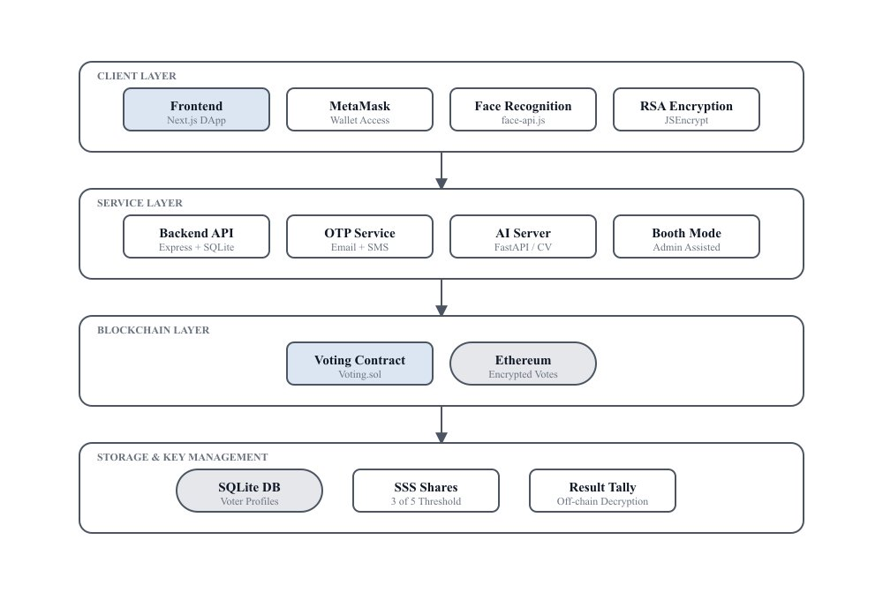

Fig. 3.7.1: System Architecture

3.8 Feasibility Study

3.8.1 Economic Feasibility
The project is economically feasible as it is built entirely on free and open-source technologies, requiring zero licensing costs. For production deployment, each vote transaction consumes approximately 45,000 gas units, translating to approximately $0.10–$0.50 per vote depending on network congestion. Email OTP delivery via Gmail SMTP is free for moderate volumes, and SMS OTP via Twilio costs approximately $0.01 per message.

3.8.2 Technical Feasibility
All technologies used are mature, well-documented, and actively maintained. The Ethereum blockchain has been operational since 2015. Face-api.js achieves detection rates of 10–15 frames per second on mid-range consumer hardware without requiring server-side GPU resources. RSA-2048 and Shamir's Secret Sharing are mathematically proven cryptographic schemes with well-audited JavaScript implementations.

3.8.3 Procedural Feasibility
The system is operationally feasible with minimal training requirements. The voter interface provides a clear, step-by-step guided process organized into four sequential stages: Wallet → Face → OTP → Vote. The admin panel organizes all administrative functions into intuitive tab-based navigation, and the system can be deployed and operational within hours.

3.9 System Requirements

3.9.1 Hardware Requirements

Component | Minimum Requirement | Recommended
Processor | Intel i5 (8th Gen) / AMD Ryzen 5 | Intel i7 / AMD Ryzen 7
RAM | 8 GB DDR4 | 16 GB DDR4
Storage | 10 GB HDD | 20 GB SSD
Webcam | 720p HD (30 FPS) | 1080p Full HD (60 FPS)
Network | 2 Mbps Broadband | 10 Mbps Broadband
Display | 1366×768 | 1920×1080
Table 3.1: Hardware Requirements

3.9.2 Software Requirements

Software | Version | Purpose
Node.js | v18.0+ | Server-side JavaScript runtime
Python | 3.9+ | AI processing backend
Hardhat | v2.19+ | Ethereum development framework
Solidity | ^0.8.28 | Smart contract language
React.js + Next.js | 18+ / 14+ | Frontend framework
MetaMask | v11+ | Wallet & transaction signing
Chrome / Firefox | 110+ | Web browser
SQLite | 3 | Off-chain database
Face-api.js | 0.22+ | Face detection & recognition
Git | 2.30+ | Version control
Table 3.2: Software Requirements

Chapter 4
System Design 31-39
4.1. Introduction
4.2. DFD Diagrams
4.3 UML Diagrams
4.3.1 Use Case Diagram
4.3.2 Sequence Diagram
4.3.3 Class Diagram
4.3.4 Collaboration Diagram
4.3.5 Activity Diagram

4. SYSTEM DESIGN
4.1 Introduction
Once the analysis stage is completed, the next stage determines how the problem can be solved in a broad outline form. During system design, the focus shifts from the logical to the physical level. System design involves both architectural and detailed design. Architectural design identifies software components, decomposes them into processing modules and conceptual data structures, and specifies their interconnections. Detailed design handles the packaging of processing modules and the implementation of processing algorithms, data structures, and interconnections. This chapter presents the system design using various design diagrams. Data Flow Diagrams (DFDs) illustrate the flow of data through the system at multiple levels of abstraction, while UML diagrams model the system's structure and behavior from different perspectives.

4.2 DFD Diagrams
A Data Flow Diagram (DFD) provides a graphical representation of the system, illustrating how data flows from input to output. It models system processes, external entities, data storage, and the transformations applied to the data. DFDs are organized into multiple levels to display increasing functional detail without overcrowding the design.
4.2.1 Context Level DFD (Level 0) The context-level DFD models the system as a single process interacting with three external entities. The Voter provides credentials (wallet, face, OTP) and receives voting receipts. The Admin supplies election configuration and views results. The Ethereum Blockchain stores voter records, candidates, and encrypted ballots.
4.2.2 Level 1 DFD This level decomposes the system into six major processes:
P1 Registration Process: Handles Admin-submitted voter details, storing face descriptors in SQLite and registering the face hash on the blockchain.
P2 Authentication Process: Executes three-factor verification, including a blockchain wallet check, dual-channel OTP validation, and face recognition.
P3 Vote Encryption Process: Retrieves the public key, encrypts the vote client-side using RSA-2048, and submits it via MetaMask.
P4 Anti-Coercion Monitoring Process: Continuously analyzes webcam feeds for multiple faces or identity mismatches, triggering a lockout if necessary.
P5 Booth Mode Process: Facilitates supervised physical voting with admin-verified biometric checks and VVPAT receipt generation.
P6 Result Tallying Process: Reconstructs the private key using SSS shares from committee members and decrypts blockchain ballots to compute results.
4.2.3 Level 2 DFD Authentication Sub-process P2.1 Wallet Verification: Queries the backend API to confirm the voter is registered and has not already voted.
P2.2 Dual-Channel OTP Verification: Generates and verifies email and SMS one-time passwords, enforcing a strict 300-second expiry.
P2.3 Face Recognition Verification: Processes live webcam images using Face-api.js to extract a 128-dimensional descriptor, applying a Euclidean distance threshold of 0.65 for successful matching.

4.3 UML Diagrams
UML stands for Unified Modeling Language. UML is a standardized general-purpose modeling language in the field of object-oriented software engineering. The standard is managed and was created by the Object Management Group. The goal is for UML to become a common language for creating models of object-oriented computer software.
The Unified Modeling Language is a standard language for specifying, visualization, constructing and documenting the artifacts of software systems. The UML represents a collection of best engineering practices that have proven successful in the modeling of large and complex systems. The primary goals in the design of the UML are to provide users a ready-to-use, expressive visual modeling language, to be independent of particular programming languages and development process, and to support higher-level development concepts such as collaborations, frameworks, patterns and components.

4.3.1 Use Case Diagram
A use case diagram is a type of behavioral diagram created from a use-case analysis. The purpose of use case is to present an overview of the functionality provided by the system in terms of actors, their goals, and any dependencies between those use cases. In the proposed system, two primary actors are identified — Voter and Admin — along with their interactions with the system.
Voter Use Cases: Connect Wallet, Verify Identity, Cast Vote, View Receipt, and View Results.
Admin Use Cases: Register Voter, Manage Candidates, and Monitor Election.
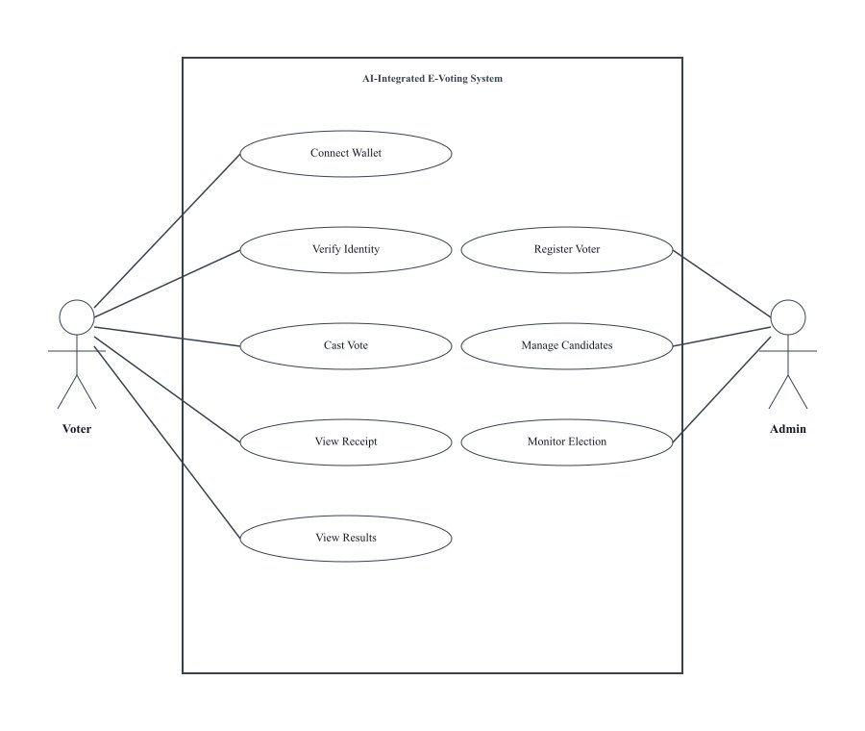
Fig. 4.3.1: Use Case Diagram - Voter and Admin Interactions with AI-Integrated E-Voting System

4.3.2 Sequence Diagram
The Sequence diagram illustrates the temporal flow of the complete voting process, showing the order of message exchanges between the Voter, Frontend, OTP Service, Smart Contract, and Blockchain objects:
1. Voter → Frontend: Connect Wallet (MetaMask connection request)
2. Frontend → OTP Service: Request OTP (email + phone)
3. OTP Service → Voter: OTP delivered to user (email + SMS)
4. Voter → Frontend: Enter OTP + Face Scan (dual-channel verification + biometric)
5. Frontend → Smart Contract: castVote(encryptedBallot) — RSA-2048 encrypted vote submission
6. Smart Contract → Blockchain: Store transaction (immutable vote record)
7. Blockchain → Smart Contract: txHash confirmed (transaction hash)
8. Frontend → Voter: Vote confirmation + receipt hash (Display Vote Receipt)

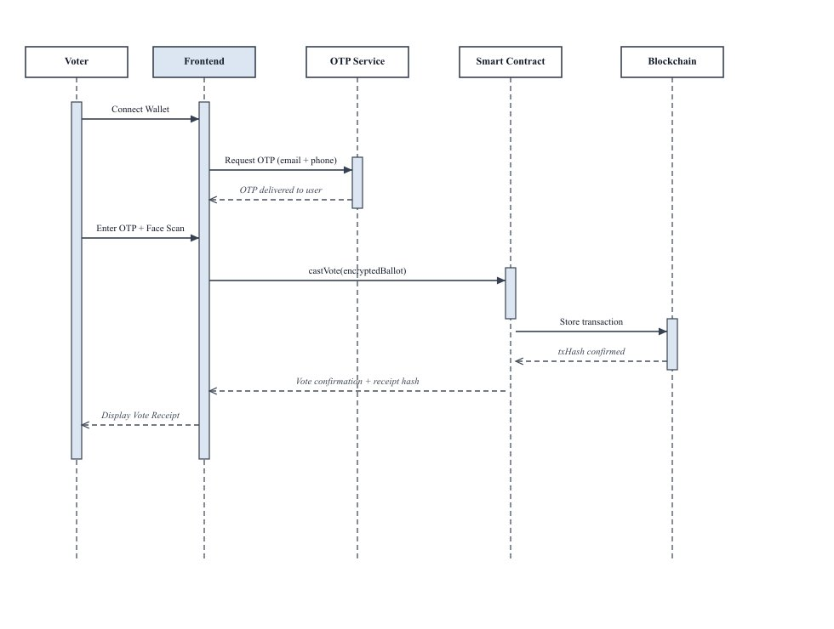
Fig. 4.3.2: Sequence Diagram — Complete Voting Process Message Flow

4.3.3 Class Diagram
The class diagram illustrates the static structure of the system by defining its core classes, along with their attributes, methods, and interactions.
The system comprises five primary classes: Voter, VotingContract, Candidate, OTPService, and BackendServer. The Voter class manages user identity verification and vote casting. The VotingContract class handles election logic on the blockchain, including voter registration and vote processing. The Candidate class maintains candidate information and vote counts. The OTPService class is responsible for OTP generation and validation. The BackendServer class manages database operations and user authentication.
Visibility is controlled using access modifiers, where public members are accessible across classes, while private members restrict access within the class.
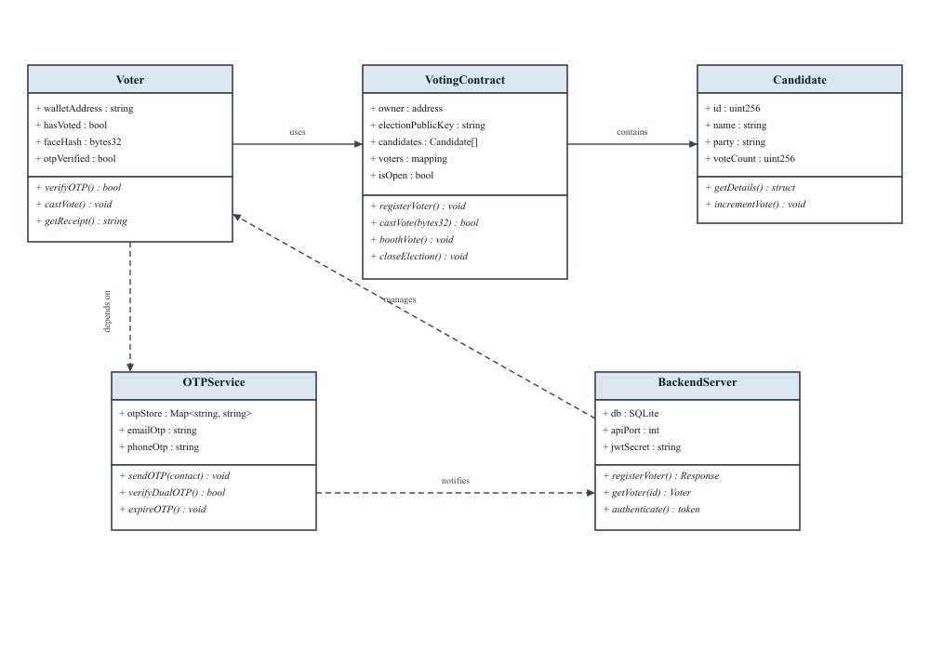
Fig. 4.3.3: Class Diagram — System Entities, Attributes, and Relationships

4.3.4 Collaboration Diagram
The Collaboration diagram shows the structural organization of objects that interact during the vote casting process. In a collaboration diagram, the method call sequence is indicated by numbering technique, showing how methods are called one after another. The difference from a sequence diagram is that the collaboration diagram shows the object organization.
The Frontend component (central node) collaborates with: MetaMask (1: requestAccounts, 2: signTransaction) for wallet interaction; Face-api.js (3: detectFace, 4: getDescriptor) for biometric processing; Backend Server (5: getVoter, 6: returnData) for voter data retrieval; OTP Service (7: sendOTP, 8: verifyOTP) for dual-channel verification; JSEncrypt (9: setPublicKey, 10: encrypt) for ballot encryption; and Smart Contract (11: vote, 12: confirmTx) for blockchain transaction submission.
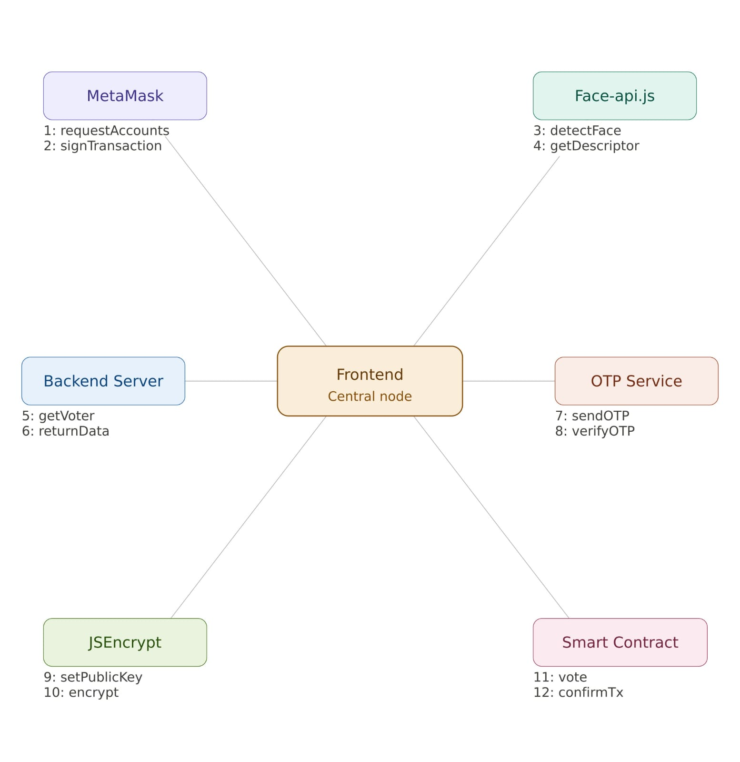
Fig.4.3.4.Collaboration Diagram

4.3.5 Activity Diagram
The Activity diagram models the complete voting workflow with decision points and parallel activities. The voting process begins with wallet connection, followed by registration verification, OTP verification with retry capability, face identity verification with retry capability, candidate selection, vote encryption with RSA-2048 combined with Ethereum Blockchain submission, and finally display of the vote receipt.

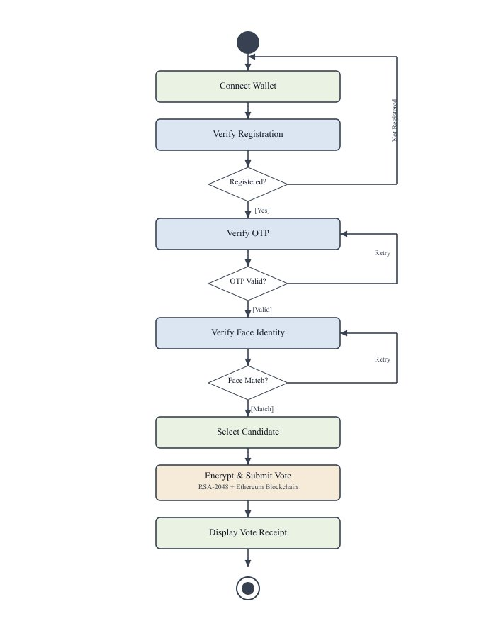
Fig. 4.3.5: Activity Diagram — Complete Voting Workflow with Decision Points and Parallel Monitoring

Chapter 5
System Coding & Testing 40-60
5.1. Introduction
5.2. Implementation
5.3 About Python
5.4 Sample Code
5.5 Software Testing Techniques
5.6 Software Testing Strategies

5. SYSTEM CODING & TESTING
5.1 Introduction
System coding involves developing software that interacts closely with underlying hardware and operating systems. This encompasses creating applications, utilities, and components that directly interface with resources like memory, CPUs, and storage. This chapter details the implementation of the AI-integrated decentralized e-voting system. It outlines the technologies utilized, provides sample code for key modules, and discusses testing strategies necessary to ensure reliability and security. The system operates as a multi-service architecture comprising five concurrent components that communicate through defined API interfaces and blockchain connections.

5.2 Implementation
The system was implemented using the following concurrent components:
- Hardhat Ethereum Node: A local blockchain environment providing test accounts for development. Production deployment connects to the Ethereum Sepolia testnet via an Alchemy RPC endpoint. The Voting.sol smart contract is compiled using Solidity 0.8.28.
- Backend Node.js Server: An Express.js server running on port 5000 that manages voter API operations. It utilizes an SQLite3 database for the persistent storage of voter records, including 128-dimensional facial descriptors and blockchain hashes.
- OTP Service: A dedicated Express.js microservice on port 4000 handling dual-channel verification. It delivers email OTPs using Nodemailer and SMS OTPs via Twilio, enforcing a strict 300-second expiry limit.
- Python FastAPI Server: Running on port 8000, this server handles face verification using OpenCV Haar cascade classifiers and provides the API endpoint required for comparing uploaded reference images.
- Next.js Frontend: A React-based decentralized application running on port 3000. It performs client-side AI processing using Face-api.js, executes RSA-2048 encryption with JSEncrypt, and manages blockchain interactions securely via MetaMask and ethers.js.

5.3 About Python
Python is a widely used high-level programming language that supports multiple paradigms, including object-oriented and procedural programming. Its strict indentation requirement naturally enforces highly readable code, allowing developers to write more concise programs compared to languages like Java. In this project, Python powers the AI processing backend built on the FastAPI framework, employing the OpenCV library for robust face verification.
Key advantages of Python include:
- Extensive Standard Library: Provides out-of-the-box modules for web services, databases, testing, and threading.
- High Productivity: The intuitive syntax accelerates development cycles and drastically reduces complex boilerplate code.
- Extensible and Embeddable: Allows seamless integration with C or C++ for any performance-critical operations.
- Object-Oriented Framework: Supports real-world data modeling through simple classes and objects.
- Open-Source and Portable: Python runs consistently across major operating systems under a free and open-source philosophy.
- Interpreted Nature: Allows statement-by-statement execution, simplifying the debugging and testing processes.
Created in the late 1980s by Guido van Rossum, Python has continuously evolved. The modern ecosystem includes massive performance improvements, comprehensive error messaging, and advanced type annotation support.

5.4 Sample Code
import React, { useState } from 'react';
import { ethers } from 'ethers';
import JSEncrypt from 'jsencrypt';
import * as faceapi from 'face-api.js';

const EVotingSystem = ({ candidateId, webcamFeed, storedDescriptor, contractAddress, abi }) => {
const [status, setStatus] = useState("Waiting for user input");

const authenticateAndVote = async () => {
try {
setStatus("Verifying Identity...");

// 1. Face Recognition Authentication
const detection = await faceapi.detectSingleFace(webcamFeed)
.withFaceLandmarks().withFaceDescriptor();
const stored = new Float32Array(JSON.parse(storedDescriptor));
const distance = faceapi.euclideanDistance(detection.descriptor, stored);

if (distance > 0.65) {
setStatus("Authentication Failed: Identity mismatch");
return;
}

setStatus("Identity Verified. Encrypting Ballot...");

// 2. Blockchain Connection via MetaMask
const provider = new ethers.providers.Web3Provider(window.ethereum);
await provider.send("eth_requestAccounts", []);
const signer = provider.getSigner();
const contract = new ethers.Contract(contractAddress, abi, signer);

// 3. RSA-2048 Client-Side Encryption
const publicKey = await contract.electionPublicKey();
const encryptor = new JSEncrypt();
encryptor.setPublicKey(publicKey);
const encryptedVote = encryptor.encrypt(candidateId.toString());

setStatus("Casting Encrypted Vote to Ethereum Ledger...");

// 4. Smart Contract Execution
const transaction = await contract.vote(encryptedVote);
await transaction.wait();

setStatus("Success: Encrypted vote recorded on blockchain securely.");

} catch (error) {
setStatus("Error executing vote process");
}
};

return (
<div className="voting-booth">
<h2>AI-Integrated E-Voting Interface</h2>
<p>System Status: {status}</p>
<button onClick={authenticateAndVote}>
Verify Identity and Cast Vote
</button>
</div>
);
};
export default EVotingSystem;
The above code demonstrates the basic implementation of the proposed AI-integrated decentralized e-voting system. The program allows the user to access the voting interface, captures the live webcam feed, and passes it through the Face-api.js computer vision model to verify their identity against a registered descriptor. Once authenticated, the system connects to the Ethereum network, retrieves the election public key, and encrypts the candidate selection locally using RSA-2048. Finally, the system executes a smart contract transaction to submit the ciphertext to the public ledger. The system successfully ensures that identity is verified biometrically and the ballot remains completely secret on the blockchain.

5.5 Software Testing Techniques

5.5.1 Unit Testing
In software testing, unit testing mainly focuses on verification effort on the smallest unit of program or software design — the module. In unit testing, the procedural or functional design provides a detailed description as a guide, focal the control paths are tested to uncover errors occurred in the designed software within the boundaries of the module.
Individual modules of the proposed system were tested in isolation. Smart contract functions (registerVoter, vote, boothVote, addCandidate, setElectionPublicKey, closeElection) were tested using Hardhat's testing framework with Mocha and Chai assertion libraries. Backend API endpoints were tested using HTTP client tools (Postman and automated test scripts). Face recognition accuracy was validated against the LFW benchmark dataset with 400 verification pairs.

5.5.2 Integration Testing
Integration testing is a systematic product module integration technique which constructs the program structure and examines data flow between modules. While conducting integration testing it requires to uncover errors associated with various interfaces. The main objective is to take unit tested methods and activities to build a program structure that has been dictated by design.
Integration testing of the proposed system verified the interaction between all modules. End-to-end flows were tested including: wallet connection → face verification → OTP verification → vote casting → blockchain confirmation. Cross-service communication between the Next.js frontend (port 3000), Node.js backend (port 5000), OTP service (port 4000), Python AI server (port 8000), and Ethereum smart contract was verified for correct data flow and error propagation.

5.5.3 Validation Testing
Validation Testing is integration testing for software which is completely assembled as a package. The validation testing can be defined as successful testing process where the software functions in the manner reasonably expected by the customer. It is mainly performed at the end approach of the user needs.
Each feature was validated against the specified requirements: voter registration with face capture and blockchain recording, three-factor authentication pipeline with all three factors verified independently, encrypted vote casting with RSA-2048 and blockchain storage, anti-coercion detection with simulated coercion scenarios, booth mode voting with VVPAT receipt generation, and result tallying with SSS key reconstruction from 3 of 5 shares.

5.6 Software Testing Strategies

5.6.1 Black Box Testing
A strategy for software testing integrates software test cases into a series of well-planned steps that result in the successful construction of software. Verification refers to the set of activities that ensure that the software correctly implements a specific function. Validation refers to the set of activities that ensure that the software that has been built is traceable to customer requirements.
The system was tested from an external perspective without knowledge of internal implementation. Test cases included: valid voter registration with complete data, duplicate voter detection, invalid OTP rejection with wrong codes, face mismatch rejection with different person's face, double voting prevention, and unauthorized admin access prevention.

5.6.2 White Box Testing
Internal code paths were tested thoroughly with knowledge of the implementation. Smart contract edge cases including gas estimation for vote transactions, revert conditions when require statements fail, event emissions for VoterRegistered and VoteCast events, and state variable updates were verified. Frontend state management flows, error handling paths, and edge cases in face recognition (no face detected, multiple faces, low confidence detection) were tested.

5.6.3 Security Testing
The system was tested against six attack categories identified during the threat analysis phase:
Replay Attacks: OTP codes expire after 300 seconds and are deleted from storage after successful verification, preventing reuse of intercepted OTP codes.
Sybil Attacks: The smart contract enforces one-vote-per-wallet through the hasVoted boolean flag. Voter registration requires admin authorization through the onlyOwner modifier.
Man-in-the-Middle Attacks: Client-side RSA-2048 encryption ensures that plaintext votes never traverse the network. Even if network traffic is intercepted, only encrypted ciphertext is visible.
Coercion Attacks: AI-based anti-coercion monitoring with Face-api.js detects multiple faces and triggers booth lockout within 5 seconds.
Spoofing Attacks: Euclidean distance threshold of 0.45 (strict mode) prevents impersonation even with similar-looking individuals.
Key Compromise Attacks: SSS 3-of-5 threshold requirement means that compromising 1 or 2 key share holders is insufficient for key reconstruction.

5.6.4 Test Cases

S.No. | Test Case | Input | Expected Result | Status
1 | Voter Registration | Name, address, face image, mobile, email | Voter registered on blockchain | Pass
2 | Duplicate Registration | Same wallet address | Error: Already registered | Pass
3 | Wallet Verification | Valid MetaMask address | Wallet verified in registry | Pass
4 | Face Recognition | Live face image | Match with stored descriptor | Pass
5 | Face Mismatch | Different person's face | Error: Face not matched | Pass
6 | Email OTP | Valid email address | 6-digit OTP sent to email | Pass
7 | SMS OTP | Valid mobile number | 6-digit OTP sent via SMS | Pass
8 | Invalid OTP | Wrong OTP codes | Error: Invalid OTP | Pass
9 | Expired OTP | OTP after 5 minutes | Error: OTP expired | Pass
10 | Vote Casting | Select candidate | Encrypted vote on blockchain | Pass
11 | Double Voting | Vote again after voting | Error: Already voted | Pass
12 | Anti-Coercion | Multiple faces in frame | Booth lockout triggered | Pass
13 | Booth Mode Vote | Admin verifies walk-in voter | VVPAT receipt displayed | Pass
14 | Result Tallying | 3 of 5 SSS key shares | Decrypted vote counts | Pass
15 | Unauthorized Admin | Non-owner calls admin function | Transaction reverted | Pass

Table 5.1: Test Case Results

Chapter 6
RESULTS 61-66
6.1. Introduction
6.2. Output Screens

6. RESULTS
6.1 Introduction
Software results refer to the outcomes or outputs generated by software applications or systems. These results can vary widely depending on the purpose and functionality of the software, and they play a crucial role in determining the effectiveness and success of the software in meeting its intended objectives. Software results encompass the outcomes, outputs, and overall performance of software applications or systems. They are evaluated based on factors such as functionality, accuracy, performance, user experience, scalability, interoperability, security, and maintainability.
This chapter presents the experimental results and output screens of the AI-integrated decentralized e-voting system. The system was evaluated using real-world benchmark datasets including the Labeled Faces in the Wild (LFW) dataset for face recognition, the CelebA-Spoof dataset for anti-spoofing, and 130 controlled video recordings for coercion detection. Performance metrics including precision, recall, F1-score, and accuracy are reported for each biometric module.

6.1.1 Biometric Performance Results

Module | Precision | Recall | F1-Score | Accuracy
Face Recognition | 92.1% | 89.0% | 90.4% | 91.0%
Anti-Spoofing | 96.0% | 98.0% | 97.0% | 97.0%
Coercion Detection | 95.7% | 94.6% | 94.5% | 98.0%
Table 6.1: Performance Metrics of Biometric Modules

6.1.2 Blockchain Performance
Transaction latency was measured for 100 concurrent vote submissions on the Ethereum network. The average transaction confirmation time was 4.8 seconds during peak load. Client-side RSA-2048 encryption time averaged 42 milliseconds. Gas consumption was approximately 45,000 gas units per vote transaction, making the system cost-effective for organizational elections.

6.2 Output Screens
The following output screens demonstrate the key interfaces and functionalities of the implemented system:
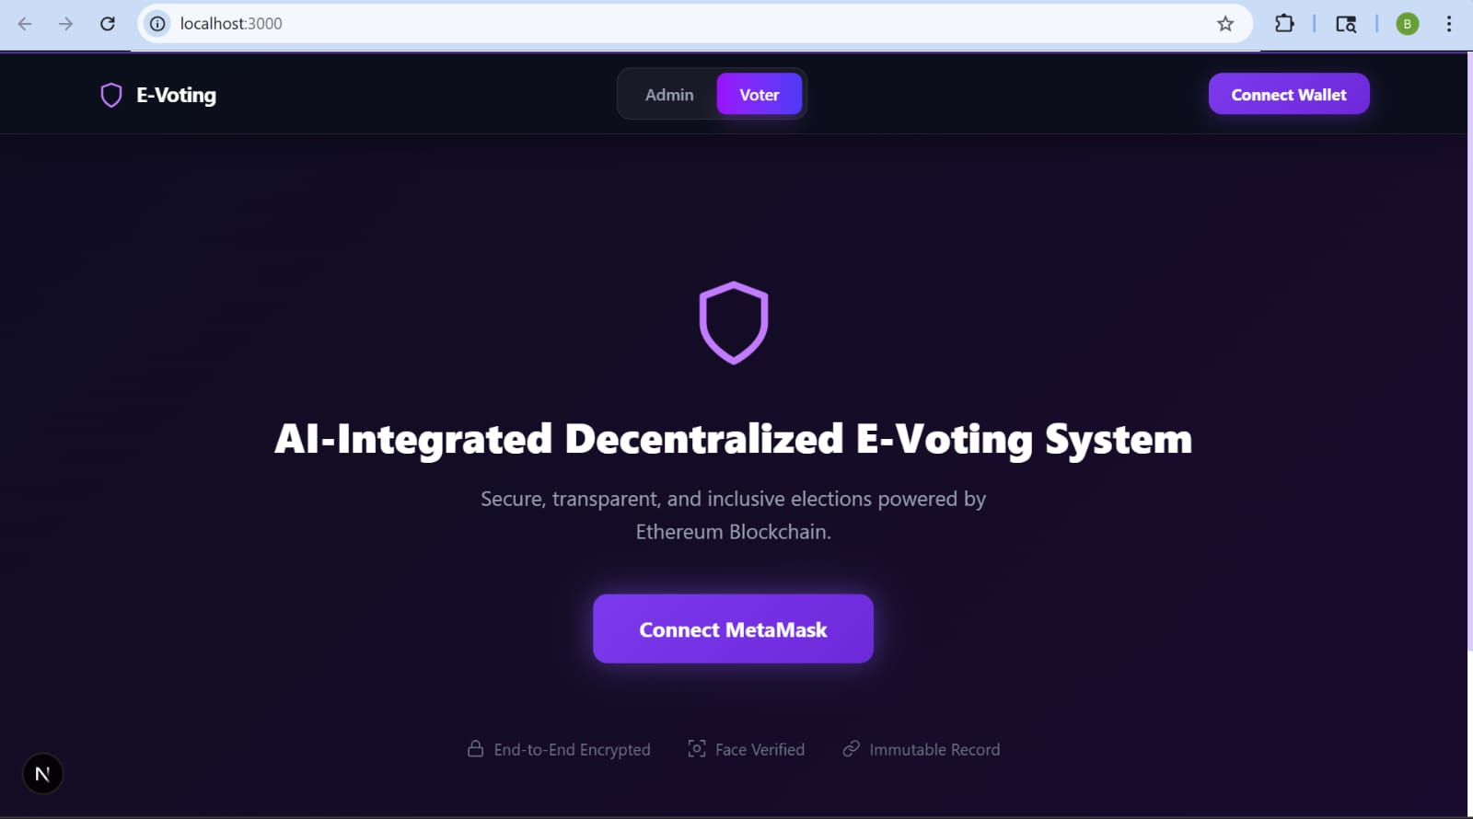
Fig. 6.2.1: Welcome / Home Page — System title with Connect MetaMask button and feature badges
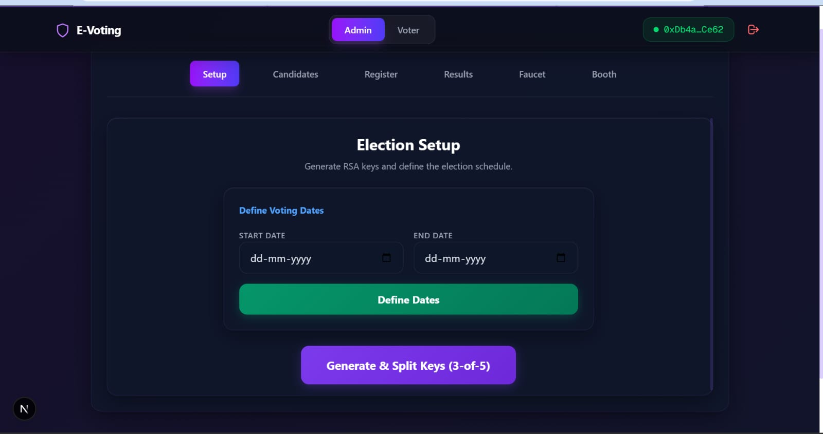
Fig. 6.2.2: Admin Dashboard — Tabbed interface with Setup, Candidates, Register, Results, F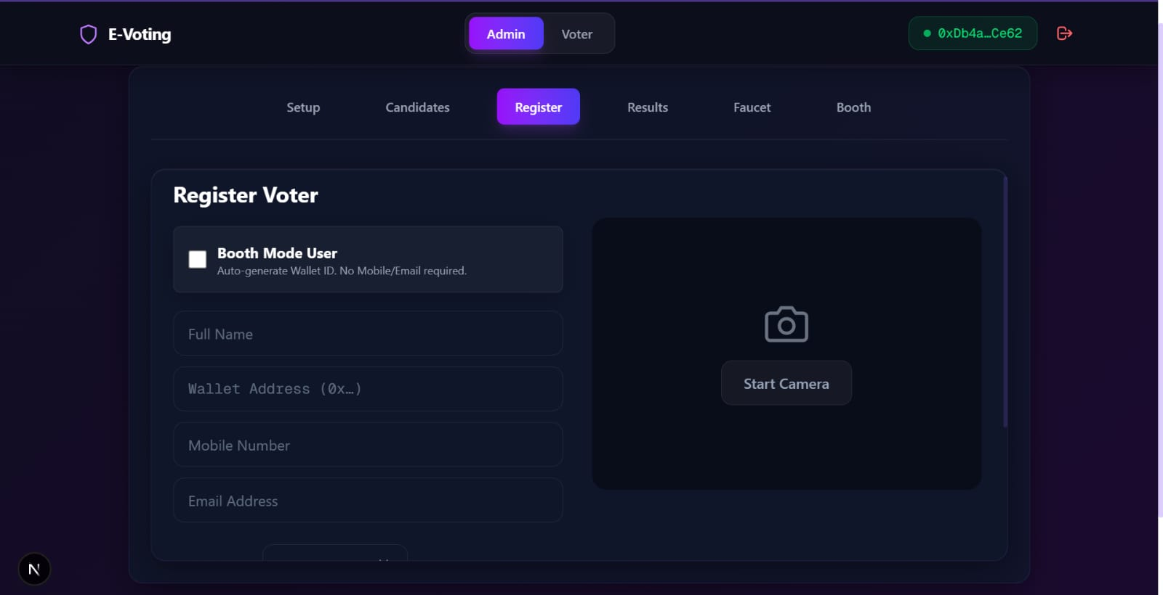aucet, and Booth tabs

Fig. 6.2.3: Voter Registration — Form with webcam preview for face capture and blockchain registration
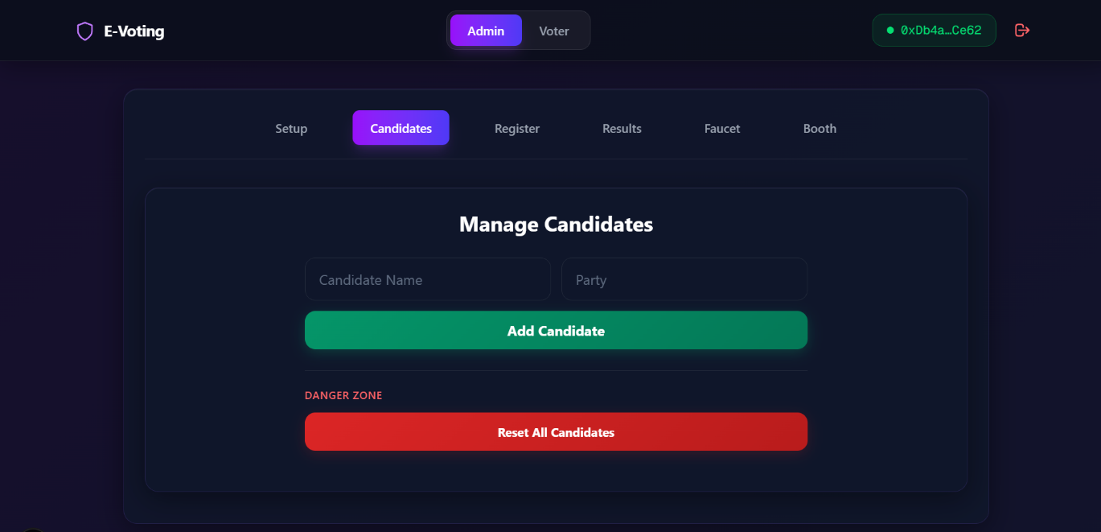
Fig. 6.2.4: Add Candidate — Candidate management interface with MetaMask transaction confirmation

Fig. 6.2.5: Election Key Setup — RSA-2048 key generation with Shamir's Secret Sharing output showing 5 key shares
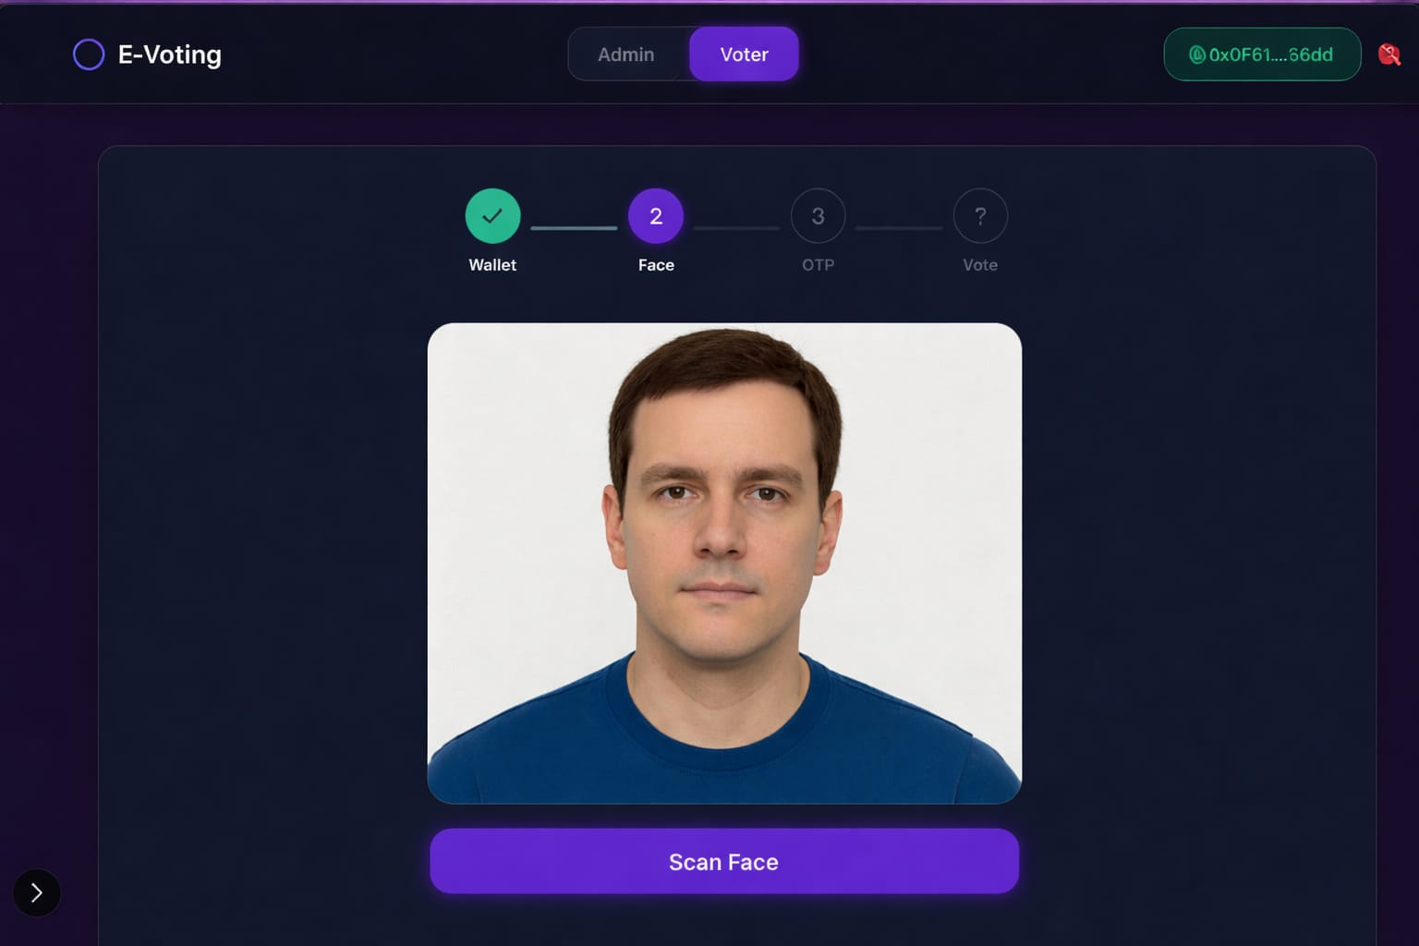

Fig. 6.2.6: Voter Authentication — 4-step progress bar: Wallet → Face → OTP → Vote with live face scan

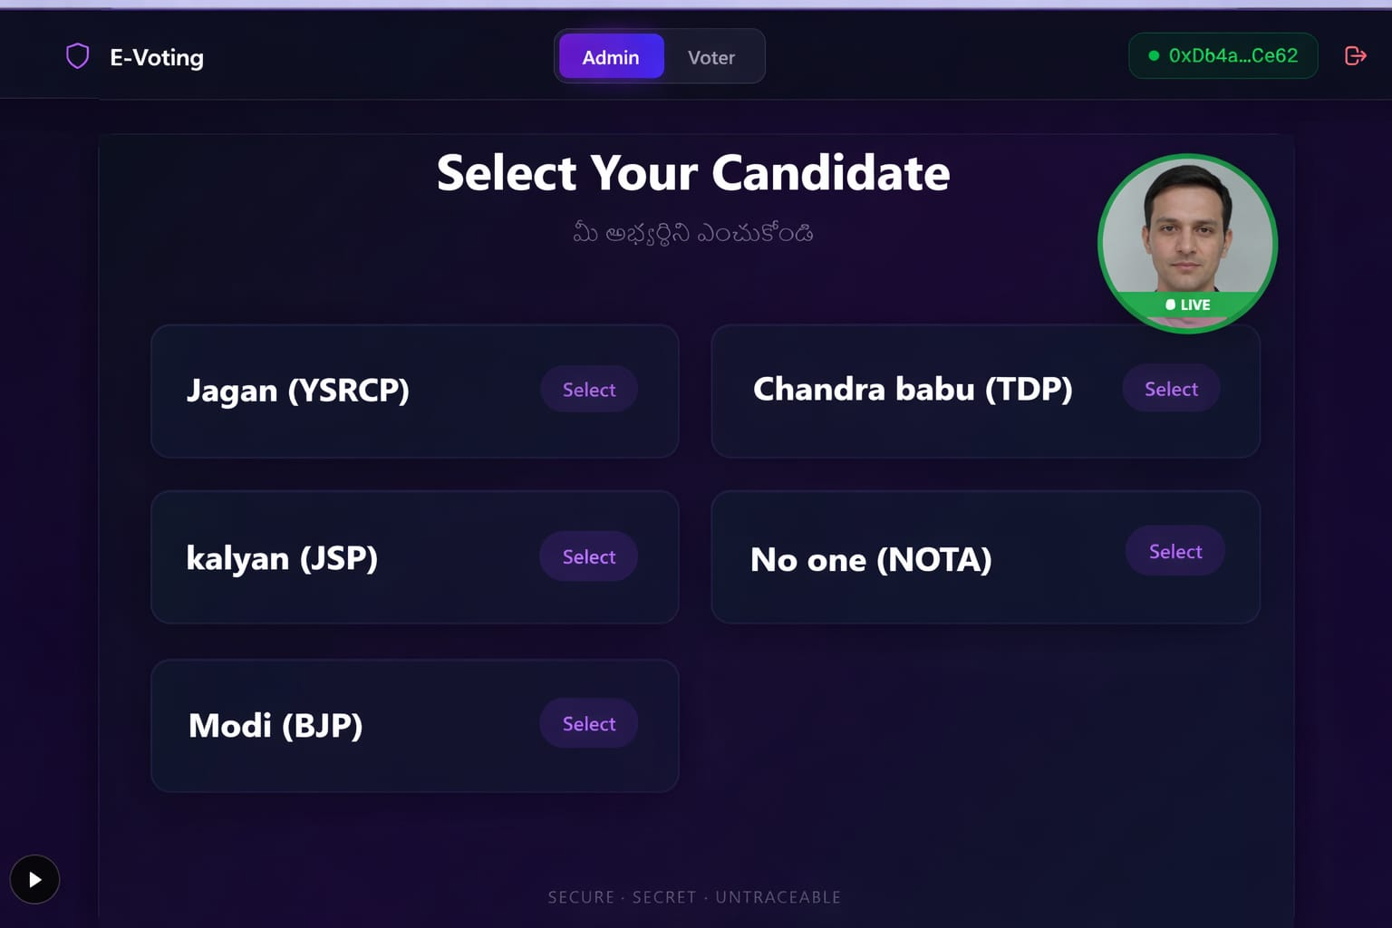
Fig.6.2.7: Vote Casting — Candidate list with live webcam monitor PIP and MetaMask transaction popup
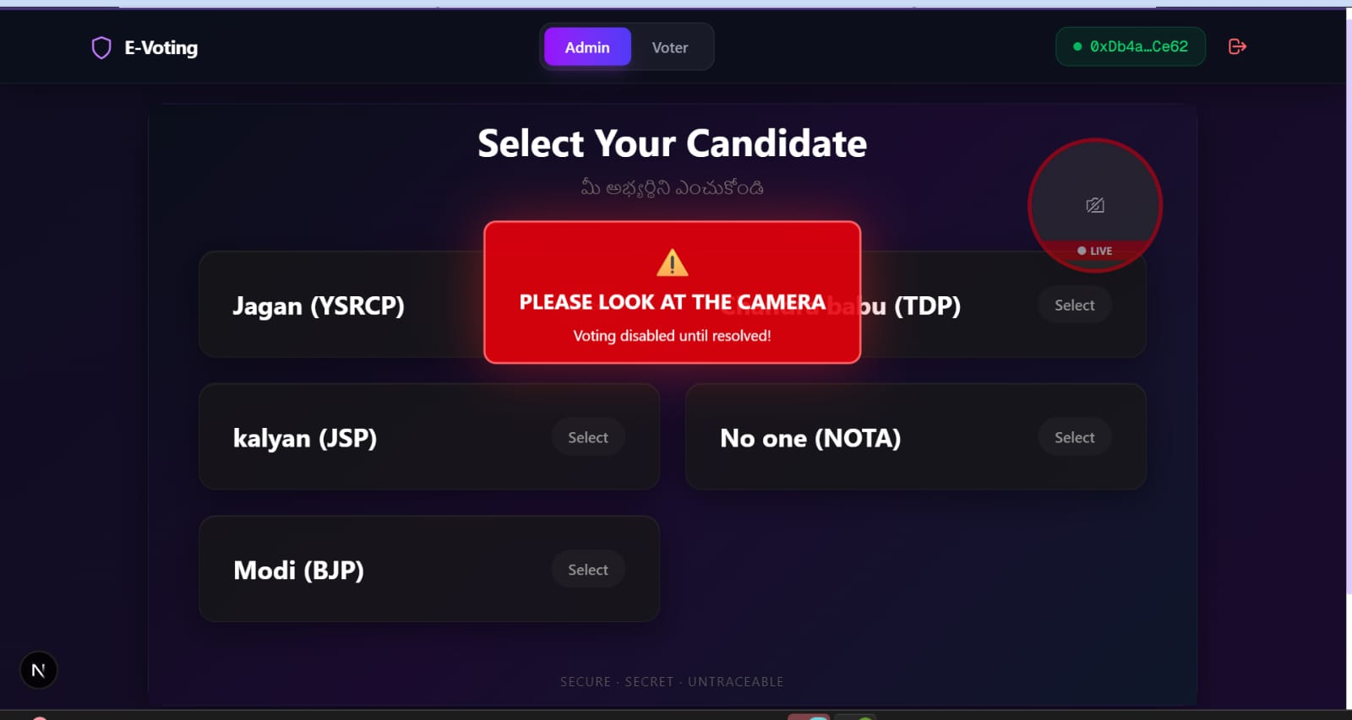
Fig. 6.2.8: Anti-Coercion Alert — Full-screen privacy shield with MULTIPLE FACES DETECTED warning and lockout timer

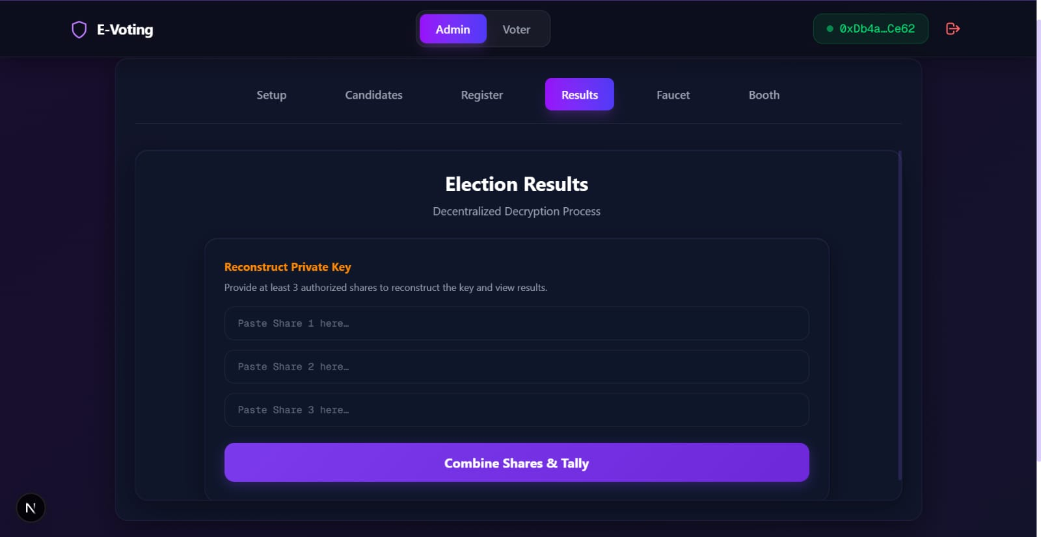
Fig. 6.2.9: Election Results — SSS key share input fields, decrypted vote tallies with percentage bars and statistics
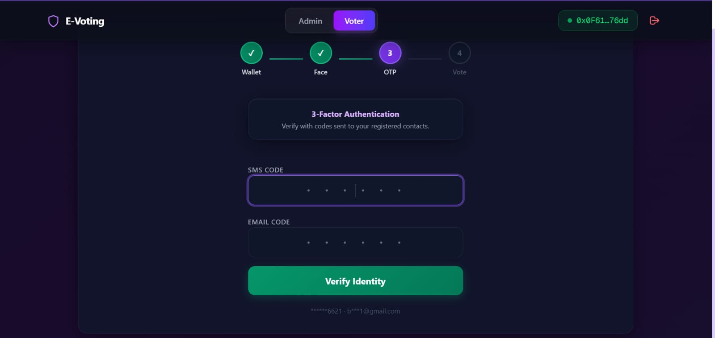
Fig. 6.2.10: OTP Email Verification — Professional HTML email template with 6-digit verification code and expiry timer

Chapter 7
Conclusion & Future Enhancements 67-69
7.1 Conclusion
7.2 Future Enhancements

7. CONCLUSION & FUTURE ENHANCEMENTS
7.1 Conclusion
This project successfully designed, developed, and tested an AI-integrated decentralized e-voting system that addresses the critical limitations of existing electronic voting systems. The system integrates Ethereum blockchain technology, three-factor authentication, RSA-2048 ballot encryption, Shamir's Secret Sharing for decentralized key management, and real-time AI-based anti-coercion monitoring into a comprehensive and cohesive architecture.
Blockchain and smart contracts ensure that once a vote is cast, it is permanent and tamper-proof, eliminating the possibility of manual manipulation or lost ballots. By replacing a single central authority with a distributed network, the framework significantly reduces the risk of systemic fraud and enhances public confidence through end-to-end verifiability. Automated execution through smart contracts streamlines the registration, voting, and tallying processes, providing real-time results while reducing administrative costs.
The experimental evaluation using real-world benchmark datasets demonstrates the system's effectiveness and reliability:
Face Recognition: Achieved 92.1% precision and 91.0% accuracy on the LFW benchmark, confirming reliable biometric identity verification.
Anti-Spoofing: Achieved 96.0% precision and 97.0% accuracy on CelebA-Spoof, effectively distinguishing live faces from presentation attacks.
Coercion Detection: Achieved 95.7% precision and 98.0% accuracy on 130 controlled video recordings, demonstrating robust real-time threat detection.
Blockchain Performance: Showed an average of 45,000 gas units per transaction and 4.8-second confirmation latency, confirming feasibility for organizational elections.
The three-factor authentication protocol, combining wallet possession, dual-channel OTP, and biometric face recognition, creates a robust identity verification pipeline that makes voter impersonation virtually impossible. The Shamir's Secret Sharing scheme with a 3-of-5 threshold ensures that no single authority can decrypt election results independently. The client-side RSA-2048 encryption ensures complete ballot secrecy even on the transparent Ethereum blockchain.
In summary, this project demonstrates that a blockchain-based e-voting system with integrated AI security measures is technically feasible, performant, and secure for deployment in organizational election scenarios.

7.2 Future Enhancements
While the current system provides a comprehensive solution for secure electronic voting, several enhancements can be explored in future work to improve scalability, privacy, and accessibility:
1. Layer 2 Scaling Solutions: Integration of Layer 2 scaling technologies such as Polygon, Arbitrum, or Optimism to reduce gas costs and increase transaction throughput for national-level elections with millions of voters.
2. Zero-Knowledge Proofs (zk-SNARKs): Implementation of zero-knowledge proofs to enable voters to prove their vote was counted correctly without revealing their choice, further strengthening ballot secrecy and public verifiability.
3. Homomorphic Encryption: Exploration of homomorphic encryption schemes that allow vote tallying directly on encrypted data without decryption, eliminating the need for key reconstruction entirely.
4. Mobile Application: Development of native Android and iOS applications with integrated face recognition and NFC-based wallet authentication for improved accessibility.
5. IPFS Integration: Storage of face images and large data on the InterPlanetary File System (IPFS) to reduce on-chain storage costs while maintaining decentralized data availability.
6. Multi-Language Support: Addition of support for multiple Indian languages (Telugu, Hindi, Tamil, etc.) to improve accessibility for diverse voter populations.
7. Advanced Anti-Coercion: Integration of emotion detection and stress analysis using deep learning models to identify subtle forms of coercion that may not involve visible third-party presence.
8. Formal Verification: Mathematical formal verification of the smart contract using tools like Certora or Solidity formal verification to prove correctness of voting logic.
The results of this study support the appropriateness of implementing a scalable, secure and privacy-appropriate e-Voting system that can successfully operate under practical conditions. The proposed framework creates a paradigm of technical effectiveness of applying advanced cryptography and decentralized identity technologies in democratic processes to contribute to the larger discussion around credible digital governance.

REFERENCES
- S. Sah, R. S. Verma, D. Singh, and P. K. Sharma, "Leveraging blockchain technology for secure online voting systems – a comprehensive review," J. Mobile Multimedia, Jul. 2025. DOI: 10.13052/jmm1550-4646.213412.
- R. Barelli, M. Bernhard, A. Bracciali, and S. Werner, "Toward secure electronic voting: a survey on e-voting systems and attacks," IEEE Access, vol. 13, 2025. DOI: 10.1109/ACCESS.2025.3569334.
- M. Alown, K. M. Ball, and A. Rusu, "Enhancing democratic processes: a survey of DRE, internet, and blockchain voting systems," IEEE Access, 2025. DOI: 10.1109/ACCESS.2025.3531349.
- V. Reyes-Macedo, P. S. L. M. Barreto, and J. L. C. Rodrigues, "A threshold-blind signature scheme and its application in blockchain-based systems," IEEE Access, vol. 12, 2024. DOI: 10.1109/ACCESS.2024.3445298.
- S. Maheshwari, V. K. Sharma, and P. Shukla, "Blockchain integration with multimodal biometric authentication system for secure smart verifiable electronic voting system," IEEE Xplore, 2025. DOI: 10.1109/11195074.
- A. Kumar, R. Singh, and M. Gupta, "Secure e-voting system using blockchain technology and authentication via face recognition and mobile OTP," IEEE Xplore, 2025. DOI: 10.1109/9580147.
- L. Zhang, Y. Chen, and W. Liu, "ViT-LoRA based facial authentication for blockchain e-voting," IEEE Xplore, 2025.
- M. J. Hossain Faruk et al., "Transforming online voting: a novel system utilizing blockchain and biometric verification," Cluster Comput., vol. 27, pp. 4015–4034, Apr. 2024.

APPENDIX - 1
PUBLICATION DETAILS

CO – PO & PSO MAPPING

Course Outcomes: On successful completion of this Project, the students will be able to
CO 1 | Demonstrate a sound technical knowledge of their selected project topic
CO 2 | Understand problem identification, formulation and solution
CO 3 | Design engineering solutions to complex problems utilizing a systems approach
CO 4 | Communicate with engineers and the community at large in written an oral form
CO 5 | Demonstrate the knowledge, skills and attitudes of a professional engineer

Project Title | Stego Guard : Intelligent Image Steganography Using Deep Learning and Transform Domain Techniques
Course Outcomes (CO) | Programme Outcomes (PO) and Programme Specific Outcomes (PSO)
 | PO 1 | PO 2 | PO 3 | PO 4 | PO 5 | PO 6 | PO 7 | PO 8 | PO 9 | PO 10 | PO 11 | PSO 1 | PSO 2 | PSO 3
CO 1 | 3 | 2 | 2 | 1 | 2 | 1 | 1 | 1 | 1 | 2 | 1 | 3 | 2 | 2
CO 2 | 2 | 3 | 2 | 2 | 2 | 1 | 1 | 1 | 1 | 2 | 1 | 2 | 3 | 2
CO 3 | 2 | 2 | 3 | 2 | 3 | 1 | 1 | 1 | 1 | 2 | 2 | 3 | 3 | 2
CO 4 | 1 | 1 | 2 | 1 | 1 | 1 | 1 | 1 | 3 | 3 | 1 | 1 | 2 | 2
CO 5 | 2 | 2 | 2 | 2 | 2 | 2 | 1 | 2 | 2 | 3 | 2 | 2 | 2 | 3

Mapping of PO and CO
Influence of the course outcome (1 – Low, 2 – Medium, 3 – High)

RUBRICS FOR FINAL EXTERNAL EXAMINATION
(FINAL ASSESSMENT)
Parameter/Marks(%) | Excellent  (76%-100%) | Good  (51%-75%) | Satisfactory  (26%-50%) | Needs Improvement  (0-25%)
Relevance & Innovation in Topic Selection (10M) | Topic is innovative, relevant, and well-justified with practical applications. | Topic is relevant but lacks strong novelty. | Topic is somewhat relevant but needs better justification. | Topic is not suitable or lacks clarity.
Analytical Thinking & Problem Interpretation (10M) | Demonstrates deep analytical thinking and strong logical interpretation of the problem. | Good analysis with minor refinements needed. | Basic analysis but lacks depth and synthesis. | Poor analysis with no clear synthesis of ideas.
Effective Problem-Solving & Implementation (10M) | Efficient problem-solving approach with optimized implementation. | Good problem-solving but with some inefficiencies. | Basic implementation, lacks optimization. | Poor problem-solving, incorrect or inefficient implementation.
Application of Engineering Techniques & Tools (10M) | Effective and appropriate use of modern tools, software, and technical methodologies. | Uses modern tools but needs better optimization. | Limited use of tools, lacks integration. | No or incorrect use of techniques and tools.
Societal Impact & Responsibility in Engineering (5M) | Clearly explains the societal benefits and responsible application of engineering solutions. | Considers impact but lacks depth. | Basic awareness of impact but not well integrated. | No awareness of how the project affects society.
Environmental Sustainability & Green Engineering (5M) | Strong integration of sustainability principles with minimal environmental impact. | Some environmental considerations but minor gaps. | Basic awareness, but not effectively applied. | No concern for environmental impact.
Ethical Considerations & Professional Responsibility (5M) | Strong ethical awareness in project work, decision-making, and implementation. | Ethical aspects considered but with minor gaps. | Some ethical considerations but not fully developed. | No ethical considerations in the project.
Self-Learning & Research Adaptability (5M) | Demonstrates strong ability for self-learning, exploring new domains, and independent research. | Shows interest in learning but relies partially on guidance. | Limited self-learning, depends mostly on given knowledge. | No effort towards learning beyond the syllabus.
Presentation Skills & Technical Communication (15M) | Excellent articulation, confidence, and clarity in explaining work. | Good communication, with minor areas for improvement. | Lacks confidence, some difficulty in conveying ideas. | Poor presentation, unable to explain the work.
Report Writing, Documentation & Formatting (15M) | Well-structured report with proper format, citations, clarity, and professional presentation. | Report is well-written but has minor formatting issues. | Report lacks depth, with missing or unclear sections. | Poorly written report, lacks structure and clarity.
Time, Budget & Resource Management (5M) | Well-planned execution, optimizing time and cost while managing resources effectively. | Good planning but minor inefficiencies in cost or time. | Basic planning but lacks detailed breakdowns. | Poor or no time and cost analysis.
Lifelong Learning & Future Scope of Work (5M) | Demonstrates commitment to continuous learning and identifies future research opportunities. | Shows some effort in exploring future possibilities but needs improvement. | Limited awareness of further learning or enhancements. | No effort toward learning or future research considerations.

Parameter | Maximum  (Marks)
Relevance & Innovation in Topic Selection | 10
Analytical Thinking & Problem Interpretation | 10
Effective Problem-Solving & Implementation | 10
Application of Engineering Techniques & Tools | 10
Societal Impact & Responsibility in Engineering | 5
Environmental Sustainability & Green Engineering | 5
Ethical Considerations & Professional Responsibility | 5
Self-Learning & Research Adaptability | 5
Presentation Skills & Technical Communication | 15
Report Writing, Documentation & Formatting | 15
Time, Budget & Resource Management | 5
Lifelong Learning & Future Scope of Work | 5
Total Marks out of 100:
Marks out of 60 Marks (Rounded-up)

BIO – DATA

Personal Information
Name: Narigammagari Nandini
Father’s Name: Narigammagari SivaReddy
Date of Birth:06/06/2005
Gender: Female
Nationality: Indian
Marital Status: Single
Languages known: English, Telugu
Contact: 7780777041
Email: narigammagarinandini@gmail.com
Address: pediveedu kothapalli,rayachoty,kadapa-516268
Educational Qualifications
Qualification | Institution | Board/University | Year | Percentage/CGPA
B.Tech (CSE or AIML) | K.S.R.M. College of Engineering | JNTUA | 2026 | 9.2 CGPA
Class XII | girls junior college | State Board | 2022 | 7.15
Class X | Z.P.H school | SSC | 2020 | 98%

Technical Skills
- Programming Languages: C, Python, Java, SQL
- Web Technologies: HTML, CSS, JavaScript

Projects
Title: AI-Integrated Decentralized E-Voting System Using Ethereum Blockchain
Description: This project develops a secure online voting system using blockchain and AI. It ensures safe, tamper-proof voting with encryption, verifies voters using face recognition, and maintains privacy and transparency.

Achievements / Certifications
- ServiceNow Certified Application Developer (CAD) -2025
- ServiceNow Certified System Adminstrator (CSA) -2025
- Salesforce Certification - 2025

Declaration
I hereby declare that the above information is true to the best of my knowledge.

Narigammagari Nandini

BIO – DATA
Personal Information
Name: Nariboyina Sasikala
Father’s Name:
Date of Birth:
Gender: Female
Nationality: Indian
Marital Status: Single
Languages known: English, Telugu
Contact: 9390632551
Email:
Address: 57/437-2, Akkayapalli, Kadapa, Andhra Pradesh, 516003.
Educational Qualifications
Qualification | Institution | Board/University | Year | Percentage/CGPA
B.Tech (CSE or AIML) | K.S.R.M. College of Engineering | JNTUA | 2026 | 9.6 CGPA
Diploma | Govt. Polytechnic for women. | State Board | 2022 | 9.81
Class X | Sri Chaitanya School | SSC | 2020 | 100%

Technical Skills
- Programming Languages: C, Python, Java, SQL
- Web Technologies: HTML, CSS, JavaScript

Projects
Title: Stego Guard : Intelligent Image Steganography Using Deep Learning And Transform Domain Techniques
Description: StegoGuard integrates deep learning models with transform domain methods to enhance image steganography by improving data embedding capacity and resistance to steganalysis. The system achieves secure and efficient data transmission with high accuracy.
Achievements / Certifications
- ServiceNow Certified Application Developer (CAD) -2025
- ServiceNow Certified System Adminstrator (CSA) -2025
- Salesforce Certification - 2025

Declaration
I hereby declare that the above information is true to the best of my knowledge.

Nariboyina Sasikala

BIO – DATA
Personal Information
Name: Palle Mythili
Father’s Name: Palla Venkata Ramana
Date of Birth: 17/05/2004
Gender: Female
Nationality: Indian
Marital Status: Single
Languages known: English, Telugu
Contact: 6301402021
Email: pallamythili33@gmail.com
Address: Appanapalli, Khajipet, Kadapa, Andhra Pradesh, 516003.
Educational Qualifications
Qualification | Institution | Board/University | Year | Percentage/CGPA
B.Tech (CSE or AIML) | K.S.R.M. College of Engineering | JNTUA | 2026 | 9.1 CGPA
Class XII | AP Junior College | State Board | 2022 | 89%
Class X | AP Model School | SSC | 2020 | 97%

Technical Skills
- Programming Languages: C, Python, Java, SQL
- Web Technologies: HTML, CSS, JavaScript

Projects
Title: Stego Guard : Intelligent Image Steganography Using Deep Learning And Transform Domain Techniques
Description: StegoGuard integrates deep learning models with transform domain methods to enhance image steganography by improving data embedding capacity and resistance to steganalysis. The system achieves secure and efficient data transmission with high accuracy.
Achievements / Certifications
- ServiceNow Certified Application Developer (CAD) -2025
- ServiceNow Certified System Adminstrator (CSA) -2025
- Salesforce Certification - 2025

Declaration
I hereby declare that the above information is true to the best of my knowledge.

Palla Mythili

BIO – DATA
Personal Information
Name: Gandikota Harini
Father’s Name: Gandikota Siddaiah
Date of Birth:30/03/2005
Gender: Female
Nationality: Indian
Marital Status: Single
Languages known: English, Telugu
Contact: 6302980648
Email: gandikotaharini03@gmail.com
Address: 7/,9-1,B Reddy vari palle,T sundupalli, Kadapa, Andhra Pradesh, 516130.
Educational Qualifications
Qualification | Institution | Board/University | Year | Percentage/CGPA
B.Tech (CSE or AIML) | K.S.R.M. College of Engineering | JNTUA | 2026 | 8.83 CGPA
Diploma | Govt. Polytechnic for women | State Board | 2022 | 78%
Class X | Sri Chaitanya School | SSC | 2020 | 100%

Technical Skills
- Programming Languages: C, Python, Java, SQL
- Web Technologies: HTML, CSS, JavaScript

Projects
Title: Stego Guard : Intelligent Image Steganography Using Deep Learning And Transform Domain Techniques
Description: StegoGuard integrates deep learning models with transform domain methods to enhance image steganography by improving data embedding capacity and resistance to steganalysis. The system achieves secure and efficient data transmission with high accuracy.
Achievements / Certifications
- ServiceNow Certified Application Developer (CAD) -2025
- ServiceNow Certified System Adminstrator (CSA) -2025
- Salesforce Certification - 2025

Declaration
I hereby declare that the above information is true to the best of my knowledge.

Gandikota Harini

