TimeSprint Challenges – Advanced System Architecture
This document presents an advanced and visually enhanced system architecture designed to clearly communicate database structure, data flow, and user journey.

1. Entity Relationship Diagram (ERD)
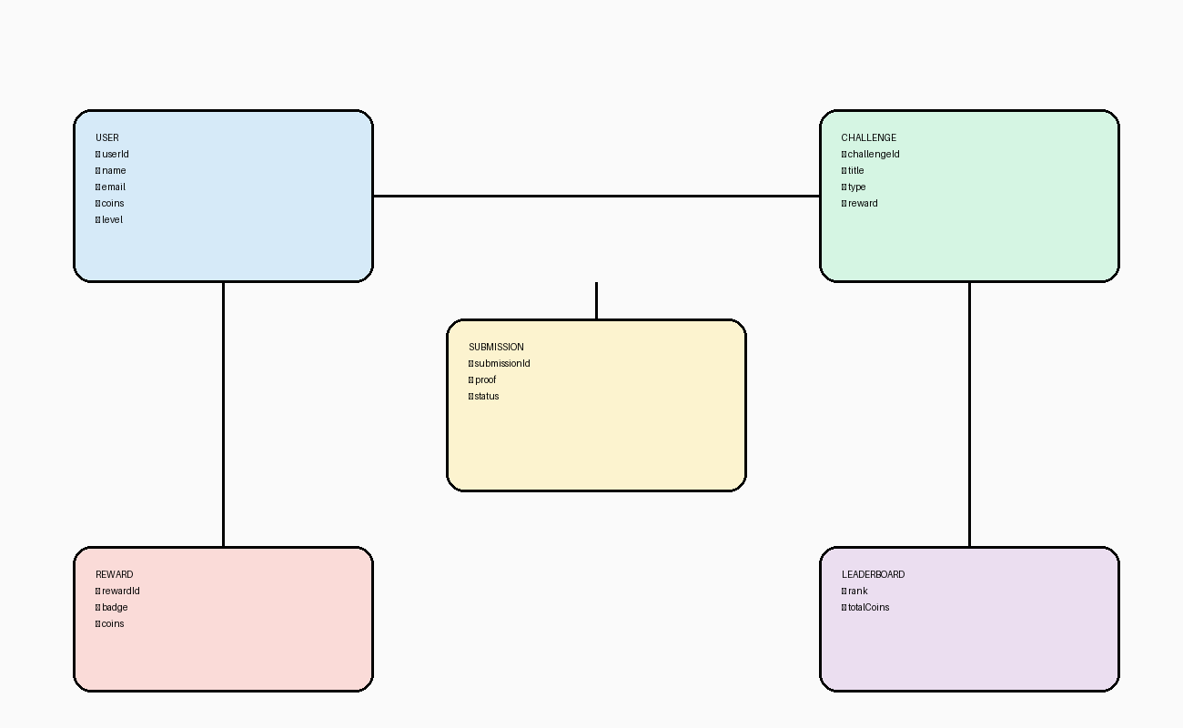

2. Data Relationship Diagram (DRD / DFD)
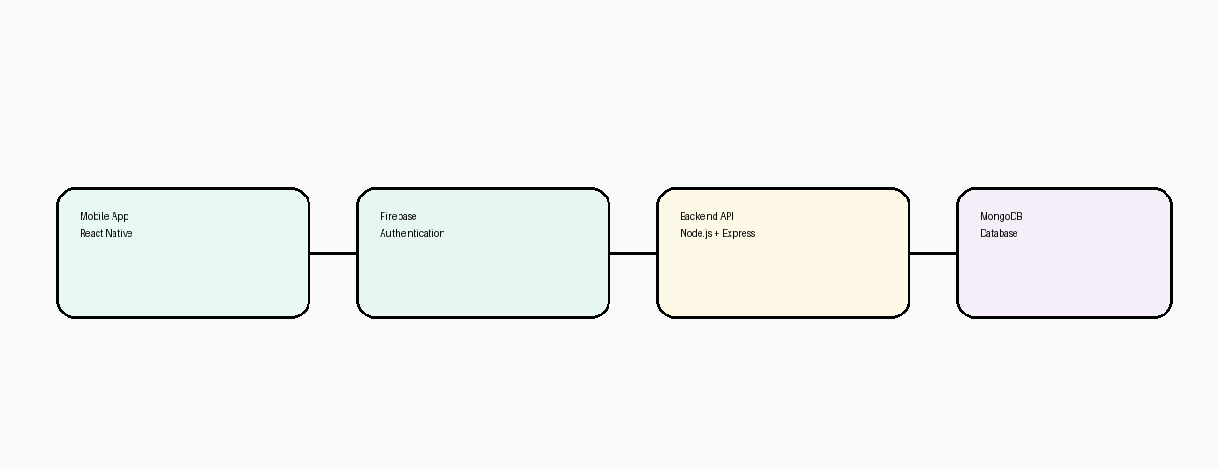

3. User Flow Diagram
