Program 3 – Energy Management System based on Abstract classes

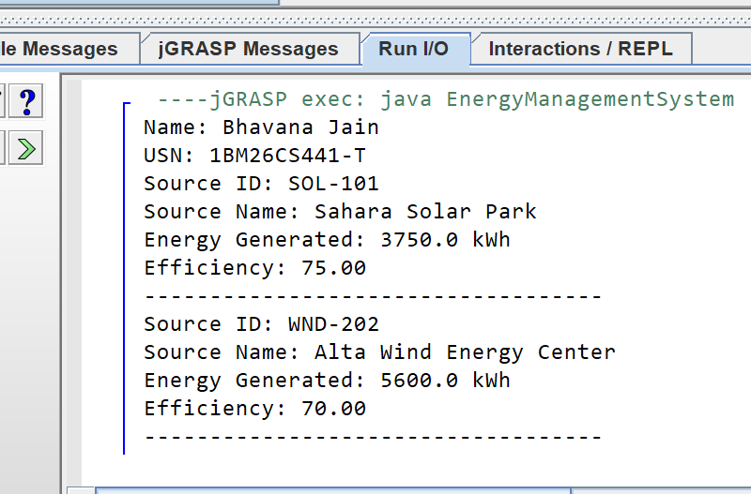
abstract class EnergySource {
String sourceId;
String sourceName;
double energyGenerated;
EnergySource(String sourceId, String sourceName, double energyGenerated) {
this.sourceId = sourceId;
this.sourceName = sourceName;
this.energyGenerated = energyGenerated;
}
abstract double calculateEfficiency();
void displayDetails() {
System.out.println("Source ID: " + sourceId);
System.out.println("Source Name: " + sourceName);
System.out.println("Energy Generated: " + energyGenerated + " kWh");
System.out.printf("Efficiency: %.2f\n", calculateEfficiency());
System.out.println("-----------------------------------");
}
}
class SolarEnergy extends EnergySource {
SolarEnergy(String sourceId, String sourceName, double energyGenerated) {
super(sourceId, sourceName, energyGenerated);
}
double calculateEfficiency() {
return (energyGenerated / 5000.0) * 100.0;
}
}
class WindEnergy extends EnergySource {
WindEnergy(String sourceId, String sourceName, double energyGenerated) {
super(sourceId, sourceName, energyGenerated);
}
double calculateEfficiency() {
return (energyGenerated / 8000.0) * 100.0;
}
}
public class EnergyManagementSystem {
public static void main(String[] args) {
System.out.println("Name: Bhavana Jain");
System.out.println("USN: 1BM26CS441-T");
EnergySource ref;
ref = new SolarEnergy("SOL-101", "Sahara Solar Park", 3750.0);
ref.displayDetails();
ref = new WindEnergy("WND-202", "Alta Wind Energy Center", 5600.0);
ref.displayDetails();
}
}

Output:

Program 4 – Parking Management System based on Interfaces

interface ParkingCharge {
double calculateCharge();
void displayParkingDetails();
}
class VehicleParking {
String vehicleNumber;
String vehicleType;
int parkingHours;
public VehicleParking(String vehicleNumber, String vehicleType, int parkingHours) {
this.vehicleNumber = vehicleNumber;
this.vehicleType = vehicleType;
this.parkingHours = parkingHours;
}
}
class TwoWheeler extends VehicleParking implements ParkingCharge {
public TwoWheeler(String vehicleNumber, int parkingHours) {
super(vehicleNumber, "Two Wheeler", parkingHours);
}
public double calculateCharge() {
if (parkingHours <= 2) {
return parkingHours * 20.0;
} else {
return (2 * 20.0) + ((parkingHours - 2) * 10.0);
}
}
public void displayParkingDetails() {
System.out.println("Vehicle Number: " + vehicleNumber);
System.out.println("Vehicle Type: " + vehicleType);
System.out.println("Parking Hours: " + parkingHours + " hrs");
System.out.println("Total Parking Charge: Rs. " + calculateCharge());
System.out.println("-----------------------------------");
}
}
class FourWheeler extends VehicleParking implements ParkingCharge {
public FourWheeler(String vehicleNumber, int parkingHours) {
super(vehicleNumber, "Four Wheeler", parkingHours);
}
public double calculateCharge() {
if (parkingHours <= 2) {
return parkingHours * 50.0;
} else {
return (2 * 50.0) + ((parkingHours - 2) * 30.0);
}
}
public void displayParkingDetails() {
System.out.println("Vehicle Number: " + vehicleNumber);
System.out.println("Vehicle Type: " + vehicleType);
System.out.println("Parking Hours: " + parkingHours + " hrs");
System.out.println("Total Parking Charge: Rs. " + calculateCharge());
System.out.println("-----------------------------------");
}
}
public class ParkingManagementSystem {
public static void main(String[] args) {
System.out.println("Name: Bhavana Jain");
System.out.println("USN: 1BM26CS441-T");
ParkingCharge parkingRef;
parkingRef = new TwoWheeler("KA-01-AB-1234", 5);
parkingRef.displayParkingDetails();
parkingRef = new FourWheeler("KA-05-CD-5678", 4);
parkingRef.displayParkingDetails();}}

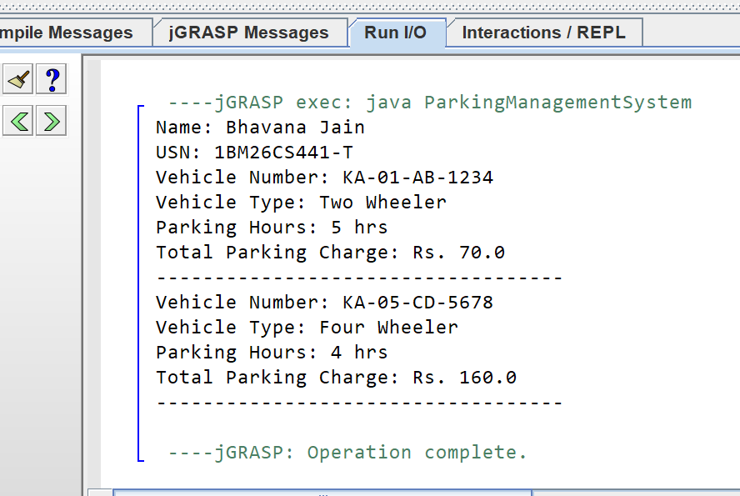
Output:

