**Exercise 1: Configuring a Basic Spring Application**

**Scenario:**

Your company is developing a web application for managing a library. You need to use the Spring Framework to handle the backend operations.

**Steps:**

**1.Set Up a Spring Project:**

Go to:  
**File → New → Maven Project**

In the pop-up:

* **Check** Create a simple project (skip archetype selection)
* Click **Next**

Enter:

* **Group Id:** com.library
* **Artifact Id:** LibraryManagement
* Click **Finish**

**Add Spring Core dependencies in the pom.xml file.**

**pom.xml**

<project xmlns="http://maven.apache.org/POM/4.0.0"

xmlns:xsi="http://www.w3.org/2001/XMLSchema-instance"

xsi:schemaLocation="http://maven.apache.org/POM/4.0.0

http://maven.apache.org/xsd/maven-4.0.0.xsd">

<modelVersion>4.0.0</modelVersion>

<groupId>com.library</groupId>

<artifactId>LibraryManagement</artifactId>

<version>0.0.1-SNAPSHOT</version>

<dependencies>

<dependency>

<groupId>org.springframework</groupId>

<artifactId>spring-context</artifactId>

<version>5.3.31</version>

</dependency>

</dependencies>

<build>

<plugins>

<plugin>

<groupId>org.apache.maven.plugins</groupId>

<artifactId>maven-compiler-plugin</artifactId>

<version>3.10.1</version>

<configuration>

<source>1.8</source>

<target>1.8</target>

</configuration>

</plugin>

</plugins>

</build>

</project>

**2.Configure the Application Context:**

**applicationContext.xml**

<?xml version="1.0" encoding="UTF-8"?>

<beans xmlns="http://www.springframework.org/schema/beans"

xmlns:xsi="http://www.w3.org/2001/XMLSchema-instance"

xsi:schemaLocation="http://www.springframework.org/schema/beans

https://www.springframework.org/schema/beans/spring-beans.xsd">

<bean id="bookRepository" class="com.library.repository.BookRepository"/>

<bean id="bookService" class="com.library.service.BookService">

<property name="bookRepository" ref="bookRepository"/>

</bean>

</beans>

**3.Define Service and Repository Classes:**

**BookService.java**

package com.library.service;

import com.library.repository.BookRepository;

public class BookService {

private BookRepository bookRepository;

public void setBookRepository(BookRepository bookRepository) {

this.bookRepository = bookRepository;

}

public void addBook(String bookName) {

System.*out*.println("Adding book: " + bookName);

bookRepository.saveBook(bookName);

}

}

**BookRepository.java**

package com.library.repository;

public class BookRepository {

public void saveBook(String bookName) {

System.*out*.println("Book '" + bookName + "' saved to database.");

}

}

**4.Run the Application:**

**Create a main class to load the Spring context and test the configuration.**

**Main.java**

package com.library;

import com.library.service.BookService;

import org.springframework.context.ApplicationContext;

import org.springframework.context.support.ClassPathXmlApplicationContext;

public class Main {

public static void main(String[] args) {

ApplicationContext context = new ClassPathXmlApplicationContext("applicationContext.xml");

BookService bookService = (BookService) context.getBean("bookService");

bookService.addBook("Spring in Action");

((ClassPathXmlApplicationContext) context).close();

}

}

Right-click on MainApp.java

**Run As → Java Application**

**OUTPUT:**

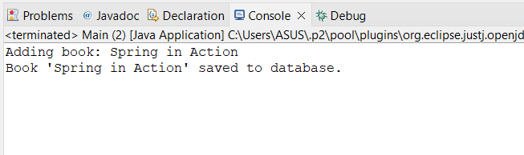

**Exercise 2: Implementing Dependency Injection**

**Scenario:**

In the library management application, you need to manage the dependencies between the BookService and BookRepository classes using Spring's IoC and DI.

**Steps:**

**1.Modify the XML Configuration:**

Update applicationContext.xml to wire BookRepository into BookService.

**applicationContext.xml**

<?xml version="1.0" encoding="UTF-8"?>

<beans xmlns="http://www.springframework.org/schema/beans"

xmlns:xsi="http://www.w3.org/2001/XMLSchema-instance"

xsi:schemaLocation="

http://www.springframework.org/schema/beans

https://www.springframework.org/schema/beans/spring-beans.xsd">

<!-- Define BookRepository Bean -->

<bean id="bookRepository" class="com.library.repository.BookRepository" />

<!-- Define BookService Bean and inject dependency -->

<bean id="bookService" class="com.library.service.BookService">

<property name="bookRepository" ref="bookRepository"/>

</bean>

</beans>

**2.Update the BookService Class:**

Ensure that BookService class has a setter method for BookRepository.

package com.library.service;

import com.library.repository.BookRepository;

public class BookService {

private BookRepository bookRepository;

public void setBookRepository(BookRepository bookRepository) {

this.bookRepository = bookRepository;

}

public void addBook(String bookName) {

System.*out*.println("Adding book: " + bookName);

bookRepository.saveBook(bookName);

}

}

**3.Test the Configuration:**

Run the LibraryManagementApplication main class to verify the dependency injection.

**Main.java**

package com.library;

import com.library.service.BookService;

import org.springframework.context.ApplicationContext;

import org.springframework.context.support.ClassPathXmlApplicationContext;

public class Main {

public static void main(String[] args) {

ApplicationContext context = new ClassPathXmlApplicationContext("applicationContext.xml");

BookService bookService = (BookService) context.getBean("bookService");

bookService.addBook("Dependency Injection in Spring");

((ClassPathXmlApplicationContext) context).close();

}

}

OUTPUT:

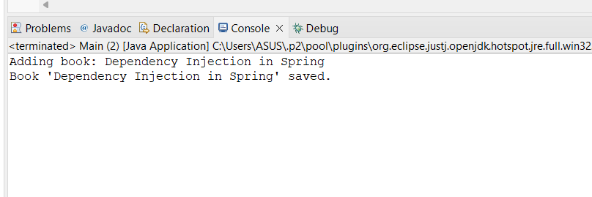

**Exercise 4: Creating and Configuring a Maven Project**

**Scenario:**

You need to set up a new Maven project for the library management application and add Spring dependencies.

Go to File → New → Maven Project.

In the New Maven Project wizard:

* Check - Create a simple project.
* Click Next.

Fill in the project details:

* Group Id: com.library
* Artifact Id: LibraryManagement
* Name: LibraryManagement
* Click Finish.

**pom.xml**

<project xmlns="http://maven.apache.org/POM/4.0.0"

xmlns:xsi="http://www.w3.org/2001/XMLSchema-instance"

xsi:schemaLocation="http://maven.apache.org/POM/4.0.0

http://maven.apache.org/xsd/maven-4.0.0.xsd">

<modelVersion>4.0.0</modelVersion>

<groupId>com.library</groupId>

<artifactId>LibraryManagement</artifactId>

<version>1.0-SNAPSHOT</version>

<packaging>war</packaging>

<dependencies>

<dependency>

<groupId>org.springframework</groupId>

<artifactId>spring-context</artifactId>

<version>5.3.34</version>

</dependency>

<dependency>

<groupId>org.springframework</groupId>

<artifactId>spring-aop</artifactId>

<version>5.3.34</version>

</dependency>

<dependency>

<groupId>org.springframework</groupId>

<artifactId>spring-webmvc</artifactId>

<version>5.3.34</version>

</dependency>

<dependency>

<groupId>javax.servlet</groupId>

<artifactId>javax.servlet-api</artifactId>

<version>4.0.1</version>

<scope>provided</scope>

</dependency>

</dependencies>

<build>

<plugins>

<plugin>

<groupId>org.apache.maven.plugins</groupId>

<artifactId>maven-compiler-plugin</artifactId>

<version>3.11.0</version>

<configuration>

<source>1.8</source>

<target>1.8</target>

</configuration>

</plugin>

</plugins>

</build>

</project>