**Spring REST Using Spring Boot**

**1.Create a Spring Web Project using Maven** 

**Step 1: Go to Spring Initializr**

* URL: <https://start.spring.io>
* Group: com.cognizant
* Artifact: spring-learn
* Dependencies:
  + **Spring Web**
  + **Spring Boot DevTools**
* Project Type: Maven
* Language: Java

**Step 2: Download and Extract ZIP**

* Click Generate, and a ZIP is downloaded.
* Extract the zip file into Eclipse workspace folder.

**Step 3: Build the Project using Maven**

In Command Prompt:

cd C:\Users\ASUS\eclipse-workspace\spring-learn

mvn clean package -Dhttp.proxyHost=proxy.cognizant.com -Dhttp.proxyPort=6050 -Dhttps.proxyHost=proxy.cognizant.com -Dhttps.proxyPort=6050 -Dhttp.proxyUser=123456

**Step 4: Import Project into Eclipse**

* Go to Eclipse → File > Import > Maven > Existing Maven Projects
* Browse to: spring-learn folder
* Click Finish

**Step 5: Verify main() Method with Log**

**SpringLearnApplication.java:**

package com.cognizant.spring_learn;

import org.springframework.boot.SpringApplication;

import org.springframework.boot.autoconfigure.SpringBootApplication;

@SpringBootApplication

public class SpringLearnApplication {

public static void main(String[] args) {

SpringApplication.run(SpringLearnApplication.class, args);

System.out.println("SpringLearnApplication started successfully!");

}

}

**Pom.xml:**

<project xmlns="http://maven.apache.org/POM/4.0.0"

xmlns:xsi="http://www.w3.org/2001/XMLSchema-instance"

xsi:schemaLocation="http://maven.apache.org/POM/4.0.0

https://maven.apache.org/xsd/maven-4.0.0.xsd">

<modelVersion>4.0.0</modelVersion>

<groupId>com.cognizant</groupId>

<artifactId>spring-learn</artifactId>

<version>0.0.1-SNAPSHOT</version>

<packaging>jar</packaging>

<name>spring-learn</name>

<description>Spring Boot Web Project</description>

<parent>

<groupId>org.springframework.boot</groupId>

<artifactId>spring-boot-starter-parent</artifactId>

<version>3.1.0</version>

<relativePath/> <!-- lookup parent from repository -->

</parent>

<properties>

<java.version>21</java.version>

</properties>

<dependencies>

<dependency>

<groupId>org.springframework.boot</groupId>

<artifactId>spring-boot-starter-web</artifactId>

</dependency>

<dependency>

<groupId>org.springframework.boot</groupId>

<artifactId>spring-boot-devtools</artifactId>

<scope>runtime</scope>

<optional>true</optional>

</dependency>

<dependency>

<groupId>org.springframework.boot</groupId>

<artifactId>spring-boot-starter-test</artifactId>

<scope>test</scope>

</dependency>

</dependencies>

<build>

<plugins>

<plugin>

<groupId>org.apache.maven.plugins</groupId>

<artifactId>maven-compiler-plugin</artifactId>

<version>3.10.1</version>

<configuration>

<source>${java.version}</source>

<target>${java.version}</target>

</configuration>

</plugin>

</plugins>

</build>

</project>

**Step 6: Run the Project**

* Right-click SpringLearnApplication.java
* Click Run As > Java Application

OUTPUT:

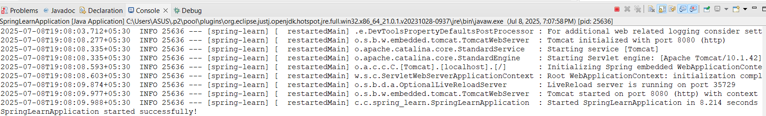

**2. Spring Core – Load Country from Spring Configuration XML** 

An airlines website is going to support booking on four countries. There will be a drop down on the home page of this website to select the respective country. It is also important to store the two-character ISO code of each country. 

1. **Create Spring XML Configuration (country.xml):**

<?xml version="1.0" encoding="UTF-8"?>

<beans xmlns="http://www.springframework.org/schema/beans"

xmlns:xsi="http://www.w3.org/2001/XMLSchema-instance"

xsi:schemaLocation="

http://www.springframework.org/schema/beans

http://www.springframework.org/schema/beans/spring-beans.xsd"

<bean id="country" class="com.cognizant.spring_learn.Country">

<property name="code" value="IN" />

<property name="name" value="India" />

</bean>

</beans>

**2**. **Country Class (com.cognizant.spring_learn.Country):**

package com.cognizant.spring_learn;

import org.slf4j.Logger;

import org.slf4j.LoggerFactory;

public class Country {

private String code;

private String name;

private static final Logger LOGGER = LoggerFactory.getLogger(Country.class);

public Country() {

LOGGER.debug("Inside Country Constructor.");

}

public String getCode() {

LOGGER.debug("Inside getCode()");

return code;

}

public void setCode(String code) {

LOGGER.debug("Inside setCode()");

this.code = code;

}

public String getName() {

LOGGER.debug("Inside getName()");

return name;

}

public void setName(String name) {

LOGGER.debug("Inside setName()");

this.name = name;

}

@Override

public String toString() {

return "Country [code=" + code + ", name=" + name + "]";

}

}

**3. SpringLearnApplication.java:**

* Contains displayCountry() method:

package com.cognizant.spring_learn;

import org.slf4j.Logger;

import org.slf4j.LoggerFactory;

import org.springframework.context.ApplicationContext;

import org.springframework.context.support.ClassPathXmlApplicationContext;

import org.springframework.boot.SpringApplication;

import org.springframework.boot.autoconfigure.SpringBootApplication;

@SpringBootApplication

public class SpringLearnApplication {

private static final Logger LOGGER = LoggerFactory.getLogger(SpringLearnApplication.class);

public static void main(String[] args) {

SpringApplication.run(SpringLearnApplication.class, args);

LOGGER.debug("SpringLearnApplication started successfully!");

displayCountry();

}

public static void displayCountry() {

ApplicationContext context = new ClassPathXmlApplicationContext("country.xml");

Country country = context.getBean("country", Country.class);

LOGGER.debug("Country : {}", country.toString());

}

}

**In applications.properties:**

logging.level.root=DEBUG

**pom.xml:**

<?xml version="1.0" encoding="UTF-8"?>

<project xmlns="http://maven.apache.org/POM/4.0.0" xmlns:xsi="http://www.w3.org/2001/XMLSchema-instance"

xsi:schemaLocation="http://maven.apache.org/POM/4.0.0 https://maven.apache.org/xsd/maven-4.0.0.xsd">

<modelVersion>4.0.0</modelVersion>

<parent>

<groupId>org.springframework.boot</groupId>

<artifactId>spring-boot-starter-parent</artifactId>

<version>3.5.3</version>

<relativePath/> <!-- lookup parent from repository -->

</parent>

<groupId>com.cognizant</groupId>

<artifactId>spring-learn</artifactId>

<version>0.0.1-SNAPSHOT</version>

<name>spring-learn</name>

<description>Demo project for Spring Boot</description>

<url/>

<licenses>

<license/>

</licenses>

<developers>

<developer/>

</developers>

<scm>

<connection/>

<developerConnection/>

<tag/>

<url/>

</scm>

<properties>

<java.version>17</java.version>

</properties>

<dependencies>

<dependency>

<groupId>org.springframework.boot</groupId>

<artifactId>spring-boot-starter-web</artifactId>

</dependency>

<dependency>

<groupId>org.springframework.boot</groupId>

<artifactId>spring-boot-devtools</artifactId>

<scope>runtime</scope>

<optional>true</optional>

</dependency>

<dependency>

<groupId>org.springframework.boot</groupId>

<artifactId>spring-boot-starter-test</artifactId>

<scope>test</scope>

</dependency>

</dependencies>

<build>

<plugins>

<plugin>

<groupId>org.springframework.boot</groupId>

<artifactId>spring-boot-maven-plugin</artifactId>

</plugin>

</plugins>

</build>

</project>

OUTPUT:

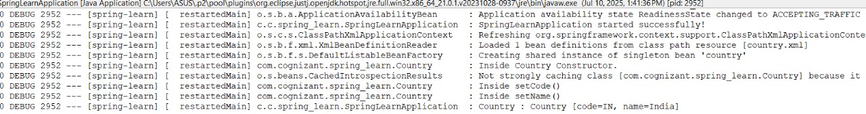

**3.Hello World RESTful Web Service**

Write a REST service in the spring learn application created earlier, that returns the text "Hello World!!" using Spring Web Framework. Refer details below:  
**1. Project Structure:**

* Project Name: spring_learn
* Controller Class: com.cognizant.spring_learn.controller.HelloController

**HelloController.java**

package com.cognizant.spring_learn.controller;

import org.slf4j.Logger;

import org.slf4j.LoggerFactory;

import org.springframework.web.bind.annotation.GetMapping;

import org.springframework.web.bind.annotation.RestController;

@RestController

public class HelloController {

private static final Logger LOGGER = LoggerFactory.getLogger(HelloController.class);

@GetMapping("/hello")

public String sayHello() {

LOGGER.info("START - sayHello()");

String message = "Hello World!!";

LOGGER.info("END - sayHello()");

return message;

}

}

**SpringLearnApplication.java**

package com.cognizant.spring_learn;

import org.slf4j.Logger;

import org.slf4j.LoggerFactory;

import org.springframework.boot.SpringApplication;

import org.springframework.boot.autoconfigure.SpringBootApplication;

@SpringBootApplication

public class SpringLearnApplication {

private static final Logger LOGGER = LoggerFactory.getLogger(SpringLearnApplication.class);

public static void main(String[] args) {

SpringApplication.run(SpringLearnApplication.class, args);

LOGGER.info("SpringLearnApplication started successfully!");

}

}

**In application.properties:**

server.port=8083

OUTPUT:

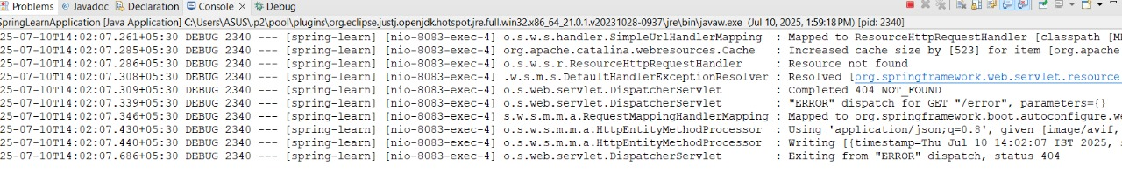

In postman:

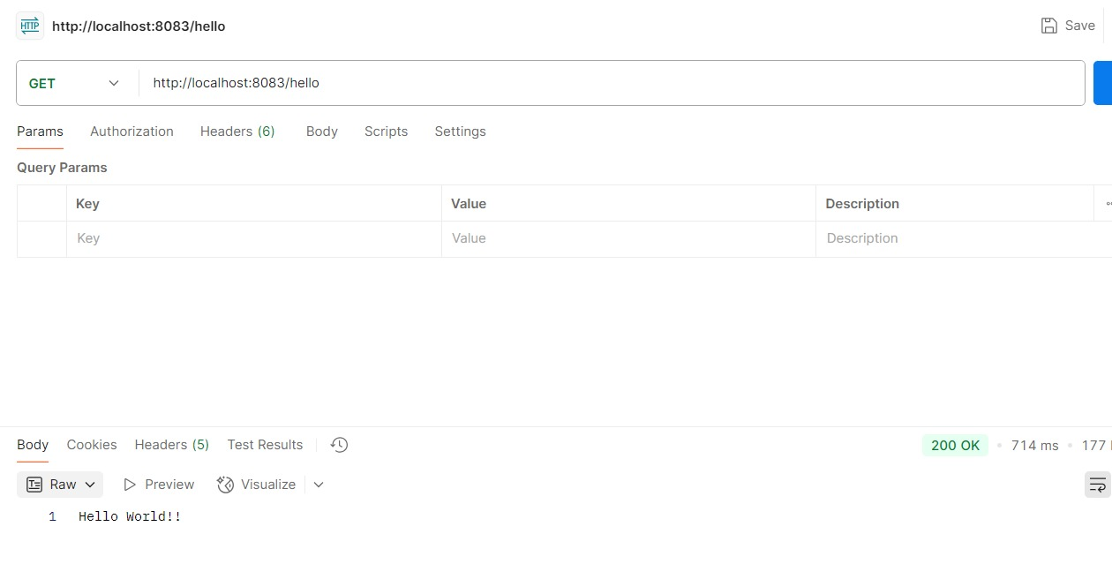

In Brower:

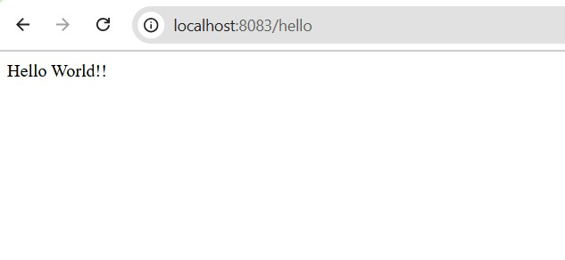

**4.REST - Country Web Service**

Write a REST service that returns India country details in the earlier created spring learn application.

**1. Configuration: country.xml**

<?xml version="1.0" encoding="UTF-8"?>

<beans xmlns="http://www.springframework.org/schema/beans"

xmlns:xsi="http://www.w3.org/2001/XMLSchema-instance"

xsi:schemaLocation="

http://www.springframework.org/schema/beans

http://www.springframework.org/schema/beans/spring-beans.xsd">

<bean id="country" class="com.cognizant.spring_learn.Country">

<property name="code" value="IN" />

<property name="name" value="India" />

</bean>

</beans>

**2. Controller Class: CountryController.java**

package com.cognizant.spring_learn.controller;

import com.cognizant.spring_learn.Country;

import org.slf4j.Logger;

import org.slf4j.LoggerFactory;

import org.springframework.context.ApplicationContext;

import org.springframework.context.support.ClassPathXmlApplicationContext;

import org.springframework.web.bind.annotation.RequestMapping;

import org.springframework.web.bind.annotation.RestController;

@RestController

public class CountryController {

private static final Logger LOGGER = LoggerFactory.getLogger(CountryController.class);

@RequestMapping("/country")

public Country getCountryIndia() {

LOGGER.info("START - getCountryIndia()");

ApplicationContext context = new ClassPathXmlApplicationContext("country.xml");

Country country = context.getBean("country", Country.class);

LOGGER.info("END - getCountryIndia()");

return country;

}

}

**SpringLearnApplication.java**

package com.cognizant.spring_learn;

import org.slf4j.Logger;

import org.slf4j.LoggerFactory;

import org.springframework.boot.SpringApplication;

import org.springframework.boot.autoconfigure.SpringBootApplication;

@SpringBootApplication

public class SpringLearnApplication {

private static final Logger LOGGER = LoggerFactory.getLogger(SpringLearnApplication.class);

public static void main(String[] args) {

SpringApplication.run(SpringLearnApplication.class, args);

LOGGER.info("SpringLearnApplication started successfully!");

}

}

OUTPUT:

In postman:

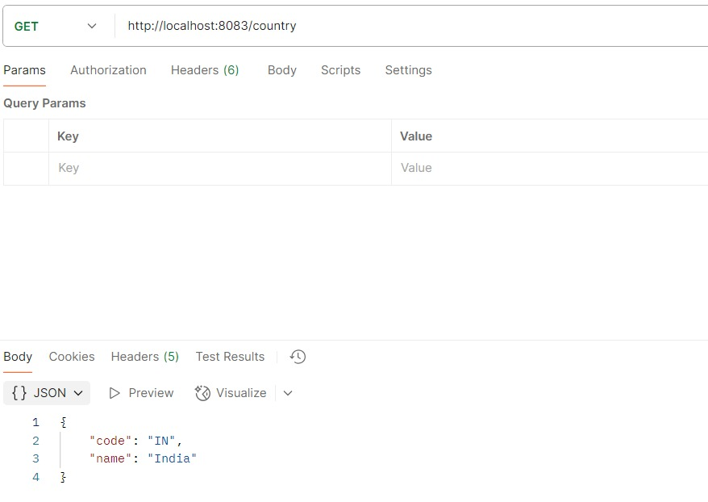

In Browser:

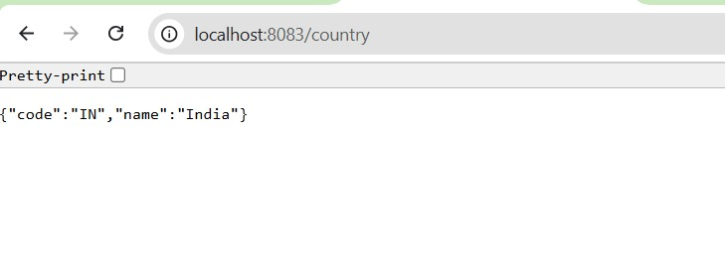

**5.REST - Get country based on country code**   
  
Write a REST service that returns a specific country based on country code. The country code should be case insensitive.

**1. Spring XML Configuration: country.xml**

<?xml version="1.0" encoding="UTF-8"?>

<beans xmlns="http://www.springframework.org/schema/beans"

xmlns:xsi="http://www.w3.org/2001/XMLSchema-instance"

xsi:schemaLocation="http://www.springframework.org/schema/beans

http://www.springframework.org/schema/beans/spring-beans.xsd">

<bean id="countryList" class="java.util.ArrayList">

<constructor-arg>

<list>

<bean class="com.cognizant.spring_learn.Country">

<property name="code" value="IN" />

<property name="name" value="India" />

</bean>

<bean class="com.cognizant.spring_learn.Country">

<property name="code" value="US" />

<property name="name" value="United States" />

</bean>

<bean class="com.cognizant.spring_learn.Country">

<property name="code" value="JP" />

<property name="name" value="Japan" />

</bean>

<bean class="com.cognizant.spring_learn.Country">

<property name="code" value="DE" />

<property name="name" value="Germany" />

</bean>

</list>

</constructor-arg>

</bean>

</beans>

**2. Controller: CountryController.java**

package com.cognizant.spring_learn.controller;

import com.cognizant.spring_learn.Country;

import com.cognizant.spring_learn.service.CountryService;

import org.slf4j.Logger;

import org.slf4j.LoggerFactory;

import org.springframework.beans.factory.annotation.Autowired;

import org.springframework.web.bind.annotation.*;

@RestController

public class CountryController {

private static final Logger LOGGER = LoggerFactory.getLogger(CountryController.class);

@Autowired

private CountryService countryService;

@GetMapping("/countries/{code}")

public Country getCountry(@PathVariable String code) {

LOGGER.info("START - getCountry() with code: {}", code);

Country country = countryService.getCountry(code);

LOGGER.info("END - getCountry()");

return country;

} }

**3. Service: CountryService.java**

package com.cognizant.spring_learn.service;

import com.cognizant.spring_learn.Country;

import org.springframework.context.ApplicationContext;

import org.springframework.context.support.ClassPathXmlApplicationContext;

import org.springframework.stereotype.Service;

import java.util.List;

@Service

public class CountryService {

public Country getCountry(String code) {

ApplicationContext context = new ClassPathXmlApplicationContext("country.xml");

List<Country> countryList = (List<Country>) context.getBean("countryList");

return countryList.stream()

.filter(c -> c.getCode().equalsIgnoreCase(code))

.findFirst()

.orElseThrow(() -> new RuntimeException("Country not found with code: " + code));

}

}

OUTPUT:

In Brower:

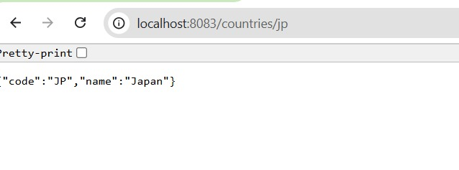

In postman:

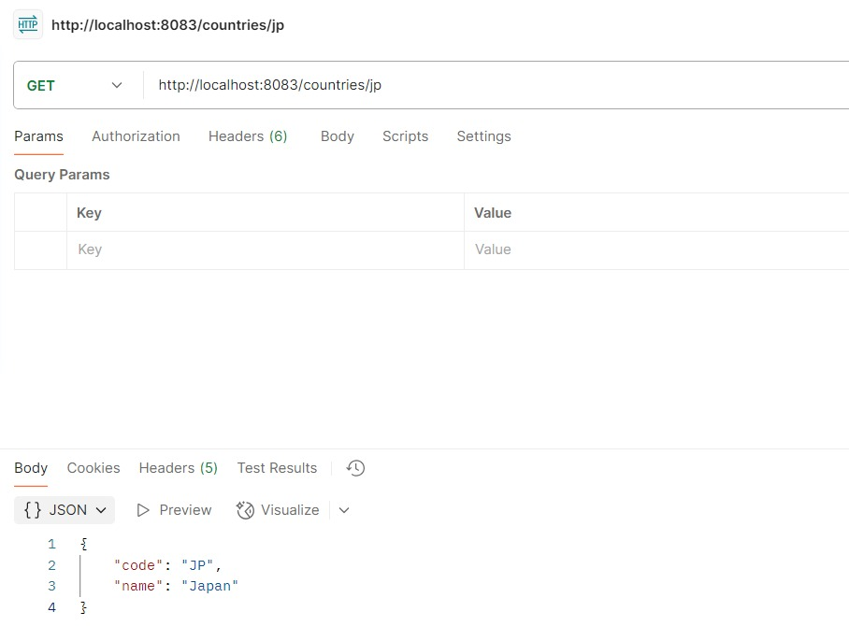

**6.Create authentication service that returns JWT**   
  
As part of first step of JWT process, the user credentials needs to be sent to authentication service request that generates and returns the JWT.  
  
**1. Create Authentication Controller**

**AuthController.java**

package com.cognizant.spring_learn.controller;

import io.jsonwebtoken.JwtBuilder;

import io.jsonwebtoken.Jwts;

import io.jsonwebtoken.SignatureAlgorithm;

import io.jsonwebtoken.security.Keys;

import org.slf4j.Logger;

import org.slf4j.LoggerFactory;

import org.springframework.web.bind.annotation.*;

import java.util.Base64;

import java.util.Date;

import java.util.HashMap;

import java.util.Map;

@RestController

public class AuthController {

private Logger logger = LoggerFactory.getLogger(AuthController.class);

@GetMapping("/authenticate")

public Map<String, String> authenticate(@RequestHeader("Authorization") String authHeader) {

logger.info("START: authenticate()");

logger.debug("Authorization Header: {}", authHeader);

String user = getUser(authHeader);

logger.debug("Decoded User: {}", user);

String token = generateJwt(user);

Map<String, String> map = new HashMap<>();

map.put("token", token);

logger.info("END: authenticate()");

return map;

}

private String getUser(String authHeader) {

logger.info("START: getUser()");

String base64Credentials = authHeader.substring("Basic".length()).trim();

byte[] decoded = Base64.getDecoder().decode(base64Credentials);

String decodedString = new String(decoded);

String username = decodedString.split(":")[0];

logger.debug("Extracted Username: {}", username);

logger.info("END: getUser()");

return username;

}

private String generateJwt(String user) {

return Jwts.builder()

.setSubject(user)

.setIssuedAt(new Date())

.setExpiration(new Date(System.currentTimeMillis() + 20 * 60 * 1000))

.signWith(Keys.hmacShaKeyFor("mysecretkeymysecretkeymysecretkey!".getBytes()), SignatureAlgorithm.HS256)

.compact();

}

}

**2. Configure Security in SecurityConfig**

**SecurityConfig.java**

package com.cognizant.spring_learn.config;

import org.springframework.context.annotation.Bean;

import org.springframework.context.annotation.Configuration;

import org.springframework.security.config.Customizer;

import org.springframework.security.config.annotation.web.builders.HttpSecurity;

import org.springframework.security.core.userdetails.User;

import org.springframework.security.core.userdetails.UserDetailsService;

import org.springframework.security.provisioning.InMemoryUserDetailsManager;

import org.springframework.security.web.SecurityFilterChain;

@Configuration

public class SecurityConfig {

@Bean

public UserDetailsService userDetailsService() {

return new InMemoryUserDetailsManager(

User.withUsername("user").password("{noop}pwd").roles("USER").build(),

User.withUsername("admin").password("{noop}adminpwd").roles("ADMIN").build()

);

}

@Bean

public SecurityFilterChain filterChain(HttpSecurity http) throws Exception {

http.csrf().disable()

.authorizeHttpRequests(auth -> auth

.requestMatchers("/countries").hasRole("USER")

.requestMatchers("/authenticate").hasAnyRole("USER", "ADMIN")

.anyRequest().authenticated()

)

.httpBasic(Customizer.withDefaults());

return http.build();

}

}

**Pom.xml**

<?xml version="1.0" encoding="UTF-8"?>

<project xmlns="http://maven.apache.org/POM/4.0.0" xmlns:xsi="http://www.w3.org/2001/XMLSchema-instance"

xsi:schemaLocation="http://maven.apache.org/POM/4.0.0 https://maven.apache.org/xsd/maven-4.0.0.xsd">

<modelVersion>4.0.0</modelVersion>

<parent>

<groupId>org.springframework.boot</groupId>

<artifactId>spring-boot-starter-parent</artifactId>

<version>3.5.3</version>

<relativePath/> <!-- lookup parent from repository -->

</parent>

<groupId>com.cognizant</groupId>

<artifactId>spring-learn</artifactId>

<version>0.0.1-SNAPSHOT</version>

<name>spring-learn</name>

<description>Demo project for Spring Boot</description>

<url/>

<licenses>

<license/>

</licenses>

<developers>

<developer/>

</developers>

<scm>

<connection/>

<developerConnection/>

<tag/>

<url/>

</scm>

<properties>

<java.version>17</java.version>

</properties>

<dependencies>

<dependency>

<groupId>org.springframework.boot</groupId>

<artifactId>spring-boot-starter-web</artifactId>

</dependency>

<dependency>

<groupId>org.springframework.boot</groupId>

<artifactId>spring-boot-starter-security</artifactId>

</dependency>

<dependency>

<groupId>org.springframework.boot</groupId>

<artifactId>spring-boot-devtools</artifactId>

<scope>runtime</scope>

<optional>true</optional>

</dependency>

<dependency>

<groupId>org.springframework.boot</groupId>

<artifactId>spring-boot-starter-test</artifactId>

<scope>test</scope>

</dependency>

<dependency>

<groupId>io.jsonwebtoken</groupId>

<artifactId>jjwt-api</artifactId>

<version>0.11.5</version>

</dependency>

<dependency>

<groupId>io.jsonwebtoken</groupId>

<artifactId>jjwt-impl</artifactId>

<version>0.11.5</version>

<scope>runtime</scope>

</dependency>

<dependency>

<groupId>io.jsonwebtoken</groupId>

<artifactId>jjwt-jackson</artifactId>

<version>0.11.5</version>

<scope>runtime</scope>

</dependency>

</dependencies>

<build>

<plugins>

<plugin>

<groupId>org.springframework.boot</groupId>

<artifactId>spring-boot-maven-plugin</artifactId>

</plugin>

</plugins>

</build>

</project>

OUTPUT:

