**Group A: Assignment No 1**

|  |  |  |  |  |  |  |
| --- | --- | --- | --- | --- | --- | --- |
| **W (4)** | **C (4)** | **D (4)** | **V(4)** | **T (4)** | **Total(20)** | **Sign** |
|  |  |  |  |  |  |  |

**Title of Assignment: ER Modeling and Normalization**

**Assignment Name: -** Propose a Conceptual Design using ER features using tools like ERD plus, ER Win etc. (Identifying entities, relationships between entities, attributes, keys, cardinalities, generalization, specialization etc.) Convert the ER diagram into relational tables and normalize Relational data model.

**Theory: -**

**Prerequisite:** Basics of RDBMS.

**Objective:**

* To learn and understand the concept offer Model and steps to Design ER Model and to ER Model into table.

**New Concepts:**

Entity-Relationship model is used in the conceptual design of a database (☞ conceptual level, conceptual schema). A database schema in the ER model can be represented pictorially (Entity-Relationship diagram)

**Components of ER Diagram:**

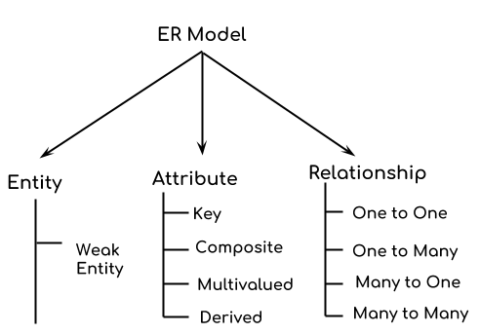

**1> Entity:** real-world object or thing with an independent existence and which is distinguishable from other objects. An entity is an object or component of data. An entity is represented as rectangle in an ER diagram.

Examples are a person, car, customer, product, gene, book etc.

**2> Attributes:** an entity is represented by a set of attributes . An attribute describes the property of an entity. e.g., name, age, salary, price etc. Attribute values that describe each entity become a major part of the data eventually stored in a database.

An attribute is represented as Oval in an ER diagram. There are four types of attributes:

1. Key attribute  
2. Composite attribute  
3. Multivalued attribute  
4. Derived attribute

**1. Key attribute:**

ER diagram key attribute: A key attribute can uniquely identify an entity from an entity set. For example, student roll number can uniquely identify a student from a set of students. Key attribute is represented by oval same as other attributes however the text of key attribute is underlined.

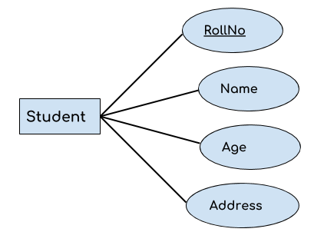

**2. Composite attribute:**

ER diagram composite attribute: An attribute that is a combination of other attributes is known as composite attribute. For example, In student entity, the student address is a composite attribute as an address is composed of other attributes such as pin code, state, country.

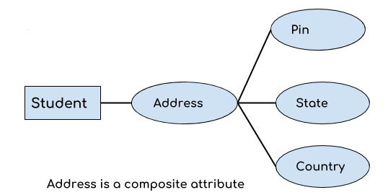

**3. Multivalued attribute:**

An attribute that can hold multiple values is known as multivalued attribute. It is represented with double ovals in an ER Diagram. For example – A person can have more than one phone numbers so the phone number attribute is multivalued.

**4. Derived attribute:**

A derived attribute is one whose value is dynamic and derived from another attribute. It is represented by dashed oval in an ER Diagram. For example – Person age is a derived attribute as it changes over time and can be derived from another attribute (Date of birth).

Multivalued and derived attribute

E-R diagram with multivalued and derived attributes:

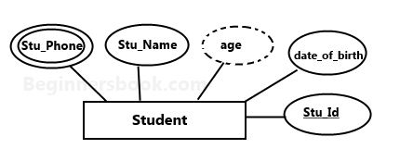

* Rectangles represent entity types
* Ellipses represent attributes
* Diamonds represent relationship types
* Lines link attributes to entity types and entity types to relationship types
* Primary key attributes are underlined
* Empty Circle at the end of a line linking an attribute to an entity type represents an optional (null) attribute
* Double Ellipses represent multi-valued attributes

### 3> Relationship

A relationship is represented by diamond shape in ER diagram, it shows the relationship among entities. There are four types of relationships:  
1. One to One  
2. One to Many  
3. Many to One  
4. Many to Many

**Many-To-Many (default)**

Meaning: An employee can work in many departments (≥ 0),and a department can have several employees

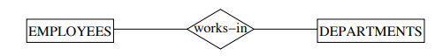

**Many-To-One**

Meaning: An employee can work in at most one department (≤ 1), and a department can have several employees.



**One-To-Many**

Meaning: An employee can work in many departments (≥ 0), but a department can have at most one employee.

**One-To-One**

Meaning: An employee can work in at most one department, and a department can have at most one employee.



**Specialization**

• Process of defining a set of subclasses of an entity type (top-down)

HOURLY EMPS is a subclass of EMPLOYEES and thus inherits its attributes and relationships (same for CONTRACT EMPS).

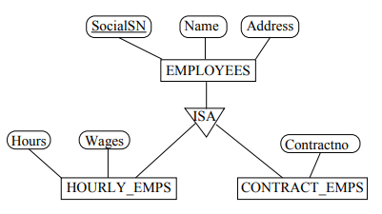

**Generalization:**

• Reverse process of specialization (bottom-up); identify common features of entity types and generalize them into single superclass (including primary key!)

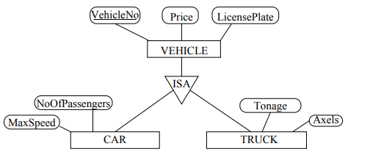

**Steps in Designing an Entity-Relationship Schema**

[Step 1] Identify entity types (entity type vs. attribute)

[Step 2] Identify relationship types

[Step 3] Identify and associate attributes with entity and

relationship types

[Step 4] Determine attribute domains

[Step 5] Determine primary key attributes for entity types

[Step 6] Associate (refined) cardinality ratio(s) with

relationship types

[Step 7] Design generalization/specialization hierarchies

including constraints (includes natural language statements

as well)

**Translation of ER Schema into Tables**

• An ER schema can be represented by a collection of tables which represent contents of the database (instance).

• Primary keys allow entity types and relationship types to be expressed uniformly as tables.

• For each entity and relationship type, a unique table can be derived which is assigned the name of the corresponding entity or relationship type.

• Each table has a number of columns that correspond to the attributes and which have unique names. An attribute of a table has the same domain as the attribute in the ER schema.

• Translating an ER schema into a collection of tables is the basis for deriving a relational database schema from an ER diagram.

ERD Plus: A database modeling tool for creating Entity Relationship Diagrams, Relational Schemas, Star Schemas, and SQL DDL statements.

https://erdplus.com/standalone