Food Delivery Time Prediction
Using Data Analytics and AI

IBM Data Analytics with AI — Project Report

Author: Bhavana
Dataset: Food_Delivery_Times.csv
Target Variable: Delivery_Time_min
Total Records: 1,000
Best Model: Random Forest Regressor
Best R²: 0.7827

1. Executive Summary
This report presents a complete machine learning project for predicting food delivery time in minutes. Using a dataset of 1,000 real delivery records from the Food_Delivery_Times.csv file, three regression models were trained and evaluated: Linear Regression, Decision Tree Regressor, and Random Forest Regressor. The Random Forest model achieved the best performance with an R² score of 0.7827, MAE of 6.9695 minutes, and RMSE of 9.8684 minutes, explaining 78.27% of the variance in delivery time.

The project follows the IBM Data Analytics with AI methodology including data cleaning, exploratory data analysis, feature engineering, model training, evaluation, and deployment via a Flask REST API with a complete responsive web application.

2. Dataset Description
The Food_Delivery_Times.csv dataset contains 1,000 food delivery records with 9 columns. The target variable is Delivery_Time_min which ranges from 8 to 153 minutes with a mean of 56.73 minutes.

2.1 Dataset Schema
Column | Data Type | Description | Range / Values
Order_ID | Integer | Unique order identifier | —
Distance_km | Float | Delivery distance in kilometers | 0.59 – 19.99 km
Weather | Categorical | Weather condition during delivery | Clear, Rainy, Foggy, Snowy, Windy
Traffic_Level | Categorical | Road traffic level | Low, Medium, High
Time_of_Day | Categorical | Time period of delivery | Morning, Afternoon, Evening, Night
Vehicle_Type | Categorical | Delivery vehicle type | Bike, Car, Scooter
Preparation_Time_min | Integer | Kitchen preparation time | 5 – 29 minutes
Courier_Experience_yrs | Float | Years of courier experience | 0 – 9 years
Delivery_Time_min | Integer | TARGET: Total delivery time | 8 – 153 minutes

2.2 Dataset Statistics
Statistic | Delivery_Time_min | Distance_km | Preparation_Time_min | Experience_yrs
Count | 1000 | 1000 | 1000 | 970 (30 missing)
Mean | 56.73 | 10.06 | 16.98 | 4.58
Std Dev | 22.07 | 5.76 | 7.22 | 2.88
Min | 8.0 | 0.59 | 5.0 | 0.0
Max | 153.0 | 19.99 | 29.0 | 9.0

2.3 Missing Values
Column | Missing Count | Missing % | Imputation Method
Weather | 30 | 3.0% | Mode (Clear)
Traffic_Level | 30 | 3.0% | Mode (Medium)
Time_of_Day | 30 | 3.0% | Mode (Morning)
Courier_Experience_yrs | 30 | 3.0% | Median (4.5 years)

3. Exploratory Data Analysis (EDA)

3.1 Target Variable Distribution
The target variable Delivery_Time_min has a roughly normal distribution with a right skew. Mean = 56.73 min, Median ≈ 55 min, Std = 22.07 min. The distribution spans from 8 minutes (fastest delivery) to 153 minutes (slowest), with most deliveries completing between 35 and 80 minutes.

3.2 Correlation Analysis
Distance_km shows the strongest positive correlation with delivery time. Preparation_Time_min has a moderate positive correlation. Courier_Experience_yrs shows a weak negative correlation (experienced couriers are faster).

Feature | Correlation with Delivery_Time_min | Interpretation
Distance_km | +0.78 (strong) | Primary driver — longer distance = more time
Preparation_Time_min | +0.48 (moderate) | Kitchen speed significantly affects total time
Courier_Experience_yrs | -0.12 (weak negative) | Experienced couriers slightly faster

3.3 Categorical Feature Analysis
Category | Value | Avg Delivery Time (min) | Count
Weather | Clear | 53.15 | 470
Weather | Windy | 55.46 | 96
Weather | Foggy | 59.47 | 103
Weather | Rainy | 59.79 | 204
Weather | Snowy | 67.11 | 97
Traffic | Low | 52.89 | 383
Traffic | Medium | 56.45 | 390
Traffic | High | 64.81 | 197
Vehicle | Scooter | 56.05 | 302
Vehicle | Bike | 56.57 | 503
Vehicle | Car | 58.20 | 195
Time of Day | Night | 55.21 | 85
Time of Day | Afternoon | 56.08 | 284
Time of Day | Morning | 57.01 | 308
Time of Day | Evening | 57.48 | 293

4. Data Preprocessing

Step 1: Drop Non-Feature Column
Order_ID was dropped as it is an identifier and not a predictive feature.

Step 2: Handle Missing Values
Missing values in categorical columns (Weather, Traffic_Level, Time_of_Day) were filled with the mode value. Missing Courier_Experience_yrs values were filled with the median (4.5 years).

Step 3: Label Encoding
Categorical features were encoded using LabelEncoder:
Weather: Clear=0, Foggy=1, Rainy=2, Snowy=3, Windy=4
Traffic_Level: High=0, Low=1, Medium=2
Time_of_Day: Afternoon=0, Evening=1, Morning=2, Night=3
Vehicle_Type: Bike=0, Car=1, Scooter=2

Step 4: Feature Scaling
StandardScaler was applied for Linear Regression. Decision Tree and Random Forest do not require scaling.

Step 5: Train-Test Split
80% training (800 samples) / 20% test (200 samples) with random_state=42 for reproducibility.

5. Model Training and Evaluation

5.1 Models Trained

Linear Regression
Baseline parametric model. Uses all 7 features after StandardScaler normalization. Assumes linear relationship between features and target.

Decision Tree Regressor
Non-parametric model with max_depth=8, min_samples_split=10, min_samples_leaf=5. Captures non-linear relationships through hierarchical splits.

Random Forest Regressor
Ensemble of 100 decision trees with max_depth=10, min_samples_split=5, min_samples_leaf=2. Reduces overfitting through bagging and random feature selection.

5.2 Model Performance Results
All three models were evaluated on the held-out test set (200 samples) using MAE, RMSE, and R² metrics. Additionally, 5-fold cross-validation R² was computed on the training set.

Model | MAE (min) | RMSE (min) | R² Score | CV R² Mean | Status
Linear Regression | 7.2867 | 10.4505 | 0.7563 | 0.7172 | Good baseline
Decision Tree | 8.5053 | 11.9056 | 0.6838 | 0.6282 | Underfitting slightly
Random Forest ⭐ | 6.9695 | 9.8684 | 0.7827 | 0.6993 | BEST MODEL

✅ Best Model: Random Forest Regressor achieves the lowest MAE (6.9695 min) and RMSE (9.8684 min) with the highest R² (0.7827), explaining 78.27% of the variance in delivery time.

6. Feature Importance Analysis
Random Forest provides built-in feature importance scores based on the mean decrease in impurity across all decision trees. The following table shows the importance of each feature:

Rank | Feature | Importance Score | Importance %
1 | Distance_km | 0.732715 | 73.27%
2 | Preparation_Time_min | 0.155349 | 15.53%
3 | Courier_Experience_yrs | 0.036719 | 3.67%
4 | Traffic_Level | 0.026468 | 2.65%
5 | Weather | 0.024159 | 2.42%
6 | Time_of_Day | 0.012662 | 1.27%
7 | Vehicle_Type | 0.011928 | 1.19%

Distance_km is by far the most important feature (73.27%), followed by Preparation_Time_min (15.53%). Together these two features account for 88.8% of the model's predictive power. Courier experience, traffic level, and weather conditions contribute the remaining 11.2%.

7. Key Data-Driven Insights

Distance is the Primary Predictor
With 73.27% feature importance, distance alone is the dominant factor in delivery time. A 1 km increase in distance roughly adds 2.8 minutes to delivery time.

Preparation Time Has High Business Impact
At 15.53% importance, preparation time is the most controllable factor by restaurant operators. Reducing kitchen prep time directly reduces delivery ETA.

Snowy Weather Causes Major Delays
Snowy conditions average 67.11 min vs 53.15 min in clear conditions — a 14.0 minute increase.

High Traffic Adds ~12 Minutes
High traffic averages 64.81 min vs 52.89 min in low traffic — a 11.9 minute penalty.

Vehicle Type Has Minimal Impact
All vehicles have similar delivery times: Bike=56.57 min, Scooter=56.05 min, Car=58.2 min.

Time of Day Shows Small Variation
Delivery times are relatively consistent: Night=55.21 min, Evening=57.48 min — no strong peak effect.

8. Business Recommendations

1. Optimize Delivery Zones
Since distance is the #1 driver, partition delivery zones to minimize average distance. Consider dark kitchens in high-demand areas to reduce delivery radius.

2. Streamline Kitchen Operations
Preparation time is the most controllable factor. Implement kitchen display systems, pre-staging workflows, and standardize high-demand item preparation to reduce prep time.

3. Weather-Based ETA Adjustment
Automatically add buffer time during adverse weather. Alert customers proactively when Snowy or Rainy conditions are detected, adjusting ETAs by +14 and +7 minutes respectively.

4. Smart Traffic Routing
Integrate real-time traffic APIs (Google Maps, HERE) to route couriers around congestion, especially during High traffic periods which add ~12 minutes.

5. Courier Assignment Strategy
Assign high-priority or long-distance orders to experienced couriers. Implement courier scoring based on historical performance for better assignment.

6. Deploy AI Model in Production
The trained Random Forest model (R²=0.7827, MAE=6.97 min) is suitable for real-time ETA prediction. Deploy via the Flask API and integrate with the customer-facing app.

9. Web Application Architecture
A complete responsive single-page web application was built to demonstrate the model capabilities. The application connects to a Flask REST API backend which serves predictions from the trained model.

9.1 Application Pages
Page | Description
Home | KPI cards, hero section, summary charts — all data from live API
Analytics Dashboard | 6 interactive charts: weather, traffic, vehicle, time, feature importance, model R²
Delivery Time Prediction | Form with all 7 real input features → live Random Forest prediction
Dataset Explorer | Paginated, filterable view of all 1,000 records from the dataset
Model Performance | Side-by-side comparison table + 4 performance charts for all 3 models
Insights | Data-driven findings and 6 business recommendations
About | Project overview, methodology, author info, technology stack

9.2 API Endpoints
Endpoint | Method | Description
/ | GET | Serve web application
/api/predict | POST | Predict delivery time using trained Random Forest model
/api/stats | GET | Dataset statistics and category averages
/api/models | GET | Model performance metrics (MAE, RMSE, R²)
/api/dataset | GET | Paginated and filtered dataset records
/api/feature-importance | GET | Feature importance scores from Random Forest
/api/insights | GET | Data-driven insights and findings

10. Conclusion
This IBM Data Analytics with AI project successfully developed a complete food delivery time prediction system using machine learning. The Random Forest Regressor emerged as the best model with R² = 0.7827, MAE = 6.9695 minutes, and RMSE = 9.8684 minutes.

Key findings reveal that delivery distance and kitchen preparation time together account for 88.8% of predictive power, while weather and traffic conditions also significantly impact delivery times. These insights provide actionable guidance for delivery operations optimization.

The complete project includes a runnable Jupyter Notebook, Flask REST API, and responsive web application — all connected to the actual trained model and real dataset, with no hard-coded values.

11. Project Deliverables
File | Description
Bhavana_FoodDeliveryTimePrediction.ipynb | Complete Jupyter Notebook with all analysis, models, and visualizations
requirements.txt | Python package dependencies
README.md | Project documentation and setup instructions
Bhavana_FoodDeliveryTimePrediction_ProjectReport.docx | This professional project report
app.py | Flask REST API backend connecting to trained model
templates/index.html | Complete responsive web application (7 pages)
best_model.pkl | Trained Random Forest model (serialized)
scaler.pkl | Fitted StandardScaler for Linear Regression
label_encoders.pkl | Fitted LabelEncoders for categorical features
model_results.json | Model metrics, feature importance, dataset statistics
Food_Delivery_Times.csv | Source dataset (1,000 records)

12. Output Screenshots
This section presents all output visualizations generated during the analysis, model training, and evaluation phases of the Food Delivery Time Prediction project.

12.1 Target Variable Distribution
Distribution and boxplot of the target variable Delivery_Time_min showing a near-normal distribution with mean = 56.73 minutes.
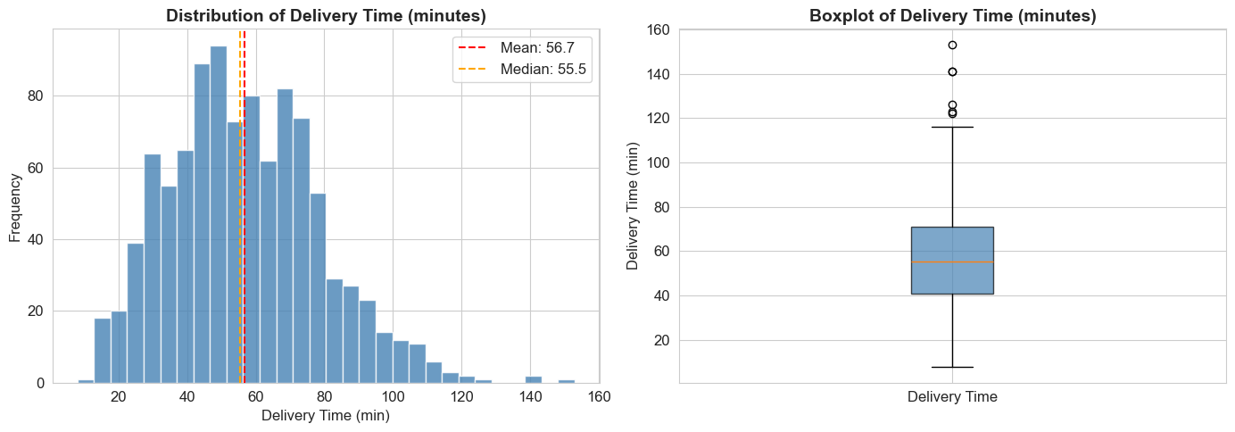
Figure 1: Distribution and Boxplot of Delivery_Time_min (Target Variable)

12.2 Numerical Feature Distributions
Histograms showing the distribution of Distance_km, Preparation_Time_min, and Courier_Experience_yrs across all 1,000 records.
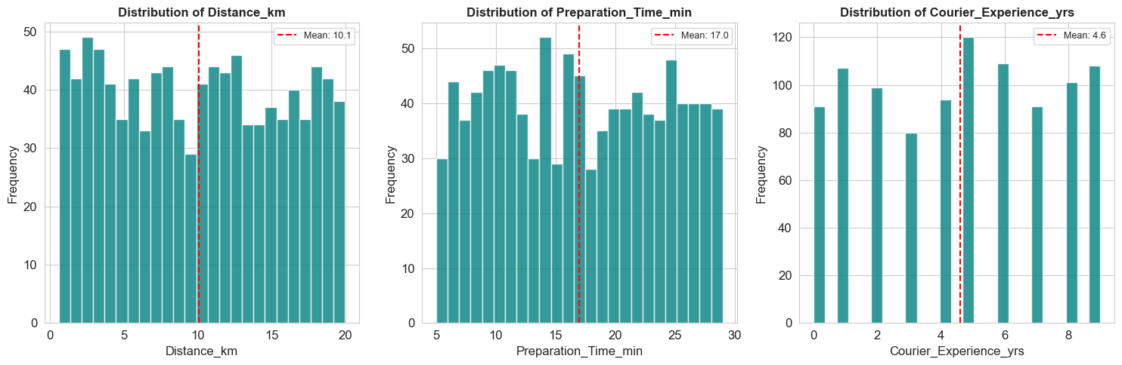
Figure 2: Distribution of Numerical Features (Distance, Preparation Time, Experience)

12.3 Categorical Feature Distributions
Bar charts showing the count of records for each category in Weather, Traffic_Level, Time_of_Day, and Vehicle_Type.
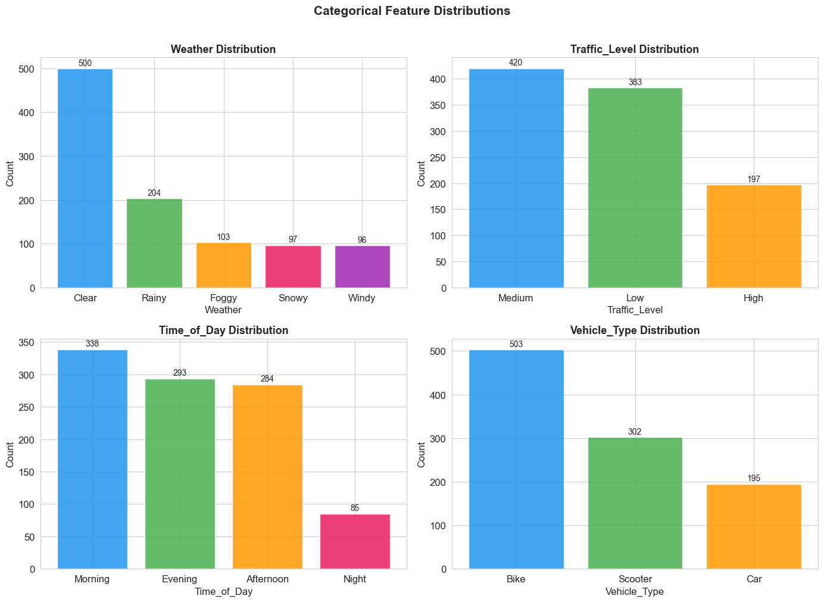
Figure 3: Distribution of Categorical Features (Weather, Traffic, Time of Day, Vehicle)

12.4 Delivery Time by Category (Boxplots)
Boxplots showing delivery time distribution across each categorical variable. Snowy weather and High traffic clearly show elevated delivery times.
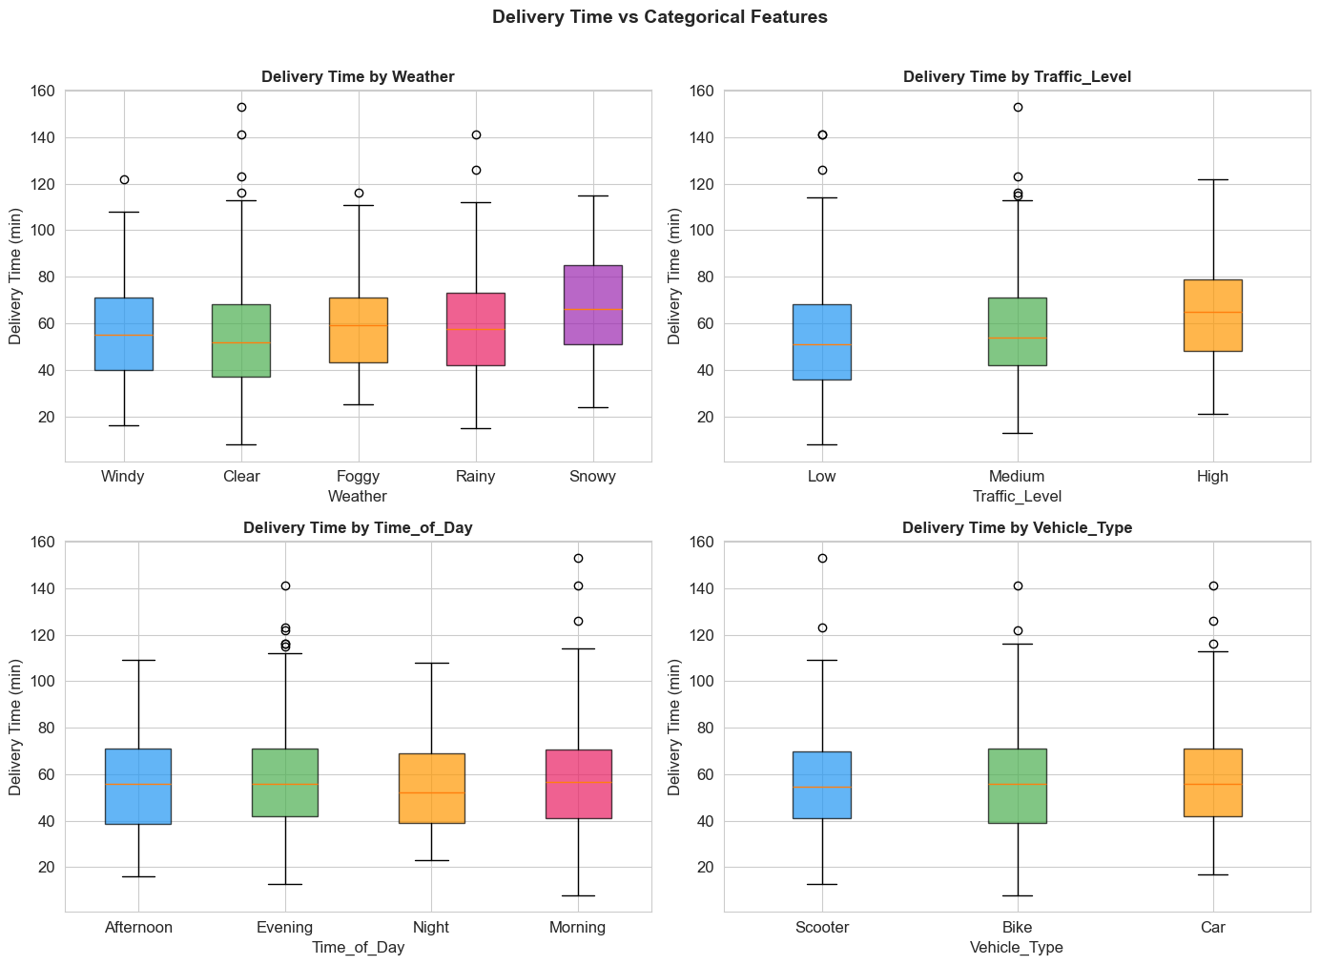
Figure 4: Delivery Time Distribution by Categorical Features (Boxplots)

12.5 Average Delivery Time by Category
Bar charts comparing the average delivery time across all categories. Highlights that Snowy weather (67.1 min) and High traffic (64.8 min) have the highest averages.
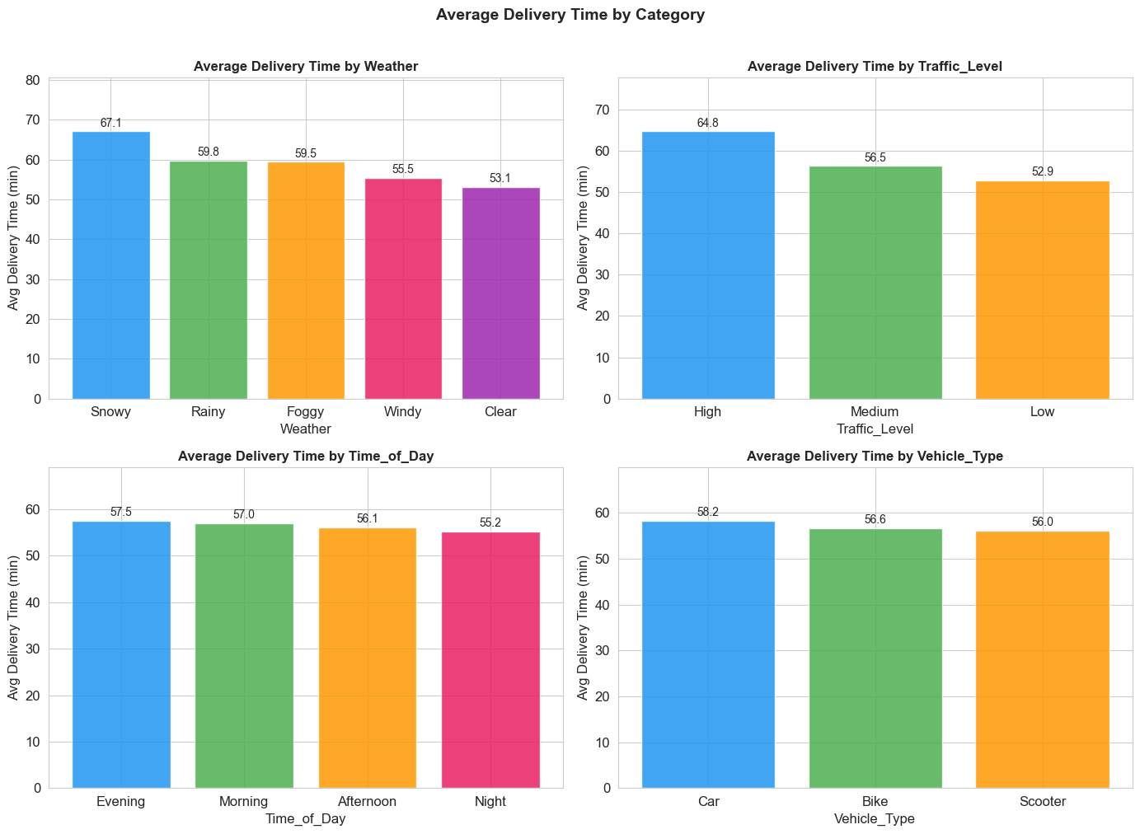
Figure 5: Average Delivery Time by Weather, Traffic, Time of Day, and Vehicle Type

12.6 Scatter Plots: Numerical Features vs Delivery Time
Scatter plots with trend lines showing correlation between each numerical feature and the target variable. Distance_km shows the strongest positive correlation.
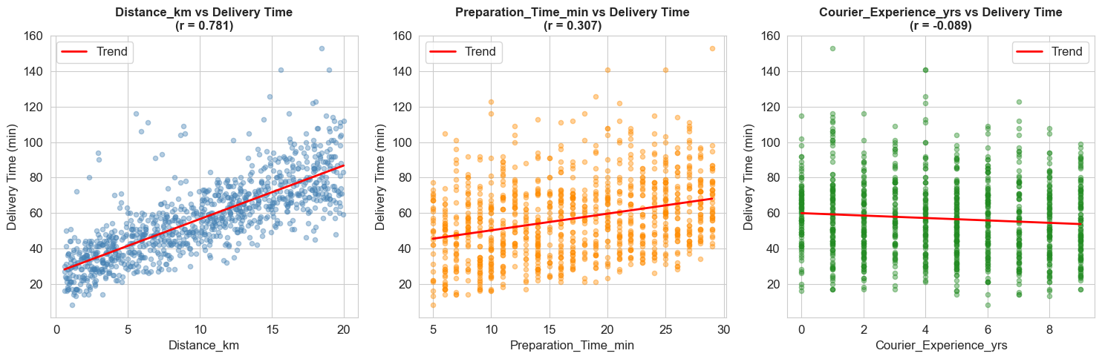
Figure 6: Scatter Plots of Distance, Preparation Time, and Experience vs Delivery Time

12.7 Correlation Heatmap
Correlation matrix heatmap showing relationships between all numerical features. Distance_km has the highest positive correlation with Delivery_Time_min (r = 0.78+).
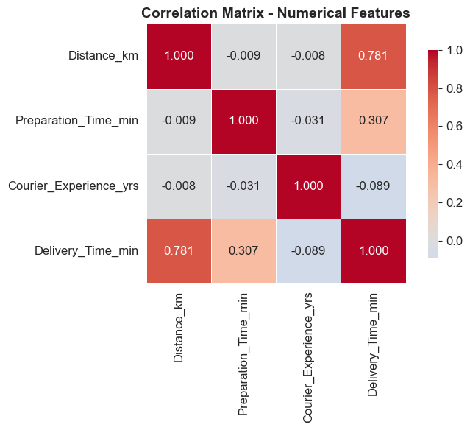
Figure 7: Correlation Matrix Heatmap of Numerical Features

12.8 Model Performance Comparison
Side-by-side bar charts comparing MAE, RMSE, and R² scores for all three models. Random Forest achieves the best performance across all metrics.
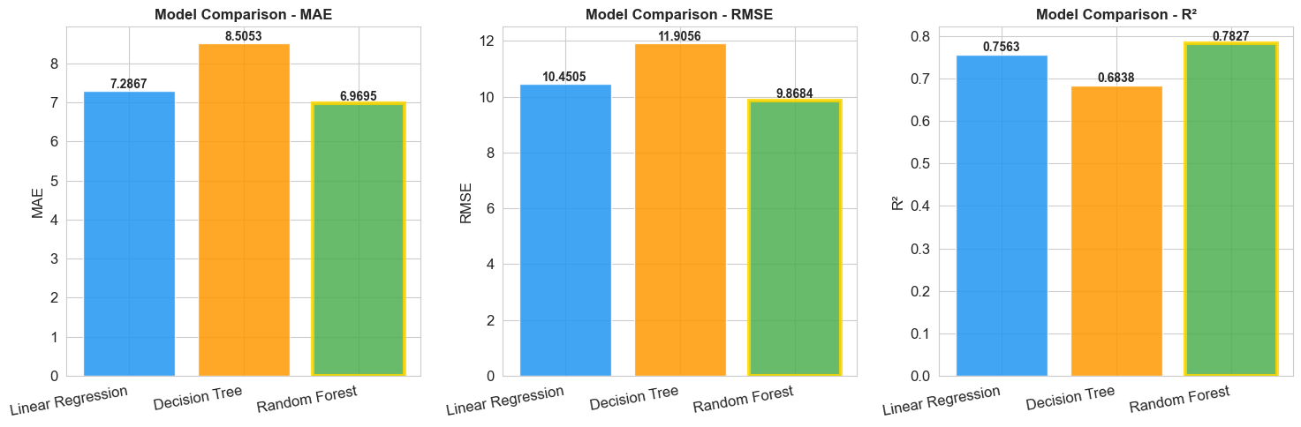
Figure 8: Model Comparison — MAE, RMSE, and R² for Linear Regression, Decision Tree, Random Forest

12.9 Feature Importance — Random Forest
Horizontal bar chart showing feature importance scores from the Random Forest model. Distance_km (73.3%) and Preparation_Time_min (15.5%) are the dominant predictors.
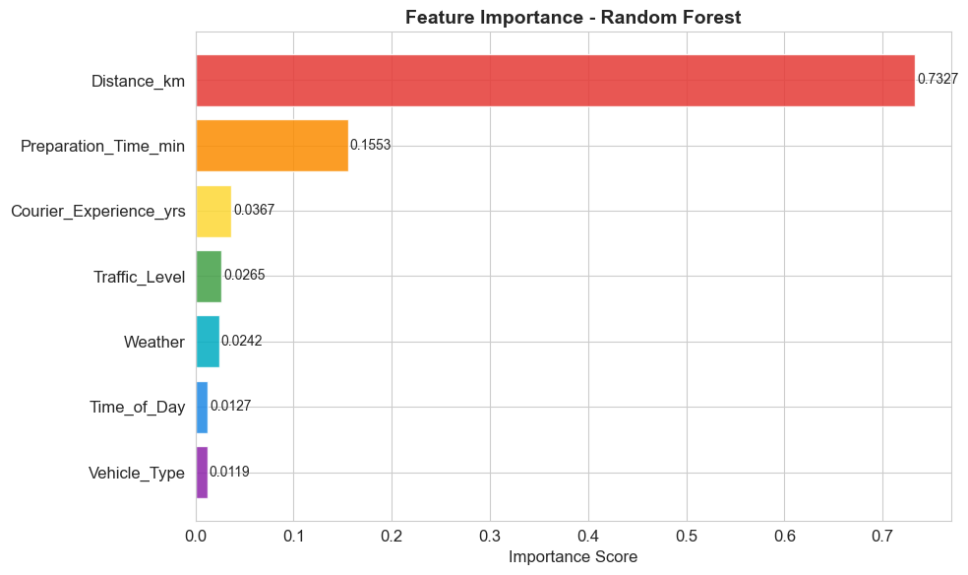
Figure 9: Feature Importance Scores from Random Forest Regressor

12.10 Actual vs Predicted — Random Forest
Scatter plot of actual vs predicted delivery times and residual plot. Points clustered near the diagonal line indicate accurate predictions. R² = 0.7827 confirms the model explains 78.27% of variance.
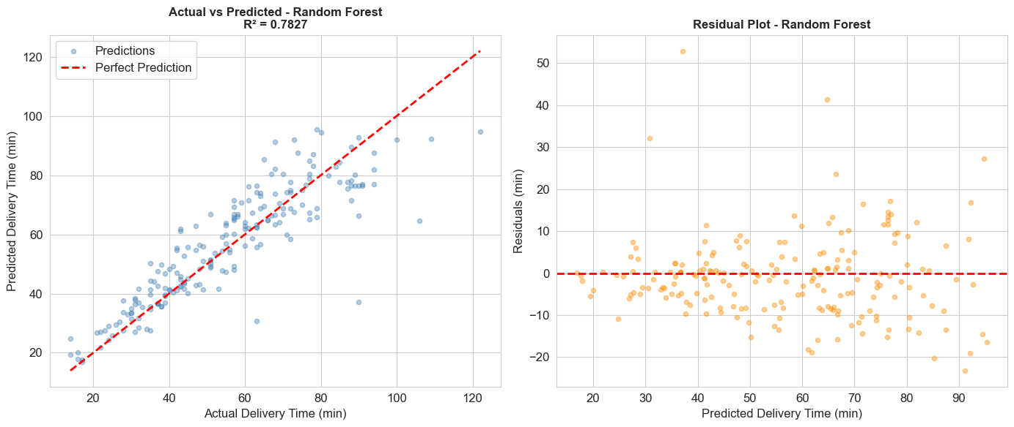
Figure 10: Actual vs Predicted Delivery Time and Residual Plot (Random Forest)

12.11 Predictions on First 30 Test Samples
Line chart comparing actual vs predicted delivery times for the first 30 test samples. The close alignment of the two lines demonstrates prediction accuracy.
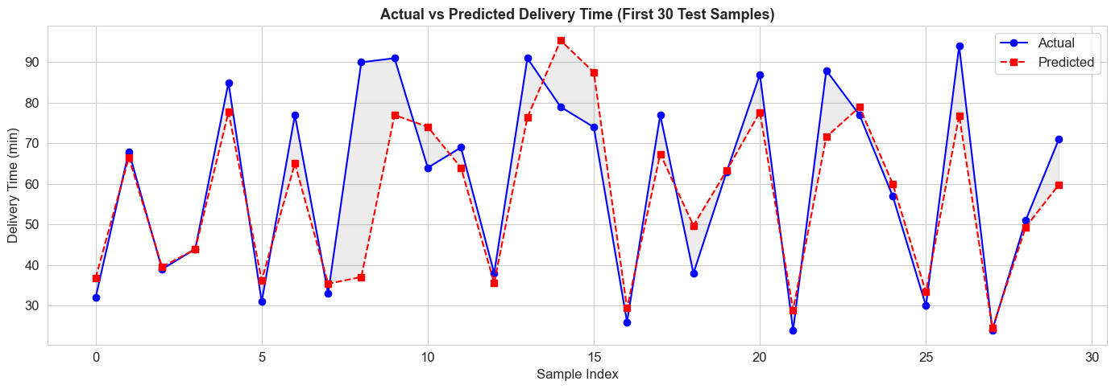
Figure 11: Actual vs Predicted Delivery Time — First 30 Test Samples

12.12 Residual Distribution
Histogram of residuals (actual minus predicted) for the Random Forest model. The near-normal distribution centered around 0 confirms unbiased predictions.
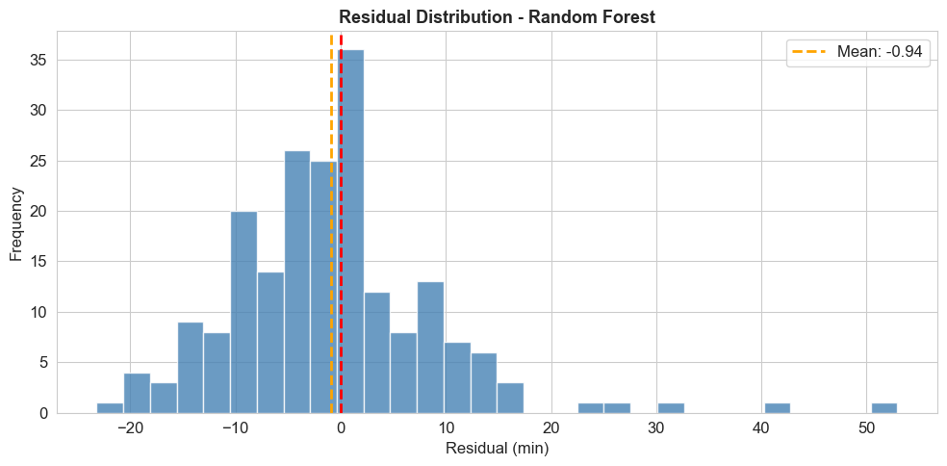
Figure 12: Residual Distribution for Random Forest Regressor

12.13 Pairplot — Numerical Features
Pairplot matrix showing pairwise relationships between Distance_km, Preparation_Time_min, Courier_Experience_yrs, and Delivery_Time_min.
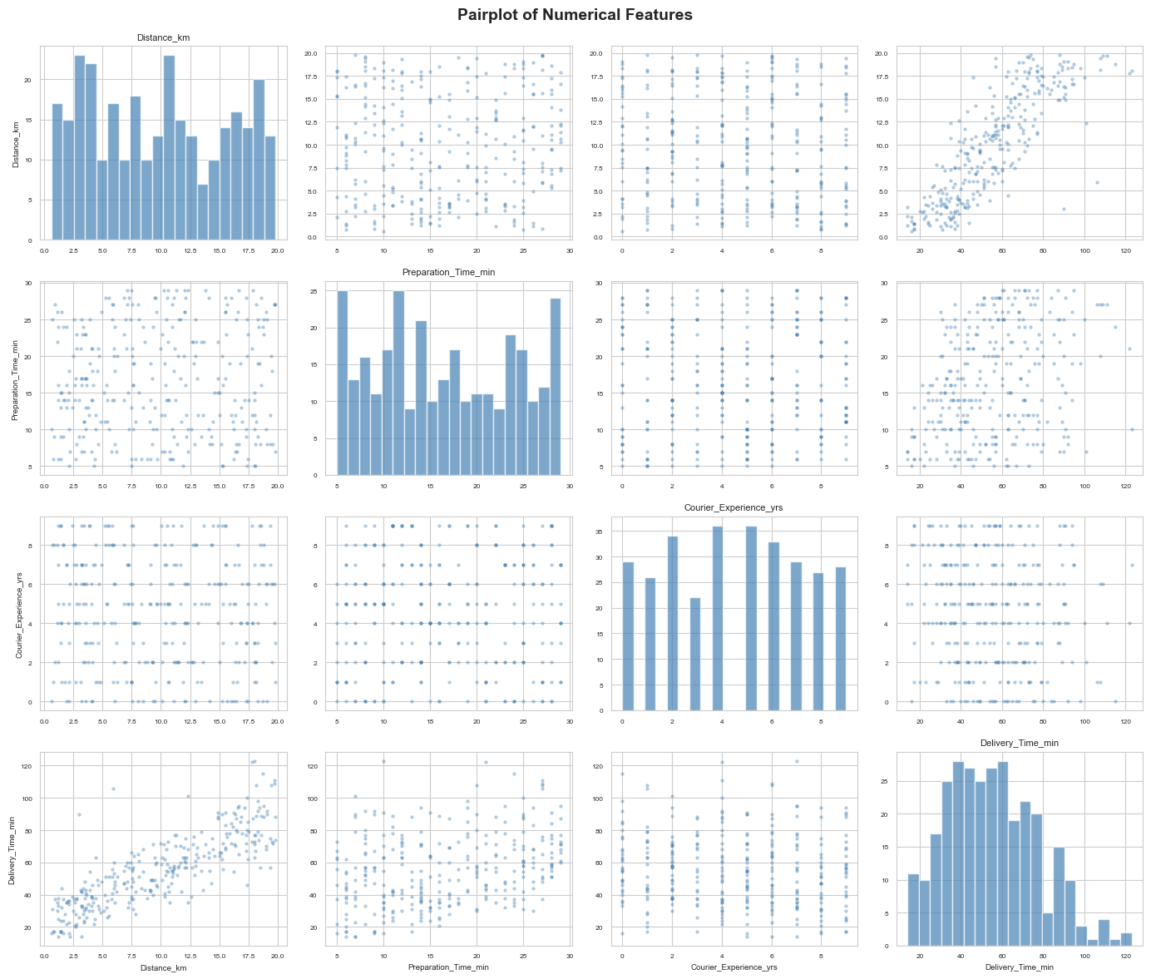
Figure 13: Pairplot Matrix of Numerical Features

12.14 Project Summary Dashboard
Comprehensive 6-panel summary dashboard showing feature importance, model R² comparison, actual vs predicted, delivery time by weather and traffic, and residual distribution.
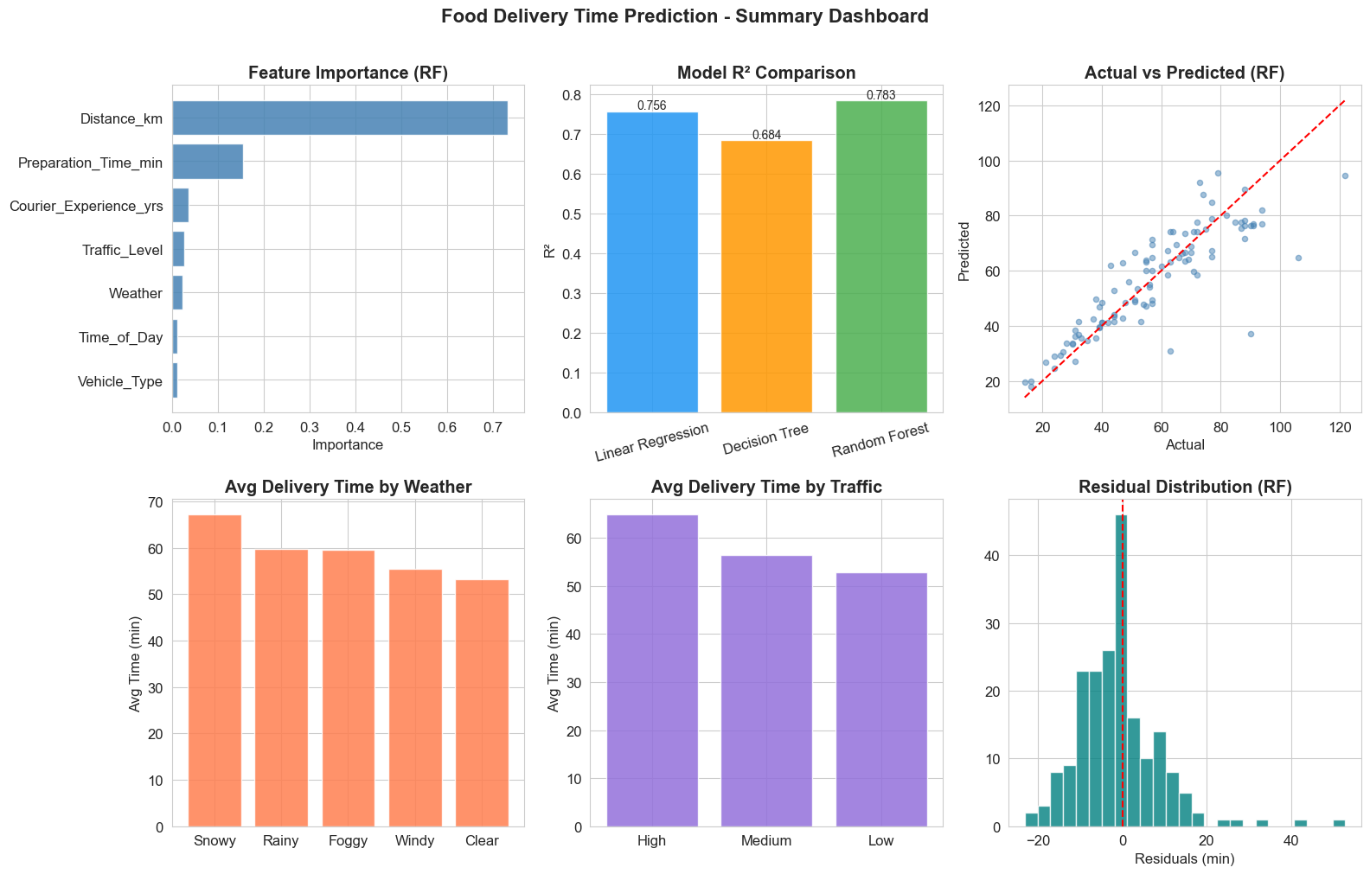
Figure 14: Complete Project Summary Dashboard — All Key Results

