📘 DocSpot: Seamless Appointment Booking for Health
Full Stack MERN Project Documentation

🔖 1. Introduction
Project Title:
DocSpot: Seamless Appointment Booking for Health
Team Id: LTVIP2026TMIDS47812
Team Leader:
D.Chandrika
Team Members:
Kommera Sujana
Kotte Hemalatha
Kodidela Maneesha
Mallam Bhavana

Overview:
DocSpot is a full-stack healthcare web application that streamlines the process of booking medical appointments. It provides a user-friendly interface for patients to book appointments online, doctors to manage their schedules, and administrators to oversee system operations. The app includes secure role-based logins and integrated online payments for a complete appointment experience.

📌 2. Project Overview
Purpose:
To provide a centralized, convenient, and secure platform for healthcare appointment management accessible by patients, doctors, and administrators.
Key Features:
- User (Patient) registration, login, and appointment booking
- Doctor login and appointment management dashboard
- Admin panel to manage users and appointments
- Razorpay integration for online payments
- Secure authentication using JWT

🏗️ 3. System Architecture
Frontend (React.js)
- Built with React and React Router
- UI components from Material UI, Bootstrap, Ant Design
- Axios for HTTP requests
- Responsive design for mobile and desktop
Backend (Node.js + Express.js)
- RESTful API architecture
- Role-based access control
- Razorpay payment API integration
- JWT authentication and route protection
Database (MongoDB)
- Collections:
o users (patients) o doctors o appointments o admins o payments
- Mongoose for schema definitions and data modeling

⚙️ 4. Setup Instructions Prerequisites:
- Node.js (v18+)
- MongoDB (Local or Atlas)
- npm
- Git
Installation & Setup:
bash
Copy code # Clone repository git clone https://github.com/your-username/docspot.git

# Frontend setup cd client npm install

Frontend terminal:
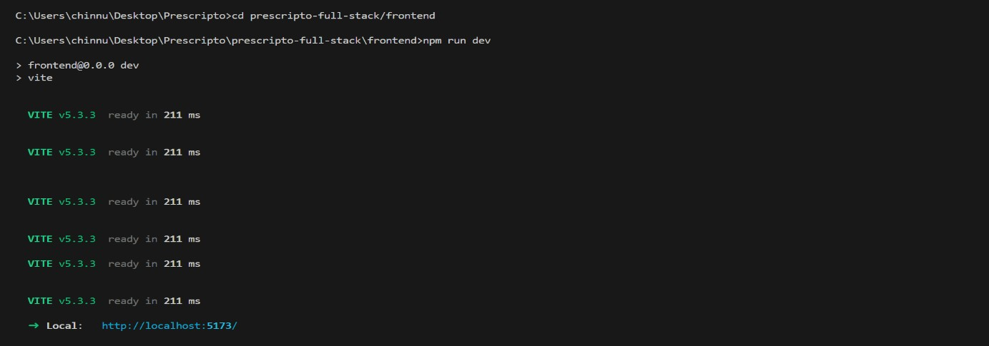

# Backend setup
cd ../server npm install

Backend terminal:
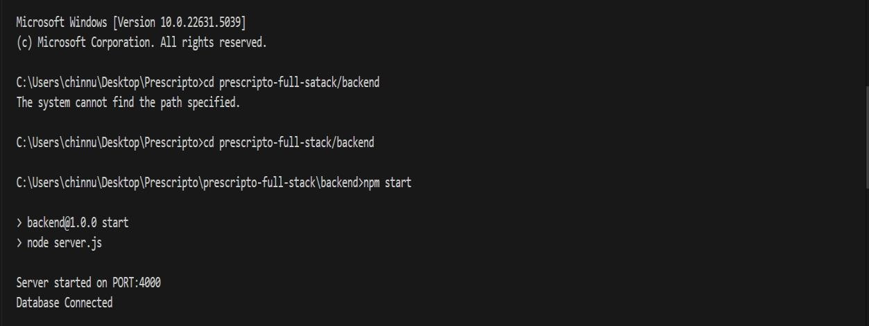

# .env file in /server/
MONGO_URI=your_mongo_uri
JWT_SECRET=your_jwt_secret
RAZORPAY_KEY=your_razorpay_key
RAZORPAY_SECRET=your_razorpay_secret
PORT=5000

📁 5. Folder Structure
Client: pgsql Copy code
client/
├── public/
├── src/
│ ├── components/
│ ├── pages/
│ ├── context/ │ └── App.js, index.js
Server: pgsql Copy code server/
├── controllers/
├── routes/
├── models/
├── config/
├── middlewares/
└── server.js

Backend Folder Structure:

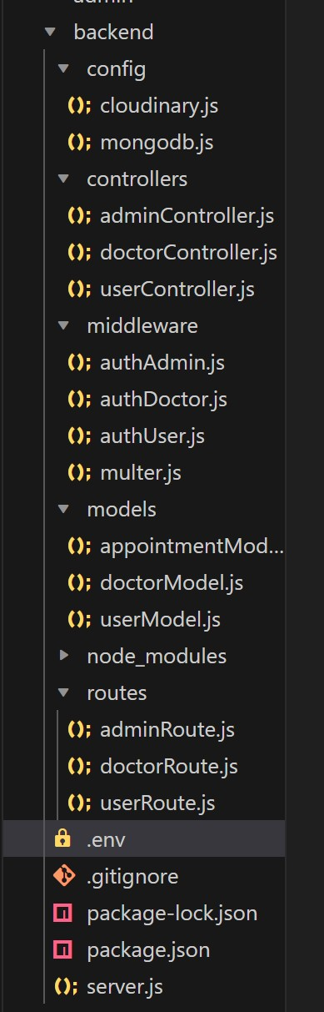

Frontend Folder Structure:

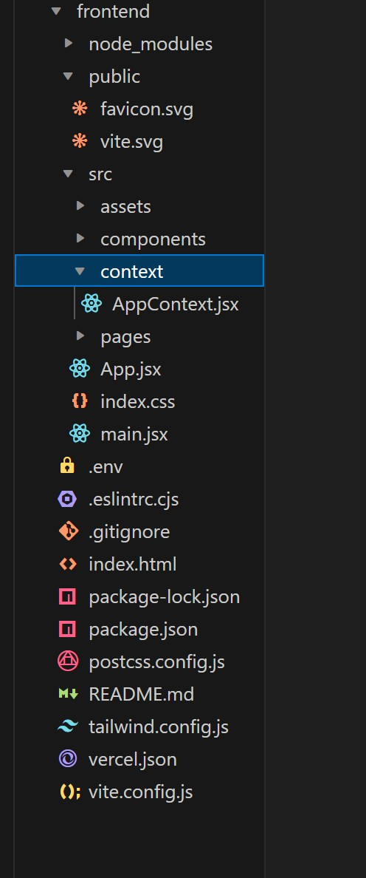

Admin Folder Setup:
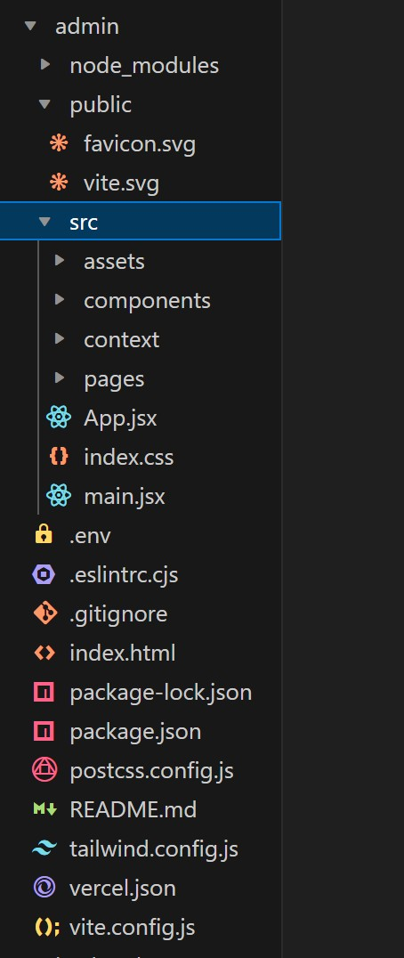

▶️ 6. Running the Application bash
Copy code # Frontend cd client npm start

# Backend cd server
npm start

📡 7. API Documentation
Method Endpoint Description
POST | /api/users/register Register a new user
POST | /api/users/login Login as user
POST | /api/doctors/login Doctor login
POST | /api/admin/login Admin login
POST | /api/appointments/book Book an appointment
GET | /api/doctors/:id/appointments Doctor views appointments
GET | /api/admin/appointments Admin views all appointments
POST | /api/payments/order Initiate Razorpay order
POST | /api/payments/verify Verify payment

🔐 8. Authentication & Authorization
- JWT Tokens used for secure authentication
- Protected Routes: Based on roles (User, Doctor, Admin)
- Token Flow:
  - On login, token is generated and stored in local storage
  - Every protected request includes this token in the headers

🎨 9. User Interface Screenshots
Please upload the following screenshots with the specified names:
Page Screenshot Name
User Login Page | user-login.png
Doctor Login Page | doctor-login.png
Admin Login Page | admin-login.png
User Dashboard (after login) | user-dashboard.png
Appointment Booking Page | book-appointment.png
Payment Checkout Page | payment-page.png
Doctor Dashboard | doctor-dashboard.png
Admin Dashboard | admin-dashboard.png
Success Message after Booking success-booking.png
Payment Success Page payment-success.png
Home page(website):
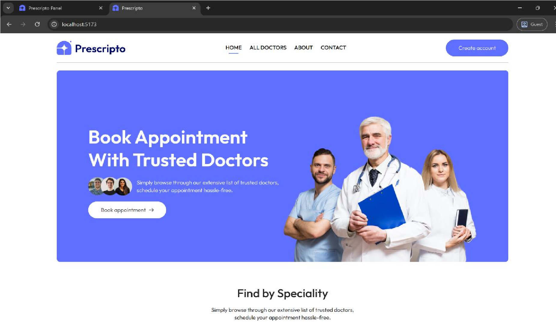

User Login:
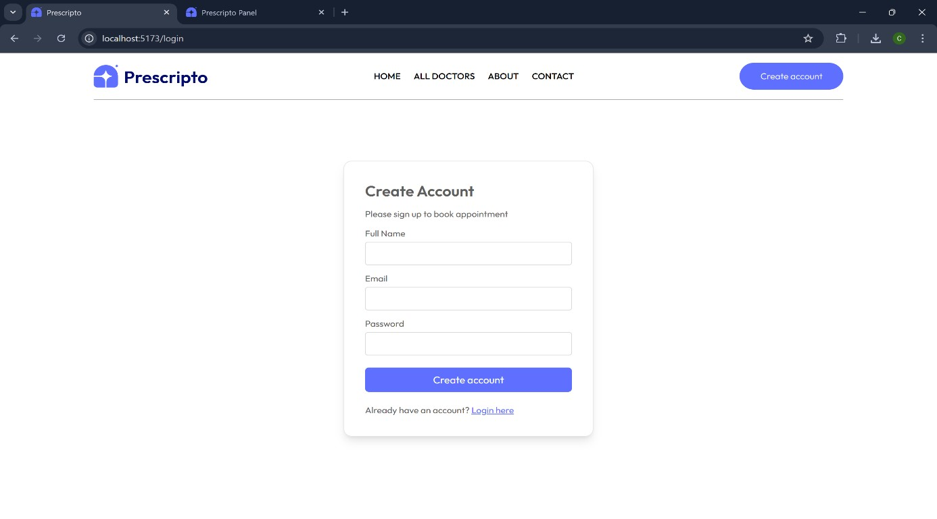
User Dashboard:
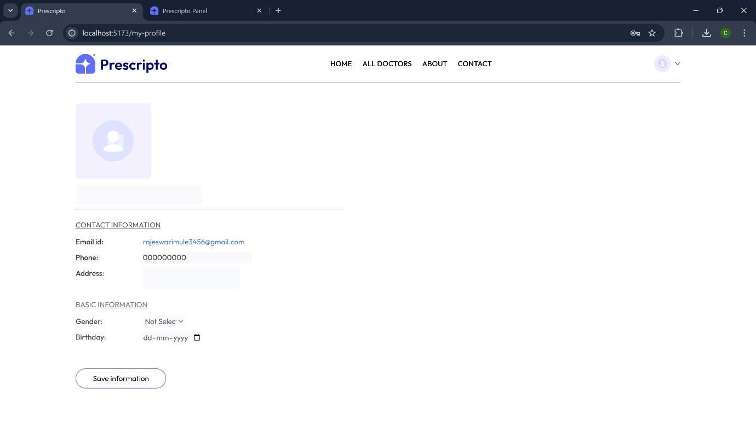
Admin Login Page:
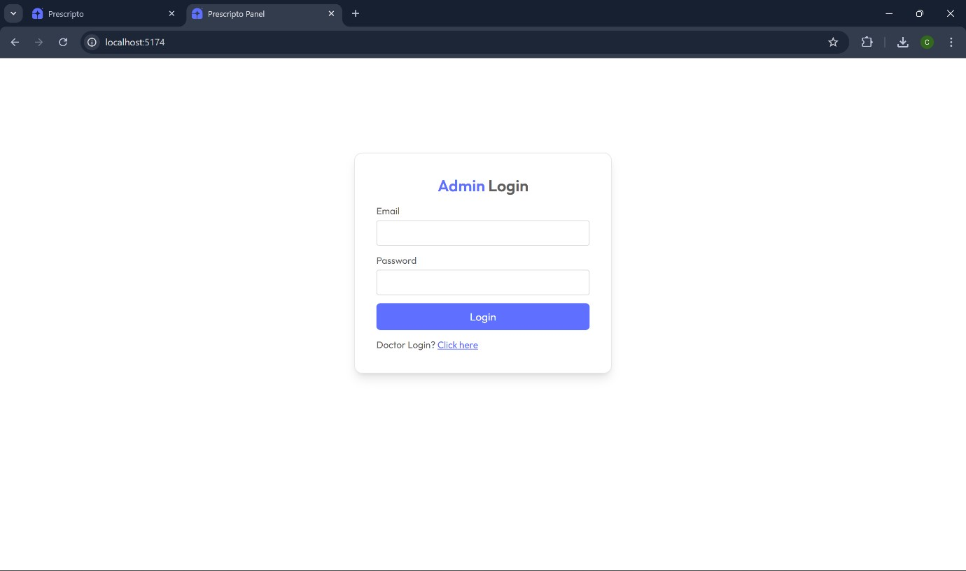

Admin Dashboard Page:
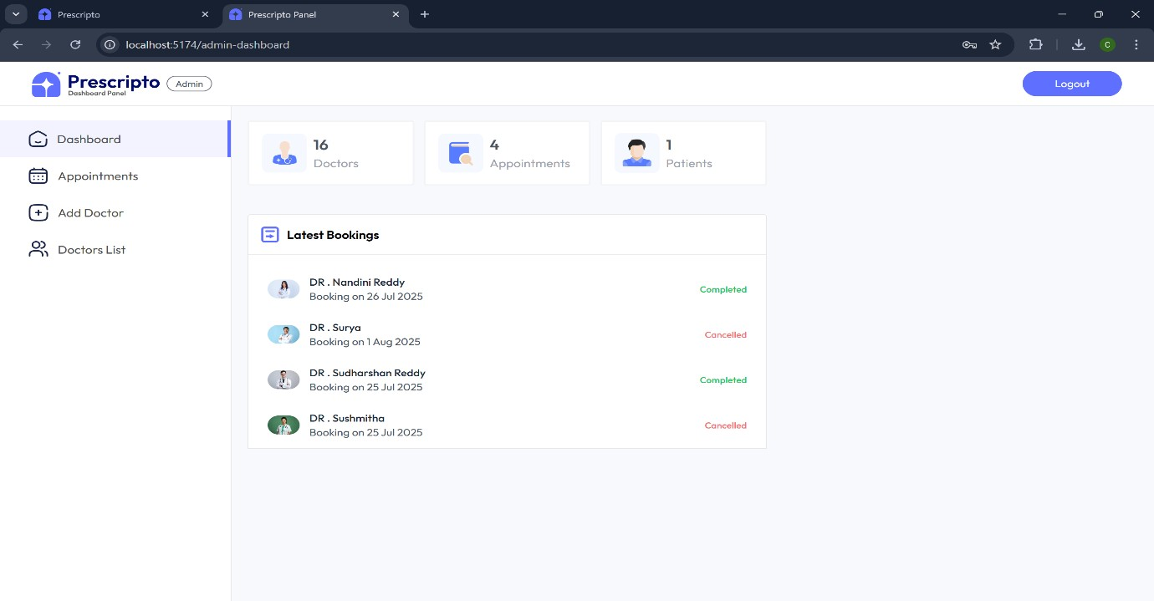

Doctor Login Page:
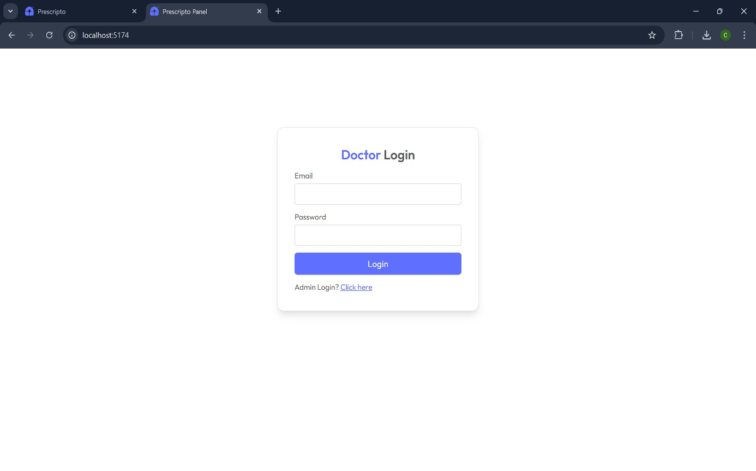
Doctor Dashboard:

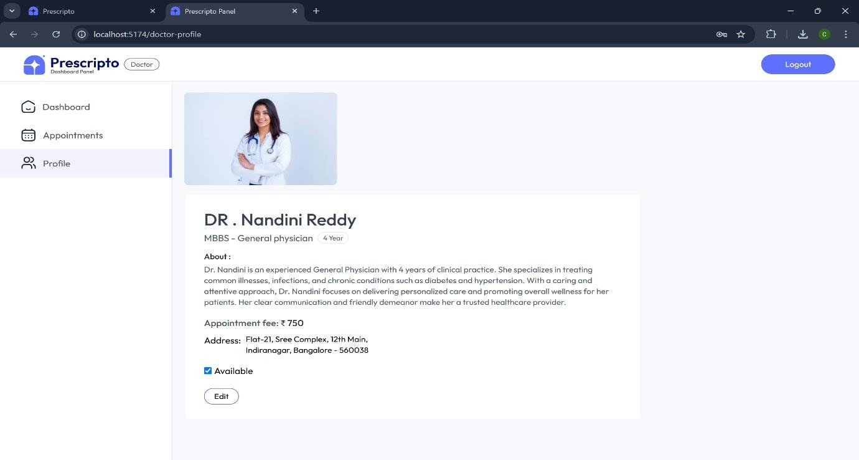
Appointment Booking:
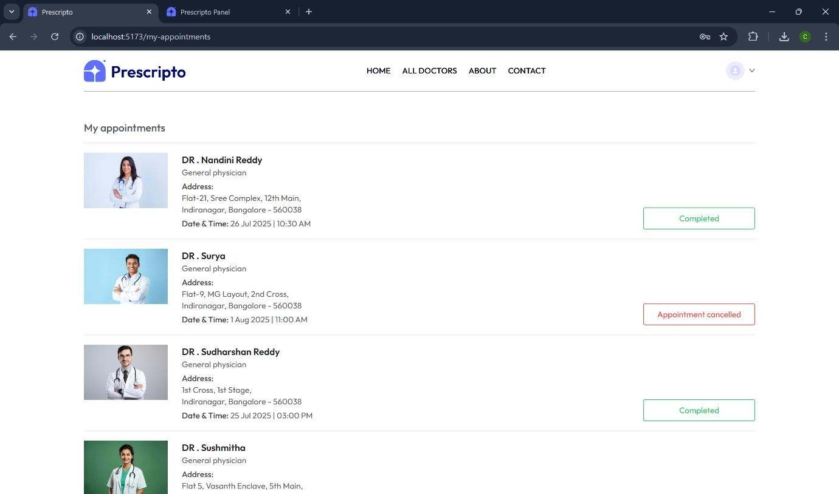
Appointment Booked Successfully:
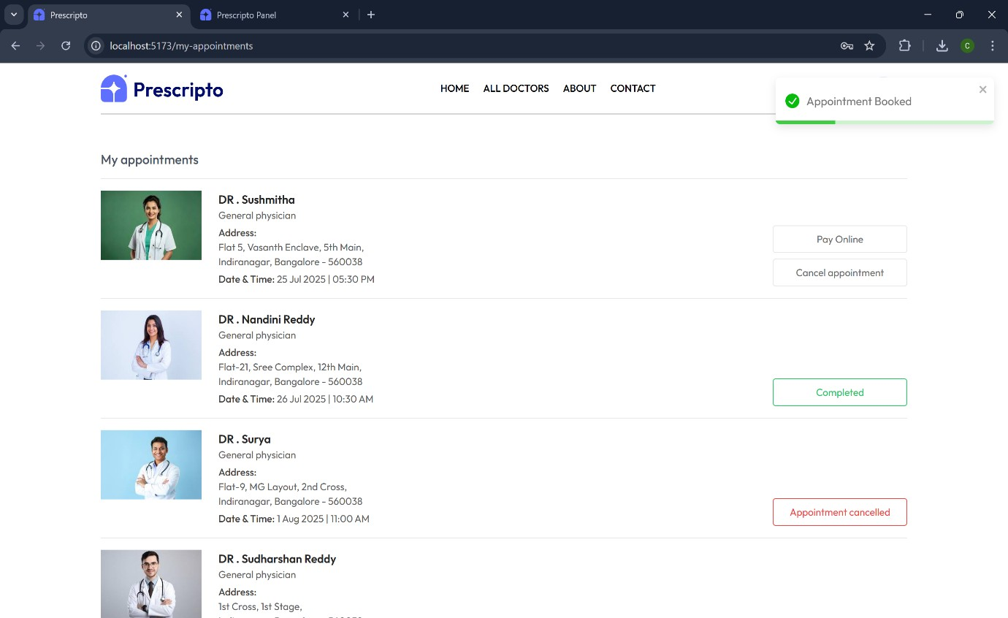

🧪 10. Testing
Tools Used:
- Postman – Backend API testing
- Lighthouse – Frontend performance and accessibility
- Browser DevTools – UI and console validation
Testing Coverage:
- User login/logout and protected routes
- Doctor and admin access control
- Appointment conflict handling
- Payment success/failure scenarios

📷 11. Demo or Showcase
- Screenshots: As listed above
- Optional Demo Video Link: [Insert YouTube/Google Drive demo link]

⚠️ 12. Known Issues
- No pagination for appointment list
- Doctor profile editing not implemented
- No email/SMS notifications yet

🚀 13. Future Enhancements
- Implement video consultations via WebRTC or Jitsi
- Add appointment filtering (by date/speciality)
- Notifications for appointment reminders
- Email confirmations for patients
- Real-time availability for doctors

📌 14. Conclusion
DocSpot successfully integrates frontend and backend technologies to deliver a secure and userfriendly platform for medical appointment management. With online payments and role-based control, it lays the groundwork for scalable future enhancements in digital healthcare.

