CONTENTS
- Acknowledgement
- Project Abstract
- Organization Profile
- Overview of the Project
  - Description of the Project
  - Feasibility Study
- System Analysis
  - Existing System – It’s Drawbacks
  - Proposed System – It’s Advantages
- Hardware and Software Requirements
- System Design
  - UML Diagrams
  - Data Dictionary
  - Client – Server Model
  - Technologies
    - Web Technologies
    - Java
    - Java Servlets
    - MySql
    - JDBC
    - HTML
- User Interfaces
- Implementation and Testing
- Conclusion
- Bibliography

Acknowledgement

“Task successful” makes everyone happy. But the happiness will be gold without glitter if we didn’t state the persons who have supported us to make it a success.
Success will be crowned to people who made it a reality but the people whose constant guidance and encouragement made it possible will be crowned first on the eve of success.
This acknowledgement transcends the reality of formality when we would like to express deep gratitude and respect to all those people behind the screen who guided, inspired and helped me for the completion of our project work.
I take it as a great privilege for having done this project
for NIC on behalf of Government of Andhra Pradesh. I consider myself lucky enough to get such a good project. This project would add as an asset to my academic profile.
I would like to express my thankfulness to
Mr. K. RajaSekhar, Technical Director, National Informatics Center, Hyderabad, for his constant supervision, guidance and co-operation.

R. Kalyana Chakravarthi.

Abstract
The project is entitled “Portable and Generic tool for Web Applications “ helps to handle the web applications. It is very difficult for a programmer to create user interface forms and to provide database connectivity for each and every form separately whenever he needs it. The work will be very fast if he had a utility, which can provide him all the activity, which he has to do for creating those forms.

Hence, it was received that there was a strong need for generating a utility which can help the programmer with on-fly user interface forms and providing database. Connectivity to those form and to maintain the database.

This project mainly comprises three modules:

- Creation and modification of tables
- Creating User Forms to the tables and retrieving data using these forms

These modules deal with several kinds of information related from linking a user applicable form to the database to retrieving information and updating the database.

The information is stored in the database in a systematic way so that it can be easily retrieved whenever required through queries by the reporting module. Data capturing is done through user-friendly screens depending upon the type of data. The entire system is being protected by a user level password to enable different assigned activities so that no intruder can access the data. The user for this application is a person who wants to generate a new web enabled dynamic content application and not the end user working at the client side.

This tool is a portable one. We can use this tool in windows or unix environment. We have to just set the settings file to work in any server. It is very user-friendly and portable tool for developing we applications.

Organization Profile
Social Computer Services is an organization of Professionals with multi disciplinary experience in the fields of Software development, services and consultancy and specialization in Web portals, Banking, Insurance, Hospital and Business Solutions.

Strengths:

The major strengths of Social Computer Services are its advanced technological skills and a committed team of professionals, which bring in a constant stream of satisfied customers to the company's fold both in the export and the domestic markets.

We have a dedicated team of professionals with real experience in the functional areas in a variety of state-of-the-art, Hardware and Software platforms. Our business interest is focused on Product Development for Banking, Hospital Management, Hotel Management, Rice Mill Automation, Web Portals, Image Processing Tools, Factory Automation and Office Automation. Our clear vision can provide new perspective to any area requiring IT solution with total commitment on quality, delivery and cost with our proven expertise both in well established and cutting edge technologies.

Focus:

The company focuses on delivery of cost effective and timely business solutions developed on cutting-edge technology. M/s BIL has an advanced Software development center backed by committed and experienced Software Professionals. M/s BIL respects customers and the development with full quality in mind and believes in nurturing a relationship, Trust and dependability.

Mission:

Social Computer Services’s Mission is to build a quality product, respect human values, upgrade its process and technical capabilities on a continuous basis, providing an employee-centric work atmosphere where every employee feels at home and is sensitive for enhancing the quality norms of the Software development work in IT and the State-of-art Technology and Services. To deliver innovative business solutions that maximizes the success of organizations in India and Abroad. To develop and maintains strategic alliances with institutions of expertise in India and Abroad.

Vision:

Social Computer Services’s Vision is to emerge as one of the fastest growing IT services company with special emphasis on quality, integrity, innovation, commitment, human values for varied and specific requirements and to deliver such products which will have far reaching advantages and applications.

Social Computer Services envisages of undertaking Business Outsource Processing works like Data enumeration, e-Catalog, Insurance processing, Accounting, Auditing, Back end Data processing for Banks, Insurance companies and MNC's.

Human Resource:

An aspect that makes Social Computer Services so special is its strength in possessing manpower resources that comprise of experienced, talented and dedicated computer science graduates and postgraduates. These professionals are continuously trained to provide smart business solutions using skills in the very latest technology that includes Client/Server, Object Oriented Design and programming and Internet technologies. Social Computer Services’s human resources comprise of personnel qualified in computer sciences: M.Tech's, B.Tech's, MCA's and MSc's.

Infrastructure:

At M/s SIL the Infrastructure facilities are excellent and abundantly available for the IT personnel to work with. This company is located very close to the Software Technology Park where in all the facilities for Data Transmission is available. This is located in our own premises of approximately 10,000 sft . This center has following facilities to handle international parties.

Description of the Project

It is very difficult for a programmer to create user interface forms and to provide database connectivity for each and every form separately whenever he needs it. The work will be very fast if he had a utility, which can provide him all the activity, which he has to do for creating those forms.
Hence, it was received that there was a strong need for generating a utility which can help the programmer with on-fly user interface forms and providing database. Connectivity to those forms and to maintain the database.
This project mainly comprises three modules:
- Creation and modification of tables
- Connecting User Forms to the tables and retrieving data using these forms
These modules deal with several kinds of information related from linking a user applicable form to the database to retrieving information and updating the database.
The information is stored in the database in a systematic way so that it can be easily retrieved whenever required through queries by the reporting module. Data capturing is done through user-friendly screens depending upon the type of data. The entire system is being protected by a user level password to enable different assigned activities so that no intruder can access the data. The user for this application is a person who wants to generate a new web enabled dynamic content application and not the end user working at the client side.

FEASIBILITY STUDY

Feasibility study is an important phase in the software development process. It enables the developer to have an assessment of the product being developed. It refers to the feasibility study of the product in terms of outcomes of the product, operational use and technical support required for implementing it.

Feasibility study should be performed on the basis of various criteria and parameters. The various feasibility studies are:
- Economic Feasibility
- Operational Feasibility
- Technical Feasibility
- Economic Feasibility: It refers to the benefits or
Outcomes we are deriving from the product as compared to the total cost we are spending for developing the product. If the benefits are more or less the same as the older system, then it is not feasible to develop the product.
In the present system, the development of new product
greatly enhances the accuracy of the system and cuts short the delay in the processing of Birth and Death application. The errors can be greatly reduced and at the same time providing a great level of security. Here we don’t need any additional equipment except memory of required capacity.
No need for spending money on client for maintenance because the database used is web enabled database.
- Operational Feasibility: It refers to the feasibility of the
product to be operational. Some products may work very well at design and implementation but may fail in the real time environment. It includes the study of additional human resource required and their technical expertise.
In the present system, the different levels Birth and Death
Registrations and issuing of certificates and support for backlog data. Hence there is need for additional analysis. It was found that the additional modules added are isolated modules as far as the operational is concerned. So the Developed system is operationally feasible.
- Technical Feasibility: It refers to whether the software that
is available in the market fully supports the present application. It studies the pros and cons of using a particular software for the development and its feasibility. It also studies the additional training needed to be given to the people to make the application work.
In the present system, the user interface is user friendly
and does not require much expertise and training. It just needs a mouse click to do any sort of application. The software that is used for developing i.e. PL/SQL server pages fully is highly suitable for the present application since the users require fast access to the web pages with a high degree of security. This is achieved through integration of Web Server and Database server in the same environment.

Implementation Plan:
The main plan for the system developed is to upgrading and existing system to proposed system.
There are mainly 4 methods of upgrading the existing system to the proposed

- Parallel Run System
- Direct Cut-Over Over
- Pilot System
- Phase-in Method

Parallel Run System:

It is the most secure method of converting from an existing to a new system. In this approach both the systems are run in parallel for a specific period of time. During that period if any serious problems were identified while using the new system, the new system is dropped and the older system is taken at the start point again.

Direct Cut-Over Method:

In this approach the existing system is converted to the new system abruptly, sometimes over a weekend or even overnight. The old system is used until a planned conversion day. Thee exist no parallel activities.

Pilot Method:

In this approach a working Version of the system is implemented in one art fo the organization such as a single work area or department. When the system is deemed complete it is installed through out the organization either all at once(direct cut-over) or gradually(phase-in).

Phase-in Method:

In this method a part of the system is first implemented and over time other remaining parts are implemented

Implementation Planed used:

In Births and Deaths Registration System is developed on the basis of “Parallel Run Method” because we upgraded the system which is already in use to fulfill the requirements of the client.

The system already in use is treated as the old system and the new system is developed on the basis of old system and maintained the Standards possessed by the old system.

The upgraded system is working well and is implemented on the client successfully.

Limitations

- does not support receiving mails
- cant create/delete multiple lists at a time
- cant create/delete multiple forms at a time
- cant add/modify the existing lists/forms

SYSTEM ANALYSIS

Analysis is the detailed study of the various operations performed by a system and their relationships within and outside of the system. A key question is: What must be done to solve the problem? One aspect of analysis is defining the boundaries of the system and determining whether or not candidate system should consider other related systems. During analysis, data are collected on the available files, decision points, and transactions handled by the present system.

System Requirement Specification

What is SRS?
Software Requirement Specification (SRS) is the starting point of the software developing activity As system grew more complex it became evident that the goal of the entire system cannot be easily comprehended. Hence the need for the requirement phase arose. The software project is initiated by the client needs. The SRS is the means of translating the ideas of the minds of clients (the input) into a formal document (the output of the requirement phase.)
The SRS phase consists of two basic activities:
- Problem/Requirement Analysis:
The process is order and more nebulous of the two, deals with understand the problem, the goal and constraints.
- Requirement Specification:
Here, the focus is on specifying what has been found giving analysis such as representation, specification languages and tools, and checking the specifications are addressed during this activity.
The Requirement phase terminates with the production of the validate SRS document. Producing the SRS document is the basic goal of this phase.

ROLE OF SRS:
The purpose of the Software Requirement Specification is to reduce the communication gap between the clients and the developers. Software Requirement Specification is the medium though which the client and user needs are accurately specified. It forms the basis of software development. A good SRS should satisfy all the parties involved in the system.

EXISTING SYSTEM

The existing system totally dependent on the type of the application being used and each and every application, even having the same needs, are having different coding sections. That is, each and every application has different coding modules for the same type of transactions like retrieval , updation , insertion etc into the database.

Since, information server is the main source of information, the databases of information server should be up to date. The information generated globally has to be updated in the database server on time. At this stage, if there is a new application to be embedded into the present system, Organization had to write a separate code for the maintenance of data of that particular application. Hence, there shall be a wastage of time for writing separate code for each and every module for the same type of transactions.

At present, Our Organization is using CGI script for writing its application code. Since, the organization needs to publish it’s applications on the web, it is necessary that the data provided must be very accurate and effective.

DRAWBACKS OF THE EXISTING SYSTEM

- Separate coding must be done for each and every application having the same type of transactions.
- Data must be manually updated in the database.
- Any modifications to the database must be done manually.
- Every form must be connected to the database manually, in order to access the database.

The present system makes use of CGI which has the following drawbacks ::

- CGI is very slow.

- CGI is hard on server performance.

- Improperly coded CGI can cause security problems.

- Debugging can be difficult.

- Limited Functionality.

PROPOSED SYSTEM

The Proposed system is over come the all draw backs of the existing system. In this system is developed on Java. So it is a platform independent and secured one. The user needs to create a table with the required field name with this tool and also he must link the input fields with the database. Then the tool updates the records of the fields in the specified table.

In a big organization there exist so many forms, it highly difficult to write the code for every form. This tool simplifies the problems. It is a portable one, so it can be run on any platform. Generic tool provides user-friendlier, so users can use this tool with out much of knowledge about the computers.

The main drawback in existing system is, all the data was processed in parsing method. It was very difficult to the user specify the parameters for parsing. In this system, parsing method is omitted and implemented new technology i.e. assigning field tag names to the records. It simplifies the difficulties in the existing system.

System Requirements

Hardware Requirements

Server:

RAM : | 256 MB
Hard Disk : | 40 GB
Processor : | Pentium III Processor

Client:

RAM : | 128 MB
Hard Disk : | 20 GB
Processor : | Any Processor

Software Requirement

Server:

Operating System : | Red Hat Linux or Windows NT
Database : | Oracle8i,
Web Server : | Any Web Server

Client:

Operating System : | Any Operating System in which IE 6.0 is supported
Browser : | Internet Explorer Version 6.0

UML DIAGRAMS

Use case Diagrams:

Use case diagrams model behavior within a system and help the developers understanding of what it is users require.
The stick man represents what’s called an actor. An actor represents an outside entity – either human or technological. In this example its human (Stick man).

Notice the curved rectangle on the diagram – this represents the system boundary – everything inside that is part of that system, every thing outside are actors (basically not part of the system).
Use case diagrams can be useful for getting an overall view of the system and clarifying who can do what and more importantly what they can’t do.

Use case Diagram:

Create Table
Modify Table
Drop Table
Insert Record
Delete Record
Modify Record
Reports
Server
Database

Identification Of Actors:
- Primary Actor : User
- Secondary Actor : NIC forms

Activity Diagram

NO
Enter UserName
and Password
Is
Valid User
?
YES
Create , Modify , Delete tables
Insert , Delete , Modify the records
More Requests

Sequence Diagram

Submit Details
Send a Query
Insertion/Creation
Retrival /Reporting
Response of Query
: Form
: Server
: Database

Collaboration Diagram

DataBase
USER
Server
Form
1.Submit details to the form
2.Send a Query
5.Response to Query
3.Insert the data
4.Retrieve reports

Class Diagram

MODISTRUCT
+ getSession()
+ connectDb()
+ tableExists()
+ modiStruct()

UserAuth

+ Chklogin()
+ setSession()

+Username
+pwd
Multable
+ getSession()
+ connectDb()
+ createTable()
+ tableExists()

DELETE
+ getSession()
+ connectDb()
+ tableExists()
+ deleteData()
INSERT
+ getSession()
+ connectDb()
+ tableExists()
+ insertData()

MODIFY
+ getSession()
+ connectDb()
+ tableExists()
+ modifyData()
TRANSFER
+transInsert()
+transDelete()
+transModify()
+transReport()

+opt
REPORT
+ getSession()
+ connectDb()
+ tableExists()
+ reportData()

Data Dictionary

Data dictionaries are integral component of structured analysis,since data flow diagrams by themselves not fully describe the subject of the investigation. The data dictionary provides additional information about the system, A data dictionary is a catalog – repository provides additional information about the system.

A data dictionary is a catalog – a repository – of the elements in a sytem. In a data dictionary we will find a list of all the elements composing the data flowing throw a system. The major elements are data flows, data stores and process. The data dictionary stores details and descriptions of those elements.

Why is a data dictionary important?
Analysis use data dictionaries foe live important reasons:
- To manage the details in large systems.
- To communicate a common meaning for all system elements
- To document the features of the system
- To facilitate analysis of the details in order to evaluate
characteristics and determine where system changes should
be made
- To locate errors and omissions in the system

Database Tables
Table Name

Fieldname Datatype

CLIENT SERVER MODEL

When an architect designs a building, he has a vision of the finished product and produces result based on that vision. Client-Server, on the other hand, is more like Darwinian model of the evolution of a living species. No one has a vision of the finished products; rather, day-today events and gradual changes affect it over time in reaction to those events.

In the beginning, application were fairly simple, reading input transaction in a ‘batch’, processing them against a data store, and the output was paper. Record retrieval was usually a set of subroutines embedded in the updating program.

Common functions gradually migrated from the application tothe operating system. Database processing was one of the first major functions to be removed from application control.Much of the time database functions in the application included retrieval, replacement, and insertion. Since it was function had to be introduced database administration. This new function was separated from the application code and involved defining the structure of the database, value ranges, backup, rollback, and so forth.

ADVANTAGES OF CLIENT – SERVER MODEL:

- The hardware and software can be placed where it will do the
most good.
- In Client – Server model PCs, the power can be spread across
the client and server.
- On client side, an Active X object is used to present the data.
- By having the client side so it can do more work.
- The client software supplies the interface (such as windowed
program) and the knowledge of how to pass the request to the
server, and the format the data for the user when it’s returned
from the server. The server’s job is to manipulate the data
according to the user’s request.

TECHNOLOGIES

World Wide Web - Web Technologies

The World Wide Web is an open-ended information system where the information can be retrieved and is designed to use in the Internet's distributed environment. It contains Web pages that provide information and controls. The World Wide Web initially started as a text-only medium but now ranges of features are added like graphics, sounds, animation and video. A large portion of Internet is organized as the World Wide Web. A web application is defined as a multi-tier application based on the Internet standards, using a Web browser as client. The rule-making body of the Web is the W3C. W3C stands for the World Wide Web Consortium. W3C puts together specifications for Web standards. The most essential Web standards are HTML, CSS and XML. The latest HTML standard is XHTML 1.0.

Hyper Text Transfer Protocol (HTTP):

The standard Web transfer protocol is HTTP. Each interaction consists of one ASCII request, followed by one RFC 822 MIME-like response. Although the use of TCP for the transport connection is very common, it is not formally required by the standard. HTTP is constantly evolving. Several versions are in use and others are under development.

THREE-TIER ARCHITECTURE
A Web Application follows a 3-tier model. The first tier consists of the Presentation Layer, the second tier consists of the Application Layer an the third tier provides the data. A web application will collect the data from the client (the first tier) and sends the request to the Web Server.
Server
Web Browser
Run- Time Environment
Server Script
(or program)
Data Stores
Request
Response
1st tier

3rd Tier
2nd Tier
Web Server

In a Web application the first tier includes the Web Browser and the Web Server. The relevant script let program runs and gets the data (second and the third tier) and sends the data to the Web Server. The Web Server sends the data back to the client (first tier).

TCP/IP PROTOCOL:

The most basic internet standard is the TCP/IP protocol. This protocol defines the rules for establishing connections between computers, that is, between client and server hardware.

Apache Web Server:
Apache was originally based on code and ideas found in the most popular HTTP server of the time. NCSA httpd1.3 (early 1995). It has since evolved into a far superior system which can rival (and probably surpass) almost any other UNIX based HTTP server in terms of functionality, efficiency and speed. Since it began, it has been completely rewritten, and includes many new features. Apache is, as of January 1997, the most popular WWW server on the Internet, according to the Net craft Survey.

Why Apache?
To address the concerns of a group of WWW providers and part-time http programmers that http didn't behave, as they wanted it to behave. Apache is an entirely volunteer effort, completely funded by its members, not by commercial sales. Apache has been shown to be substantially faster than many other free servers

Hypertext Markup Language (HTML):

HTML is a collection of platform independent styles used to create a web document. HTML can be used to display any type of document on the host computer, which can be geographically at a different location .It is a versatile language and can be used on any platform or desk top being platform independent, HTML indicates the manner in which the document to be read by the interpreter. This can be done with the set of HTML elements and tags which mark up the document and inform the browser, such as Internet Explorer, about the action to be taken when a certain element or tag is specified.

HTML Elements and Tags

A Web page is made up of elements, each of which is defined by an HTML code, or a tag. A tag is always enclosed in angle brackets, and most tags come in pairs, with an opening and a closing tag. The closing tag is the same as the opening tag, but starts with a forward slash.

Dynamic Hypertext Markup Language (DHTML):

With the explosion of interest in the World Wide Web, Hypertext Markup Language (HTML) has assumed a prominent place in the computer world. HTML has evolved to meet the increasing demand for eye-catching and mind-catching -Web sites. Until recently, however, the evolutionary process mostly involved new and improved tags and attributes. The end products, static Web pages that often required repeated time-consuming round trips between client and server machines, clearly showed a new direction was in order. Dynamic HTML (DHTML) is that new direction. It combines HTML with Cascading Style Sheets (CSS) and scripting languages.

Java Script:

JavaScript is a script-based programming language that supports the development of both client and server components of web-based applications. On the client-side, it can be used to write programs that are executed by a Web browser within the context of a Web page. On the server side, it can be used to write Web server programs that can process information submitted by a Web browser and then update the browser's display accordingly. Microsoft's version of JavaScript is named JScript

Embedding JavaScript in HTML documents:

JavaScript statements can be included in HTML documents by enclosing the statements between an opening <SCRIPT> tag and a closing </SCRIPT> tag. Within the opening tag the language attribute is set to "JavaScript" to identify the script as being JavaScript as opposed to some other scripting language, such as Visual Basic Script (VBScript).The script tag typically used as follows:

<script language="JavaScript">
JavaScript statements
</script>
When a user submits an HTML form using a browser that does implement JavaScript, a JavaScript event-handling function may be called to process the form data. The processing may vary from validating the data to performing all of the required form processing. Server-side JavaScript scripts are used to replace traditional CGI programs. JavaScript is an object-based programming language; it supports instances, methods and properties. The advantage of JavaScript is that validations can be done on the client side itself rather than on the server side thereby reducing the network traffic.

JavaScript's Event Handling

The server invokes the script. Data is passed from the browser to the script by objects, which the server creates.

The Web browser passes the data from the script after it processes and returns the data to the requesting browser
Server
Script
Outgoing response generated by script
Incoming URL request from browser

JAVA
When the chronicle of computer languages is written, the following will be said: B led to C, C evolved into C++, and C++ set the stage for Java. To understand the reasons that drove the creation, the forces that shaped it, and the legacy that it inherits. Like the successful compute languages that came before, Java is a blend of the best elements of its rich heritage combined with the innovative concepts required by its unique environment.
JAVA’S FEATURE SET :
Although the fundamental forces that necessitated the invention of Java are portability and security, other factors also played an important role in molding the final form of the language and are given by
- Simple
- Secure
- Portable
- Object – oriented
- Robust
- Multithreaded
- Architecture – neutral
- Interpreted
- High performance
- Distributed
- Dynamic

Overview of Servlets
Servlets are modules that extend request/response-oriented servers, such as Java-enabled web servers. For example, a servlet might be responsible for taking data in an HTML order-entry form and applying the business logic used to update a company's order database.
Servlets are to servers what applets are to browsers. Unlike applets, however, servlets have no graphical user interface.
Servlets can be embedded in many different servers because the servlet API, which you use to write servlets, assumes nothing about the server's environment or protocol. Servlets have become most widely used within HTTP servers; many web servers support the Servlet API.

Use Servlets instead of CGI Scripts!
Servlets are an effective replacement for CGI scripts. They provide a way to generate dynamic documents that is both easier to write and faster to run. Servlets also address the problem of doing server-side programming with platform-specific APIs: they are developed with the Java Servlet API, a standard Java extension.
So use servlets to handle HTTP client requests. For example, have servlets process data POSTed over HTTPS using an HTML form, including purchase order or credit card data. A servlet like this could be part of an order-entry and processing system, working with product and inventory databases, and perhaps an on-line payment system.

Other Uses for Servlets
Here are a few more of the many applications for servlets:
- Allowing collaboration between people. A servlet can handle multiple requests concurrently, and can synchronize requests. This allows servlets to support systems such as on-line conferencing.
- Forwarding requests. Servlets can forward requests to other servers and servlets. Thus servlets can be used to balance load among several servers that mirror the same content, and to partition a single logical service over several servers, according to task type or organizational boundaries.

Additional Capabilities of HTTP Servlets
The classes and interfaces described above make up a basic Servlet. HTTP servlets have some additional objects that provide session-tracking capabilities. The servlet writer can use these APIs to maintain state between the servlet and the client that persists across multiple connections during some time period. HTTP servlets also have objects that provide cookies. The servlet writer uses the cookie API to save data with the client and to retrieve this data.

Client Interaction
When a servlet accepts a call from a client, it receives two objects:
- A ServletRequest, which encapsulates the communication from the client to the server.
- A ServletResponse, which encapsulates the communication from the servlet back to the client.
ServletRequest and ServletResponse are interfaces defined by the javax.servlet package.

The ServletRequest Interface
The ServletRequest interface allows the servlet access to:
- Information such as the names of the parameters passed in by the client, the protocol (scheme) being used by the client, and the names of the remote host that made the request and the server that received it.
- The input stream, ServletInputStream. Servlets use the input stream to get data from clients that use application protocols such as the HTTP POST and PUT methods.
Interfaces that extend ServletRequest interface allow the servlet to retrieve more protocol-specific data. For example, the HttpServletRequest interface contains methods for accessing HTTP-specific header information.

The ServletResponse Interface

The ServletResponse interface gives the servlet methods for replying to the client. It:
- Allows the servlet to set the content length and MIME type of the reply.
- Provides an output stream, ServletOutputStream, and a Writer through which the servlet can send the reply data.
Interfaces that extend the ServletResponse interface give the servlet more protocol-specific capabilities. For example, the HttpServletResponseinterface contains methods that allow the servlet to manipulate HTTP-specific header information.

Requests and Responses
Methods in the HttpServlet class that handle client requests take two arguments:
- An HttpServletRequest object, which encapsulates the data from the client
- An HttpServletResponse object, which encapsulates the response to the client

HttpServletRequest Objects
An HttpServletRequest object provides access to HTTP header data, such as any cookies found in the request and the HTTP method with which the request was made. The HttpServletRequest object also allows you to obtain the arguments that the client sent as part of the request.
To access client data:
- The getParameter method returns the value of a named parameter. If your parameter could have more than one value, use getParameterValues instead. The getParameterValues method returns an array of values for the named parameter. (The method getParameterNames provides the names of the parameters.)
- For HTTP GET requests, the getQueryString method returns a String of raw data from the client. You must parse this data yourself to obtain the parameters and values.
- For HTTP POST, PUT, and DELETE requests,
- If you expect text data, the getReader method returns a BufferedReader for you to use to read the raw data.
- If you expect binary data, the getInputStream method returns a ServletInputStream for you to use to read the raw data

HttpServletResponse Objects
An HttpServletResponse object provides two ways of returning data to the user:
- The getWriter method returns a Writer
- The getOutputStream method returns a ServletOutputStream
Use the getWriter method to return text data to the user, and the getOutputStream method for binary data.
Closing the Writer or ServletOutputStream after you send the response allows the server to know when the response is complete.

HTTP Header Data
You must set HTTP header data before you access the Writer or OutputStream. The HttpServletResponse class provides methods to access the header data. For example, the setContentType method sets the content type. (This header is often the only one manually set.)

Handling GET and POST Requests
The methods to which the service method delegates HTTP requests include,
- doGet, for handling GET, conditional GET, and HEAD requests
- doPost, for handling POST requests
- doPut, for handling PUT requests
- doDelete, for handling DELETE requests
By default, these methods return a BAD_REQUEST (400) error. Your servlet should override the method or methods designed to handle the HTTP interactions that it supports. This section shows you how to implement methods that handle the most common HTTP requests: GET and POST.
The HttpServlet's service method also calls the doOptions method when the servlet receives an OPTIONS request, and doTrace when the servlet receives a TRACE request. The default implementation of doOptions automatically determines what HTTP options are supported and returns that information. The default implementation of doTrace causes a response with a message containing all of the headers sent in the trace request. These methods are not typically overridden.

Threading Issues
HTTP servlets are typically capable of serving multiple clients concurrently. If the methods in your servlet that do work for clients that access a shared resource, then you must either:
- Synchronize access to that resource, or
- Create a servlet that handles only one client request at a time

Servlet Descriptions
In addition to handling HTTP client requests, servlets are also called upon to supply descriptions of themselves. This section shows you how to provide a description by overriding the method, getServletInfo, that supplies the servlet description.

The Life Cycle of a Servlet
Each servlet has the same life cycle:
- A server loads and initializes the servlet
- The servlet handles zero or more client requests
- The server removes the servlet
(some servers do this step only when they shut down)

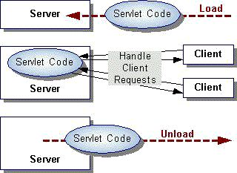

Initializing a Servlet
When a server loads a servlet, the server runs the servlet's init method. Initialization completes before client requests are handled and before the servlet is destroyed.
Even though most servlets are run in multi-threaded servers, servlets have no concurrency issues during servlet initialization. The server calls the init method once, when the server loads the servlet, and will not call the init method again unless the server is reloading the servlet. The server can not reload a servlet until after the server has destroyed the servlet by calling the destroy method.

Interacting with Clients
After initialization, the servlet is able to handle client requests.

Destroying a Servlet
Servlets run until the server are destroys them, for example, at the request of a system administrator. When a server destroys a servlet, the server runs the servlet's destroy method. The method is run once; the server will not run that servlet again until after the server reloads and reinitializes the servlet.
When the destroy method runs, another thread might be running a service request

Saving Client State
The Servlet API provides two ways to track client state:

Session Tracking
Session tracking is a mechanism that servlets use to maintain state about a series of requests from the same user (that is, requests originating from the same browser) across some period of time.

Cookies
Cookies are a mechanism that a servlet uses to have clients hold a small amount of state-information associated with the user. Servlets can use the information in a cookie as the user enters a site (as a low-security user sign-on, for example), as the user navigates around a site (as a repository of user preferences for example), or both.

JDBC

The JDBCTM API provides universal data access from the JavaTM programming language. Using the JDBC 2.0 API, you can access virtually any data source, from relational databases to spreadsheets and flat files. JDBC technology also provides a common base on which tools and alternate interfaces can be built.
The JDBC 2.0 API is comprised of two packages:

the java.sql package -- included in the Java 2 SDK, Standard Edition
the javax.sql package -- included in the Java 2 SDK, Enterprise Edition or available as a separate download
JDBC Technology Drivers

To use the JDBC API with a particular database management system, you need a JDBC technology-based driver to mediate between JDBC technology and the database. Depending on various factors, a driver might be written purely in the Java programming language or in a mixture of the Java programming language and JavaTM Native Interface (JNI) native methods. The JDBC web site maintains a list of vendors with drivers currently available or under development.

The latest SDK includes a JDBC-ODBC Bridge driver that makes most Open Database Connectivity (ODBC) drivers available to programmers using the JDBC API. JDBC-ODBC Bridge Driver describes the current status of this software. Note that the bridge driver included in the SDK is appropriate only for experimental use or when no other driver is available.

There are four types of JDBC drivers each having its own functionality. Please note that, they do not substitute one another. Each having their own suitability aspects. They are classified based on how they access the data from the database.

1. Native JDBC Driver- A JDBC driver, which is partly written in, and most of it is implemented using native methods to access the database. This is useful in case of java Application that can run only on some specific platforms. Writing this type of is easier compare to writing other drivers.

2. All Java JDBC Net Drivers: A JDBC net driver when uses a common network protocol to connect an intermediate server. Which in turn employees native calls to connect to the database. This approach suited for applets. Where the request must go through the intermediate server.

3. JDBC-ODBC Bridge Driver- A bridge driver provided with JDBC can convert the JDBC call into equivalent ODBC calls using the native methods. Since ODBC provides connection to any type of database i.e. ODBC complaint,to connect a no of databases simultaneously is a very simple matter. This approach is a recommended one since using ODBC drivers, which are industry standard as of now, would make an application truly portable across databases.

4. Native Protocol all-Java Drivers: This type of JDBC drivers is written completely in java and can access the database by making the use of native protocols of database. This method of data access is suitable in case of intranets where every thing can run as an application instead of an applet. This driver id generally provided by vendor of the database.
ORACLE

INTRODUCTION:

Oracle is a relational database management system, which organizes data in the form of tables. Oracle is one of many database servers based on RDBMS model, which manages a seer of data that attends three specific things-data structures, data integrity and data manipulation. With oracle cooperative server technology we can realize the benefits of open, relational systems for all the applications. Oracle makes efficient use of all systems resources, on all hardware architecture; to deliver unmatched performance, price performance and scalability. Any DBMS to be called as RDBMS has to satisfy Dr.E.F.Codd’s rules.

DISTINCT FEATURES OF ORACLE:

- ORACLE IS PORTABLE:

The Oracle RDBMS is available on wide range of platforms ranging from PCs to super computers and as a multi user loadable module for Novel NetWare, if you develop application on system you can run the same application on other systems without any modifications.

- ORACLE IS COMPATIBLE:

Oracle commands can be used for communicating with IBM DB2 mainframe RDBMS that is different from Oracle, that is Oracle compatible with DB2. Oracle RDBMS is a high performance fault tolerant DBMS, which is specially designed for online transaction processing and for handling large database applications.

- MULTITHREADED SERVER ARCHITECTURE:

Oracle adaptable multithreaded server architecture delivers scalable high performance for very large number of users on all hardware architecture including symmetric multiprocessors (sumps) and loosely coupled multiprocessors. Performance is achieved by eliminating CPU, I/O, memory and operating system bottlenecks and by optimizing the Oracle DBMS server code to eliminate all internal bottlenecks.

FEATURES OF ORACLE:

Most popular RDBMS in the market because of its ease of use
- Client/server architecture.
- Data independence.
- Ensuring data integrity and data security.
- Managing data concurrency.
- Parallel processing support for speed up data entry and online transaction processing used for applications.
DB procedures, functions and packages.

UserIntefaces
home page
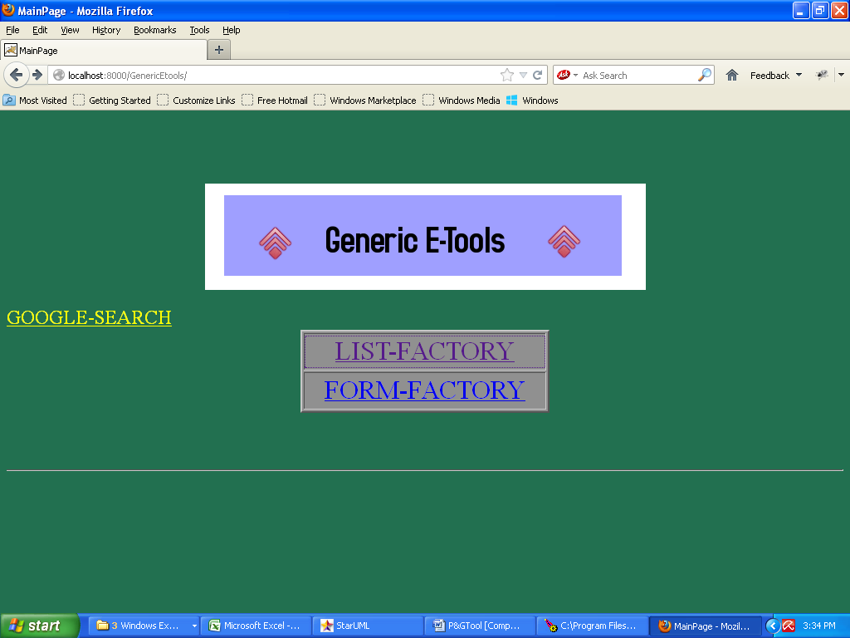

Listfactory
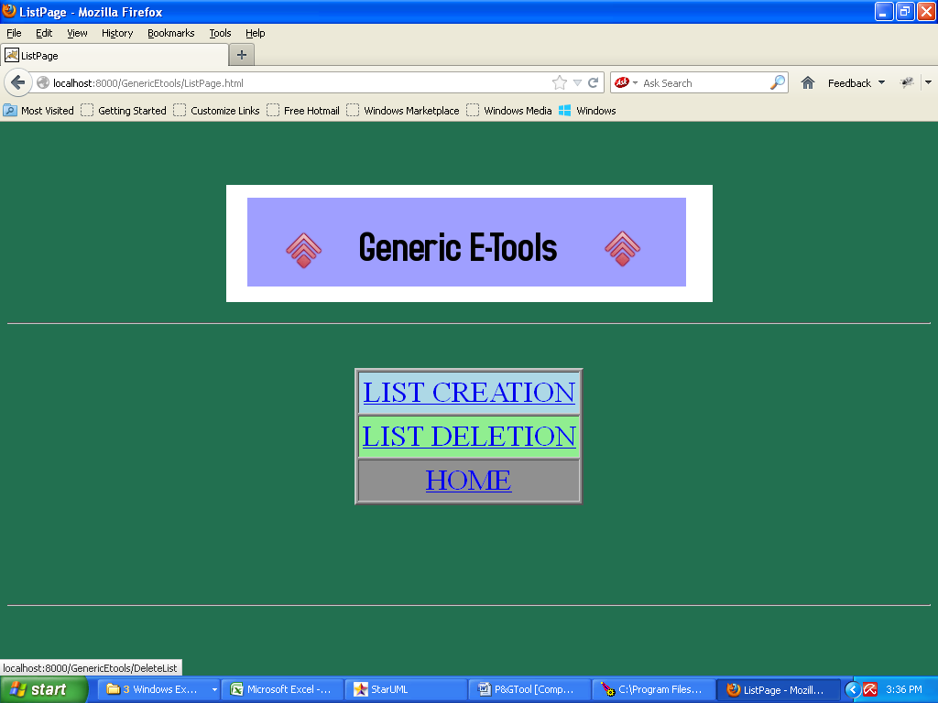

Listcreation
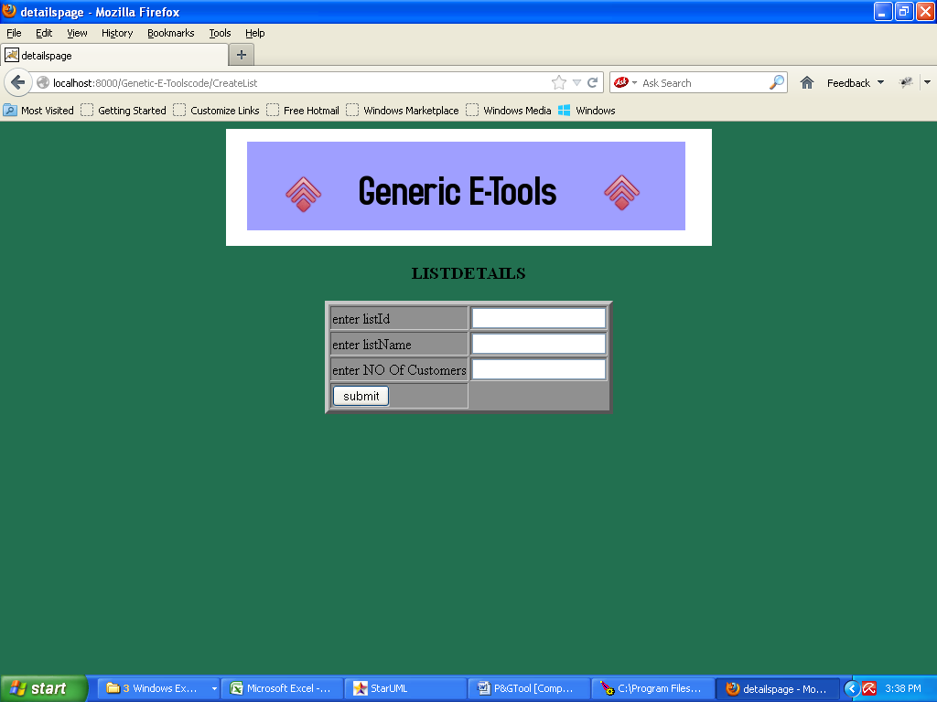

Enterlistdetails
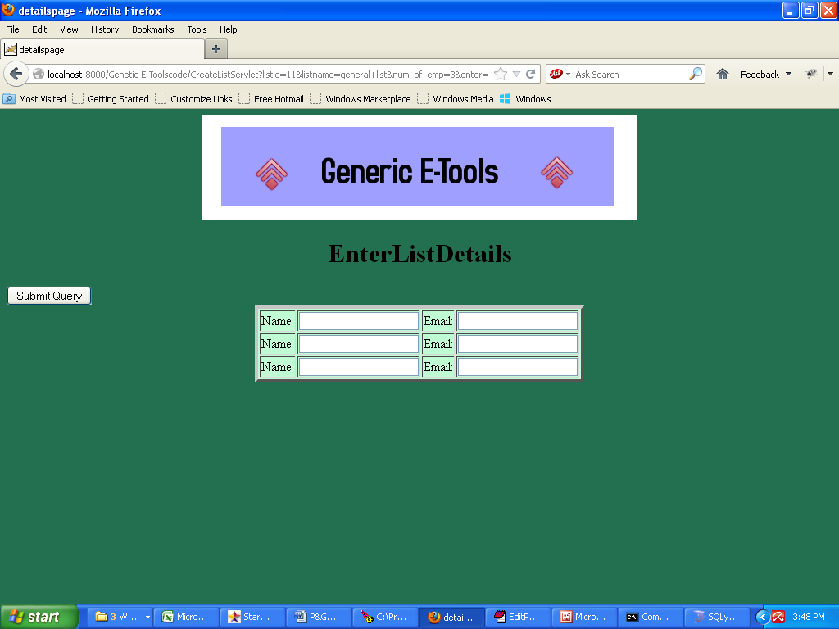

Deletionoflist
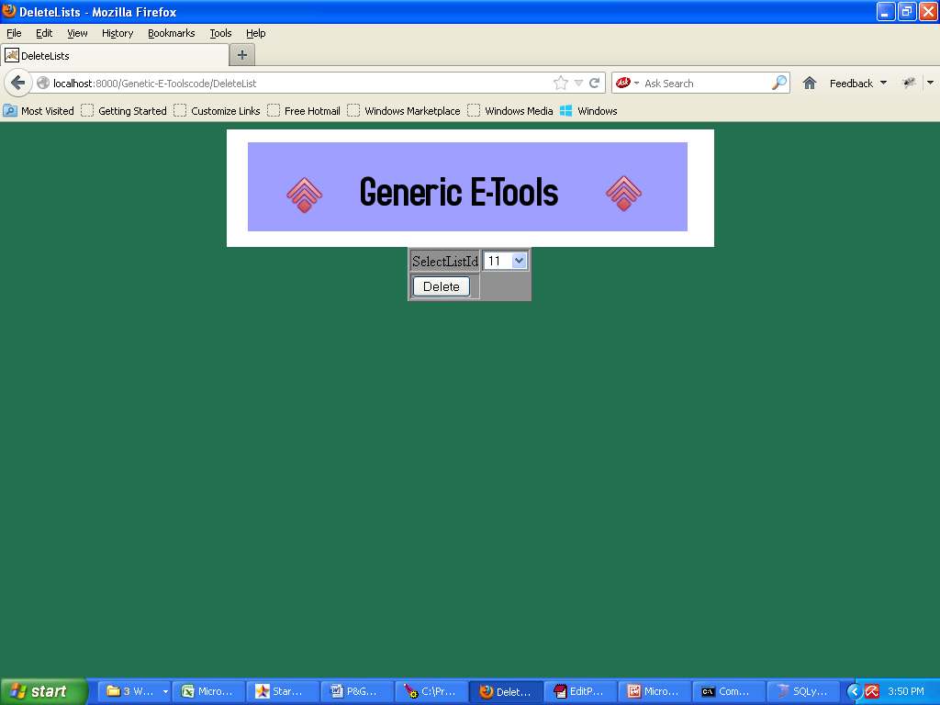

Afterdeletion

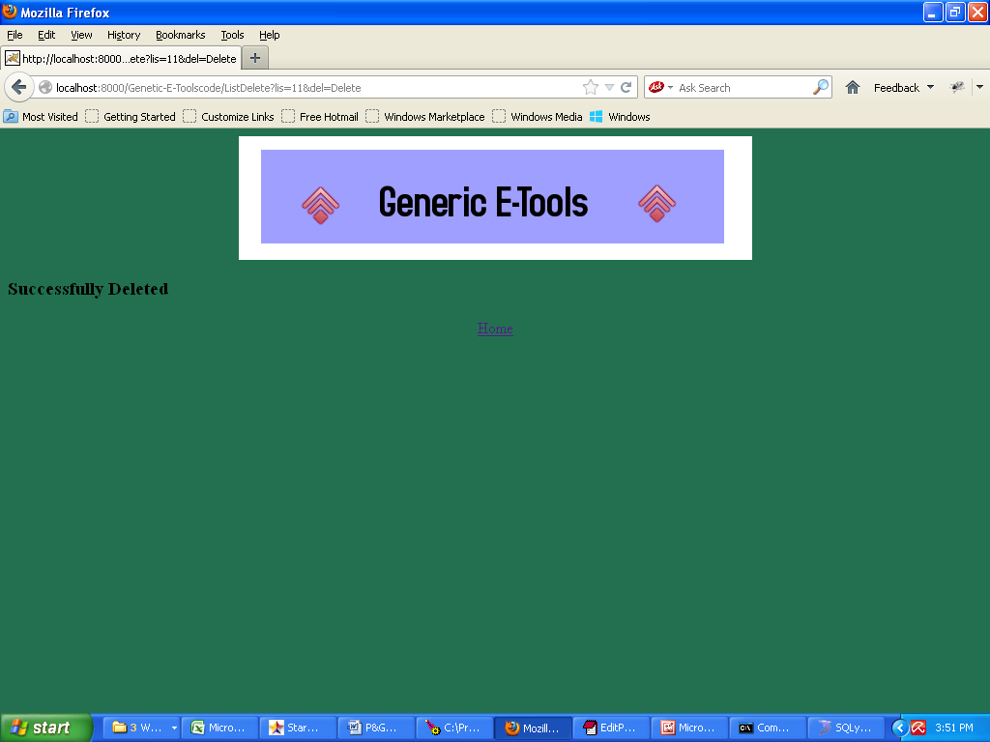

Form factory

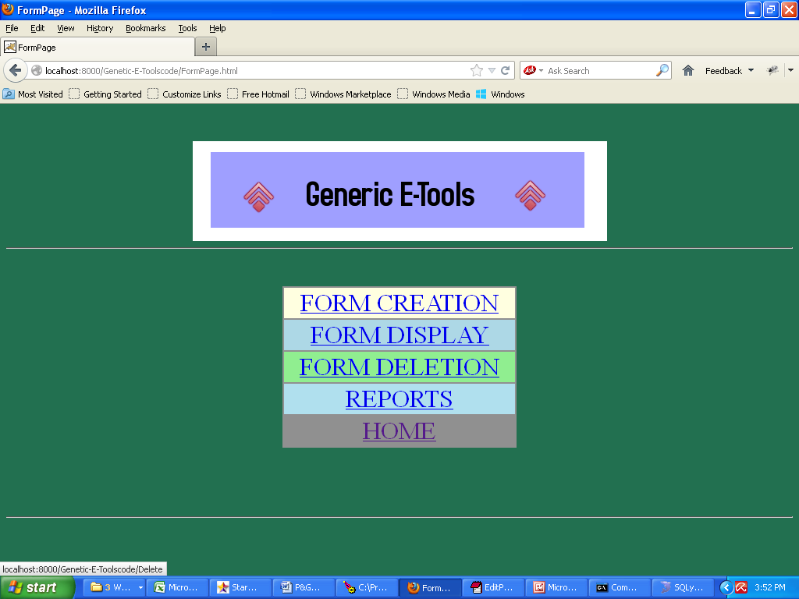

Form creation

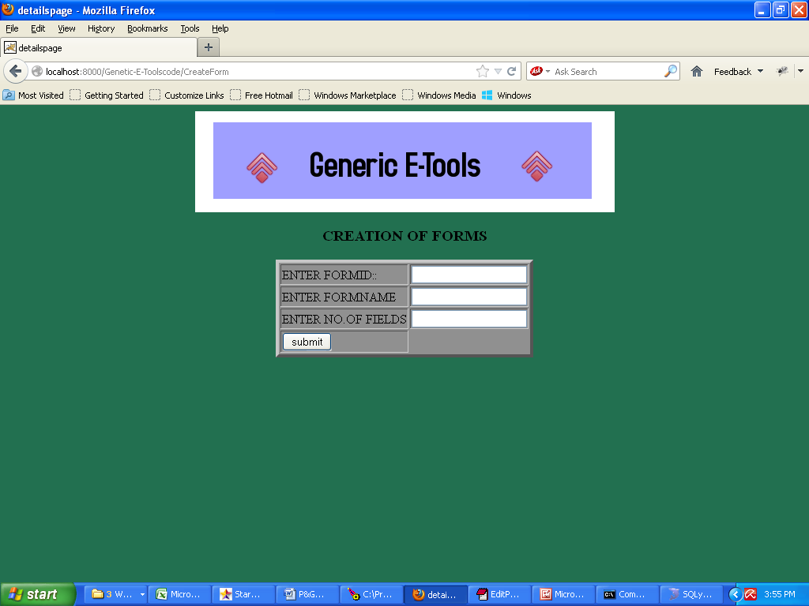

Form details

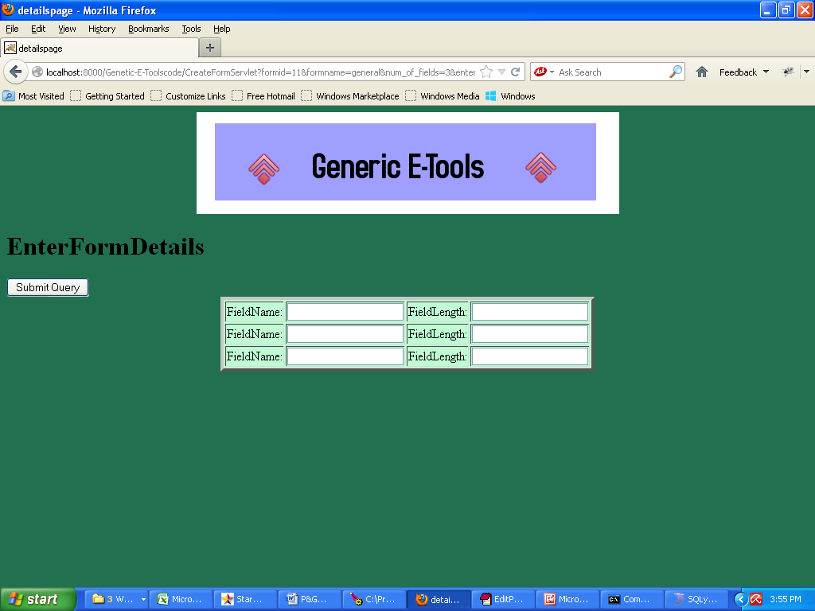

Form display

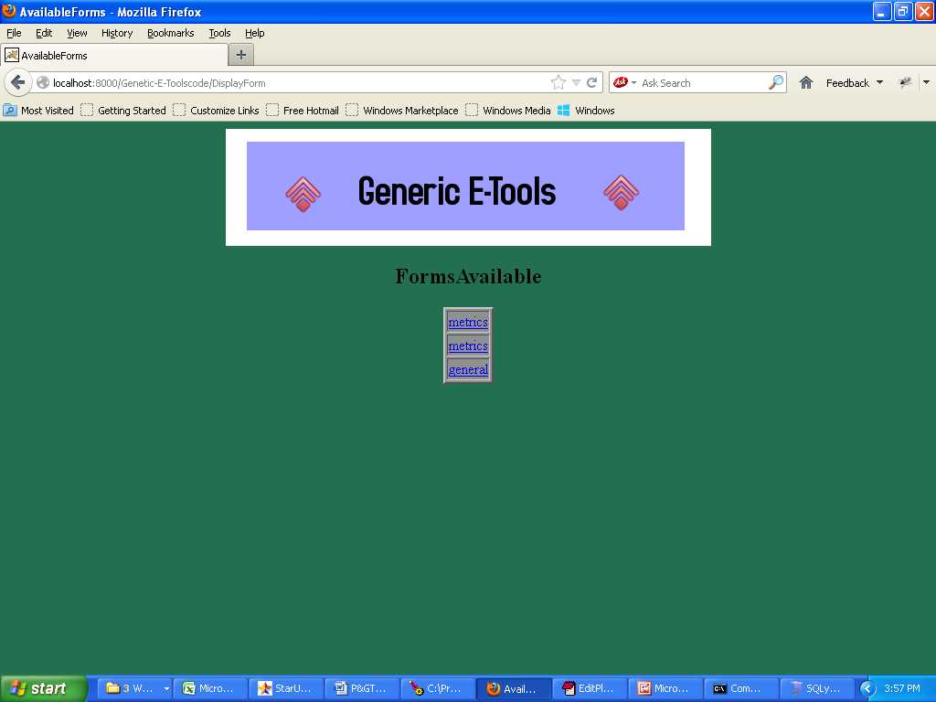

Form details

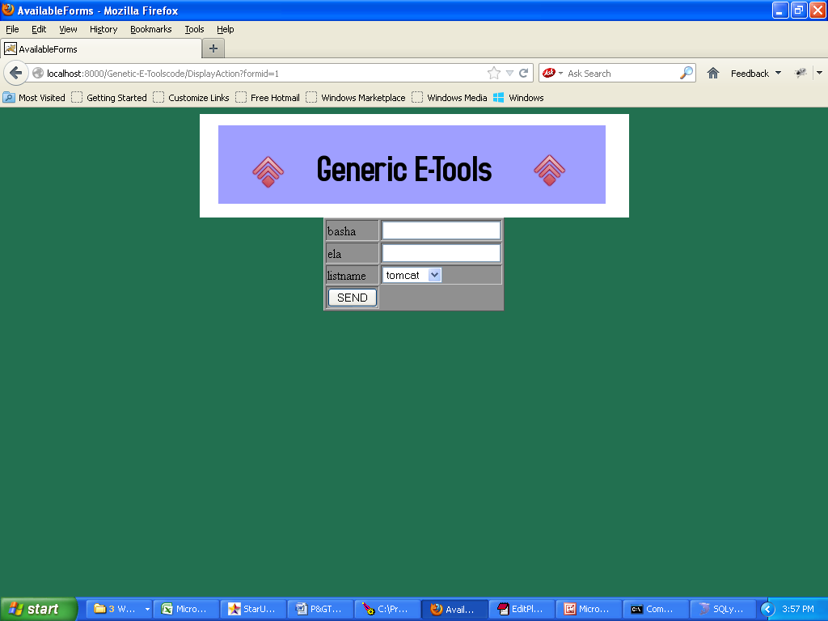

Adding of forms

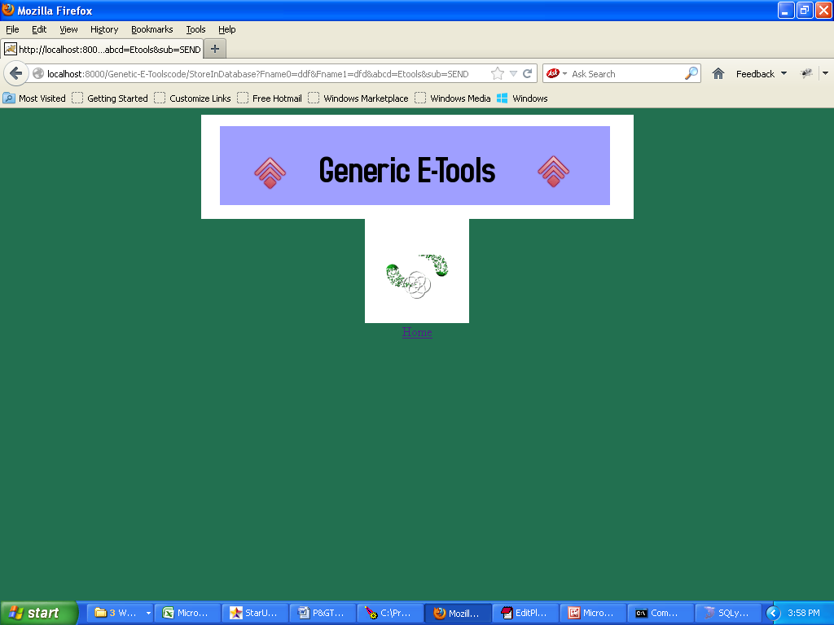

Form deletion

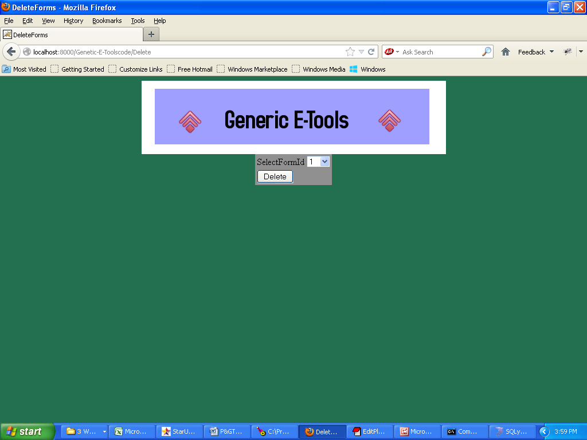

After form deletion

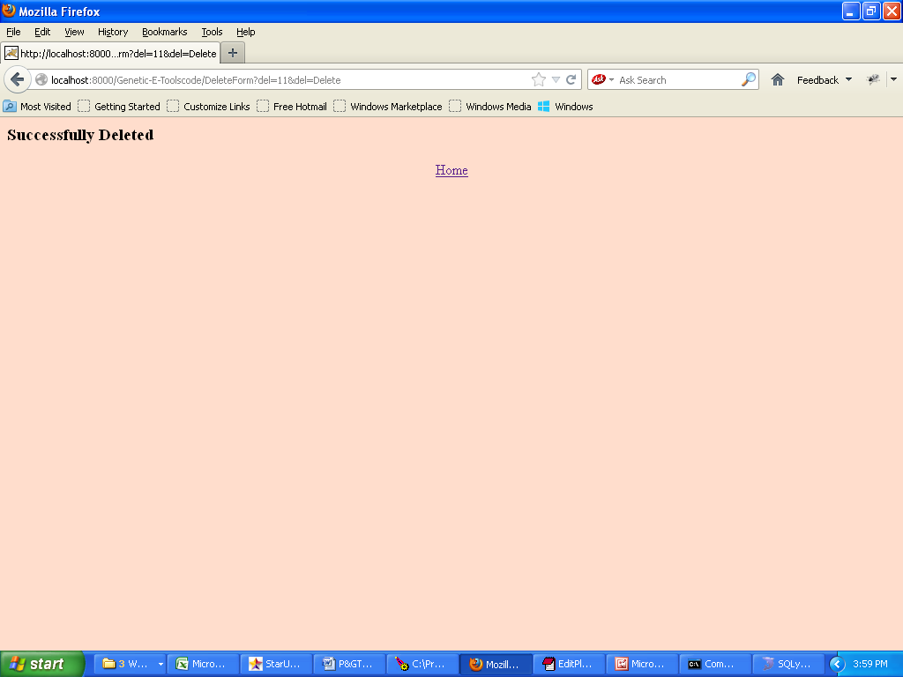

Reports

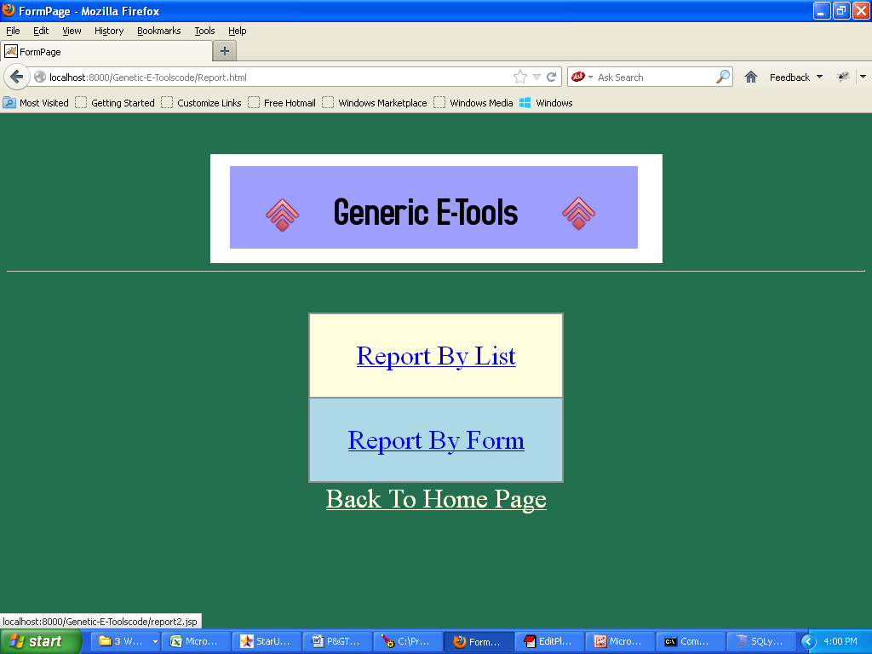

Report by list

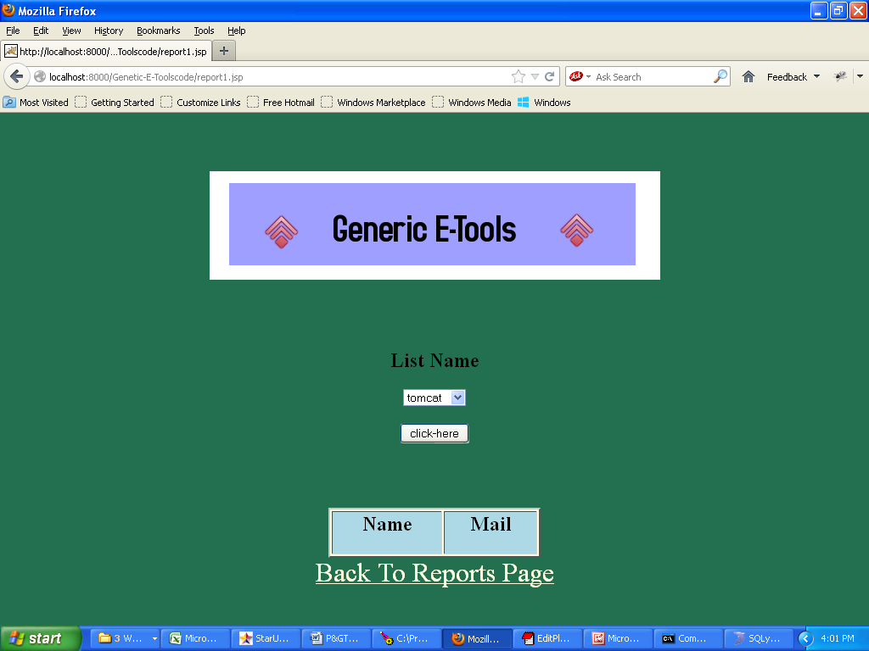

Display of list
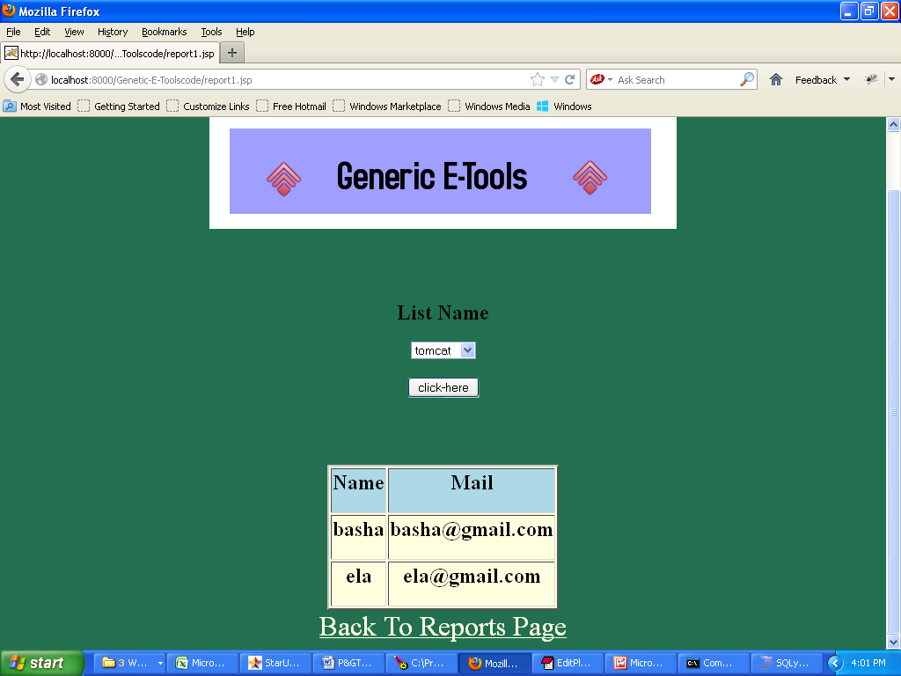

Report by form

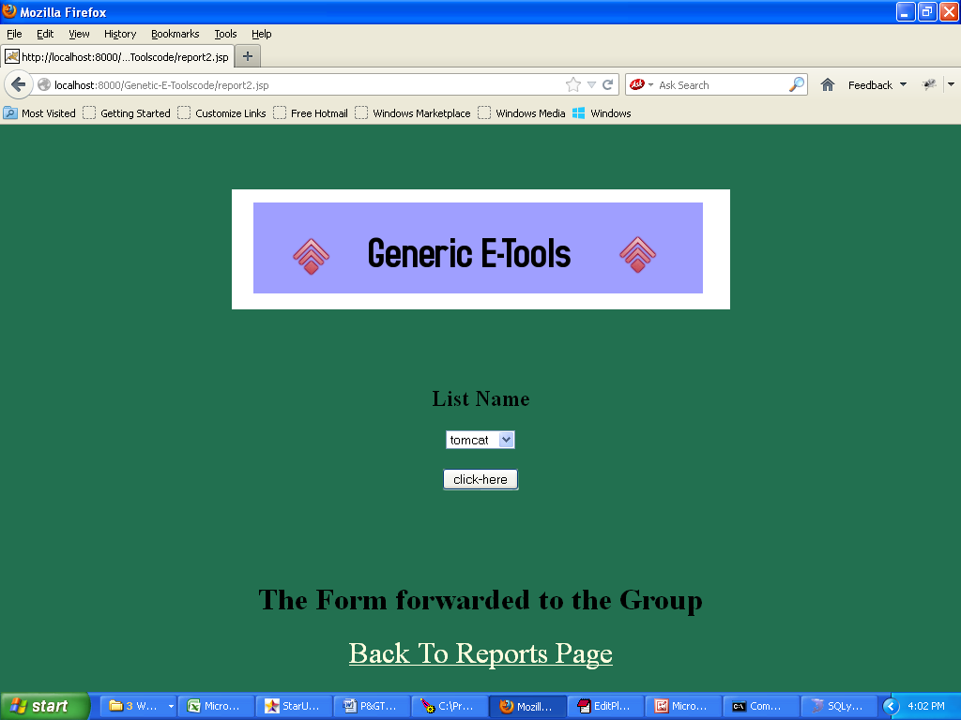

Report by group

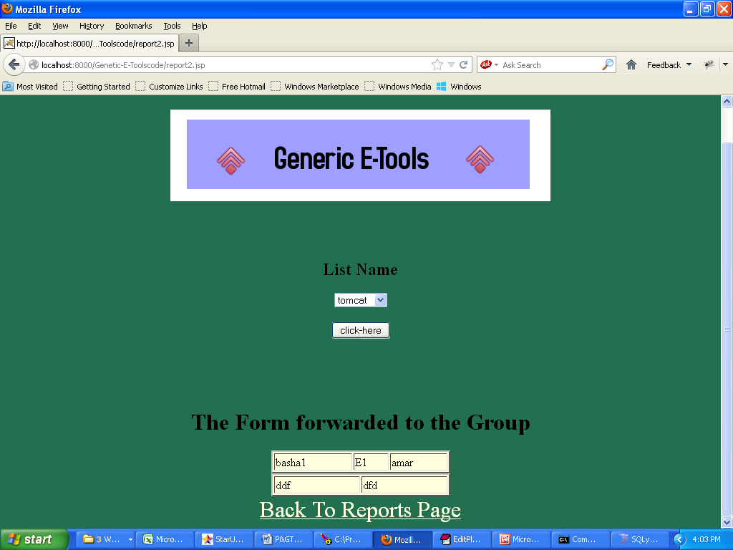

IMPLEMENTATION

Implementation is the process of converting a new or revised system design into operational one.There are three types of Implementation:

- Implementation of a computer system to replace a manual system. The problems encountered are converting files, training users, and verifying printouts for integrity.
- Implementation of a new computer system to replace an existing one. This is usually a difficult conversion. If not properly planned there can be many problems.
- Implementation of a modified application to replace an existing one using the same computer. This type of conversion is relatively easy to handle, provided there are no major changes in the files.

Implementation in Generic tool project is done in all modules. In the first module User level identification is done. In this module every user is identified whether they are genuine one or not to access the database and also generates the session for the user. Illegal use of any form is strictly avoided.
In the Table creation module, the tables are created with user specified fields and user can create many table at a time. They may specify conditions, constraints and calculations in creation of tables. The Generic code maintain the user requirements through out the project.

In Updating module user can update or delete or Insert the new record into the database. This is very important module in Generic code project. User has to specify the filed value in the form then the Generic tool automatically gives whole filed values for that particular record.
In Reporting module user can get the reports from the database in 2Dimentional or 3Dimensional view. User has to select the table and specify the condition then the report will be generated for the user.

TESTING

Software testing is a critical element of software quality assurance and represents the ultimate review of specification, design and coding. Testing is the exposure of the system to trial input to see whether it produces correct output.

Testing Phases:
Software testing phases include the following:
Test activities are determined and test data selected.
The test is conducted and test results are compared with the expected
results.

There are various types of Testing:
Unit Testing:
Unit testing is essentially for the verification of the code produced during the coding phase and the goal is test the internal logic of the module/program. In the Generic code project, the unit testing is done during coding phase of data entry forms whether the functions are working properly or not. In this phase all the drivers are tested they are rightly connected or not.
Integration Testing:
All the tested modules are combined into sub systems, which are then tested. The goal is to see if the modules are properly integrated, and the emphasis being on the testing interfaces between the modules. In the generic code integration testing is done mainly on table creation module and insertion module.
System Testing:
It is mainly used if the software meets its requirements. The reference document for this process is the requirement document. Acceptance Testing:
It is performed with realistic data of the client to demonstrate that the software is working satisfactorily. In the Generic code project testing is done to check whether the Creation of tables and respected data entry was working successfully or not.
Testing Methods:
Testing is a process of executing a program to find out errors. If testing is conducted successfully, it will uncover all the errors in the software. Any testing can be done basing on two ways:

White Box Testing:
It is a test case design method that uses the control structures of the procedural design to derive test cases. using this testing a software Engineer can derive the following test cases:
Exercise all the logical decisions on either true or false sides. Execute all loops at their boundaries and within their operational boundaries. Exercise the internal data structures to assure their validity.
Black Box Testing:
It is a test case design method used on the functional requirements of the software. It will help a software engineer to derive sets of input conditions that will exercise all the functional requirements of the program. Black Box testing attempts to find errors in the following categories:
Incorrect or missing functions
Interface errors
Errors in data structures
Performance errors

Initialization and termination errors

By black box testing we derive a set of test cases that satisfy the following criteria:
Test cases that reduce by a count that is greater than one, the number of additional test cases that must be designed to achieve reasonable testing.
Test cases that tell us something about the presence or absence of classes of errors rather than errors associated only with a specific test at hand.

TEST APPROACH
Testing can be done in two ways:
Bottom up approach
Top down approach
Bottom up approach:
Testing can be performed starting from smallest and lowest level modules and proceeding one at a time. For each module in bottom up testing a short program executes the module and provides the needed data so that the module is asked to perform the way it will when embedded with in the larger system. When bottom level modules are tested attention turns to those on the next level that use the lower level ones they are tested individually and then linked with the previously examined lower level modules.

Top down approach:
This type of testing starts from upper level modules. Since the detailed activities usually performed in the lower level routines are not provided stubs are written. A stub is a module shell called by upper level module and that when reached properly will return a message to the calling module indicating that proper interaction occurred. No attempt is made to verify the correctness of the lower level module.

Conclusion

The project is able to successfully incorporate all the requirements specified by the user. Proper care has been taken during database design to maintain data integrity and to avoid data redundancy. A client side validation has also been done with utmost care by considering all the possibilities and requirements of different users to avoid data inconsistency. The user is provided with a very friendly interface, hiding all the technical intricacies. Design procedures and user manuals are also included in the project to help users better understand the system.
The project is designed and coded in such a way that any further modifications that are needed in future can be easily implemented without affecting the functionality of the system. The technical documentation provided in the project report helps the application developers understand the internal architecture of the system and thus assists them in enhancing the system.

This project is purely user-friendly and platform independent, so user can run this tool in any environment. And also it is generic code, it compactable any type of format of HTML files. It very easy to implement or add many feature to this tool. Finally it a very need full and simple tool for any big organizations.

Bibliography

- System Analysis and Design
    - Senn
- Database System Design
    - Elmasree
    - Korth
- Software Engineering Concepts
    - Robert Pressman
- Servlet Programming Orally Series
- Java Complete Reference
N Shildit

