**Name: Bhavana Prajapati Class: FYIT Roll no: 66**

**Practical No: 1 Introduction about Contribution to Wikipedia**

* **Description about Wikipedia and its features**
* **Description about Wikipedia:**

Wikipedia is a free, open content online encyclopaedia created through the collaborative effort of a community of users known as *Wikipedians*. Anyone registered on the site can create an article for publication; registration is not required to edit articles. The site's name comes from [wiki](https://whatis.techtarget.com/definition/wiki), a server program that enables anyone to edit Web site content through their Web browser. Jimmy Wales and Larry Sanger co-founded Wikipedia as an offshoot of an earlier encyclopaedia project, Nupedia, in January 2001. Originally, Wikipedia was created to provide content for Nupedia. However, as the wiki site became established it soon grew beyond the scope of the earlier project. As of January 2015, the website provided well over five million articles in English and more than that number in all other languages combined. At that same time, Alexa ranked Wikipedia as the seventh-most popular site on the Internet. Wikipedia was the only non-commercial site of the top ten.

Wikipedia was one of the first [social media](https://whatis.techtarget.com/definition/social-media) websites.

* **Features of Wikipedia:**

1. Wikipedia is a free, multilingual open-collaborative online encyclopedia created and maintained by a community of volunteer editors using a wiki-based editing system.
2. Wikipedia has openness - anyone could create articles, and any Wikipedia article could be edited by any reader, even those who did not have a Wikipedia account.
3. Wikipedia has restrictions for publishing the articles
4. Changes can be reviewed by others. The software that powers Wikipedia provides tools allowing anyone to review changes made by others.
5. Wikipedia has a power to remove the Vandalism on the content.
6. Wikipedia is a great place to start your research, giving you background information on your topic and possible keywords to help you conduct more in-depth research elsewhere.

* **Creating Account on Wikipedia:**

**Step 1:**

For Publishing a Page on Wikipedia, first you should have an account on Wikipedia.

Go to <https://www.wikipedia.org/>

Click on the Language as per your need. We are selecting English for the simplicity

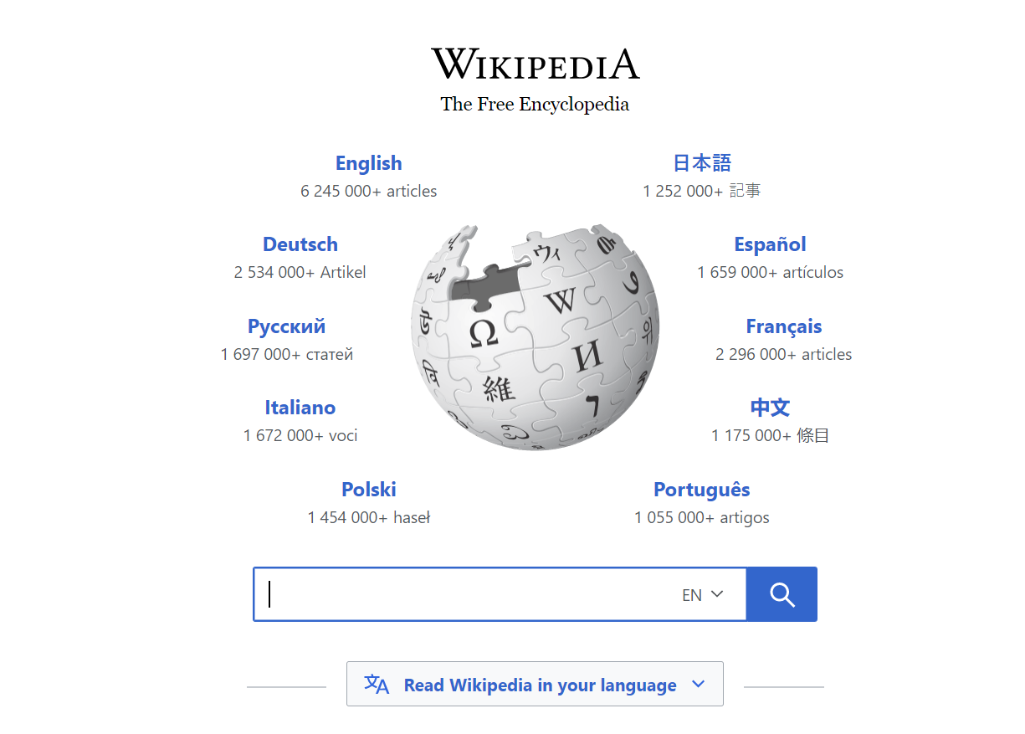

**Step2:**

Click on ***Create Account***

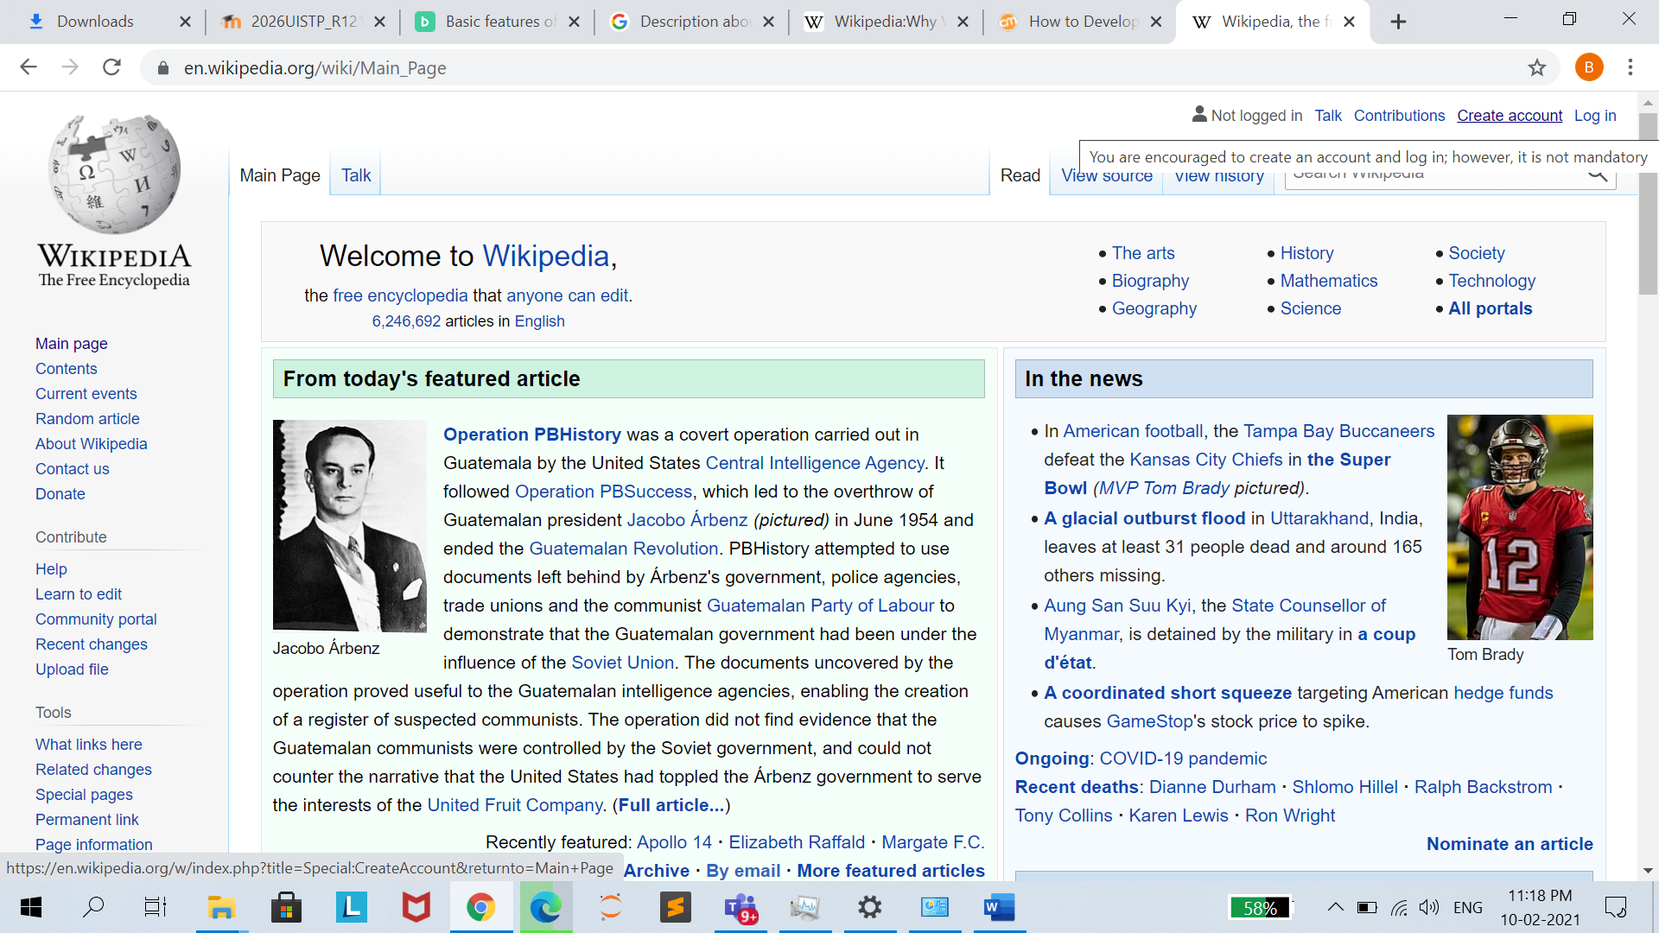

**Step 3:**

Provide proper Username and Password as per the policy of Wikipedia, then Submit it and your account will be created.

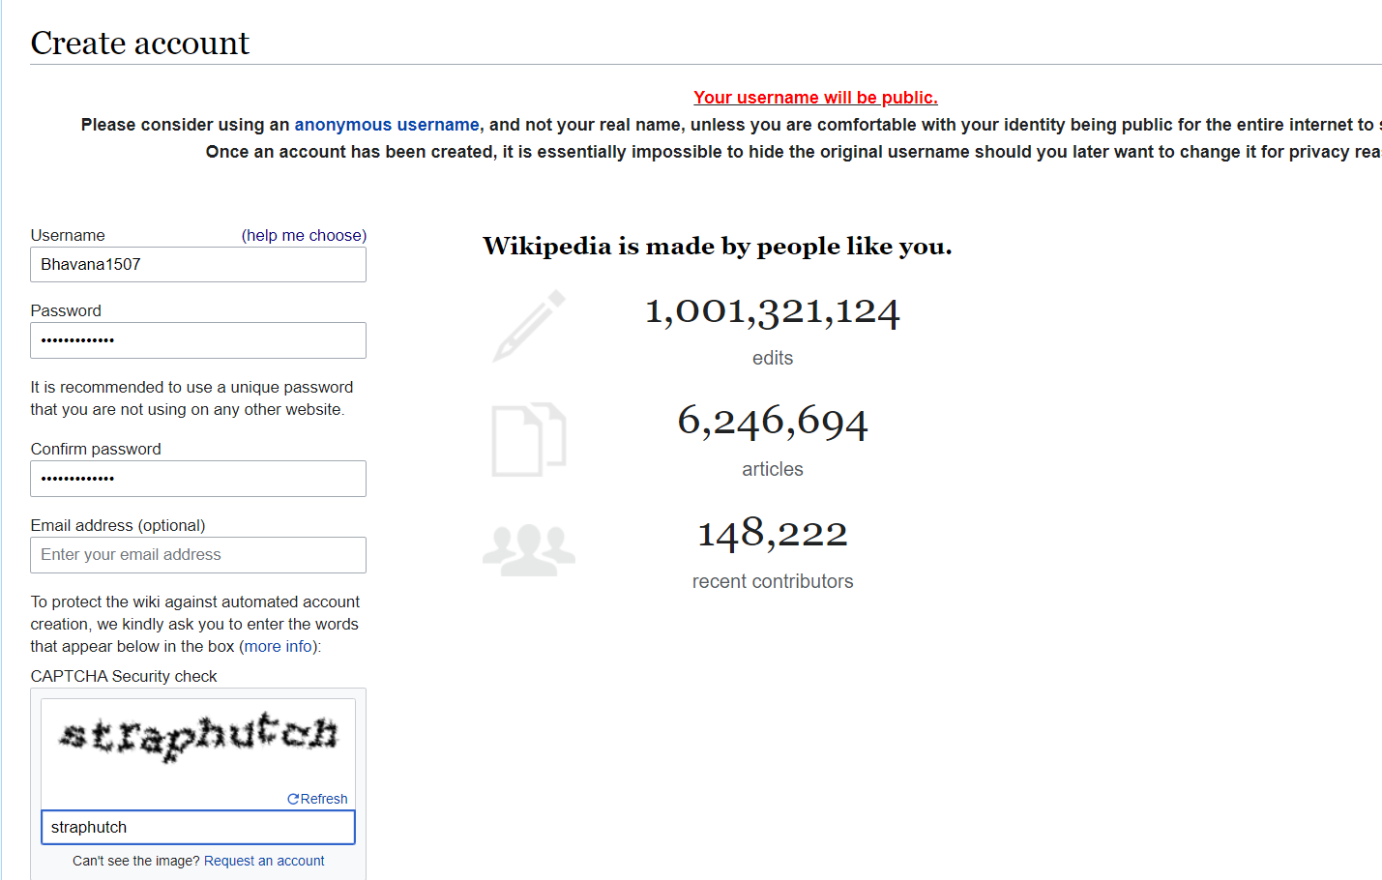

**Step 4**:

Once your account is created, now we should login using the credentials.

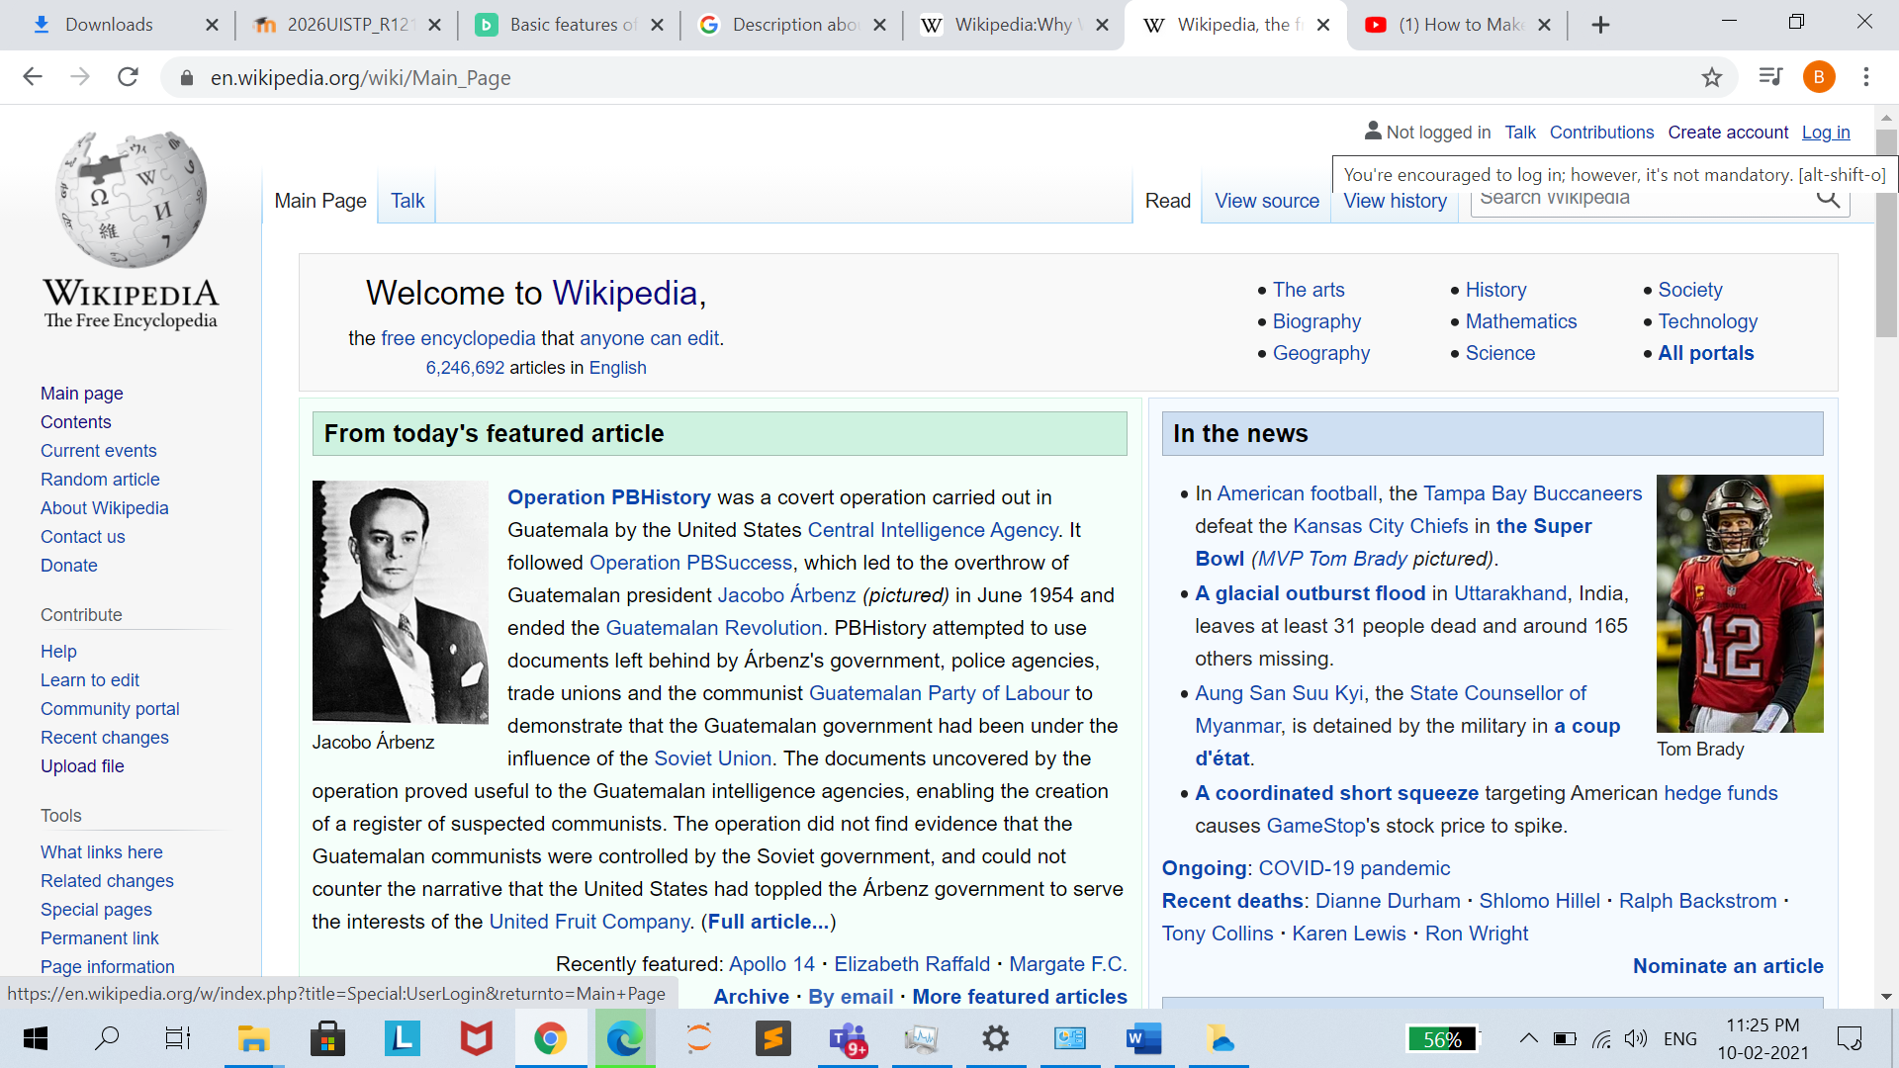

Step 5:

Give proper credentials and login to Wikipedia.

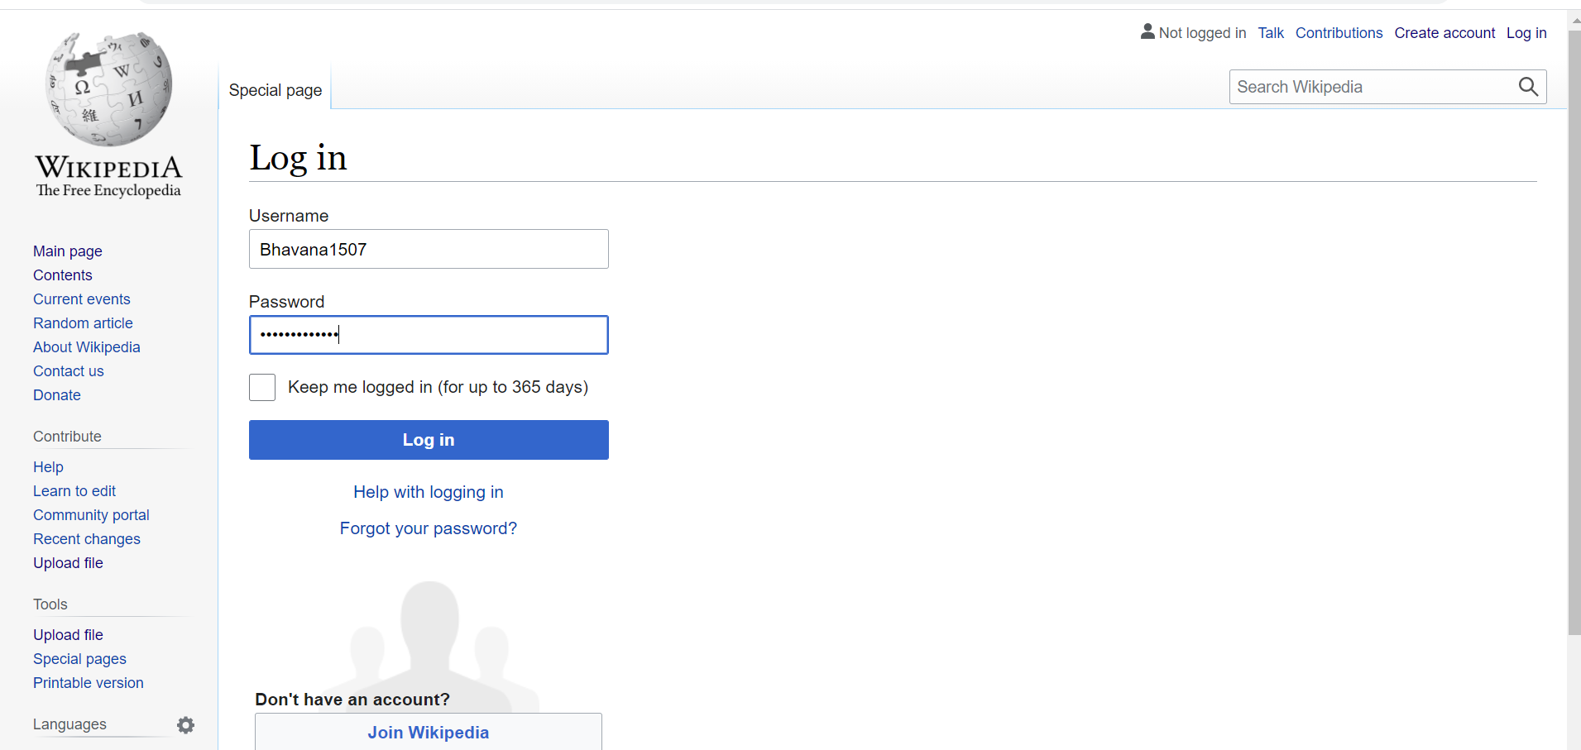

**Creating your page on Wikipedia:**

**Step1:**

1. **Create an account**
2. **Create the page**
3. **Go to the Wikipedia Article Wizard**
4. **The Wizard and the Sandbox**
5. **Submit your page for review**

**Step1:**

Click on ***Sandbox***

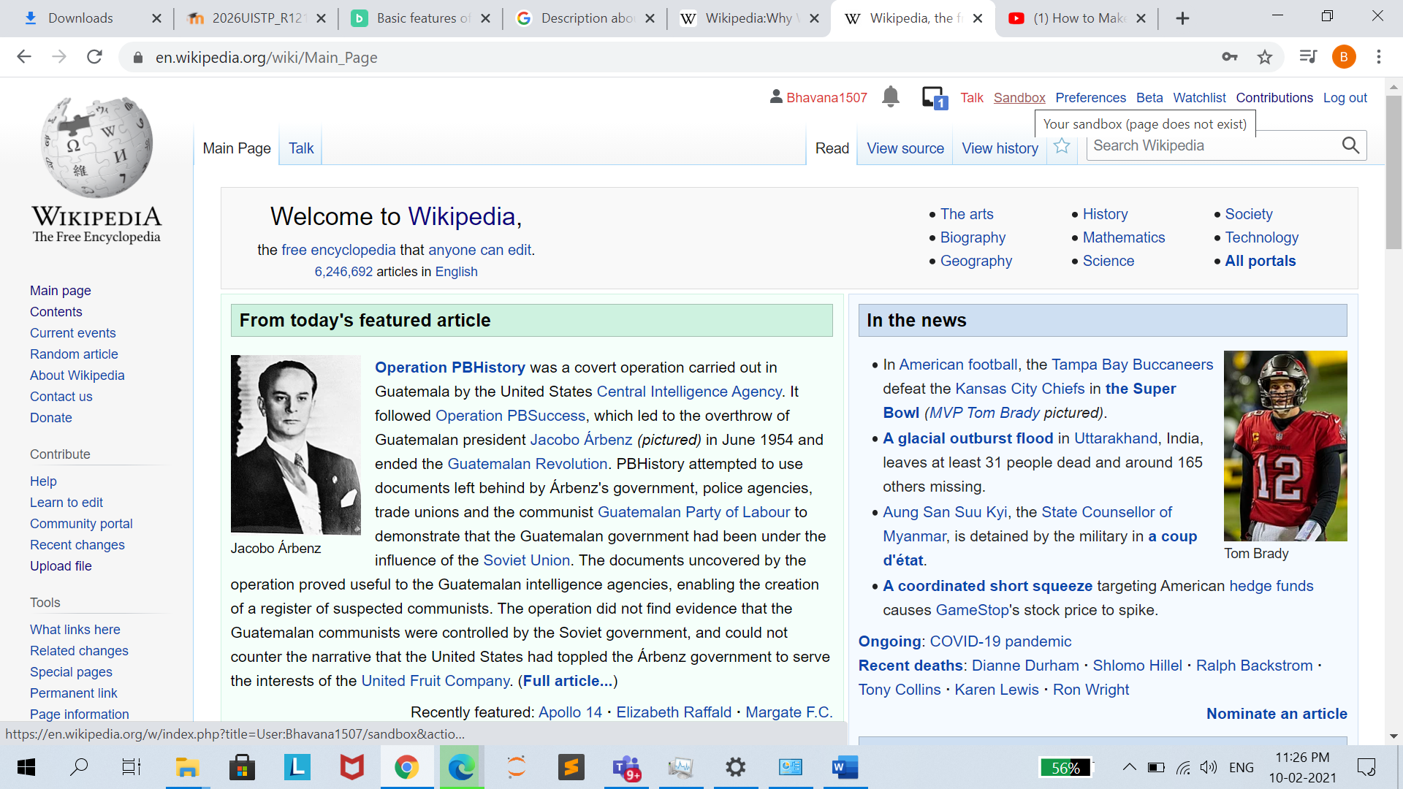

**Step 2:**

This is the main page where we provide the content that we want to Publish over Wikipedia.

We can include images, links, format the texts like we do in Microsoft Word, we can link the references and many more

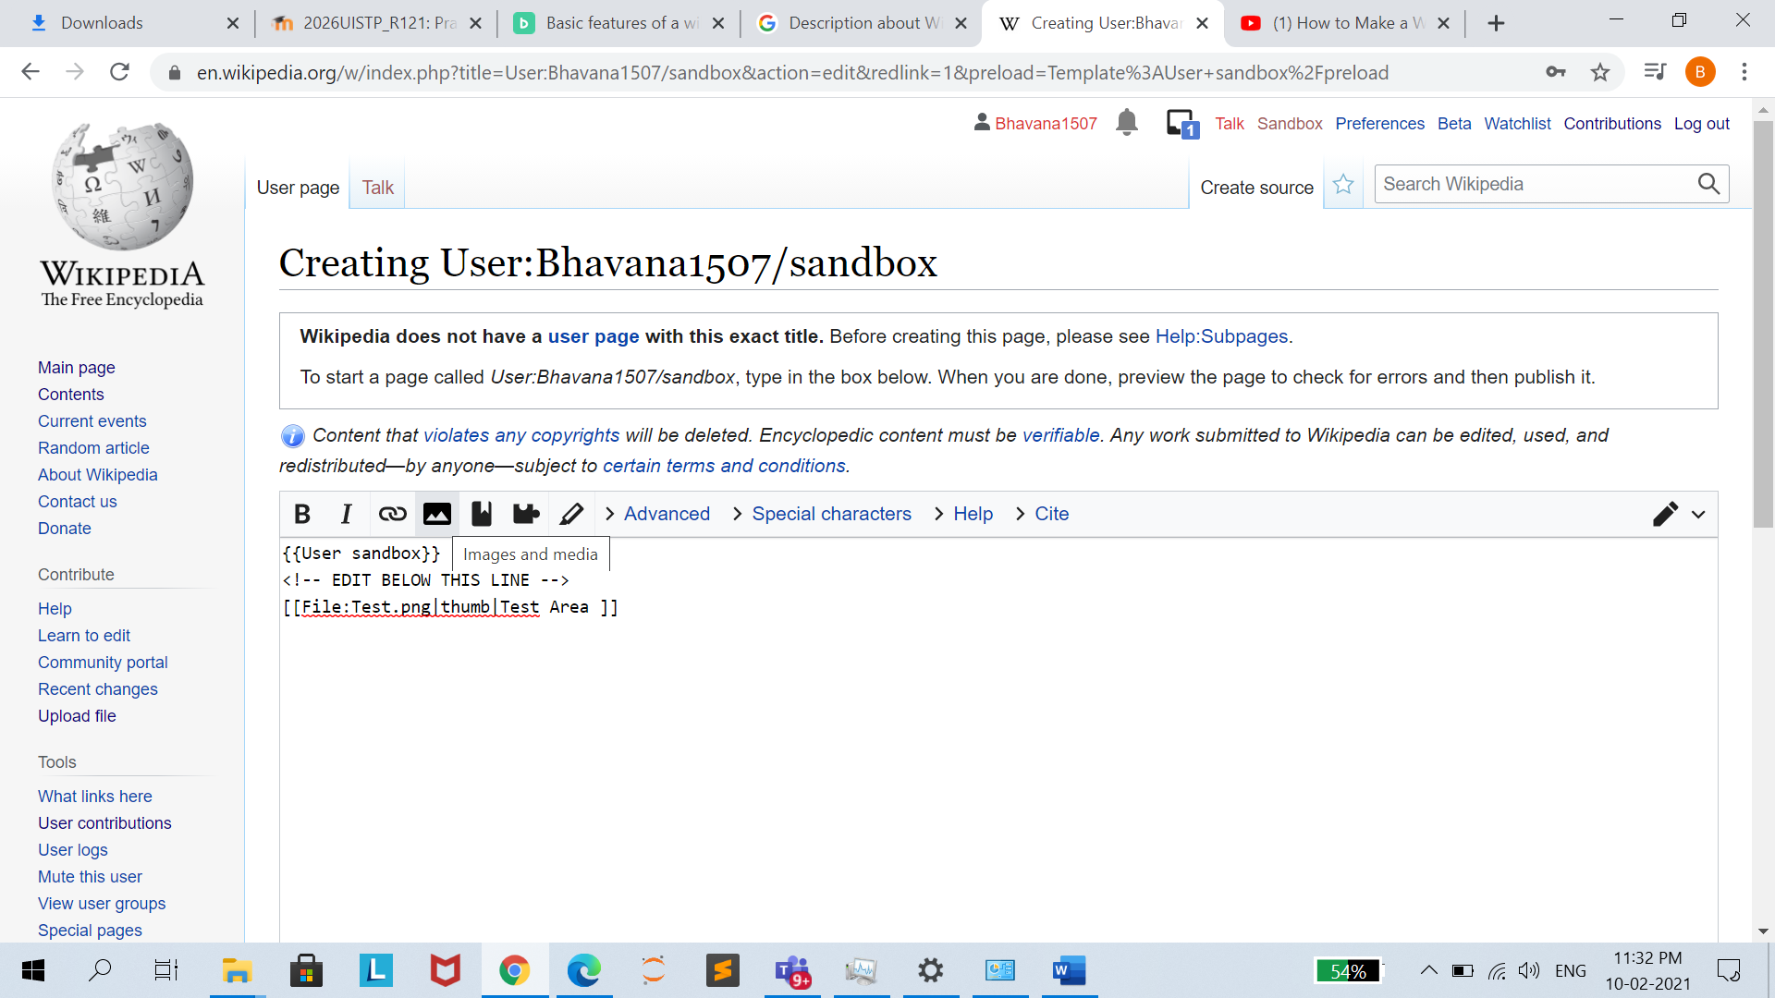

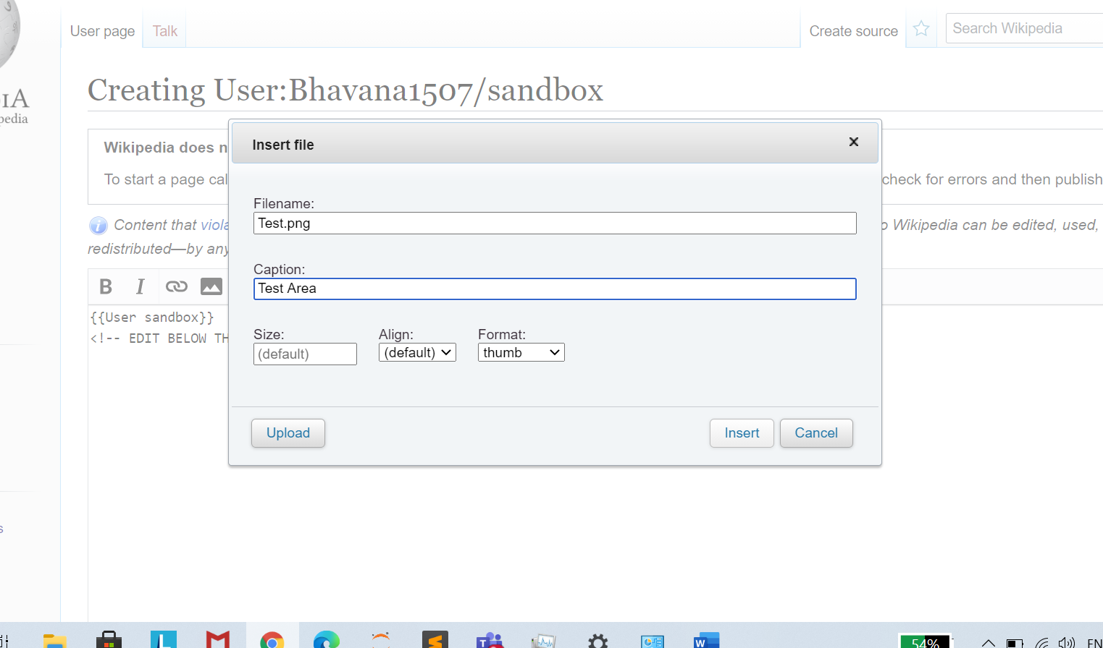

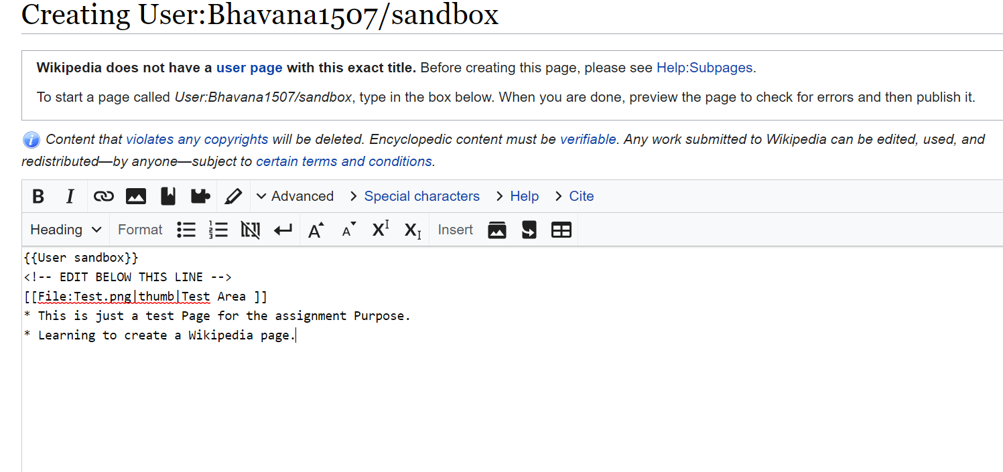

**Step3:**

After you have arranged your content in the editor, then click on ***Show Preview***, once you find that Preview is the same like you want the content to be. Then comes the Final stage, you click on ***Publish Page***

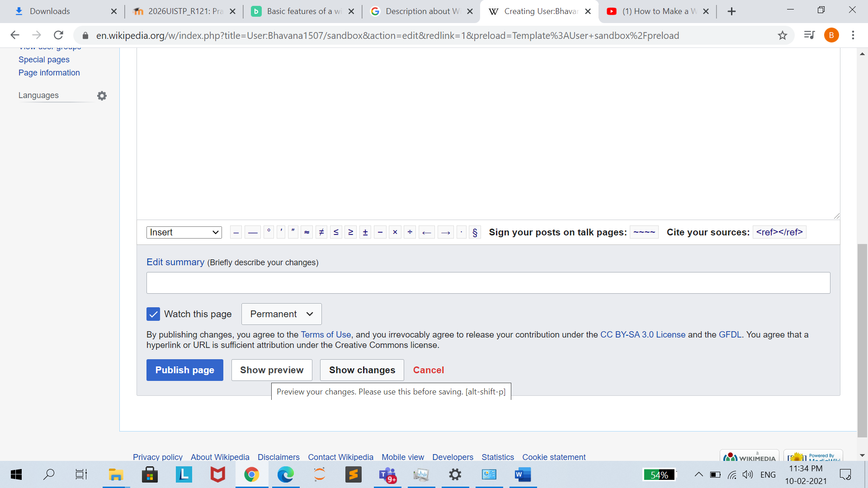

Then your content will be reviewed by Wikipedia community, once it is reviewed and passed by them, then it will be publicly accessible, otherwise they will provide you feedback based on your content and suggest you what is make your content not publishable.

* **Editing your page on Wikipedia:**

**Step1:**

**Editing an Unprotected Page**

Click on ***Edit Source***

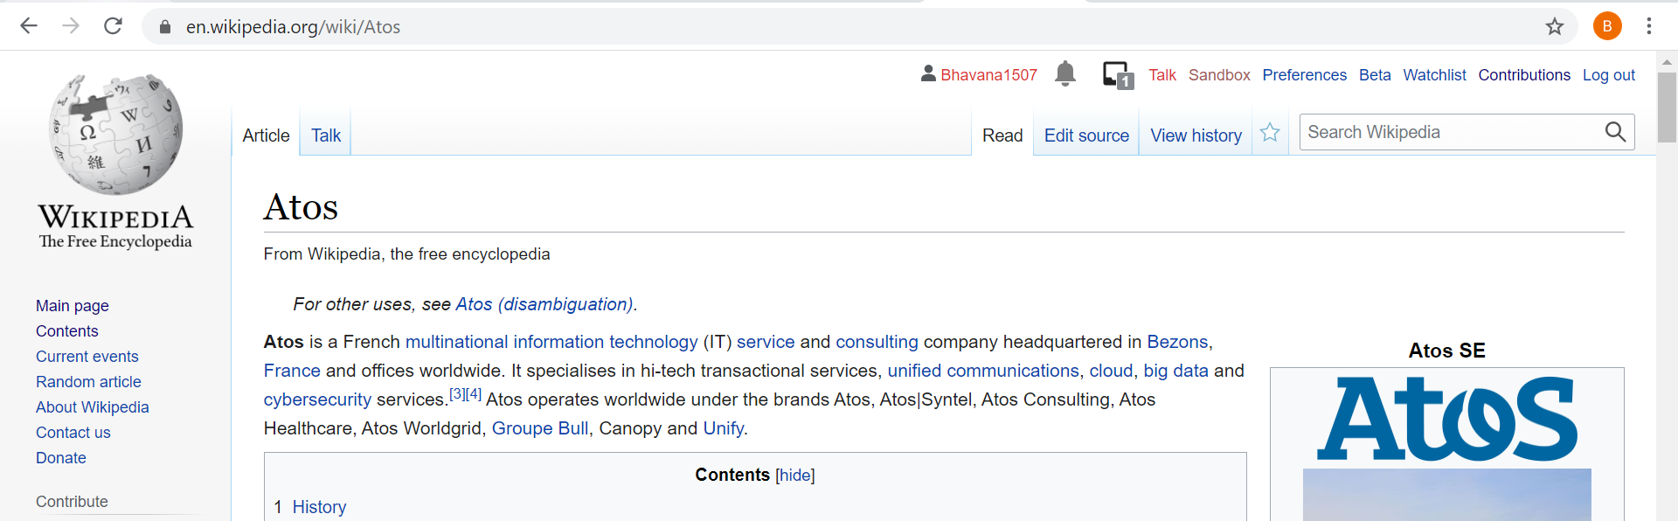

**Step2:**

Make the necessary changes under the Editing Section

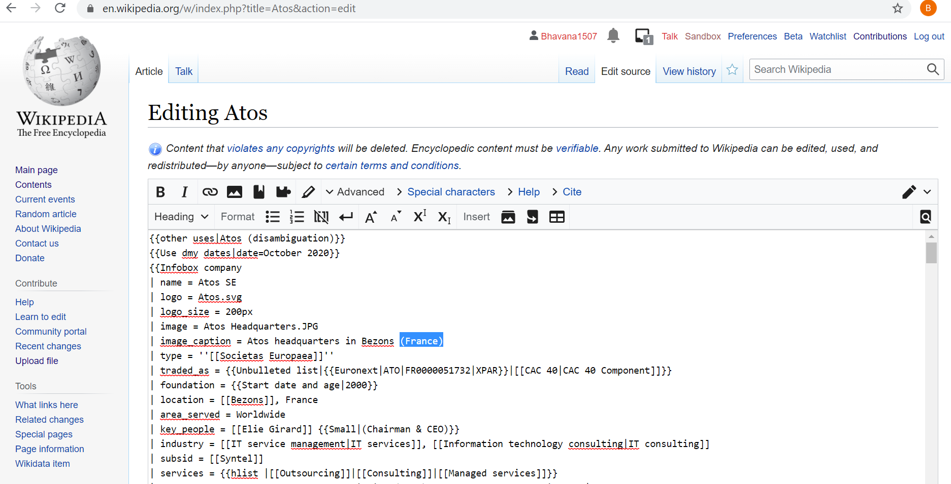

Step3:

**Click on Show preview.** It will give you the chance to take a look at the article with your edits without saving the edit.

**Then Click Publish changes.** When you edited the page and clicked Show preview, click Publish changes to save your edits.

Always do your best to leave an edit summary to describe that changes you have made.

