**Name: Bhavana prajapati Class: FYIT Roll No: 66**

## Practical No: 2

## [Creating account, repository on Github and Cloning repository in Github]

**1.Creating a GitHub Account:**

**Step1:**

* Go to GitHub.com and click on ***Sign Up***



**Step2:**

Fill in the Proper details like Username, Email Address and Password

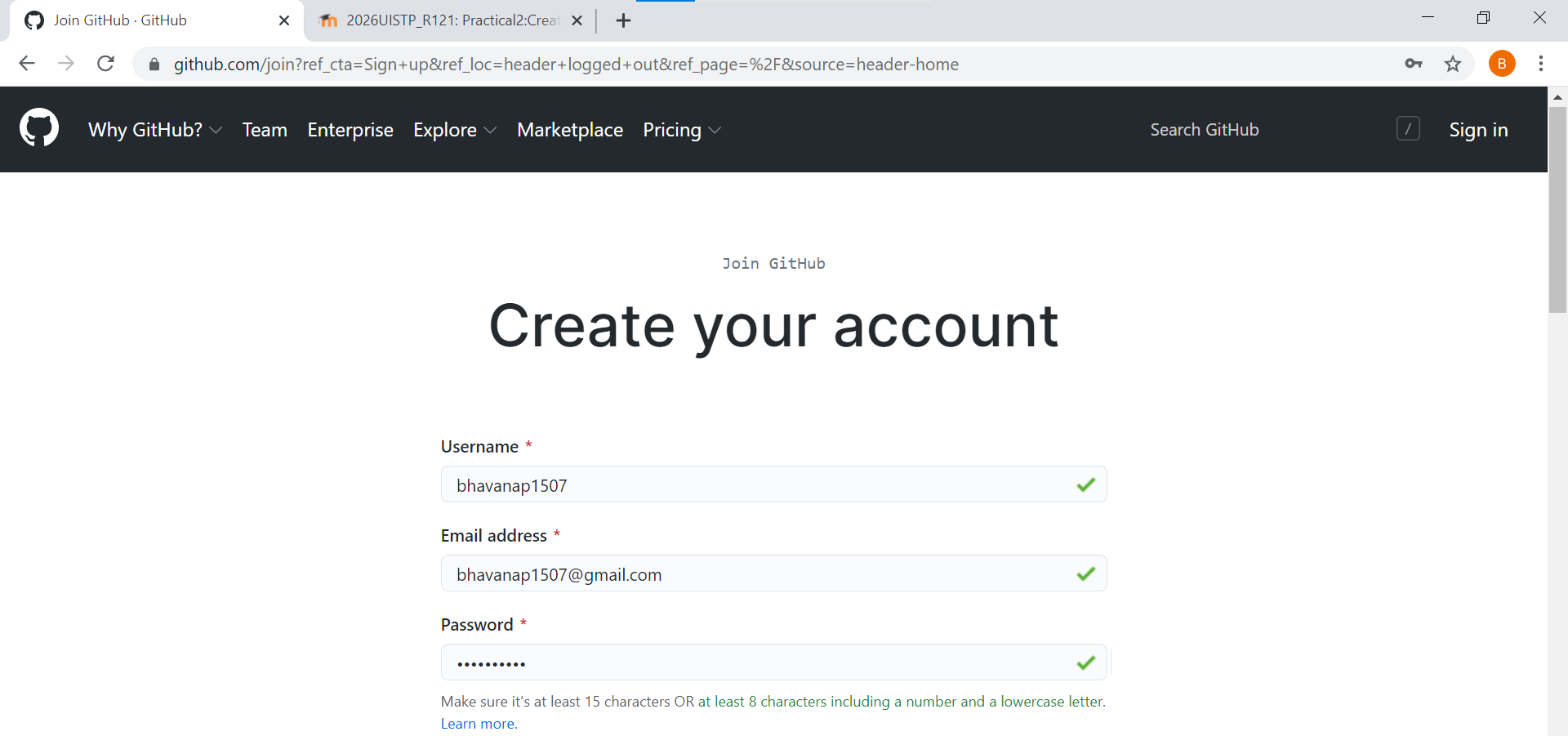

**Step3:**

Verify the captcha and then click on ***Create Account***

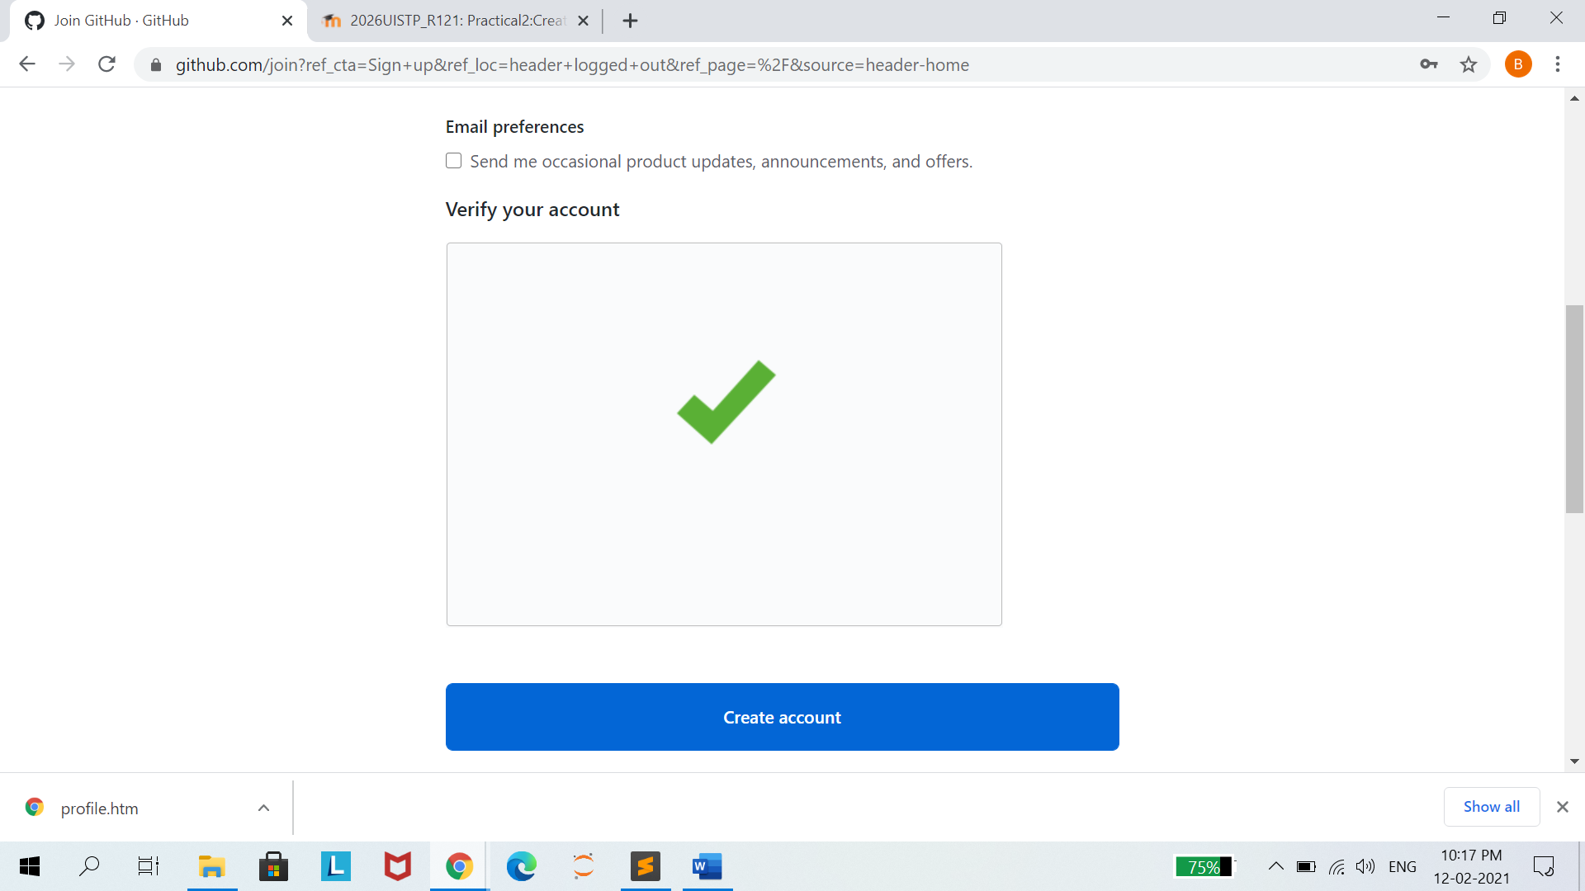

**Step4:**

We will get an email on registered mail ID to verify the github account

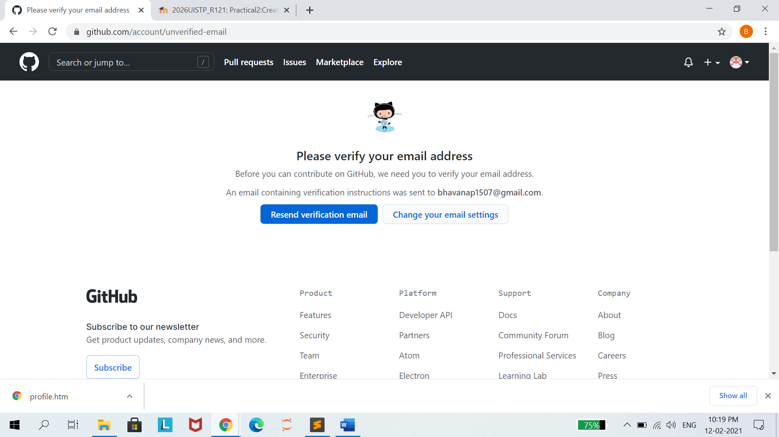

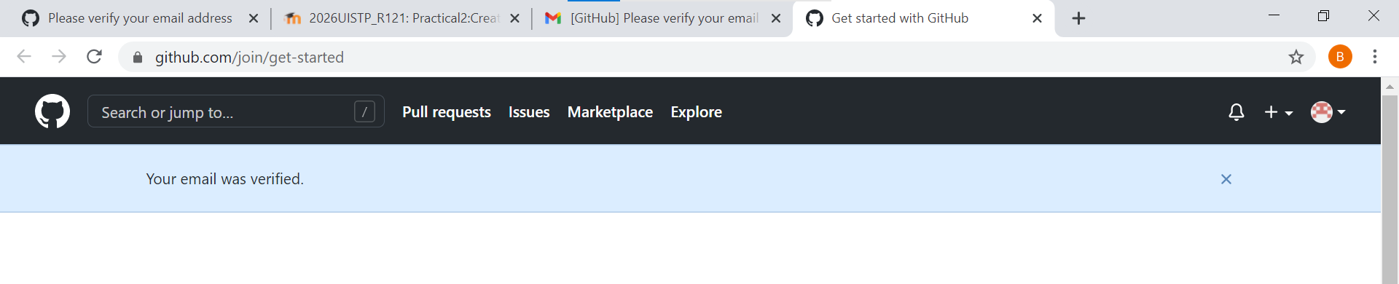

**2.Creating a Repository:**

**Step1:**

After Verifying the GitHub account, then Logon to Github account and create a new Repository by clicking on Button ***Create Repository.***

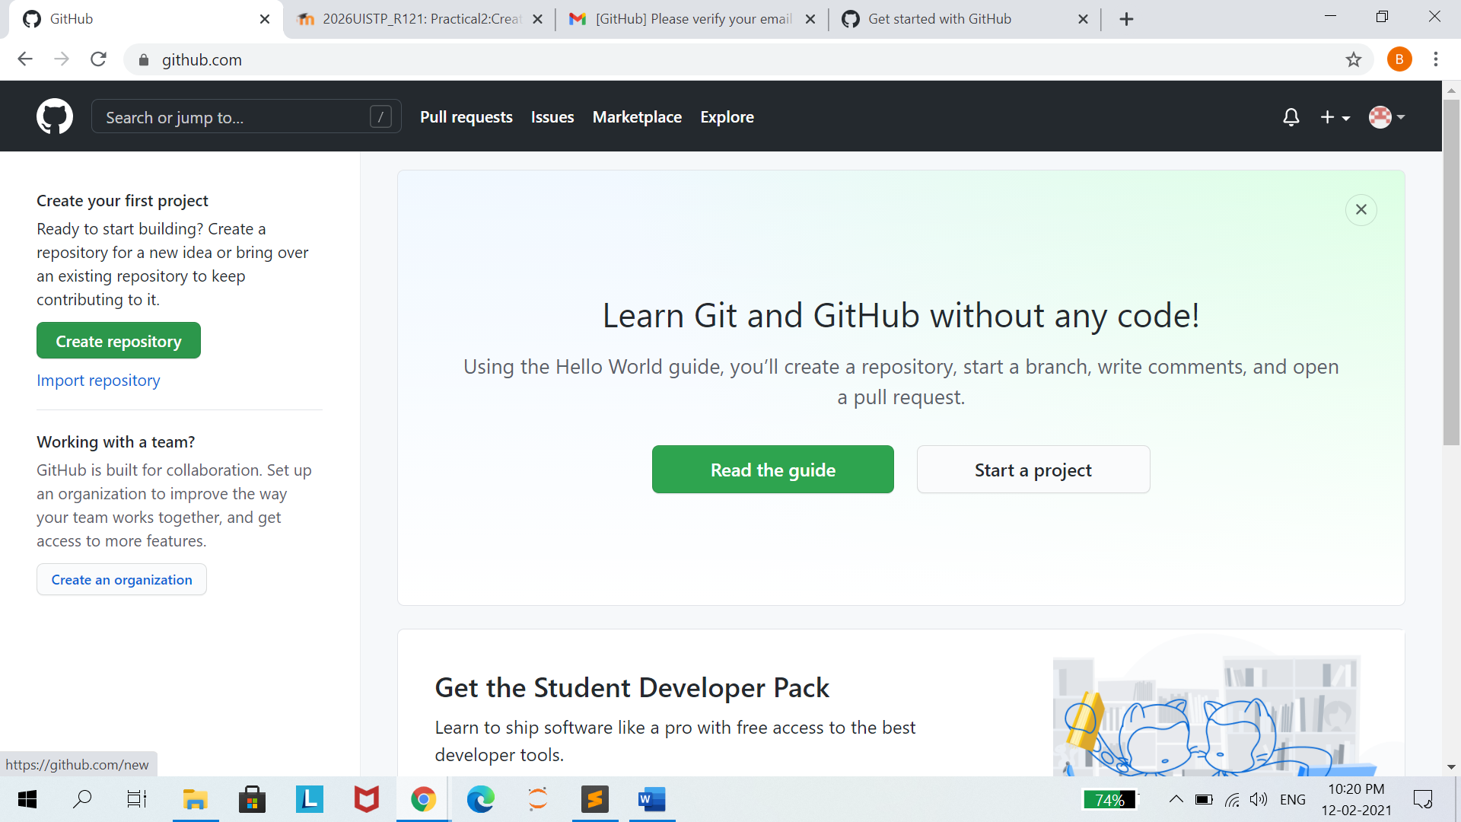

**Step2:**

Give a ***Repository Name*** and select the option as shown below

We are creating a repository named ***IT_TOOLS_PRACTICAL***

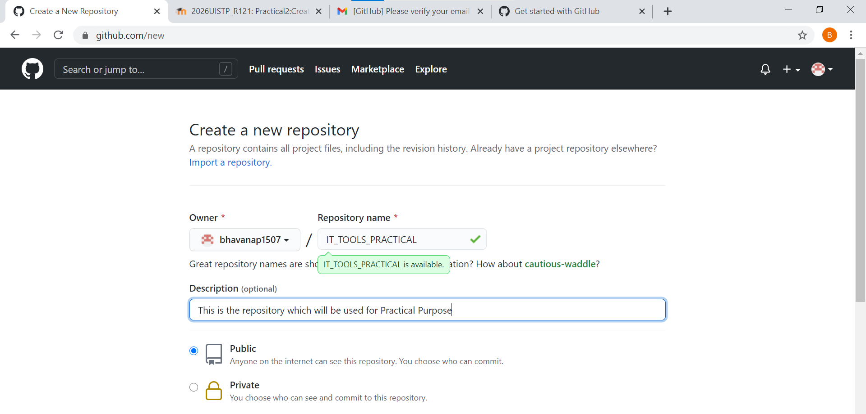

**Step3:**

Click on ***Create Repository*** after filling on all the necessary details

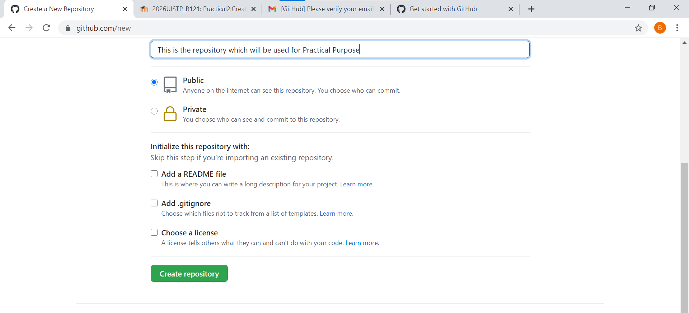

**3.Cloning a Repository:**

**Step1:**

Create a Folder on your computer where you want to clone the repository

I created a ***GitHub*** Folder on my Desktop

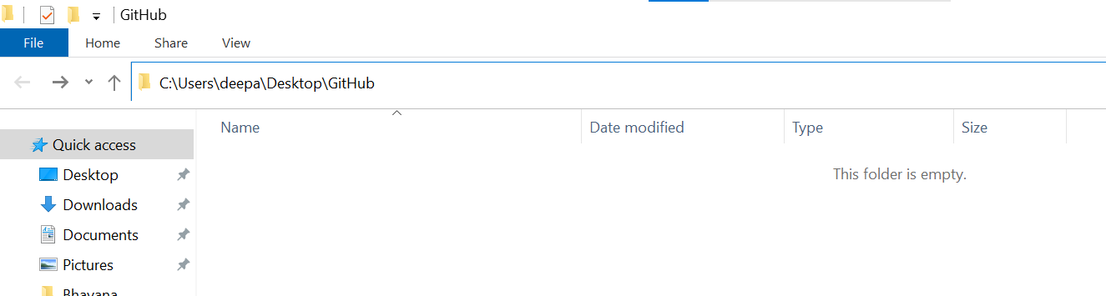

**Step2:**

We will clone the repository ***IT_TOOLS_PRACTICAL*** which we created above.

First, We will go to the repository on the Github account which we want to clone.

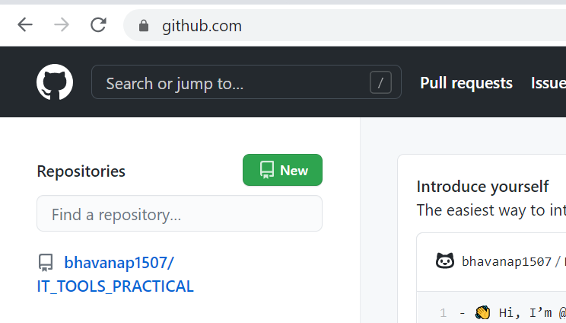

Step3:

Drop down the ***Code*** button and Copy the link under ***HTTPS*** Section

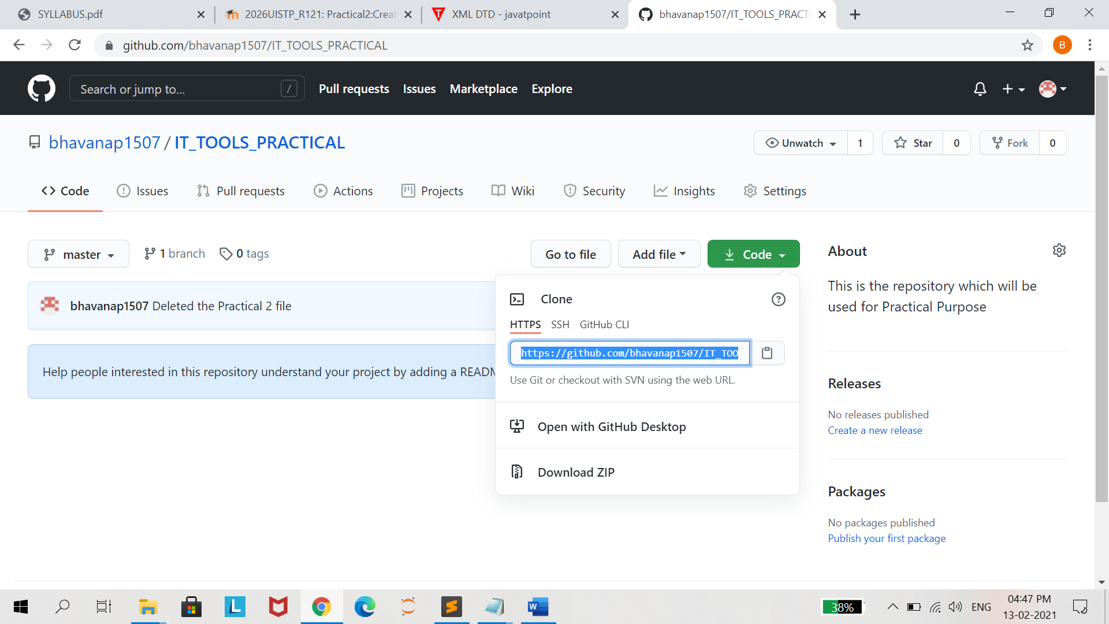

**Step 4:**

Open ***Command Prompt*** and go to the Path where you want to clone the Repository.

Command: **git clone <HTTPS_PATH_OF_THE_REPOSITORY>**

Execute this command

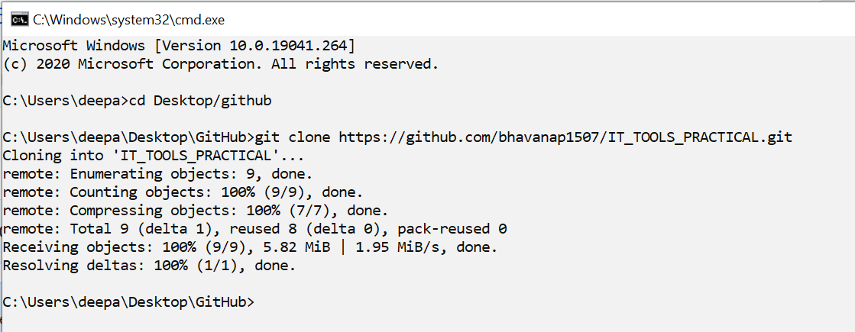

Now you can see that the Repository has been cloned to your computer

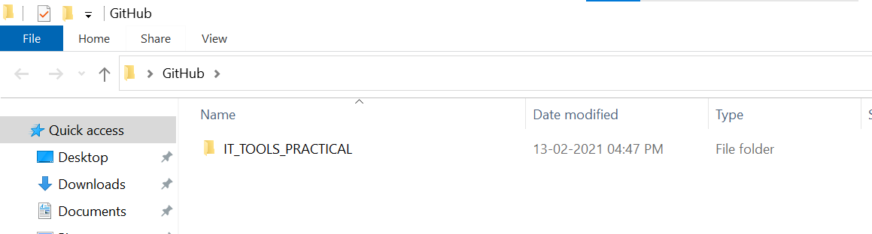

**Step5:**

Now, you can do the changes in the local repository.

For e.g: We are adding a ***Practical_1_Wikipedia.docx*** in the local repository

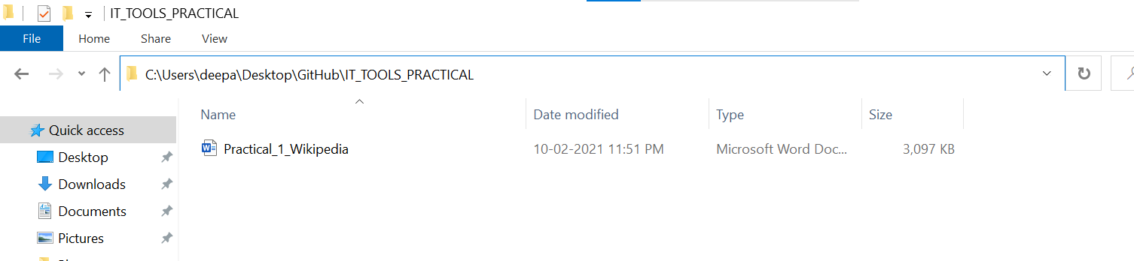

**Step6:**

Check the Status of the local Repository

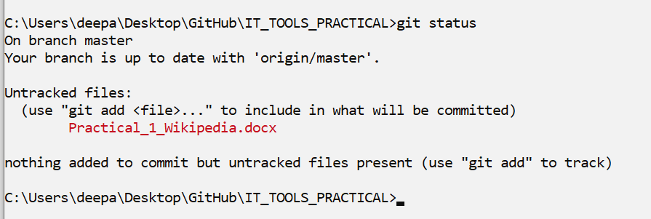

Now we will try to add the newly made changes in the Staging area before pushing the final changes to the Github repository

Adding changes to Staging Area

Command: **git add <FILE_NAME_SHOWN_IN_GIT_STATUS>**

Execute this command

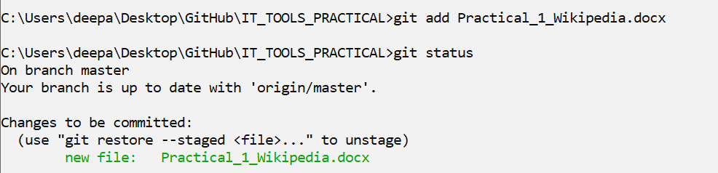

Committing the changes

Command: **git commit -m “Meaningful Message relevant to changes”**

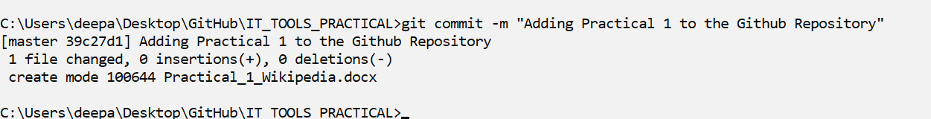

This is the final stage, Pushing the changes to the GitHub Repository

Command: **git push**

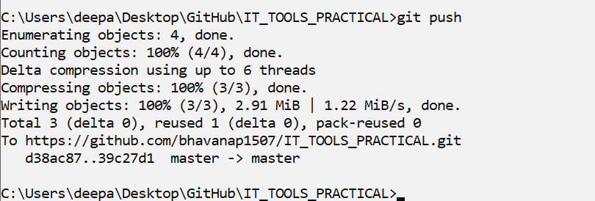

Now we can see that the changes have been reflected in the GitHub Repository.

