**Question : Assertions in Junit:**

**Codes:**

**Main code:**

package example;  
  
public class Calc {  
  
 public int add(int num1, int num2)  
 {  
 return num1+num2;  
 }  
 public int sub(int num1, int num2)  
 {  
 return num1-num2;  
 }  
}

**Testing Code:**

package SampleTest;  
  
import example.Calc;  
import org.junit.jupiter.api.Assertions;  
import org.junit.jupiter.api.Test;  
  
  
public class CalcTest {  
  
  
  
@Test  
 void myTest(){  
 Calc cal = new Calc();  
  
 Assertions.*assertEquals*(5, cal.add(2,3));  
 Assertions.*assertEquals*(1, cal.sub(2,2));  
 }  
}

**Outputs:**

1.When test cases and parameters are satisfied:

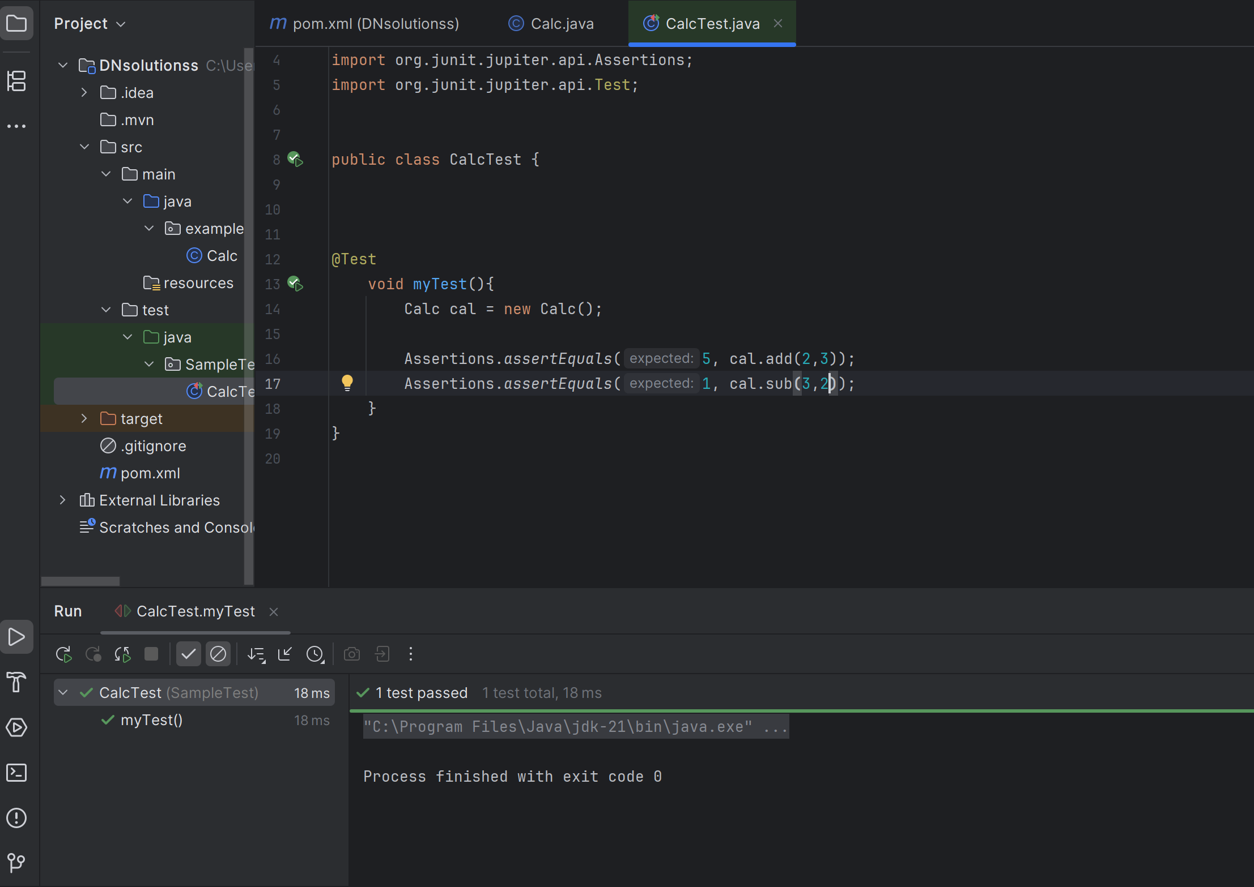

2.when test cases are not satisfied:

