**Question : Exercise 1: Configuring a Basic Spring Application**

**Steps:**

**1.**

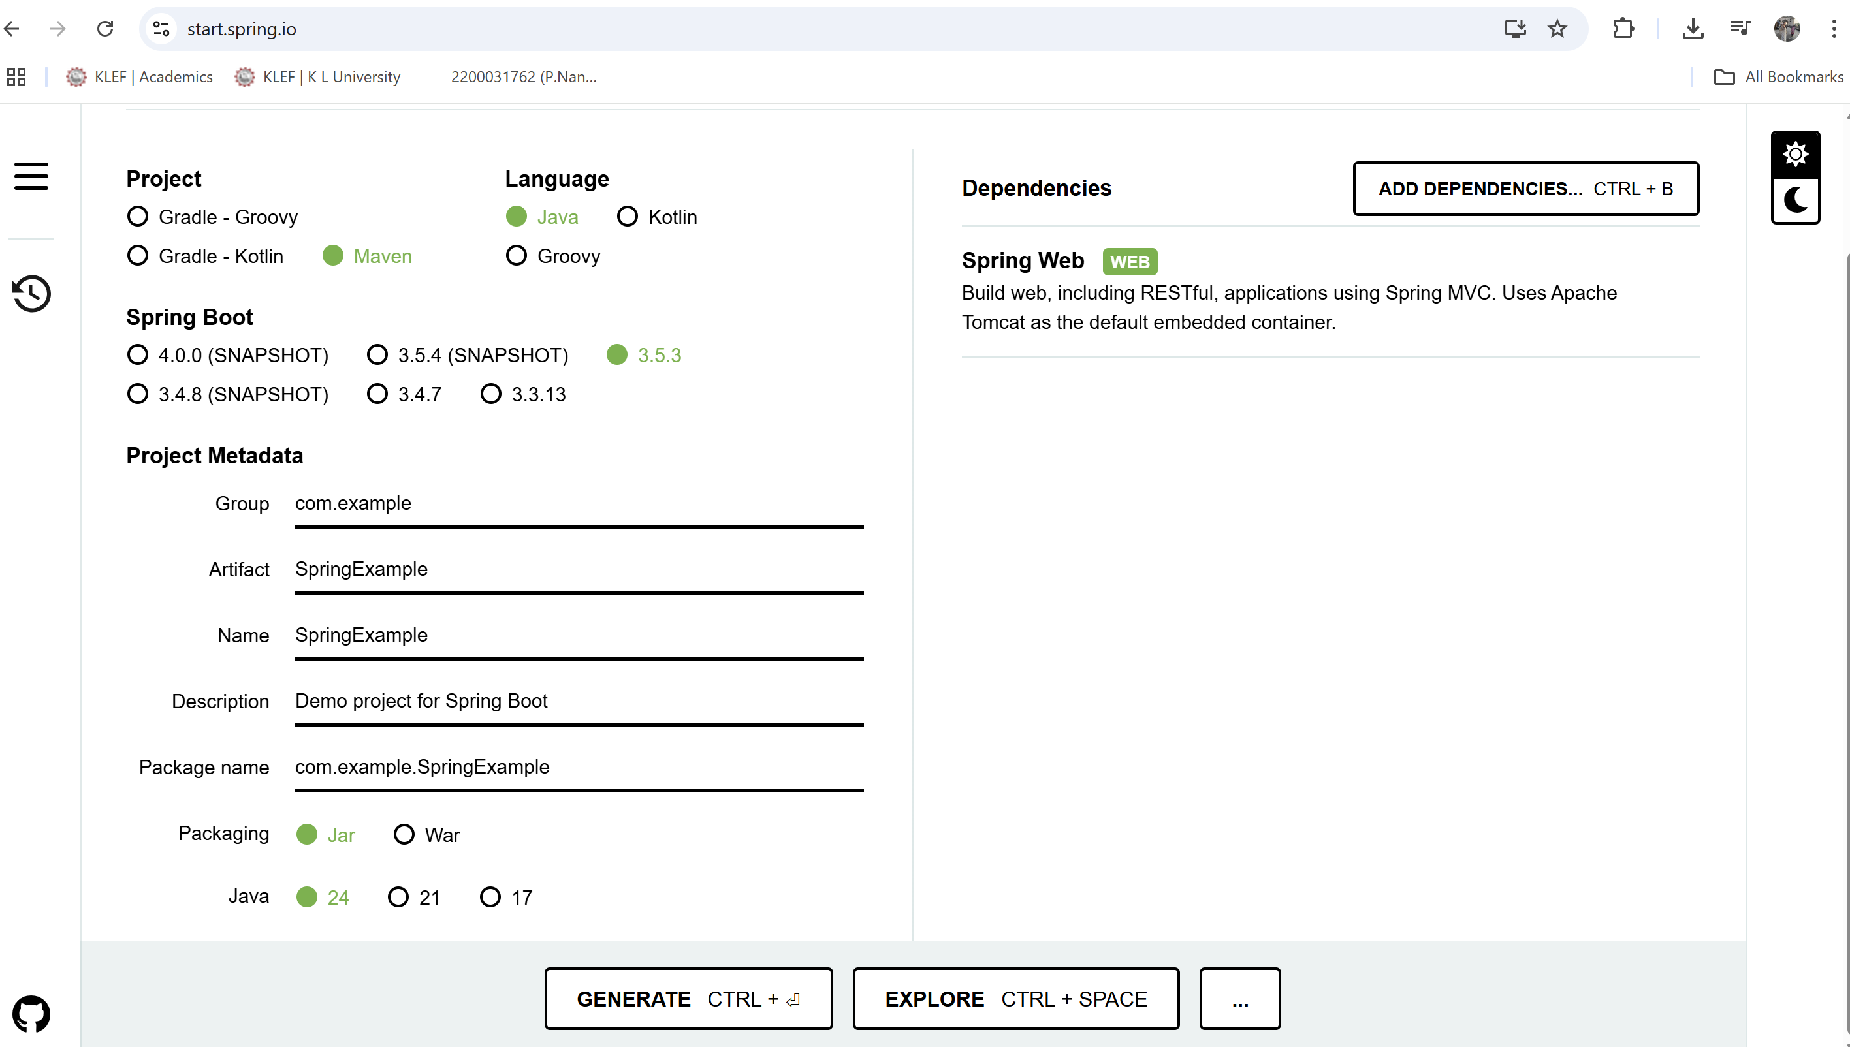

**2**.generate and then it will download

**3**. extract the zip folder

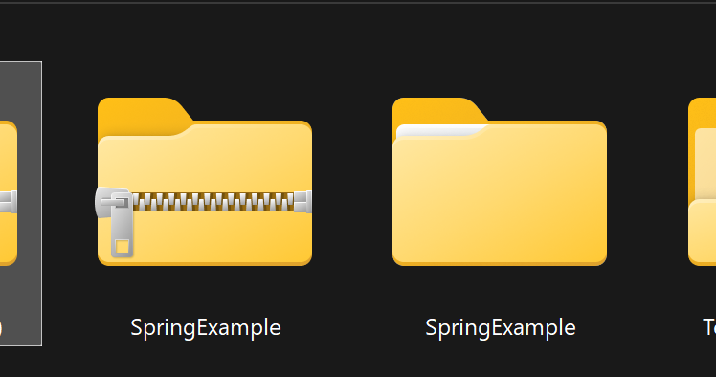

**4**.open in ide

**Code:**

package com.example.SpringExample;  
  
import org.springframework.boot.SpringApplication;  
import org.springframework.boot.autoconfigure.SpringBootApplication;  
  
@SpringBootApplication  
public class SpringExampleApplication {  
  
 public static void main(String[] args) {  
 SpringApplication.*run*(SpringExampleApplication.class, args);  
 }  
  
}

**Output:**

