**Question: Creating and Configuring a Maven Project**

**Step 1 :**

Go to file> then click new>then click project

**Step 2:**

Name the project>select maven and the create

**Step 3:** it will be created without any dependencies

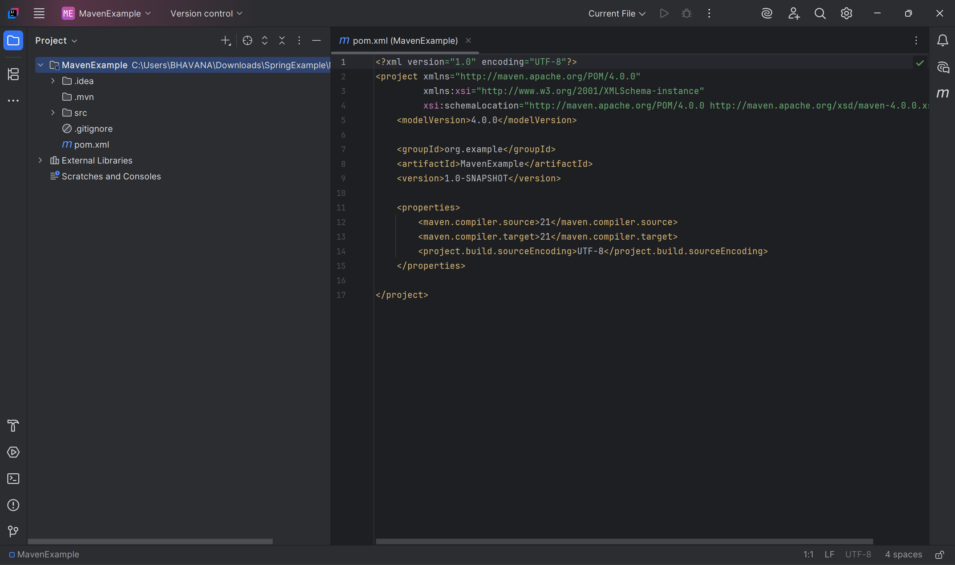

We can now configure and make any type of changes in the project

We added some dependencies

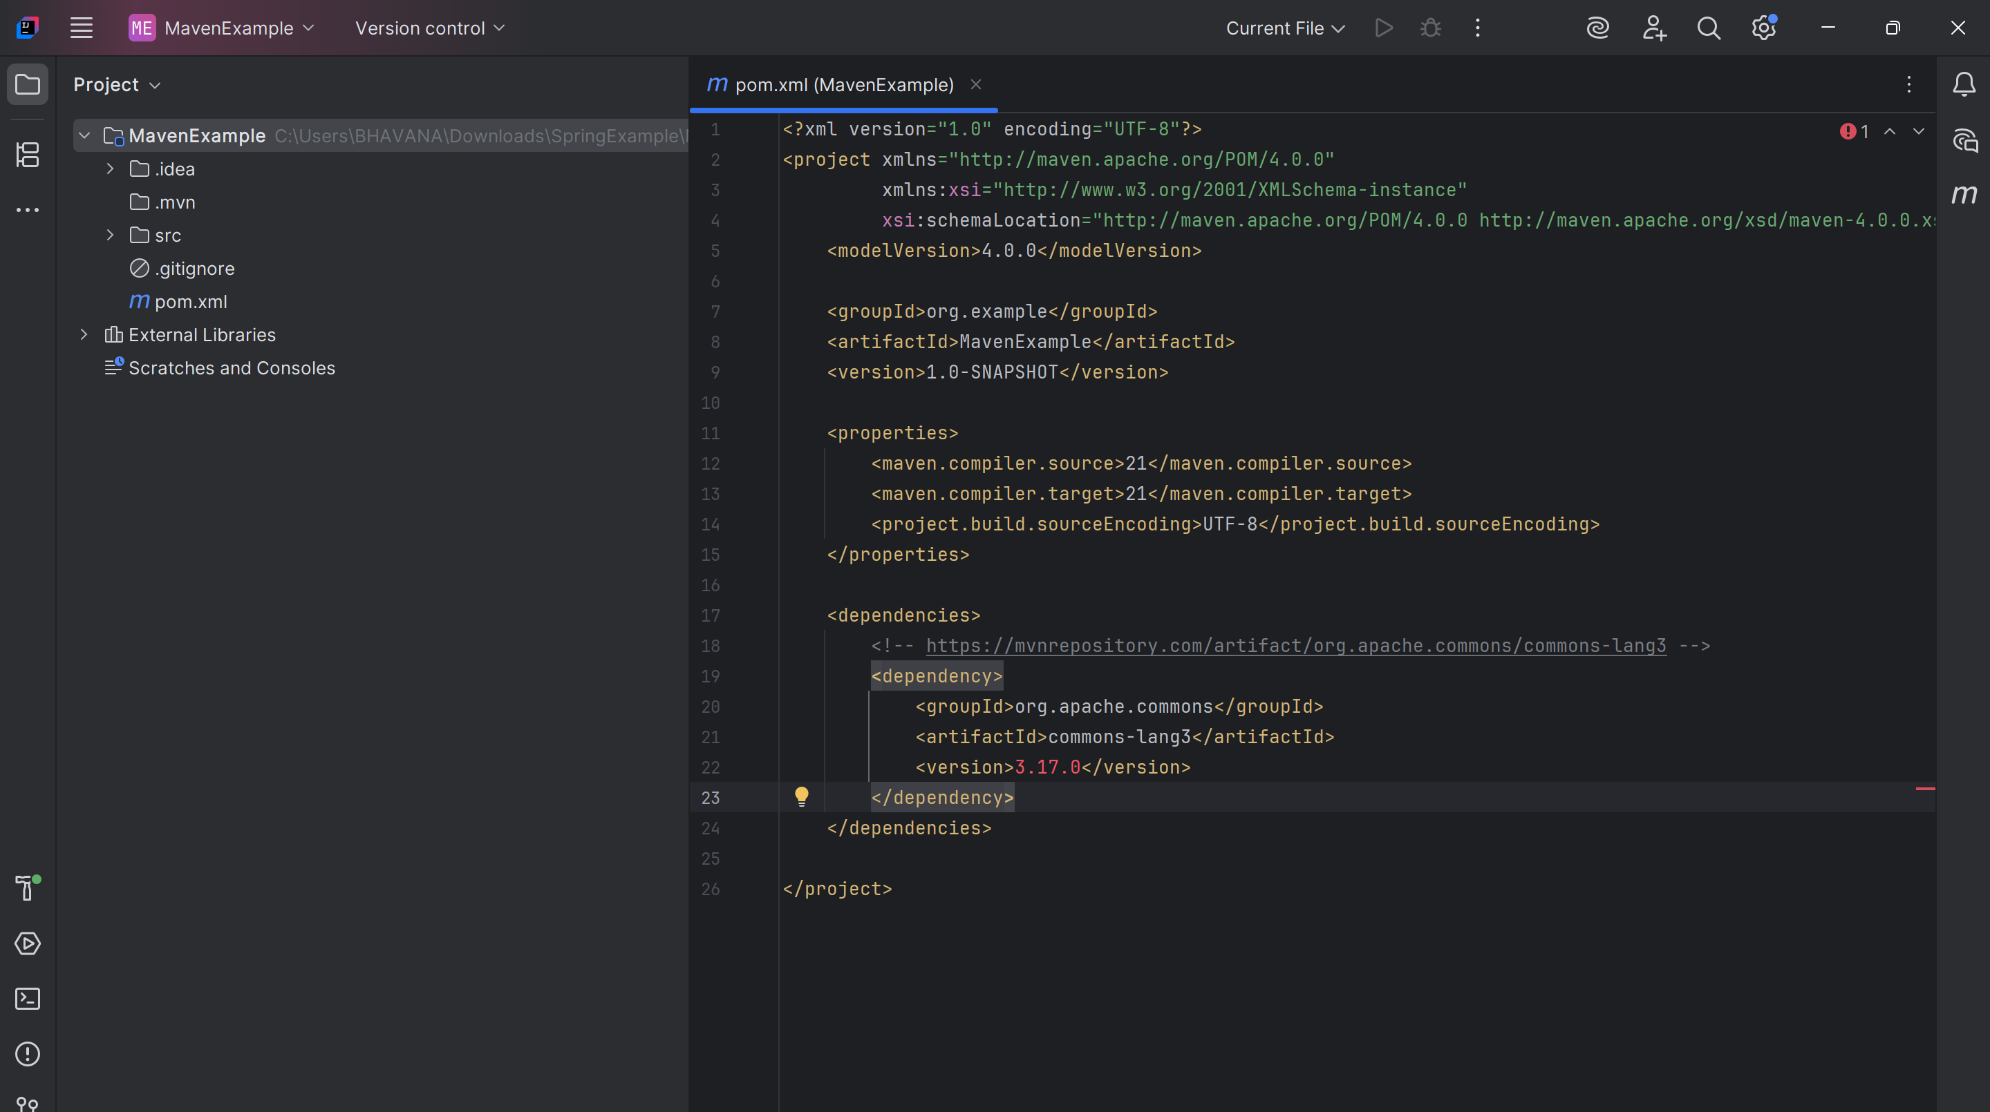

Now based on dependency we wrote a code whether string is empty or not

**Code:**

package mvnexm;  
import org.apache.commons.lang3.StringUtils;  
public class mvncls {  
 public static void main(String[] args){  
 String testString = "abc";  
 if(StringUtils.*isEmpty*(testString)){  
 System.*out*.println("The string is empty");  
 }else{  
 System.*out*.println("The string is not empty");  
  
 }  
 }  
}

**output:**

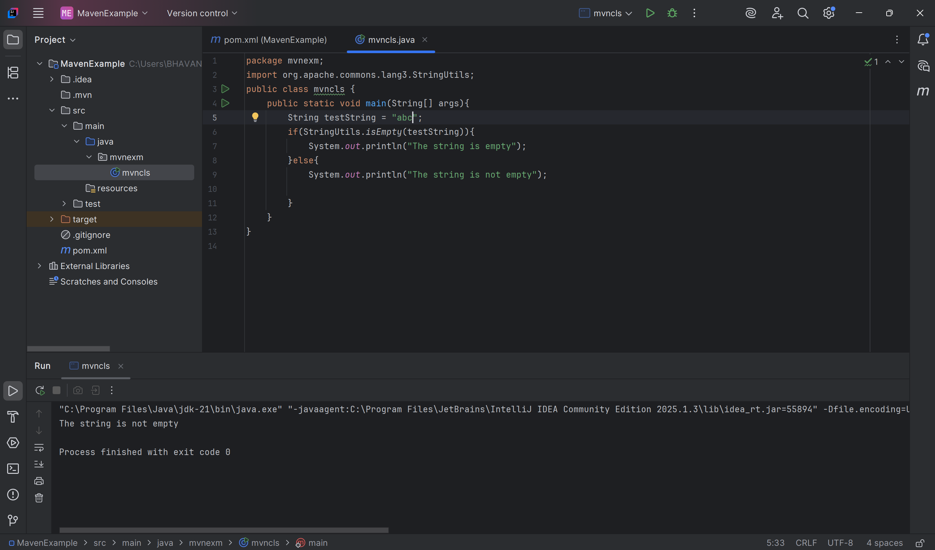

**Code:**

package mvnexm;  
import org.apache.commons.lang3.StringUtils;  
public class mvncls {  
 public static void main(String[] args){  
 String testString = "";  
 if(StringUtils.*isEmpty*(testString)){  
 System.*out*.println("The string is empty");  
 }else{  
 System.*out*.println("The string is not empty");  
  
 }  
 }  
}

**Output:**

