**Question: Spring Data JPA - Quick Example**

**Step 1**

Go to spring initialzr > give project name >add dependencies etc

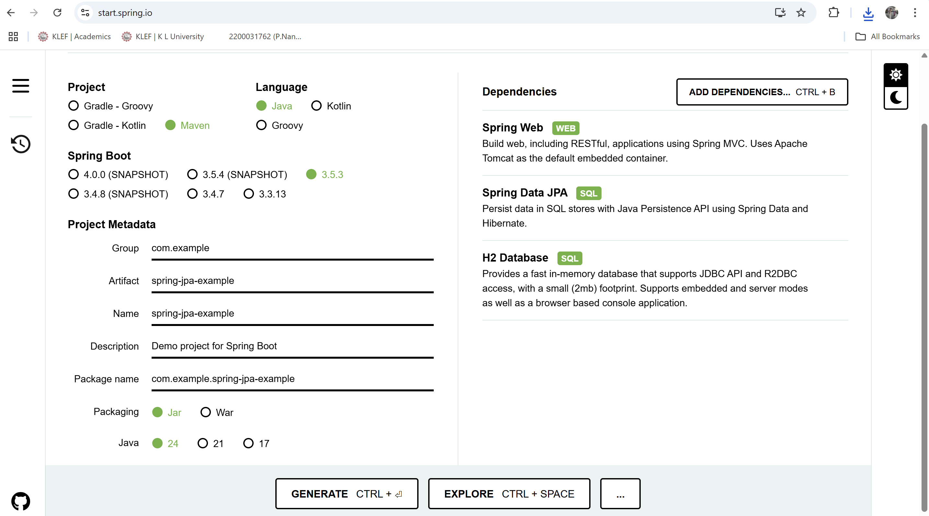

**Step 2 :**

Exract the downloaded zip file

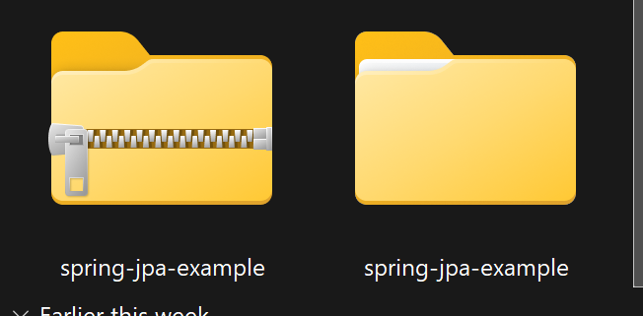

**Step 3 :**

We have to create multiple java classes like a 2 or 3 then add the codes and we will get the ouput

**Code:**

**Product repository**

package com.example.springjpaexample;  
  
import org.springframework.data.jpa.repository.JpaRepository;  
import org.springframework.stereotype.Repository;  
  
@Repository  
public interface ProductRepository extends JpaRepository<product, Long> {  
  
}

**data initializer**

package com.example.springjpaexample; // Ensure package matches your project's base package  
  
import org.springframework.boot.CommandLineRunner;  
import org.springframework.stereotype.Component;  
  
import java.util.Arrays;  
  
@Component // Marks this as a Spring component  
public class DataInitializer implements CommandLineRunner {  
  
 private final ProductRepository productRepository; // Inject ProductRepository  
  
 // Constructor-based injection  
 public DataInitializer(ProductRepository productRepository) {  
 this.productRepository = productRepository;  
 }  
  
 @Override  
 public void run(String... args) throws Exception {  
 // This method runs after the Spring application context is loaded  
  
 System.*out*.println("--- Initializing Products ---");  
  
 // Create some products  
 product p1 = new product("Smartphone", 899.99);  
 product p2 = new product("Wireless Earbuds", 149.00);  
 product p3 = new product("Smartwatch", 299.50);  
  
 // Save products to the database using the repository  
 productRepository.saveAll(Arrays.*asList*(p1, p2, p3));  
  
 System.*out*.println("Saved products:");  
 // Retrieve all products and print them to the console  
 productRepository.findAll().forEach(System.*out*::println);  
  
 // Example: Find a product by ID  
 productRepository.findById(1L).ifPresent(product ->  
 System.*out*.println("Found product with ID 1: " + product.getName())  
 );  
  
 System.*out*.println("--- Product Initialization Complete ---");  
 }  
}

**spring application**

package com.example.spring_jpa_example;  
  
import org.springframework.boot.SpringApplication;  
import org.springframework.boot.autoconfigure.SpringBootApplication;  
  
import java.util.Arrays;  
  
@SpringBootApplication  
public class SpringJpaExampleApplication {  
  
 public static void Main() {  
 *Main*(null);  
 }  
  
 public static void Main(String[] args) {  
 SpringApplication.*run*(SpringJpaExampleApplication.class, Arrays.*toString*(args));  
 }  
}

**output**

