Question: Installing Git : Download and Installation Steps, Configuring Basic Settings

Steps:

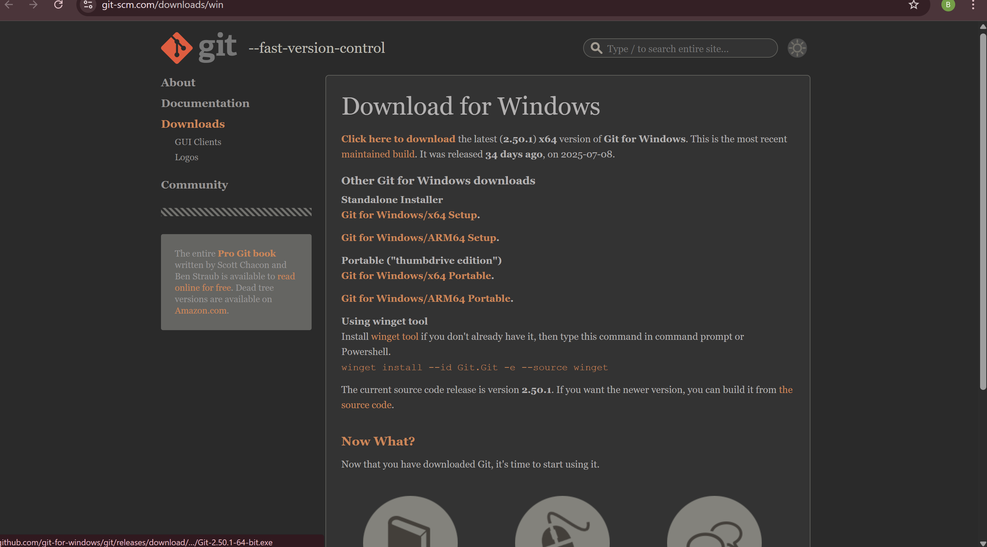

Install 64 bit for windows

Configuring:

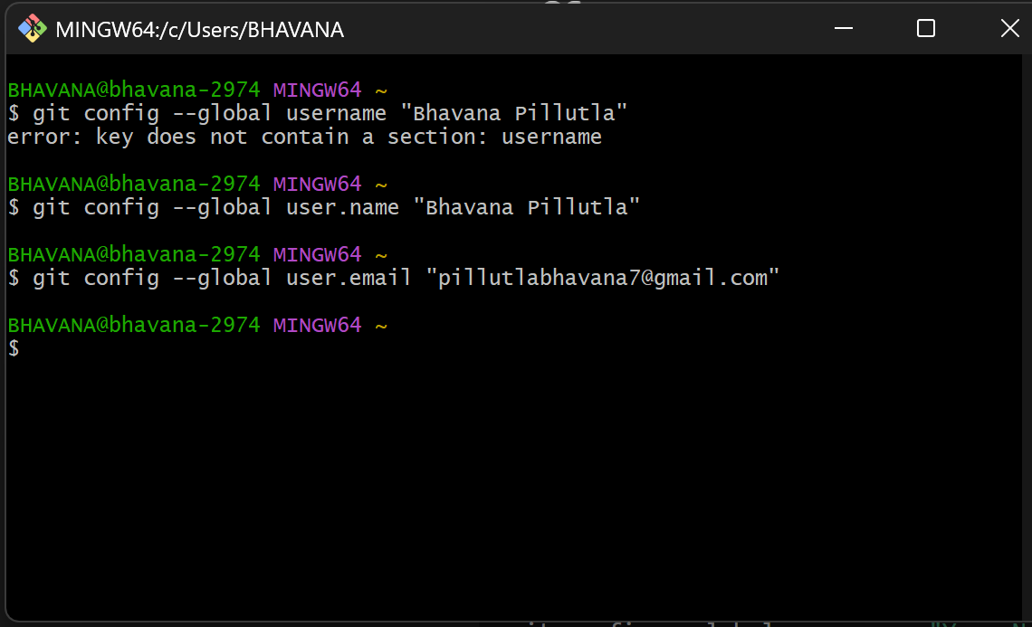

Setting global name and email..

2.Checking:

