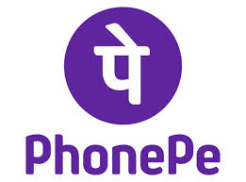

Product Dissection for PhonePe

Company Overview:

PhonePe, founded in 2015 by Sameer Nigam, Rahul Chari and Burzin Engineer, is an Indian digital payments and financial services company based out of Bangalore, India. It is based on the Unified Payments Interface. Offers a wide range of services for the common people as well as for businesses enhancing their payment experiences. They also have additional features which will help people handle their finances by helping them in investing, paying for services. etc. PhonePe was acquired by Flipkart in 2016 and is India's one of the fastest-growing fintech companies. It has crossed the 250 million registered users mark in 2020, the market-leading share of over 40% in UPI transactions.

Product Dissection and Real-World Problems Solved by PhonePe:

PhonePe is a significant digital payments and financial technology company based in India, facilitating a wide range of online transactions. It provides a comprehensive suite of features. Users can utilize UPI for swift interbank transfers, employ the digital wallet for expedited payments, and manage various bill payments, including those for utilities, mobile phone services, and DTH. It offers financial services, encompassing investment options such as mutual funds, insurance, and like more. PhonePe Switch allows users to access other applications, such as Ola and BookMyShow, from within the its interface.

PhonePe has substantial growth potential. Opportunities exist to expand its reach into underserved markets, including rural areas and the unbanked population, to introduce new financial products, such as lending and credit facilities, and to deepen its integration with e-commerce platforms. It possesses several key strengths, including a substantial user base throughout India, a diverse portfolio of services, a user-friendly interface, and robust partnerships with banks, merchants, and service providers. It encounters strong competition from entities like Google Pay and Paytm, maintains a dependence on the UPI infrastructure, which can be susceptible to disruptions, and, like all digital platforms, must address security concerns and the risk of fraud.

PhonePe solved real problems of rural transactions easily. Its primary target demographic comprises Indian users with bank accounts and smartphone access, seeking digital payment solutions. This demographic is characterized by its diversity, encompassing a wide range of income levels and technological literacy.

PhonePe's revenue is generated through several avenues. The company charges transaction fees for specific activities, collecting commissions from bill payments, recharges, and merchant transactions, earns revenue from advertising by promoting other applications and services on its platform, and derives commissions and fees from the sale of financial products. This multi-faceted revenue model is characterized by its diversification, reducing reliance on any single income stream.

It has diversified revenue approach enables to address several real-world problems in India's rapidly evolving digital landscape. Firstly, by charging small fees on a variety of transactions, PhonePe makes digital payments more sustainable and accessible for a large user base, including merchants and individuals who may have been hesitant to adopt such technologies due to cost concerns. This encourages greater participation in the digital economy, driving financial inclusion and reducing the reliance on cash transactions, which can be inefficient and pose security risks.

In conclusion, PhonePe's strategic focus on addressing real-world challenges through a diversified revenue model and user-centric approach has established it as a key player in India's digital transformation, driving financial inclusion and economic growth.

Case Study: Real-World Problems and PhonePe's Innovative Solutions

Digital payment platforms like PhonePe have emerged as a transformative force in India, addressing these challenges by leveraging technology to provide innovative and accessible financial solutions.

Problem 1: Lack of access to formal banking services in rural areas.

Real-World Challenge: A significant portion of India's population, particularly in rural areas, has historically lacked access to traditional banking infrastructure. This includes limited or no access to bank branches, ATMs, and other financial institutions.

PhonePe's Solution:
UPI-based transactions on mobile phones, enabling people without traditional bank branches nearby to send and receive money. This solution leverages the widespread mobile phone penetration in India, even in areas with limited infrastructure, and empowers individuals to manage their finances digitally, reducing their dependence on physical cash and the need to travel long distances to access banking facilities.

Problem 2: Inefficiency and security risks of cash transactions.
Real-World Challenge: Cash transactions in India are often cumbersome, requiring physical exchange and posing risks like theft or loss. They also lack traceability, making it difficult to track financial flows and increasing the potential for fraud and black money transactions.

PhonePe's Solution:
Digital wallet and QR code payments for secure and convenient transactions at local stores and businesses. By promoting digital wallets and QR codes, PhonePe offers a more secure and efficient alternative to cash. This reduces the risk of theft and loss associated with carrying cash, streamlines the payment process for both consumers and merchants, and improves transparency in financial transactions.

Problem 3: Difficulty in paying bills and making recharges.

Real-World Challenge: Paying bills for utilities, mobile services, and other regular expenses in India often involves visiting multiple physical locations, standing in long queues, or dealing with inconvenient payment timings. This process is time-consuming, inefficient, and can lead to delays or missed payments.

PhonePe's Solution:
Integrated bill payment and recharge features within the app, streamlining these processes and making them more convenient. PhonePe's platform consolidates various bill payment and recharge options, eliminating the need for users to visit multiple platforms or stand in long queues. This saves time and effort, simplifies recurring payments, and reduces the risk of missed deadlines or errors.

Problem 4: Limited access to financial products and services.
Real-World Challenge: Many individuals in India, particularly in lower-income groups and in rural areas, have limited access to formal financial products like insurance, mutual funds, and other investment options. This lack of access hinders their ability to grow their wealth, manage financial risks, and achieve long-term financial security.

PhonePe's Solution:
Offering a range of financial products like mutual funds and insurance within the app, increasing accessibility for a broader population. PhonePe democratizes access to financial products by integrating them into a user-friendly mobile app. This allows individuals, regardless of their location or income level, to invest in mutual funds, purchase insurance policies, and access other financial tools that were previously only available to a privileged few. This promotes financial literacy and empowers individuals to take control of their financial well-being.

Conclusion:
In conclusion, PhonePe's strategic focus on addressing real-world challenges through a diversified revenue model and user-centric approach has established it as a key player in India's digital transformation, driving financial inclusion and economic growth.

Top Features of PhonePe:

- UPI-Enabled Transactions: PhonePe leverages the Unified Payments Interface (UPI) to facilitate instant bank-to-bank transfers. This enables users to send and receive money directly from their bank accounts using just their smartphones, making transactions fast, secure, and convenient.

- Digital Wallet: It provides a comprehensive platform for managing various bill payments, including utilities, mobile recharges, and DTH services. This feature simplifies the process of paying recurring bills, saving users time and effort.

- Financial Services: Offers a wide range of financial products, including mutual funds and insurance. This allows users to invest and manage their finances directly through the app, making financial planning more accessible to a broader audience.

- PhonePe Switch: Unique feature that allows users to access and use other apps like Ola, BookMyShow, and many more, directly within the PhonePe interface. This provides a convenient way to access multiple services without having to switch between different apps.

Schema Description:

Here's a breakdown of the entities, attributes, and primary keys from the PhonePe schema design:

Entities and Attributes:
- Users:
- user_id (primary key): A unique identifier for each user.
- name: The full name of the user.
- phone_number: The user's mobile phone number (should be unique).
- email: The user's email address.
- address: The user's residential address.
- registration_date: The date when the user registered on PhonePe.

- Banks:
- bank_id (primary key): A unique identifier for each bank.
- bank_name: The name of the bank.

- UserAccounts:
- account_id (primary key): A unique identifier for each user account.
- user_id (foreign key): The ID of the user who owns this account.
- bank_id (foreign key): The ID of the bank where this account is held.
- account_number: The user's account number at the bank (should be unique within the bank).
- account_type: The type of account (e.g., savings, current).

- Transactions:
- transaction_id (primary key): A unique identifier for each transaction.
- from_account_id (foreign key): The ID of the account from which the transaction originated.
- to_account_id (foreign key): The ID of the account to which the transaction was directed.
- transaction_type: The type of transaction (e.g., payment, transfer, recharge)
- amount: The amount of the transaction.
- transaction_date: The date and time when the transaction occurred.
- status: The status of the transaction (e.g., pending, successful, failed).

- Wallet:
- wallet_id (primary key): A unique identifier for each user's wallet.
- user_id (foreign key): The ID of the user who owns this wallet.
- balance: The current balance in the user's wallet.

- Bills:
- bill_id (primary key): A unique identifier for each bill.
- user_id (foreign key): The ID of the user to whom the bill is addressed.
- bill_type: The type of bill
- amount: The amount of the bill.
- due_date: The date by which the bill must be paid.
- payment_status: The current payment status of the bill

- Recharges:
- recharge_id (primary key): A unique identifier for each recharge.
- user_id (foreign key): The ID of the user who initiated the recharge
- service_provider: The provider of the service being recharged.
- amount: The amount of the recharge.
- recharge_date: The date and time when the recharge was performed.

- FinancialProducts:
- product_id (primary key): A unique identifier for each financial product.
- product_type: The type of financial product.
- product_name: The name of the financial product.
- description: A description of the financial product.

- UserInvestments:
- investment_id (primary key): A unique identifier for each investment made by a user.
- user_id (foreign key): The ID of the user who made the investment
- product_id (foreign key): The ID of the financial product invested in
- investment_amount: The amount invested.
- investment_date: The date when the investment was made.

- PhonePeSwitchApps:
- app_id (primary key): A unique identifier for each app on PhonePe Switch.
- app_name: The name of the app.
- app_category: The category of the app.

- UPI_Transactions:
- upi_transaction_id (primary key): Unique identifier for UPI transactions
- transaction_id (foreign key): The transaction id of the transaction
- upi_id: UPI id for the transaction

Relationships are:

User - UserAccounts:
- A User can have multiple UserAccounts (one-to-many relationship).
- Each UserAccount belongs to one User.

UserAccounts - Banks:
- Each UserAccount belongs to one Bank (one-to-one relationship).
- A Bank can be associated with multiple UserAccounts.

UserAccounts - Transactions:
- A UserAccount can be involved in multiple Transactions as either the sender or receiver (one-to-many relationship in both directions).
- Each Transaction involves two UserAccounts (sender and receiver).

User - Wallet:
- A User has one Wallet (one-to-one relationship).

User - Bills:
- A User can have multiple Bills (one-to-many relationship).

User - Recharges:
- A User can have multiple Recharges (one-to-many relationship).

User - UserInvestments:
- A User can make multiple UserInvestments (one-to-many relationship).

FinancialProducts - UserInvestments:
- A FinancialProduct can be associated with multiple UserInvestments (one-to-many relationship).

Transactions - UPI_Transactions:
- A Transaction can be a UPI_Transaction (one-to-one relationship).

ER Diagram:

Let's construct an ER diagram that vividly portrays the relationships and attributes of the entities within the Phonepe schema. This ER diagram will serve as a visual representation, shedding light on the pivotal components of PhonePe data model. By employing this diagram, we will gain a clearer grasp of the intricate interactions and connections that define the platform's dynamics.

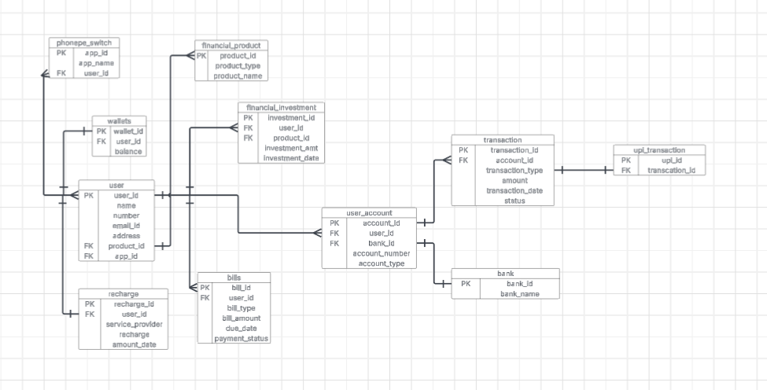

Conclusion

This detailed exploration of PhonePe's ER diagram underscores the critical role of a well-structured database design in supporting a complex digital payments ecosystem. By clearly defining entities, their attributes, primary keys, and the cardinalities of their relationships—including the crucial many-to-many link between Users and PhonePe Switch Apps—this schema provides the foundational blueprint. Such a robust design is essential for ensuring data integrity, enabling efficient transaction processing, facilitating the seamless integration of diverse financial services, and allowing for the future scalability and expansion of PhonePe's offerings. It highlights how a meticulously planned ER diagram is not just a technical artifact, but a strategic asset that underpins the reliability, security, and innovative capabilities of a leading fintech platform.

