|  |
| --- |
| IFMR RURAL FINANCE |
| SCREENING |
|  |
| **IFMR Rural Finance**  **10/11/2016** |
|  |

|  |
| --- |
|  |

Contents

1. Process 3

1.1 Process flowchart 3

1.2 Process Steps 4

2. Stage definition 4

3. Stage-role access 4

4. Screening Queue 5

4.1 UI specification 5

4.2 Screenshot 5

5. Functional requirements 6

5.1 Upload 6

5.2 Download 6

5.3 Reports 6

6. Capturing Screening data 7

6.1 UI requirements 7

6.2 Screenshots 34

6.3 Functional requirements 52

6.4 Uploads 52

6.5 Downloads 52

6.6 Reports 52

7. Risk Score 1 53

7.1 UI specification 53

7.2 Screenshot 53

7.3 Functional requirements 54

7.4 Upload 58

7.5 Download 58

7.6 Reports 58

# Process

# Process flowchart



# Process Steps

1. Loan officer logs in and is able to view all profiles that completed lead generation stage
2. LO can search profiles based on the following criteria
   * + Screening date
     + Applicant Name
     + Business Name
     + Customer ID
     + Area
     + City /Village/Town
     + Pincode
3. All search parameters will have a sort/arrange facility
4. LO will click on the desired profile to select the customer. Lead data of that customer will be auto-populated and screening fields will be displayed.
5. LO will enter details to capture screening data.
6. On clicking ‘**submit’** the system will run a de-dupe check. If it is found to be a duplicate, an error message will be displayed and will remain on the data capture screen.
7. If it is not a duplicate, the system will send details for CB check
8. After CB check, system will compute Risk Score 1 (Screening Score)
9. If CB score and Risk Score 1 fulfil the auto-approval criteria, the profile is directly sent to the application stage, and will be displayed in the pending for application queue.
10. If CB score or Risk Score 1 or both do not fulfil the auto-approval criteria, the profile is sent to the screening review stage, and will be displayed in the pending for screening review queue.

# Stage definition

|  |  |
| --- | --- |
| **Stage** | **Description** |
| Screening Queue | The Loan Officer Selects a profile from the Screening Queue |
| Capture Details | The Loan Officer captures data and sends the same for auto approval. |
| Risk Score 1 | System will tabulate risk score 1 based on data collect at screening |

# Stage-role access

|  |  |
| --- | --- |
| **Stage** | **Applicable Role** |
| Screening Queue | Loan Officer |
| Capture Screening Details | Loan officer |
| Risk Score 1 | -NA- |

# Screening Queue

## UI specification

|  |  |  |  |  |
| --- | --- | --- | --- | --- |
| **Field name** | **Section** | **Data Type** | **Attribute** | **Population logic** |
| Screening Date | Screening Queue | date | Sort/Search | From Lead Generation Stage |
| Applicant Name | Screening Queue | Text | Sort/search | From ‘Lead name’ of lead generation stage |
| Business Name | Screening Queue | Alphanumeric | Sort/search | From Lead Generation Stage |
| Customer ID | Screening Queue | Alphanumeric | Sort/search | From System database |
| Area | Screening Queue | Text | Sort/search | From Lead Generation Stage |
| City/Village/Town | Screening Queue | Text | Sort/search | From Lead Generation Stage |
| Pincode | Screening Queue | Numeric |  | From Lead Generation Stage |

## Screenshot

1. Search Page

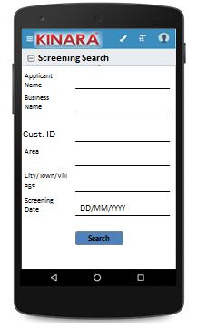

1. Screening Queue

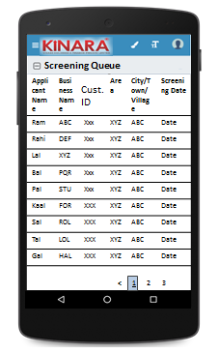

# Functional requirements

**Loan Officer** logs in

* The loan officer opens the process dash board, and enters the Screening queue.
* If the loan officer performs a search without selecting any parameter, then all cases with status ‘Pending for Screening’ to be displayed in a tabular format
* Also display all the cases which have been assigned to loan officer from existing customer.
* If the loan officer searches with ‘Applicant name’, ‘Business name’ or ‘URN no’, then all matching records (including existing customers) to be displayed in a tabular format
* The loan officer can **search and sort** the profiles based on the following parameters: Screening date, Customer ID, Applicant Name, Business Name, Area, City/Village/Town.
* The loan officer then selects a profile from the Screening queue. The queue table should have applicant name, business name, Customer ID, Area, City/Town/Village and Screening Date as column names.
* All the columns will have **sorting** facility.

## Upload

-NA-

## Download

-NA-

## Reports

# Capturing Screening data

## UI requirements

|  |  |  |  |  |  |  |  |
| --- | --- | --- | --- | --- | --- | --- | --- |
| **Entity** | **Tab** | **Sub tab** | **Fields** | **Field Value** | **Mandatory** | **Conditional Mandatory** | **Remarks** |
| APPLICANT | Applicant Profile | KYC Details | Aadhar No | Numeric | Yes |  | Aadhar -QR Code Scan (Auto fill Profile & Address data) |
| Document Capture | Upload | Yes |  |  |
| Pan Number | Alpha numeric | Yes |  |  |
| Document Capture | Upload | Yes |  |  |
| ID Type | Dropdown |  |  | Ration Card, Voter Card, Passport, Pan Card, Aadhar card, Driving License |
| ID No | Alpha numeric |  | Yes | If ID type selected |
| Valid up to | Date |  | Yes | If ID type selected |
| Document Capture | Upload |  | Yes | If ID type selected |
| **Add Button** |  |  |  | ID type, ID No, Valid Up to, Document Capture populate again |
| Applicant Details | Title | Auto populated/  Text | Yes |  | Aadhar QR Code scanning |
| Name | Auto populated/ Text | Yes |  | Aadhar QR Code scanning |
| Gender | Auto populated/ Text | Yes |  | Aadhar QR Code scanning |
| Date Of birth | Auto populated/ Date | Yes |  | Aadhar QR Code scanning |
| Age | Auto populated |  |  |  |
| Father's Name | Auto populated/Text | yes |  | Aadhar QR Code scanning |
| Educational Level | Dropdown | Yes |  | Below SSLC, SSLC, HSC, Graduate/Diploma/ITI, Professional Degree, Others |
| Religion | Dropdown | Yes |  | Hindu, Muslim, Christian, Jain, Buddhist, Others |
| Mobile No | Numeric | Yes |  | from lead |
| Alternative Mobile No. | Numeric |  |  |  |
| WhatsApp Mobile No. | Radio Buttons and free text |  |  | Same as mobile no, same as alternative mobile no., other (enter as free text) |
| Email ID | Alphanumeric, special characters |  |  |  |
| Preferred language of communication | Dropdown | Yes |  | Hindi, English, Kannada, Malayalam, Gujarati, Marathi, Tamil, Bengali, Odia, Punjabi, Marwari |
| Mother’s Name | Text |  |  |  |
| Marital Status | Text | Yes |  | Married, Unmarried, Separated, Divorced, Widow(er) |
| Spouse Name | Text |  |  |  |
| Relationship with Business | Dropdown | Yes |  | Proprietor, Partner, Director, Others |
| Business Involvement | Dropdown | Yes |  | Full Time, Part Time, None |
| Have you ever been a proprietor or partner of any other company | Yes, No |  |  |  |
| If yes, did the business close? | Yes, No |  |  |  |
| Month/Year (of business closure) | Date |  |  | MM/YYYY |
| Address Details | Type Of Address | Dropdown | Yes |  | Permanent, Communication, As per Aadhar card |
| Care of | text |  |  |  |
| Building | Alphanumeric, special characters | yes |  |  |
| Street | Alphanumeric, special characters |  |  |  |
| Landmark | Alphanumeric, special characters |  |  |  |
| Locality | Alphanumeric, special characters |  |  |  |
| Pincode | Numeric | yes |  | Provide Pincode search master and populate – city/town, district,state and country |
| Village/Town/City | Text | yes |  | Auto-populated from Pincode master |
| District | Text | yes |  | Auto-populated from Pincode master |
| State | Text | yes |  | Auto-populated from Pincode master |
| Country | Text | yes |  | Auto-populated from Pincode master |
| APPLICANT | Location | GPS Co-ordinates |  |  |  |
| Is the Communication Address same as the Aadhar Card address? | Yes, No | Yes |  |  |
| Line 1 | Alpha numeric | Yes |  | Populate if communication address different from Aadhar card |
| Line 2 | Alpha numeric |  |  | Populate if communication address different from Aadhar card |
| Area | Alpha numeric |  |  | Populate if communication address different from Aadhar card |
| Land Mark | Alpha numeric | Yes |  | Populate if communication address different from Aadhar card |
| Pincode | Numeric | yes |  | Populate if communication address different from Aadhar card |
| State | Auto populated | Yes |  | Auto populated based on Pincode; Populate if communication address different from Aadhar card |
| District | Auto populated | Yes |  | Auto populated based on Pincode; Populate if communication address different from Aadhar card |
| City/Town/Village | Auto populated | Yes |  | Auto populated based on Pincode; Populate if communication address different from Aadhar card |
| Landline Number | Numeric |  |  |  |
| Ownership | Dropdown | Yes |  | Own, Rent, Lease |
| How many years are you living in present Area? | Dropdown | Yes |  | Less than 1 year, 1 to 3 years, 4 to 6 years, 6 to 10 years, greater than 10 years |
| How many years are you living in current Address? | Dropdown | Yes |  | Less than 1 year, 1 to 3 years, 4 to 6 years, 6 to 10 years, greater than 10 years |
| Is the Communication Address same as Permanent Address? | Radio Buttons | Yes |  | Yes/No- If no, populate same fields to capture permanent Address |
| Liabilities | - | Debt Source | dropdown |  |  | refer to screening dropdown sheet (required), If it is CC it should be auto populated from Bank statement |
|  | Creditor's Name | Alphanumeric |  |  |  |
|  | Loan Amount | Numeric |  |  |  |
|  | Loan Outstanding | Numeric |  |  |  |
|  | Loan term | Alphanumeric |  |  |  |
|  | Monthly Installment | Numeric |  |  |  |
|  | No. Of instalment Paid | Numeric |  |  |  |
|  | Purpose | dropdown |  |  | Machine Refinance, Asset Purchase, Debt Consolidation, Working Capital, Line Of Credit, Business Development |
|  | **Add Button** |  |  |  | In case there is more than one liability |
|  | Bank Statement Details | - | IFSC Code | Alphanumeric | Yes |  | Provide IFSC search master |
| Bank Name | Alphanumeric |  |  | Auto-populate from IFSC search master |
| Branch Name | Alphanumeric |  |  | Auto-populate from IFSC search master |
| A/C name | Alphanumeric | Yes |  |  |
| A/C type | Dropdown | Yes |  | Current, Saving, OD, CC |
| A/C no | Numeric | Yes |  |  |
| Banking since | Date |  |  | MM/YYYY |
| Net banking available | Radio Buttons | Yes |  | Yes/No |
| Sanctioned Amount | Numeric |  | Yes | (If A/C type is OD, CC) |
| Start Month | Date | Yes |  | MM/YYYY |
| Total Deposits | Numeric | Yes |  |  |
| Total Withdrawals | Numeric | Yes |  |  |
| Balance as on 15th | Numeric | Yes |  |  |
| Button to Add Bank details |  |  |  | On clicking Add button – display fields for start month, total deposits, total withdrawals and balance as on 15th |
| No of cheques bounced | Numeric | Yes |  |  |
| Bank Statement Photo | Photo Capture |  |  |  |
| **Button to add account** |  |  |  | In case applicant has more than one bank account |
| CO-APPLICANT | Co-Applicant Profile | KYC Details | Aadhar No | Numeric | Yes |  | Aadhar -QR Code Scan (Auto fill Profile & Address data) |
| Document Capture | Upload | Yes |  |  |
| Pan Number | Alpha numeric | Yes |  |  |
| Document Capture | Upload | Yes |  |  |
| ID Type | Dropdown |  |  | Ration Card, Voter Card, Passport, Pan Card, Aadhar card, Driving License |
| ID No | Alpha numeric |  | Yes | If ID type selected |
| Valid up to | Date |  | Yes | If ID type selected |
| Document Capture | Upload |  | Yes | If ID type selected |
| **Add Button** |  |  |  | In case more than one KYC details to be captured |
| Co-Applicant Details | Title | Text | Yes |  | Aadhar QR Code scanning |
| Name | Text | Yes |  | Aadhar QR Code scanning |
| Gender | Text | Yes |  | Aadhar QR Code scanning |
| Date Of birth | Date | Yes |  | Aadhar QR Code scanning |
| Age | Numeric |  |  | Auto-calculate from date of birth |
| Father's Name | Auto populated/ Text | Yes |  | Aadhar QR Code scanning |
| Educational Level | Dropdown | Yes |  | Below SSLC, SSLC, HSC, Graduate/Diploma/ITI, Professional Degree, Others |
| Religion | Dropdown | Yes |  | Hindu, Muslim, Jain, Christian, Buddhism, Others |
| Mobile No | Numeric | Yes |  | from lead |
| Alternative Mobile No. | Numeric |  |  |  |
| WhatsApp Mobile No. | Radio buttons and free text |  |  | Same as mobile no, same as alternate no, other (enter as free text) |
| Email ID | Alphanumeric, special characters |  |  |  |
| Preferred language of communication | Dropdown | Yes |  | Hindi, English, Kannada, Malayalam, Gujarati, Marathi, Tamil, Bengali, Odia, Punjabi, Marwari |
| Mother’s Name | Text |  |  |  |
| Marital Status | Text | Yes |  | Married, Unmarried, Separated, Divorced, Widow(er) |
| Spouse Name | Text |  |  |  |
| CO-APPLICANT | Relationship with Applicant | Text | Yes |  | To be populated for co-applicant & guarantor only |
| Co-Applicant Profile | Relationship with Business | Dropdown | Yes |  | Proprietor, Partner, Director, Others  (not to be populated for guarantor) |
| Business Involvement | Dropdown | Yes |  | Part Time, Full Time, None |
| Have you ever been a proprietor or partner of any other company | Radio Buttons |  |  | Yes/No |
| If yes, did the business close? | Radio Buttons |  |  | Yes/No |
| Month/Year (of business closure) | Date |  |  | MM/YYYY |
| Address Details | Type of Address | Dropdown | Yes |  | Permanent, Communication, As per Aadhar card |
| Care of | text |  |  |  |
| Building | Alphanumeric, special characters | Yes |  |  |
| Street | Alphanumeric, special characters |  |  |  |
| Landmark | Alphanumeric, special characters |  |  |  |
| Locality | Alphanumeric, special characters |  |  |  |
| Pincode | Numeric | Yes |  | Provide search option with pincode master |
| Village/Town/City | Text | Yes |  | Auto-populate from Pincode master |
| District | Text | Yes |  | Auto-populate from Pincode master |
| State | Text | Yes |  | Auto-populate from Pincode master |
| Country | Text | Yes |  | Auto-populate from Pincode master |
| Location | GPS Co-ordinates |  |  |  |
| Is the Communication Address same as the Aadhar Card address? | Radio Buttons | Yes |  | Yes/No |
| Line 1 | Alpha numeric | Yes |  | Populate if communication address different from Aadhar card |
| Line 2 | Alpha numeric |  |  | Populate if communication address different from Aadhar card |
| Area | Alpha numeric |  |  | Populate if communication address different from Aadhar card |
| Land Mark | Alpha numeric | Yes |  | Populate if communication address different from Aadhar card |
| Pincode | Numeric | Yes |  | Populate if communication address different from Aadhar card |
| State | Auto populated/text | Yes |  | Auto populated based on Pincode; Populate if communication address different from Aadhar card |
| District | Auto populated/text | Yes |  | Auto populated based on Pincode; Populate if communication address different from Aadhar card |
| City/Town/Village | Auto populated/text | Yes |  | Auto populated based on Pincode; Populate if communication address different from Aadhar card |
| Landline Number | Numeric |  |  |  |
| Ownership | Dropdown | Yes |  | Owned, Rented, Lease |
| How many years are you living in present Area? | Dropdown | Yes |  | Less than 1 year, 1 to 3 years, 4 to 6 years, 6 to 10 years, greater than 10 years |
| How many years are you living in current Address? | Dropdown | Yes |  | Less than 1 year, 1 to 3 years, 4 to 6 years, 6 to 10 years, greater than 10 years |
| Is the Communication Address same as Permanent Address? | Radio Buttons | Yes |  | Yes/No- If no, populate same fields to capture permanent Address |
| Liabilities | - | Debt Source | dropdown |  |  | refer to screening dropdown sheet (required), If it is CC it should be auto populated from Bank statement |
| Creditor's Name | Alphanumeric |  |  |  |
| Loan Amount | Numeric |  |  |  |
| Loan Outstanding | Numeric |  |  |  |
| Loan term | Alphanumeric |  |  |  |
| Monthly Installment | Numeric |  |  |  |
| No. Of instalment Paid | Numeric |  |  |  |
| Purpose | dropdown |  |  | Machine Refinance, Asset Purchase, Debt Consolidation, Working Capital, Line Of Credit, Business Development |
| **Add Button** |  |  |  | In case Co-Applicant has more than one liability |
|  | Bank Statement Details | - | IFSC Code | Alphanumeric |  |  | Provide search option with IFSC master |
| Bank Name | Alphanumeric | Yes |  | Auto-populate from IFSC master |
| Branch Name | Alphanumeric |  |  | Auto-populate from IFSC master |
| A/C name | Alphanumeric | Yes |  |  |
| A/C type | dropdown | Yes |  | Current, Saving, OD, CC |
| A/C no | Numeric | Yes |  |  |
| Banking since | Date |  |  | MM/YYYY |
| Net banking available | Radio Buttons | Yes |  | Yes/No |
| Sanctioned Amount | Numeric |  | yes | (If A/C type is OD, CC) |
| Start Month | Date | Yes |  | MM/YYYY |
| Total Deposits | Numeric |  |  |  |
| Total Withdrawals | Numeric |  |  |  |
| Balance as on 15th | Numeric |  |  |  |
| Button to Add Bank Details |  |  |  | On clicking Add – display fields start month, total deposits, total withdrawals, balance as on 15th |
| No of cheques bounced | Numeric |  |  |  |
| **Button to add account** |  |  |  |  |
| **Add button- in case there are more than one co-applicant** | | | | | | | |
| GUARANTOR | Guarantor Profile | KYC Details | Aadhar No | Numeric | Yes |  | Aadhar -QR Code Scan (Auto fill Profile & Address data) |
| Document Capture | Upload | Yes |  |  |
| Pan Number | Alpha numeric | Yes |  |  |
| Document Capture | Upload | Yes |  |  |
| ID Type | Dropdown |  |  | Ration Card, Voter Card, Passport, Pan Card, Aadhar card, Driving License |
| ID No | Alpha numeric |  | Yes | If ID type selected |
| Valid up to | Date |  | Yes | If ID type selected |
| Document Capture | Upload |  | Yes | If ID type selected |
| **Add Button** |  |  |  | In case more than one KYC Detail to enter |
| Guarantor Details | Title | Auto populated/Text | Yes |  | Aadhar QR Code scanning |
| Name | Auto populated/Text | Yes |  | Aadhar QR Code scanning |
| Gender | Auto populated/Text | Yes |  | Aadhar QR Code scanning |
| Date Of birth | Auto populated/Date | Yes |  | Aadhar QR Code scanning |
| Age | Auto populated |  |  |  |
| Father's Name | Auto populated/Text | yes |  | Aadhar QR Code scanning |
| Educational Level | Dropdown | Yes |  | Below SSLC, SSLC, HSC, Graduate/Diploma/ITI, Professional Degree, Others |
| Religion | Dropdown | Yes |  | Hindu, Muslim, Christian, Jain, Buddhism, Others |
| Mobile No | Numeric | Yes |  | from lead |
| Alternative Mobile No. | Numeric |  |  |  |
| WhatsApp Mobile No. | Radio buttons and free text |  |  | Same as mobile no, same as alternate no, other (enter as free text) |
| Email ID | Alphanumeric, special characters |  |  |  |
| Preferred language of communication | Dropdown | Yes |  | Hindi, English, Kannada, Malayalam, Gujarati, Marathi, Tamil, Bengali, Odia, Punjabi, Marwari |
| Mother’s Name | Text |  |  |  |
| Marital Status | Text | Yes |  | Married, Unmarried, Separated, Divorced, Widow(er) |
| Spouse Name | Text |  |  |  |
| Relationship with Applicant | Text | Yes |  | To be populated for co-applicant & guarantor only |
| Business Involvement | Dropdown | Yes |  | Full Time, Part Time, None |
| Have you ever been a proprietor or partner of any other company | Radio Buttons |  |  | Yes/No |
| If yes, did the business close? | Radio Buttons |  |  | Yes/No |
| Month/Year (of business closure) | Date |  |  | MM/YYYY |
| Address Details | Type Of Address | Dropdown | Yes |  | Permanent, Communication, As per Aadhar card |
| Care of | Text |  |  |  |
| Building | Alphanumeric, special characters | yes |  |  |
| Street | Alphanumeric, special characters |  |  |  |
| Landmark | Alphanumeric, special characters |  |  |  |
| Locality | Alphanumeric, special characters |  |  |  |
| Pincode | Numeric | Yes |  | Provide search option with Pincode master |
| Village/Town/City | Text | Yes |  | Auto-populate from Pincode master |
| District | Text | Yes |  | Auto-populate from Pincode master |
| State | Text | Yes |  | Auto-populate from Pincode master |
| Country | Text | Yes |  | Auto-populate from Pincode master |
| Location | GPS Coordinates |  |  |  |
| Is the Communication Address same as the Aadhar Card address? | Radio Buttons | Yes |  | Yes/No |
| Line 1 | Alpha numeric | Yes |  | Populate if communication address different from Aadhar card |
| Line 2 | Alpha numeric |  |  | Populate if communication address different from Aadhar card |
| Area | Alpha numeric |  |  | Populate if communication address different from Aadhar card |
| Land Mark | Alpha numeric | Yes |  | Populate if communication address different from Aadhar card |
| Pincode | Numeric | Yes |  | Populate if communication address different from Aadhar card |
| State | Auto populated | Yes |  | Auto populated based on Pincode; Populate if communication address different from Aadhar card |
|  | District | Auto populated | Yes |  | Auto populated based on Pincode; Populate if communication address different from Aadhar card |
| City/Town/Village | Auto populated | Yes |  | Auto populated based on Pincode; Populate if communication address different from Aadhar card |
| Landline Number | Numeric |  |  |  |
| Ownership | Dropdown | Yes |  | Owned, rented, Lease |
| How many years are you living in present Area? | Dropdown | Yes |  | Less than 1 year, 1 to 3 years, 4 to 6 years, 6 to 10 years, greater than 10 years |
| How many years are you living in current Address? | Dropdown | Yes |  | Less than 1 year, 1 to 3 years, 4 to 6 years, 6 to 10 years, greater than 10 years |
| Is the Communication Address same as Permanent Address? | Radio Buttons | Yes |  | Yes/No- If no, populate same fields to capture permanent Address |
| **Add button- in case there are more than one guarantor** | | | | | | | |
| BUSINESS | Business Profile | Business Details | Referred by | Dropdown | Yes |  | Cold Call, Existing Customer Reference, Referral Partner |
| Referred Name | Text |  | Yes  (Based on dropdown) | If it is cold call then referred name column should not show |
| Business Name | Auto populated & Editable | Yes |  | auto populated from lead - but editable |
| Business type | Dropdown | Yes |  | Manufacturing, Trading, Services |
| Business Activity | Dropdown | Yes |  | Job Work, Sales, Retail, Wholesale, B2B, B2C |
| Business Sector | Dropdown | Yes |  | Refer to another table attached below |
| Business Sub sector | Dropdown | Yes |  | Refer to another table attached below |
| ITR available? | Radio Buttons |  |  | Yes/No |
| Business Operating since | Date |  |  | MM/YYYY |
| Is the Business Registered? | Radio Buttons | Yes |  | Yes/No |
| Business Registration Type | Dropdown |  | Yes | Tin, SSL No, VAT No, Business Pan Card No, Service Tax No, DIC, MSME, S&E, PAN (Mandatory if PVT LTD)  (If business registered is yes) |
| Business Registration Proof No | Alphanumeric |  | Yes | (If business registered is yes) |
| Business Registration Date | Date |  | Yes | (If business registered is yes) |
| Valid up to | Date |  | Yes | Depending on the ID type ((If business registered is yes)) |
| Document Capture | Upload |  | Yes | (If business registered is yes) |
| **Add Business Registration Type button** |  |  |  | On click show Business Registration Type, Business registration Proof No, Business Registration Date, Valid up to and Document Capture again |
| Constitution | Dropdown | Yes |  | Proprietorship, Partnership, Private LTD |
| If partnership, how many total partners | Dropdown |  | Yes | 2; 3; 4; >4 (populate only for partnership) |
| Has anyone else been a partner of your present business | Radio Buttons |  |  | Yes/No |
| If yes, when was that partnership dissolved? | Date |  | Dissolution Agreement required |  |
| Address Details | Line 1 | Alpha numeric | Yes |  | auto populated from lead - but editable |
| Line 2 | Alpha numeric |  |  | auto populated from lead - but editable |
| Pin Code | Numeric | Yes |  | Provide search option with Pincode master |
| Land Mark | Text | Yes |  | Auto populated from pincode master |
| City/Village | Auto populated | Yes |  | Auto populated from pincode master |
| District | Auto populated | Yes |  | Auto populated from pincode master |
| State | Auto populated | Yes |  | Auto populated from pincode master |
| Location (GPS) | GPS co-ordinates |  |  |  |
| Ownership | dropdown | Yes |  | Owned, Rent, Lease |
| How many years business in present Area? | dropdown | Yes |  | Less Than 1 year, 1 to 3 years, 4 to 6 years, 6 to 10 years, greater than 10 years |
|  | How many years business in current address? | dropdown | Yes |  | Less Than 1 year, 1 to 3 years, 4 to 6 years, 6 to 10 years, greater than 10 years |
| Liabilities |  | Debt Source | dropdown |  |  | refer to screening dropdown sheet (required), If it is CC it should be auto populated from Bank statement |
| Creditor's Name | Alphanumeric |  |  |  |
| Loan Amount | Numeric |  |  |  |
| Loan Outstanding | Numeric |  |  |  |
| Loan term | Alphanumeric |  |  |  |
| Monthly Instalment | Numeric |  |  |  |
| No. Of instalment Paid | Numeric |  |  |  |
| Purpose | dropdown |  |  | Machine Refinance, Asset Purchase, Debt Consolidation, Working Capital, Line Of Credit, Business Development |
| **Add Button** |  |  |  | In case there are more than one liability |
| Bank Statement | - | IFSC Code | Alphanumeric |  |  | Provide search option with IFSC master |
| Bank Name | Alphanumeric | Yes |  | Auto-populate from IFSC master |
| Branch Name | Alphanumeric |  |  | Auto-populate from IFSC master |
| A/C name | Alphanumeric | Yes |  |  |
| A/C type | Dropdown | Yes |  | Current, Saving, OD, CC |
| A/C no | Numeric | Yes |  |  |
| Banking since | Date |  |  | MM/YYYY |
| Net banking available | Radio Buttons | Yes |  | Yes/No |
| Sanctioned Amount | Numeric |  | yes | (If A/C type is OD, CC) |
| Start Month | Date | Yes |  | MM/YYYY |
| Total Deposits | Numeric | Yes |  |  |
| Total Withdrawals | Numeric | Yes |  |  |
| Balance as on 15th | Numeric | Yes |  |  |
| Button to add bank details |  |  |  | On clicking add- display fields- start month, total deposits, total withdrawals, balance as on 15th |
| No of cheques bounced | Numeric | Yes |  |  |
| No of EMI cheques bounced | Numeric | Yes |  |  |
| **Button to add account** |  |  |  |  |
|  | Business Financials | - | Monthly turnover | Numeric | Yes |  |  |
| Monthly Business Expenses | Numeric |  |  |  |
| Average Monthly Net Income | Auto Calculated |  |  | Auto calculated |
| LOAN REQUEST | - | - | Purpose | Dropdown | Yes |  | Machine Refinance, Asset Purchase, Debt Consolidation, Working Capital, Line Of Credit, Business Development |
| Sub-purpose | Dropdown | Yes |  | refer to screening dropdown sheet |
| Do you have assets available for hypothecation? | Radio Buttons |  | yes | Yes/No  And, If purpose is WC, BD or LOC |
| If yes, estimated value of assets | Numeric |  | yes | If assets for hypothecation is yes |
| Loan Amount | Numeric | Yes |  |  |
| EMI Requested | Numeric | Yes |  |  |
| EMI Payment Date Requested | Date |  |  |  |
| Product Type | dropdown |  |  | Working Capital, Loan Refinance, Asset Purchase, Business Development, to be auto populated based on questions above |

**Business Type- Manufacturing**

|  |  |  |  |
| --- | --- | --- | --- |
| **Business Type** | **Business Activity** | **Business Sector** | **Business Sub Sector** |
| Manufacturing | Sales | Machine Components |  |
|  | Job Work |  | Agriculture Machinery |
|  | Job work & Sales |  | Satellite Equipment |
|  |  |  | Construction Equipment |
|  |  |  | Textile Machinery |
|  |  |  | Plastics Machinery |
|  |  |  | Chemical Processing Machinery |
|  |  |  | Paper & Paperboard making machinery |
|  |  |  | Food Manufacturing Machinery |
|  |  |  | Semi-conductor Machinery |
|  |  |  | Wire Cutting Machinery |
|  |  |  | Automation Machinery |
|  |  |  | Special Purpose Machinery |
|  |  |  | Aircraft/Defence Machines |
|  |  |  | Air-conditioning/Heating |
|  |  |  | Elevator/Conveyor |
|  |  |  | Ovens/Furnaces |
|  |  |  | Office Machinery/Equipment |
|  |  |  | Pumps/Compressors/Valves |
|  |  |  | Power Equipment |
|  |  |  | General Purpose Machinery |
|  |  |  |  |
|  |  | Auto Components | 2-Wheelers |
|  |  |  | 4-Wheelers |
|  |  |  | Light Commercial Vehicles (utility trucks, pickups, etc.) |
|  |  |  | Heavy Commercial Vehicles (Trucks/Lorries) |
|  |  |  | Passenger Vehicles (Vans, Buses) |
|  |  |  | Agriculture Vehicles (Tractors, Tillers) |
|  |  |  | Construction Vehicles (Bobcats, Loaders, Compactors, Drillers, Earth-moving, etc.) |
|  |  | Fabrication | Welding |
|  |  |  | Tool & Dies |
|  |  | Food Products | Dairy Products |
|  |  |  | Beverage |
|  |  |  | Oils |
|  |  |  | Grain Mills |
|  |  |  | Animal Feed |
|  |  |  | Processing/Preserving meat, fish, vegetables |
|  |  |  | Starch and Starch Products |
|  |  |  | Bakery Goods |
|  |  |  | Prepared Meals & Dishes |
|  |  | Leather | Tanning & Dyeing |
|  |  |  | Footwear |
|  |  |  | Luggage |
|  |  |  | Handbags |
|  |  | Wood | Sawmill |
|  |  |  | Wood Materials |
|  |  |  | Furniture |
|  |  |  | Household goods |
|  |  | Textiles | Spinning |
|  |  |  | Weaving |
|  |  |  | Bleaching |
|  |  |  | Dyeing |
|  |  |  | Dressing |
|  |  |  | Drying |
|  |  |  | Steaming |
|  |  |  | Shrinking |
|  |  |  | Printing |
|  |  | Apparel | Knitwear |
|  |  |  | Ethnic Wear |
|  |  |  | Western Wear |
|  |  |  | Underwear |
|  |  | Paper | Paper Recycling |
|  |  |  | Pulp making |
|  |  |  | Paper & Paper Rolls |
|  |  |  | Paper Products (cups, plates, toys, etc) |
|  |  |  | Cardboard Paper Products |
|  |  |  | Corrugated Paper Products |
|  |  |  | Carbon Paper & Stationary Items |
|  |  | Printing | Packaging Printing |
|  |  |  | Publication Printing |
|  |  |  | Commercial Printing |
|  |  | Plastics | Plastic Recycling |
|  |  |  | Industrial Injection Moulding |
|  |  |  | Household Injection Moulding |
|  |  |  | Plastic Sheets and Films |
|  |  |  | Plastic Packaging (bags, boxes, cases, et) |
|  |  |  | Optical (eye glass frames, etc.) |
|  |  |  | Housewares |
|  |  |  | Pipes, Tubes and Fittings |
|  |  |  | Other Plastic Moulding & Extrusion |
|  |  |  | Plastic Furniture |
|  |  |  | Medical & Dental Appliances |
|  |  |  | Games & Toys |
|  |  |  | Writing (pens, desk stuff, etc) |
|  |  |  | Sanitary (tubs, basins, etc) |
|  |  |  | Travel Goods (luggage, bags, etc) |
|  |  | Electronics | Electronic Components |
|  |  |  | Computer Components |
|  |  |  | Communication Equipment |
|  |  |  | Measuring & Testing Equipment |
|  |  |  | Optical Instruments |
|  |  |  | Electro-medical Equipment |
|  |  | Electrical | Control Panels |
|  |  |  | Motors |
|  |  |  | Generators |
|  |  |  | Batteries/Accumulators |
|  |  |  | Wiring and Wiring Devices |
|  |  |  | Lighting Equipment |
|  |  |  | Domestic Appliances |
|  |  | Medical Equipment | Medical Instruments |
|  |  |  | Dental Instruments |
|  |  |  | Hospital Equipment |
|  |  | Chemicals | Basic Chemicals |
|  |  |  | Fertilizers & Nitrogen Compounds |
|  |  |  | Plastics & Synthetic Rubber |
|  |  |  | Pesticides & Agro-chemicals |
|  |  |  | Paints, Varnishes, Coatings, Enamels & Lacquer |
|  |  |  | Soap & Detergents |
|  |  | Pharmaceuticals | Antibiotics, Serums, Vitamins |
|  |  |  | Ayurvedic Preparations |
|  |  |  | Homeopathic Preparations |
|  |  |  | Veterinary Preparations |
|  |  |  | Gauze, Bandages, Dressings |
|  |  | Rubber | Rubber Tyres and Tubes |
|  |  |  | Tyre and Tube Repair |
|  |  |  | Elastic Fabrics |
|  |  |  | Footwear |
|  |  |  | Glues & Adhesives |
|  |  |  | Rubber Sports Equipment |
|  |  |  | Boats & Rafts |
|  |  |  | Games & Toys & Balloons |
|  |  |  | Rubber Fittings (plates, sheets, rods, hoses) |
|  |  |  |  |

**Business Type-Trading**

|  |  |  |  |
| --- | --- | --- | --- |
| **Business Type** | **Business Line** | **Business Sector** | **Business Sub Sector** |
| Trading | Whole Sale | Automobiles | Auto Accessories |
| Retail | Automobiles | Auto Parts |
|  |  | Automobiles | Auto Tyres |
|  |  | Book Stores | Book Stores |
|  |  | Construction | Painting |
|  |  | Construction | Cement |
|  |  | Electricals | Electricals |
|  |  | Electricals | lighting stores |
|  |  | Electronics | camera stores |
|  |  | Electronics | computers/tech shops |
|  |  | Electronics | home appliances |
|  |  | Electronics | Kitchen appliances |
|  |  | Houseware | Kitchen Goods |
|  |  | Electronics | mobile shops |
|  |  | Fashion | baby products |
|  |  | Fashion | clothing stores |
|  |  | Fashion | luggage stores |
|  |  | Fashion | shoe stores |
|  |  | Food & Beverage | Fruit/Veg Stands |
|  |  | Food & Beverage | Provision stores |
|  |  | Food & Beverage | Water Suppliers |
|  |  | Food & Beverage | Snack Shops |
|  |  | Food & Beverage | Sweet Shops |
|  |  | Food & Beverage | Ice-cream shops |
|  |  | Furniture | Wood Furniture |
|  |  | Furniture | Steel Furniture |
|  |  | Furniture | Plastic Furniture |
|  |  | Health & Beauty | Beauty Products |
|  |  | Health & Beauty | Eyewear stores |
|  |  | Health & Beauty | health food stores |
|  |  | Health & Beauty | jewellery stores |
|  |  | Health & Beauty | Pharmacy |
|  |  | Health & Beauty | Ayurvedic Medical |
|  |  | Health & Beauty | Homeopathic Medical |
|  |  | Health & Beauty | sports equipment |
|  |  | Hobbies | art and crafts store |
|  |  | Hobbies | musical instruments |
|  |  | Hobbies | pet goods store |
|  |  | Hobbies | video stores |
|  |  | Houseware | Home Decor & Gifts |
|  |  | Houseware | watch and clocks |
|  |  | Industrial | Industrial products |
|  |  | Industrial | Scrap Dealers |
|  |  | Stationary | Stationary |

**Business Type-Services**

|  |  |  |  |
| --- | --- | --- | --- |
| **Business Type** | **Business Line** | **Business Sector** | **Business Sub Sector** |
| Services | Retail (Business to Consumer) | Automobiles | Car Maintenance Services |
| Retail (Business to Business) | Automobiles | Tyre Retreading |
|  |  | Education | Education |
|  |  | Health & Beauty | Beauty/Hair |
|  |  | Health & Beauty | Diagnostics |
|  |  | Health & Beauty | Gym/Fitness |
|  |  | Health & Beauty | Salons |
|  |  | Home Care | Appliance Repair |
|  |  | Home Care | Carpentry |
|  |  | Home Care | Cleaning |
|  |  | Home Care | Construction |
|  |  | Home Care | Gardening |
|  |  | Home Care | Movers |
|  |  | Home Care | Painting |
|  |  | Home Care | Pest Control |
|  |  | Home Care | Plumbing |
|  |  | Industrial | Electro-plating |
|  |  | Industrial | Hydro-plating |
|  |  | Industrial | Heat Treatment |
|  |  | Industrial | Industrial Gases |
|  |  | Industrial | Waste &Water Management |
|  |  | Professional | Advertising |
|  |  | Professional | Dry Cleaning/Laundry |
|  |  | Professional | Event Planning |
|  |  | Professional | Financial |
|  |  | Professional | Legal |
|  |  | Professional | Medical |
|  |  | Professional | Opticians |
|  |  | Professional | Real Estate |
|  |  | Software & Tech | Graphic Design |
|  |  | Software & Tech | Software |
|  |  | Software & Tech | Telecommunication |
|  |  | Travel | Hotels |
|  |  | Travel | Restaurants |
|  |  | Travel | Tourism/Travel |
|  |  | Travel | Transport |

## Screenshots

UI layout:

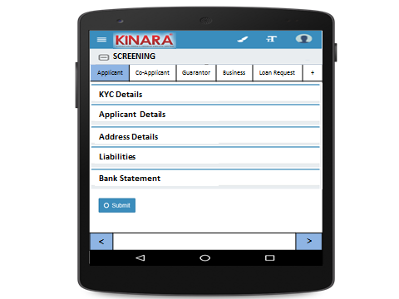

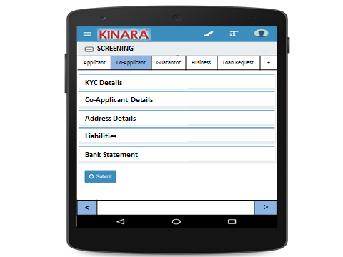

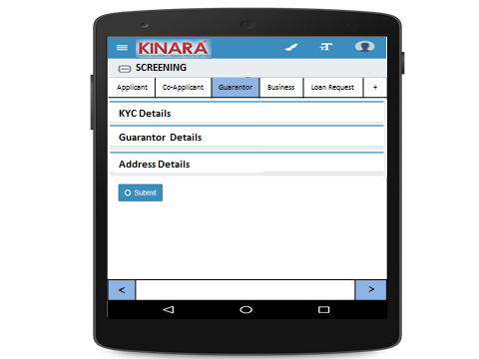

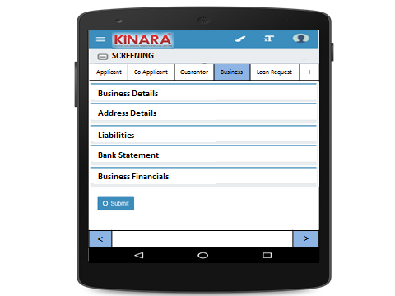

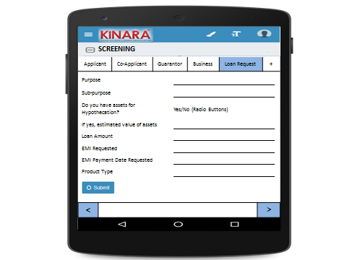

To add Co-Applicant or guarantor or remarks, click on + button.

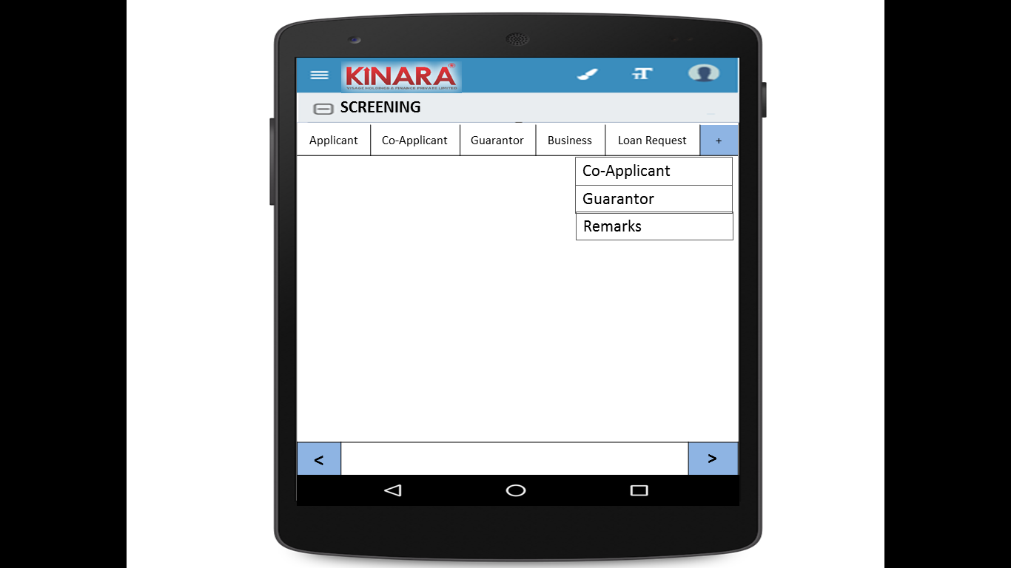

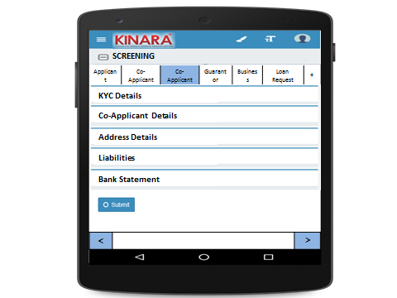

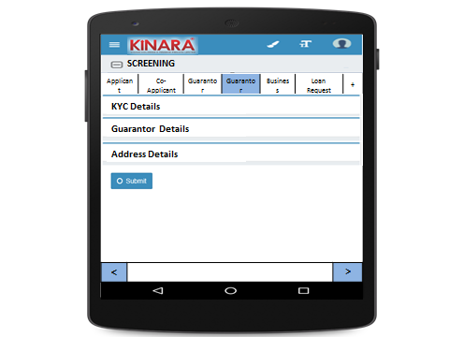

**Applicant**

Entity wise data capture and it will start with Applicant.



1. KYC details:

|  |  |
| --- | --- |
| Page 1 | Page 2 |

To add more than one KYC Details, Click on +KYC Details Button.

1. Applicant Details

|  |  |  |
| --- | --- | --- |
| Page 1 | Page 2 | Page 3 |

1. Address Details

|  |  |  |
| --- | --- | --- |
| Page 1 | Page 2 | Page 3 |

1. Liabilities

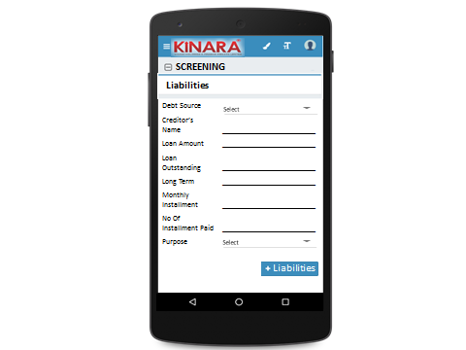

1. Bank Statement

|  |  |
| --- | --- |
| Page 1 | Page 2 (provide add bank details button) |

To add more than one account, click on +Add Account Button.

**Co-Applicant**

1. KYC Details

|  |  |
| --- | --- |
| Page 1 | Page 2 |

1. Co-Applicant Details

|  |  |  |
| --- | --- | --- |
| Page 1 | Page 2 | Page 3 |

1. Address details

|  |  |  |
| --- | --- | --- |
| Page 1 | Page 2 | Page 3 |

1. Liabilities



1. Bank Statement

|  |  |
| --- | --- |
| Page 1 | Page 2(provide add bank details button) |

**Guarantor**

1. KYC Details

|  |  |
| --- | --- |
| Page 1 | Page 2 |

1. Guarantor Details

|  |  |  |
| --- | --- | --- |
| Page 1 | Page 2 | Page 3 |

1. Address Details

|  |  |  |
| --- | --- | --- |
| Page 1 | Page 2 | Page 3 |

**Business**

1. Business Details

|  |  |  |
| --- | --- | --- |
| Page 1 | Page 2 | Page 3 |

1. Address Details

|  |  |
| --- | --- |
| Page 1 | Page 2 |

1. Liabilities



1. Bank Statement

|  |  |
| --- | --- |
| Page 1 | Page 2 |

1. Business Financials

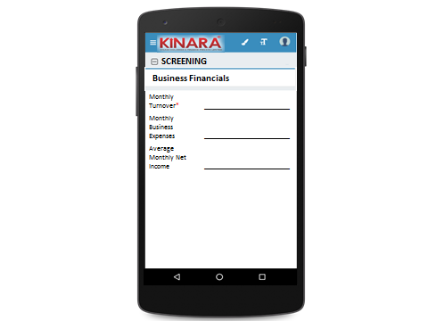

**Loan Request**

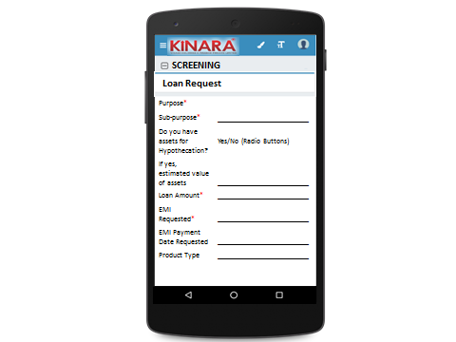

## Functional requirements

* 1. Once the profile is selected from the screening queue, the loan officer captures the screening data and submits the profile to undergo an auto approval process.
  2. Here, de- dupe check and credit bureau check is conducted
  3. Risk Score 1 (Screening Score) is also generated and auto-approval process will run at the back end (all checks run at back end).
  4. If approved, the profile goes to Application stage else it goes for Screening Review with the deviations that have been observed.

## Uploads

-NA-

## Downloads

-NA-

## Reports

Customer wise Risk Score

# Risk Score 1

## UI specification

## Screenshot

-NA-

## Functional requirements

Risk Score 1 is a completely automated calculation.

|  |  |  |  |  |  |  |  |  |  |  |  |  |  |  |
| --- | --- | --- | --- | --- | --- | --- | --- | --- | --- | --- | --- | --- | --- | --- |
| **S.No** | **Parameter** | **Stage** | **Entity** | **Main Tab** | **Field Name** | **Options** | **RS Option** | **Weightage in consolidated risk score** | **Weightage in screening score** | **Scoring** | | | | |
| **1** | **2** | **3** | **4** | **5** |
| 1 | Age | Screening | Applicant | Applicant Details | Age |  | 1. < 25 2. 25 - 30 3. 30 - 40 4. 40 - 55 5. > 55 | 2 | 2/52% | 1 | 3 | 5 | 5 | 2 |
| 2 | Qualification | Screening | Applicant | Applicant Details | Education Level |  | 1. Below SSLC 2. ITI/Diploma/ Professional Qualification 3. Graduate/ Equivalent to graduate 4. Post graduate & equivalent 5. More than post-graduation | 1 | 1/52% | 1 | 5 | 3 | 4 | 3 |
| 3 | Exp in Biz | Screening | Applicant |  |  |  | 1. <2 years 2. 2-3 years 3. 3-4 years 4. 4-5 years 5. >5 years | 3 | 3/52% | 1 | 2 | 3 | 4 | 5 |
| 4 | # of Years residence in area /Locality | Screening | Applicant | Address Details | How many years are you living in present Area? |  | 1. < 1 year 2. 1-3 years 3. 3-4 years 4.4-5 years 5. > 5years | 1 | 1/52% | 1 | 2 | 3 | 4 | 5 |
| 5 | Housing Status | Screening | Applicant | Address Details | Ownership |  | 1. Owned 2. Own house without registration 3. Family Property 4. Leased 5. Rental | 2 | 2/52% | 5 | 4 | 3 | 2 | 1 |
| 6 | Married Status | Screening | Applicant | Applicant Details | Marital Status |  | 1. Unmarried 2. Married 3. Separated 4. Divorced 5. Widow(er) | 1 | 1/52% | 4 | 5 | 0 | 1 | 3 |
| 7 | Involvement in Biz | Screening | Applicant | Applicant Details | Business Involvement |  | 1. Full Time 2. Part Time 3. Not Involved | 3 | 3/52% | 5 | 3 | 0 |  |  |
| 8 | CB score | Screening | Applicant |  |  |  | 1. No data/ -1 to 5 2. 700+ 3. 600-700 4. 550-600 5.<550 | 6 | 6/52% | 3 | 5 | 4 | 2 | 0 |
| 9 | Referred by | Screening | Business | Business Details | Referred by |  | 1. Channel Partner 2. Existing Customer Referral 3. Direct (Cold Call) 4. Referral Partner | 2 | 2/52% | 5 | 3 | 1 | 2 |  |
| 10 | Business Vintage (verifiable) | Screening | Business | Business Details | Business Operating since |  | 1. <6 months 2. 6 months to 1 year 3. 1-2 years 4. 2-3 years 5. >3 years | 3 | 3/52% | 1 | 2 | 3 | 4 | 5 |
| 11 | # of Years business in area /Locality | Screening | Business | Business Details | How many years business in present Area? |  | 1. <6 months 2. 6 months to 1 year 3. 1-2 years 4. 2-3 years 5. >3 years | 5 | 5/52% | 0 | 1 | 2 | 3 | 5 |
| 12 | Business premises Status | Screening | Business | Business Details | Ownership |  | 1. Owned 2. Own house without registration 3. Family Property 4. Leased 5. Rental | 2 | 2/52% | 5 | 4 | 3 | 2 | 1 |
| 13 | Business History | Screening | Business | Business Details | Constitution | 1. Proprietorship  2. Partnership 3. Private LTD | 1. Clean - Single owner/ Structure | 2 | 2/52% | 5 | 4 | 3 | 1 | 2 |
| Business | Business Details | Constitution | 1. Proprietorship  2. Partnership 3. Private LTD | 2. Partnership with 2 partners |
| If partnership, how many total partners | 1. 2  2. 3 3. 4 4. >4 |
| Business | Business Details | Constitution | 1. Proprietorship  2. Partnership 3. Private LTD | 3. Partnership with more than 2 partners |
| If partnership, how many total partners | 1. 2  2. 3 3. 4 4. >4 |
| Applicant | Applicant Details | Have you ever been a proprietor or partner of any other company | 1. Yes 2. No | 4. Previously closed another business |
| If yes, did the business close? | 1. Yes 2. No |
| Business | Business Details | Has anyone else been a partner of your present business | 1. Yes 2. No | 5. Previously dissolved partnership |
| If yes, when was that partnership  dissolved? | Date |
| 14 | Commercial High mark / CIBIL | Screening | Business | CB Check |  |  | 1. No Data 2. STD 3. Sub DBT, Loss | 5 | 5/52% | 3 | 5 | 0 |  |  |
| 15 | No. of cheque returns including EMIs | Screening | Business | Bank Statement Details | No. of cheques bounced |  | 1. 0-1 2. 2-3 3. 3-4 4. 4-6 5. >6 | 4 | 4/52% | 5 | 4 | 3 | 1 | 0 |
| 16 | Number of EMI bounces | Screening | Business | Bank Statement Details | No of EMI cheques bounced* |  | 1. No Bounces 2. Technical Bounces paid in same month 3. 3 bounces paid in same month 4. >3 bounces paid after the month | 5 | 5/52% | 5 | 4 | 2 | 0 |  |
| 17 | No of Bounces in Kinara loan track |  |  |  |  | From Kinara records for existing customer ID for applicant/ Business | 1. No Bounces 2. Technical Bounces paid in same month 3. 2 bounces paid in same month 4. >2 bounces paid after the month | 5 | 5/52% | 5 | 4 | 2 | 0 |  |
| **CONSOLIDATED** | | | | | | | | **52** | **100%** |  |  |  |  |  |

* For Screening Score or risk score 1 to calculate, 17 parameters are used. These 17 parameters are mentioned in the table above.
* Each parameter has maximum of five categories- 1,2,3,4 and 5 (refer column no.8)
* The weightage for each parameter is mentioned in column no. 10. The total sum of each parameter is 100%. So if the weightage is 1/52% then its weightage is 1.923%.
* Value of each parameter will fall in one of the five categories say 1,2,3,4 or 5. For each category corresponding score is also mapped in column 11,12,13,14 and 15.
* By using one example we will understand this case. Applicant’s age (parameter 1) is 32 years. Thus applicant is falling in category 3(Column no.8). Now we will map category with score. Category 3 has corresponding scores in column 13 which in this case (score) is 5. For parameter age, applicant has scored 5 marks. The maximum mark each parameter can earn is 5. Thus, applicant has scored 5 out of 5.
* Score calculation method: (Score/5)*(Weightage*100)
* For the given applicant’s parameter age, he has scored : (5/5)*((2/52)*100)= 3.8461538
* The score for each parameter is necessary and applicant/business should fall in either of five categories.
* The maximum score for each parameter is 5. Thus any parameter will not fall in more than one category. For example, for parameter age, all the categories are mutually exclusive.
* The cut off score should be configurable. The score will be stored in the system only and it will not be shown anywhere.

## Upload

-NA-

## Download

-NA-

## Reports

-NA-