**RESUME**

P. Durga Bhavani

D/O P.Apparao [Email:bhavanivadisala5@gmail.com](mailto:bhavanivadisala5@gmail.com) Paravada Mobile: 7416809848



**CAREER OBJECTIVE:**

To pursue a deserving career in a reputed organization where I can utilize my abilities and contribute in the success of the organization and grow consistently with the organization.



**EDUCATIONAL QUALIFICATION:**

|  |  |  |  |
| --- | --- | --- | --- |
| QUALIFICATION | NAME OF  INSTITUTION | YEAR OF  PASSING | PERCENTA GE |
| BSC | Kakaraparti Bhavanarayana college (KBN) Vijayawada | 2025 | 81%(upto fifth sem) |
| Intermediate (M.P.C) | Sri Chaitanya junior college Vijayawada | 2019 | 9.59 points |
| Secondary school examination | Maddi Subbha rao E.H school | 2017 | 7.5 points |

* Languages Known: C, C++, JAVA, SQL, HTML (BASICS)



**TECHNICAL SKILLS:**

* Office Tools: MS Office.

**WORKSHOP:**

* Participated in mathematics models.

: D-no 9-27-18, Near Nehru Bomma Center kothapeta, Vijayawada – 1, NTR district.



**CO-CURRICULAR ACHIEVEMENTS:**

* Participated in short-term internship.
* Got a certificate for Ms office.



**PERSONAL DETAILS:**

|  |  |  |
| --- | --- | --- |
| Name | : | P. Durga Bhavani |
| Father Name | : | P. Apparao |
| Date OF Birth | : | 05-11-2001 |
| Hobbies | : | Reading books, playing game indoor and outdoor, solving coding challenges. |
| Strength | : | Quick learner, Responsible, Creative, working |
| Religion | : | Hindu |
| Nationality | : | Indian |
| Languages Known | : Telugu, English. | |
| Gender | : female | |
| Address : 2-42, Settibalija Street, Beside Jagadamba Sweet shop, Paravada, Anakapalli-531021. | | |



I hereby declare that all the information given by me in the resume, is true and complete to the best of my knowledge.

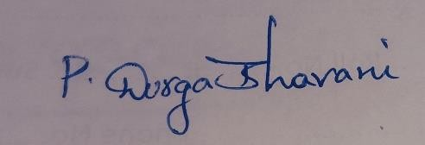

Date: Signature

Place: Paravada