**PROJECT NAME:**

**DIGITAL CLOCK AND EXPENSE TRACKER**

** PRESENTED BY:**

**BHAVANI ATKAPURAM**

**INTERN ID:**

**VN-JD-4W213**

**INTRODUCTION**

The Digital Clock and Expense Tracker Application is a Java-based solution designed to assist users in managing their daily expenses efficiently while displaying the current time in a digital clock format. This project aims to combine functionality with usability, providing users with a simple and intuitive interface to record, track, and analyze their expenses.

The application includes the following key features:

1. Digital Clock: A live digital clock that displays the current time in a user-friendly format, implemented using the javax.swing.Timer class.
2. Expense Management: A robust system to add, edit, view, and delete expense records, allowing users to categorize and organize their spending.
3. Database Integration: Persistent storage of expense data using SQLite, ensuring that users can save and retrieve their expense history.
4. Reports: Summaries of expenses categorized by date or type, helping users analyze their spending habits.

This project demonstrates the integration of core Java technologies such as Swing for GUI development and JDBC for database connectivity, making it an ideal demonstration of practical Java application development. Optional features, such as exporting data to Excel or importing/exporting JSON/XML, enhance the application’s utility for users requiring advanced functionality.

**SYSTEM REQUIREMENTS**

The **Digital Clock and Expense Tracker Application** is designed to run efficiently on modern personal computers. The minimum hardware requirements include a dual-core 1.8 GHz processor, 4 GB of RAM, and 500 MB of free disk space. For optimal performance, it is recommended to use a system with a quad-core 2.5 GHz processor, 8 GB of RAM, and at least 1 GB of free disk space. The application is platform-independent and supports major operating systems, including Windows 10/11, macOS, and Linux. It requires the installation of the **Java Development Kit (JDK)** version 8 or higher (version 17+ recommended for access to the latest features and optimizations). The runtime environment must have the **Java Runtime Environment (JRE)** installed and correctly configured in the system's PATH.

The application employs an embedded **SQLite database** to persist expense data, ensuring lightweight and hassle-free operation without the need for external database servers. The **SQLite JDBC driver** is included in the project to facilitate database connectivity. For enhanced functionality, the application can leverage optional libraries like **Apache POI** for generating expense reports in Excel format and JSON/XML parsers (e.g., Jackson or Gson) for exporting and importing data. The user interface, developed using **Java Swing**, provides an intuitive and user-friendly experience, allowing users to view the digital clock and manage expenses efficiently. The system must also provide the application with read/write permissions for the working directory to enable seamless database operations.

Since the application is standalone, it does not require an internet connection to function, making it suitable for offline use. However, to test or deploy the application in a development environment, an Integrated Development Environment (IDE) such as IntelliJ IDEA, Eclipse, or NetBeans is recommended. The application is tested for compatibility across multiple environments, ensuring reliability and stability on diverse hardware and software configuration.

**ARCHITECTURE AND DESIGN**

The Digital Clock system architecture consists of three main components: the User Interface (UI), Core Logic, and the Time Provider. The UI displays the time in either 12-hour or 24-hour format, with options for the user to toggle between these formats. The Core Logic manages the time formatting and ensures that the time is updated every second. The Time Provider retrieves the current time from the system clock and sends it to the Core Logic for display. User interaction allows changes to settings like time format and, optionally, setting alarms. In this system, the interaction between the Time Provider, Core Logic, and UI ensures the clock is accurately displayed and updated in real time.

The Expense Tracker system is a bit more complex, comprising the User Interface (UI), Core Logic, Database, and optional Authentication components. The UI presents the user with a dashboard showing their financial balance, income, expenses, and visualizations like graphs. Users can add income or expense transactions, categorize them (e.g., groceries, rent), and view reports. The Core Logic handles the management of transactions, categories, and balance calculations, while the Database stores transaction and category data. Optionally, Authentication allows users to securely track their expenses across multiple devices or sessions. The flow of data between the UI, Core Logic, and Database ensures that the user can input, categorize, and visualize their financial data in real time. Both systems can be designed as client-server architectures, where the frontend (UI) interacts with the backend (Core Logic) and stores data in either local or cloud storage, depending on the specific needs of the application.

**PROJECT SETUP**

To set up both **Digital Clock** and **Expense Tracker** projects in one unit using **VS Code**:

1. **Install Extensions**: Install necessary extensions for Java, Python, JavaScript, or SQLite in VS Code.
2. **Create a Workspace Folder**: Create a folder for the workspace (e.g., Digital-Clock-Expense-Tracker-Workspace) and add subfolders for each project (DigitalClock and ExpenseTracker).
3. **Initialize Projects**:
   * For **Digital Clock**, create files (Clock.java for Java, clock.py for Python, or index.html for web) and implement the time display logic.
   * For **Expense Tracker**, create files (ExpenseTracker.java for Java, expense_tracker.py for Python, or index.html for web), set up a database (SQLite), and implement transaction management and balance calculation.
4. **Add UI Components**: Design simple UI components (using JavaFX/Swing for Java, Tkinter for Python, or HTML/CSS for web).
5. **Database Setup**: Set up an SQLite or local database for storing transaction and category data for the **Expense Tracker**.
6. **Run Both Projects**:
   * Run **Digital Clock** via VS Code (Live Server for web, or terminal for Java/Python).
   * Run **Expense Tracker** similarly.
7. **Version Control**: Initialize Git in the workspace folder, commit changes, and push to GitHub.

**FEATURES:**

**Digital Clock Features:**

1. **Real-Time Time Display: Shows the current time in either 12-hour or 24-hour format.**
2. **Time Format Toggle: Option to switch between 12-hour and 24-hour time formats.**
3. **AM/PM Indicator: Display of AM/PM for 12-hour format (optional).**
4. **Alarm Functionality (Optional): Set alarms that alert the user at a specified time.**
5. **Customizable Themes: Option to change the background or clock color (optional).**
6. **Clock Updates Every Second: Ensures the time display is always up to date.**

**Expense Tracker Features:**

1. **Transaction Management: Ability to add, edit, or delete income and expense transactions.**
2. **Categorization of Expenses: Categorize transactions into predefined categories like Groceries, Rent, etc.**
3. **Balance Calculation: Automatically calculates the user’s balance based on income and expenses.**
4. **Expense Reports: Generate visual reports (pie charts, bar graphs) to track spending patterns.**
5. **Monthly/Weekly Budget Tracking: Set and track budgets for different categories or overall expenses.**
6. **Transaction History: View past transactions, filtered by category or date.**
7. **Recurring Transactions (Optional): Set recurring transactions for regular payments (e.g., monthly subscriptions).**

**SOURCECODE**

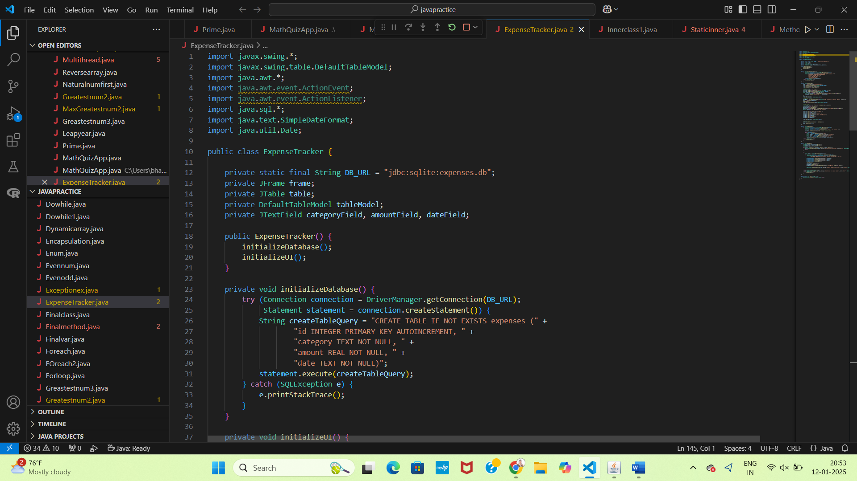

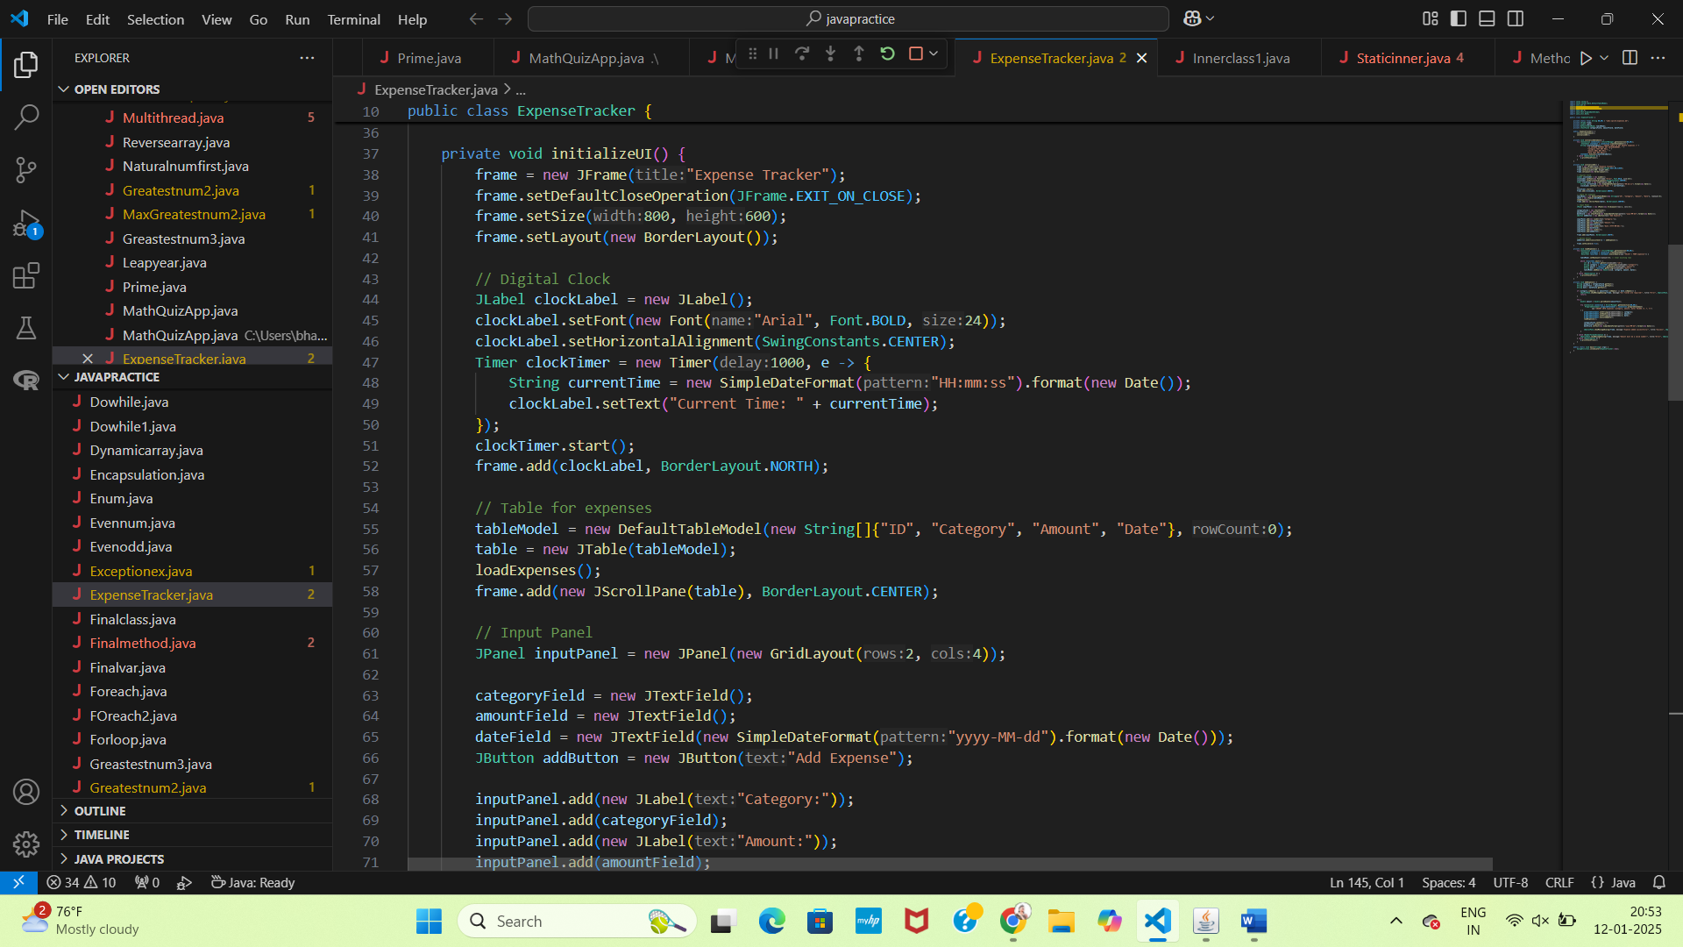

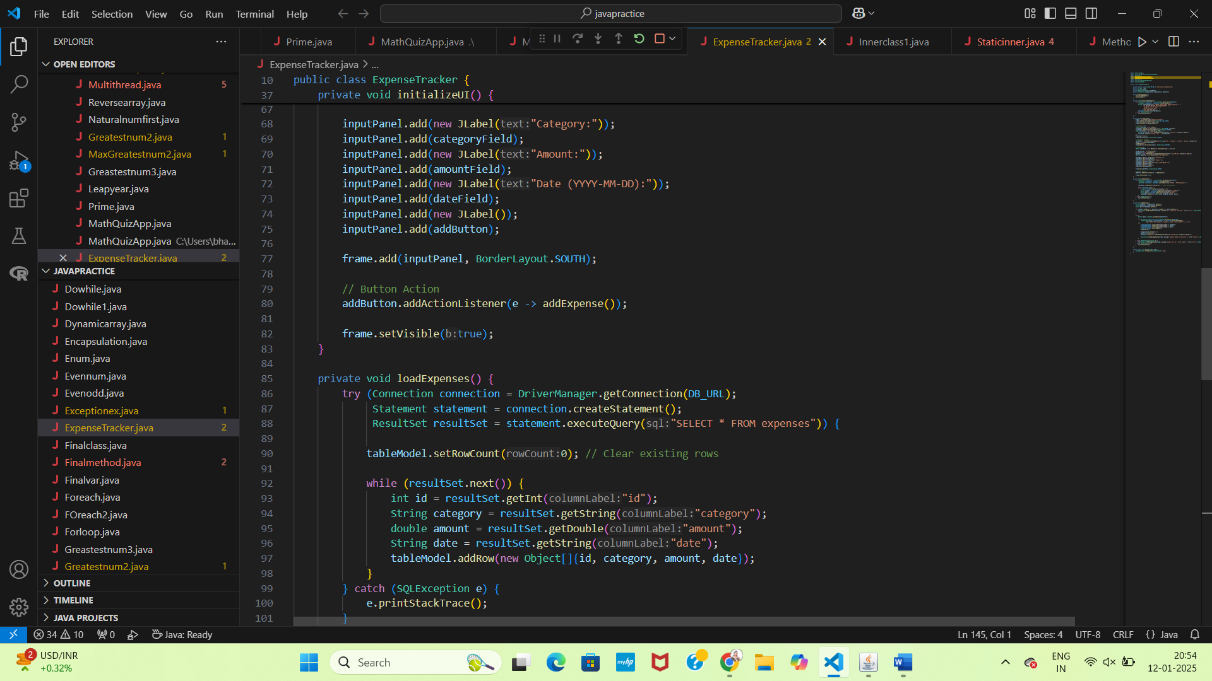

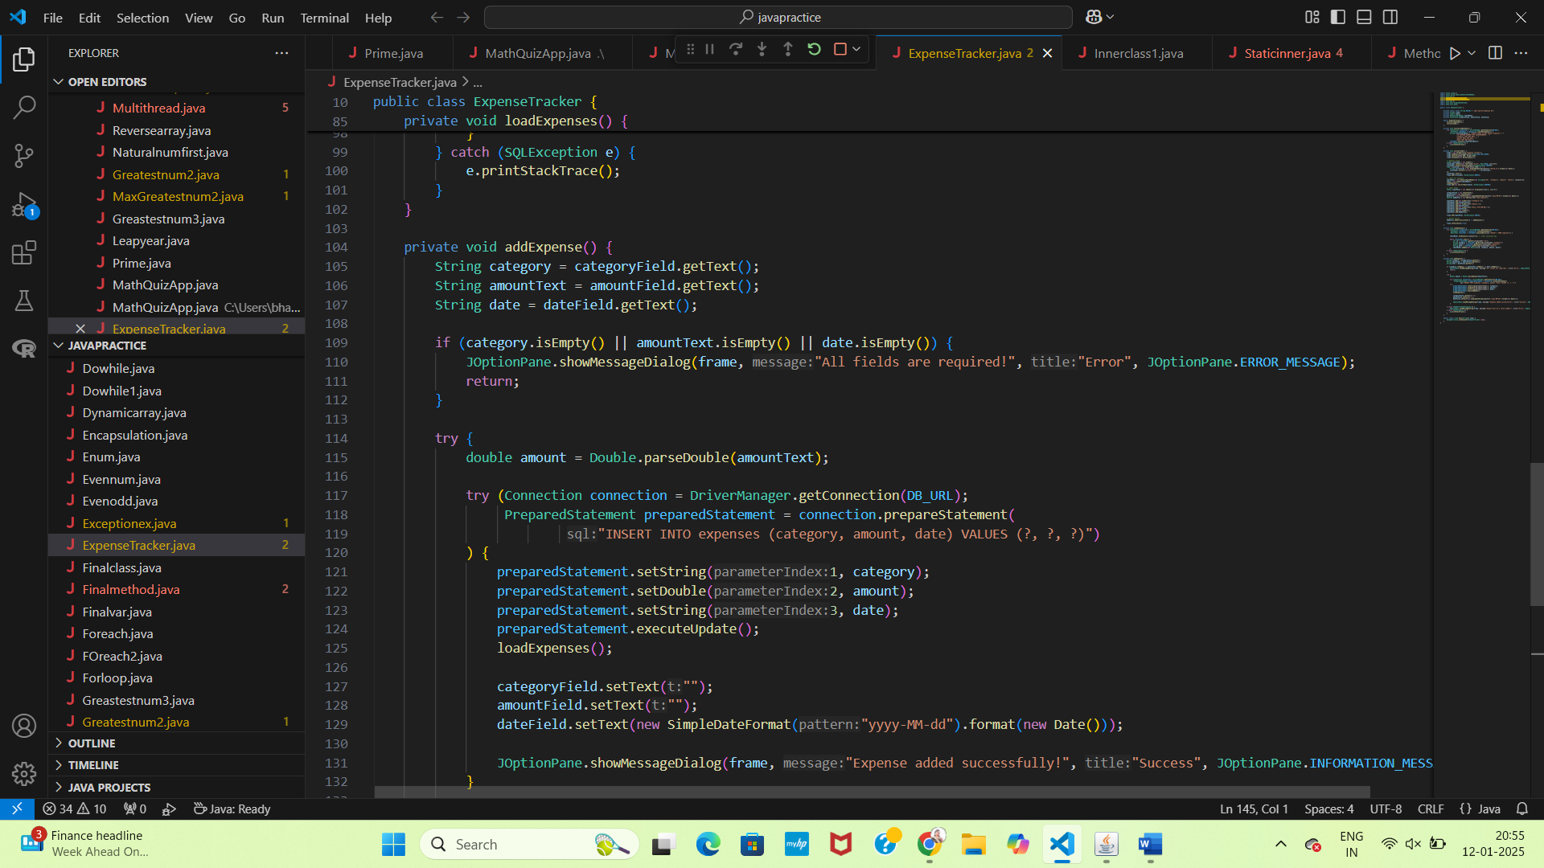

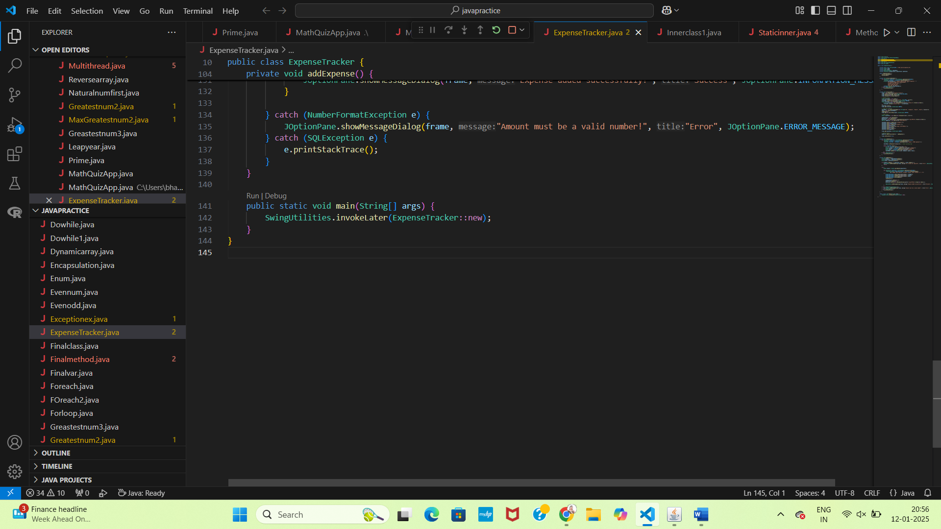

**RESULT:**

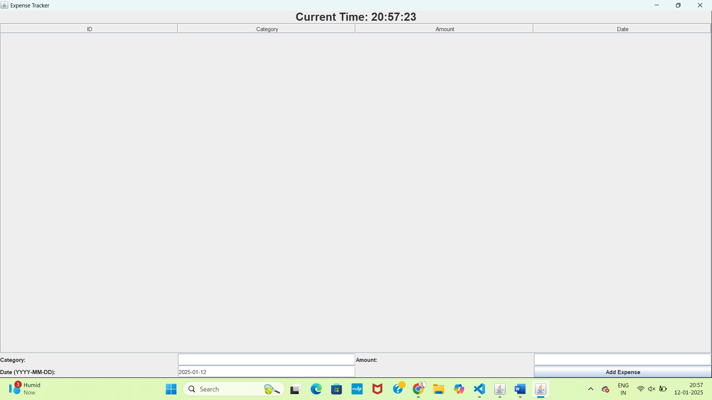

**FUTURE ENHANCEMENTS:**

1.Unified Dashboard: Display both real-time clock and financial summary (income, expenses, balance) in one screen.

2.Multi-Function Alarms: Set alarms for both time and financial reminders (e.g., bill payments or budget limits).

3.Task & Expense Sync: Link tasks with expenses (e.g., "Buy groceries" task links to an expense category).

4. Time-Based Budgeting: Suggest spending adjustments based on time of day or weekly goals.

5. Cloud Syncing: Sync data across devices for both time and financial tracking.

6. Voice Integration: Use voice commands to set alarms and add expenses or check balance.

7. Health & Financial Management: Integrate fitness tracking and time budgeting for better financial planning.

8.Predictive Insights: Provide AI-driven suggestions for managing time and expenses.

9.Time-Expense Correlation: Visualize how time spent correlates with spending in different categories.

10.Customizable Themes: Offer a unified UI with customizable layouts and dark mode for both features.

**CONCLUSION**

This combined Digital Clock and Expense Tracker app represents a powerful, multi-functional solution for managing both time and finances in a unified platform. By bringing together time management, task tracking, and expense monitoring, it helps users optimize their daily routines while keeping their finances in check. With advanced features like cloud syncing, AI-driven insights, and cross-platform support, this app offers immense potential for enhancing user productivity, financial health, and overall efficiency. As more enhancements are made in the future, such as voice integration and predictive financial tools, this app will continue to evolve, ensuring it remains a valuable tool for users seeking to harmonize their time and money management.