-- 1.Total Revenue
select sum(total_price) as Revenue from pizza_sales;
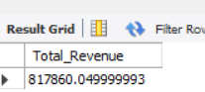

-- 2.Total Orders
select count(distinct(order_id)) from pizza_sales;

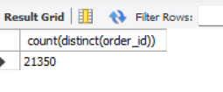
-- 3.Total Pizzas sold
select sum(quantity) from pizza_sales;
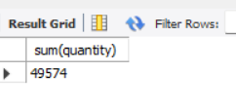
-- 4.Average Order Value
select sum(quantity)/count(distinct(order_id)) as Avg_Pizzas_per_order from pizza_sales;
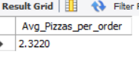
5. -- 5.Hourly Trend for Total Pizzas sold

select Hour(order_time),sum(quantity) from pizza_sales group by Hour(order_time) order by Hour(order_time);

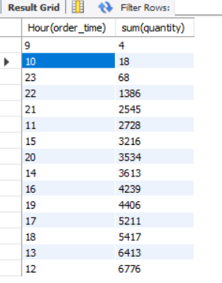

-- 6.Weekly Trend for total orders
SELECT
YEARWEEK(STR_TO_DATE(order_date, '%d-%m-%Y'), 3) DIV 100 AS iso_year,
YEARWEEK(STR_TO_DATE(order_date, '%d-%m-%Y'), 3) % 100 AS iso_week,
COUNT(DISTINCT order_id) AS total_orders
FROM pizza_sales
GROUP BY iso_year, iso_week
ORDER BY iso_year, iso_week;

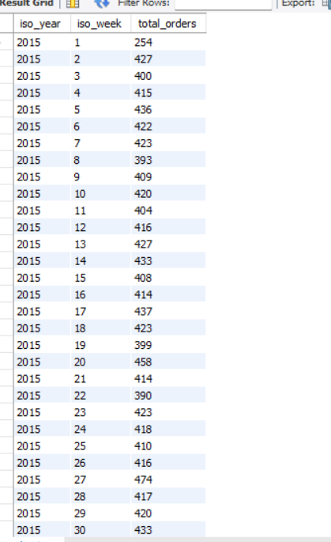

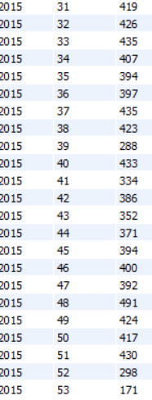

-- 7.Percentage of Sales by pizza_category

select
pizza_category,
sum(total_price) as Total_sale_by_category,
round(sum(total_price)*100/(select sum(total_price) from pizza_sales where MONTH(STR_TO_DATE(order_date, '%d-%m-%Y'))=1),2) as Percentage
from pizza_sales
where MONTH(STR_TO_DATE(order_date, '%d-%m-%Y'))=1
group by pizza_category;
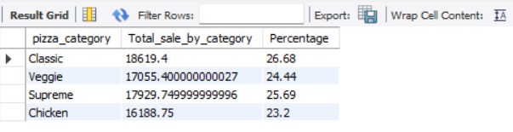

-- 8.Percentage of Sales by Pizza_Size

select pizza_size,
sum(total_price) as Total_Sale_by_Size,
round(sum(total_price)*100/(select sum(total_price) from pizza_sales),2) as Percentage
from pizza_sales
group by pizza_size
order by Percentage;

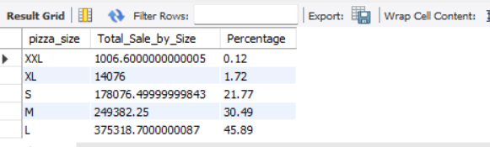

-- 9.Top 5 Pizzas by Revenue
select pizza_name,sum(total_price) as Total_Revenue from pizza_sales group by pizza_name order by Total_Revenue Desc limit 5;


-- 10.bottom 5 pizzas by Revenue

select pizza_name,sum(total_price) as Total_Revenue from pizza_sales group by pizza_name order by Total_Revenue limit 5;
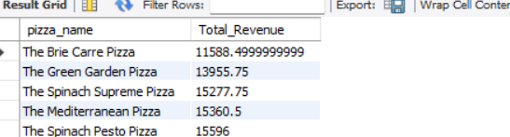

-- 11.top 5 pizzas by qunatity

select pizza_name,sum(quantity) as Total_quantity from pizza_sales group by pizza_name order by Total_quantity Desc limit 5;

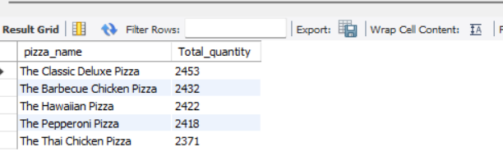

-- 12.top 5 pizzas by Total_orders

select pizza_name,count(distinct(order_id)) as Total_Orders from pizza_sales group by pizza_name order by Total_Orders Desc limit 5;

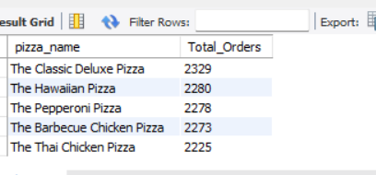

-- 13.bottom 5 Pizzas by Total_orders

select pizza_name,count(distinct(order_id)) as Total_Orders from pizza_sales group by pizza_name order by Total_Orders limit 5;

