# List out the employees who are earning salary between 3000 and 4500

Select Employee_ID, Last_name, First_name from test.employee where Salary between 3000 and 4500;

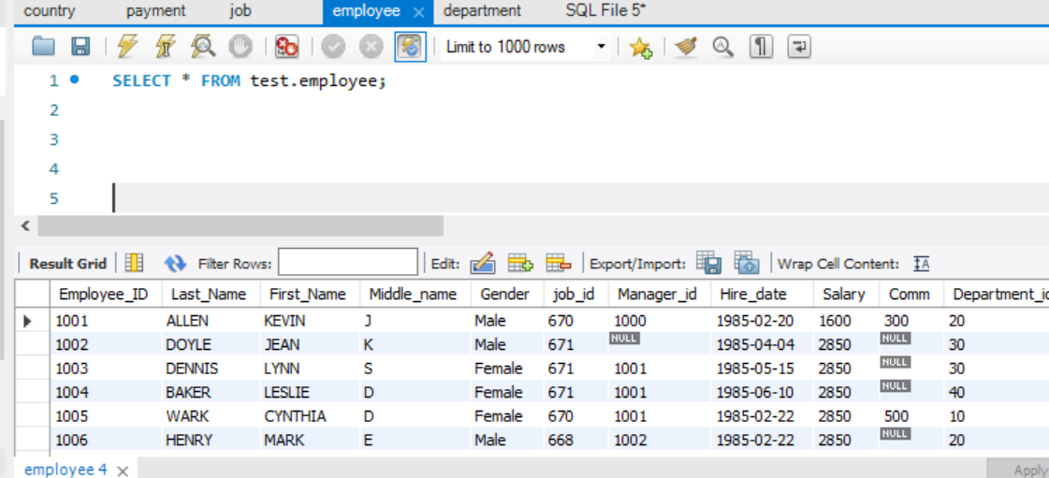

# List out the employees who are working in department 10 and draw the salaries more than 3500

# List out the department id having at least four employees.

SELECT Department_id FROM test.employee GROUP BY Department_id

HAVING COUNT(*)>=4

# Which is the department id having greater than or equal to 3 employees who joined in April 1985.

select Department_id,count(*) from test.employee where date_format(hire_date, '%Y')=1985

and date_format(hire_date, '%m')=04 group by date_format(hire_date, '%Y'),date_format(hire_date, '%m'), Department_id having **count(*)=1;**

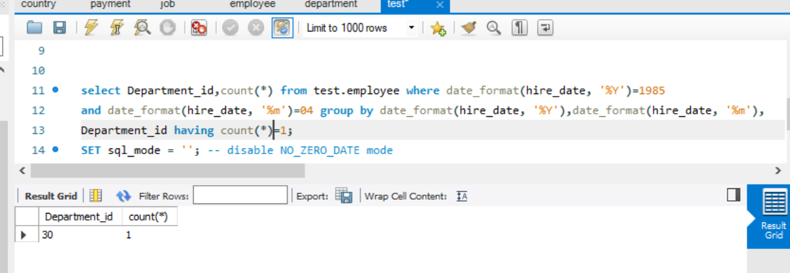

select Department_id,count(*) from test.employee where date_format(hire_date, '%Y')=1985

and date_format(hire_date, '%m')=04 group by date_format(hire_date, '%Y'),date_format(hire_date, '%m'), Department_id having **count(*)>=3;**

# How many employees have joined in January or September month.

Select Employee_ID,Last_name, First_name from sys.employee where date_format(hire_date, '%m')=01 or date_format(hire_date, '%m')=09;

# Update the employees’ salaries, who are working as Clerk on the basis of 10%.

update sys.employee set salary=salaryz+(salary*0.1) where job_id=(select job_id from job where Job_name='clerk');

# Display the employee details who earn more than their managers salaries.

SELECT * FROM sys.employee m, sys.employee e

WHERE m.Manager_id = e.Employee_ID and e.Salary>m.Salary;

(or)

Select e.last_name emp_name, e.salary emp_salary, m.last_name mgr_name, m.salary mgr_salary

from sys.employee e, sys.employee m where e.manager_id=m.employee_id and m.salary;

# Write a query in SQL to list the employee id, name, department id, location of all the employees.

Select e. Employee_ID,e.last_name,e.first_name,d.department_id,l.Regional_group

from sys.employee e inner join sys.department d on d. Department_id= e. Department_id inner join sys.location l on l. location_id=d.location_id;

# Write a query in SQL to list the employee id, name, hire_date, current date and experience of the employees in years in ascending order

select e.employee_id,e.Hire_date,current_date(),

DATEDIFF( SYSDATE(), hire_date )/365 as experience from sys.employee e order by experience asc;

# Write a query in SQL to list the employees who are senior to their own manager.

SELECT * FROM sys.employee m, sys.employee e

WHERE m.Manager_id = e.Employee_ID and m.Hire_date<e.hire_date;

