# Write a query to display all departments including those who does not have any employee.

select d.department_id from test2.department d left outer join test2.employee e on d.Department_id = e.department_id;

# Write a query to display the first name of all employees including the first name of their manager.

select m.first_name as firstnameofemployee,e.first_name as firstnameofmanager from

test2.employee m, test2.employee e where m.Manager_id=e.employee_id;

# Write a query in SQL to display the first name, last name, department number and name, for all employees who have or have not any department.

SELECT E.first_name, E.last_name, E.department_id, D.department_name

FROM test2.employee E LEFT OUTER JOIN test2.department D ON E.department_id = D.department_id;

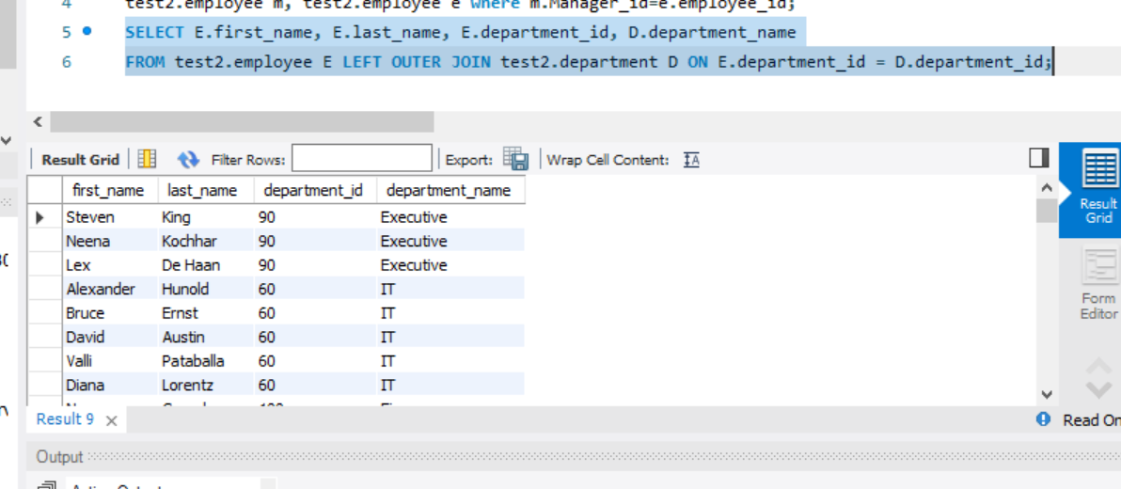

# Write a query to display the first name of all employees and the first name of their manager including those who does not working under any manager.

select m.first_name as firstnameofemployee,m.last_name,e.first_name as firstnameofmanager from

test2.employee m left outer join test2.employee e on m.Manager_id=e.employee_id;

# Write a query to display the country name, city, and number of those departments where at least 2 employees are working.

SELECT country_name,city, COUNT(department_id) FROM test2.country

JOIN test2.location USING (COUNTRY_ID) JOIN test2.department USING (location_id) where department_id in (select e.department_id from test2.employee e group by department_id having count(*)>=2) GROUP BY country_name,city;

# Write a query to determine the 3rd highest salary.(Use both Ranking Functions and Subquery)

Subquery:

Select e1. EMPLOYEE_ID,e1.first_name,e1.salary from test2.employee e1

Where 2=(select count(distinct salary) from test2.employee e2 where e2.salary>e1.salary)

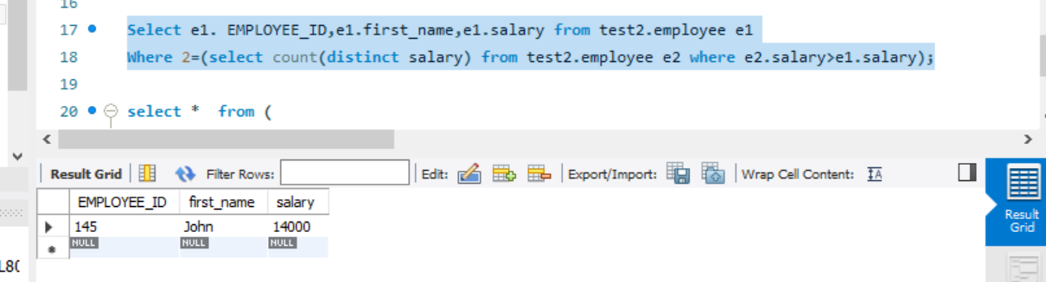

Dense_rank:

select * from (select e.Employee_ID,e.First_Name,e.Salary, DENSE_RANK() over(order by salary desc) as R from test2.employee e) result where result.R=3

# Write a query to determine the highest salary department wise.

select e2.Department_id,max(salary) from test2.employee e2 group by department_id ;

**(or)**

SELECT e2.Department_id,e2.salary FROM test2.employee e2 WHERE Salary IN

( SELECT max(Salary) FROM test2.employee GROUP BY department_id );

# Find out the Department_ID, Department_Name and no of Employees working under each department.

Select e.department_id,d.DEPARTMENT_NAME, count(employee_id) from test2.employee e

left outer join test2.department d USING (department_id) where department_id in(select

department_id from test2.employee group by Department_id) group by department_id

# Find out the employees who earn greater than the average salary for their department.

select e1.* from test2.employee e1 inner join (select avg(salary) avg_sal,e2.department_id

from test2.employee e2 group by department_id) as e3

on e1.department_id=e3.department_id and e1.Salary>e3.avg_sal;

## DATE FUNCTIONS:

# How many employees joined each month in 2015.

SELECT count(employee_id),date_format(STR_TO_DATE(hire_date, "%d-%m-%Y %k:%i"),'%m') as months from test2.employee where

date_format(STR_TO_DATE(hire_date, "%d-%m-%Y %k:%i"),'%Y')=2015 group by months;

# How many employees who are joined in December 2016.

SELECT count(employee_id) from test2.employee e where

date_format(STR_TO_DATE(hire_date, "%d-%m-%Y %k:%i"),'%Y')=2016 and

date_format(STR_TO_DATE(hire_date, "%d-%m-%Y %k:%i"),'%m')=12;

# List out the no.of employees for each month and year, in the ascending order based on the year, month.

SELECT count(employee_id),date_format(STR_TO_DATE(hire_date, "%d-%m-%Y %k:%i"),'%m') as

months,date_format(STR_TO_DATE(hire_date, "%d-%m-%Y %k:%i"),'%Y') as

years from test2.employee group by months,years order by years,months asc;

