Resume

Name:Bhavani.R

Email id;bhavaniaakash2002@gmail.com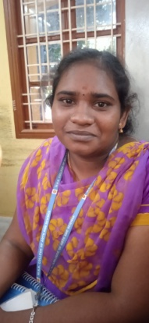

Mobile number:8807030561

Addresss;

Attrangarai(st)

Kandamanagalam(po)

Kattumannar koll(tk)

Cuddalore 608305

Objective;

To be a successful and to work for an organization with full zeal and aiming at not only authority ‘s satisfaction bull also over all personal development.

Personal profile;

Name; Bhavani.R

Father name; Rajenthiran.P

Date of birth ;28.9.2002

Gender; female

Nationality; Indian

Religion; hindu

Language known ;tamil,English

Permanent addresss ;

Attrangarai (st)

Kandamangalam(po)

Kattumannar (tk)

Cuddalore 608305