Question 1: Smallest of Two Numbers (If-Else)
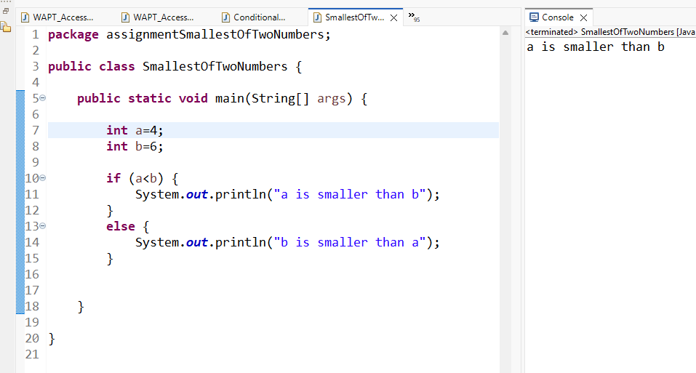
Question 2: Greatest of Three Numbers (if-ElseIf)
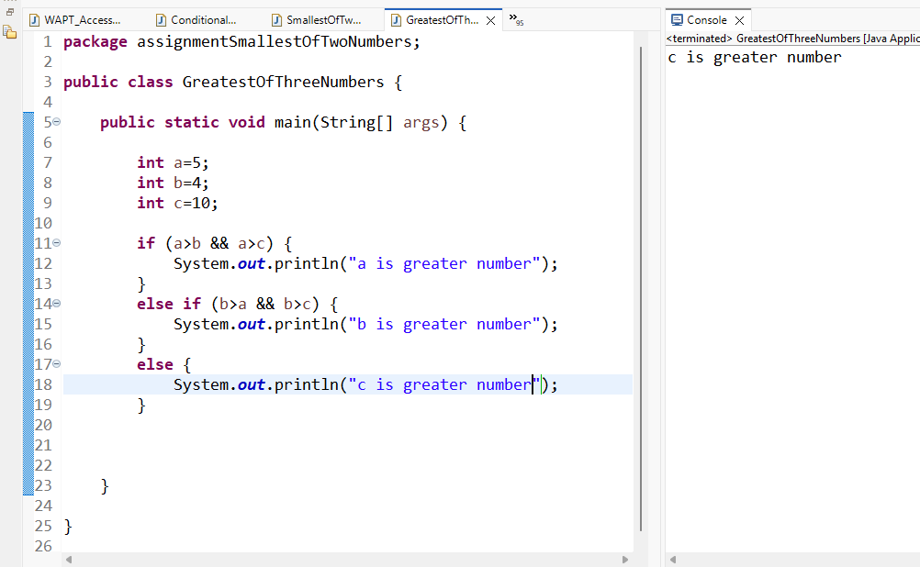
Question 3: Grading System

