Select account-7011410-click filter
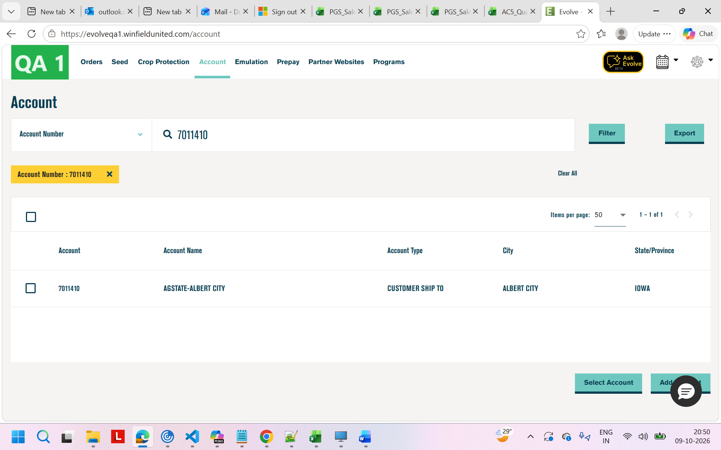
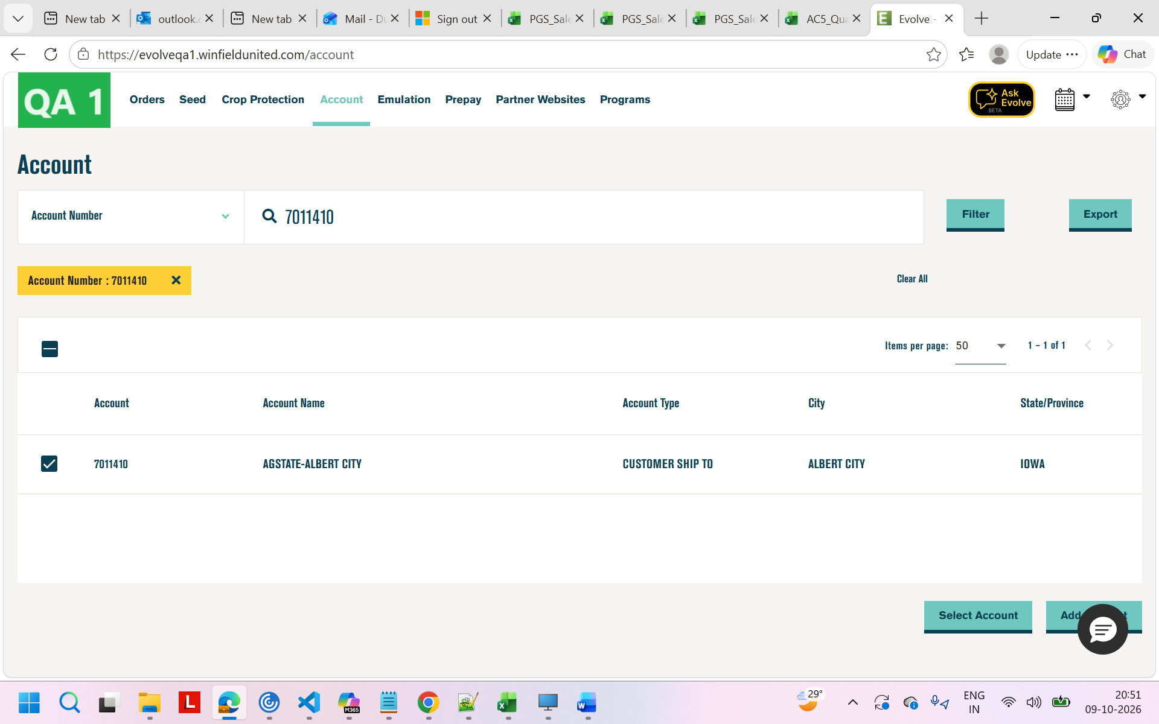
Select account
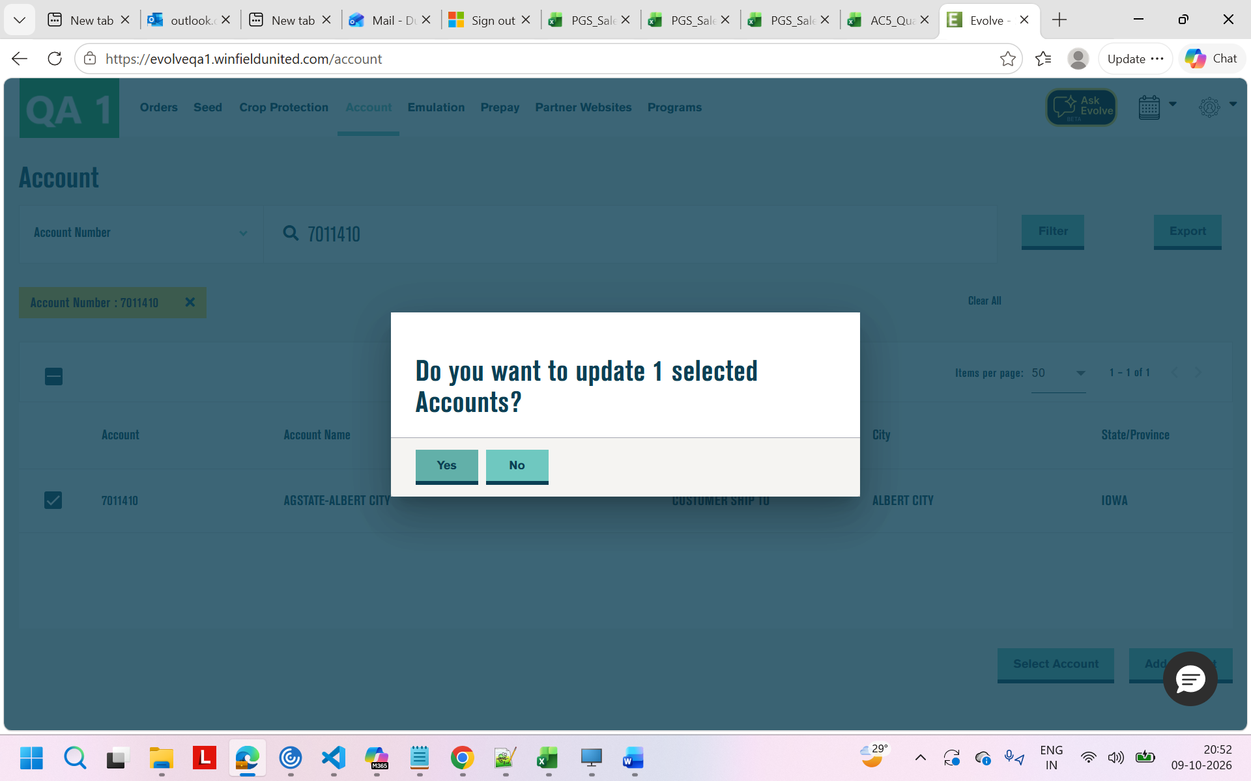
Click-yes

Seed->orders
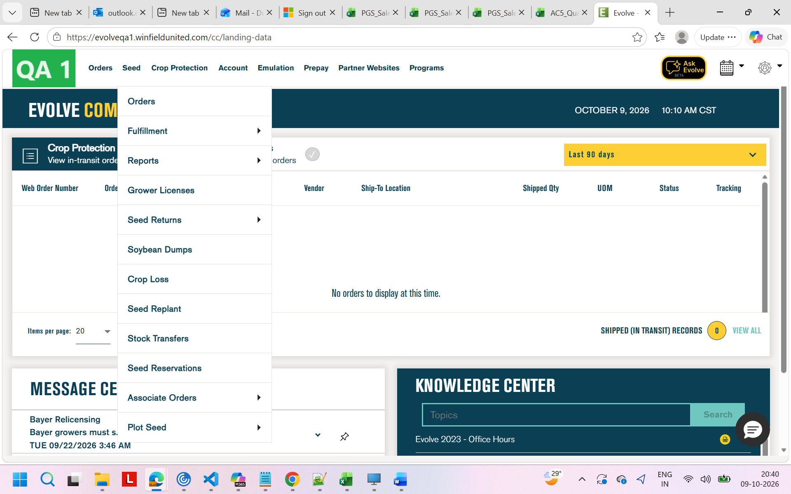
Order grid
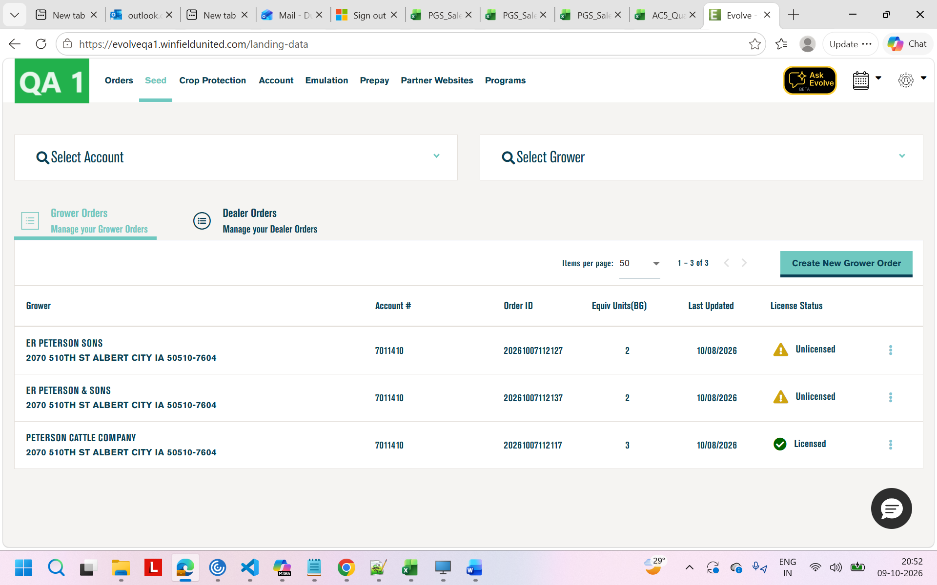
Verify the order Licence status
1.Unlicenced
2.Licenced
3.NotApplicable
->Click on Unlicenced 2links will show
->first link will open on same tab
Verifications
1.Licence status
2.order no
3.Down grid

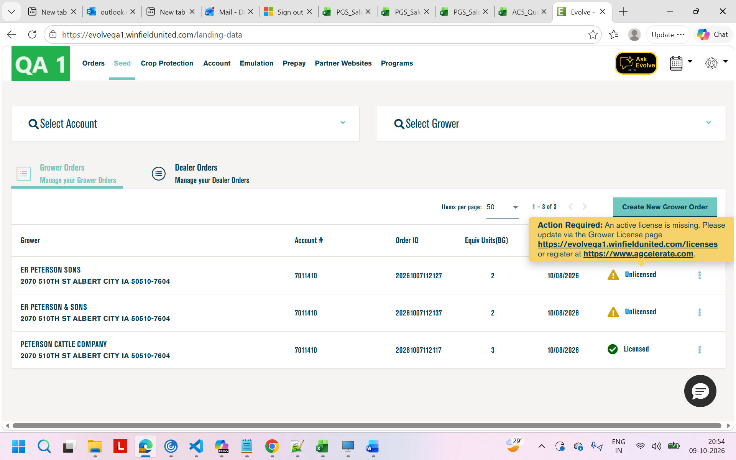
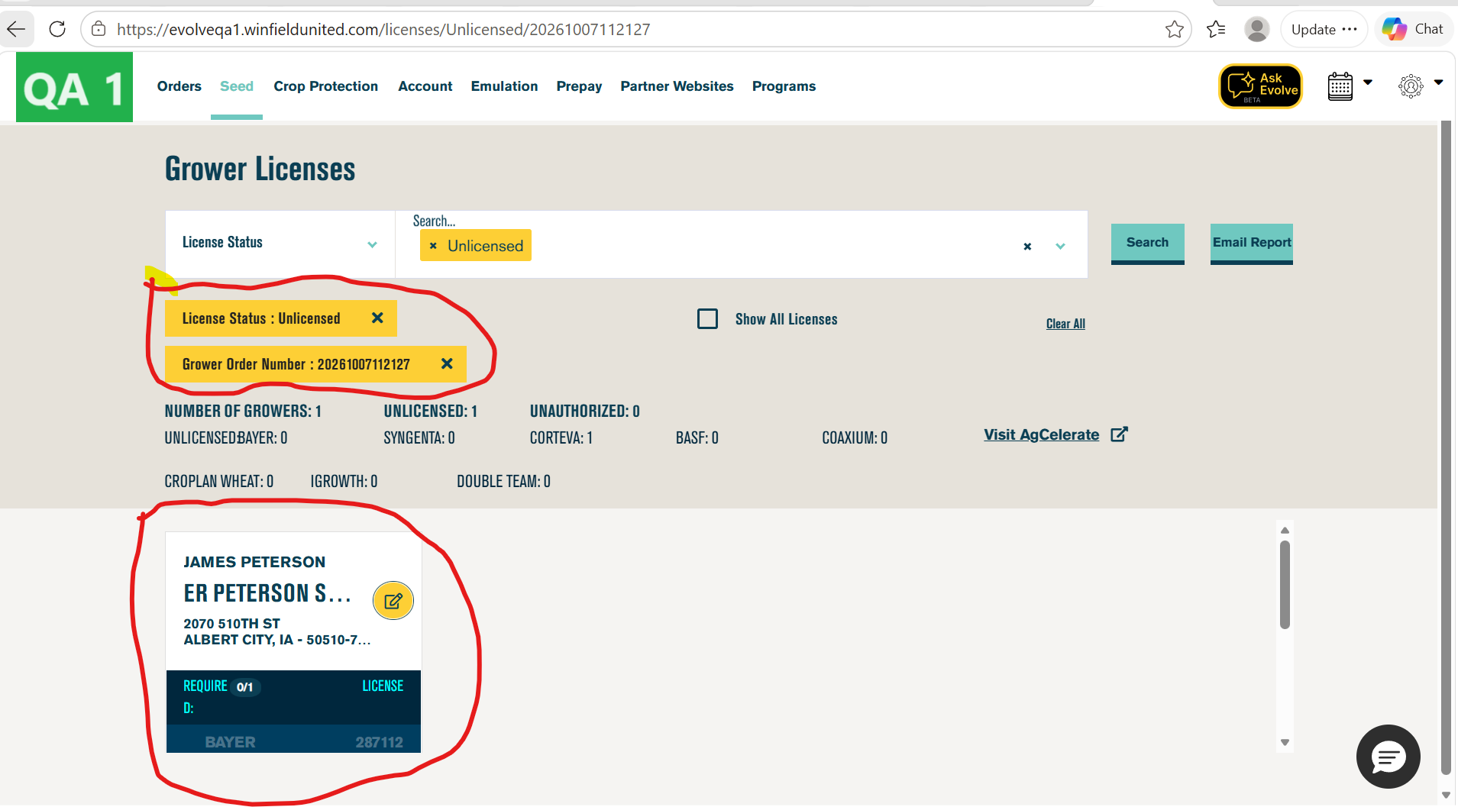
Second link redirected to another tab and verify welcome message
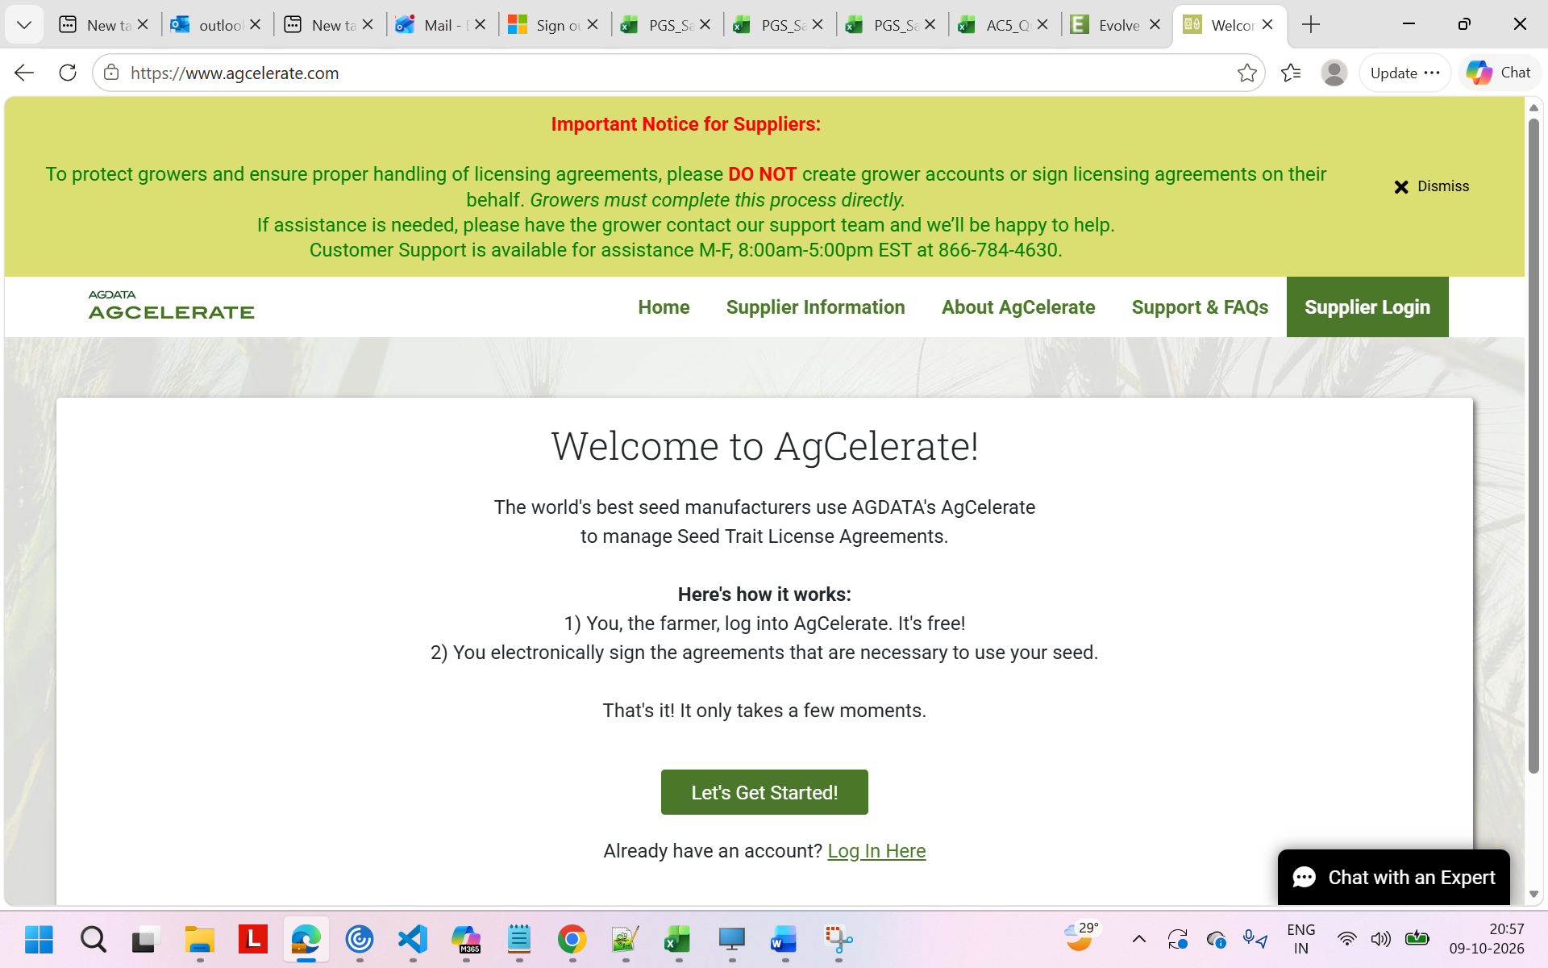
2.Edit
Click on seed->orders->click on unlicenced order
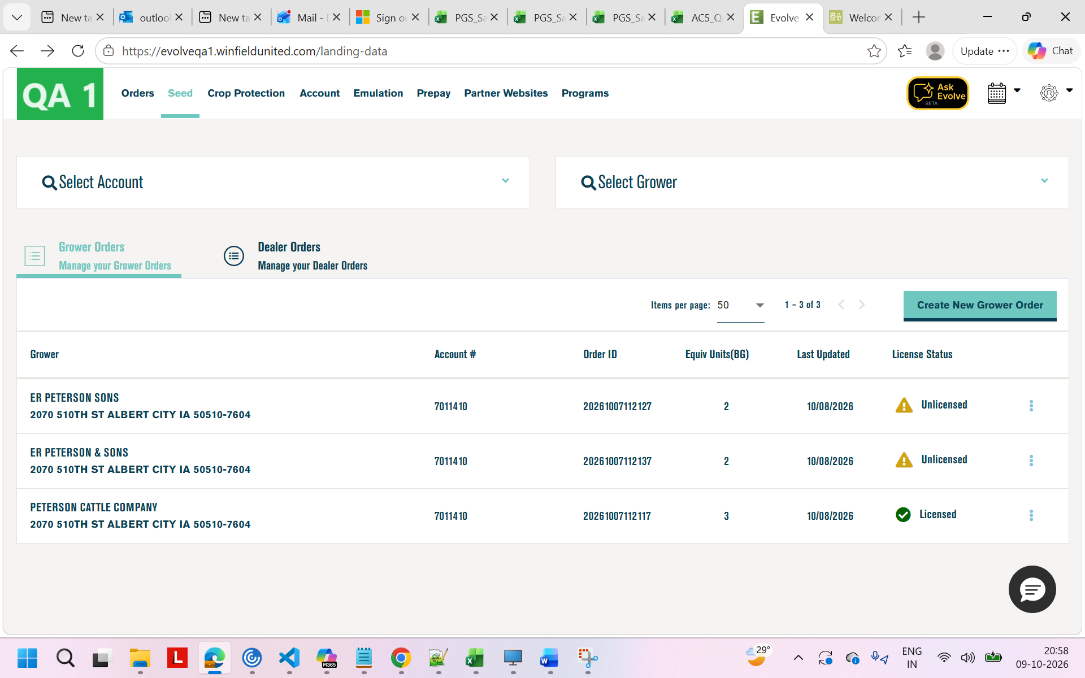
Yellow message verification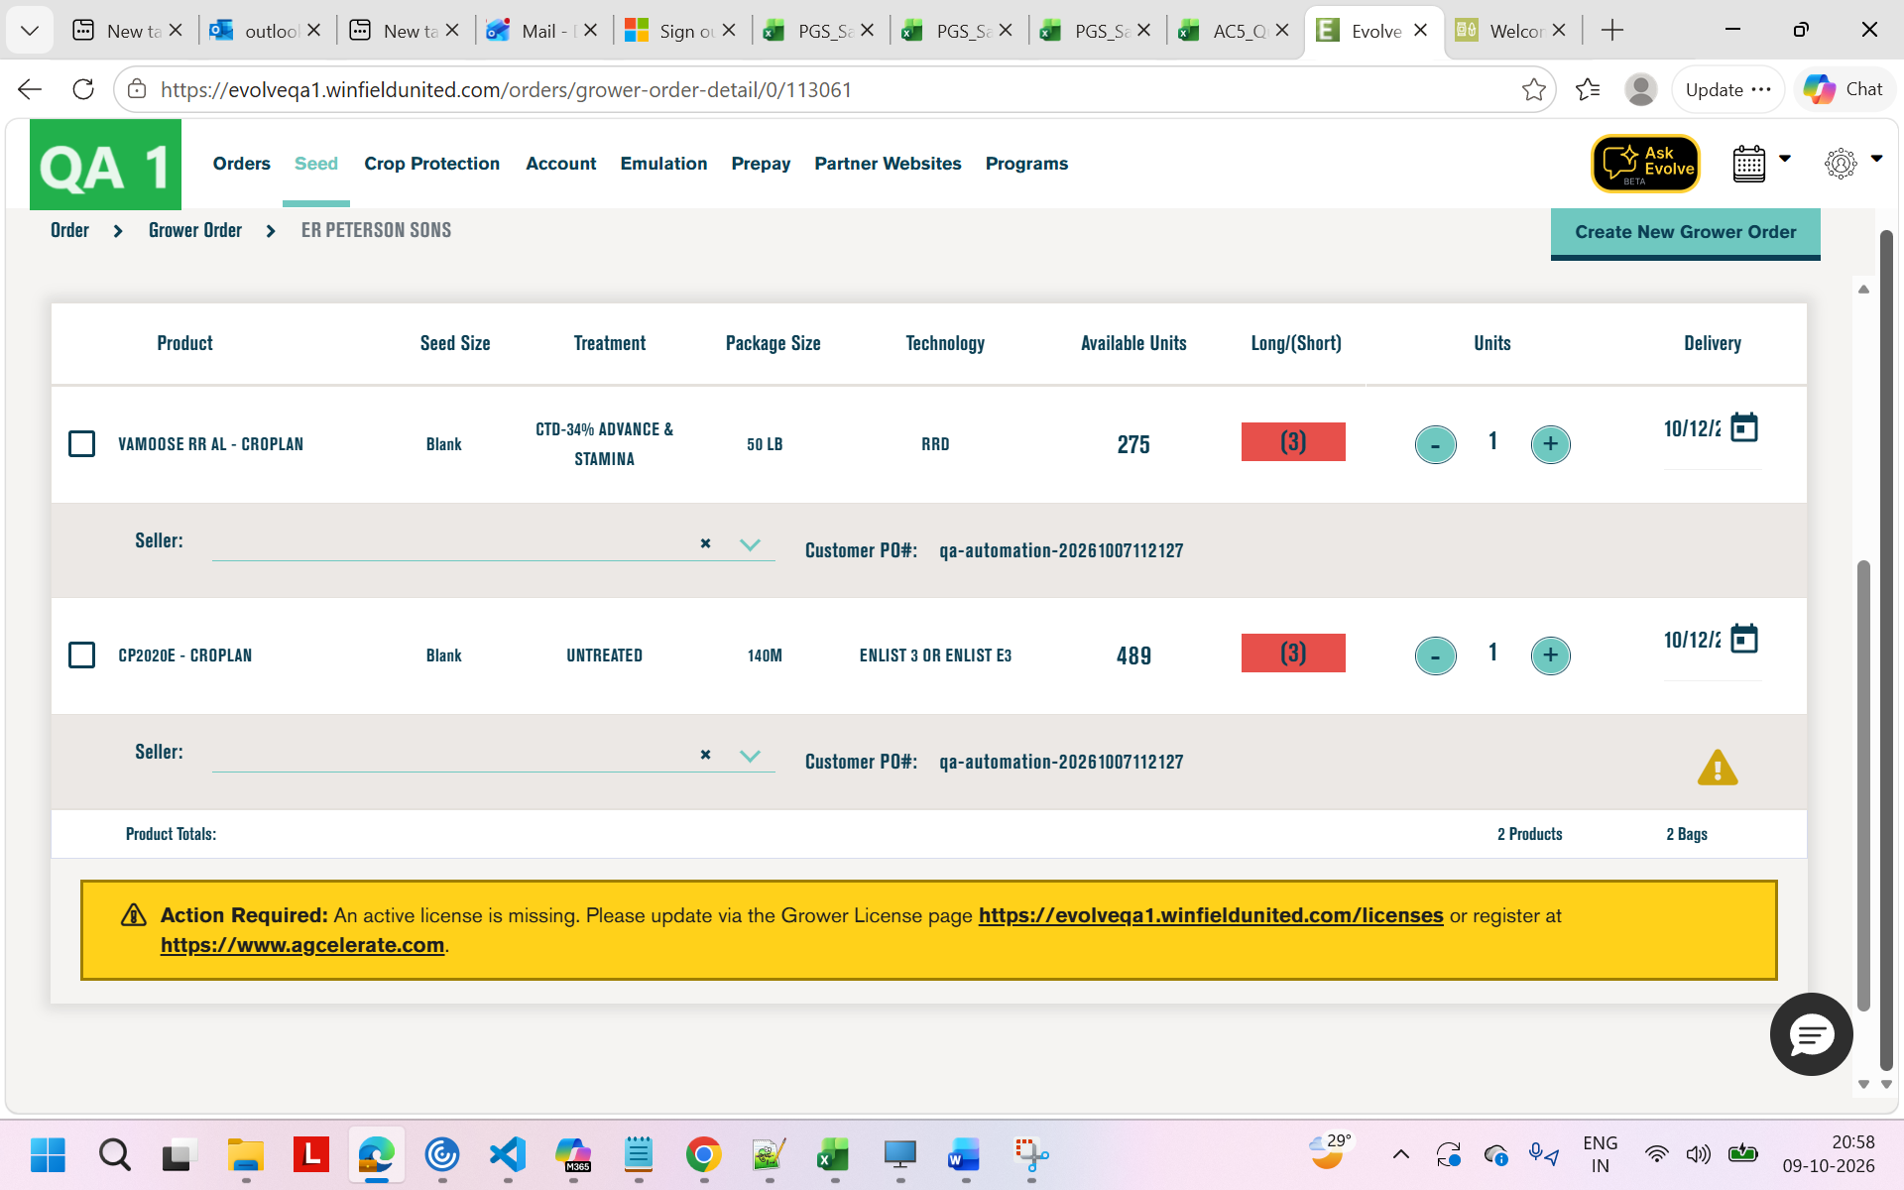
Yellow message veification
3.New order-.
Seed->orders
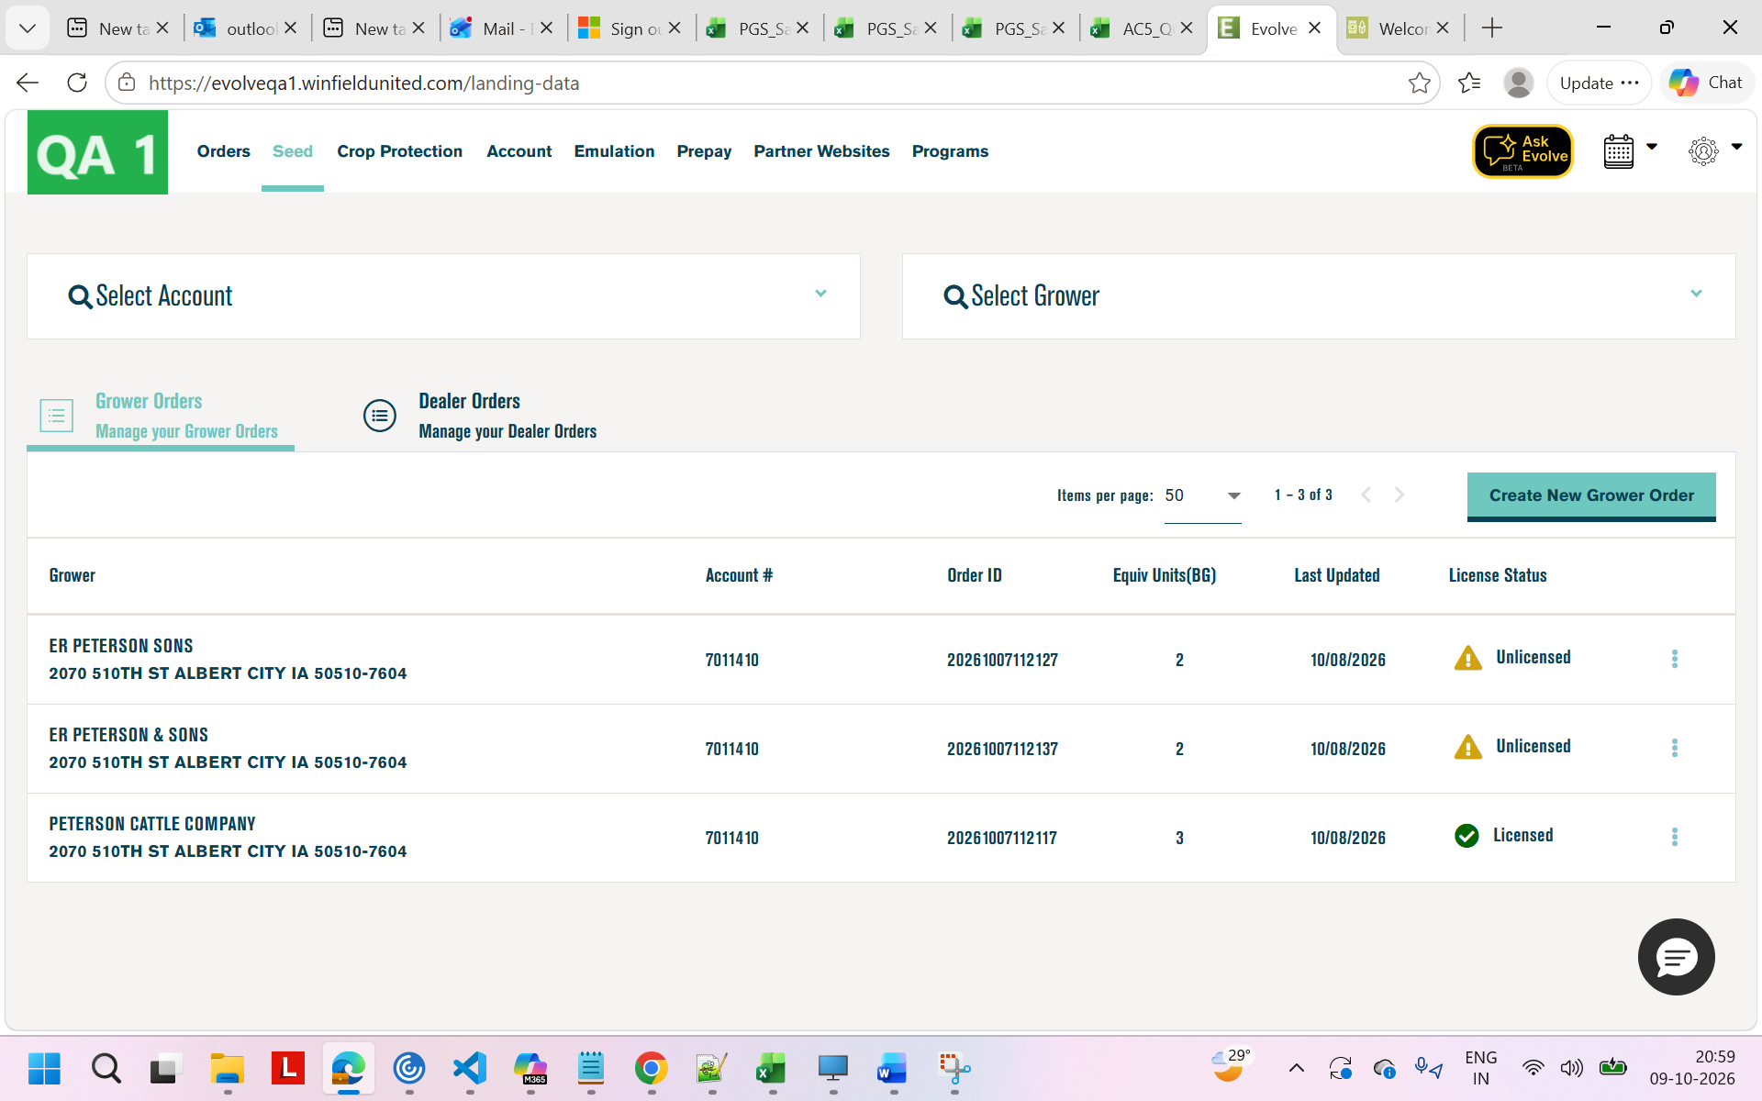

Click on create new order
Select account and Grower
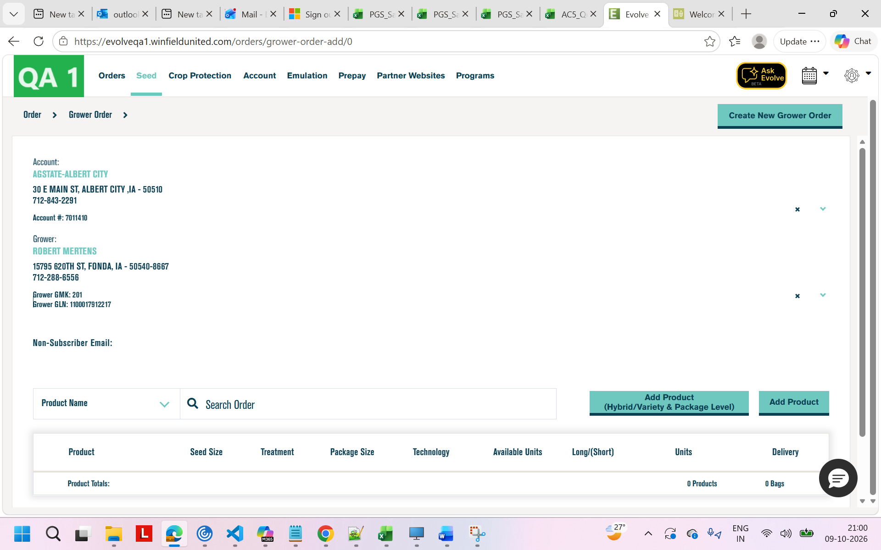
Click on Add product

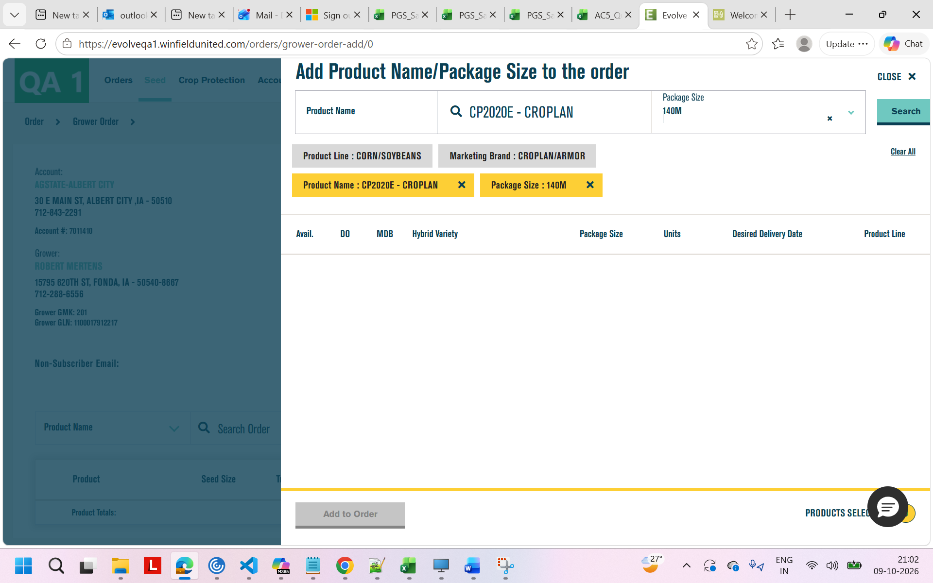
Click on search
Increase units and click on Add to order
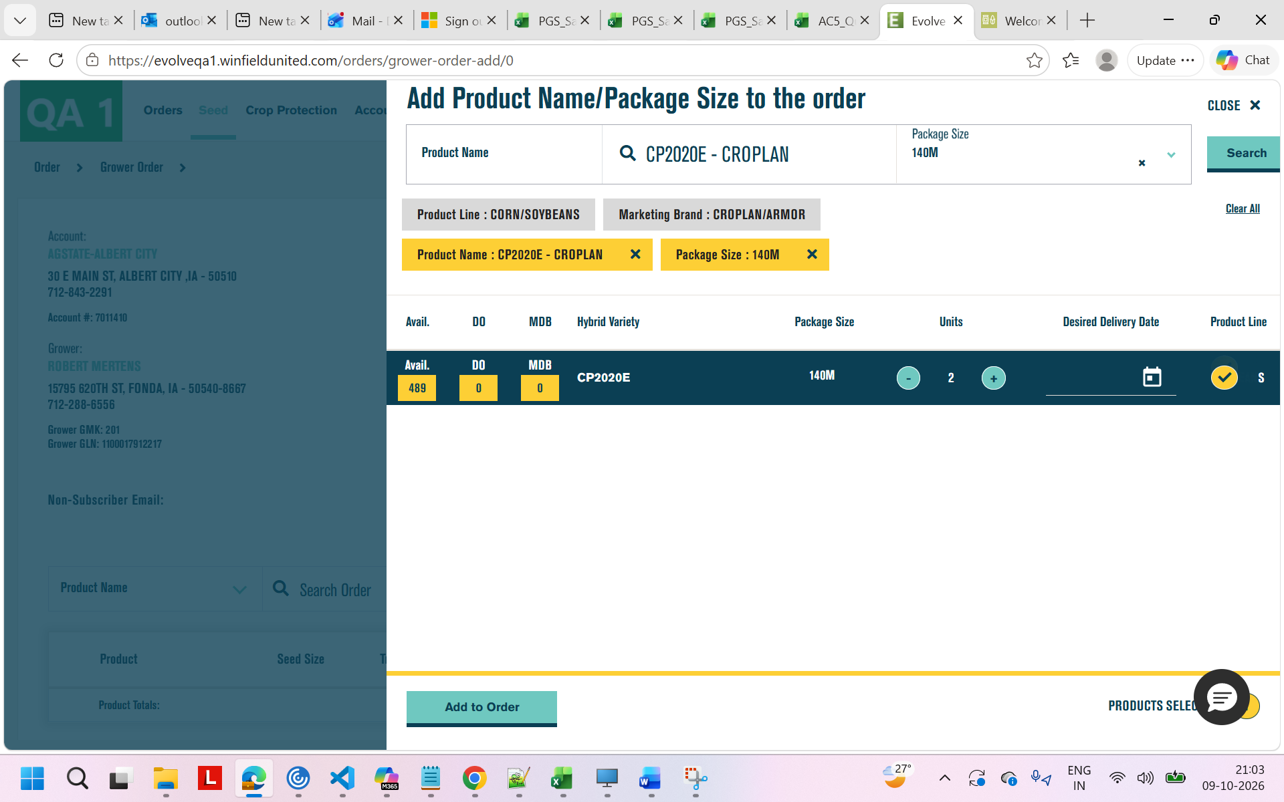
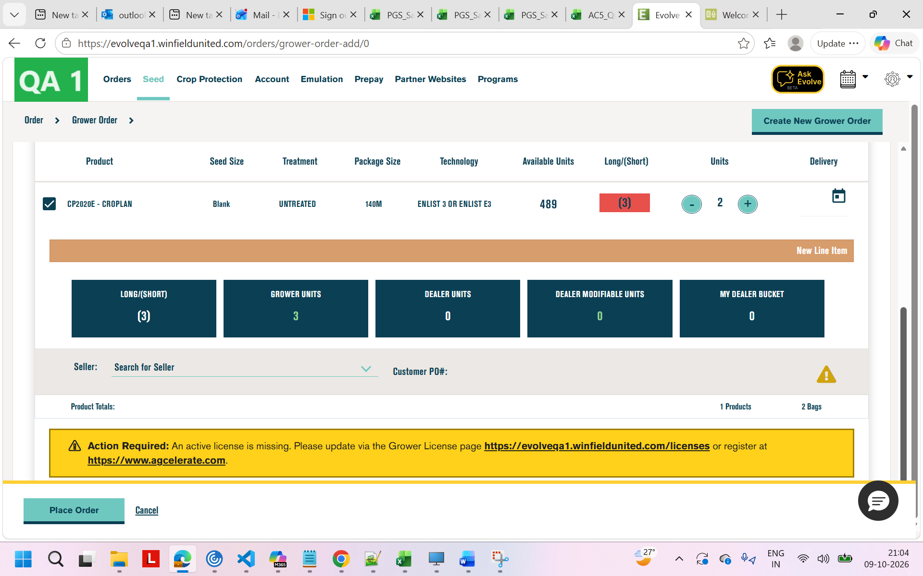
Same yellow link verification
Click on First link
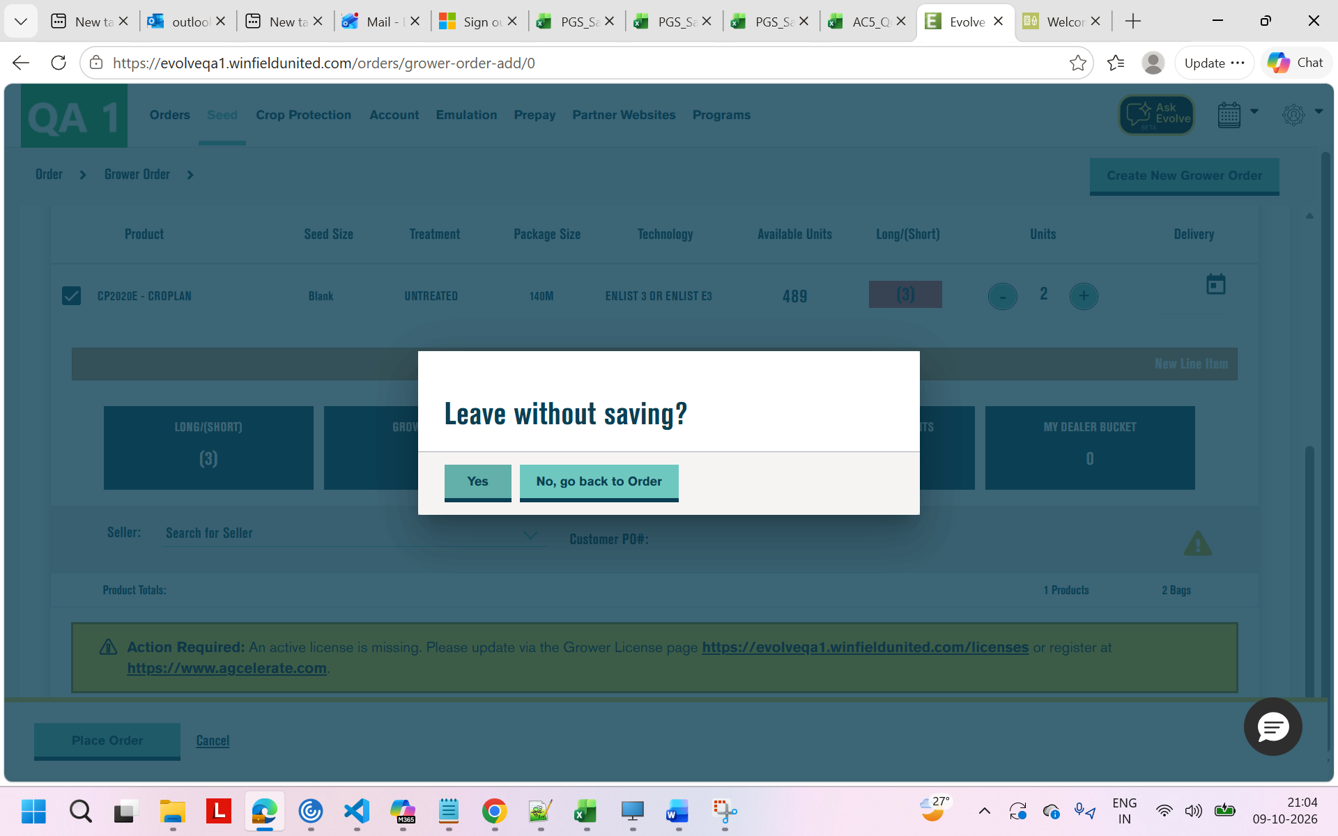
Click on yes and verify Grower
