React.js Component Creation

Name: Bhavani

Roll no.: 20KT1A05A8

COLLEGE: PSCMRCET

source code :

CARD COMPONENT :

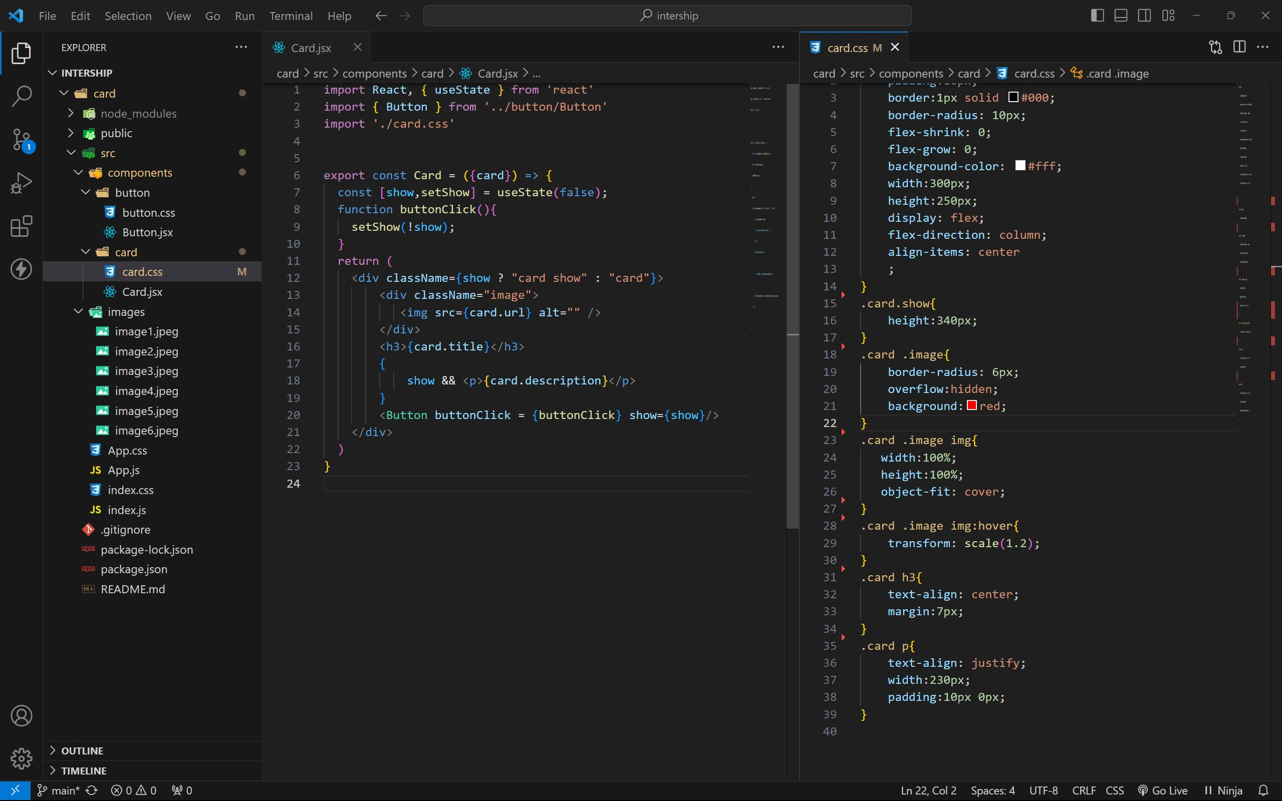

BUTTON COMPONENT :

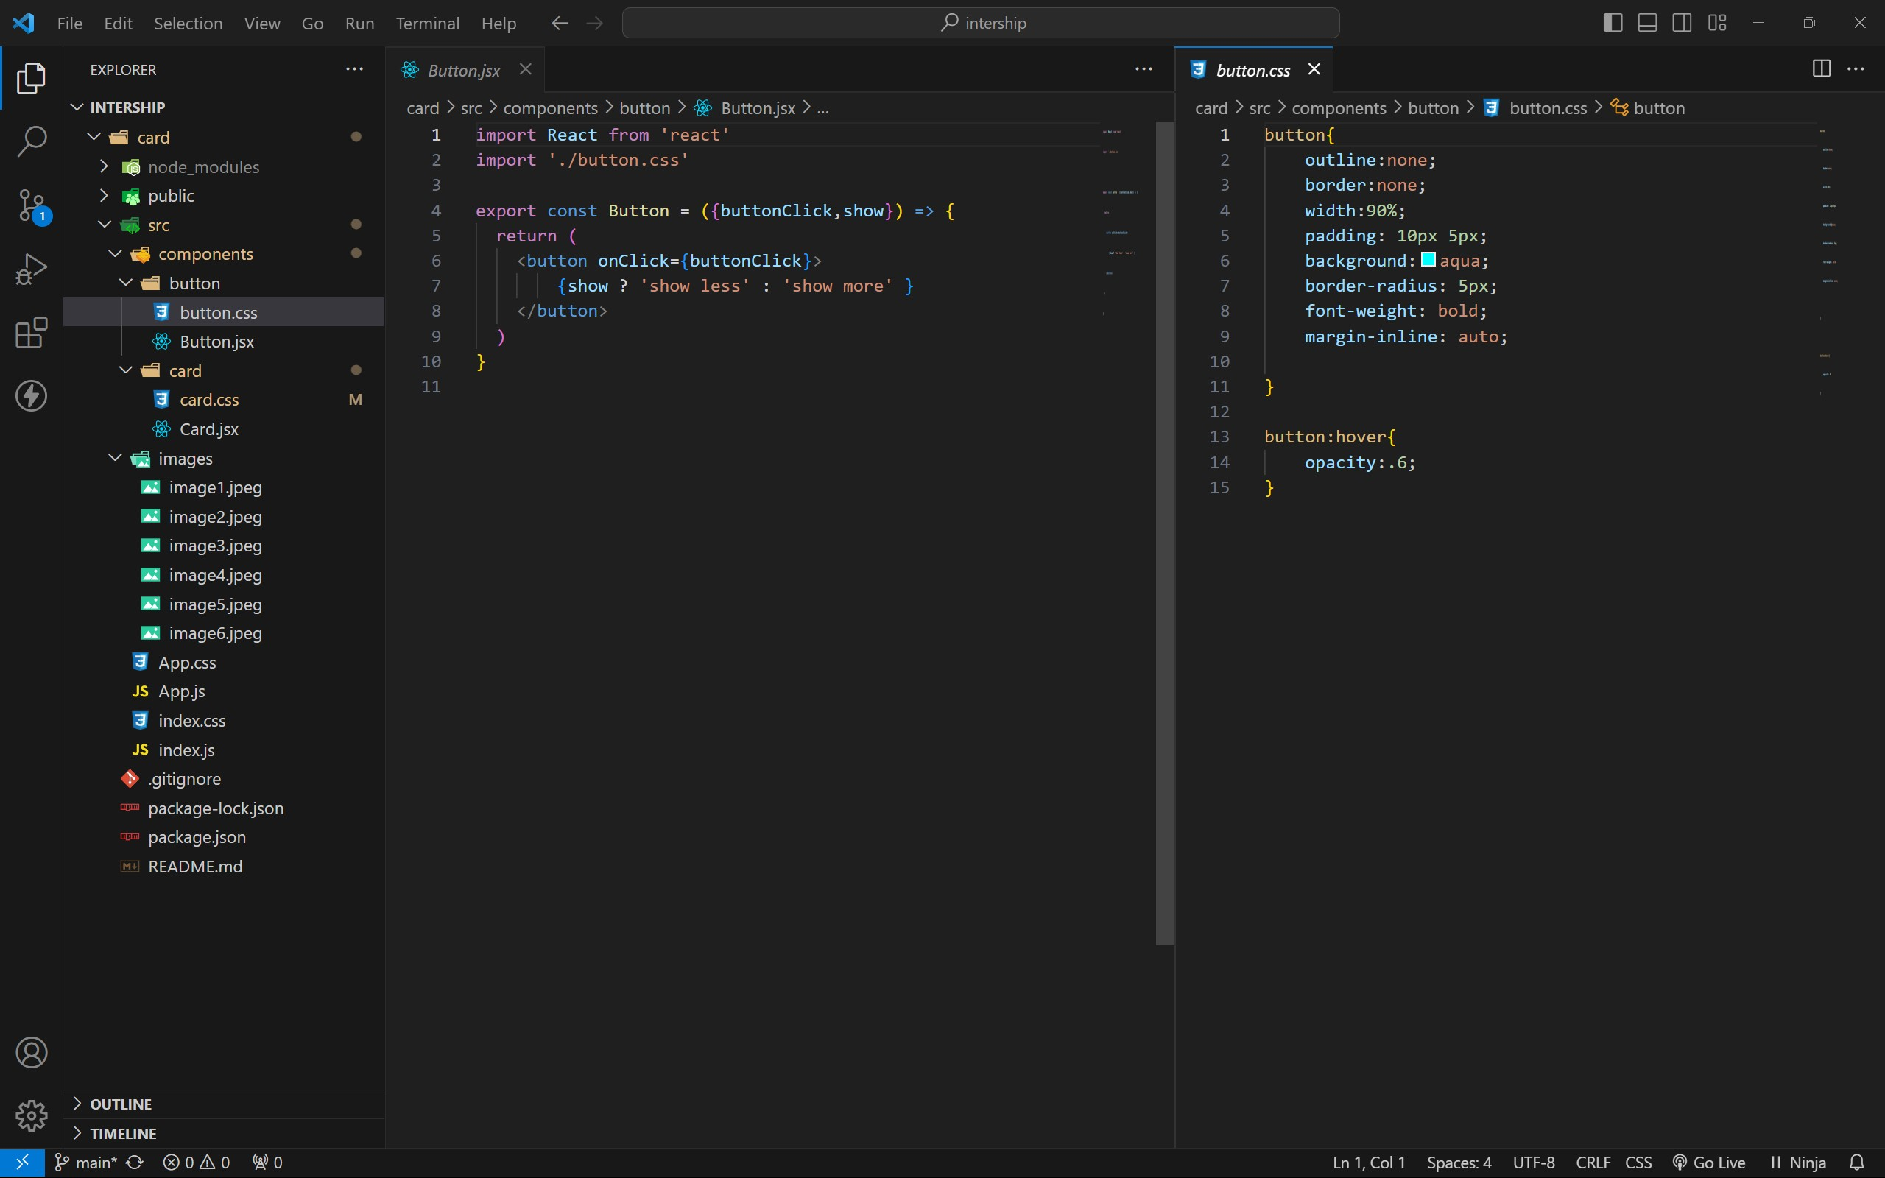

APP COMPONENT :

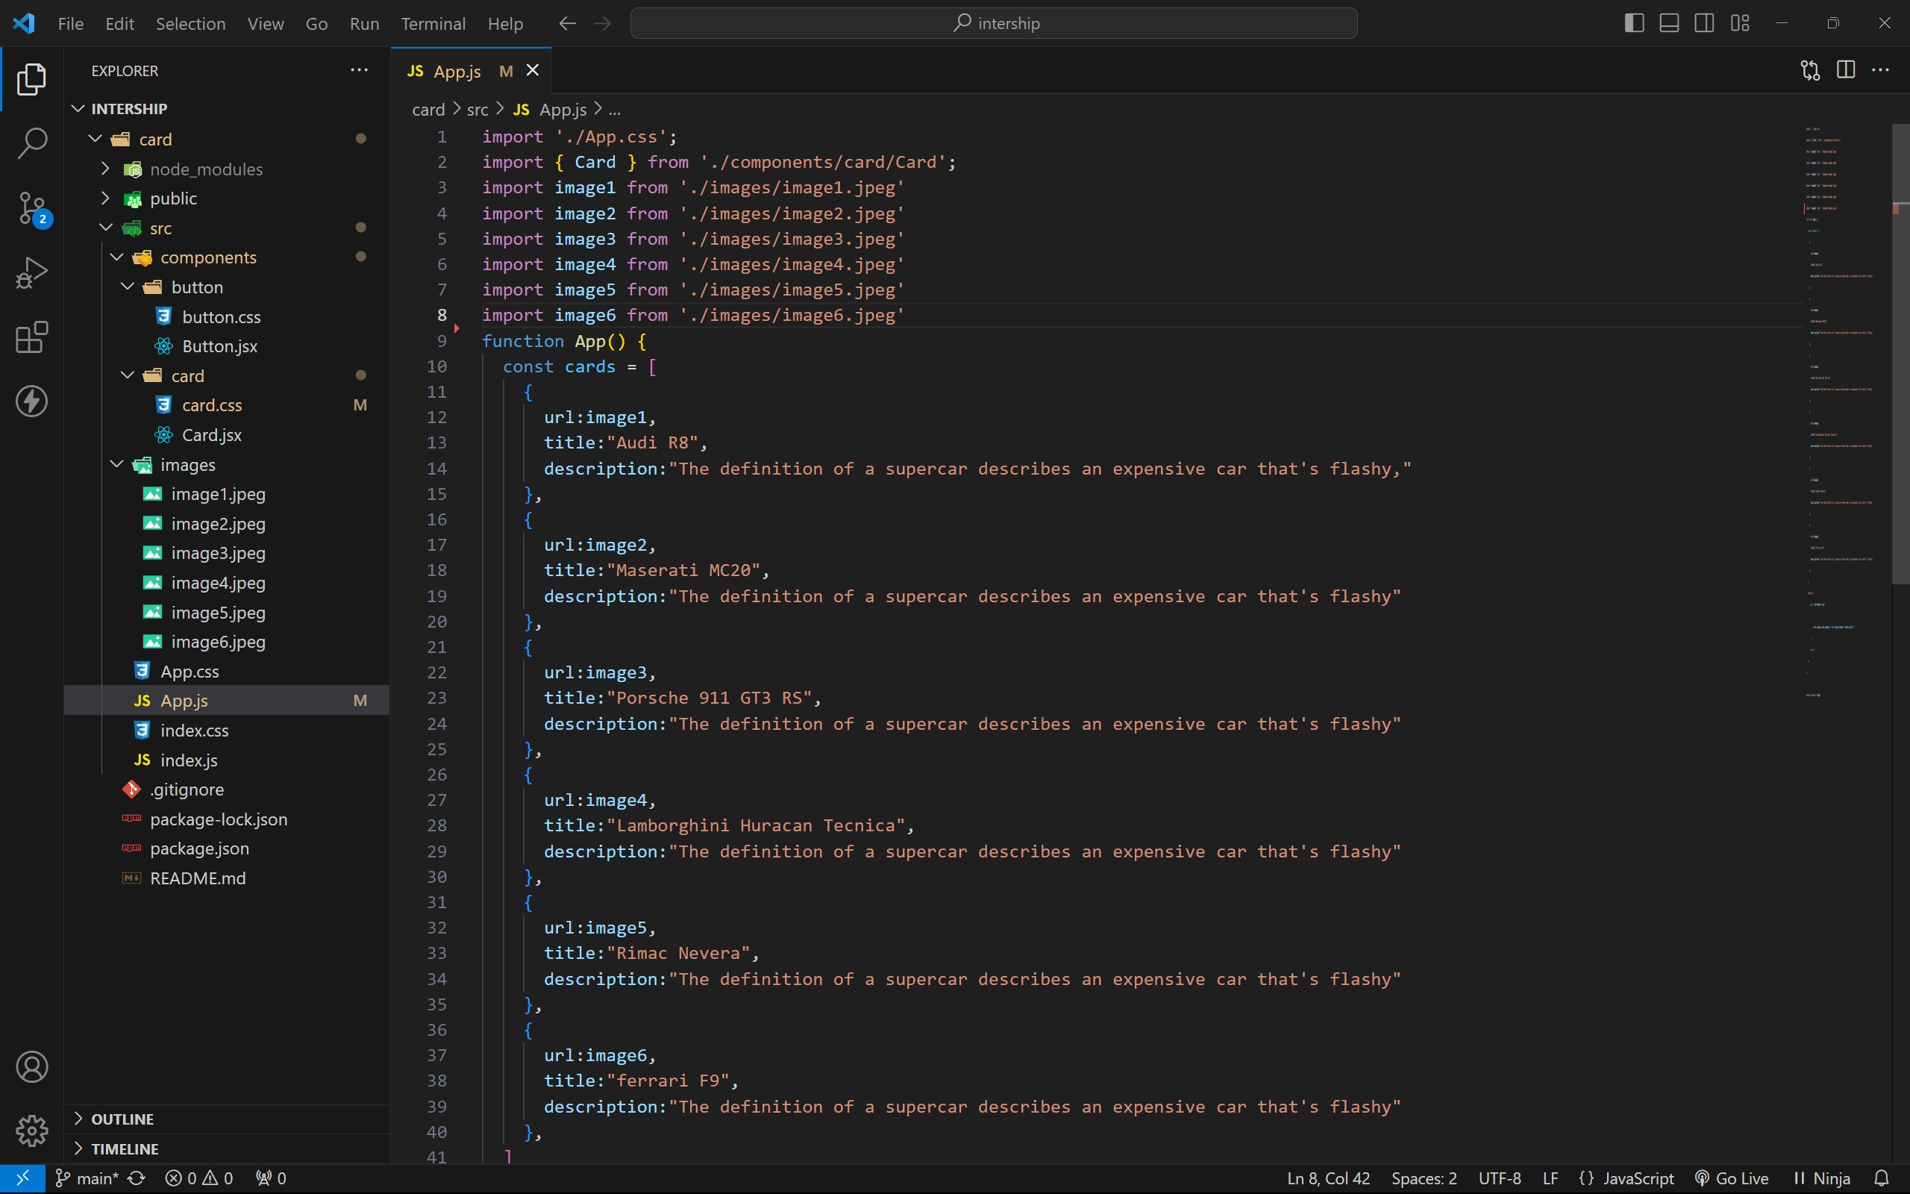

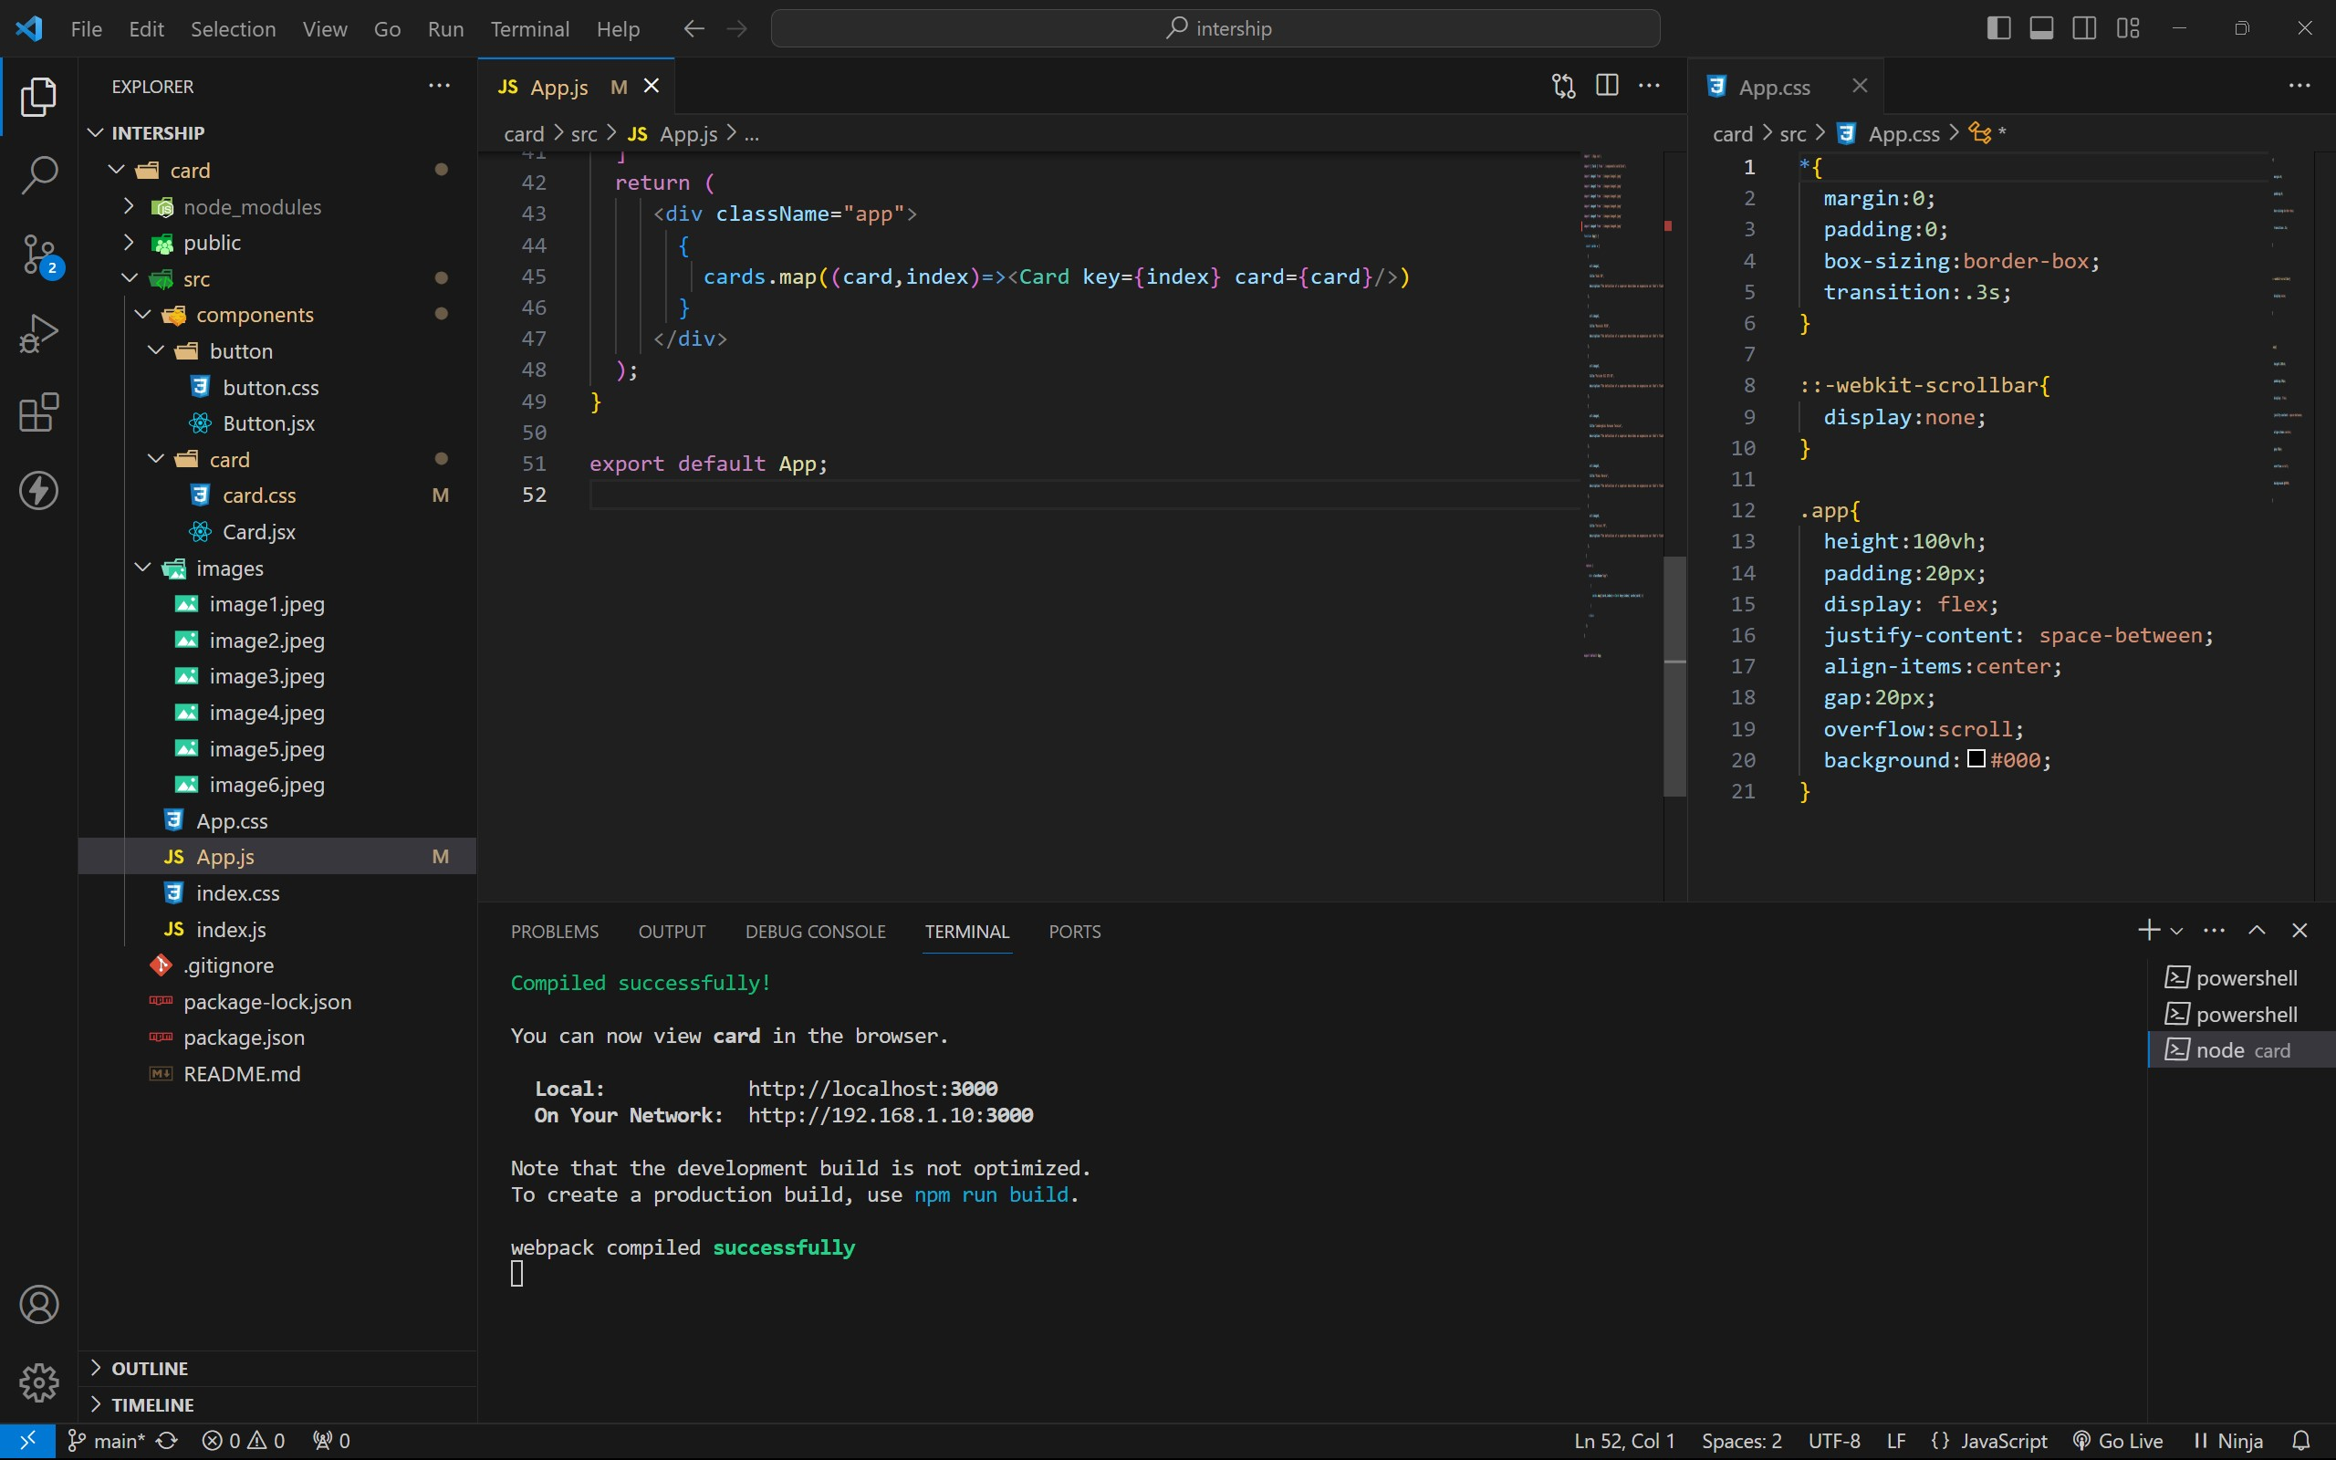

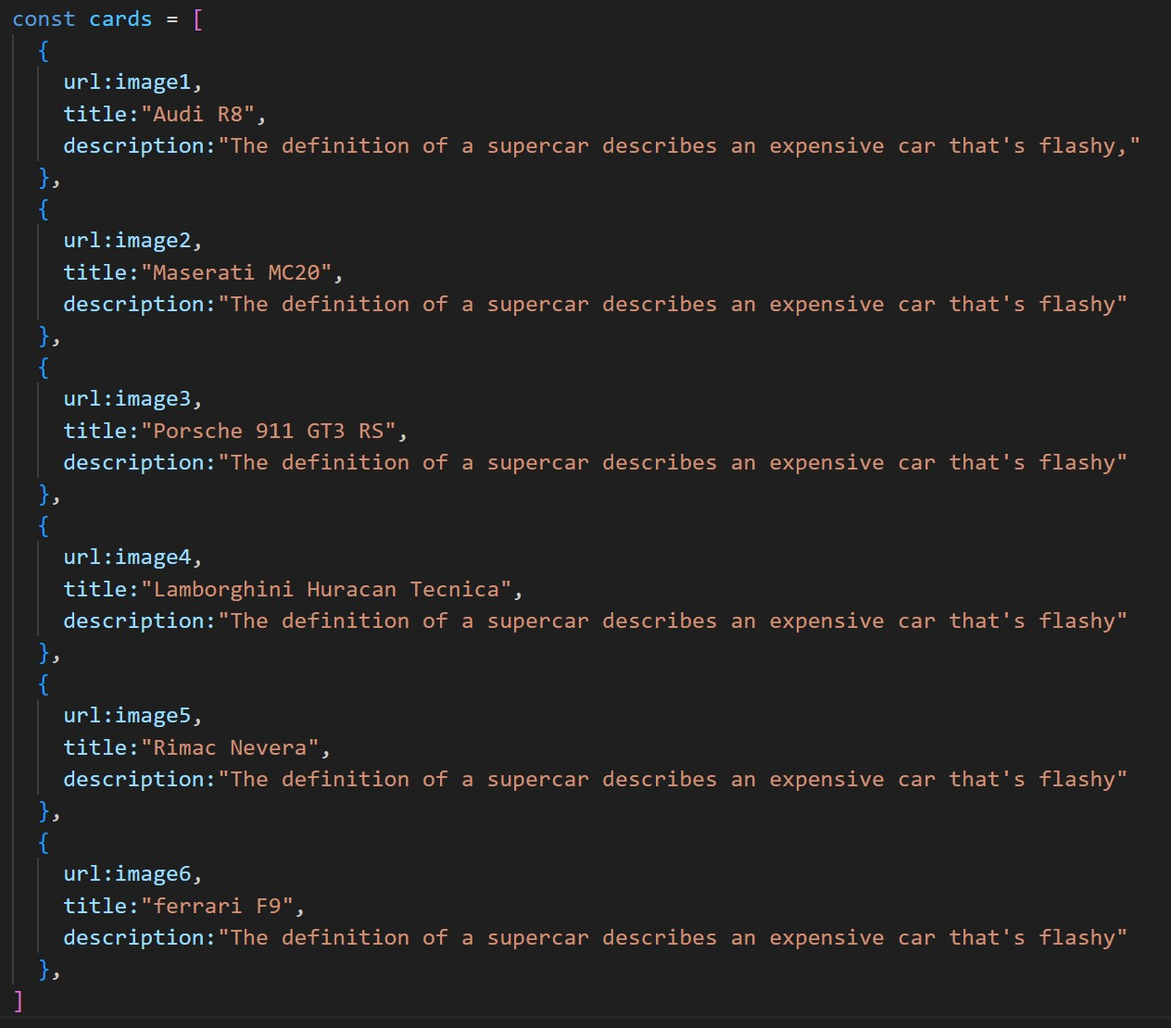

OUTPUT :

