Software Requirements Specification
Datacon
Internal Project Name: Datacon
Enterprise Intelligence Platform
Multi-Agent Orchestration • RAG • Unified Data Connectors

Table of Contents

Contents
Table of Contents 2
1. Introduction 3
1.1 Purpose 3
1.2 Scope 3
2. Technology Stack 3
2.1 Frontend Stack 4
2.2 Backend Stack 4
3. System Architecture & Flows 4
3.1 Overall Context / System Flow 4
3.2 Unified Connector Sync Architecture 5
4. Key Functional Features 6
4.1 Authentication & RBAC (Role-Based Access Control) 6
4.2 Agentic Chat Engine 6
4.3 Unified Database Connectors 6
4.4 Insights Dashboard 6
4.5 Data Source Management (RAG File Store) 7
5. Database Schema & Data Models 7
5.1 MongoDB Collections 7
Collection: users 7
Collection: conversations 7
Collection: messages 7
Collection: connectors 8
Collection: unified_datasets 9
Collection: data_sources 9
6. Non-Functional Requirements 9
6.1 Security & Protection 9
6.2 Data Processing & Performance 10

1. Introduction

1.1 Purpose
This document specifies the software requirements for the Datacon enterprise intelligence platform (also referred to under its internal project name, Lyra). Datacon is a B2B SaaS analytics application combining multi-agent business orchestration, Retrieval-Augmented Generation (RAG) over corporate documents, and database connectors.

1.2 Scope
Datacon provides business users with:
- Interactive Chat & Orchestrated Analysis: Answers descriptive, diagnostic, predictive, and prescriptive questions.
- Unified Data Connectors: Connects to database engines (SQLite, MySQL, PostgreSQL, Snowflake, BigQuery) and file systems (HTTP/CSV) to sync structured tables into a governed semantic store.
- Document-Based RAG: Processes and indexes PDFs, markdown, and text files into a vector store for search.
- Insights Dashboard: Visually presents key metrics, interactive charts, and system alerts (anomalies).

2. Technology Stack
Datacon is built using a modern, decoupled architecture:
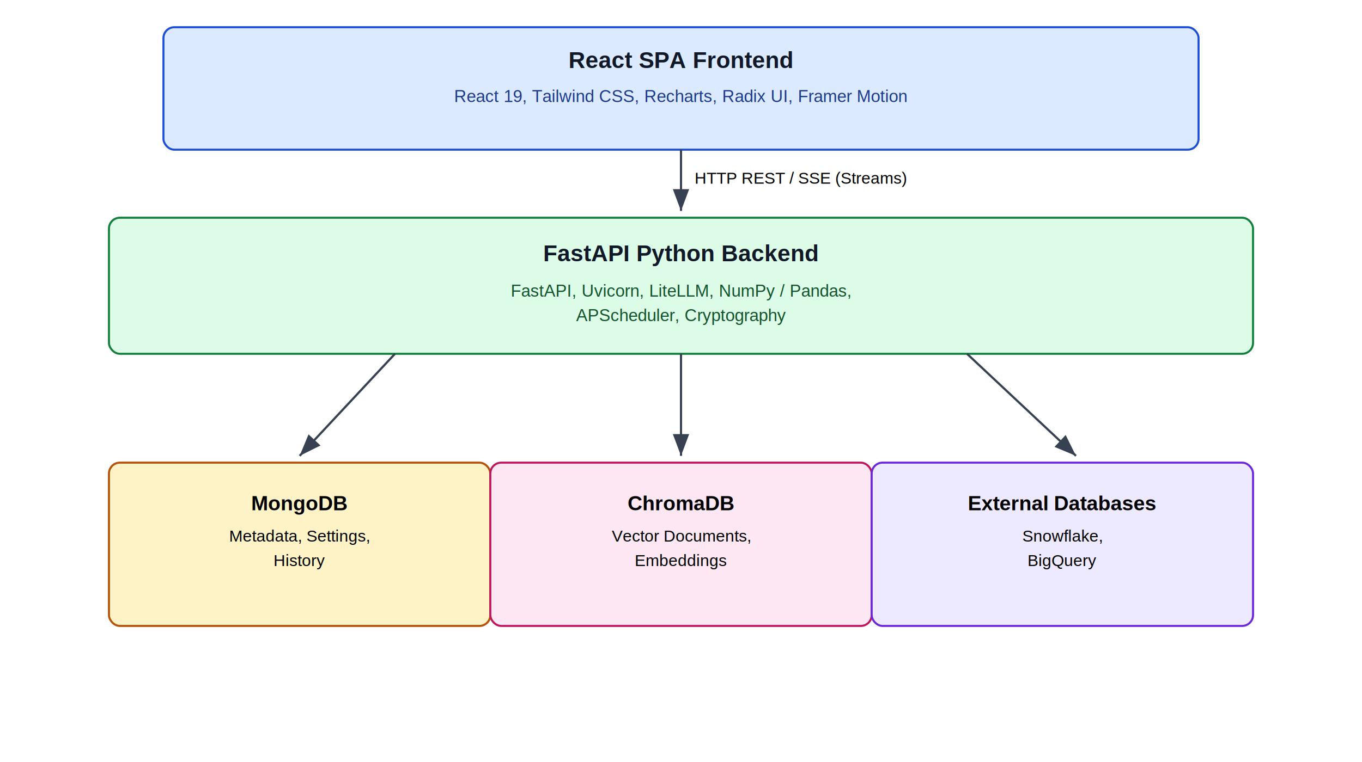
Figure 1. High-level technology stack architecture

2.1 Frontend Stack
- Framework: React 19.0.0 (JavaScript-based SPA).
- Routing: React Router DOM v7.15.0.
- Styling: Tailwind CSS v3.4.17 (Vanilla utility classes with tailwindcss-animate).
- Design & Theme: Custom Swiss & High-Contrast Light theme (governed by design_guidelines.json).
- UI Components: Radix UI primitives configured with Tailwind CSS (Dialog, Dropdown Menu, Tabs, Accordion, Alert Dialog, Separator, Command).
- Icons: Phosphor Icons (@phosphor-icons/react) and Lucide React.
- Visualizations: Recharts v3.6.0 (Line and Bar charts with interactive tooltips).
- State Management & Data Fetching: TanStack React Query v5.56.2, Axios v1.16.0, SWR v2.3.8.
- Animations: Framer Motion v11.18.0.

2.2 Backend Stack
- Framework: FastAPI v0.110.1 (Asynchronous Python API framework).
- Application Server: Uvicorn v0.25.0 (ASGI server).
- LLM Orchestrator: LiteLLM (Gemini 2.5 Flash as the default model: gemini/gemini-2.5-flash).
- Vector Database: ChromaDB v1.5.9 (with standard Cosine metric and ONNX all-MiniLM-L6-v2 local embeddings).
- Primary Database Driver: Motor v3.3.1 (Async MongoDB client) and PyMongo v4.6.3.
- Forecasting Engine: Pure NumPy & Python implementation for time-series forecasting (OLS and Holt-Winters Exponential Smoothing).
- Data Processing: Pandas (for CSV parsing), PyPDF (for extracting text from PDFs).
- Scheduler: APScheduler v3.11.3 (runs background interval-based database synchronization).
- Security & Encryption: Cryptography v42.0.8 (Fernet symmetric encryption for credentials), Bcrypt v4.1.3 (for passwords), PyJWT v2.10.1.
- Database Client Drivers:
  - PostgreSQL: psycopg2-binary
  - MySQL: PyMySQL
  - Snowflake: snowflake-connector-python
  - Google BigQuery: google-cloud-bigquery
  - SQLite: SQLAlchemy (built-in SQLite integration)

3. System Architecture & Flows

3.1 Overall Context / System Flow
This sequence shows how a user interacts with the system to ask analytics questions:
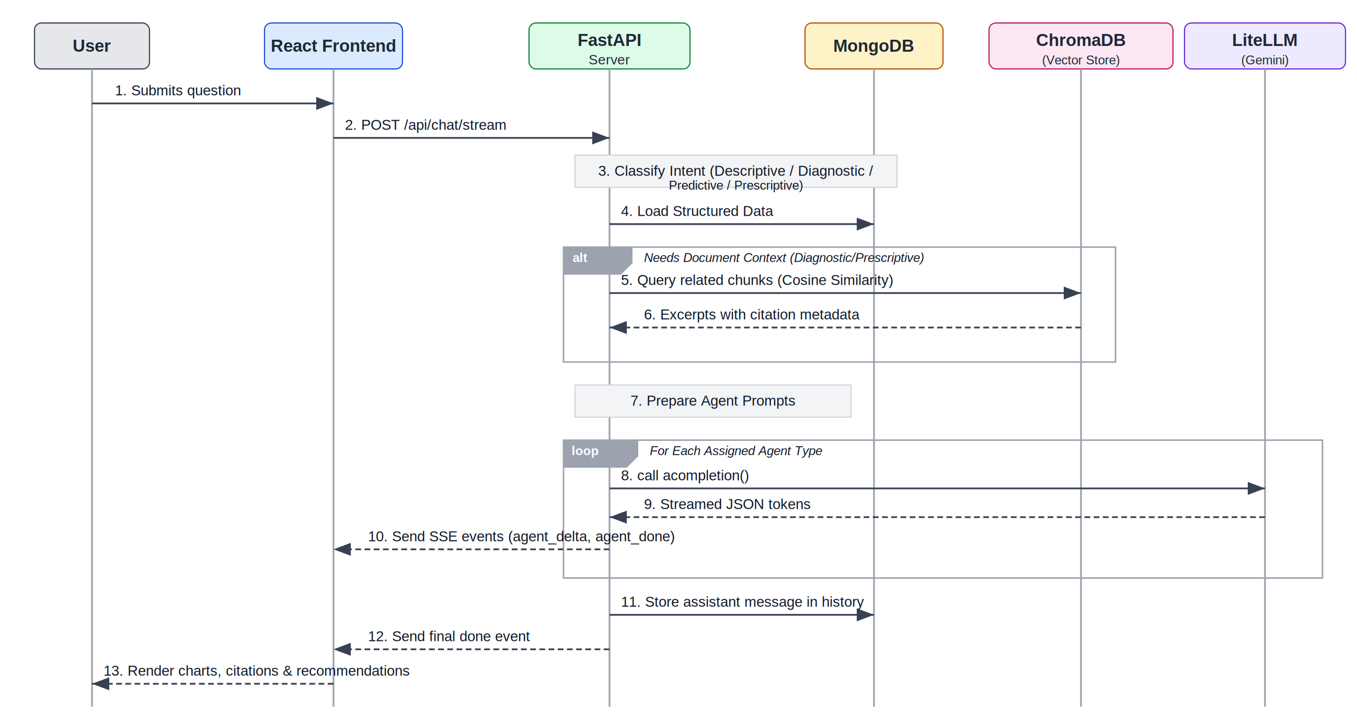
Figure 2. End-to-end sequence diagram for the chat and orchestrated analysis flow

3.2 Unified Connector Sync Architecture
How external data connectors ingest schema catalogs and synchronize databases:
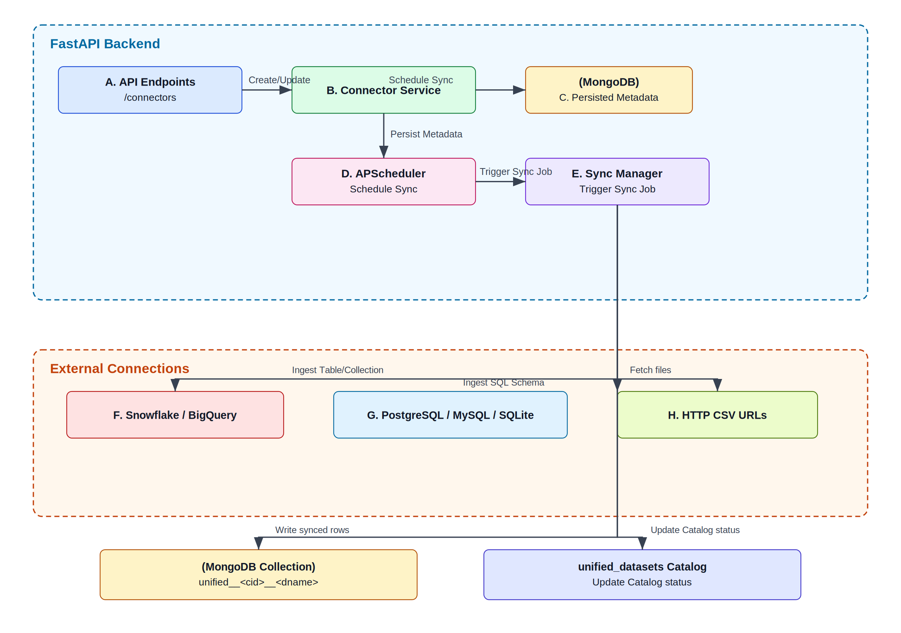
Figure 3. Unified connector synchronization architecture

4. Key Functional Features

4.1 Authentication & RBAC (Role-Based Access Control)
- Sign-Up / Register: Registers email, name, password.
- Sign-In / Login: Session management using double JWT cookies (access_token and refresh_token).
- Roles:
  - viewer: Restricted to viewing insights, browsing database catalogs, and messaging. Cannot upload documents, configure database connectors, or write sync commands.
  - analyst / admin: Full write privileges to modify, delete, and manually trigger connector synchronization.

4.2 Agentic Chat Engine
- Intent Classifier: Analyzes the question tokens to assign relevant agents:
  - Descriptive Agent: Synthesizes structured data tables. Generates Recharts line/bar visualizations.
  - Diagnostic Agent: Queries ChromaDB vector index to extract root-cause excerpts from documentation and lists causal links.
  - Predictive Agent: Executes forecasting models using historical context and plots the forecast output alongside confidence intervals.
  - Prescriptive Agent: Formulates actionable recommendations, estimating effort (low, medium, high), financial impact, and suggesting stakeholders.
- Streaming SSE Engine: Streams real-time progress via Server-Sent Events (/api/chat/stream), parsing JSON blocks and feeding data sequentially to the UI.
- Feedback loop: Upvote/downvote buttons for every assistant answer.

4.3 Unified Database Connectors
- Connector Profiles: Integrates SQL Databases (MySQL, PostgreSQL, SQLite), Cloud Warehouses (BigQuery, Snowflake), Document databases (MongoDB), and file services (HTTP/CSV).
- Secure Credentials Storage: Encrypts secret variables (password, uri, service_account_json) using Fernet cryptography. Masks values with *** in API outputs.
- Metadata Discovery: Retrieves database schemas, formats, and structures. Caches schema configurations.
- Scheduler: Automated background polling schedules synced with APScheduler.

4.4 Insights Dashboard
- Key Performance Indicators (KPIs): Generates aggregate statistics (Total quarterly revenue, QoQ change %, Monthly Churn %, support ticket averages).
- Anomalies Monitor: Automatically highlights detected outliers (e.g., ticket spikes, churn trends).
- Renewals pipeline tracker: Computes committed vs at-risk targets.

4.5 Data Source Management (RAG File Store)
- File Uploader: Parses CSVs, PDFs, and plain text/markdown files.
- File Parser:
  - CSV: Loaded into Pandas dataframes; schema columns are cached, and top 20 rows are displayed in UI previews.
  - PDF/TXT/MD: Splits documents into overlapping word chunks (480 words, 60 overlap).
- Vector Search & Indexing: Inserts document chunks into ChromaDB's persistent vector collection.

5. Database Schema & Data Models

5.1 MongoDB Collections

Collection: users
Tracks authorized system users.
{
"_id": "ObjectId",
"email": "string (unique)",
"name": "string",
"role": "string (admin | analyst | viewer)",
"password_hash": "string (bcrypt)",
"created_at": "string (ISO Date)"
}

Collection: conversations
Maintains conversational metadata.
{
"_id": "ObjectId",
"id": "string (UUID)",
"user_id": "string (User Ref)",
"title": "string",
"created_at": "string (ISO Date)",
"updated_at": "string (ISO Date)"
}

Collection: messages
Stores multi-turn conversational logs.
{
"_id": "ObjectId",
"id": "string (UUID)",
"conversation_id": "string (Conversation Ref)",
"role": "string (user | assistant)",
"content": "string",
"agents": ["string (descriptive | diagnostic | predictive | prescriptive)"],
"intent_confidence": "string (high | medium | low)",
"results": [
{
"agent": "string",
"insight": "string",
"details": "string",
"citations": ["integer"],
"chart": {
"type": "string (bar | line)",
"title": "string",
"x_label": "string",
"y_label": "string",
"data": [
{ "label": "string", "value": "number", "lower": "number", "upper": "number" }
]
},
"table": {
"columns": ["string"],
"rows": [["string"]]
},
"recommendations": [
{
"title": "string",
"rationale": "string",
"expected_impact": "string",
"effort": "string (low | medium | high)",
"owner_suggestion": "string",
"citations": ["integer"]
}
],
"confidence": "string"
}
],
"citations": [
{
"id": "integer",
"document_title": "string",
"filename": "string",
"chunk_index": "integer",
"snippet": "string"
}
],
"feedback": "string (up | down | null)",
"created_at": "string (ISO Date)"
}

Collection: connectors
Stores integration parameters and encryption configurations.
{
"_id": "ObjectId",
"id": "string (UUID)",
"name": "string",
"type_id": "string (sqlite | postgresql | mysql | bigquery | snowflake | mongodb | http_csv)",
"owner": "string (email)",
"config": {
"path": "string",
"uri": "string (enc::encrypted_value)",
"password": "string (enc::encrypted_value)",
"host": "string",
"port": "integer"
},
"status": "string (ok | error | not_tested)",
"last_test": "string (ISO Date | null)",
"last_test_message": "string | null",
"last_sync": "string (ISO Date | null)",
"sync_interval_minutes": "integer (0 = manual)",
"datasets_cache": ["string"],
"created_at": "string (ISO Date)",
"updated_at": "string (ISO Date)"
}

Collection: unified_datasets
Acts as the central registry of synchronized data tables.
{
"_id": "ObjectId",
"id": "string (UUID)",
"connector_id": "string (Connector Ref)",
"connector_name": "string",
"connector_type": "string",
"dataset_name": "string",
"collection_name": "string (unified__<cid>__<dname>)",
"rows": "integer",
"columns": ["string"],
"status": "string (ok | error)",
"last_sync": "string (ISO Date)",
"last_error": "string | null"
}

Collection: data_sources
Tracks document source ingestion histories.
{
"_id": "ObjectId",
"id": "string (UUID)",
"filename": "string",
"title": "string",
"uploaded_by": "string (email | system)",
"created_at": "string (ISO Date)",
"status": "string (processed | error)",
"size_bytes": "integer",
"source_type": "string (pdf | text | csv)",
"rows": "integer (CSV only)",
"columns": ["string (CSV only)"],
"preview": ["object (CSV head entries)"],
"content": "string (extracted document text)",
"chunks": [
{ "chunk_index": "integer", "content": "string" }
],
"chunk_count": "integer"
}

6. Non-Functional Requirements

6.1 Security & Protection
- Cookie Protection: Auth tokens reside in HTTP-Only, Secure, and SameSite configuration cookies.
- Cryptography at rest: Data connector secrets are encrypted via stable Fernet keys generated from the application's unique JWT_SECRET.
- CORS Configuration: Restricts origins dynamically via environmental allow-lists (CORS_ORIGINS) while permitting standard local ports (3000, 5173, 127.0.0.1) for testing.

6.2 Data Processing & Performance
- Efficient Forecasting: Custom NumPy-based statistical engines (Holt-Winters & OLS) avoid dependency heavy weights (like statsmodels), ensuring rapid computations.
- Context Control: Prompt sizes are constrained by dynamically scoring unified datasets based on relevance to the user's question, passing only the most matching rows.
- Cosine Space Retrieval: Document snippets are searched using cosine distance optimization in ChromaDB vector space.

